Evaluation The Use Of Iraqi Cement In Production
Self-Compacting Concrete (SCC)

Muhammed K. Al Kafaji
Babil Tech. Inst.

Abstract
A laboratorial test analysis has been made to evaluate a Self-Compacting Concrete (SCC) mixes by using the available Iraqi cement. Six types of Iraqi cement are used in this study. Extensive preliminary physiochemical tests have been carried out for all types of cement. Fresh concrete tests show that the maximum and minimum slump flow values of 758mm and 650mm have obtained from SCC mixes made of Kerbala (Sulfate Resistance) and Tasluja (Ordinary) respectively. Kerbala (Sulfate Resistance) fulfills 2 sec and 8sec are the minimum values through T_{50cm} and V-Shape Tests
The maximum and minimum compressive strength values of 62.7 Mpa and 40 Mpa have been obtained after 28days from SCC mixes made of Tasluja cement (Ordinary) and Kerbala cement (Sulfate Resistance) respectively.
الخلاصة
اجري التحليل المختبري لتقييم تقنية الخرسانة ذاتية الرص باستخدام انواع السمنت الوطني العراقي المتوفرة. استحخمت ستة انواع من السمنت في الدراسة. لقد اجريت فحوصات اولية فزيوكيمياوية لكل انواع السمنت. ان فحوصات الخرسانة الطرية بينت اكبر واقل قيمة للانسياب هي 758ملم و650 ملم استحصلت من خلطات
خرسانية ذاتية الرص مصنوعة من اسمنت كربلاء المقاوم للاملاح وسمنت كربلاء العادي على التوالي . ان اسمنت كربلاء المقاوم للاملاح حقق 2ثانية و8ثانية أقل قيم لفحصي (تي 50 سم) و(شكل V).
ان اقصى واقل قيمتي قوة انضغاط هما 62.7 ميكا باسكال و 40 ميكا باسكال لخلطات خرسانية ذاتية الرص معمولة من سمنت طاسلوجة عادي وسمنت كربلاء مقاوم على التوالي.
Introduction
The concrete performance relies on concrete compaction to ensure a satisfied strength and durability is achieved. Concrete is normally compacted manually either by using mechanical vibrating machinery or by skillful and unskillful labors but in both cases, there are a side effects such segregation phenomenon for mixes material and nonhomogeneous compacting process for concrete body.
The concept of self-compacting concrete (SCC) is inherently originated for in situ casting of concrete mixes whenever and whatever cannot be compacted; such as in situ casting underwater body and in inaccessible media.
Many attempts have been undertaken to the underwater placement technology in mid- 1980s in the United Kingdom, north USA and Japan. These attempts start the development of technical foundations for (SCC), [Okamura et al. (1998)].
Khayat and Roussel (1999) indicate although, many researchers try to develop the industry and employment of (SCC) as well as the development of materials entering in its industry, SCC relatively still characterized with less understanding comparing with the conventional concrete (CC) mixes. For more understanding of materials properties requested for SCC mixes design and how this can be optimized by utilizing their availability, John and Ban (2003). Luiz et al work (2006) presents the results of a comparative study of the capillary adsorption, accomplished in mixtures of self-compacting concrete with different types of additives and a normal concrete compacted by vibration. A modified carboxylates superplasticizer is used to obtain a specific workability. The capillary absorption is carried out at 7, 14 and 28 days of age, through a methodology described in the work. The results permit to conclude that in terms of capillary absorption, the mixtures with fly ash have a better performance.
In the current research the SCC theory is applied and the mixes are designed and produced by using a Rational Mix Method according to Okamura and Ozawa (1994) as they have presented ; 50% of coarse aggregate of solid volume, 40% of fine aggregate of mortar volume, and W/P (water / powder ratio by volume) of (0.9-1.0).
Review of Fine Materials characterization in SCC Technology
Most of SCC researches are based on the use of Portland Cement (PC) as a binder. Preliminary work in japan by Okamura H. and Ouchi (1999), and Bartos (1999) in the UK focused on the use of PC for SCC industry.
Domone and Chai (1996) and Nishibayashi et al (1996) indicated that huge number of concrete types is currently available around the word which leads to a variety of binder compositions being used by many workers. Fine particle such as Pulverized-Fuel Ash (PFA) and Ground Granulated Blast Furnace Slag (GGBS) have been employed in SCC mixes industry to enhance the workability and reduce the PC content of these mixes. Khayat et al (2000) and Henderson (2000) signify that these additions also lower heat of hydration that exploited in practical situations. Petersson et al (1996) and Khayat et al (2000) have entered CSF in SCC to keep the required workability by increasing the superplasticizer.
Dommne and His-Wen (1997), Petersson et al (1996), Sedran and Delartarel (1996), and Bartos and Grauers (1999) unfortunately, the more use of fine contents in SCC mixes should be offset by filler materials. The most common fine substance used for this purpose is limestone powder because it is economically feasible and easy to be gotten. Domone and Chai (1997) and Nawa et al (1998) indicate that Limestone significantly plays an important role to maintain good stability and control heat of hydration in SCC mixes.
The combination of cement, limestone powder and plasticizer is strongly affected the yield shear stress, plastic viscosity and segregation high resistance. The Packing of these materials has been undertaken in this research to achieve the desired purposes.
Purpose of Study
Currently, in this research the properties of (SCC) mixes by using Iraqi cement types is aimed to be evaluated through common fresh concrete tests, resistivity to segregation and hardening Concrete compressive tests.
Case Study
Many problems associate in situ casing of conventional concrete mixes technology i.e. material segregation with and without compaction, some inaccessible areas to be casted and needs to be compacted are encounter in many projects, many cast in situ projects require to carry out concrete in situ casting underwater body surface as in piling foundations. The need to understanding validity of Iraqi Cement in the production of (SCC) mixes becomes a sensitive and forceful problem.
Conceptualization of SCC Industry & Rheology
John & Ban (2003), Okamura & Ozawa (1994) Petersson et.al (1996) and many others indicate that two main important properties should be available in the rudimental materials entering in the industry of (SCC) mixes; firstly they should cause a significant resistance to segregation this may be fulfilled by using high viscous material and secondly the yield stress is exaggerated to be in its maximum value and offer a high transporting concrete, this may be obtained by employing a certain additives. Although, a super- plasticizer and fine material additives are active to increase the yield stress but unfortunately it reduces slightly the viscosity of the produced mixes simultaneously. In general, mixes viscosity can be increased by modifying their constituents or using a viscosity modifier but it is also associated with increasing of yield stress of the resulting paste. Self-compacting concrete (SCC) is a highly flowable concrete that is able to flow into place without vibration. The worldwide application of SCC is proceeding rapidly. Because SCC is essentially defined in terms of its workability, the characterization and control of rheology is crucial for the successful production of SCC. Accordingly, the adoption of rheology and SCC has proceeded in tandem. In terms of rheology, SCC exhibits a yield stress near zero and a moderate plastic viscosity. The low yield stress ensures that SCC flows under its own mass. If the yield stress is too low, however, segregation can occur. The plastic viscosity should be high enough to help maintain the stability of the concrete. If the plastic viscosity is too high, the concrete can be sticky and difficult to mix and place. In addition, SCC must exhibit the right amount of thixotropy and thixotrope to ensure (segregation resistance and to minimize formwork pressure) and (high workability) sequentially, if applicable.
In this way, it is necessary to find out the optimum mix constituents to produce a mid-state between the mentioned previous properties. Dimitri Feys et al (2008) represent the higher the plastic viscosity, the greater is the resistance to flow. Concrete mixtures with high plastic viscosity are often described as 'sticky' or 'cohesive'
Extensive studies have proved under the highlight of SCC mixes design that a super- plasticizer and limestone powder additives are active to produce SCC mixes. Accordingly, a ratio 6% of (Glinume 51) and limestone powder are used to prepare the interested SCC mixes in this research.

Gradation of Coarse Aggregates
- Gradation of Gravel
A natural gravel of Sammera Region is used in the current analysis. The material is obtained and graded according to the Iraqi Specifications (IQS 45/1984) as shown in Table (1).
Table (1) Gradation of Gravel
Sieve Size, mm | Passing% by weight | Allowable Limits
75 | 100 | -
37.5 | 100 | 100
20 | 98 | 95 – 100
10 | 32 | 30 – 60
5 | 0.4 | 0 - 10
Tested by the Author, 2010
- Gradation of Sand
A natural sand of Kerbala quarries is used to prepare the SCC mixes. It is found to be of a gradation listed in Table (2).

Table (2) Gradation of Sand
Sieve Size, mm | Passing% by weight | Allowable Limits
10 | 100 | 100
5 | 98 | 90 – 100
2.36 | 79 | 75 – 100
1.18 | 64 | 55 – 90
0.6 | 39 | 35 – 59
0.3 | 28.5 | 8 – 30
0.15 | 1 | 0 - 10
Tested by the Author, 2010

Physiochemical Analysis of Cement and Filler
The physoichemical analysis of both cement and limestone Powder is carried out and the results are obtained and compared by IQS No.5 as well.

- Table (3) indicates the chemical composition of limestone powder.

Table (3) Chemical Composition of Limestone Powder
Oxide | %
CaO | 62.21
MgO | 0.2
SO₃ | 2.16
SiO₂ | 1.56
Fe₂O₃ | 0.13
Al₂O₃ | 0.81
L.O.I | 33.85
Tested by Babylon University. Laboratories, 2010

Comment: limestone is added to the constituents of SCC mixes for two purposes; fluidity enhancement and restriction of heat generation, Nawa et al (1998).

- Six types of Iraqi cement are decided to used in this study to produce the SCC mixes for evaluation purposes; they are:-
- Sulfate Resistance Kerbala Cement (Kerbala SR).
- Sulfate Resistance Tasluja Cement (Tasluja SR).
- Ordinary Tasluja Cement (Tasluja O)
- Sulfate Resistance Al Muthanna Cement (Al Muthanna SR).
- Ordinary Al Sadda Cement (Al Sadda O).
- Ordinary Al Kufa Cement (Al Kufa O).
A physiochemical analysis of the previous types of Iraqi cement are achieved and sequentially listed in Table (4).
Fresh Concrete Test
Five tests for fresh concrete mixes have been executed for the selected type of Iraqi cement under interest; they are Slump Flow, T₅₀, L-Box, V-Funnel and U-B Tests. The results are indicated in Table (5) and represented graphically in Figs. (1 to 4).
Table (5) Fresh Concrete Tests
Cement Type | Slump Flow, mm | t_{50cm}, sec | L-Box  (H₂/H₁) | V-Funnel,  Sec | U-B  (h₂-h₁) mm
Kerbala SR | 758 | 2 | 0.91 | 8 | 0
Tasluja SR | 732 | 2 | 0.90 | 8 | 0
Tasluja O | 650 | 5 | 0.86 | 12 | 1
Al Muthanna SR | 705 | 3 | 0.89 | 10 | 0
Al Sadda O | 664 | 4 | 0.97 | 12 | 1
Al Kufa O | 655 | 4 | 0.86 | 12 | 1
Tested by the Author, 2010

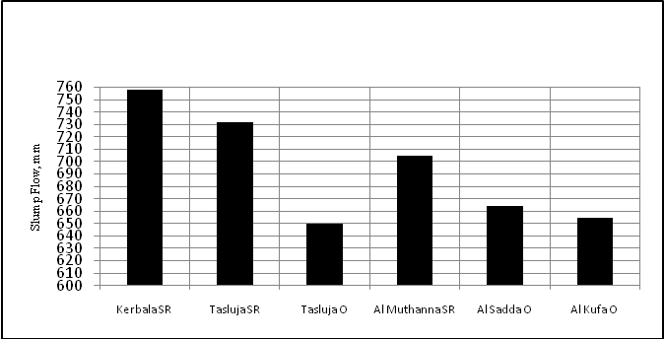
Fig. (1) Slump Flow Values of SCC for Iraqi Cement

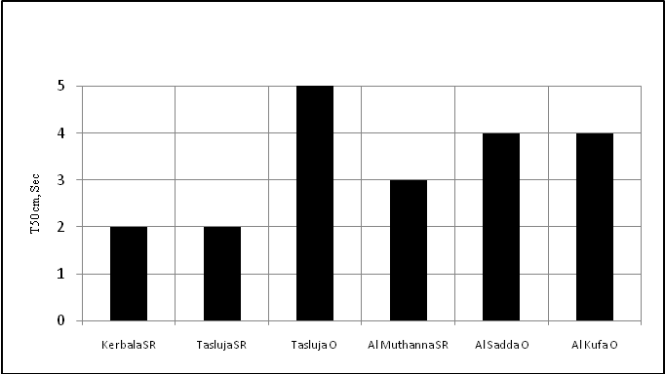
Fig.(2) T_{50cm} Time of the SCC Mixes made of Iraqi Cement Types

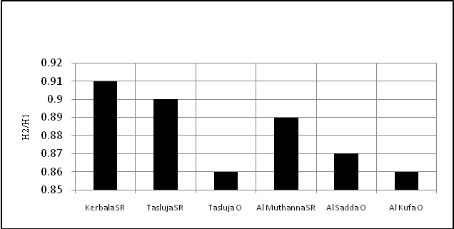
Fig.(3) L-Box Results
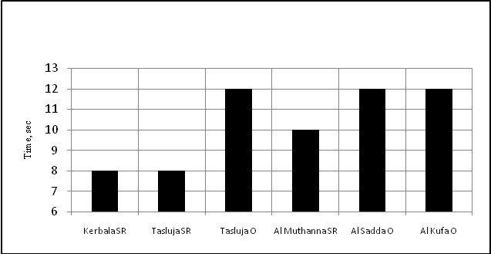
Fig.(4) V-Funnel Results

Structural Properties & Compressive Strength Results

Samples of concrete have been prepared corresponding to Table (6) ; half of them manufactured of a self-Compacting concrete (SCC) mixes whereas the other half manufactured of conventional concrete (CC) mixes. The Iraqi cement types are included in these mixes. A compressive test has been conducted for all types of concrete samples with time schedule of curing. SCC compressive strengths are comparable to those of conventional vibrated concrete (CC) made of similar mix proportions and water/cement ratio. The results are presented in Table (7) and represented graphically in Figs.(5-10).

Table (6) Mix Proportion of Concrete
Item | For all Types of Iraqi Cement
Cement, kg/m³ | 425
Sand, kg/m³ | 790
Gravel, kg/m³ | 810
Water, kg/m³ | 180
Superplasticizer, litter | 5
W/C ratio | 0.42
Limestone Powder, kg/m³ | 150
Prepared by The Author, 2009

Table (7) Compressive Strength of Concrete corresponding to Iraqi Cement Types under Interest, Mpa
Cement Type | Status of Mix | 3 days | 7 days | 28 days
Kerbala  SR | SCC Mixes | 30 | 34.6 | 40
Kerbala  SR | CC Mixes | 18 | 25.2 | 31.7
Tasluja  SR | SCC Mixes | 32 | 37.4 | 43.4
Tasluja  SR | CC Mixes | 20 | 28 | 33.5
Tasluja  O | SCC Mixes | 36.5 | 45.3 | 62.7
Tasluja  O | CC Mixes | 23.8 | 30.5 | 36.2
Al Muthanna  SR | SCC Mixes | 29.2 | 35.4 | 41.3
Al Muthanna  SR | CC Mixes | 18.1 | 25 | 32.2
Al Sadda  O | SCC Mixes | 35.6 | 41 | 55.4
Al Sadda  O | CC Mixes | 22.4 | 28.7 | 34
Al Kufa  O | SCC Mixes | 36.8 | 42.7 | 58.5
Al Kufa  O | CC Mixes | 24.1 | 30 | 35.8
Tested by the Author, 2009

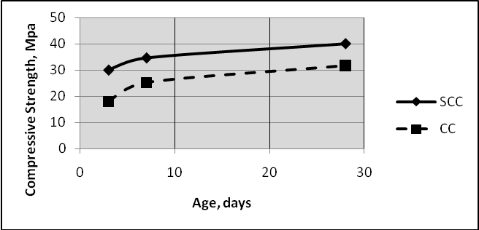
Fig.(5) Compressive Strength of Kerbala SR Concrete Mixes

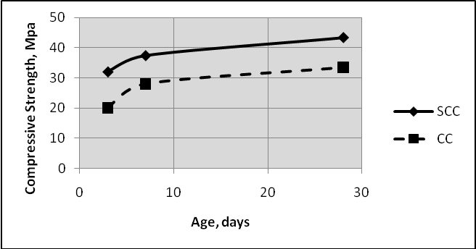
Fig.(6) Compressive Strength of Tasluja SR Concrete Mixes

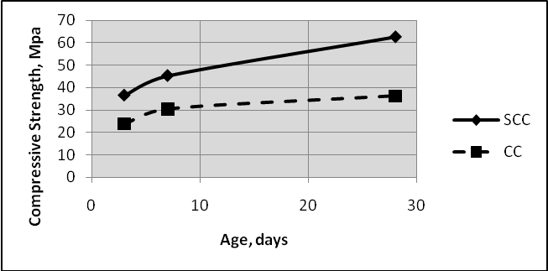
Fig.(7) Compressive Strength of Tasluja O Concrete Mixes

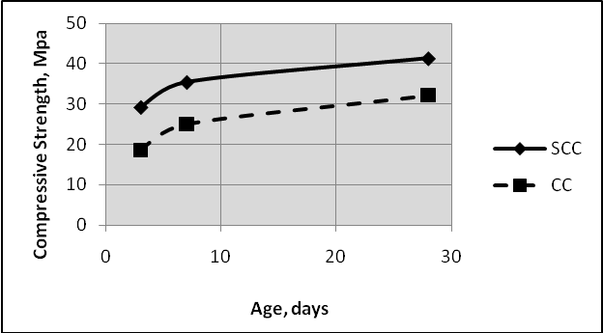
Fig.(8) Compressive Strength of Al Muthanna O Concrete Mixes

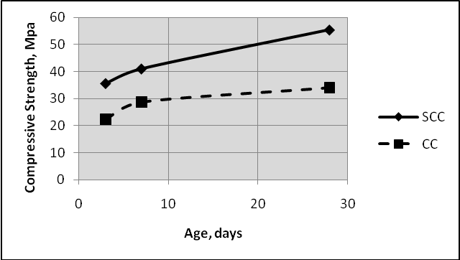
Fig.(9) Compressive Strength of Al Sadda O Concrete Mixes

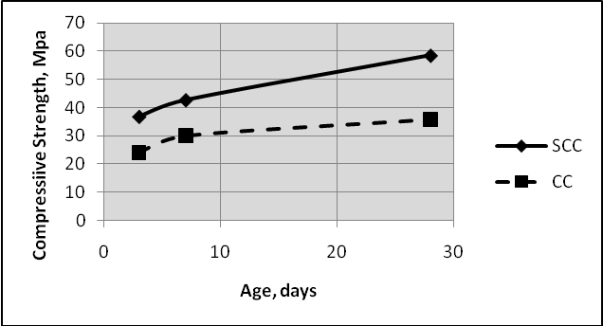
Fig.(10) Compressive Strength of Al Kufa O Concrete Mixes
A comparison between the compressive strength of SCC for different types of Iraqi cement types are shown in Fig.(11)

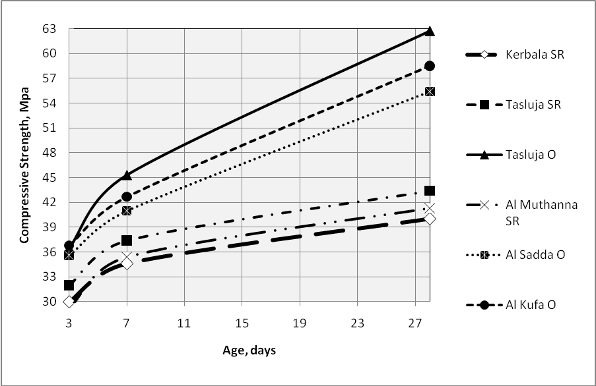
Fig.(11) Compressive Strength of SCC mixes for different Types of Iraqi Cement Types
Discussion of the Results
- Slump Flow Test
Slump Flow test results of the SCC mixes prepared by using the Iraqi cement types as shown in Fig.(1) reveal that Kerbala SR Cement fulfills a maximum slump flow of 758mm, whereas Al Muthana cement fulfills a minimum one of 705mm among sulfate resistance cement of the interested types .
Besides, the maximum slump flow value (664mm) of the ordinary cement is obtained by Al Sadda O cement.
- T_{50cm} Test
The results of T₅₀ Test indicate that the minimum value of T_{50cm} is 2sec obtained by Kerbala SR and Tasluja SR cement.
- L-Box Test
Kerbala SR attains the maximum L-Box Value of 0.91 among all sulfate resistance types.
- V-Funnel Test
8sec is the minimum value of V-Funnel Test which is obtained Kerbala SR and
Tasluja SR cement.
Comment: The good characteristics (workability) of fresh concrete tests values associated with Kerbala SR cement are attributed to the low percentage content of C₃A in the chemical composition of cement.
- Compressive Strength
A summary of the compressive strength results for samples prepared from the SCC mixes as represented graphically for the comparison purposes in Fig.(9).
- The results indicate that Tasluja O cement offers a maximum compressive strength of 62.7 Mpa occurred after 28days among
- kerbala SR cement fulfill a minimum compressive strength of 40 Mpa occurred after 28days among sulfate resistance cement . This is return to the low percentage of C₃S component which is equal to 42.92% entering in the composition of this type as represented in Table (4).
Conclusions
The following conclusions are abstracted:-
- The types of Iraqi cement under study can be used in SCC mixes industry.
- Tasluja O offers a superior compressive strength value of 62.7 Mpa and less slump flow value of 650mm.
- Compressive strength-Time curves of Fig.(10) shows that is rapid increasing in the compressive strength of Cement types. This means that there are no sudden accelerated changes in compressive strength with curing time advance for all types of Iraqi cement.
- The high slump flow values 758mm and 732mm of Kerbala SR and Tasluja SR respectively are attributed to the low percentage content of Tri-Calicium Aluminate (C₃A) of 1.54% and 1.93% in both of them as indicated in Table (4).
- The high superior compressive strength 62.7 Mpa of Tasluja O after 28days is attributed to the high percentage content 52.76% of Tri-Calicium Silicate (C₃S) as indicated in Table (4).
Recommendations
The following axises are recommended:-
- Generally under the highlight of good compressive strength values of SCC mixes for the types under study of Iraqi cement and especially for Tasluja O, the use of SCC technology is recommended.
- An extensive comparison study for SCC technology between the Iraqi cement and the available foreigner imported cement is recommended.
Abbreviations
Symbol | Meaning
SCC | Self-Compacting Concrete
CC | Conventional Concrete
SR | Sulfate Resistance
O | Ordinary
Mpa | Mega Pascal

References
Bartos P. J. M. & Hoy C. (1999), “Interaction and Packing of Fibers: Effects on the mixing Process, High Fiber Reinforced Cement Composites”. Eds H.W. Rrinhardt and A.E. Naaman. RILEM Publications. Paris. May pp. 181-192.
Bartos. P.J.M., & Grauers. M. (1999), “Self-Compacting Concrete”. Cocrete. April, 9-13.
Dimitri Feys, Ronny Verhoeven and Geert De Schutter (2008), “Fresh self compacting concrete, a shear thickening material” , Magnel Laboratory for Concrete Research, Department of Structural Engineering, Ghent University, Technologiepark 904, B-9052 Zwijnaarde, Belgium.
Domone P.L. Chai H.W. (1996), “ Dsign and Testing of Self-Compacting Concrete” Production Methods and Workability of Concrete. RILEM Lnternational Conference, Eds P.J.M. Eds.P.J.M. Bartos, D.L. Marrs and D.J. Cleland, June PP. 199-208.
Domone. P.L., Chai. H.-W. (1997), “Testing of Binders for High Performance Concrete” Cement and Concrete Research, 27, 1141-1147.
John Newman. & Ban Seng C. (2003), “Advanced Concrete Technology”. (1) Dpt. Of Civil. Eng. mperial Coll. London & School of the Built Environement Napier Unv. Edinburgh.
Khayat K. H., Roussel. Y. (2000), “testing and Performance of Fiber-Reinforced, Self-Compacting Concrete”. Materials and Structures, 33, 391-397.
Nawa. T., Izumi. T., Edamatsu. Y. (1998), “State-of- the Art Report on Materials and Design of Self-Compacting Concrete”. Proceedings of International Workshop on Self Compacting Concrete, Koch Unv., Japan, August.
Luiz A.P., João P., Cristiana N., (2006), “Study of Sorptivity Self-Compacting Concrete with Mineral Additives”, University of Beira Interior, Dept of Civil Engineering and Architecture, Calçada Fonte do Lameiro, 6201-001 Covilhã, Portugal. E-mail: luiz.oliveira@ubi.pt. Civil Eng. & Management. http:/www.jcem.vgtu.lt, 2006, Vol XII, No 3, 215–220.
Okamura H., Ouchi M., Hibino M., and Otawa K. (1998), “A Rational Mix- Design Method for Mortar in Self-Compacting Concrete”. The 6th East Asia-Pacific Conference on Structural Engineering &Construction. Vol.2. PP. 1307-1312.
Okamura H. & Ozawa K. (1994), “Self-Compactable High Performance Concrete in Japan SP-169”. American Concrete Inst., Detroit, PP. 31-44.
Okamura H. & Ochi (1999), “Self- Compacting Concrete Development Present Use and Future”. Proceedings of Fast RILEM International Symposium. Stockholm, 13-15 September.
Petersson. O, Billberg. O., Norberg. J., & Larsson. A. (1996), “Effects of the Second Generation of Superplasticizers on Concrete Properties”. Kochi Unv. Japan. August.
Sedran. T. & Delarrard. F. (1996), “Mix Design of Self-Compacting Concrete”. Procedings of the International RILEM Conference on Production Mthods and Workability of Concrete.Pailey. Eds. P.J.M. Bartos. D.L., Marr. and,J. Cleland, PP. 439-450.
Shikoku Island Concrete Research Association (2002), "Self-Compacting Concrete in Shikoku Island". Report by Self-Compacting Concrete Research Committee.

