Automated Criminal Investigation using Facial Imagery of the Suspect

Hussein A. lafta
Computer Science Department, Science college for women, Babylon University

Abstract
In this search, a new scheme based on facial imagery of suspect is used for automated criminal investigation. Because, classification of fingerprint by pixel-wise matching is tedious and the features based schemes often lead to misclassification and hence improper matching. The image matching algorithm attempts to partially match the facial image of the suspect with known images. The conventional model based approaches are difficult to be implemented. Unfortunately, with the increase in the complexity of the process being modeled, the difficulty in developing dependable fuzzy rules and membership functions increases. A novel approach based on Adaptive neuro-fuzzy is used. It has the benefits of both neural networks and fuzzy logic. The neuro-fuzzy hybrid system combines the advantages of fuzzy logic system, which deal with explicit knowledge that can be explained and understood, and neural networks, which deal with implicit knowledge, which can be acquired by learning. Fuzzy logic has tolerance for imprecision of data, while neural networks have tolerance for noisy data. The main trick in this matching lies in fuzzy membership, which keeps track of the important features in the human faces and their relative distances. The matching scheme has the advantages of size and rotational invariant. This means that the matching scheme is insensitive to variation of image size or their angular rotation on the facial image plane.

Keywords: Facial Image, fuzzy Logic, suspect, criminal Investigation, Member Ships, Neural Nets, Noisy Data, Imprecision of Data
الخلاصة
في هذا البحث, تستخدم طريقه أوتوماتكية جديدة مبنية على تخيلات وجه المشتبه بيه لكشف الجريمة, بسبب كون طريقة كشف المتهم بواسطة تصنيف بصمة الإبهام شاقة و غالبا ما تعطي نتائج غير مقبولة. تستخدم خوارزمية ترابط الصورة لربط صور تخيلات وجه المتهم مع صورة معلومة. لكون الطرق التقليدية صعبة التمثيل و لسوء الحظ مع ازدياد تعقيد العملية المطلوب نمذجتها, تزداد الصعوبات في دوال العضوية و القواعد المضببة المعتمدة عليها. تستخدم طريقة جديدة تسمى النظام العصبي المضبب المتكيف. يمتلك هذا النظام محاسن الشبكات العصبية و المنطق المضبب. يهتم المنطق المضبب بالمعرفة الصريحة بينما تهتم الشبكات العصبية بالمعرفة الضمنية التي تكتسب من خلال تعلم النظام.يسمح المنطق المضبب باستخدام البيانات غير الدقيقة بينما تسمح الشبكات العصبية باستخدام البيانات المضببة.
الخدعة في هذه الطريقة تكمن في نتاج مسافة العضوية المضببة التي تحفظ متابعة الخصائص المهمة في وجه الإنسان و مسافتها ذات الصلة.تكون طريقة الترابط حساسة لتغيرات حجم الدوران الزاوي لحفظ صورة وجه الإنسان.
1 Introduction to Image Matching
With the advent of electronic medium, especially computer, society is increasingly dependent on computer for processing, storage and transmission of information. Computer plays an important role in every parts of today life and society in modern civilization. With increasing technology, man becomes involved with computer as the leader of this technological age and the technological revolution has taken place all over the world based on it. It has opened a new age for humankind to enter into a new world, commonly known as the technological world. Computer vision is a part of every day life. One of the most important goals of computer vision is to achieve visual recognition ability comparable to that of human [Sarawat and Anam,2009] .
Among many recognition subjects, face recognition has drawn considerable interest and attention from many researchers for the last two decades because of its potential applications, such as in the areas of surveillance, secure trading terminals, Closed Circuit Television (CCTV) control, user authentication, HCI Human Computer Interface, intelligent robot and so on.
There exist quite an extensive literature on image matching [(Sinha, 1995]; [Lee ,1996]; [Kwon and .Victoria ., 1994]; [Biswas, 1995]; [Dellepiane and Vernazza, 1992]. Most of these methods employ statistical tools[ (Turk and Pentland, 1991]; [Pentland ,1994], profile analysis [Kaufman and Breeding,1976], feature matching [Manjunath , 1992] and neural nets [Kohonen, 1988]; [Sohan., 1981]. Each of these techniques has its own merits and demerits, as already analysed by Chellapa in his recent paper [Chellappa ,1995]. One generic limitation of these works lie in exact matching of the image features/attributes. The images of most scenes, however, are corrupted with noise because of non-uniform lighting of the sources. Further, facial images impose additional restriction in exact matching due to diversity in poses and ageing conditions. Spot identification of persons through exact matching of their image attributes thus is not feasible in most cases. Fuzzy logic, which has proved itself successful in matching of inexact data, can equally be used for inexact matching of close image attributes. Recently, [Dellepiane and Vernazza, 1992], and [Wu , 1999] have developed two distinct approaches for image matching using fuzzy membership functions [Biswas, 1996].
In this work, the neuro-fuzzy approach is used because it gets the benefits of neural networks as well as of fuzzy logic systems and it removes the individual disadvantages by combining them on the common features. A neural network’s learning capability provides a good way to adjust expert’s knowledge and it automatically generates additional fuzzy rules and membership functions to meet certain specifications. This reduces the design time and cost. On the other hand, the fuzzy logic approach possibly enhances the generalization capability of a neural network by providing more reliable output.

2 Pre-estimated image parameters
2.1 Edge
An edge is a contour of pixels that (artificially) separates two regions of different intensities. It also can be defined as a contour along which the brightness in the image changes abruptly. Figure(1) describes the edges in a synthetic image.
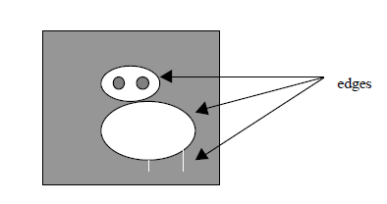
Figure(1) :Edge of image
To find edges is to evaluate the directional derivatives of g(x, y) in x- and y-directions. Let us call them g1 and g2 respectively. Thus,

g1 = ∂g(x, y) / ∂x

and . g2 = ∂g(x, y) / ∂y.

The resulting gradient can be evaluated by the vector addition of g1 and g2 and
is given by

gradient g = [ g₁² + g₂² ] ^{1/2}

and phase φ = tan ^{–1} (g₂ / g₁).

A pixel is said to lie on an edge if the gradient g is over a given threshold[Konar,1999] . A linear edge segment that makes an angle α with respect to a well defined line (X- axis) on the image is said to be an edge with edge-angle α .In this search edges are considered with edge-angle( 0˚ to 360˚). Figure (2) helps us to get gradient and the angle φ of block b[j,k] with respect to X-axis, Y-axis.

Figure (4): An outline of the image-matching schema
B(Cos90, Sin90 =(0,1)₎
C(Cos180,Sin180) =(-1,0)

α
A(Cos0,Sin0) =(1,0)
A(Cos270,Sin270) =(0,-1)
A(Cos360,Sin360) =(1,0)
Figure (2): Angle α of block b[j,k] with respect to X-axis.
2.2 Shade: Is a region over an image with a small or no variation of gray levels.
2.3 Mixed-range: Is a region excluding edges and shades on a given image.
2.4 Gradient: The gradient at a pixel (x, y) in an image is estimated by taking the square root of the sum of difference of gray levels of the neighboring pixels with respect to pixel (x, y) [.Gonzalez and Wintz, 1993].
2.5 Gradient difference (Gdiff ) : The gradient difference within a partitioned block is defined as the difference of maximum and minimum gradient values in that block.
2.6 Gradient average (Gavg): The gradient average within a block is defined as the average of the gradient of all pixels within that block.
2.7 variance ( σ²): The variance of gradient is defined as the arithmetic mean of square of deviation from mean. It is expressed formally as variance σ² =.Σ(G – Gavg)²P(G), where G denotes the gradient values at pixels, and P(G) represents the probability of the particular gradient G in that block [ .Pratt, 1978].
3 Outline of The System
The issues of the design and implementation of the Face Recognition System can be subdivided into two main parts. The first part is image processing and the second part is recognition techniques. The image processing part consists of partitioned a gray Face image into m non-overlapped blocks of (n × n) pixels. Blocks contains, `edge' , `shade' and `mixed range' [Ramamurthy and Gershe, 1986]. The degree of membership of a given block to contain edges of typical sub-classes, shades and mixed range is measured subsequently with the help of a few pre-estimated image parameters like average gradient, variance and the difference of the maximum and the minimum of gradients are input to the Adaptive Neuro-Fuzzy Inference System.
After training the neural network , the reference image is compared with the stored images to get the target image.
4 Adaptive Neuro-Fuzzy Inference System (ANFIS)
4.1 Neuro-Fuzzy Architecture
The neuro-fuzzy system consists of the components of a conventional fuzzy system except that computations at each stage is performed by a layer of hidden neurons and the neural network’s learning capacity is provided to enhance the system knowledge.
The system contains the following three different layers:
1-Fuzzification layer .
2-Fuzzy rule layer
3-Defuzzification layer
In a fuzzification layer each neuron represents an input membership function of the antecedent of a fuzzy rule (Figure 3). In a fuzzy inference layer fuzzy rules are fired and the value at the end of each rule represents the initial weight of the rule, and will be adjusted to its appropriate level at the end of training. In the defuzzification layer each neuron represents a consequent proposition and its membership function can be implemented by combining one or two sigmoid functions and linear functions. The weight of each output link here represents the centre of gravity of each output membership function of the consequent and is trainable. After getting the corresponding output the adjustment is made in the connection weights and the membership functions in order to compensate the error and produce a new control signal[[Lee and Ham,1996], [Cornelius and Leondes,1998].

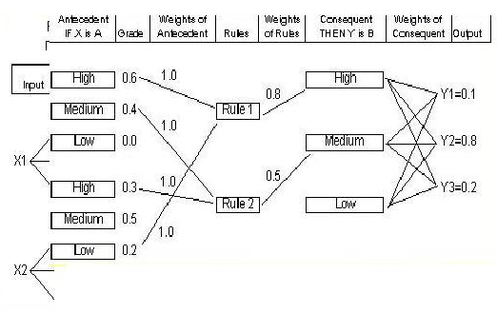
Figure (3): Neuro-Fuzzy System Architecture

4.2 Adaptive Neuro-Fuzzy Inference System Structure and parameters adjustment
A network-type structure similar to that of a neural network, which maps inputs through input membership functions and associated parameters, The basic structure of the type of fuzzy inference system is a model that maps input characteristics to input membership functions, input membership function to rules, rules to a set of output characteristics, output characteristics to output membership functions, and the output membership function to a single-valued output or a decision associated with the output. Then through output membership functions and associated parameters to outputs, can be used to interpret the input/output map. The parameters associated with the membership functions will change through the learning process. The computation of these parameters (or their adjustment) is facilitated by a gradient vector, which provides a measure of how well the fuzzy inference system is modeling the input/output data for a given set of parameters. Once the gradient vector is obtained, any of several optimization routines could be applied in order to adjust the parameters so as to reduce some error measure (usually defined by the sum of the squared difference between actual and desired outputs). ANFIS uses either back propagation or a combination of least squares estimation and backpropagation for membership function parameter estimation[Tadao Murata,2005].
5 Design and Implementation
The flow chart shown in figure (4) gives the steps of the work.

Membership Estimation for dge,Shade and mixed range by using ANFIS

Mi

Defuzzification to get the member ships of the output ,by aggregation get the output picture
Testing the ANFIS to get the reference imge
Features for the first image
Features for the second image

Features for the n-th image
Partitioning Into Blocks
Feature Extraction
Variance

G_{av}
Gdiff
The nearest matched image

Figure (4): An outline of the image-matching schema
Image

5.1 Selection of Member Ships
In this section, the shape and range of membership is selected for training as input to the ANFIS. In this layer each neuron represents an input membership function of the antecedent of a fuzzy . As shown in figures(5,6).
- 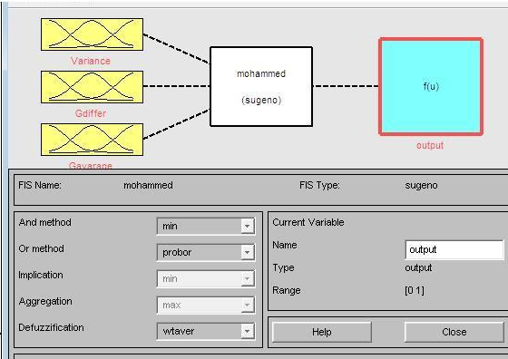

Figure(5): Shape of Selected Membership Functions
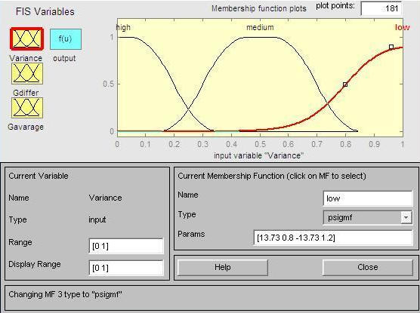
Figure(6): Rrange of Selected Membership Functions

5.2 Crating Rules for the system
In this section the rules is build by ANDing input membership. In a fuzzy inference layer fuzzy rules are fired and the value at the end of each rule represents the initial weight of the rule, and will be adjusted to its appropriate level at the end of training. Figure(7) shows the resulting rules for this system.

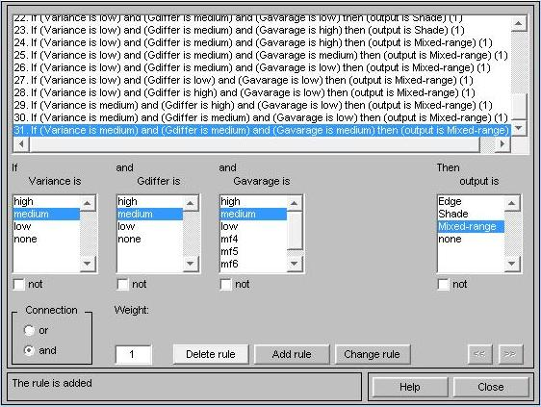

Figure(7):Generated rules

5.3 Adaptive Neuro-Fuzzy Inference System Model Structure
The resulting model structure for this system is shown in figure(8).

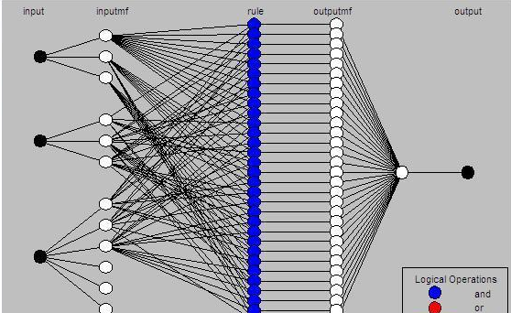

Figure(8): System Mmodel Sstructure
5.4 Model Training
The input/output data is collected in a form that will be usable by ANFIS for training. You can then use ANFIS to train the FIS model to emulate the training data presented to it by modifying the membership function parameters according to a chosen error criterion. In general, this type of modeling works well if the training data presented to ANFIS for training (estimating) membership function parameters is fully representative of the features of the data that the trained FIS is intended to model. This is not always the case, however. In some cases, data is collected using noisy measurements, and the training data cannot be representative of all the features of the data that will be presented to the model. This is where model validation comes into play. Figure (9) shows the training process. This process contains the following steps:
1-Load data (training, testing, and checking) .
2-Generate an initial FIS model or load an initial FIS model .
3-View the FIS model structure once an initial FIS has been generated .
4- Choose the FIS model parameter optimization method: backpropagation or a mixture of backpropagation and least squares (hybrid method).
5-Choose the number of training epochs and the training error tolerance. Train the FIS model . This training adjusts the membership function parameters and plots the training error plot(s) in the plot region.
6-View the FIS model output versus the training, testing data output . This function plots the test data against the FIS output in the plot region.
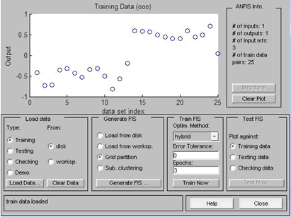

Figure(9):Training data

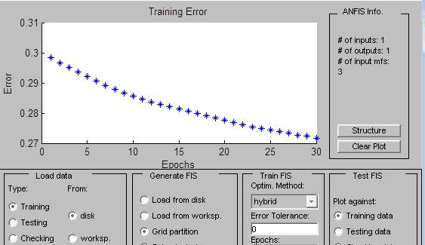

Figure(10):Training error

After the network trains on the features of input images, and known this images. Now the network is tested on any image which train or any image near to it, the network has the ability to recognize image, which train on and image with noise, this is because the ability of fuzzy logic and neural nets. Figure(11) shows the result of testing the net on any reference image.

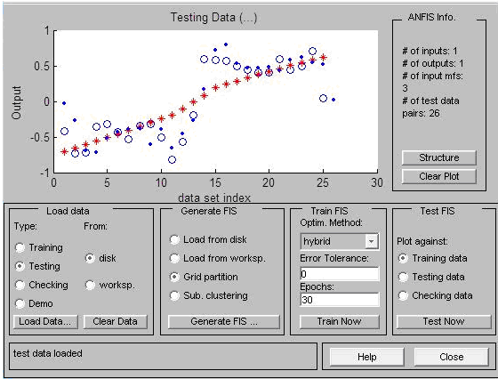
Figure(11):Testing results

The system is trained on the following images

Testing of the system on the image below

\
The system can recognize this image. Also the system can recognize the images similar to the images which train on, this is because of Fuzzy logic has tolerance for imprecision of data, while neural networks have tolerance for noisy data.

8- Conclusions and Future works
This search introduced a new concept for matching of digital images by estimating and comparing the fuzzy membership degree with respect to each partitioned block of images. The proposed method is free from size and rotational variance and requires insignificantly small time for the matching process. The smaller the size of the partitioned block in the image, the lower is the computational time for matching.
On the other hand, increasing the dimension of the partitioned blocks hampers the resolution of matching. The choice of the size of each partitioned block, therefore, is a pertinent decisive factor in connection with the process of matching.
Fuzzy logic has been successfully used for matching of digital images . However, the methods of matching adopted in this works are computationally intensive and sensitive to rotation and size variation of images. Further, the existing matching techniques, which search a reference image among a set of images, often fail to identify the correct image in the presence of noise.

Future works
1-Selecting of membership functions that cause the least error in the process of matching is yet to be identified. This is an open problem to the interested researches.
2-Because, facial image undergoes changes with aging and mood of the persons and thus matching of facial images in many accessions fails to identify the suspects. The voice based neural networks and genetic algorithms, is used to uniquely identify the suspects.

References
Biswas (1998). "Image Matching with Fuzzy Moment Descriptors", Communicated to Engineering Applications of Artificial Intelligence, Pergamon, Elsevier, North Holland.
Biswas (1995). "Matching of Digital Images using Fuzzy Logic", Advance in Modeling and Aylisis, Vol.35, No.2.
Chellappa (1995). "Human and machine recognition of faces: a survey", Proceedings of the IEEE '83, pp. 705±740.
Cornelius and Leondes (1998). "Fuzzy Logic and Expert Systems Applications", University of California, Los Angeles, California.
Dellepiance (1992). " Model Generation and Model Matching of Real Images by a Fuzzy Approach", Pattern Recognition, Vol.25, No.2, PP.115-137.
Gonzaledz (1976). "Digital Image Processing", Addison Wesley, Reading, Ma.
Kaufman and Breeding (1976). "The automatic recognition of human faces from profile silhouettes", IEEE Transactions on Systems, Man and Cybernetics, SMC 6, 113±121.
Kohonen (1999). "Self-organization and Associative Memory", Springer, Berlin, 1988.
Konar "Artificial Intelligence and Soft Computing: Be-havioral and Cognitive Modeling of the Human Brain",CRC Press, Boca Raton.
Kwon and Vitoria (1994). "Face detection using templates", ICPR '94, pp. 764±767.
Lee and Ham (1996). "Recognition of human front faces using knowledge based feature extraction and neuro-fuzzy algorithm",Pattern Recognition 29 (11), 1863±1876.
Manjunath and Chellapa (1992). "A feature based approach to face recognition", Proceedings of the IEEE Computer Society Conference on Computer Vision and Pattern Recognition, pp. 373±378.
Man and Kwong (2005). "Genetic Algorithms", Springer, London, pp. 176±184, 1999.
Nick Fieller "Computer-Assisted Facial Identification", Department of Probability & Statistics, University of Sheffield.
Nikolaos and Bourbakis (2003). "A synergistic Model for Representing and Interpreting Human Activities and Events From Video", International Journal on Artificial Intelligence Tools World Scientific Publisher, Vol. 12, No.1.
Pentland and Moghaddam (1994). "View based modular eigen spaces for face recognition",Proceedings of the IEEE Computer Society Conference on Computer Vision and Pattern Recognition, pp. 84±91.
Pratt "Digital Image Processing", (1978). Wiley-Interscience, New York.
Ramamurthy and Gershe (1986). "Classified vector quantization of images. IEEE Transaction on Communications Com-34 (11), 1105±1115.
Sarawat and Anam (2009). "Face Recognition Using Genetic Algorithm And Back Propagation Neural Network, Proceeding of the International Multiconference of Engineers and Computer Science ,Hong Kong.
Sinha (1995). "Recognition of changed facial appearances with the aid of a facial image recognition system", Polish Research and Development. BPR & D, Ministry of Home Affairs, Government of India, pp. 37±41.
Sohan (1981). "Practical face recognition and verification with WISARD", In: Ellis, H.D., Jeeves, M.A., Newcomb, F., Young, A. (Eds.), Aspects of Face Processing. Nijhoff, Dordrecht, pp. 426±441.
Tadao Murata (2005). "Fuzzy Logic and Soft Computing", University of Illinois at Chicago, murata@ uic. Edu, Timisoara, Romania, March 22.
Turk and Pentland (1991). "Face recognition using eigen spaces",Proceedings of International Conference on Pattern Recognition,pp. 536±591.
Wu and Yachida (1999). "Face detection from color images using a fuzzy pattern matching method", IEEE Transaction on Pattern Matching and Machine Intelligence 21 (6), 557±563.

