Pulse Width Modulation Electromagnetic Servos (PWMES) Simulation and Analysis
Saad A-R. Makki
Computer Science Department , Collage of Education, Al-Mustansiriah University

Abstract
Electromagnetic servos (ES) are devices converting the electrical signals to a mechanical motion. The ES are simple in design, stricture and reliable. They have wide applications in control and guidance systems. These devices have disadvantage of there non linear characteristics in the dynamic systems which can be over come by using PWM technique with a frequency suitable for the requirements of that dynamic system.
This paper includes the following:-
- Theoretical background, structure, operation, performance, mathematical model and the block diagram of these devices.
- Simulation and analysis of a supposed type of PWMES suitable for applications in control and guidance systems of small aircrafts and small calibers guided missiles by using Mat lab and Simulink programs.
- Results of some important tests and showing some of the important performance behavior and parameters.
This simulation program enable the users to choice and to test the effect of any parameter and to investigate its influence on the performance of the device ,for example the dimensions and the magnetic characteristics of the ferrite parts , effect of the air gab ,influence of the coils and windings ,showing the values and behavior of the motion and its speed and acceleration, the effect of changing the frequency ,the effect of the load ,showing the values of generated forces and moments ,or any electric , magnetic or mechanical parameters.
Key words: electrical servo, pulse width modulation, dynamic systems, electromagnetic servo, Simulation , modeling. magnetic circuit
الخلاصة
إن المؤازرات الكهرومغناطيسية هي آلات تحول الإشارة الكهربائية إلى حركة ميكانيكية. تكون هذه المؤازرات بسيطة في التصميم والتركيب وذات معوليه. المؤازرات تطبيقات واسعة في السيطرة ومنظومات التوجيه. للمؤازرات بعض السلبيات منها خصائصها اللاخطية في المنظومات الديناميكية والتي يمكن التغلب عليها باستخدام تقنية التحميل بعرض النبضة وبتردد مناسب لتطبيقات المنظومة الديناميكية المعنية.
يتضمن البحث الأتي:-
ا- خلفية نظرية لبناء وعمل وانجازيه والنموذج الرياضي وكذلك المخطط الكتلي لهذه المؤازرات.
ب- نموذج تشبيهي و تحليل للنوع المفترض من هذه المؤازرات والمسمى () وهو النوع المناسب في تطبيقات منظومات السيطرة والتوجيه في الطائرات الصغيرة وفي الصواريخ صغيرة العيار وباستخدام برامج الماتلاب والسميلنك.
ج- عرض لنتائج بعض الفحوصات المهمة والتي تظهر بعض المعالم والخصائص الانجازية.
يمكن البرنامج ألتشبيهي المستخدم من اختيار ومن فحص تأثير أي معلم وكذلك من التحري عن تأثيره على الأنجازية للمؤازر, مثلا تأثير الأبعاد والخصائص المغناطيسية للأجزاء الحديدية وتأثير الفسحة الهوائية وتأثير الملفات الكهربائية وكذلك عرض قيم وتصرف الحركة والسرعة والتعجيل للأجزاء الحركية وتأثير تغيير التردد وتأثير الأحمال وعرض قيم القوى والعزوم أو أية معالم ميكانيكية أو كهربائية أو مغناطيسية.
1- Introduction
Electromagnetic servos (ES) are devices converting the electrical signals to a mechanical movement. They have a special use in the dynamic systems (DS) and in guidance and control systems (GCS) as actuators to drive the control surfaces of the flying object.
The literature covering this type are very rear and this type of servos belong to military application in guided weapon system and missiles [MAKKI,2002].
The PWM is a well known technique and has very wide applications in power supplies and communications... act.
The principle of construction and operation of this type of servos is the electromechanical relay, which is well known and many literature available about them.
Electromagnetic servos are generally simple in design, structure, and reliable. They are many types one of them ,the simplest one in structure ,is so called pulse width modulating electromagnetic servos. It consists of the two coils wound around two ferrite cores to form the right and left sides of the magnetic circuit (the stator part). These two sides are separated by air gap. The moving part is a ferrite type core move to side of the energized coil. The two coils are connected to the drive circuit which energize one coil at a time with a DC voltage of say 26 volts. When the servo at rest, the moving part standing at the mid position by the effect of the spring stiffness.
2- Concept Of Operation
The stricture of the PWMES is shown in Fig.(1). When supplying one of the coils with the DC voltage, the force will create and the moving part will move and stick to that side. When supplying the other side with the voltage the moving part will move to the second side. The movement of the moving part between both sides is performed with help of the spring. To avoid sticking of the ferrite materials, the air gaps are isolated by nonmagnetic materials (copper sheet of 0.05 – 0.20 mm for example). This type of motion is a none linear behavior. The movement in control and dynamic systems wanted to be proportional to the error or control signal. One method of improving the behavior of the nonlinear system is the use of pulse width modulation (PWM) technique.

vr
Moving part
Stationary part
Stationary part
VL
Φmt
Φrt
Φlt
Michanical motion

Fig.(1) The main parts of the servo

3- Mathematical Model
The mathematical model will cover the main parts of the servo. These parts are the coils, the magnetic circuit and the moving parts. The model will deal with the final equations and the detail equations are available in the references.
3-1 Mathematical model of coils:[ HUGHES,1973;Clyde, 1973 ; PETROV, 1982 ]
The coils can be represented by resistance R, reluctance L and the number of terns N. The subscripts l, r, m and a when any where mentioned here denote to the left, right, mid, and air gap parts respectively. The relation between the current (I) passing through the coil and the applied voltage (V) is:
Vl = Rcl I + Lcl dIl/dt …… (1)
Vr = Rcr I + Lcr dIr/dt … (2)
Where; Rc is the resistance of the coil [Ohm], Lc is the inductance of the coil [H]
Note that L is a function to the magnetic circuit permanence which in term functions to the air gap dimension and the position of the moving part. The relation of finding L is,
Lcl = NlΦlt/ Il ………….… (3)
Lcr = NrΦrt/ Ir …………..… (4)
Where; N is the number of turns, Φt is the magnetic flux [Wb], I is the current [Amp]

3-2 Mathematical model of the magnetic circuit:[Edward HUGHES,1973], [PETROV, 1982 ]
The magnetic circuit consists of right, left and mid parts. The right and left parts form the fixed or stationary part of the servo. The moving part in the mid is connected directly to the control surface. The movement of this part is limited mechanically by an angle equal to 13 degrees around the mid position. The total reluctance (S) seen from the right and left parts of the magnetic circuit are;
Srt = Sr + Sar + ((Sal + Sl)Sm/(Sal + Sl + Sm)).…..(5)
Slt = Sl+ Sal + ((Sar + Sr)Sm/(Sar + Sr + Sm))...….(6)
The flux (Φ) and the flux density (B) of the magnetic circuit parts and there mutual effects depend on the m.m.f. and the reluctance of the magnetic circuit.
Φrt. = Φr – Φrl …..……… (7)
Φlt = Φl – Φlr ……….… .(8)
Bal = Φlt/Aal ………….. (9)
Bar = Φrt/Aar….….…… (10)
Bm =Φm/Am …….…… (11)
The force (F) and the generated torque (Tg) effecting on the moving part is;
Ft = Fr – Fl ……. (12)
Tg= Ft b...…….. (13)
Where; b is the torque arm connected top the moving part[m].

3-3- Mathematical model of the dynamic system:[ KATSUHIKO,1994 ],[TOKEJEV CYPLJAKOV, 1983 ],[ DAZZO, 1966 ]
The dynamic system includes all the forces and torques connected to the moving mechanical parts which they are spring stiffness torsion torque (Ts), inertia torque (Tj), friction torque (Tf), and applied torque (aerodynamic torque for Example) (Ta).
Tg = Ts + Tj + Tf + Ta …. (14)

4- Simulating Program
Simulating program was performed using MATLAM ver. 6.5 and Simulink. The program contains four main blocks as following:
First block addressed " initial conditions " contains all the dimensions of servo parts, air gap, number of turns of coils, switching voltage values, friction coefficient, stiffness of the spring, and other parameters.
Second block addressed "electric circuits" contains the electric circuits and the output current represented in Equ. (1, 2).
Third block addressed "magnetic" contains the solution of magnetic circuit and finding the flux, flux density, forces, and the resultant torque included in Equ. (5 to 13). This block also contains the look-up tables for finding the relative permeability of different parts of the magnetic circuit as a function of flux density and the calculation of the inductance Equ. (3,4).
Forth block addressed "dynamic" contains the solution of the dynamic system. The output is the deflection angle, the angle rate and the angle acceleration represented in Equ. (14).

5- Evaluation And Results
The simulation program had been performed. It includes four main blocks representing the main components and parts of the servo. Annex (1) attached includes the MATLAB report of the PWMES.
The electrical block arranged in a simple way. It includes the resistance, the inductance, and the number of turns of each coil. The model toke the inductance as a time varying coefficient. The inductance is a function of the magnetic characteristic which depends mainly on the instantaneous value of the flux density and in turn on the instantaneous value of the current flow and the position of the moving part. The model can be expanded to contain the type and the behavior of the coil wire to get the approximate dimensions and the weight of the coil. In this model the electric drive circuit is not included.
The magnetic circuit calculated with the time variable magnetic permeability value, which depends on the flux density value. The value of the magnetic permeability of each part (left, right, and moving part) of the magnetic circuit evaluated by using look-up table. The look-up table contains the information of four deferent ferrite materials (sheet steel, cast steel, stalloy, and cast iron). The reluctances and the flux density of all parts of the magnetic circuit have been calculated. All these calculations have been done by make use of Matlab function.
The dynamic system, which explains the mechanical behavior of the moving part, contained all the basic parameters. It includes the angular position, the angular rate, and the angular acceleration. In addition to the torque generated by the magnetic circuit, friction torque and stiffness torque are included. The calculations has been done by make use of Matlab function.
Simulating program has been performed and tested and some of the important results and
conclusions have been pointed out as following:
- The basic out put parameters of the servo are the angular position of the moving part Fig.(1) and the generated torque and acted on the moving part Fig.(2). The responding time of the moving part (the time needed for moving part to travel from one side to another) is about 8 mSec. and the maximum torque is about 0.375 N.m for stalloy ferrite material. These values are suitable for application in small fighting object.

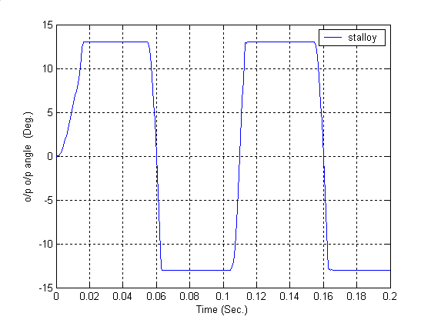

Fig. (2) Angular position behavior of the BWMES
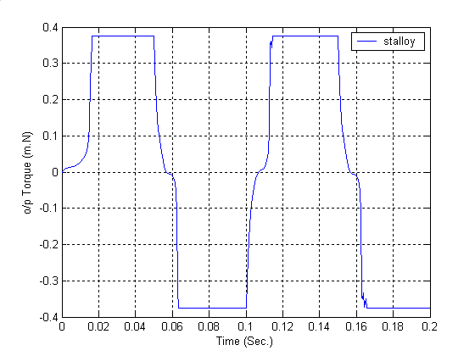

Fig. (3) Generated torque of the BWMES
B-The type of the ferrite material has an important and effective influence on both traveling time of the moving part Fig.(3) and the generated torque Fig.(4).
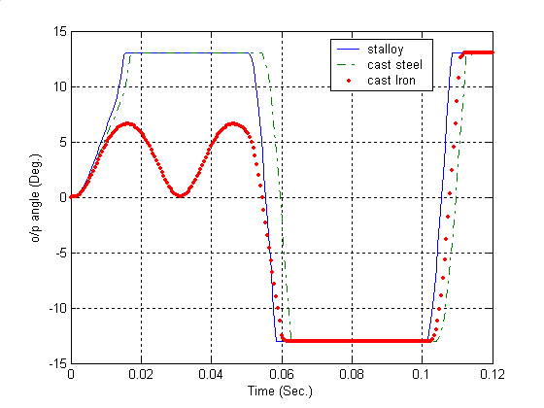

Fig.(4) Influence of ferrite material type
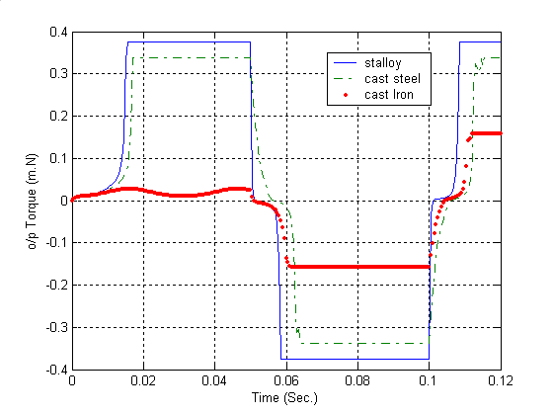

Fig.(5) Influence of ferrite material type On the traveling time.
C-Fig.(6) and Fig.(7) show the influence and effect of the isolating material thickness on the traveling time of the moving part and the generated torque of the servo.
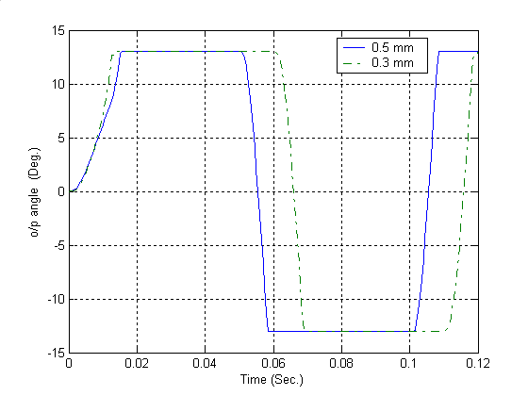

Fig.(6) Influence of isolating thickness on the generated torque
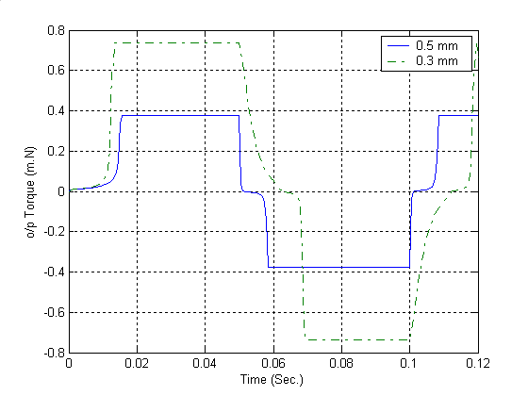

Fig.(7) Influence of isolating thickness
On the traveling time on the generated torque

D-To minimize the time of traveling high voltage up to 24 V could be used and using a Special ferrite material having a very high permeability.
E- It is possible to evaluate and test the effect of other parameters to reach an optimum design.

References
- MAKKI, Saad 2002" Lecture Notes In Antitank Guided Missile", MIC, Baghdad 2002.
- HUGHES, Edward 1973 "Electrical Technology", 4th edition, Longman group limited, London 1973.
- Herrick, Clyde N. 1973 "Instruments Measurements For Electronics", McGraw-Hill Kogadusha, LTD, Tokyo 1973.
- PETROV G.N., 1982 "Electricke Stroje", Academia Praha, Prague 1982
- Ogata KATSUHIKO,1994 "System Dynamics", IEEE Trans. Aero. Elec., syst, Vol. 30, No. 2, 1994, pp. 545-555 .
- TOKEJEV J. I. and A. P. CYPLJAKOV, 1983 "Sbirka Prikladu z Teoria Automatickeho Rrizeni", SNTL-nakladetelistvi technicke literatury, Praha, Prague 1983..
- DAZZO, John J. 1966 "Feedback Control System Analysis And Synthesis" , McGraw-Hill Kogadusha, LTD, Tokyo 1966.

ANNEX (1): MATLAB REPORT

Simulink Default Report
01-Sep-2004

The MathWorks

Model - philad
Table 1-1. philad Simulation Parameters
Solver ode4 | ZeroCross on | StartTime 0.0 StopTime 0.2
RelTol 1e-3 | AbsTol auto | Refine 1
InitialStep auto | FixedStep 0.0005 | MaxStep auto
Table 1-2. Signal Properties
Name | Description | ParentSystem | CompiledPortDataType
<814.0005> |  | philad
<815.0005> |  | philad
- philad
  - dynamic
  - electric circuit
  - initial condition
  - magnetic

System – philad

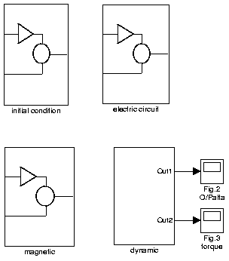
Table 1-3. philad System Information
Name | philad | Parent | <root>
Description |  | Tag
Blocks | Fig.2 O/Palfa  Fig.3 torque  dynamic  electric circuit  initial condition  magnetic | LinkStatus | N/A

Table 1-4. Block Type Count System - initial condition
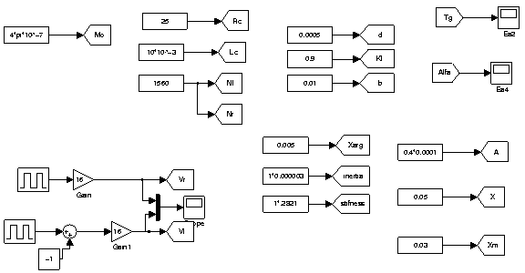

BlockType | # of Occurrences | Block Names
SubSystem | 4
  dynamic
  electric circuit
  initial condition
  magnetic
Scope | 2
  Fig.2 O/Palfa
  Fig.3 torque

Table 1-5. initial condition System Information System - magnetic

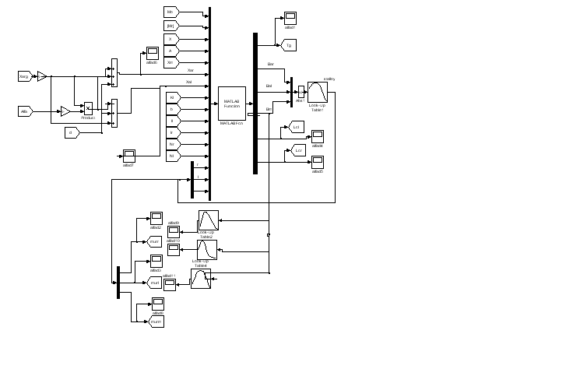

Table 1-6. magnetic System Information Dynamic system simulation

