Online Monitoring, Evaluation and Improvement of Steady State Voltage Stability for Electric Power Systems using Artificial Neural Networks Techniques

Shamam F. Alwash
Babylon University, College of Engineering
Abstract
This paper presents a method for monitoring, evaluation and improving of electrical power system voltage stability that is based on Artificial neural networks(ANN). The training data is obtained by solving several normal and abnormal condition using the Linear Programming technique. The selected objective function gives minimum deviation of the reactive power control variables, which leads to the maximization of minimum Eigen value of load flow Jacobian. The considered reactive power control variables are switchable VAR compensators, OLTC transformers and excitation of generators. The method has been implemented on a modified IEEE 30-bus test system. The results obtain from the test clearly show that the trained neural network is capable of improving the voltage stability in power system with a high level of precision and speed. Thus, the method can be used as a guide by the operator in Energy Control Center (ECC) for power system control.
الخلاصة
يقدم هذا البحث طريقة للمراقبة، التقييم، ولتحسين استقرارية الفولتية في منظومات القدرة الكهربائية باستخدام الشبكات العصبية الاصطناعية. حصل على بيانات التدريب عن طريق حل حالات طبيعية وغير طبيعية باستخدام تقنية البرامج الخطية .(LP) تعطي الدالة المعتمدة اقل انحراف لمتغيرات السيطرة والمؤدي إلى تحقيق الحدّ الأقصى للقيمة الذاتية الصغرى للمنظومة. إن متغيرات السيطرة المدروسة في هذا البحث هي المعوضات السعوية، المحولات ذو المأخذ المتغيرة وإثارة محطات التوليد. تم اختبار الطريقة على النموذج اختباري المعدل (IEEE 30-bus). تظهر النتائج بوضوح بان الشبكة العصبية المدربة قادرة على السيطرة على استقرارية الفولتيات في منظومات القدرة الكهربائية بمستوى عالي من الدقة والسرعة. لذلك ان هذه الطريقة يمكن ان تستخدم كمرشد للسيطرة على منظومات القدرة الكهربائية بواسطة العامل في مركز سيطرة الطاقة.
KEYWORDS: steady state voltage stability improvement, artificial neural networks, Eigen sensitivity, optimization.
List of Symbols
$\left[A\right]$ : Square matrix.
$a_{\text{ij}}$ : ${\text{ij}}^{\text{th}}$ element of square matrix $[A]$.
$\left[B\right]$ : Bus susceptance matrix.
: Deviation of reactive power control variables.
$δ_{i}$ : Voltage phase angle at bus-i.
$η_{K}$ : Left Eigen vector corresponding to $K^{\text{th}}$ Eigen value.
$η_{\text{min}}$ : Left Eigen vector corresponding to minimum Eigen value of load flow Jacobian.
$\left[G\right]$ : Bus conductance matrix.
$\left[H\right]$ : System subjacobian matrix.
$\left[J\right]$ : System jacobian matrix.
$\left[L\right]$ : System subjacobian matrix.
$λ_{K}$ :$K^{\text{th}}$Eigen value of square matrix.
$λ_{\text{min}}$ : Minimum Eigen value of load flow Jacobian.
$λ_{{\text{min}}_{{}_{\text{New}}}}$: New minimum Eigen value of load flow Jacobian.
$λ_{{\text{min}}_{{}_{\text{Old}}}}$ : Old minimum Eigen value of load flow Jacobian.
$\left[M\right]$ : System subjacobian matrix.
$\left[N\right]$ : System subjacobian matrix.
$\text{NC}$ : Number of system control variables.
$P_{i}$ : Net active power at bus-i.
$Q_{C}$ : Shunt capacitive compensations.
$Q_{G}$ : Reactive power generation.
$Q_{i}$ : Net reactive power at bus-i.
$\overline{Sλ}$ : Sensitivity of minimum Eigen value with respect to reactive power control variables.
${Sλ}_{K}$ : Sensitivities of minimum Eigen value with respect to $K^{\text{th}}$reactive power control variable.
$\text{Tp}$ : Tap changing transformers.
$θ_{\text{ij}}$ : Phase angle of ${\text{ij}}^{\text{th}}$element of bus admittance matrix.
$\bar{U}$ : System control variables.
$\overline{\text{Ur}}$ : Reactive power control variables.
$\left|V_{G}\right|$ : Voltage magnitude of generator bus.
$V_{i}$ : Voltage at bus-i.
$ξ_{K}$ : Right Eigen vector corresponding to $K^{\text{th}}$ Eigen value.
$ξ_{\text{min}}$ : Right Eigen vector corresponding to minimum Eigen value of load flow Jacobian.
$\left|Y_{\text{ij}}\right|$ : Magnitude of ${\text{ij}}^{\text{th}}$ element of bus admittance matrix.
1. Introduction
Most of the time, power Systems operate under semi-steady state conditions, many types of disturbance frequently occur on electric power system which result in loss of stability. Voltage stability is concerned with the ability of a power system to maintain acceptable voltages in the system under normal conditions and after being subjected to a disturbance. A system enters a state of voltage instability when a disturbance causes a progressive and uncontrollable decline in voltage. Fundamentally, voltage instability is caused by the system inability to meet reactive power demand.
One of the main considerations in power system operation and control is to provide solutions in real time to the system operator in the Energy Control Center (ECC). This will enable system operators to meet the ever growing demand of electric power while maintaining system security.
As a consequence, the terms "voltage instability" and "voltage collapse" are appearing more frequently in the literature and in discussions of system planning and operation. Many approaches have been used for power system voltage stability assessment, e.g., power flow Jacobian matrix technique[Mohamed E.A.,2000 ], total active and reactive power losses technique [Elrazaz et al., 1998 ], singular value decomposition method [Lof et al., 1993 ], multiple load flow solution technique [Abdelkader, 1998,], energy function methods[Overbye., 1993], and Artificial neural networks (ANN)[ Andrade. et al., 2006][ Elkady et al., 2001] [Abdelaziz, et al., 2003]. Most of the methods discussed above have assessed the voltage instability based on the indices which depend on load bus voltage magnitudes. However, voltage magnitude alone is not a sufficient indicator of voltage instability. Load bus voltages may be high but the maximum load ability may be very close to the present operating point. It is the demand of the day that modern large interconnected power system's load buses should not only have high voltage magnitude but the operating point should have sufficient distance in term of MVA from voltage collapse point. This distance is of extreme importance in the enhancement procedure of voltage stability margin. This can be incorporated via a proximity indicator. Minimum Eigen value of load flow Jacobian is such a proximity indicator that it can be used in this case, but it requires comparatively large computation time and does not offer quick screening of outages and hence is not suitable for online applications.
Artificial Neural Networks (ANN) [Demuch H., et al., 2000] can give fast, through approximate, but acceptable solutions in real time as they mostly use parallel processing technique for computation.
In this research, a method is introduced to monitor, evaluate, and improve steady state voltage stability in electrical power systems. The proposed method uses artificial neural networks (ANN) as a decision making tool to enhance steady state voltage stability. Learning vector necessary to train the ANN is generated using Linear Programming (LP) technique introduced in the MATLAB's optimization toolbox. The selected objective function gives minimum deviation of the control variables, which leads to the maximization of minimum Eigen value of load flow Jacobian. The proposed method was tested on the modified IEEE 30-bus test system.
2. Eigen Sensitivities
An estimate of absolute sensitivity of Eigen value of $λ_{K}$ in relation to any element $a_{\text{ij}}$ of square matrix $\left[A\right]$ can be written as follows [Souza Lima, et al., 2000].
$\frac{∂λ_{K}}{∂a_{\text{ij}}}\frac{η_{K}\left(i\right)ξ_{K}\left(j\right)}{{\bar{η}}_{K}^{T}{\bar{ξ}}_{K}}$ ……………………..(1)

where, $a_{\text{ij}}$ is ij^{th} element of square matrix $\left[A\right]$; $λ_{K}$ is k^{th} Eigen value of square matrix $\left[A\right]$; $η_{K}\left(i\right)$, $ξ_{K}\left(j\right)$are i^{th} and j^{th} element of left and right Eigen vector corresponding to $λ_{K}$; ${\bar{η}}_{K},{\bar{ξ}}_{K}$ are left and right Eigen vectors respectively corresponding to $λ_{K}$. Further each element $a_{\text{ij}}$ is a function of system control variables ($\bar{U}$) i.e. ;
$a_{\text{ij}}=f\left(U_{1},\text{.}\text{.}\text{.}\text{.}\text{.}\text{.}\text{.}\text{.}\text{.},U_{\text{NC}}\right)$ ……………………..(2)
Hence, the sensitivity of $λ_{K}$ with respect to system parameter of control variable can be written using chain rule of differentiation as follows;
$\frac{∂λ_{K}}{∂U_{1}}=\sum_{i,j}{\frac{∂λ_{K}}{∂a_{\text{ij}}}×\frac{∂a_{\text{ij}}}{∂U_{1}}}$ ……………………..(3)
or
$\frac{∂λ_{K}}{∂U_{1}}=\sum_{i,j}{\frac{η_{K}\left(i\right)ξ_{K}\left(j\right)}{η_{K}^{T}ξ_{K}}×\frac{∂a_{\text{ij}}}{∂U_{1}}}$ ……………………..(4)
3. Formulation of Objective Function with Respect to Reactive Power Control Variables
It has already been emphasized that minimum Eigen value of load flow Jacobian signifies proximity of the present operating point to the voltage collapse point. All Eigen values of load flow Jacobian are positive in upper segment of PV-curve. At least one Eigen value becomes negative in low segment of this nose curve. At voltage collapse point, one of the Eigen value becomes zero. Hence, the magnitude of minimum Eigen value is an indicator of relative voltage stability margin [AL-Hinai, 2000]. Sensitivities of minimum Eigen value with respect to reactive power control variables are derived in this section.
The load flow Jacobian at solution point can be written as follows:
$\left[J\right]=\left[\begin{matrix}H & N \\ M & L\end{matrix}\right]$ ……………………..(5)
The elements of subjacobians $\left[H\right]$, $\left[M\right]$, $\left[N\right]$, and $\left[L\right]$ are given as follows;
Diagonal and off diagonal element of $\left[H\right]$;
$H_{\text{ii}}=−Q_{i}−{\left|V_{i}\right|}^{2}B_{\text{ii}}$ ……………………..(6)
……………………..(7)
Diagonal and off diagonal element of $\left[M\right]$;
……………………..(8)
$M_{\text{ij}}=−\left|V_{i}\right|\left|V_{j}\right|\left|Y_{\text{ij}}\right|\text{Cos}\left(δ_{i}−δ_{j}−θ_{\text{ij}}\right)$ ……………………..(9)
Diagonal and off diagonal element of $\left[N\right]$;
$N_{\text{ii}}=\left|V_{i}\right|G_{\text{ii}}+\frac{P_{i}}{\left|V_{i}\right|}$ ……………………..(10)
$N_{\text{ij}}=\left|V_{i}\right|\left|Y_{\text{ij}}\right|\text{Cos}\left(δ_{i}−δ_{j}−θ_{\text{ij}}\right)$ ……………………..(11)
Diagonal and off diagonal element of $\left[L\right]$;
$L_{\text{ii}}=\frac{Q_{i}}{\left|V_{i}\right|}−\left|V_{i}\right|B_{\text{ii}}$ ……………………..(12)
$L_{\text{ij}}=\left|V_{i}\right|\left|Y_{\text{ij}}\right|\text{Sin}\left(δ_{i}−δ_{j}−θ_{\text{ij}}\right)$ ……………………..(13)
Let ${\bar{ξ}}_{\text{min}}$ and ${\bar{η}}_{\text{min}}$ are right and left Eigen vectors corresponding to minimum Eigen value ($λ_{\text{min}}$) of load flow Jacobian, then from Eq.(3), the sensitivity of $λ_{\text{min}}$ with respect to reactive power control variable (${\text{Ur}}_{K}$) can be written as follows;
${Sλ}_{K}=\frac{∂λ_{\text{min}}}{∂{\text{Ur}}_{K}}=\sum_{i,j}{\frac{∂λ_{\text{min}}}{∂H_{\text{ij}}}×\frac{∂H_{\text{ij}}}{∂{\text{Ur}}_{K}}+\sum_{i,j}{\frac{∂λ_{\text{min}}}{∂M_{\text{ij}}}×\frac{∂M_{\text{ij}}}{∂{\text{Ur}}_{K}}+\sum_{i,j}{\frac{∂λ_{\text{min}}}{∂N_{\text{ij}}}×\frac{∂N_{\text{ij}}}{∂{\text{Ur}}_{K}}+\sum_{i,j}{\frac{∂λ_{\text{min}}}{∂L_{\text{ij}}}×\frac{∂L_{\text{ij}}}{∂{\text{Ur}}_{K}}}}}}$ ..
where;
$\overline{\text{Ur}}=$ Vector of reactive power control variables.
$$\overline{\text{Ur}}=\left[{\text{Ur}}_{1},{\text{Ur}}_{2},\text{.}\text{.}\text{.}\text{.}\text{.}\text{.}\text{.}\text{.}\text{.}\text{.}\text{.},{\text{Ur}}_{\text{NC}}\right]$$
$$\overline{\text{Ur}}=\left[\left|V_{G}\right|:Q_{C}:\text{Tp}\right]$$
This means reactive power control variables consist of generator-bus voltage, shunt capacitive compensations and tap changing transformers.
The sensitivities $\frac{∂λ_{\text{min}}}{∂H_{i,j}}$, $\frac{∂λ_{\text{min}}}{∂M_{i,j}}$, $\frac{∂λ_{\text{min}}}{∂N_{i,j}}$,and $\frac{∂λ_{\text{min}}}{∂L_{i,j}}$ can be evaluated using Eq.(1). Expressions for other partial derivatives in Eq(14) are evaluated using the element of load flow Jacobian as given in Eq.(5)[Arya L. D. et al., 2005].
The total deviation of minimum Eigen value with respect to all reactive power control variables can be written as follows;
${Δλ}_{\text{min}}=\sum_{K=1}^{\text{NC}}{Δ{\text{Ur}}_{K}×{Sλ}_{K}}$ ……………………..(15)
Where;
${Δλ}_{\text{min}}=λ_{{\text{min}}_{\text{New}}}−λ_{{\text{min}}_{\text{Old}}}$ ……………………..(16)
After simplification, the final form of the Eq.(15) is;
$λ_{{\text{min}}_{{}_{\text{New}}}}=λ_{{\text{min}}_{\text{Old}}}+Δ{\overline{\text{Ur}}}^{T}\overline{Sλ}$ ……………………..(17)

Equation (17), is used as the objective function of Linear Programming (LP) technique and from it the minimum rescheduling of reactive power control variables can be obtained.
4. Optimal Reactive Power Control Variables for Improving of Voltage Stability
The purpose of optimal reactive power control variables is to improve the voltage stability in the power system by the control of generators voltage, transformer tap setting, and switching of VAR sources.
Linear Programming (LP) introduced in the MATLAB's optimization toolbox is used to find the optimal value of the minimum Eigen value of load flow Jacobian so as to maintain desired voltage profile with minimum shift in reactive power control variables, such that the limits of reactive power is not violated. Eq.(17) has been used as objective function, this function is maximized to obtain the highest minimum Eigen value corresponding to the best voltage stability margin. Therefore;
Maximize $F(Δ\text{Ur})=λ_{{\text{min}}_{{}_{\text{New}}}}=λ_{{\text{min}}_{\text{Old}}}+Δ{\overline{\text{Ur}}}^{T}\overline{Sλ}$ …………………..(18)
The constraints of problem are formulated as:
$V_{i}^{\text{min}}≤V_{i}≤V_{i}^{\text{max}}$ ……………………..(19)
$Q_{\text{Gi}}^{\text{min}}≤Q_{\text{Gi}}≤Q_{\text{Gi}}^{\text{max}}$ ……………………..(20)
$Q_{\text{Ci}}^{\text{min}}≤Q_{\text{Ci}}≤Q_{\text{Ci}}^{\text{max}}$ ……………………..(21)
${\text{Tp}}_{i}^{\text{min}}≤{\text{Tp}}_{i}≤{\text{Tp}}_{i}^{\text{max}}$ ……………………..(22)
5. Voltage Stability Improvement By Using ANN
The method proposed is based on using linear programming technique to generate different training patterns and obtain the input data to ANN. In this study, feed-forward ANN which contains three layers (Two hidden layers and one output layer) is trained by using Back propagation algorithm to determine the proper adjustment of the reactive power control variables required to improve voltage stability. The block diagram of the ANN-based algorithm for improving voltage stability in power systems is shown in figure (1). Furthermore, to design a neural network, it is very important to train and test the network. The well-trained neural network should give the right decision for both normal and abnormal operating conditions.
Linear programming
Artificial Neural Network

Learning
Input Data
Control Variables
Figure (1), The block diagram of the ANN-based algorithm for improving voltage stability in power systems
Training is a stage at which all the weighting factors and thresholds are regulated according to a specific rule, in such a way that the objective function may be minimized. The usual method for training a multi-layer feed-forward neural network is the method of error back-propagation (or back-propagation). In order to use this method, both the desired output and the real output of the network must be available. The difference between desired output and real output is called the error. The algorithm of error back-propagation is based on the learning rule of error correction. This algorithm is an iterative method designed for minimizing the average of the squared error.
In order to improve the performance and speed of the training process, it is very important to reduce the number of training data. In a real power system, the working conditions of the system change by variations in the scale of load demand. The load variations themselves bring about variation in the load bus voltages and sometimes cause buses to violate their voltage limits and in turn causes the system stability to violate their authorized limits. In this study, in order to improve the voltage stability against load variations in the modified IEEE 30-bus test system, initial load flow analysis is carried out for the considered power system for different load conditions. Voltage instability analysis is performed from the data that obtained from load flow. Sensitivities of minimum Eigen value with respect to reactive power control variables are computed. By performing the LP, the recommendations of transformer taps, shunt capacitors, generator voltages are computed. Voltage profile at load buses are considered as inputs to the neural network. The LP recommendation values form the target vectors (desired output). The considered structure of the neural network is shown in figure(2).

Figure (2), Structure of neural network concerning IEEE 30-bus test system
6. The Case Study
The modified IEEE 30-bus power system given in [Saddat H.,1998] and shown in figure (3) has been studied and considered to test the performance of the proposed method. Its bus data are given in table (1). The limits of bus voltages, tap settings, shunt capacitors, and generators VAR's are given in table(2). The line data of the system are given in table(3).
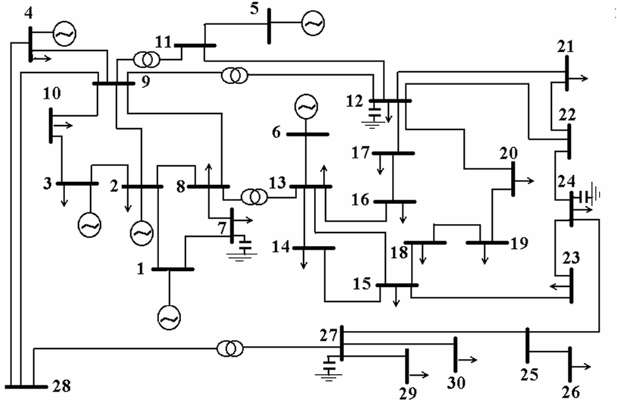

Figure (3), The modified IEEE 30-Bus Test System

Table(1), Bus data
Bus  No. | Generation |  | Load
Bus  No. | P(MW) | Q(MVA)R) | P(MW)) | Q(MVAR))
1 | ----- | ----- | 0.00 | 0.00
2 | 20.0 | ----- | 21.7 | 12.7
3 | 10.0 | ----- | 74.2 | 19.00
4 | 10.0 | ----- | 30.0 | 30.00
5 | 5.0 | ----- | 0.00 | 0.00
6 | 5.0 | ----- | 0.00 | 0.00
7 | 0.00 | 0.00 | 25.4 | 1.2
8 | 0.00 | 0.00 | 7.6 | 1.6
9 | 0.00 | 0.00 | 0.00 | 0.00
10 | 0.00 | 0.00 | 18.8 | 10.9
11 | 0.00 | 0.00 | 0.00 | 0.00
12 | 0.00 | 0.00 | 15.8 | 2.00
13 | 0.00 | 0.00 | 11.2 | 7.5
14 | 0.00 | 0.00 | 6.2 | 1.6
15 | 0.00 | 0.00 | 18.2 | 2.5
16 | 0.00 | 0.00 | 3.5 | 1.8
17 | 0.00 | 0.00 | 9.0 | 5.8
18 | 0.00 | 0.00 | 3.2 | 0.9
19 | 0.00 | 0.00 | 9.5 | 3.4
20 | 0.00 | 0.00 | 2.2 | 0.7
21 | 0.00 | 0.00 | 12.5 | 11.2
22 | 0.00 | 0.00 | 0.00 | 0.00
23 | 0.00 | 0.00 | 3.2 | 1.6
24 | 0.00 | 0.00 | 14.7 | 6.7
25 | 0.00 | 0.00 | 0.00 | 0.00
26 | 0.00 | 0.00 | 11.5 | 2.3
27 | 0.00 | 0.00 | 0.00 | 0.00
28 | 0.00 | 0.00 | 0.00 | 0.00
28 | 0.00 | 0.00 | 12.4 | 0.9
30 | 0.00 | 0.00 | 10.6 | 1.9

Table(2), Limits of system variables

Variables |  |  | Limits
 |  |  | Low | High
Control variables | (Generator voltage)$V_{G}$ | p.u. | 1.00 | 1.10
Control variables | (Tap setting) $\text{Tp}$ | p.u | 0.95 | 1.05
Control variables | (VAR source) $Q_{C}$ | MVAR | -15 | 36
Dependent variables | (Load bus voltage) $V_{l}$ | p.u. | 0.90 | 1.10
Dependent variables | (Generator reactive power) $Q_{G}$ | MVAR | -40 | 100

Table (3), Line data

From bus | To  bus | R  (P.U) | X  (P.U) | B/2  (P.U) | Tap Ratio
1 | 2 | 0.0192 | 0.0575 | 0.0264 | -
1 | 7 | 0.0452 | 0.1852 | 0.0204 | -
2 | 8 | 0.057 | 0.1737 | 0.0184 | -
7 | 8 | 0.0132 | 0.0379 | 0.0042 | -
2 | 3 | 0.0472 | 0.1983 | 0.0209 | -
2 | 9 | 0.0581 | 0.1763 | 0.0187 | -
8 | 9 | 0.0119 | 0.0414 | 0.0045 | -
3 | 10 | 0.046 | 0.116 | 0.0102 | -
9 | 10 | 0.0267 | 0.082 | 0.0085 | -
9 | 4 | 0.012 | 0.042 | 0.0045 | -
9 | 11 | 0 | 0.208 | 0 | 1
9 | 12 | 0 | 0.556 | 0 | 1
11 | 5 | 0 | 0.208 | 0 | -
11 | 12 | 0 | 0.11 | 0 | -
8 | 13 | 0 | 0.256 | 0 | 1
13 | 6 | 0 | 0.14 | 0 | -
13 | 14 | 0.1231 | 0.2559 | 0 | -
13 | 15 | 0.0662 | 0.1304 | 0 | -
13 | 16 | 0.0945 | 0.1987 | 0 | -
14 | 15 | 0.221 | 0.1997 | 0 | -
16 | 17 | 0.0824 | 0.1923 | 0 | -
15 | 18 | 0.1073 | 0.2185 | 0 | -
18 | 19 | 0.0639 | 0.1292 | 0 | -
19 | 20 | 0.034 | 0.068 | 0 | -
12 | 20 | 0.0936 | 0.209 | 0 | -
12 | 17 | 0.0324 | 0.0845 | 0 | -
12 | 21 | 0.0348 | 0.0749 | 0 | -
12 | 22 | 0.0727 | 0.1499 | 0 | -
21 | 22 | 0.0116 | 0.0236 | 0 | -
15 | 23 | 0.1 | 0.202 | 0 | -
22 | 24 | 0.115 | 0.179 | 0 | -
23 | 24 | 0.132 | 0.27 | 0 | -
24 | 25 | 0.1885 | 0.3292 | 0 | -
25 | 26 | 0.2544 | 0.38 | 0 | -
25 | 27 | 0.1093 | 0.2087 | 0 | -
28 | 27 | 0 | 0.396 | 0 | 1
27 | 29 | 0.2198 | 0.4153 | 0 | -
27 | 30 | 0.3202 | 0.6027 | 0 | -
29 | 30 | 0.2399 | 0.4533 | 0 | -
4 | 28 | 0.0636 | 0.2 | 0.0214 | -
9 | 28 | 0.0169 | 0.0599 | 0.065 | -

7. Results
Both methods of linear programming and artificial neural networks have been simulated in a MATLAB(7.5) and have been applied to the modified IEEE 30-bus test system. The ANN was trained with the three sets of data as shown in table(4), obtained by performing load flow and voltage instability analysis for different load factors such as 0.8, 1.0, and 1.2.
The data indicated in table(5) are used for testing the ANN, these data are obtained in exactly the same way as the training set. The ANN is tested with data corresponding to load factors of 0.75 and 1.3 to determine the effectiveness of the proposed method. Proper actions suggested by both techniques are shown in Table(6).
The decision of each method (LP and ANN) are almost coincident, however the ANN gives these decisions in almost on time. A comparison between the computational time of the proposed ANN technique and LP is shown in table(7). It is clearly shown that the ANN technique requires very small computational time to improve voltage stability. These results have been achieved by using a computer with Pentium CPU of 2.6 GHz, 512MB RAM specifications.
The results of pre and post optimization conditions for full load conditions (unity load factor) are shown in table(8). We can conclude that the voltage profile has increased from 0.86 to 0.968 at bus-26, as the minimum Eigen value is increased from 0.194 to 0.214 and the power loss is reduced from 24.27MW to 20.46MW. Figures (4)&(5) show the voltage profiles at each bus of the system under test at pre and post optimization conditions, assuming unity load factor.

Table(4.a), Input data used for training the ANN.
No. Load bus | Voltage with load factor 80% (P.U) | Voltage with load factor  100% (P.U) | Voltage with load factor 120% (P.U)
7 | 0.98 | 0.98 | 0.97
8 | 0.98 | 0.98 | 0.97
9 | 0.99 | 0.98 | 0.98
10 | 0.99 | 0.98 | 0.98
11 | 0.98 | 0.97 | 0.96
12 | 0.96 | 0.95 | 0.93
13 | 0.98 | 0.97 | 0.95
14 | 0.96 | 0.95 | 0.93
15 | 0.95 | 0.94 | 0.92
16 | 0.96 | 0.95 | 0.93
17 | 0.96 | 0.94 | 0.92
18 | 0.94 | 0.93 | 0.9
19 | 0.94 | 0.92 | 0.9
20 | 0.95 | 0.93 | 0.91
21 | 0.95 | 0.93 | 0.91
22 | 0.95 | 0.93 | 0.91
23 | 0.94 | 0.92 | 0.9
24 | 0.93 | 0.91 | 0.88
25 | 0.93 | 0.91 | 0.88
26 | 0.9 | 0.86 | 0.82
27 | 0.95 | 0.93 | 0.9
28 | 0.99 | 0.98 | 0.97
29 | 0.92 | 0.89 | 0.85
30 | 0.91 | 0.88 | 0.84
Table(4.b), The output data (desired) used for training the ANN.

Type of Control variables | Recommendations Provided by LP Technique
Type of Control variables | Control variables with load factor 80% (P.U) | Control variables with load factor 100% (P.U) | Control variables with load factor 120% (P.U)
V_{G} -1 | 1.07 | 1.09 | 1.1
V_{G} -2 | 1.02 | 1.04 | 1.04
V_{G} -3 | 1 | 1.05 | 1.06
V_{G} -4 | 1.01 | 1 | 1
V_{G} -5 | 1.08 | 1 | 1
V_{G} -6 | 1.05 | 1.05 | 1.07
Qc  at bus-7 | -0.12 | 0.36 | 0.369
Qc  at bus-12 | 0.221 | 0.198 | -0.12
Qc  at bus-24 | 0.293 | 0.179 | 0.382
Qc  at bus-27 | 0.035 | 0.159 | 0.112
Tp  9-11 | 0.974 | 0.98 | 0.982
Tp  9-12 | 1.041 | 1.04 | 1.027
Tp  8-13 | 0.95 | 0.95 | 0.965
Tp  28-27 | 0.995 | 1.011 | 1.028

Table(5), Input data used for Testing the ANN.

No. Load bus | Voltage with load factor 75% (P.U) | Voltage with load factor130% (P.U)
7 | 0.99 | 0.96
8 | 0.99 | 0.96
9 | 0.99 | 0.97
10 | 0.99 | 0.97
11 | 0.98 | 0.95
12 | 0.96 | 0.92
13 | 0.98 | 0.95
14 | 0.96 | 0.92
15 | 0.96 | 0.91
16 | 0.97 | 0.93
17 | 0.96 | 0.91
18 | 0.95 | 0.89
19 | 0.95 | 0.89
20 | 0.95 | 0.9
21 | 0.95 | 0.9
22 | 0.95 | 0.9
23 | 0.94 | 0.88
24 | 0.94 | 0.86
25 | 0.94 | 0.86
26 | 0.91 | 0.79
27 | 0.95 | 0.89
28 | 0.99 | 0.96
29 | 0.92 | 0.83
30 | 0.92 | 0.82
Table(6), The Recommendations Provided by both techniques (LP and ANN).
Type of Control variables | Recommendations Provided by LP Technique |  | Recommendations Provided by ANN Technique
Type of Control variables | Control variables with load factor 75% (P.U) | Control variables with load factor 130% (P.U) | Control variables with load factor 75% (P.U) | Control variables with load factor 130% (P.U)
V_{G} -1 | 1.06 | 1.09 | 1.06 | 1.089
V_{G} -2 | 1.03 | 1.05 | 1.03 | 1.045
V_{G} -3 | 1.02 | 1.04 | 1.01 | 1.06
V_{G} -4 | 1.0 | 1.0 | 1.0 | 0.998
V_{G} -5 | 1.1 | 1.04 | 1.2 | 1.04
V_{G} -6 | 1.06 | 1.01 | 1.05 | 1.015
Qc  at bus-7 | 0.36 | 0.38 | 0.35 | 0.38
Qc  at bus-12 | 0.026 | 0.039 | 0.025 | 0.035
Qc  at bus-24 | 0.055 | 0.32 | 0.057 | 0.34
Qc  at bus-27 | 0.082 | 0.156 | 0.08 | 0.16
Tp  9-11 | 0.98 | 1.024 | 0.98 | 1.025
Tp  9-12 | 1.037 | 0.95 | 1.04 | 0.95
Tp  8-13 | 0.956 | 0.983 | 0.95 | 0.97
Tp  28-27 | 0.987 | 1.030 | 0.99 | 1.03
Table(7), Computation times for LP and ANN methods.

Method | LP | ANN
Time (Sec.) | 6.39 | 0.21

Table(8), The pre and post optimization conditions with full load state.

Load factor (unity) | Pre Optimization | Post Optimization
$$V_{\text{min}}$$ | 0.86 P.U. | 0.968 P.U.
$$λ_{\text{min}}$$ | 0.194 | 0.214
power losses | 24.27 MW | 20.46MW

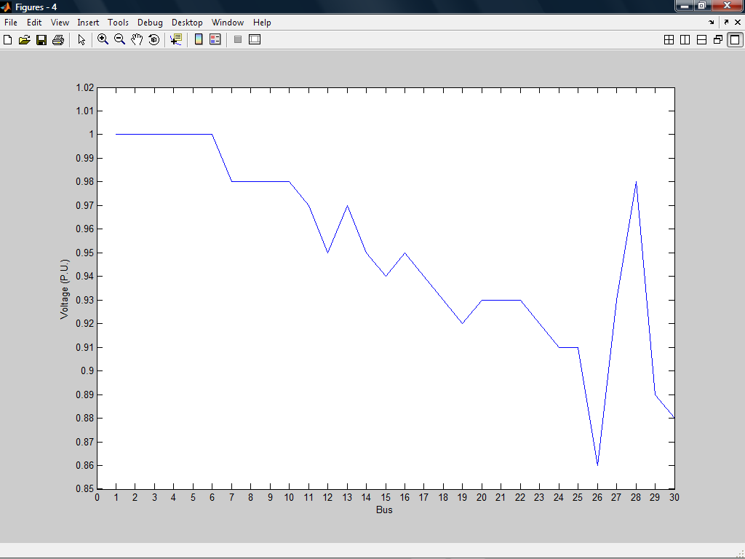

Figure (4), The pre optimization voltage profiles at each bus of the system under test.

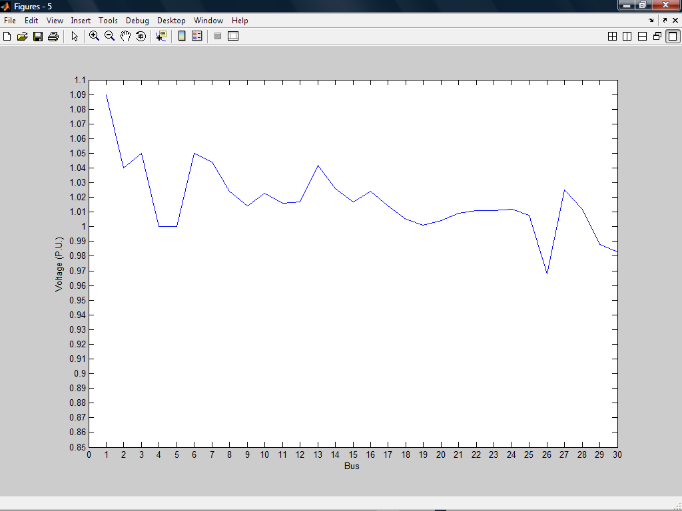

Figure (5), The post optimization voltage profiles at each bus of the system under test.

8. Conclusions
A fast technique to monitor and improve power system voltage stability is proposed, the method is based on ANN. Three layers feed-forward ANN with back-propagation is trained to give the proper rescheduling of reactive power control variables required to achieve voltage stability in the day-to-day operation. The considered reactive power control variables are switchable VAR compensators, OLTC transformers and excitation of generators. The training data is obtained by solving several conditions using the LP technique. The results obtained show clearly that the ANN approach is capable of improving voltage stability in power systems. The trained network is capable of improving the power system voltage stability from minimum to maximum range of load variations at very high speed. A comparison with the LP technique shows the clear superiority of the proposed ANN in achieving the control decision in a short computational time. Furthermore, the ANN is simple in structure and easy to operate compared with linear programming technique. Thus, the method can be used as a guide by the operator in Energy Control Center (ECC) for power system control. The proposed method indicates a significant improvement in voltage stability which eventually leads to a considerable decrease in system losses.

9. References
Abdelaziz A. Y., Abu-Elnaga, El-bahrawy K. M., and El-sharkawy M. A., 2003, "ANN-Based Technique for Predicting Voltage Collapse in Power Systems", the Ninth International Middle-East Power Systems Conference, MEPCON 2003, Minoufiya University, Shebin El-Kom, Egypt.
Abdelkader S., 1998, "Determination of Lower Voltage Power Flow Solutions for Voltage Stability Assessment", Proceedings of the Sixth Middle East Power Systems Conference MEPCON, 1998, Mansoura, Egypt.
AL-Hinai A., 2000, "Voltage collapse Prediction for Interconnected Power Systems", M. Sc. Thesis, West Virginia University.
Andrade A. C. et al., 2006, "FSQV and Artificial Neural Networks to voltage Stability Assessment" IEEE PES Transmission and Distribution Conference and Exposition Latin America, Venezuela.
Arya L. D. et al, 2005 "Static voltage Stability Enhancement Using Eigen Sensitivities", International journal of Electrical Power and Energy System, February 28, PP. 164-170.
Demuch H. and Beale M., 2000, "Neural network toolbox manual for MATLAB", User's Guide, Version 6.
Elkady F.M. and Abdelaziz A.Y., 2001, "Voltage Stability Assessment of Electrical Power Systems Using Artificial Neural Networks", Journal of Engineering and Applied Science, Faculty of Engineering, Cairo University, Vol. 48, No. 4, August 2001, pp. 727-743.
Elrazaz Z. S., Yassin I., Hegazy A. and Mostafa H.,1998 "Voltage Stability Indicators Via Artificial Neural Networks", Proceedings of the Sixth Middle East Power Systems Conference MEPCON’98, Mansoura, Egypt, Dec. 1998.
Lof P. A, Anderson G. and Hill D. J., 1993, "Voltage Stability Indices for Stressed Power Systems", IEEE Trans. on Power Systems, Vol. 8, No. 1, February 1993.
Mohamed E.A.,2000, "Power System Steady State Voltage Stability Assessment", Proceedings of the Seventh Middle East Power Systems Conference MEPCON’, Cairo, Egypt, March 2000, pp. 467-474.
Overbye T. J., 1993, "Use of Energy Methods for on-Line Assessment of Power System Voltage Security", IEEE Trans. on Power Systems, Vol. 8, No. 2.
Saddat H.,1998, "Power system analysis", McGraw-Hill Book Company New York.
Souza Lima E. E. and De J Fernandes L. F., 2000, "Assessing Eigen Value Sensitivities", IEEE Transactions on Power Systems, vol 15, no 1, pp. 299-305.

