Manufacturing and Calibration of Subsonic Wind Tunnel

Hani Aziz Ameen Rana Ali Hussien
Technical College / Al-Musaib, Pumps Engineering Dept.

Abstract
In this research the open type wind tunnel is designed, manufactured and calibration. Test section was 30 cm squared, 60 cm long. And with overall length was 3 m , it is consists of contraction cone(nozzle), test section and diffuser. Subsonic flow are achievable allowing experiments on many aspects of incompressible air flow and subsonic aerodynamics to be performed at satisfactory Reynolds numbers .The tunnel has a smooth contraction fitted with the protective screen. The working section is constructed of clear perspex. Turbine blade specimen is investigated in this wind tunnel to check the operation and calibration of the wind tunnel. ANSYS12 software is used to study the velocity & pressure distribution in the wind tunnel. Good agreement is evident between the experimental and ANSYS12 results.
الخلاصة
في هذا البحث تم تصميم وتصنيع ومعايرة مجرى هوائي مفتوح. مقطع الاختبار له بابعاد 30 سم × 30 سم وبطول 60 سم والطول الكلي للمجرى الهوائي 3 متر ، ويتكون من مخروط متخصر (منفث) ، مقطع الاختبار و الناشر. الجريان التحت الصوتي تم تحقيقه عمليا في هذا المجرى مع الاخذ بنظر الاعتبار الجريان اللاانضغاطي والتي تحقق رقم رينولدز .لقد تم وضع مشبك لتحديد اتجاه الهواء وتم صنع مجرى الاختبار من البيرسبكس الشفاف . لقد تم استخدام ريشة التوربين كعينة لاجراء الفحوصات في المجرى الهوائي . تم استخدام برنامج ANSYS12 لدراسة توزيع السرع والضغط في المجرى الهوائي . تطابق جيد تم الحصول عليه بين النتائج العملية والنظرية .
Symbols
U velocity in x- direction
V velocity in y- direction
$φ$ stream line function
r radial coordinate
f(x) polynomial equation of nozzle
A, B, B₁, B₂, k , k₂ constants
P static pressure
w width of test section
$ρ$ density
L test section length
A₁, A₂ inlet , outlet area of test section

Introduction
Wind tunnel are used in many engineering and environmental applications as a key tool in understanding the problems associated with aerodynamic and transport phenomena (Bienkiewicz, 1996). The wind tunnel is intended to carry out low Renolds number. Incompressible flow research and development activities on aircraft and turbomachinery components under its controlled flow qualities. An open type wind tunnel chosen to be the best compromise between efficiency and economy. The general layout of the present wind tunnel with its important dimensions is shown in Fig (1) and Fig (2).

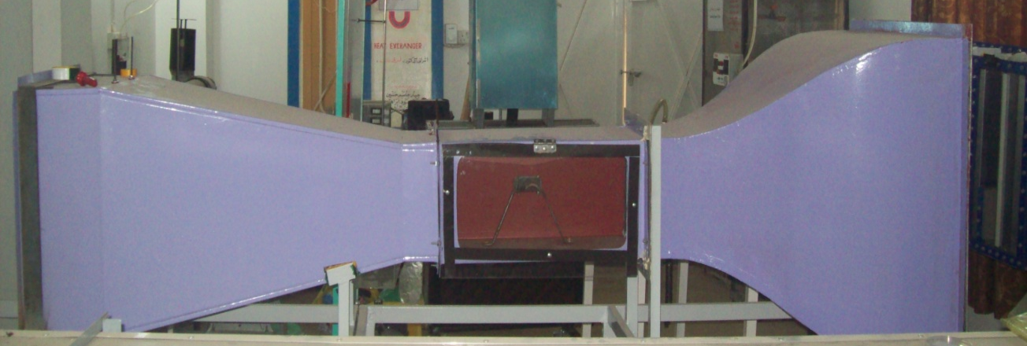
Fig (1) Designed and manufactured wind tunnel
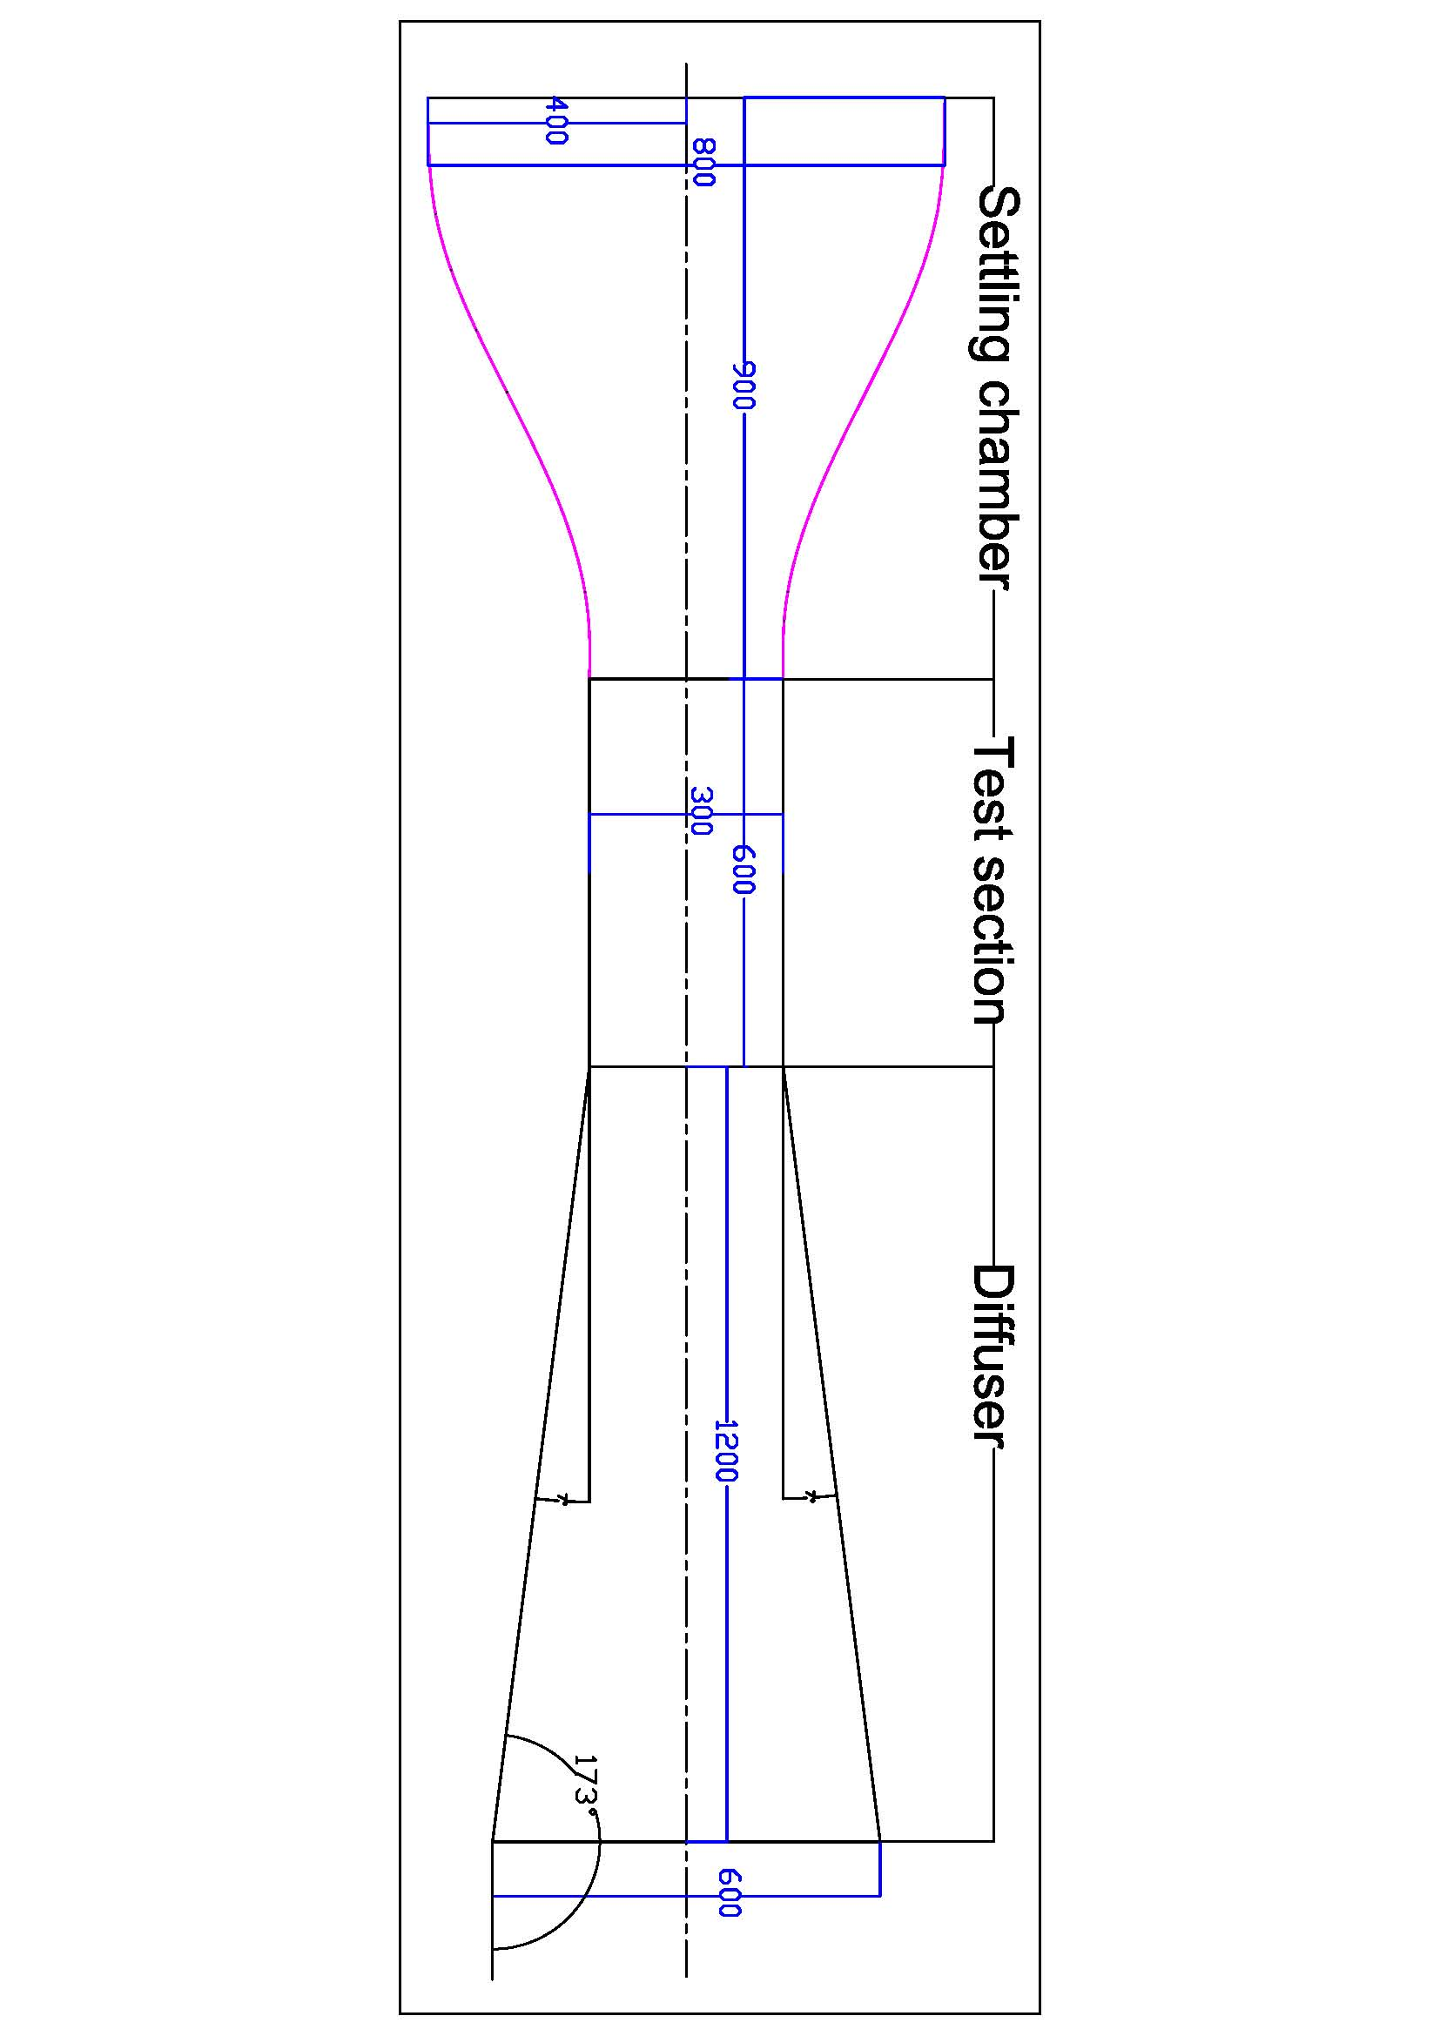
Fig (2) Schematic diagram of the designed wind tunnel.

The design conforms to the recommendations given in the references (Barlow et al,1999 , Cook , 1982, Kong & Parkinson,1997), given here in , on the state – of art to find optimum construction ratio, wall profile , wire screen and honeycomb selection for the settling chamber to have good flow qualities in the test section. The flow qualities are initiated in the large settling chamber where very low velocities permit use of multiple wire screens honeycomb without incurring much losses to make flow uniform and reduced turbulence level. The settling chamber cross section is made to contract considerably to reach test section at a short test possible distance. Interpretation of results is sensitive to the test section airflow quality, Yousif et al,1991, design the wind tunnel with cross-section (0.85 m) square and (1.5m) long and contraction ratio 4.4% and Abbaspour and Shojaee,2009, designed multipurpose wind tunnel with adjustable test section could used either as the environment, subsonic or climatic wind tunnel. Literature survey indicates acceptable value of mean velocity variation of about +0.2% to 0.5%, flow angularity of about +0.5, turbulence intensity of 0.5%and power factor for this type of tunnel of about 2.5 .
Exact solutions have not proved sufficient to predict adverse velocity gradient near the wall trial and error methods and empirical relationships were deployed wherever necessary. Also ANSYS12 software is used to check the distribution of velocity & pressure.
Design, construction and testing of a subsonic wind tunnel that the wind tunnel simulates a high speed stream of air to flow past a model of the object being tested[Fig.(3)]
Wind tunnel is a chamber though which air is forced at controlled velocities in order to study the effects of aerodynamic flow around airfoils or scale models.
The parts of wind tunnel are:
- A settling chamber to straighten the flow and control turbulence intensity.
- A contraction zone to takes a large volume of low –velocity air and reduces it to a small volume of high velocity air without creating turbulence.
- A test section where the test article and sensors are installed.
- A diffuser to slow down the speed of airflow and a drive section to provide the force and pull air through the wind tunnel.

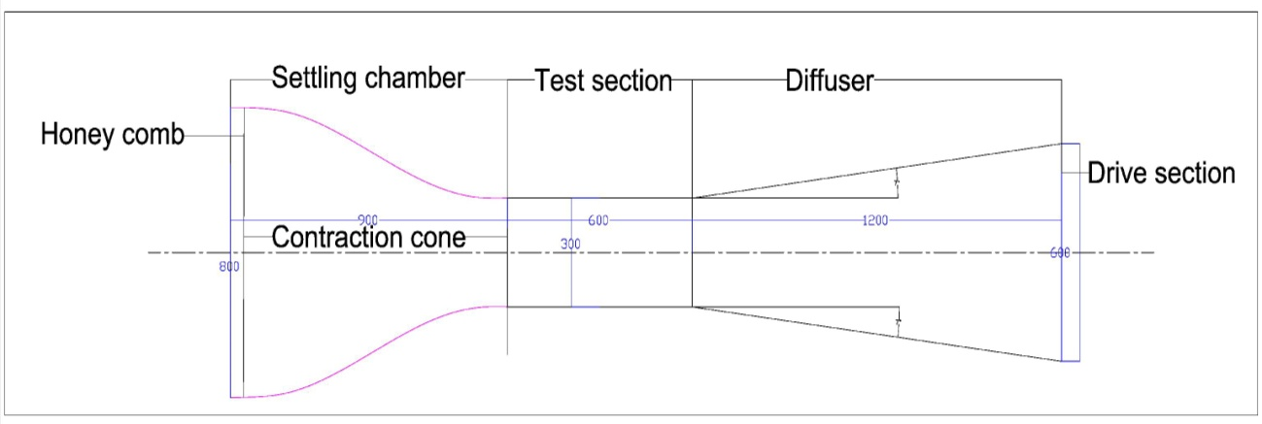

Fig.(3) Parts of wind tunnel
Theoretical Analysis of Wind Tunnel
Contraction Design
Axisymmetric steady ideal irrotational flow in cylindrical coordinate system is considered sufficient for the approximation the design (Aldruby ,1988).
Continuity equation:
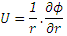
Irrotationality condition:
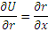
Combining it reduces to stoke Beltrame equation:
With particular solution of the form
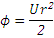
And general solution of the from:
On substituting general solution equation(3) in continuity equation (1)
The velocity components becomes (Yousif et al ,1991) :-

Indication at x axis, r =0,u_{r=0}=2f(x),v_{r=0}=0 ………………………………..….(5)
As x→∞, the boundary condition at the end of contraction should be :
U→2f(x)
For all r ………………………………………….….. (6)
V→0

This is possible when f(x) →0 as x →±∞ suggesting formation of f(x) to satisfy the following two conditions hyperbolic in nature.
Change in axial velocity pattern should be in continuity from inlet to outlet of contraction.
Airflow at the inlet and outlet of contraction to be uniform therefore, the simplest form of f(x) which satisfies the B.C. is:
Where k₁ is constant representing controlling parameter for the accuracy of contraction, the two constants A and B₁ can be determine form the B.C.
However equation (7) has un-satisfaction wall velocity gradients resulting in delayed wall inflexion for contraction.
Cohen suggested modification as followers (Yousif et al, 1991):
Where constants k₁, A and B₁ are as in eq. (7) and K₂ is a constant of small value while B₂ can be determine from the B.C.at x=0.
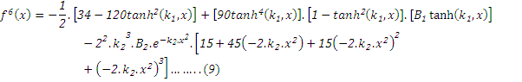
Substituting Eq.(9) in Eq.(3), the stream function becomes:
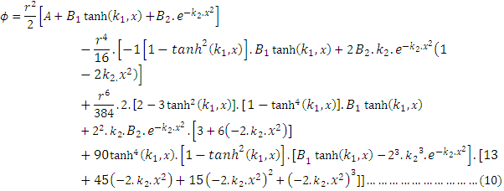
Defining the profile of wall contraction in terms of only two variable x and r.
A, B₁ and B₂ can be obtained by specifying velocities at the inlet and outlet at x=0. k₁ and k₂ are the geometric aspect ratios of contraction affecting slenderer and the position of point of contraction.
Test Section
A closed rectangular test section with filleted corners considerably less power than the open type recommended length of test section should be less than twice the maximum width (Yousif et al ,1991 and Shapiro ,1953) gives the drop in static pressure as:
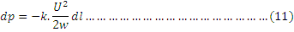
Where k=constant :( 0.016 to 0.04)
The loss may be recovered b making test section slightly divergent, the shape depending on Glauert formula as follows:-
Combining Bernoulli's equation:-
Combining with Continuity equation: A₁.v₁=A₂.v₂, it becomes;
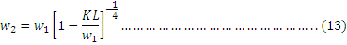
And
This givers the requires divergence and the test section outlet width.
Diffuser
Assuming constant velocity distribution, gives diffuser efficiency as:-
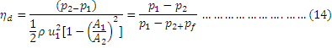
Where, p₁ and p₂ are static pressures at the cross sections at A₁(diffuser inlet) and A₂ (diffuser outlet), U₁ is the mean velocity at A₁. The low efficiency arises out of large loss moreover of energy during pressure recovery from flow kinetic energy. Adverse pressure gradient associated with velocity reduction favoures undesirable flow separation from the walls. Parameters efficiency diffuser performance are rate of expansion cross section shape , turbulence level B.L. effect and effect of wall shape, Recommended (Aldruby, 1988) values of diffuser divergence is 5° to 10° beyond which efficiency drops rapid as it depends on the turbulence level and empirical relationship derived from experimental results.
The ratio (2×B.L thickness/max. diffuser width) <0.005 give 90% and deteriorates rapidly as the ratio exceeds (0.005) .Larger diffuser angle can be reduced by B.L. control such as use of deflector vanes and /or introduce spiral flow to energies by mixing high energy core flow with B.L. growth improving up to 80% for larger diffuser angle up to 53°.
Fan
Fan differs from airplane propellers by usage of multi blades to avoid pulsation and usage of thin blades with pre rotating vanes/aft straightened vans to avoid rotationality. In open circuit wind tunnel aft fans have little effect on test section airflow quality and therefore vans may not be required. The parameters affecting fan efficiency is tip clearance, component of radial flow, blade lift/drag ratio, number of blade, blades Re. No. (www.AMCA.org ), blade angle and tip compressibility effect
Flow Quantities
While uniform and steady airflow is desirable at the test section, in practice associates with low frequency fluctuations and high frequency turbulence. The state of art of design to reduce the turbulence level. Reduction of turbulence is achieved through identifying the sources improve construction the usage of damping screen and honey comb in the setting chamber considerably improves flow qualities, if the turbulence intensity is above (0.7%). Screens reduce turbulence level but it has little effect on removing swirl and lateral mean velocity variation. Honeycomb with cell length >8× cell diameter, proved to be suitable (Abbaspour and Shvjee,2009) smaller size honey comb diameter could help abatement of turbulence and in some cause may dispense with the use of screen. Square and hexagons shaped honey comb give better result than circular section.
Experimental part
Manufacturing and Calibration the Subsonic Wind tunnel
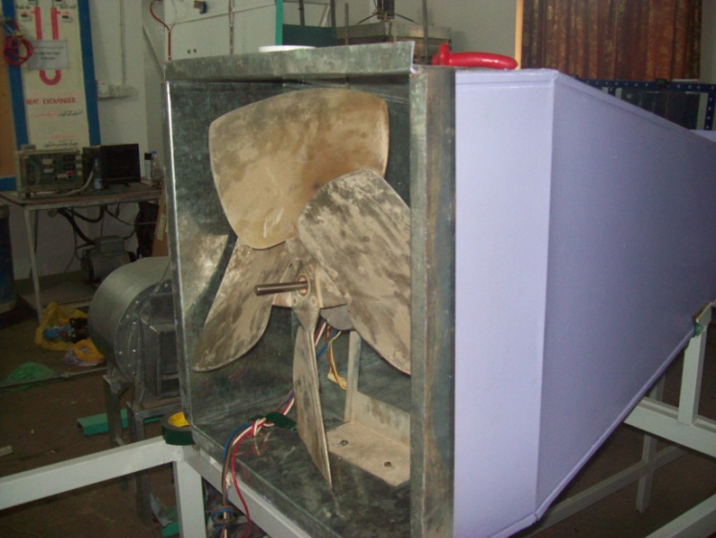
The specification of test section:-
Cross section = 30cm×30cm
Length = 60 cm
Velocity 35 m/sec

Fig.(4) the used Fan
Area ratio:-
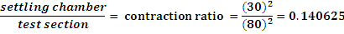
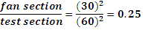
Fan:
The used fan is shown in Fig(4). With the following specification
No. of blades = 4 , Fan diameter= 50cm , Fan hub diameter = 10 cm
Tip clearance= 5cm
Settling chamber
Axisymmetric contraction yields to the following diameters based on specification laid in Fig.(5) and Fig.(6) shows the photo of settling chamber.
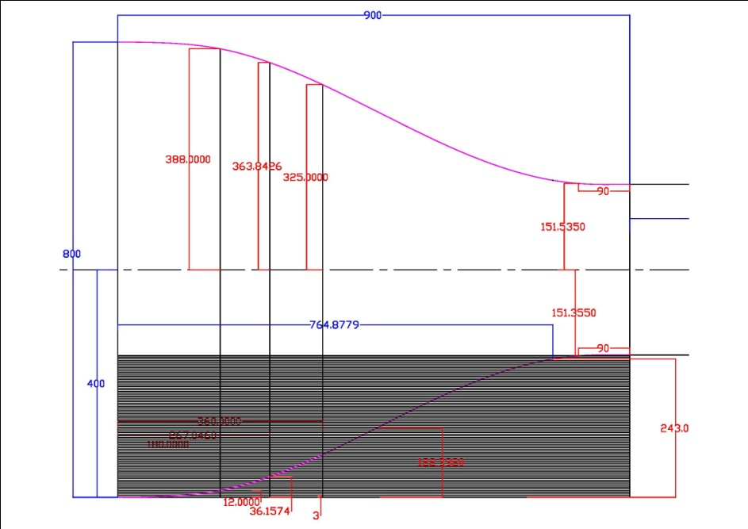

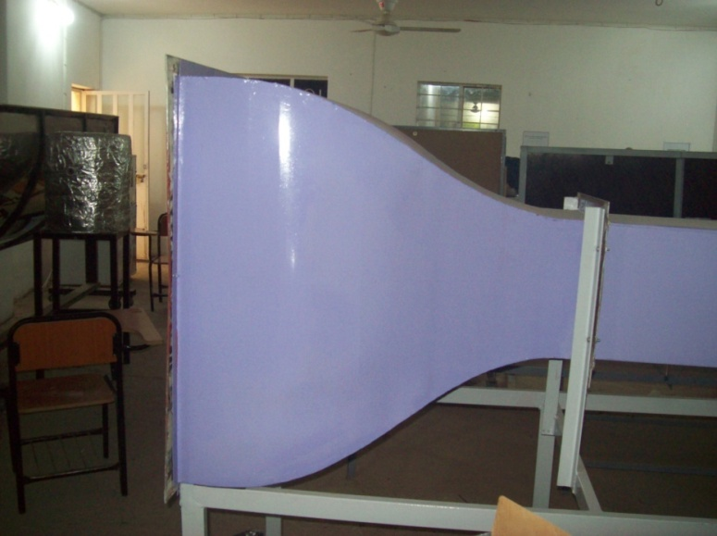
Fig. (5) settling chamber

Fig. (6) Photograph settling chamber

Test Section Design
Test suction walls must have minimal (B.L.) growth to avoid static pressure drop on account of energy losses i.e. avoid a horizontal buoyancy,phenomena.
In this study the working section is construction of clear Perspex with cross-section of (300mm×300mm) and length of 600 mm. Fig (8) represent schematic & Fig.(7) represented photo of the test section.
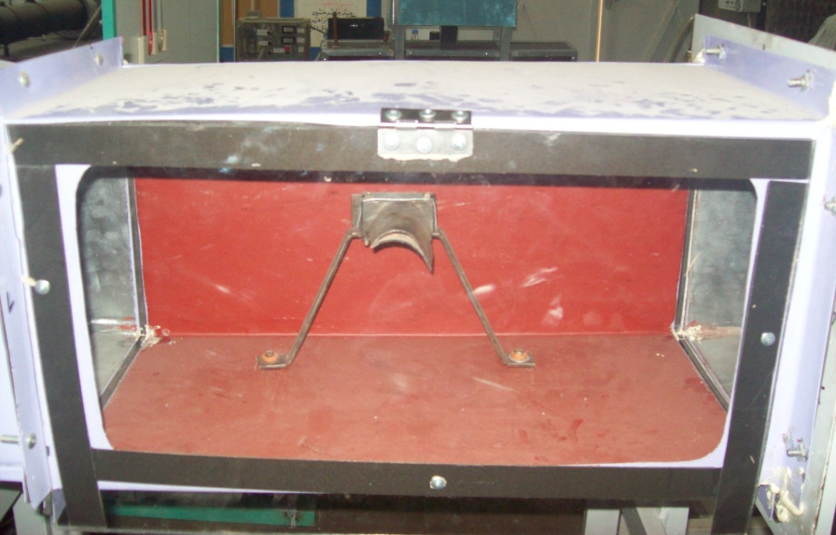

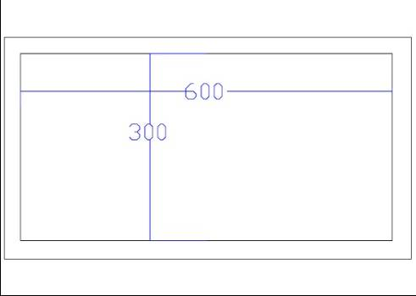

Fig(7) photo of test section with specimen Fig (8) schematic diagram of test section
Diffuser Design
The Diffuser slope angle is (173 degree) to avoid separation of shown in Fig.(9 a,b)
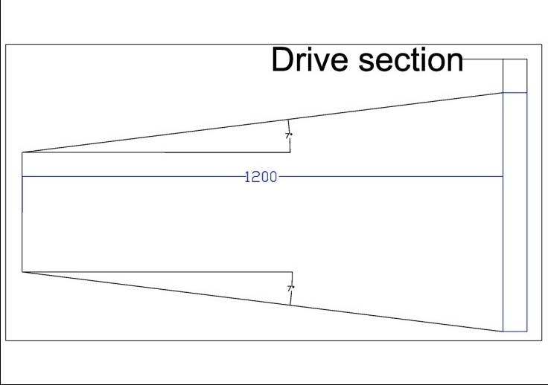
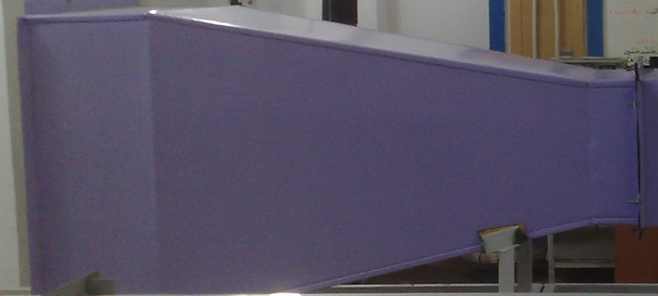

Fig.(9.a) Diffuser Design Fig.(9.b) Diffuser photo
The Construction
The bell mouth settling chamber, test section, and diffuser were separately constructed as an unit joint together by bolt and isolated by cascade which can decreased the vibration between the element of the device at less the device is hung on a load table and isolated by cascade too, the part of the fan is support in the diffuser and isolated from it. Fig(10) shows the joining of the parts of wind tunnel .
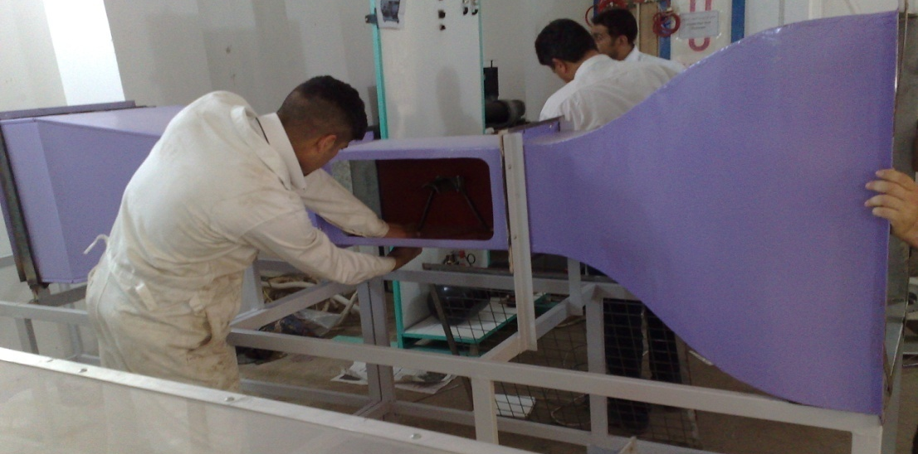

Fig. (10) Joining the wind tunnel
The fan caused vibration which is shake the device tightly . During final assembly, care was taken to align center lines of each section to be in one straight horizontal line. The joints were sealed to give smoothness of flow and oil was coated to reduce B.L.
The final step is to commission the new tunnel into operation and to measure flow quantities .
Model of Turbine Blade
The model’s mounting device is built and support in the test section by (V) shape shown in Figs. (11)&(12).
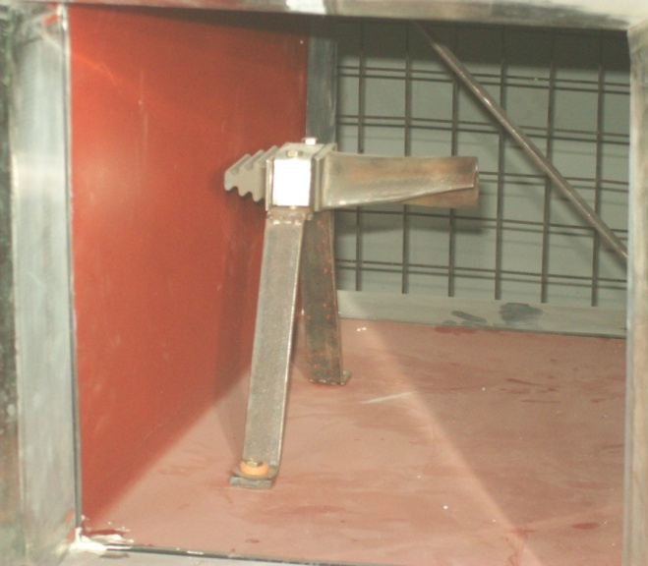
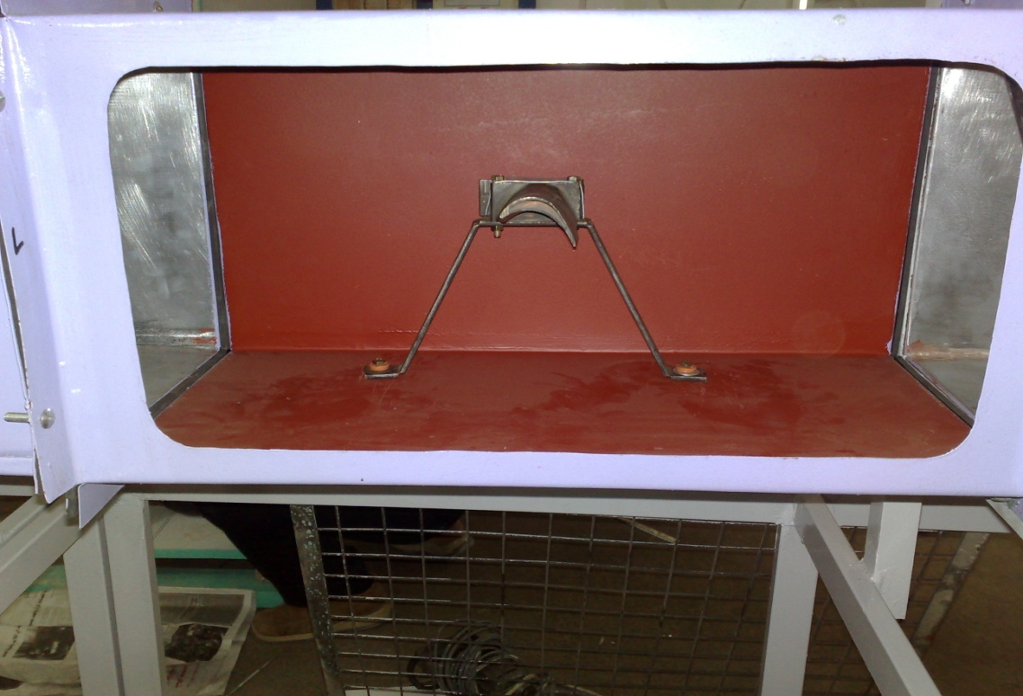
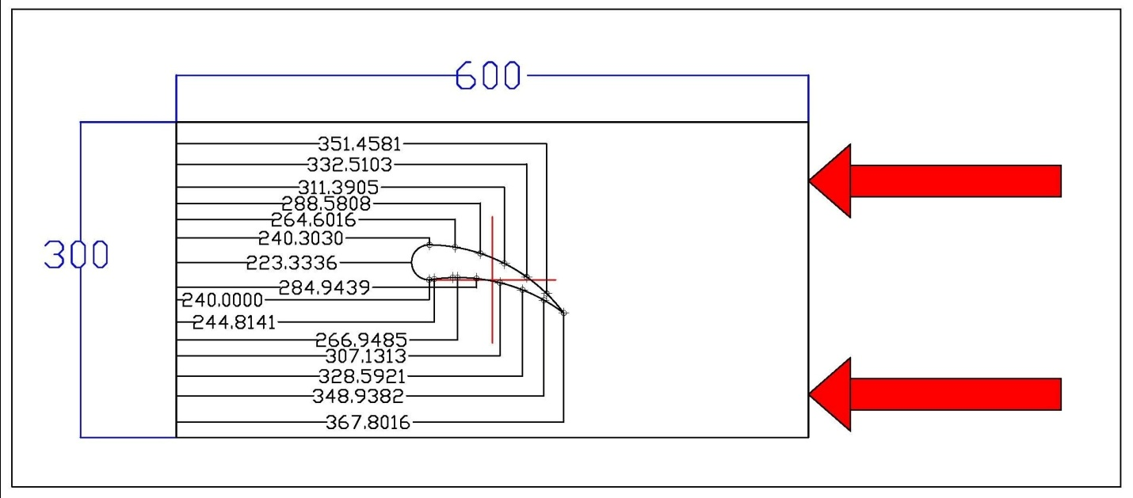
Fig(11) The mounted of the specimen

Fig (12) Schematic diagram of blade turbine

Final Assembly
The wind tunnel is assembly from the mentioned parts, and the final apparatus is shown in Figs(13)&(14).
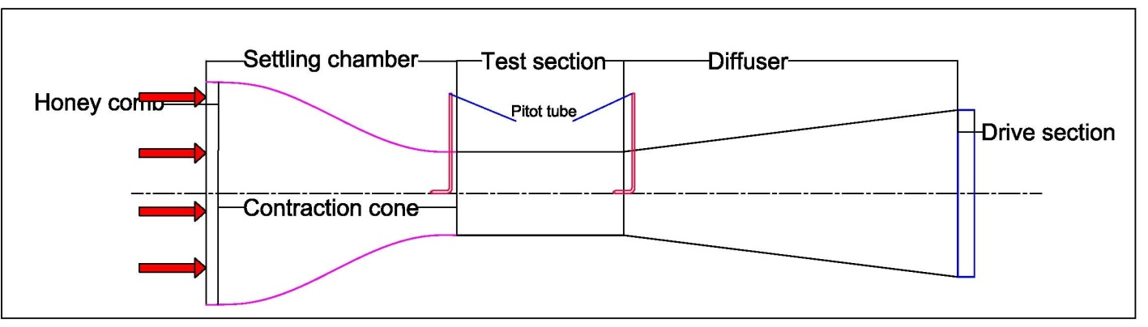
Fig (13) Schematic of wind tunnel shown the pitot tube position

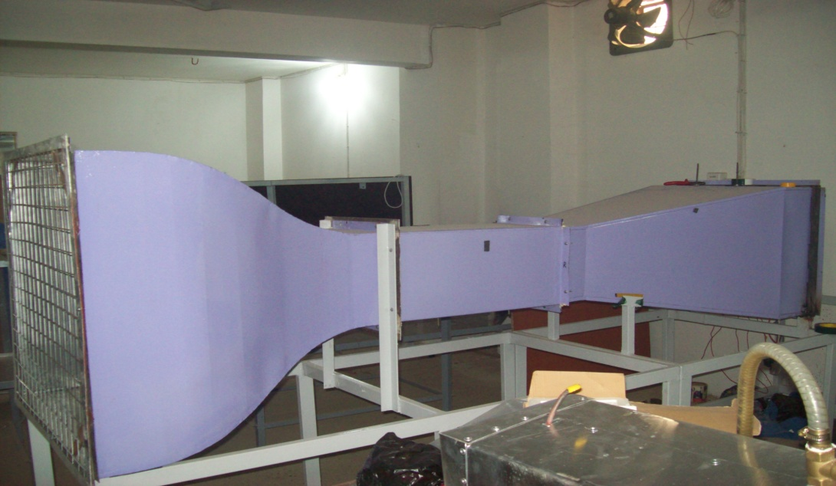
Fig (14)The final assembly of wind tunnel
Numerical Simulation
ANSYS12 is a finite element analysis (ANSYS12 help, 2009) , have the capability to analyze a wide range of different problems. There are two ways to use the ANSYS12 interactively through the graphical user:
- interface (GUI).
- used batch file and ANSYS commands.
The main complete flowchart and APDL (Ansys Parametric Design Language) for the numerical simulation (Nakasone ,2006) is shown in Fig.(15).

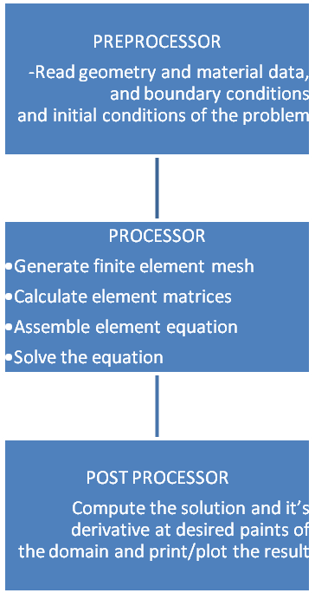
/prep7
Et,1,fluid141
! diffuser
k,1,0,0 - k,2,130/100,15/100 -k,3,130/100,45/100 - k,4,0,60/100
a,1,2,3,4 -
! test section
k,5,190/100,15/100 - k,6,190/100,45/100 - a,2,5,6,3
! nozzle
k,7,270/100,70/100 - k,8,195/100,170/100 - larc,6,7,8,125/100 - k,9,270/100,-10/100 - k,10,195/100,-110/100 - larc,5,9,10,125/100
l,7,9 - al,9,10,8,6
! blade
k,20,(130+30.25)/100,(15+15.25)/100
k,21,(130+31)/100,(15+16)/100 - k,22,(130+32)/100,(15+16.8)/100
k,23,(130+33)/100,(15+17)/100 - k,24,(130+34)/100,(15+16.9)/100
k,25,(130+35)/100,(15+16.5)/100 - k,26,(130+35.5)/100,(15+16.1)/100
k,27,(130+35)/100,(15+17.25)/100 - k,28,(130+34)/100,(15+18.3)/100
k,29,(130+33)/100,(15+18)/100 - k,30,(130+32)/100,(15+17.5)/100
k,31,(130+31)/100,(15+16.5)/100
spline,20,21,22,23,24,25 - spline,25,26,27,28,29,30
spline,30,31,20 - csys,1
a,20,21,22,23,24,25,26,27,28,29,30,31
asba,2,4 - aglue,all - SMRT,6 - SMRT,5 - SMRT,4 -SMRT,3
SMRT,2 - SMRT,1 - SMRT,2 - MSHAPE,1,2D
MSHKEY,0 - FLST,5,2,5,ORDE,2 - FITEM,5,1
FITEM,5,3 - CM,_Y,AREA - ASEL, , , ,P51X
CM,_Y1,AREA - CHKMSH,'AREA' - CMSEL,S,_Y
AMESH,_Y1 - CMDELE,_Y - CMDELE,_Y1 - CMDELE,_Y2
SMRT,1 - CM,_Y,AREA - ASEL, , , , 5
CM,_Y1,AREA - CHKMSH,'AREA' - CMSEL,S,_Y
AMESH,_Y1 - CMDELE,_Y - CMDELE,_Y1 - CMDELE,_Y2
lsel,s,,,1,3,2 - lsel,a,,,8,9- lsel,a,,,5,7,2 - lsel,a,,,11,22,1
nsll,s,1 - d,all,vx - d,all,vy - lsel,all- lsel,s,,,10 - nsll,s,1
d,all,vx,-0.01 - d,all,vy,0 - lsel,all - lsel,s,,,4 - nsll,s,1- d,all,pres,0
lsel,all - allsel,all- nummrg,elem -
finish

/solu
fldata7,prot,dens,air-si
fldata8,nomi,dens,1.23

fldata7,prot,visc,air-si
fldata8,nomi,visc,0.000891

fldata2,iter,exec,25

Solve
finish

Fig. (15): Flow chart and APDL for numerical Simulation
The used element in this analysis is FLUID141 that is two dimensional , four nodes, and the degrees of freedom are velocity, pressure and temperature.
Fig.(16) shows the geometry, node locations, and the coordinate system for this element. FLUID141 takes many type of shape that dependent on your problem.
Fig.(16) Fluid141 element
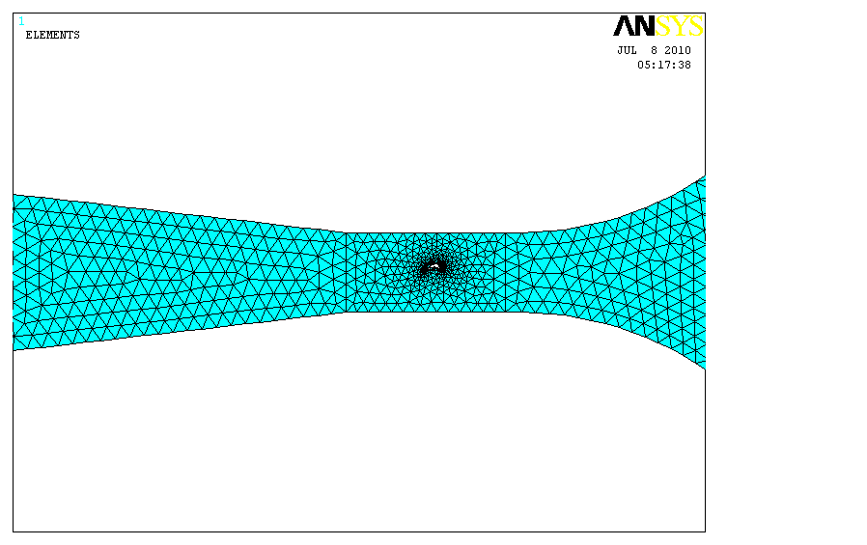
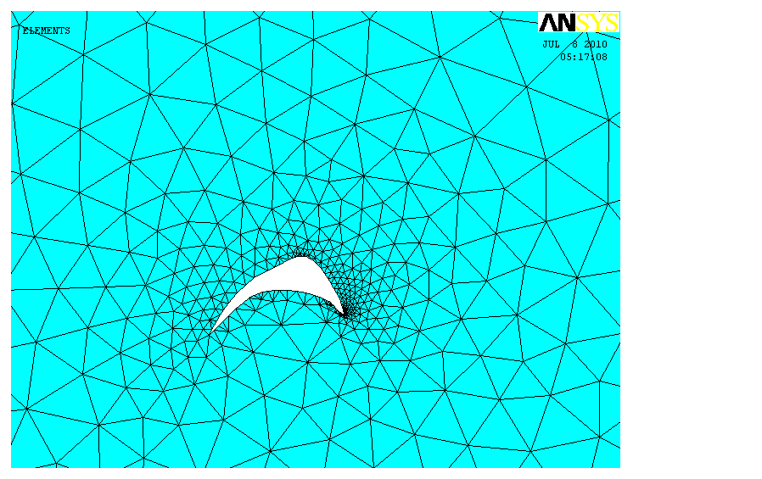
Fluid flow is represent by air flow and in ANSYS12 is express by using solid modeling approach method and meshed by using FLUID141 elements. The input for solver is velocity and output is pressure. Fig.(17) shows the mesh of the wind tunnel with turbine blade.

Fig.(17) Mesh of wind tunnel
Results and Discussion
During a final assembly care was taken to align center lines of each section to be one straight horizontal line. The Joints were sealed to give smoothness of flow and oil was coated to reduce B.L .The final step is to commission the new tunnel into operation and to calibrate measurement to establish flow qualities achieved. Pitot tube manometers were used for pressure by plotting the flow variation cross the test section. The present subsonic wind tunnel is tested, by using the specimen of turbine blade, the pressure and velocity are measured in and out the specimen by manometer and flow meter respectively , it was V_{in} = 26.7 m/s , M= 26.7/347 = 0.077 and V_{out} = 27.3 m/s , M= 27.3/347 = 0.078 . Fig.(18) shown the static pressure distribution at Mach no. approximately 0.078 on the upper surface . The compressible flow was assumed to be inviscid, and Euler equations were solved by using ANSYS12 software. The results of the present experimental wind tunnel of the inviscid subsonic flow show good agreement with the ANSYS results of blade geometry. Fig.(19) Shown the shadow capture of the turbine blade at Mach no. = 0.078.
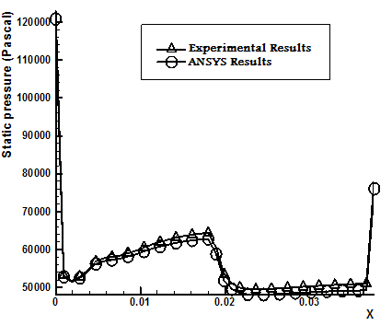

Fig.(18) Static pressure distribution on the upper surface
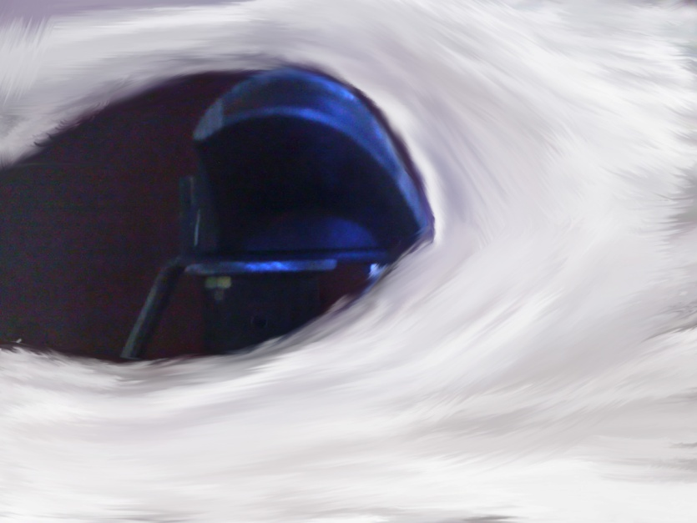

Fig. (19) Shadow capture of turbine blade at Mach no.0.078
Figs.(20) and (21) are shown the velocity distribution and velocity vector, and Fig.(22) shows the pressure distribution and Fig.(23) shows the stream line in the design’s wind tunnel with turbine blade by ANSYS12 software.
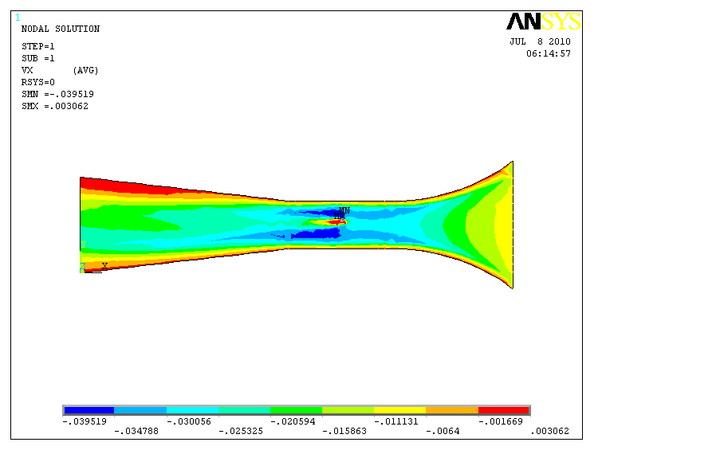
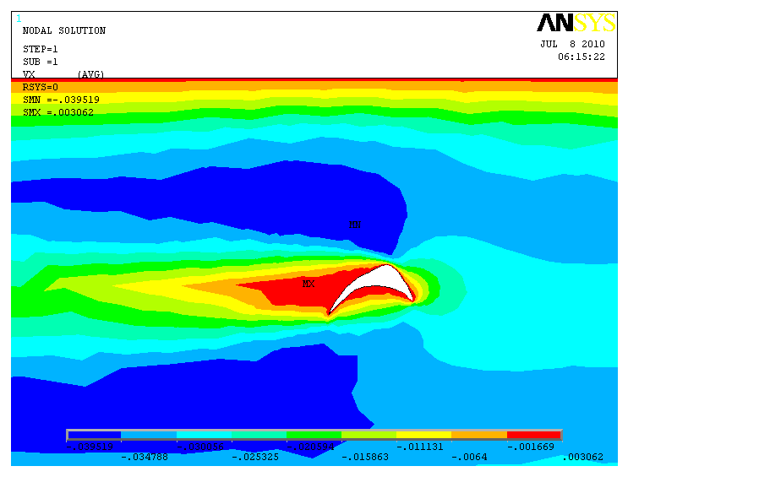

Fig.(20) velocity distribution
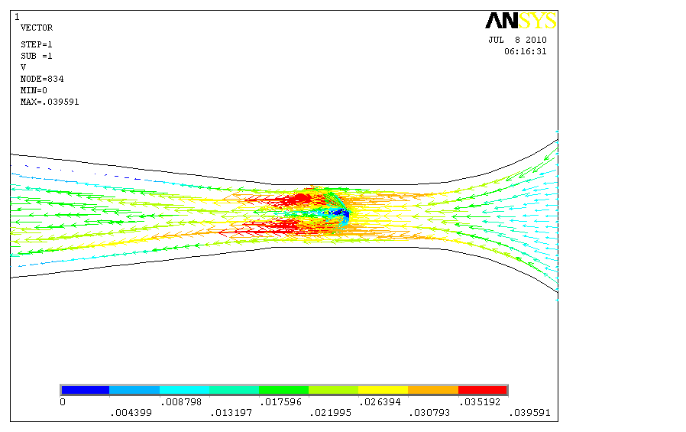
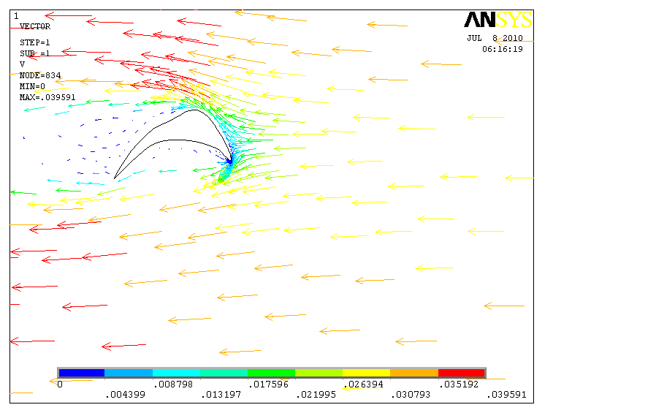

Fig.(21) velocity vector
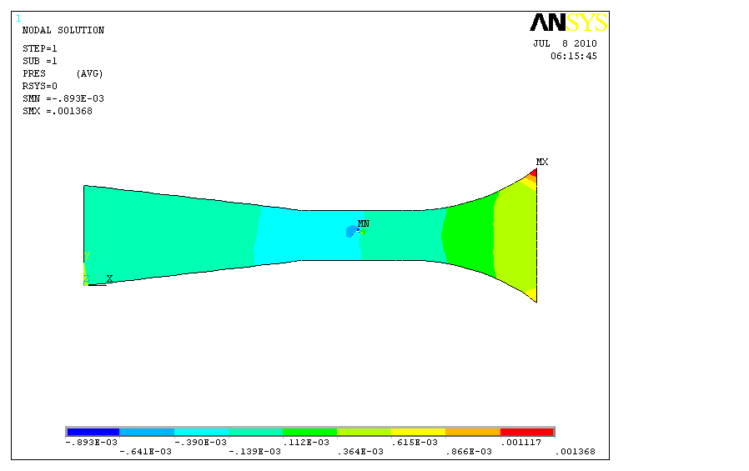
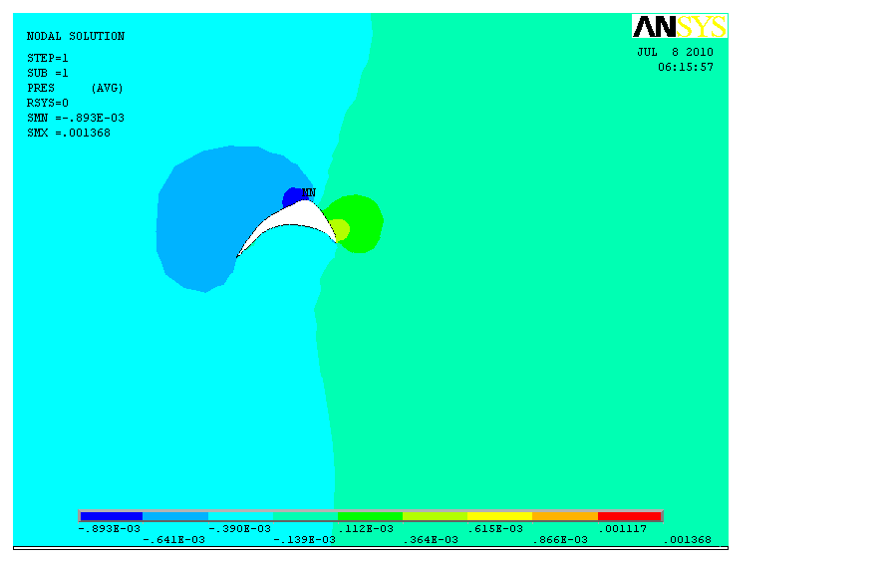

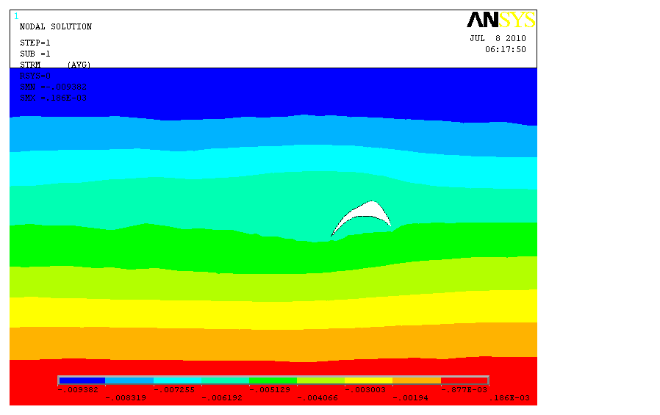
Fig.(22) Pressure distribution
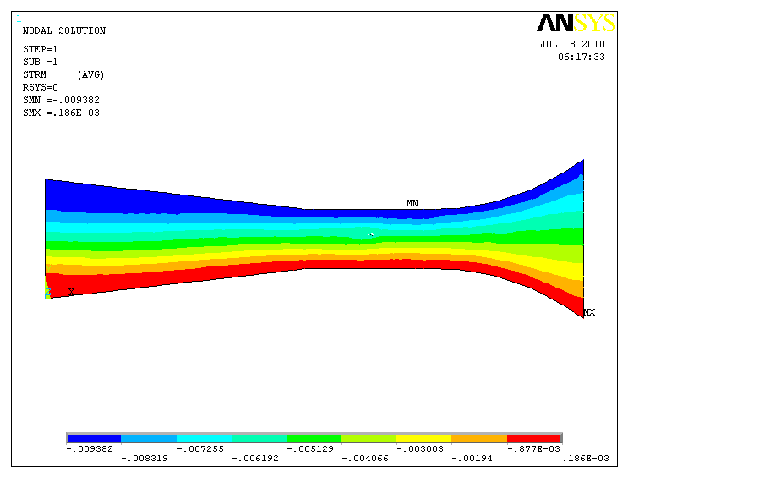

Fig.(23) Stream line distribution

Conclusions
1-In our research , the wind tunnel is manufactured and calibrated for subsonic flow .
2- Good agreement is observed for testing turbine blade specimen with complex geometry.
3- The present experimental results show good agreement with ANSYS12 results .
4- Computational fluid dynamics can be used to reduce the experimental effort (wind tunnel) which is highly expensive and take a long time to collect all the data required.

References
A Supplement to Engineered System, Nov., 2004, "Fan and Fan System Vibration", www.AMCA.org .
Abbaspour M. & M. N. Shvjee, winter, 2009. "Innovative Approach to Design a New National Low Speed Wind Tunnel". Int. J. Environ. Sci. Tech., 6(1), 23-34.
Aldruby M. I. , 1988 "Principle of Gazdynamic", 2nd edition.
ANSYS12 online help, ANSYS Manuals, 2009.
Asher H. Shapiro Vol. 1& Vol. 2, 1953" The Dynamics and Thermodynamics of Compressible Fluid Flow", (Reference Hand book).
Barlow J. B., Rea W.H and Pope A. 1999. "Low– Speed Wind Tunnel Testing” , John Wiley Inc.
Bienkiewicz B. 1996 “New Tools in Wind Engineering" J. Wind. Eng. Aerod., 65(3-1), 279-300.
Cook .N.J,1982 “Simulation Technique for Short Test – Section Wind Tunnel; Roughness , Barrier , and Mixing Device Method" , Cambridge University Press,126-136.
Kong L. & Parkinson G.V. , 1997. “A 3-D Tolerant Wind Tunnel for General Wind Engineering Test" , Proceeding of the 3rd International Colloquium on Bluff Body Aerodynamics and Applications , J. wind Eng. Ind. Aerod. , 69-71,975-985.
Nakasone Y. and Yoshimoto S. and Stolarski T.A. , 2006 "Engineering Analysis with ANSYS Software", 1st published.
Yousif A. H. ,Tlib. S. Jawad & J. A. Kadihm , 1991"Design Study of a Low Speed Wind Tunnel" , Journal of Military Eng. Collage, No.6, p.18-46.

