Feedforward Linearization of a Power Amplifier for Wireless Communication Systems

Muthana Kallil Ibrahim
College Eng. - Electrical Department / University of Babylon

Abstract
in this paper detailed simulations based on Applied Wave Research (AWR) will be introduced. This work will demonstrate the applicability of the feedforward technique to linearize the behavior of a power amplifier used in wireless communication systems. The linearized amplifier is a parametric model for AWR that takes into account actual operating characteristics of a commercial unit used for multicarrier transmission. In this paper the linearity of power amplifier will be improved, the third-order intermodulation products (IMD3) will be less than (-42dBc) and the intermodulation distortion cancellation reaches 24dB. The operation bandwidth is more than 125MHz, the carrier frequency 5.8 GHz and maximum output power is great than 30dBm.

الخلاصة
في هذا البحث سنتناول بالتفصيل محاكاة مكبر قدرة للتغذية الأمامية باستخدام Applied Wave Research ( AWR) . في هذا العمل سوف نقترح خطية الطريقة الأمامية لتحسين خطية مكبر قدرة مستخدم في أنظمة الاتصالات اللاسلكية. المكبر المحسن اخذ بنظر الاعتبار مميزات الأداء الفعلي للوحدة التجارية المستخدمة في أنظمة الإرسال المتعدد الحاملة . في هذا البحث الخطية لمكبر القدرة سوف تحسن، الدرجة الثالثة سوف يكون اقل من (-42 dBc) وإلغاء التشوه سوف يصل إلى (24dB) وعرض الحزمة الترددية هي أكثر من (125 MHZ) والتردد الحامل هو (5.8 GHZ) وأعلى قدرة خارجة هي أكثر من (30dBm).
1. Introduction
In communication systems the power amplifier is an important component and its characteristics will specify the best application of this characteristics .In each application in communication system the power amplifier must meet the requirements of that application such as (linearity, efficiency, frequency band,…etc). For example the constant envelope modulation such as (FM, FSK, MFSK, and GMSK) allows the amplifier to operate in the nonlinear region near the saturation region .In these modulation types, the amplifier introduces high efficiency and the intermodulation distortion will not appear [ Nezami Mohamed K., 2009]. These modulation types have low bit rate, therefore, more spectrally efficient linear modulations, such as QPSK and QAM must be used. The modulated signal has fluctuating envelope and phase, so intermodulation (IM) distortion will be generated in nonlinear devices, especially the power amplifier. On the other hand, IM distortion products are also generated in multicarrier configuration (CDMA and OFDM) of power amplifier at base stations [ Raab Frederick H., Senior Member, IEEE, Asbeck Peter, Fellow, IEEE, Cripps Steve, Senior Member, IEEE, Kenington Peter B., Senior Member, IEEE, Popovic´ Zoya B., Fellow, IEEE, Pothecary Nick, Member, IEEE, Sevic John F., Member, IEEE, and Sokal Nathan O., MARCH 2002, Sano Hiroaki, Matsuzaki Kenichiro, Otobe Kenji and Ohoka Mikiharu, January 2002]. Thus, it causes adjacent channel interference due to the IM distortion and spectral regrowth [Zhang Xuejun, Larson Lawrence E., and Asbeck Peter M., 2003, Gharaibeh Khaled M., and Steer Michael B., 2005, Slimane B. Slimane, 2002]. Therefore, the power amplifier is one of the key components in terms of linearization for system performance. There are two methods of realizing a linear power amplifier, namely, an amplifier with back-off operation from its 1 dB compression point and another amplifier with added linearized circuits. Several linearization approaches have been developed: The predistortion technique has the advantage of unconditional stability, but it has limited accuracy when implemented with analog technology, feedback linearization is simple but it reduces gain, and stability considerations which limit its bandwidth and accuracy. A third category, feedforward linearization, which has some distinct advantages over other techniques. Since the signals are manipulated by inherently wideband analog technology, it can handle multi-carrier signals at a mobile base station. Unfortunately, it is based on subtraction of nearly equal quantities; therefore, it is sensitive to component tolerances and drift, as well as to the change in power level when the number of carriers changes. Feedforward is the most effective and broadly used linearization technique employed in modern multicarrier and digital communication systems [Zozaya Alfonso J., Alberti Eduard Bertran, Berenguer-Sau Jordi, July 2001, Woo Young Yun, Yang Youngoo, Jaehyok Yi, Nam Joongjin, Hyeon Jeong Cha and Kim Bumman, 2002].
In this paper, the feedforward technique have been used to improve linearity of MMIC (TMD5872-2) power amplifier for 125MHz wideband digital communication systems; the third-order intermodulation product (IMD3) is measured to verify linearization. The application used in this paper is OFDM signal.

2. STRUCTURE OF THE FEEDFORWARD LINEARIZER
Fig. l shows a simplified block diagram of a feedforward system.
V_{D}
V_{ei}
V_{o}
RF output
ERROR AMP
Av
Subtractor
V_{N}
Fixed-attenuator
1/AvC
Coupler
C

r
Va
POWER AMP
Av

Delay
τ

V_{in}
RF input
Subtractor
+
-

Fig. 1 Schematic circuit of a Feedforward linearizer.
From the Fig.1, the feedforward system consists of two loops the first is called: carrier cancellation or main loop and the other is called error cancellation or error loop, each loop has some components to do certain object. The main loop is adjusted to cancel the carrier signal and introduce a sample of the distortion to the error amplifier. The coupler(C) introduce sample from the output of power amplifier to the carrier cancellation loop, the fixed attenuator minimize the output of coupler and make it equal to the input signal. The delay(τ) used to adjust the phase between the input signal and the output of power amplifier. The subtractor will subtract the two signals, therefore, the carrier will eliminate. The output of subtractor is the distortion only in ideal case, this distortion will pass through the error loop. The error loop amplifies the distortion and adjusts the phase. The error amplifier amplify. The output of the error loop(v_{D}) applied to the output subtractor to cancel the distortion. In ideal case the output
In the ideal case, error amplifier operate in the linear region (error amplifier is absolute linear). The equations of feedforward shown below

v_{a} = Avv_{in} + v_{D} ……..(1)

Av = |Av| e^{jα} : The linear gain of PA
G₁ v_{in} : Amplified version of the input signal plus a certain phase shift, α
v_{D} : Intermodulation products due to the nonlinearity of power amplifier

In the signal cancellation circuit, a fraction of the PA output signal (C₂v_{a} )/A1, with A1 real, is compared with a sample of the input C₁v_{in} , resulting in an error signal v_{ei} given by

v_{ei} = v_{N} –v_{in} ………(2)

v_{N}=(CAvv_{in} )/A_{v}C + Cv_{D} /A_{v}C ………(3)

In ideal case the error signal v_{ei} will contain only the intermodulation products.

v_{ei} = v_{D} /A_{v} ……...(4)

In order to adjust these gain and phase imbalances accurately. In a similar way, in the error canceling circuit, the error signal is amplified in error amplifier to obtain

vD = Avv_{ei} ……..(5)

where Av = |Av| e^{jβ} is the gain of the error amplifier. In a way similar to the previous case, the gain and phase of the signal v_{a} will be adjusted, before comparing it to the signal v_{o} , which is free of distortions
v_{o} = v_{a} –v_{D} ………(6)
Use equ- (1), (2), (4) and (5) in (6), the output voltage can be formed as follows:

v_{o} = Avv_{in} + v_{D} – v_{D} ……...(7)

the equation for v_{o} becomes
v_{o} = Avv_{in} ……..(8)

There are two main sources of error in the cancellation: phase error and gain error. The cancellation of the fundamental tones and the distortion products as a function of the phase error is limited by the expression:

Cancellation (dB) = …….. (9)
Where: θe is phase error
Cancellation limit as a function of amplitude error is given by:
Cancellation (dB) =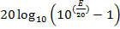 …… (10)
The variable E is the amplitude error in decibels. The cancellation in Equations 1and 2 represents the narrowband result. Assuming there is no amplitude error, the phase error required to achieve a 30 dBc cancellation is slightly less than 2°. Assuming negligible phase error, the amplitude error required for 30 dBc cancellation is 0.25 dB [William T. Thornton, and Larson Lawrence e., 1999, Cripps Steve C. 2002].

3. SIMULATION OF POWER AMPLIFIER WITH FEEDFORWARD LINEARIZATION
In the implementation of a linearized power amplifier with the Feedforward technique, we use the specifications of a typical amplifier whose characteristics are shown in table I. This amplifier is used to support four carriers but in our analysis we use only two at the frequencies 5.8 and 5.85 GHz for simulation purposes. The Feedforward Linearization circuit was analyzed and optimized for minimum IMD output.

Table I Main amplifier characteristics
Gain | 28dB
Output  Power | 34 dBm (2.5 W)
Linearity | First adjacent channel  ACLR1≤ −50 dBc  Second adjacent channel  ACLR2 ≤ −60 dBc
Efficiency | >9%, typically 10%  including DC/DC converter
Bandwidth | Any 125 MHz band within  5.7-7.2GHz, field adjustable.

The optimization variables were set to achieve the following goals: minimize the IMD levels to have power levels in the upper and lower adjacent channels close to -50dBm and 180° phase difference. The variables used for optimization are the delays of the two branches in the Feedforward Linearizer. The test used to measure the (IMD3) is the two tone test. The main amplifier is MMIC (TMD5872-2), and operates near the 1dB compression point (P1dB). The error amplifier used in this system is the same of the main amplifier to ensure that any distortion generated in the error amplifier is the same in main amplifier. The AM-AM characteristic of the main amplifier is tested using network analyzer as shown in Fig.2, in the figure the 1dB compression point at input power 7.86dBm and will note the nonlinear region begin after the 1dB compression point. When the amplifier operates back-off 10dB from P1dB, the distortion due to AM-AM is negligible.
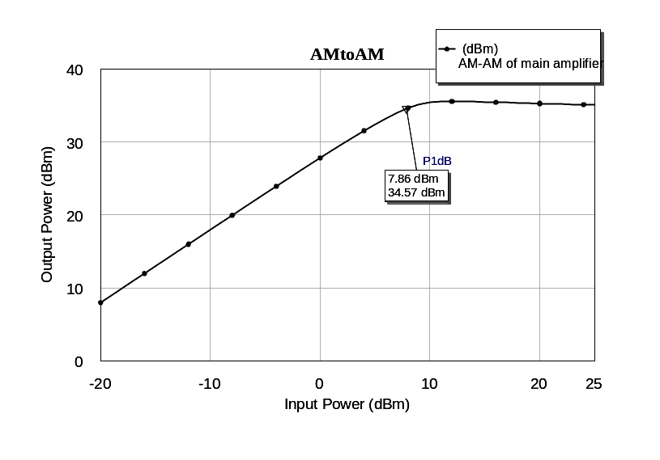
Fig.2 AM-AM characteristics of main amplifier.

The Feedforward Linearization circuit was implemented as shown in Figure.3 using a schematic circuit from AWR Design Environment ®.
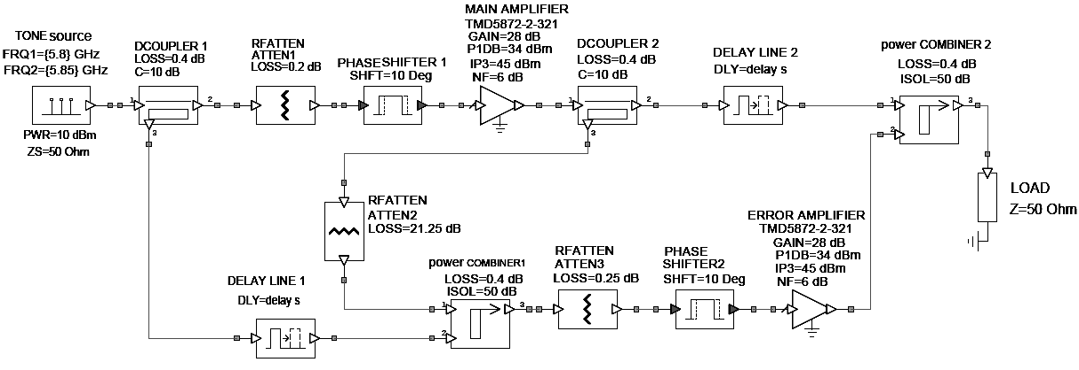 Fig. 3 AWR® implementation of the Feedforward Linearizer.
The signal error in the signal cancellation circuit is amplified by the error amplifier, and it is injected in anti-phase to the output to cancel the present IMD in the power amplifier output. The purpose of the error cancellation circuit is to suppress the distortion component of the power amplifier output signal, leaving only the linearly amplifier in the linearizer output signal. To suppress the error signal, the gain of the error amplifier is chosen to match the sum of the values of the sampling coupler, fixed attenuator, and output coupler, so the error signal is increased to approximately the same level as the distortion component of power amplifier output signal. Before the combination, the output signal of the power amplifier is delayed. The combination of the error signal with the power amplifier output signal is usually made by a directional coupler.
The sampling coupler and the fixed attenuator are chosen to match the gain of the main amplifier. Variable attenuator is included in the circuit to enable the output level to be precisely adjusted to match the input reference, while the variable phase shifter adjusts power amplifier output in an anti-phase arrangement with the input reference. The delay line in the error cancellation branch is necessary for wide bandwidth operation and compensates the group delay of the primary amplifier by the time aligning the power amplifier output and reference signal before they are combined.
4. RESULTS
The power signal flow along both branches in the Feedforward scheme is as follows. Figure.4 shows the power of the carriers along the signal cancellation circuit marked with the points 1 and 2. It can be seen that at the frequencies of 5.8 GHz and 5.85 GHz each carrier have a level of 0 dBm. In the signal cancellation circuit, the “Pup” signal is the signal that travels through the upper branch, shown in Fig.4 (a) and the “Plow” signal is the signal that travels through the lower branch, shown in Fig.4 (b).

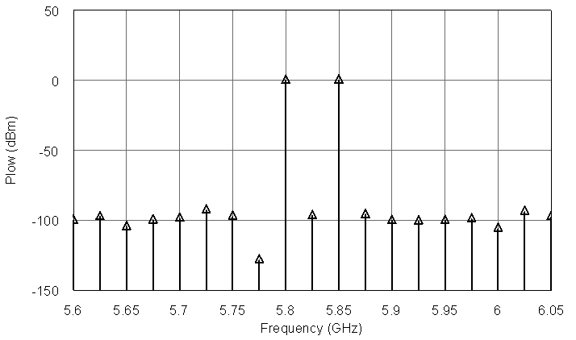
1
2
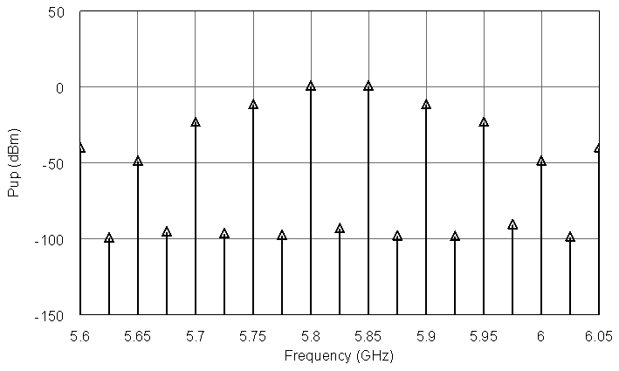
1
2
(a) (b)
Fig. 4. Signals along the cancellation loop.

In Fig.5 we observe the IMD amplitudes marked with points 1 and 2 at the frequencies 5.75 GHz and 5.9 GHz respectively will be combined and cancelled at the output power combiner. In the error cancellation circuit, the “pre-output” signal is the one that travels through the upper branch, shown in Fig.5 (a), and the “Perror” signal is the power signal provided by the error amplifier, shown in Fig.5 (b). The RF output spectrum is shown in Fig.6. We observe a decrease in IMD levels at the frequencies of 5.75 GHz (point 3) and 5.9 GHz (point 4) with powers of -50 dBm and -49 dBm respectively. We also observe the original carriers at 5.8 GHz (point 1) and 5.85 GHz (point 2) both with power levels of 30.45 dBm.

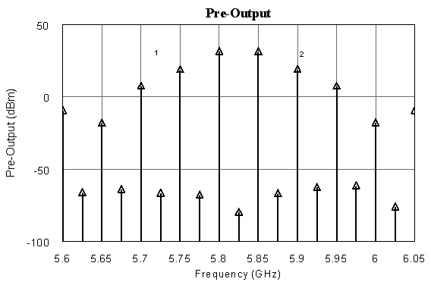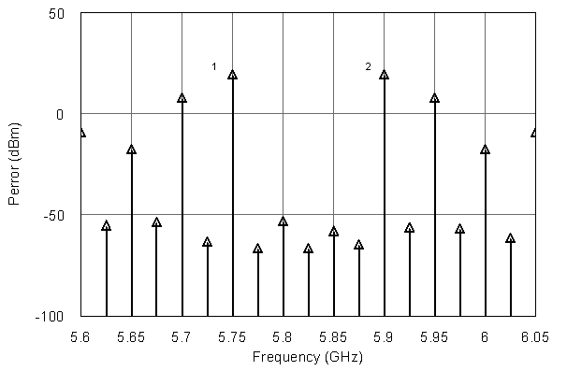
1
2
1
2
(a) (b)
Fig. 5. IMD amplitudes before the output coupler.
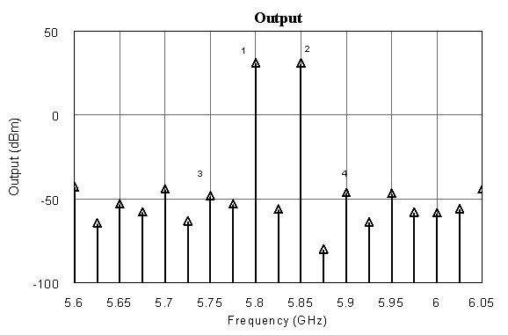
Fig. 6. RF output spectrum from the linearized.
The AM-AM characteristic of the power amplifier can be seen in Fig.7 after linearization, the feedforward linearizer improved the AM-AM curve. By comparing Fig.7 with Fig.2, the difference between them is clear.

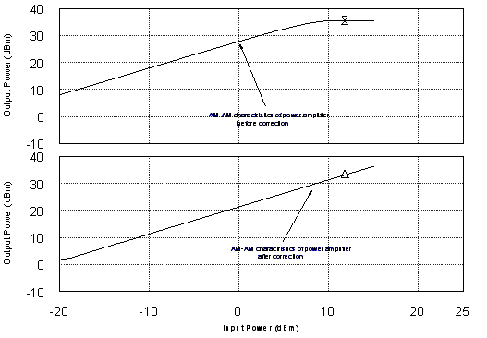
Fig. 7. AM-AM characteristic of amplifier after linearization.

4.1 OFDM Results
The source signal for simulations was an OFDM signal, similar to the DVB-T standard signal [EN ESTI Digital 2001], with the following parameters:
(i) 2K mode: 1705 active subcarriers,
(ii) Subcarrier spacing: 4.464 kHz,
(iii) Useful symbol duration: 224 microseconds,
(iv) Constellation: 16QAM.
The modulated OFDM signal during a symbol can be expressed as follows:
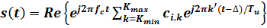 …………… (11)
with k' = k − (K_{max} + K_{min})/2. Tu is the inverse of the carrier spacing, _ is the duration of the guard interval, k denotes the carrier number, fc is the central frequency of the RF signal, and c_{i,k} is a complex symbol for the carrier k. There is a clear resemblance between (11) and the inverse Discrete Fourier Transform (DFT). Since various efficient Fast Fourier Transform algorithms exist to perform the DFT and its inverse, it is a convenient form of implementation to use the inverse FFT (IFFT) in a DVB-T modulator to generate N samples corresponding to the useful part, Tu long, of each symbol. The guard interval is added by taking copies of the last NΔ/Tu of these samples and appending them in front. This process is then repeated for each symbol in turn, producing a continuous stream of samples, which constitutes a complex baseband representation of the DVBT signal. A subsequent up-conversion process then gives the real signal s(t) centered on the frequency, fc.
The amplifier is characterized by a complex gain, which depends on the input signal level. The amplifier complex gain is extracted from AM-AM and AM-PM characteristics of a MMIC (TMD5872-2) amplifier. This design is simulated, by means of Microwave Office.
4.2. Transmit Signal Power Spectrum Performance.
Figure 9 shows the normalized power spectral density (PSD) of the output power amplifier signal with and without the proposed correction method. The interference measurement at a 35.4MHz frequency offset without correction is around –20 dBc, but applying the proposed method an interference measurement less than –70 dBc. Simulation conditions are a 1 dB amplitude imbalance and a 3◦ phase imbalance between circuit elements (corresponding to all couplers of the two loops) and 2Watts output mean power, for a 16-QAM modulated OFDM input signal.
Fig.8(a) show the normalized input signal spectrum and Fig.8(b) show the normalized output power spectrum of power amplifier before linearization. The output of power amplifier is distorted due to the nonlinear behavior of power amplifier, after using the feedforward linearizer the behavior of power amplifier was improved and the distortion decreased to very low level.
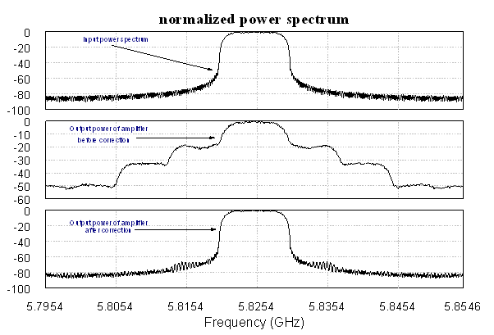
(a)
(b)
Fig.8 (a) Normalized input signal spectrum, (b) Normalized output spectrum of power amplifier before improvement
From the Fig.9 the IMD approximately removed from the output spectrum. This paper show the ability of feedforward linearizer to improve the linearity of power amplifier and
remove the most distortion

Fig.9 : Normalized output spectrum of power amplifier after improvement

4.3. Error Vector Magnitude. The Error Vector Magnitude
(EVM) is another important measurement in digital communication systems, which is more focused on modulation quality and performed on the received signal. EVM is defined in [ETSI TR 2001]\

as
, …………. (12)
where I and Q are the ideal coordinates of the constellation points, δI and δQ are the errors at the received points, N is the number of received points of the constellation, and Smax is the magnitude of the vector to the outermost state of the constellation. The difference between the position of the jth received symbol and the ideal one is the cause of nonnull values of δI, δQ, and EVM.
The 16-QAM received signal constellation without and with the correction method for the proposed FeedForward scheme is depicted in Figure 10(a) and Figure 10(b), respectively. The calculated EVM improves after the proposed linearization method is applied (EVM≈6.7% without and EVM≈2% with the proposed correction method).
(a) (b)
Figure 10: Received signal constellation diagram (normalized): (a) without and (b) with the proposed linearization method.

5. CONCLUSIONS
In this paper the linear power amplifier with feedforward linearizer without any automatic adaptive control circuits was simulated to demonstrate the effectiveness of this approach. The results presented here show that great reduction in the distortion levels can be obtained and it is expected that wide bandwidth can also be achieved making this linearization technique an excellent candidate for use in multicarrier wireless communication systems. But this approach has disadvantage, it is sensitive to component tolerances and drift, as well as to the change in power level when the number of carriers changes. To overcome this disadvantage, the vector modulator can be used instead of the attenuator and phase shifter to introduce variable attenuation and phase shifting. The vector modulator readjust the level and phase of signal to the adjusted value if any change happen in power level or frequency. Another adaptation of feedforward linearizer by use DSP to monitor the change in parameters of circuit and adjust the level and phase of signal by changing the value of attenuator and phase shifter.
Refrences
Cripps Steve C. 2002“ Advanced Techniques in RF Power Amplifier Design”. Norwood: ARTECH HOUSE, INC.
EN ESTI Digital 2001 “Framing structure, channel coding and modulation for digital terrestrial television,” v1.4.1.
ETSI TR 2001,“Measurement Guidelines for DVB Systems,” v. 1.2.1.
Gharaibeh Khaled M., and Steer Michael B., 2005” Modeling Distortion in Multichannel Communication Systems” IEEE transactions on microwave theory and techniques, vol. 53, no. 5, pp.1682-1692.
Nezami Mohamed K., 2009 "Feedforward Power Amplifier Linearization for 4G Basestation "Proceedings of the IEEE 9th Malaysia International Conference on Communications 15 -17, Kuala Lumpur Malaysia.
Raab Frederick H., Senior Member, IEEE, Asbeck Peter, Fellow, IEEE, Cripps Steve, Senior Member, IEEE, Kenington Peter B., Senior Member, IEEE, Popovic´ Zoya B., Fellow, IEEE, Pothecary Nick, Member, IEEE, Sevic John F., Member, IEEE, and Sokal Nathan O., MARCH 2002 "Power Amplifiers and Transmitters for RF and Microwave " IEEE transactions on microwave theory and techniques, vol. 50, no. 3,
Sano Hiroaki, Matsuzaki Kenichiro, Otobe Kenji and Ohoka Mikiharu, January 2002 "Development of a Power Amplifier Module for W-CDMA Base Stations" sei technical review. Number 53 ·
Slimane B. Slimane, 2002 “Peak-to-Average Power Ratio Reduction of OFDM Signals using Broadband Pulse Shaping” Vehicular Technology Conference, 2002. Proceedings. VTC 2002-Fall. 2002 IEEE 56th, VOL.2, pp.889-893, 24-28.
William T. Thornton, and Larson Lawrence e., 1999 “An improved 5.7 GHz ISM-band feedforward amplifier utilizing vector modulators for phase and attenuation control”©Horizon House Publications, Inc.
Woo Young Yun, Yang Youngoo, Jaehyok Yi, Nam Joongjin, Hyeon Jeong Cha and Kim Bumman, 2002” Feedforward Amplifier for WCDMA Base Stations with a New Adaptive Control Method” Microwave Symposium Digest, IEEE MTT-S International, Seattle, WA, p.p. 769-772.
Zhang Xuejun, Larson Lawrence E., and Asbeck Peter M., 2003 “Design of Linear RF Outphasing Power Amplifiers”. Norwood.
Zozaya Alfonso J.,Alberti Eduard Bertran, Berenguer-Sau Jordi, July 2001 ”Adaptive Feedforward Amplifier Linearizer Using Analog Circuitry”, Microwave Journal, Vol. 4, pp. 102-114.

