Evaluation of Reliability for Sulaimania Distribution Network

Asso Raouf Majeed, IEEE member Abdulrahman M. Rashed,
Electrical Engineering Department Electrical Eng.
Sulaimania University Sulaimania Technical Institute
drassomajeed@hotmail.com meer57@hotmail.com
Abstract
An effective reliability program for assessment and planning distribution networks is impossible without the collection, recording, analysis of the data and information obtained through the testing and operation of the different equipments and elements of the distribution system, as well as without the recording, retrieval, and use of information gained through experience with all manner of components, systems, machines, environments user stresses, and human errors.
The main objective of this paper is to study the different outages of the feeders of five main substations in Sulaimania City, namely Rizgari, Malkandy, Shaheed, Industrial, and Azmar.
Data were collected for five years , these data are classified and analyzed in order to calculate the most important reliability indices, such as $μ,λ,u,A,R,Q\text{.}\text{.}\text{.}\text{.}\text{.}\text{.}\text{.}\text{etc}$ for the different distribution feeders and reliability indices concerned substations such as SAIFI, SAIDI, CAIDI, …..etc. Data collection methodology is suggested, so that to establish a reliability data base system, for facilitating of achievement reliability studies.
الخلاصة:
أن أعداد برنامج فعال للوثوقية لغرض تقييم و تخطيط شبكات التوزيع غير ممكن بدون جمع و تسجيل وتحليل كافة البيانات والمعلومات التي يتم الحصول عليها خلال أختبار و تشغيل مختلف الأجهزة و مكونات منظومة التوزيع , بالأضافة الى تسجيل وأعادة البيانات والمعلومات التي يتم الحصول عليها من الخبرة الميدانية المتعلقة بالأجهزة والمكائن والمنظومات وحتى حوادث الخطأ الناتج بسبب المشغلين.
ان الغاية الأساسية لهذا البحث هو دراسة مختلف التوقفات الخاصة بالمغذيات لخمس محطات توزيع ثانوية في مدينة السليمانية وهي محطات رزكاري, ملكندي, شهيد, الصناعية, و أزمر.
تم جمع المعلومات في هذه المحطات لفترة خمس سنوات. وثم تم تصنيف و تحليل هذه المعلومات لغرض أحتساب أهم المؤشرات الوثوقية كال( $μ,λ,u,A,R,Q\text{.}\text{.}\text{.}\text{.}\text{.}\text{.}\text{.}$) والخاصة بمغذيات التوزيع , و كذلك مؤشرات الوثوقية المتعلقة بالمحطات الثانوية كال(SAIFI, SAIDI, CAIDI) .
تم أقتراح منهجية خاصة بجمع البيانات لغرض تأسيس منظومة قاعدة بيانات لأنجاز دراسات الوثوقية.
NOTATION
A availability
R reliability
U unavailability

λi failure rate of element i
μi repair rate of element i
fi frequency of element i
Pi probability of element i
unit number i is down
Subscript S denotes to scheduled
Subscript F denotes to force
NOMENCLATURE [J. Endrenyi, 1980 ]:
Availability:” The proportion of time, in the long run, that is in, or ready for, service”.

Reliability:” The probability of a device or system performing its function adequately for the period of time intended under the operating conditions intended”.

Forced outage: “an outage result from emergency conditions directly associated with component or unit requiring that unit be taken out of service immediately, either automatically or as soon as switching operations can be preformed”.

Scheduled outage: “an outage that results when unit is deliberately taken out of service at selected time, usually for

purpose of construction, preventive maintenance, repair, or reserve”.

SAIFI : System Average Interruption Frequency Index ; SAIFI = Σ Ni . λi / Σ Ni
SAIDI: System Average Interruption Duration Index ; SAIDI = Σ Ui Ni / Σ Ni
CAIDI: Customer Average Interruption Duration Index ; CAIDI = Σ Ui Ni / Σ Ni. λi

- Introduction
The Medium Voltage 11 KV network is considered as the backbone of the distribution system. A unique feature of the MV network is that it extends to every geographic locations of the system . Sulaimania Governorate is divided into Five regions fig.(1), each of these regions has its domestic. and non-domestic. demand, per-household consumption and its own electrification level Table (1).The growth rate estimation of the consumers are given in Table (2). it indicates an increase of about 3.5%[Y. H. Kareem, and A. R. Majeed, 2006 ] [ Mohamed A. Hussein, 2009] .
Table (3) shows information about losses, Voltage levels and general information of the different 11 kv feeders for Rizgari substation. Most of the problems that can be notices from the collected data about the distribution system are noted below:

- Considerable number of feeders outside the city areas are affected by Poor voltage level.In some feeder the voltage drop during the peak demand is about 20 – 30 % .
- Inadequate capacity of existing substations and lines . There is no Adequate capacity in the network to meet the present and futures demands.
- Most of the existing 132 kv and 33kv substations are loaded by the firm capacity levels and some are in fact over loaded .
- Conductors of distribution lines have been fully loaded and some sections are over loaded .
- Poor Reliability of 33 kv supply to 33/11 substation and for conductors of distribution lines. Poor voltage levels below the allowable limits .
- Some of the 11 kv feeders are having excessive feeding lengths . This has caused high level of losses in these feeders . power losses in some of the feeders are as high as 15-20%
- There is no proper system available for assessment and monitoring of technical and non – technical losses in the system .
- No efforts have been made to educate the consumers to curtail of wastage of electrical energy .
- There are no schemes available to encourage efficient use of electricity and to introduce Demand –Side management measures .

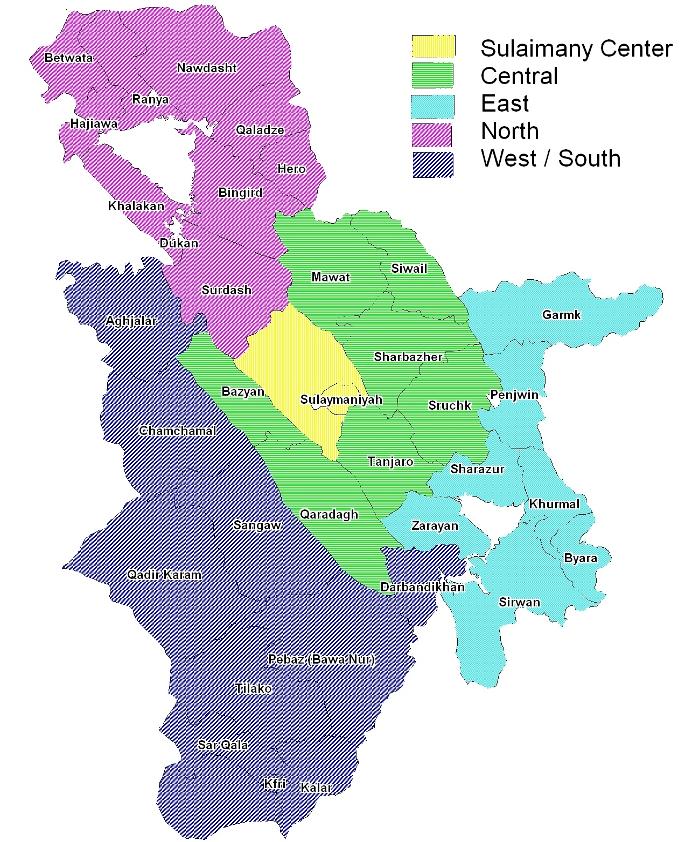

Fig. ( 1 ) Regions of Sulaimania Governorates.

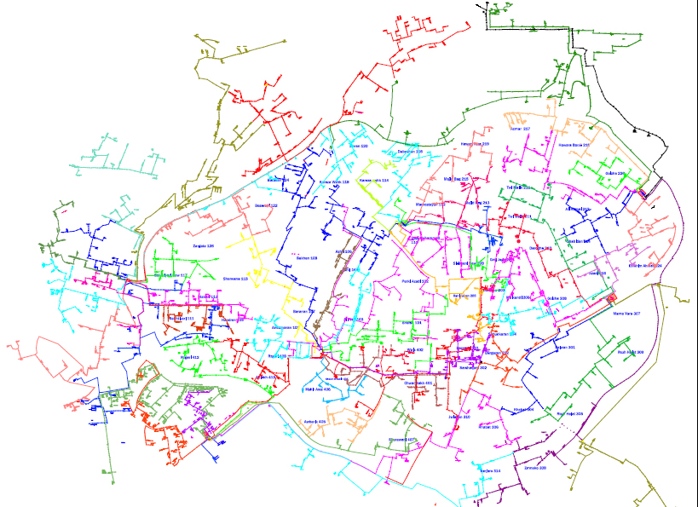

Fig. (2 ) Sulaimania city distribution Network

Table (1) Electricity Demand in Sulaimania Governorate
Demand  % | Demand / consumer  kw/ con | Total Demand  MVA | Bulk  Demand  MVA | Domestic  Demand  MVA | Num. of  Consumer | Num. of  Substation | Region
62% | 1.7 | 237.3 | 61.1 | 176.2 | 86,714 | 10 | Sulaimania center
9% | 1.4 | 33.7 | 5.4 | 28.3 | 17,018 | 04 | central
4% | 0.9 | 14.6 | 2.2 | 12.4 | 12,207 | 02 | East
12% | 0.8 | 44.6 | 16.8 | 27.8 | 20,840 | 06 | North
13% | 1.0 | 51.0 | 7.0 | 44.0 | 35,678 | 05 | west/south
100% | 1.4 | 381.2 | 92.5 | 288.7 | 181,457 | 27 | Total

Table (2) Consumer Growth rates
% 2020 - 2015 | % 2015 - 2010 | % 2010 - 2005 | Region
3.7 | 4.1 | 4.3 | Sulaimania center
2.7 | 2.9 | 2.9 | Central
2.7 | 2.9 | 2.9 | East
3.1 | 3.2 | 3.6 | North
3.1 | 3.2 | 3.5 | West /south
% 3.3 | % 3.5 | % 3.6 | Total

Table (3) ; Technical Information, Loading and Losses in the 11 kV Feeders of Sulaimania Substations.
Q.Total Loss (KVAR) | Power Total Losses (kw) | Q. Total Dement MVAR | P. Total Demand MW | Conductor Km | % Line loading | Feeder Name | Substation | No.
185 | 140 | 2.8066 | 4.3669 | 3.792 | 104 | F-1 | Rzgari S/S | 1
76 | 57 | 2.5549 | 4.0553 | 7.425 | 97 | F-2 | Rzgari S/S | 1
103 | 76.8 | 2.7636 | 4.3693 | 4.404 | 104 | F-6 | Rzgari S/S | 1
73.7 | 55.3 | 2.955 | 4.7027 | 5.137 | 112 | F-9 | Rzgari S/S | 1
92 | 69 | 2.1468 | 3.3833 | 4.656 | 80 | F-10 | Rzgari S/S | 1
77.3 | 58 | 2.4434 | 3.8744 | 3.542 | 92 | F-11 | Rzgari S/S | 1
76.7 | 57.6 | 2.4448 | 3.8771 | 4.158 | 92 | F-18 | Shaheed S/S | 2
60 | 90 | 1.0018 | 3.2684 | 4.946 | 78 | F-23 | Shaheed S/S | 2
80 | 60 | 1.9041 | 3.0022 | 7.552 | 71 | F-27 | Shaheed S/S | 2
123 | 92.3 | 2.5037 | 3.9322 | 4.211 | 94 | F-33 | Malkandi S/S | 3
101 | 76 | 2.5924 | 4.0938 | 4.457 | 97 | F-34 | Malkandi S/S | 3
86 | 64.5 | 2.4851 | 3.9341 | 3.515 | 94 | F-35 | Malkandi S/S | 3
139 | 104 | 2.8136 | 4.4185 | 4.182 | 105 | F-36 | Malkandi S/S | 3
97.41 | 73.13 | 2.7811 | 4.4016 | 3.293 | 105 | F-38 | Malkandi S/S | 3
248 | 187 | 2.1839 | 3.3085 | 7.095 | 79 | F-42 | Azmer S/S | 4
71.2 | 53.47 | 2.2342 | 3.5421 | 4.239 | 84 | F-48 | Azmer S/S | 4
93.7 | 70.34 | 1.6938 | 2.6511 | 4.978 | 63 | F-52 | Industry S/S | 5
135 | 102 | 1.2817 | 2.7541 | 7.857 | 65 | F-54 | Industry S/S | 5
209 | 157 | 2.7851 | 4.3122 | 4.414 | 102 | F-55 | Industry S/S | 5
80 | 60 | 2.1147 | 3.3425 | 3.519 | 80 | F-56 | Industry S/S | 5
109 | 81.5 | 2.5645 | 4.0427 | 7.565 | 96 | F-58 | Industry S/S | 5
118 | 84 | 2.6516 | 4.1804 | 3.434 | 100 | F-61 | Azadi S/S | 6

- Data collection and system failures:
For the purpose of achievement a comprehensive assessment of the performance of the distribution network the daily registered data for five substations in the main city of Sulaimania were collected for five years. The data classified for forced outages and programmed outages as shown in fig. (3). Then these are analyzed in order to find the main reliability indices for the different feeders and substations as clarified in the flowchart of fig. (4).
Fig.( 3 ) Failure Classification

Fig. ( 4 ) Flowchart for data collection Procedure and evaluation of reliability indices.

- Case study
We consider Rizgari substation as a case study for the purpose of reliability evaluation of the substations and feeders , since it is considered one of the most important substations that supply the city center.
The schematic diagram of Rizgari substation is shown fig. (5). Reliability block diagram is given in fig. (6).
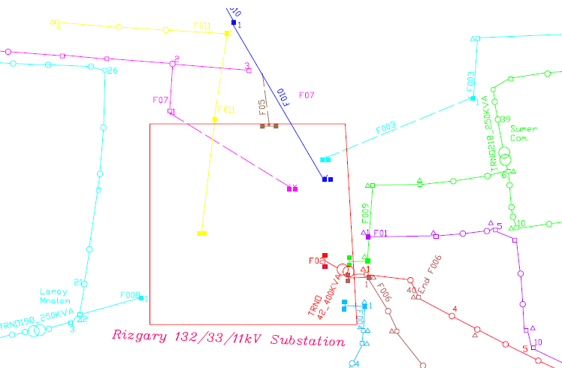

Fig. (5) single line diagram of 132/33/11 KV Rizgari Substation.

Fig. (6) Rizgari Substation reliability block diagram

Table (4) gives frequency and duration of the outages for the different feeders of Rizgari Substation and for five years, From these information reliability indices such as mean time to failure MTTF, mean time to repair MTTR, Availability ,Reliability , …etc , are calculated [R. Billinton, 1982] ,[ R. Billinton, R. N. Allan, 1991], [R. Billinton, and R. N. Allan , 1984], [J. E. Biegel ,1971] and [Roy Billinton and Satish Jonnavithulla, 1999], see table (5)

Table(4) Frequency and Duration of Rzgari Substation Feeders for Five Years

F3-3(10) |  | F3-2(9) |  | F3-1(8) |  | F2-3(6) |  | F2-2(5) |  | F2-1(4) |  | F1-3(3) |  | F1-2(2) |  | F1-1 (1)
Dr | Fr | Dr | Fr | Dr | Fr | Dr | Fr | Dr | Fr | Dr | Fr | Dr | Fr | Dr | Fr | Dr | Fr
0.73 | 23 | 0.53 | 23 | 0.53 | 23 | 1.35 | 50 | 1.74 | 48 | 1.14 | 30 | 3.33 | 64 | 0.83 | 69 | 1.78 | 59
21.3 | 372 | 16.6 | 296 | 19.6 | 320 | 17 | 316 | 24.7 | 427 | 18.8 | 309 | 26 | 430 | 5.85 | 196 | 24.7 | 399
1.8 | 58 | 1.1 | 38 | 0.6 | 20 | 0.57 | 25 | 0.73 | 43 | 0.73 | 27 | 1.7 | 66 | 3.73 | 108 | 1.74 | 67
0.11 | 6 | 0.21 | 22 | 0.28 | 14 | 0 | 10 | 0.27 | 10 | 0.22 | 16 | 0.58 | 30 | 5.5 | 208 | 0.96 | 49
0.32 | 13 | 0.03 | 5 | 0.02 | 4 | 0.9 | 5 | 0.32 | 19 | 0.08 | 8 | 1.43 | 32 | 4.02 | 121 | 0.89 | 40
Table (5) Feeder Reliability Indices of Rzgari Substation for Period of One Year
Freq. of interrupt | Un reliability | Reliability | Repair rate | Failure rate | Un availability | Availability | MTTR | MTTF | Total (Td) (days) | Total Ts ( days) | Feeder No
67 | 0.16843 | 0.831569 | 38.5057 | 0.18444 | 0.0048 | 0.9952329 | 0.025597 | 5.422 | 1.74 | 363.26 | Fdr 1-1
108 | 0.2584 | 0.7416 | 28.9544 | 0.29894 | 0.01022 | 0.98978 | 0.034555 | 3.345 | 3.73 | 361.27 | Fdr 1-2
66 | 0.1661223 | 0.833878 | 38.8235 | 0.181668 | 0.00466 | 0.995342 | 0.025575 | 5.505 | 1.7 | 363.3 | Fdr 1-3
27 | 0.0714405 | 0.928559 | 36.989 | 0.074108 | 0.00199 | 0.9980000 | 0.027037 | 13.49 | 0.73 | 364.27 | Fdr 2-1
43 | 0.1113433 | 0.888656 | 58.9041 | 0.118044 | 0.00199 | 0.998 | 0.016976 | 8.471 | 0.73 | 364.27 | Fdr 2-2
25 | 0.0663 | 0.933698 | 43.8596 | 0.0686 | 0.00156 | 0.998438 | 0.0228 | 14.57 | 0.57 | 364.43 | Fdr 2-3
20 | 0.053405 | 0.946594 | 33.3333 | 0.054488 | 0.0016 | 0.998356 | 0.03 | 18.22 | 0.6 | 364.4 | Fdr 3-1
38 | 0.0991569 | 0.900843 | 34.54546 | 0.10442 | 0.003013 | 0.996986 | 0.02894 | 9.576 | 1.1 | 363.9 | Fdr 3-2
58 | 0.147593 | 0.852406 | 32.2222 | 0.15969 | 0.0049 | 0.995068 | 0.310344 | 6.262 | 1.8 | 363.2 | Fdr 3-3

In table (6) Reliability at the bus bars is calculated in general for two type substations ; one of them has two sectional bus bars and the other has three sectional bus bars as in fig. (6) . It is clear that bus bars of the second type is more reliable for different assumed component reliabilities. Generally system reliability increases with increasing the component reliabilities see fig, (7).
Table (6) Reliability of Substation Bus bars of two different structures

Substation with three Sectional Bus bars |  | Substation with two sectional Bus bar | Component Reliability
Bus bar Section 2 Reliability | Bus bar Sections 1&3 Reliability | Bus bar Reliability | Component Reliability
0.9963902 | 0.98829 | 0.981 | 0.9
0.9981172 | 0.9926957 | 0.9877121 | 0.92
0.9991871 | 0.9960061 | 0.9930161 | 0.94
0.9995246 | 0.997284 | 0.995125 | 0.95
0.9997542 | 0.9982795 | 0.996839 | 0.96
0.9998951 | 0.9990485 | 0.9982271 | 0.97
0.9999688 | 0.9995846 | 0.9992081 | 0.98
0.9999994 | 0.9999748 | 0.9999501 | 0.995
0.99999985 | 0.999991 | 0.9999821 | 0.997
0.9999999 | 0.9999959 | 0.9999919 | 0.998
0.99999995 | 0.999999 | 0.999998 | 0.999
0.99999999 | 0.9999997 | 0.9999994 | 0.9995
1 | 0.9999999 | 1 | 0.9999
Fig. (7 ) Relationship Between Component Reliability & Reliability at Bus bars.

Reliability of the feeders at the end load point
The Reliability at load point for the different feeders for the five substations in side the city of Sulaimania is calculated and plotted as shown in the figures (8), …(12)
1st yr 2nd yr 3rd yr 4th yr 5th yr

Fig. ( 8 ) Industrial substation reliability load point for different feeders

1st yr 2nd yr 3rd yr 4th yr 5th yr
Fig. ( 9) Azmar substation reliability load point for different feeders

1st yr 2nd yr 3rd yr 4th yr 5th yr

Fig. (10 ) Malkandy substation reliability load point for different feeders

1st yr 2nd yr 3rd yr 4th yr 5th yr

Fig. ( 11) Shaheed substation reliability load point for different feeders

1st yr 2nd yr 3rd yr 4th yr 5th yr
Fig. ( 12) Rizgari substation reliability load point for different feeders

V: Reliability distribution indices of Rizgari Substation
In the field of distribution systems other indices are normally used such as SAIFI ( System Average Interruption Frequency Index) , SAIDI (System Average Interruption Duration Index ) and CAIDI “Customer Average Interruption Duration Index” and these are calculated from the reliability data given in table ( 5 )

1st yr 2nd yr 3rd yr 4th yr 5th yr

Fig. (13) Rzgari Substation Reliability Indices for five years

VI: General Discussion and Conclusions:
Reliability study and evaluation is an important part of electric power distribution network analysis .By a detailed reliability index analysis, the weak points in system design can be detected and ways for their corrections can be determined.
In this study we conclude the following:
- Most of the interruptions and weak points in distribution system of Rzgari substation and its network is in the over head lines, this is due to (Network ages, Excessive of feeder length, Over load, Improper distribution of load among the feeders, no proper and regular maintenance.
- The reliability and availability for the overhead feed decreased due to respectively high number of interruptions or failure rates.
- Reliability can be improved due to the structural design of the substation i.e. substation with three sectional bus bars more reliable than that of the two sectional bus bar arrangements. This is because of reduced rate of failure and reduced mean outage time in case of failures or in case of scheduled outages.
- Reliability of the whole distribution network were poor during the second year of the study because of the high rate of failures in the network. In the third year the system is improved by maintaining the system and the reliability improved and stabled during the fourth and fifth year of the study.

.As a summary of the result of the work it is found that the reliability and availability of the outgoing feeder increased, when:
1. The reliability of the electrical components is increased.
2. Choosing the suitable design structure for the substation.
3. The location of the load point near the feeding source points.
4. Decreasing the repair time by providing qualified repairing teams, with sufficient tools and spare parts.

VII. References
J. E. Biegel, 1977, “ Determination of Tie Sets and Cut Sets for a System Without Feedback ”, IEEE Transactions on Reliability, Vol. R-26, No.1,
J. Endrenyi, 1980., Reliability Modeling in Electric Power systems, A Wiley& Sons,
Mohamed A. Hussein, 2009, Technical Evaluation and Planning of Sulaimania Distribution Systems by Using GIS, MSc. Thesis
Roy Billinton, 1982, Power System Reliability Evaluation, Gordan and Breach Science Publishers, Seventh
R. Billinton, R. N. Allan, and L. salvaderi (editors), 1991, “Applied Reliability Assessment in Electrical Power Systems”, IEEE press, New York, NY,
R. Billinton, and R. N. Allan , 1984. “ Reliability Evaluation of Power Systems ” , Pitman Advanced
Roy Billinton and Satish Jonnavithulla, 1999 March, “Calculation of Frequency, Duration, and Availability Indexes in Complex Networks”, IEEE Trans. on Reliability, vol. 48, no. 1, pp. 25-30.
Y. H. Kareem, and A. R. Majeed , 2006 ,” Monthly Peak-load Demand Forecasting for Sulaimany Governorate Using SARIMA”, IEEE PES Transmission and Distribution Conference and Exposition Latin America, Venezuela.

