Estimation of an EEG highest predictive channel for mental tasks

AbdulSattar M. Khidhir | Diaa M. Faris
Foundation of technical education | Foundation of technical education
Mosul Technical Institute | Technical college of Mosul
Shaima Miqdad mohamad Najeeb
Bachelor of computer engineering
Foundation of technical education
Technical college of Mosul
Abstract
This paper proposed a way for estimating the highest predictive EEG channel for mental tasks (mathematics, relax and character recognition).The energy of un-mixing matrix (W) that is evaluated by applying Fast Independent Component Analysis FASTICA algorithm is used with no further processing. The highest predictive channel that discriminate between mental tasks for the same conditions is obtained. A 100% prediction of the mental task is obtained when using these channels.
الملخص
يقوم البحث باقتراح طريقة لتقدير القناة التنبؤية الأعلى للأشارة الدماغية EEG للمهام الذهنية (الحساب, الراحة, تمييز الحروف)عن طريق حساب طاقة مصفوفة الفصل (w) الناتجة عن تطبيق خوارزمية التحليل السريع للمركبات غير المعتمدة(FASTICA) استخدمت بدون معالجة اخرى.
1. Introduction
EEG obtained from scalp electrodes is a sum of large number of neurons potentials. The interest is in studying the potentials in the sources inside the brain and not only the potentials on the scalp, which globally describe the brain activity. Direct measurements from the different centers in the brain require placing electrodes inside the head, which means surgery. This is not acceptable because of the risk for the subject. Another possibility is to calculate the signals of interest from the EEG obtained on the scalp. These signals are weighed sums of the neurons activity, the weights depending on the signal path from the brain cell to the electrodes. Because the same potential is recorded from more than one electrode, the signals from the electrodes are supposed to be highly correlated. If the weights were known, the potentials in the sources could be computed from a sufficient number of electrode signals. Independent component analysis (ICA), sometimes referred to as blind signal separation or blind source separation, is a mathematical tool that can help solving the problem [Ungureanu04].
According to past experiences with mental task classification, it was observed that for each subject and especial set of mental tasks, less number of EEG channels can have nearly the same classification accuracy as that acquired by 19channels together [Kouhyar 03]. If a small number of mental states can be reliably classified, then a person could compose sequences of such states to indicate commands to a computer, just as letters are composed to form words.
The growing field of BCI research is still in its infancy; the current BCI systems are designed mainly to enable severely motor disabled patients to communicate through thoughts alone and no BCI system has become commercially available. However, this technology might become one day a revolutionary communication channel enabling users to control computer applications and devices.
So far the accuracy of classification has been one of the main pitfalls of the current mental task BCI systems. Enhancing the accuracy may be achieved through improvements in the three main stages of the mental task BCI, namely, the EEG preprocessing, the feature extraction and the techniques used for feature classification.
Many feature extraction techniques were proposed based on either frequency or non-frequency domain information. Distinguishing features are still buried in the data and the request of the best techniques to extract information from EEG signals with which can discriminate mental states is still going on.
Some method is proposed to reduce the number of EEG channels needed to classify mental tasks. By applying genetic algorithm to the search space consisting of 6 channel combinations of 19 EEG channels the more salient combinations of them in classification of three mental tasks are selected [Kouhyar 03].other method for EEG preprocessing based on Independent Component Analysis (ICA) was proposed and three different feature extraction techniques were compared: Parametric Autoregressive (AR)modeling, AR spectral analysis and power differences between four frequency bands. The best classification accuracy was approximately 70% using the parametric AR model representation with almost 5% improvement of accuracy over unprocessed data [Sarah12].
Work reported in this paper is related to a project initiated in Purdue University by Keirn and Aunon[Keirn1990], and extended later by Charles Anderson [Anderson1995, Charles1996, Anderson1997]. In their study, Keirn and Aunon investigated the use of five different mental tasks as a new mode for communication between man and computer, the tasks were: baseline task, mental multiplication, geometric figure rotation, mental letter composing, and visual counting. These tasks were chosen to invoke hemispheric brainwave asymmetry [Keirn1990] as such,Keirn and Aunon proposed that these tasks are suitable for brain-computer interfacing.
Data were recorded for 10 seconds during each task and each task was repeated five times per session. Subjects attended two sessions recorded on separate weeks, resulting in a total of ten trials for each task. With a 250 Hz sampling rate, each 10 second trial produces 2,500 samples per channel. All channels were concatenated including the EOG channel as rows of a matrix [Charles1996].
The data were recorded using six recording channels (electrodes) (Fig. 1).below from four subjects performing the five mental tasks. The recordings of mental tasks were conducted for several 10 seconds trials. Only eye blink free data segments were used to avoid spikes and noise.

Figure (1) electrodes topology on the head

This paper proposes a way for finding highest predictive EEG channel for mental tasks classification by using independent component analysis ICA. The ICA calculates the un-mixing matrix for extracting sources from the EEG channels. The proposed method suggests using the un-mixing matrix weights energy of each channel to know the highest predictive EEG channel for mental tasks classification.
2. Independent component analysis (ICA)
The ICA method is based on the following principle (Fig. 2). Assuming that the original (or source) signals have been linearly mixed, and that these mixed signals are available, ICA recognizes in a blind manner a linear combination of the mixed signals, and recovers the original source signals, possibly re-scaled and randomly arranged in the outputs.
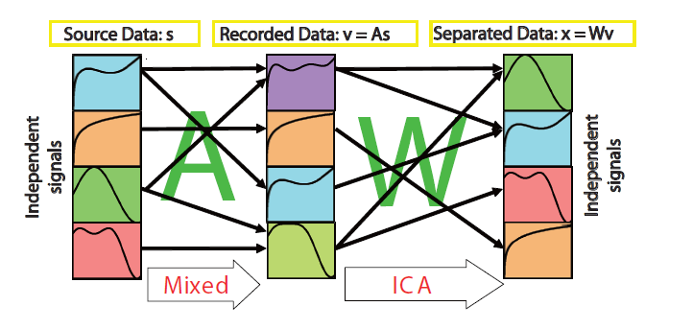

Figure (2) the principles of ICA

The s = [s₁, s₂, · · · ,s_{n}]^{T} means n independent signals from mutual EEG sources in the brain, for example. The mixed signals x are thus given by x=A*s, where A is an n×n invertible matrix. A is the matrix for mixing independent signals. In the ICA method, only x is observed. The value for s is calculated by s = W*x (W = A⁻¹). However, it is impossible to calculate A⁻¹ algebraically because information for A and s are not already known. Therefore, in the ICA algorithm, W is estimated non-algebraically. The assumption of the ICA algorithm is that s is mutually independent. In order to calculate W, different cost functions are used in the literature, usually involving anon-linearity that shapes the probability density function of the source signals [Anagahora08].

2.1. Fast ICA for n units
A unit represents a processing element, for example an artificial neuron with its weights W. To estimate several independent components, the w₁, w₂, w₃, …,w_{m} weights must be determined. The problem is that the outputs must be done as independent as possible after each iteration in order to avoid the convergence to the same maxima. One method is to estimate the independent components one by one [Ungureanu04].
Algorithms:
i) Initialize w_{i}
ii) Newton phase
Where g is a function with one of the following form:
g₁(y)=tanh(a₁y), g₂(y)=y*exp(-0.5y²),g₃(y)=4y³.
iii) Normalization
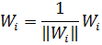

iv) Decorrelation
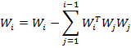
v) Normalization (like in the step(iii))
vi) Go to step(ii) if not converged. Convergence means that the old and new values of w point in the same direction i.e. their dot product equal to 1. [Ungureanu04][Alka10].

3. Proposed method
The proposed method depends on the value of energy on each column in un-mixing matrix W (produced after applying FASTICA algorithm) which indicate the importance degree of each EEG channel. The EEG channels energy difference is used to determine the highest predictive channel, that can be discriminate between three mental tasks. The FASTICA algorithm produce random source order if the initial value of W is random, then ones issued as initial value of W to produce sources in same order. The order of the source effects on the knowledge of the EEG channel importance of each source. The contrast function used is tanh. The trails were chosen so that the number of sources equal to the number of channels (i.e. W is square matrix).
4. Results
In this work, the data of three mental tasks were analyzed, the three tasks are:
(1) Baseline task. The subjects were asked to relax as much as possible.
(2) Letter task. The subjects were instructed to mentally compose a letter to a friend or relative without vocalizing.
(3) Math task. The subjects were given nontrivial multiplication problems, such as 49 times 78.
For analysis, only the trials that verify the condition (W is square matrix) are chosen. First the W energy of the first subject in the first week is examined. We noticed that channel O2 is the highest predictive channel, that can be discriminate between three mental tasks (Fig 3). Second the same is done on the same subject but in the second week and the fact that the channel O1 is the highest predictive channel that can be discriminate between three mental tasks is observed (Fig. 4). Third, the highest predictive channels of subject two are O1 and O2 when finding the related energy of W (Fig. 5). Finally, when examine the subject one in two weeks it can be seen that the visual clustering decreases (Fig. 6)
5. Conclusion
Processing EEG data using ICA gives the highest predictive channel ,that can be discriminate between mental tasks in certain conditions without any further processing. The results obtain the highest visual clustering (100%) on channel (O1 or O2) when the subject in the same conditions (take trails in one session) with different trails. The clustering is decreasing when the subject in different conditions (take trails in two sessions).

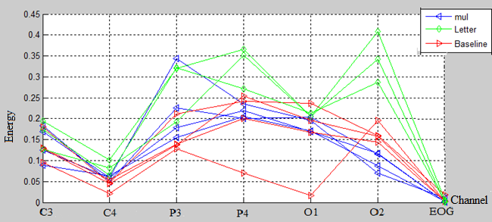
Figure (3) The energy of w for subject(person) one in the first session,O2 the highest predictive EEG channel for the three mental tasks

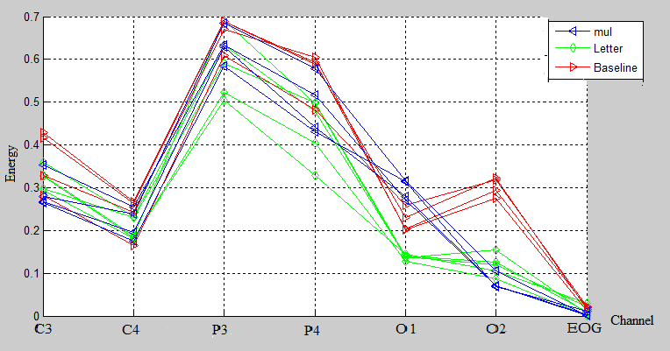
Figure (4) The energy of w for subject(person) one in the second session,O1 the highest predictive EEG channel for the three mental tasks tttttttttttttttttttttttttttttttttttttttttttttttttasks

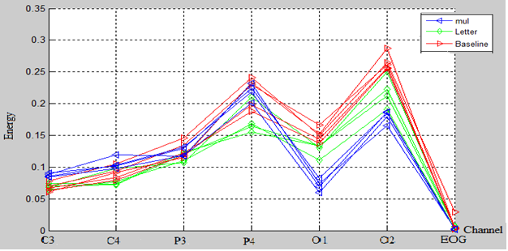
Figure (5): The energy of w for subject(person) two in the first session,O1 and O2 the highest predictive EEG channels for the three mental tasks

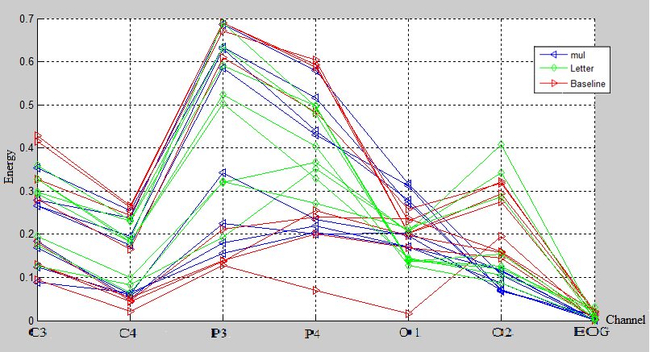
Figure (6): The energy of w for subject (person) one in the first and second sessions, No highest predictive EEG channels for the three mental tasks

References:
Alka M., Gajanan B. 2010“Blind Source Separation Using Modified Contrast Function in Fast ICA Algorithm” International Journal of Computer Applications (0975 – 8887) Volume 6– No.4, September
Anagahora, Shimoshidami, Moriyama-ku 2008 “Saccade-related EEG signals by ICA algorithms” International Symposium on Information Theory and its Applications, ISITA2008,Auckland, New Zealand, 7-10, December.
Anderson C.W., Devulapalli S. V., and Stolz E. A. 1995 “Determining mental state from EEG signals using neural networks”. Scientific Programming, Special Issue on Applications Analysis, vol. 4, no.3, pp.171–183, Fall.
Anderson C. W. 1997 “Effects of variations in neural network topology and output averaging on the discrimination of mental tasks from spontaneous electroencephalogram”. Journal of Intelligent Systems, vol.7, pp.165–190.
Charles W. A. and Zlatko S. 1996 “Classification of EEG Signals from Four Subjects During Five Mental Tasks”. In Solving Engineering Problems with Neural Networks: Proceedings of the Conference on Engineering Applications in Neural Networks, pp. 407–414.
Keirn Z. A, and. Aunon J. I. 1990 “A New Mode of Communication Between Man and His Surroundings”. IEEE Transactions on Biomedical Engineering, vol. 37, no. 12, pp. 1209-1214, December.
Kouhyar T. and Nasrabadi A. M, Hashemi M. G., Khalilzadeh M. A., Sharifi A., Setarehdan S. K. 2003 “Selecting Better EEG Channels for Classification of Mental Tasks” SCI Conference proc.. July 27-30, 2003- Orlando, Florida, U.S.A
Sarah M. Hosni, Mahmoud E. G., Sayed F. B., Mohamed S. A. 2007 “Classification of EEG Signals Using Different Feature Extraction Techniques for Mental-Task BCI” International Conference on Computer Engineering&amp;Systems Pages: 220-226.
Ungureanu M., Bigan C., Strungaru R., Lazarescu V. 2004 “ Independent Component Analysis Applied in Biomedical Signal Processing” measurement science review, Volume 4, Section 2.

