Effect of Burning on Load Carrying Capacity of Reinforced Concrete Columns
Mohammed M. Kadhum
Civil Engineering/College of Engineering /University of Babylon

Absract
In this investigation, the effect of burning by fire flame on the behavior and load carrying capacity of reinforced concrete columns.
The experimental program consisted of casting and testing of 120 column specimens were divided into two series with target compressive strength (30 and 40 MPa) and named series A and B respectively. Each series was divided into three main groups axially concentric loaded, 30mm and 80mm eccentrically loaded.
Results indicate remarkable reduction in load carrying capacity after exposure to fire flame. The residual load capacity was (86-87%), (83-85%) for concentric loaded specimens for the two series A and B respectively, while it was (88-89%), (85-87%) and (110-112%), (108-110%) for column specimens loaded at eccentricity of (30 and 80mm) respectively at fire temperature (400oC), whereas the residual load capacity at fire temperature (600oC) was (43-46%), (39-41%) for concentrically loaded specimens and (46-48%), (37-43%) and (46-52%), (45-47%) for columns loaded at eccentricity of (30 and 80mm) respectively, whereas the residual load capacity at fire temperature (750oC) was (26-29%), (24-27%) for concentrically loaded specimens and (28-32%), (23-28%) and (40-42%), (34-38%) for columns loaded at eccentricity of (30 and 80mm) respectively.
Load-deflection curves indicate deleterious response to the fire exposure. Also, it was noticed that the maximum crack width increases with increasing fire temperature and amount of spacing between lateral steel ties.

الخلاصة
في هذا البحث تم دراسة تأثير الحريق بواسطة لهب النار المباشر على سلوك وسعة التحمل القصوى للأعمدة الخرسانية المسلحة. تضمن الجزء العملي تهيئة وفحص 120 أنموذجا لأعمدة خرسانية مسلحة مقسمة إلى مجموعتين بمقاومة انضغاط (30، 40) ميكاباسكال، وكل مجموعة قسمت إلى ثلاث مجموعات رئيسيه محورية التحميل أو لامحورية التحميل بلا تمركزية 30 و 80 ملم.
لقد أشرت النتائج انخفاضا ملحوظا في مقاومة الحمل بعد التعرض إلى لهب النار، حيث كانت مقاومة الحمل المتبقية هي (86-87%) و (83-85%) للأعمدة المحملة محوريا، بينما كانت (88-89%)، (85-87%) و (110-112%)، (108-110%) لنماذج الأعمدة المحملة لامحوريا وبلا تمركزية 30 و 80 ملم على التوالي عند التعرض إلى درجة حرارة (400) درجة مئوية، بينما مقاومة الحمل المتبقية وبعد الحرق إلى (600) درجة مئوية هي (43-46%) و (39-41%) للنماذج المحملة محوريا و (46-48%)، (37-43%) و (46-52%)، (45-47%) لنماذج الأعمدة المحملة لامحوريا وبلا تمركزية 30 و 80 ملم على التوالي، بينما مقاومة الحمل المتبقية وبعد الحرق إلى (750) درجة مئوية هي (26-29%) و (24-27%) لنماذج محملة محوريا و (28-32%)، (23-%28) و (40-42%)، (34-38%) لنماذج الأعمدة المحملة لامحوريا وبلا تمركزية 30 و 80 ملم على التوالي.
إما منحنيات الحمل-الانحراف فقد كانت الاستجابة سلبية مع درجة التعرض للنار. كذلك يمكن ملاحظة إن عرض الشق الأقصى يزداد بزيادة درجة حرارة النار وزيادة المسافة بين أطواق التسليح العرضية.
Introduction
One of the problems confronting buildings is the exposure to elevated temperatures, hence, should be provided with sufficient structural fire resistance to withstand in such circumstances, or at least give occupants time to escape before strength and, or stability failure ensue.
Concrete columns are considered to be important structural elements in reinforced concrete structures because they support the structure and transfer the loads to the supports or foundation, so any failure or damage occurs in the column may cause a partial or complete failure of the structure by perhaps chain action (Sakai and Sheikh, 1989).

Research Significant
It was found that the literature lackes investigating the effect of exposing reinforced concrete columns to direct fire flame which needs a considerable attention to find the extent of damage which may occur in these important compression and flexural load bearing members.
In order to simulate this problem to practical site conditions, reduced scale column models were cast and they were as close as possible to practical circumstances. This research is seeked to cover the limited area of research about this problem. This will guide and facilitate the suggestion of rehabilitation of such members exposed to fires under loading of different degrees.
The current research proposes a reinforced concrete column model which resemble the simulation of the state of stress which the reinforced concrete columns are subjected to during fire in laboratory.
Simulation of real fires in laboratory using a set of methane burners which subjecting the column specimens to real fire flame.

Literature Review

-The Effect of Fire on Reinforced Concrete Columns
In recent years a number of notable fires have occurred during construction of concrete-framed buildings, when formwork and false work has caught fire, see Plate (1). Fortunately, even after a sever fire, reinforced concrete structures are generally capable of being repaired rather than demolished (Ingham and Tarada, 2007).
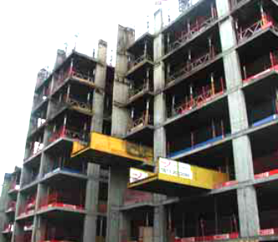
Plate (1): The concrete frame of a ten-storey building that was fire-damaged
during construction, ( Ingham and Tarada, 2007).

After a fire, an appraisal is normally required as soon as the building can be safely entered and generally before the removal of debris. To ensure safety, temporary false work may be required to secure individual members and stabilize the structure as a whole.

Jau and Huang, tested 22 reinforced concrete corner columns under high temperature of 270cm long were manufactured. The cross-section was (30×45cm). The parameters considered were the cover thickness, concrete strength, steel ratio, eccentricity, and fire duration. They concluded that the factors affecting the initiation of cracks in the sequence of importance are fire duration, concrete cover thickness, steel ratio, concrete strength, and eccentricity. However, the existence and characteristics of surface crack does not directly relate to the strength reduction.
Kodur et al., 2005 investigated the behavior of fibre reinforced polymer (FRP) wrapped (confined) reinforced concrete columns under exposure to the standard fire. Three full-scale reinforced concrete columns, two of these columns were circular and the third column was square in cross-section. The circular columns were 400 mm in diameter, while the square column was 406 mm in width. All three columns were 3810 mm long. The longitudinal reinforcement in the circular columns was comprised of eight 19.5mm diameter bars, with 40mm clear cover to the spiral reinforcement and 10mm for lateral reinforcement. The square column had four 25mm diameter longitudinal reinforcing bars with 40mm cover to the ties, and 10mm diameter for ties spaced at 406mm. These specimens were heated in furnace chamber by 32 propane gas burners, arranged in eight columns containing four burners each. The test results showed that the FRP materials used as externally bonded reinforcement for concrete structures were sensitive to the effects of elevated temperatures. They also noticed that the providing proper fire insulation a (5 and 4) hours fire endurance rating can be achieved for loaded circular and square reinforced concrete columns strengthened with FRP wraps respectively.

-Effect of Fire on Load Eccentricity of Reinforced Concrete Columns

The fire resistance of reinforced concrete columns is the time it takes for strength to be reduced to the level of the applied load. Figure (1) shows strength interaction curves during fire for a typical column, fire resistance being of the order of 2.0 hours. The fire resistance in this figure is greater in compression than in bending because the concrete core heats more slowly than the reinforcing (Allen and Lie, 1977).
Figure(1): Typical column interaction curves (Allen and Lie, 1977).
Bending
Compression
ACI Min Eccentricity
1 hr
No Fire
2 hr
3 hr
Strength
Allowable Load

Jae-Hoon and Hyeok-Soo, 2000, verified the basic design rules of high strength concrete columns. A total of 32 column specimens were tested to investigate structural behavior and strength of eccentrically loaded reinforced concrete tied columns. The main variables included in this test program were concrete compressive strength, amount of steel, and load eccentricity. In this work, concrete compressive strength varied from 34.9 to 93.2 MPa, and the longitudinal steel ratios ranged between 1.13% and 5.51%. Test results of column sectional strength were compared with the result of analysis by using the American Concrete Institute (Building Code requirements for structural concrete) rectangular stress block, trapezoidal stress block, and modified rectangular stress block. Axial force-moment-curvature analysis was also performed for predicting axial load-moment strength and compared with test results. It was found that the ACI (318-95) code rectangular stress block provides overestimated column strengths for the lightly reinforced high strength column specimens.

Experimental Work

Reinforced Concrete Column Specimens
The column specimens were divided into two series A and B with two target compressive strengths (30 and 40) MPa respectively. The specimens of each series were tested by applying compressive axial loads and divided to three groups depending on the way of load application. The specimens of the first group were concentrically loaded, whereas, the specimens of the second and third group were eccentrically loaded by eccentricity of (30mm) and (80mm) respectively. The details of the reinforced concrete column specimens are shown in Table (3-1). Each column is identified by three symbols. The first is a letter that refers to concrete strength series. The letters (A) and (B) refer to target compressive strength (30 and 40 MPa) respectively. The second symbol is a number that refers to the eccentricity of applied load; (1) refers to axially concentrically loaded columns, while (2) and (3) refer to the columns that were loaded at eccentricities of 30 and 80 mm respectively. The third symbol refers to the tie spacing; (0) for no ties, (1), (2) and (3) for 250, 150 and 50 mm tie spacing, respectively.
After greasing the moulds of the column specimens, reinforcement bars were held carefully in their position inside these moulds. In order to get a cover, small pieces of steel were placed at sides of the column reinforcement.
The reinforcement used is deformed steel bars of Ø8 mm and Ø10 mm respectively. Figure (2) shows the details of the reinforcement of column specimens.
Table (1): Summary of column test specimens.

Number | Series | Group | Temperature Stage  ( ºC ) | Column No. | Concrete Compressive Strength (MPa) | Eccentricity of Applied Load (mm) | Spacing of Lateral Ties (mm)
1 | A | 1 | 25 ºC | A10 | 30 | 0 | No ties
2 | A | 1 | 25 ºC | A11 | 30 | 0 | 250
3 | A | 1 | 25 ºC | A12 | 30 | 0 | 150
4 | A | 1 | 25 ºC | A13 | 30 | 0 | 50
5 | A | 1 | 25 ºC | A12* | 30 | 0 | 150
6 | A | 1 | 400 ºC | A10 | 30 | 0 | No ties
7 | A | 1 | 400 ºC | A11 | 30 | 0 | 250
8 | A | 1 | 400 ºC | A12 | 30 | 0 | 150
9 | A | 1 | 400 ºC | A13 | 30 | 0 | 50
10 | A | 1 | 400 ºC | A12* | 30 | 0 | 150
11 | A | 1 | 600 ºC | A10 | 30 | 0 | No ties
12 | A | 1 | 600 ºC | A11 | 30 | 0 | 250
13 | A | 1 | 600 ºC | A12 | 30 | 0 | 150
14 | A | 1 | 600 ºC | A13 | 30 | 0 | 50
15 | A | 1 | 600 ºC | A12* | 30 | 0 | 150
16 | A | 1 | 750 ºC | A10 | 30 | 0 | No ties
17 | A | 1 | 750 ºC | A11 | 30 | 0 | 250
18 | A | 1 | 750 ºC | A12 | 30 | 0 | 150
19 | A | 1 | 750 ºC | A13 | 30 | 0 | 50
20 | A | 1 | 750 ºC | A12* | 30 | 0 | 150
21 | A | 2 | 25 ºC | A20 | 30 | 30 | No ties
22 | A | 2 | 25 ºC | A21 | 30 | 30 | 250
23 | A | 2 | 25 ºC | A22 | 30 | 30 | 150
24 | A | 2 | 25 ºC | A23 | 30 | 30 | 50
25 | A | 2 | 25 ºC | A22* | 30 | 30 | 150
26 | A | 2 | 400 ºC | A20 | 30 | 30 | No ties
27 | A | 2 | 400 ºC | A21 | 30 | 30 | 250
28 | A | 2 | 400 ºC | A22 | 30 | 30 | 150
29 | A | 2 | 400 ºC | A23 | 30 | 30 | 50
30 | A | 2 | 400 ºC | A22* | 30 | 30 | 150
31 | A | 2 | 600 ºC | A20 | 30 | 30 | No ties
32 | A | 2 | 600 ºC | A21 | 30 | 30 | 250
33 | A | 2 | 600 ºC | A22 | 30 | 30 | 150
34 | A | 2 | 600 ºC | A23 | 30 | 30 | 50
35 | A | 2 | 600 ºC | A22* | 30 | 30 | 150
36 | A | 2 | 750 ºC | A20 | 30 | 30 | No ties
37 | A | 2 | 750 ºC | A21 | 30 | 30 | 250
38 | A | 2 | 750 ºC | A22 | 30 | 30 | 150
39 | A | 2 | 750 ºC | A23 | 30 | 30 | 50
40 | A | 2 | 750 ºC | A22* | 30 | 30 | 150
41 | A | 3 | 25 ºC | A30 | 30 | 80 | No ties
42 | A | 3 | 25 ºC | A31 | 30 | 80 | 250
43 | A | 3 | 25 ºC | A32 | 30 | 80 | 150
44 | A | 3 | 25 ºC | A33 | 30 | 80 | 50
45 | A | 3 | 25 ºC | A32* | 30 | 80 | 150
46 | A | 3 | 400 ºC | A30 | 30 | 80 | No ties
47 | A | 3 | 400 ºC | A31 | 30 | 80 | 250
48 | A | 3 | 400 ºC | A32 | 30 | 80 | 150
49 | A | 3 | 400 ºC | A33 | 30 | 80 | 50
50 | A | 3 | 400 ºC | A32* | 30 | 80 | 150
51 | A | 3 | 600 ºC | A30 | 30 | 80 | No ties
52 | A | 3 | 600 ºC | A31 | 30 | 80 | 250
53 | A | 3 | 600 ºC | A32 | 30 | 80 | 150
54 | A | 3 | 600 ºC | A33 | 30 | 80 | 50
55 | A | 3 | 600 ºC | A32* | 30 | 80 | 150
56 | A | 3 | 750 ºC | A30 | 30 | 80 | No ties
57 | A | 3 | 750 ºC | A31 | 30 | 80 | 250
58 | A | 3 | 750 ºC | A32 | 30 | 80 | 150
59 | A | 3 | 750 ºC | A33 | 30 | 80 | 50
60 | A | 3 | 750 ºC | A32* | 30 | 80 | 150
61 | B | 1 | 25 ºC | B10 | 40 | 0 | No ties
62  Table (1): Continued. | B | 1 | 25 ºC | B11 | 40 | 0 | 250
63 | B | 1 | 25 ºC | B12 | 40 | 0 | 150
64 | B | 1 | 25 ºC | B13 | 40 | 0 | 50
65 | B | 1 | 25 ºC | B12* | 40 | 0 | 150
66 | B | 1 | 400 ºC | B10 | 40 | 0 | No ties
67 | B | 1 | 400 ºC | B11 | 40 | 0 | 250
68 | B | 1 | 400 ºC | B12 | 40 | 0 | 150
69 | B | 1 | 400 ºC | B13 | 40 | 0 | 50
70 | B | 1 | 400 ºC | B12* | 40 | 0 | 150
71 | B | 1 | 600 ºC | B10 | 40 | 0 | No ties
72 | B | 1 | 600 ºC | B11 | 40 | 0 | 250
73 | B | 1 | 600 ºC | B12 | 40 | 0 | 150
74 | B | 1 | 600 ºC | B13 | 40 | 0 | 50
75 | B | 1 | 600 ºC | B12* | 40 | 0 | 150
76 | B | 1 | 750 ºC | B10 | 40 | 0 | No ties
77 | B | 1 | 750 ºC | B11 | 40 | 0 | 250
78 | B | 1 | 750 ºC | B12 | 40 | 0 | 150
79 | B | 1 | 750 ºC | B13 | 40 | 0 | 50
80 | B | 1 | 750 ºC | B12* | 40 | 0 | 150
81 | B | 2 | 25 ºC | B20 | 40 | 30 | No ties
82 | B | 2 | 25 ºC | B21 | 40 | 30 | 250
83 | B | 2 | 25 ºC | B22 | 40 | 30 | 150
84 | B | 2 | 25 ºC | B23 | 40 | 30 | 50
85 | B | 2 | 25 ºC | B22* | 40 | 30 | 150
86 | B | 2 | 400 ºC | B20 | 40 | 30 | No ties
87 | B | 2 | 400 ºC | B21 | 40 | 30 | 250
88 | B | 2 | 400 ºC | B22 | 40 | 30 | 150
89 | B | 2 | 400 ºC | B23 | 40 | 30 | 50
90 | B | 2 | 400 ºC | B22* | 40 | 30 | 150
91 | B | 2 | 600 ºC | B20 | 40 | 30 | No ties
92 | B | 2 | 600 ºC | B21 | 40 | 30 | 250
93 | B | 2 | 600 ºC | B22 | 40 | 30 | 150
94 | B | 2 | 600 ºC | B23 | 40 | 30 | 50
95 | B | 2 | 600 ºC | B22* | 40 | 30 | 150
96 | B | 2 | 750 ºC | B20 | 40 | 30 | No ties
97 | B | 2 | 750 ºC | B21 | 40 | 30 | 250
98 | B | 2 | 750 ºC | B22 | 40 | 30 | 150
99 | B | 2 | 750 ºC | B23 | 40 | 30 | 50
100 | B | 2 | 750 ºC | B22* | 40 | 30 | 150
101 | B | 3 | 25 ºC | B30 | 40 | 80 | No ties
102 | B | 3 | 25 ºC | B31 | 40 | 80 | 250
103 | B | 3 | 25 ºC | B32 | 40 | 80 | 150
104 | B | 3 | 25 ºC | B33 | 40 | 80 | 50
105 | B | 3 | 25 ºC | B32* | 40 | 80 | 150
106 | B | 3 | 400 ºC | B30 | 40 | 80 | No ties
107 | B | 3 | 400 ºC | B31 | 40 | 80 | 250
108 | B | 3 | 400 ºC | B32 | 40 | 80 | 150
109 | B | 3 | 400 ºC | B33 | 40 | 80 | 50
110 | B | 3 | 400 ºC | B32* | 40 | 80 | 150
111  Table (1): Continued. | B | 3 | 600 ºC | B30 | 40 | 80 | No ties
112 | B | 3 | 600 ºC | B31 | 40 | 80 | 250
113 | B | 3 | 600 ºC | B32 | 40 | 80 | 150
114 | B | 3 | 600 ºC | B33 | 40 | 80 | 50
115 | B | 3 | 600 ºC | B32* | 40 | 80 | 150
116 | B | 3 | 750 ºC | B30 | 40 | 80 | No ties
117 | B | 3 | 750 ºC | B31 | 40 | 80 | 250
118 | B | 3 | 750 ºC | B32 | 40 | 80 | 150
119 | B | 3 | 750 ºC | B34 | 40 | 80 | 50
120 | B | 3 | 750 ºC | B32* | 40 | 80 | 150

Concrete cover=15mm, except (* =30mm)
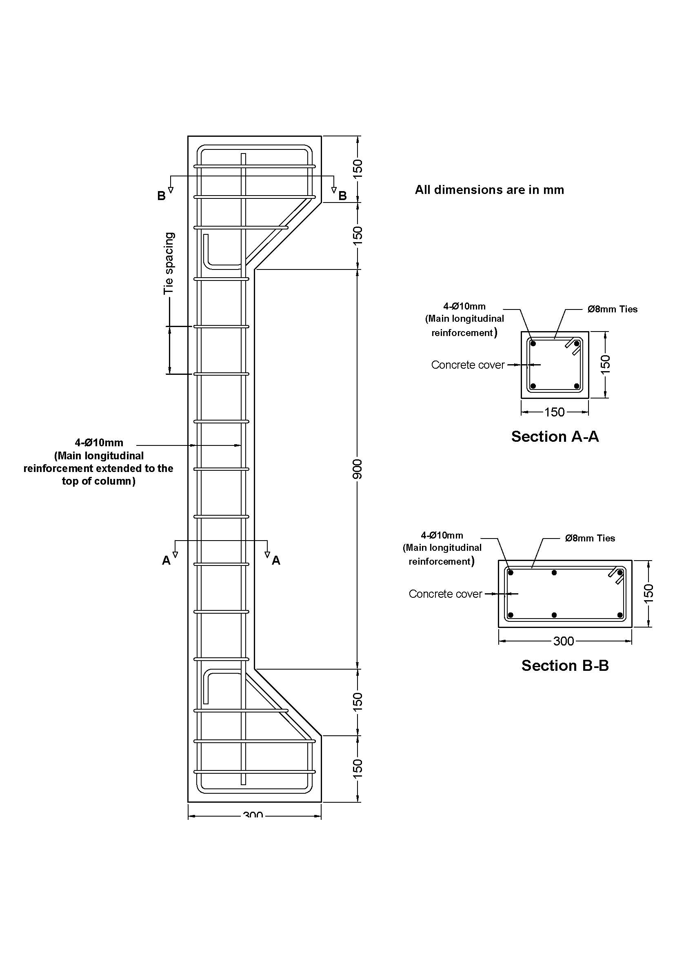
Figure (2): Reinforcement details of reinforced concrete column specimens.
15 or 30 mm
15 or 30 mm
(15 and 30mm)
(15 and 30mm)
300
15 or 30 mm
15 or 30 mm

Materials and Mixes
Introduction
The properties of materials used in any structure are of considerable importance (Neville, 1995, and ACI Committee 211, 1997). The properties of materials used in the current study are presented in this chapter. Standard tests according to the American Society for Testing and Materials (ASTM) and Iraqi specifications IQS were conducted to determine the properties of materials.
Cement
Tasluga-Bazian Ordinary Portland cement (O.P.C) (ASTM Type I) manufactured in Iraq was used for concrete mixes throughout the present work. The cement was properly stored in a dry place to avoid the exposure to the atmosphere. This cement complied with the Iraqi specification (IQS, No.5:1984). Testing of cement was conducted in the laboratories of Consultant Engineering Bureau in Babylon University. The physical properties and chemical analysis of the cement used are given in Tables (2) and (3). Also, the compounds of cement calculated according to Bogue equations are listed in Table (3).
Table (2): Physical properties of the cement.
Physical Properties | Test results | IQS (No.5: 1984) Limits
Fineness, Blaine, cm²/gm  Setting time, Vicat’s method  Initial hrs: min.  Final hrs: min.  Compressive strength of 70.7 mm cube, MPa  3 days  7 days | 3105  1:54  4:25  22.5  31.5 | ≥ 2300  ≥ 0: 45  ≤ 10: 00  ≥ 15  ≥ 23
Table (3): Chemical composition of the cement.
Oxide | Percentage (%) | IQS (No.5: 1984) Limits
CaO  SiO₂  Fe₂O₃  Al₂O₃  MgO  SO₃  L.O.I.  I.R. | 61.49  21.18  3.68  5.16  2.35  2.42  2.27  0.95 | -------  -------  -------  -------  ≤ 5.0  ≤ 2.8  ≤ 4.0  ≤ 1.5
Compound composition | Percentage (%) | IQS (No.5: 1984) Limits
C₃S  C₂S  C₃A  C₄AF  L.S.F. | 41.59  29.59  7.45  11.20  0.81 | --------  --------  --------  --------  0.66-1.02

Fine Aggregate
Well-graded natural sand from Al-Akhaidher region in Iraq was used for concrete mixes. The fine aggregate was sieved at sieve size (9.5 mm) to separate the aggregate particles of diameter greater than 9.5 mm. The sand was then washed and cleaned with water several times, then it was spread out and left to dry in air, after which it was ready for use. The physical and chemical properties of the sand are listed in Table (4). Its grading conformed to the Iraqi specification(IQS, No.45:1984), Zone(3).
Table (4): Properties of fine aggregate.
Sieve size (mm) | Percentage passing (%) | IQS (No.45: 1984) Limits, Zone 3
9.5  4.75  2.36  1.18  0.6  0.3  0.15 | 100  94  93  81  62  27  0 | 100  90-100  85-100  75-100  60-79  12-40  0-10
Properties | Test results | IQS (No.45 : 1984) Limits
Sulphate content,  SO₃ (%)  Specific gravity  Absorption (%) | 0.28  2.60  1.6 | ≤ 0.5

Coarse Aggregate
The gravel used was brought from Al-Nibaii area in Iraq with a maximum size of (20 mm). The gravel was sieved at sieve size of (20 mm). The gravel was washed and cleaned by water several times, later it was speared out and left in air to dry before use. The gravel used conforms to the Iraqi specification (IQS, No.45:1984). The grading and other properties of this type of aggregate are shown in Table (5).
Table (5): Properties of coarse aggregate.
Sieve size (mm) | Percentage passing (%) | IQS (No.45 : 1984) Limits size 20-5mm
37.5  20  9.5  4.75 | 100  100  53  5 | 100  95-100  30-60  0-10
Properties | Test results | IQS (No.45 : 1984) Limits
Sulphate content, SO₃ (%)  Specific gravity  Absorption (%) | 0.08  2.64  0.8 | ≤ 0.1

Mixing Water
Ordinary clean tap water was used throughout this work for both making and curing of specimens.

Reinforcing Steel Bars
Deformed steel bars of diameters (Ø8 mm) and (Ø10 mm) were used as reinforcement. Their mechanical properties were obtained from a digital computer complementary with the testing machine. Table (6) gives the results of testing three 1000 mm long samples from each size of bars (8 and 10 mm).
Table (6): Strength properties of the used steel reinforcement.

Approximate  Diameter  (mm) | Measured  Diameter  (mm) | Area  (mm²) | Yield stress  Fy  (MPa) | Ultimate  Strength  Fu (MPa) | ** Modulus of  Elasticity  (GPa) | Uses
10 | 10.01 | 78.69 | 585 | 745 | 200 | Main Reinforcement
8 | 8.00 | 50.26 | 523.5 | 694.4 | 200 | Ties

** Assumed

Mix Design and Proportions
Two target compressive strengths of 30 and 40 MPa were denoted as series A and B respectively. The concrete mix was designed according to American mix design method (ACI 211.1-91) specification. The proportions of the concrete mix are summarized in Table (7).

Table (7): Mix Proportions.
 |  | Mix Proportion kg/m³
Series | W/c ratio | Water | Cement | Sand | Gravel | Slump (mm)
A | 0.52 | 205 | 394 | 717 | 1024 | 80
B | 0.45 | 193 | 429 | 733 | 1024 | 60

Reinforced Concrete Columns Testing Procedure
The column specimens were tested using a load cell of maximum capacity of (150 Tons) at the age of (60 days). The load was applied through a bearing plate for the axially loaded columns, and through a cylindrical roller to simulate line load, attached to the top of bearing plates. The load was applied in small increments and the readings were taken every 10.0 kN load until failure occurrs. For each increment, the load was kept constant until the required measurements were recorded. Cracks were detected and drawn on the faces of the test column specimens. The reading of the lateral deflections versus loads were recorded simultaneously for each load increment. Testing continued until the reinforced concrete column shows a drop in load capacity with increasing deformation. The axial deformation of the columns was measured using vertical dial gauges having a minimum graduation of 0.001 mm and a maximum needle length of 50 mm mounted at the bottom face of the specimens. Plate (2) shows the setup of axial deformation measurements.
For the column specimens which were subjected to fire flame under loading as shown in Plate (3). The specified (target) fire temperature was reached by mounting the fire subjecting burners by a sliding arm to control the fire distance to the surface of the column specimens, and also by monitoring the fire intensity through controlling the methane gas pressure in the burners. The temperature was measured by the digital thermometer and infrared rays thermometer continuously till reaching the specified (target) fire temperature. Then, the sliding arm and gas pressure were kept at this position along the period of burning (1.5 hour). The lateral deflection of the column specimens exposed to fire are resulting from loading to 15% of ultimate load before burning, loading 15%and applied fire flame, and loading after burning until failure. While, for column specimens without burning the lateral deflection is resulting from applied load only.
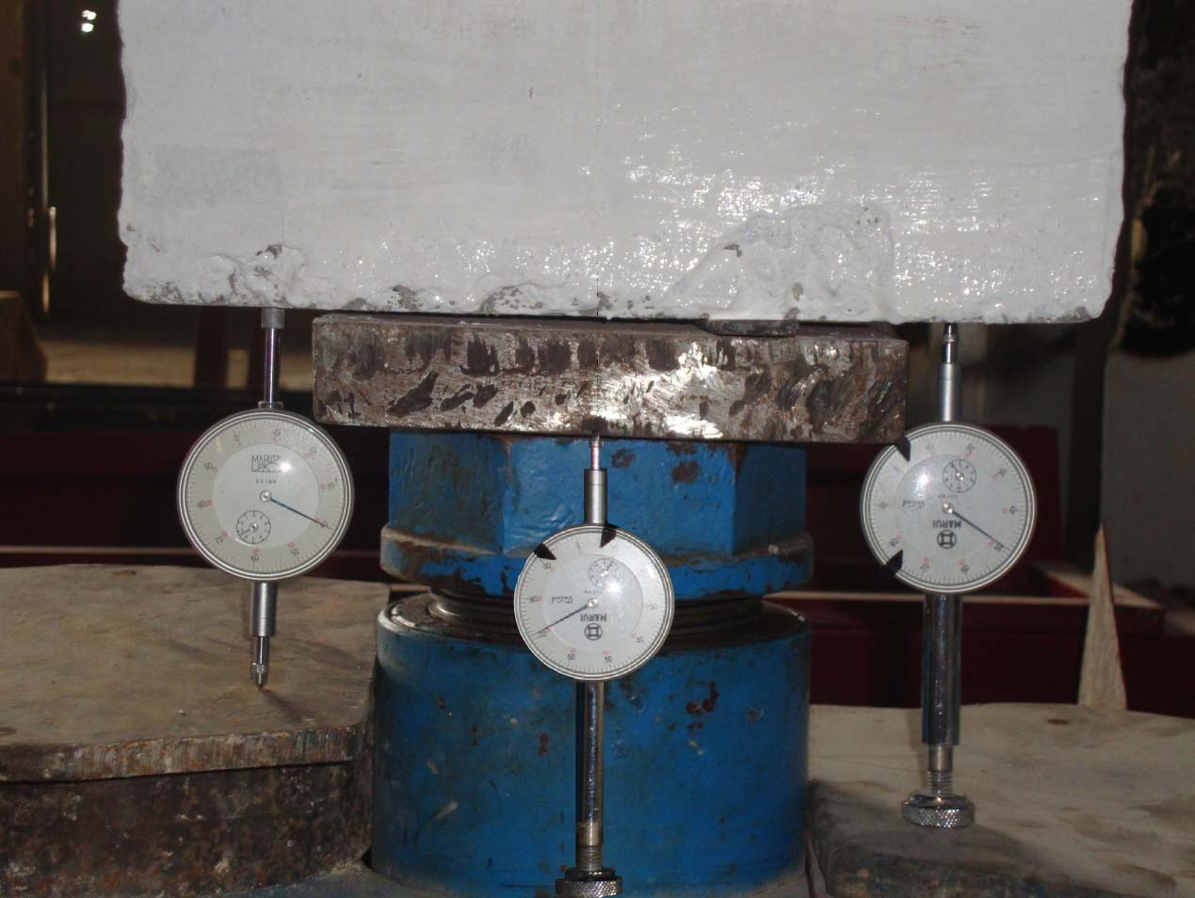
Plate (2): The testing measurements of Axial deformation.

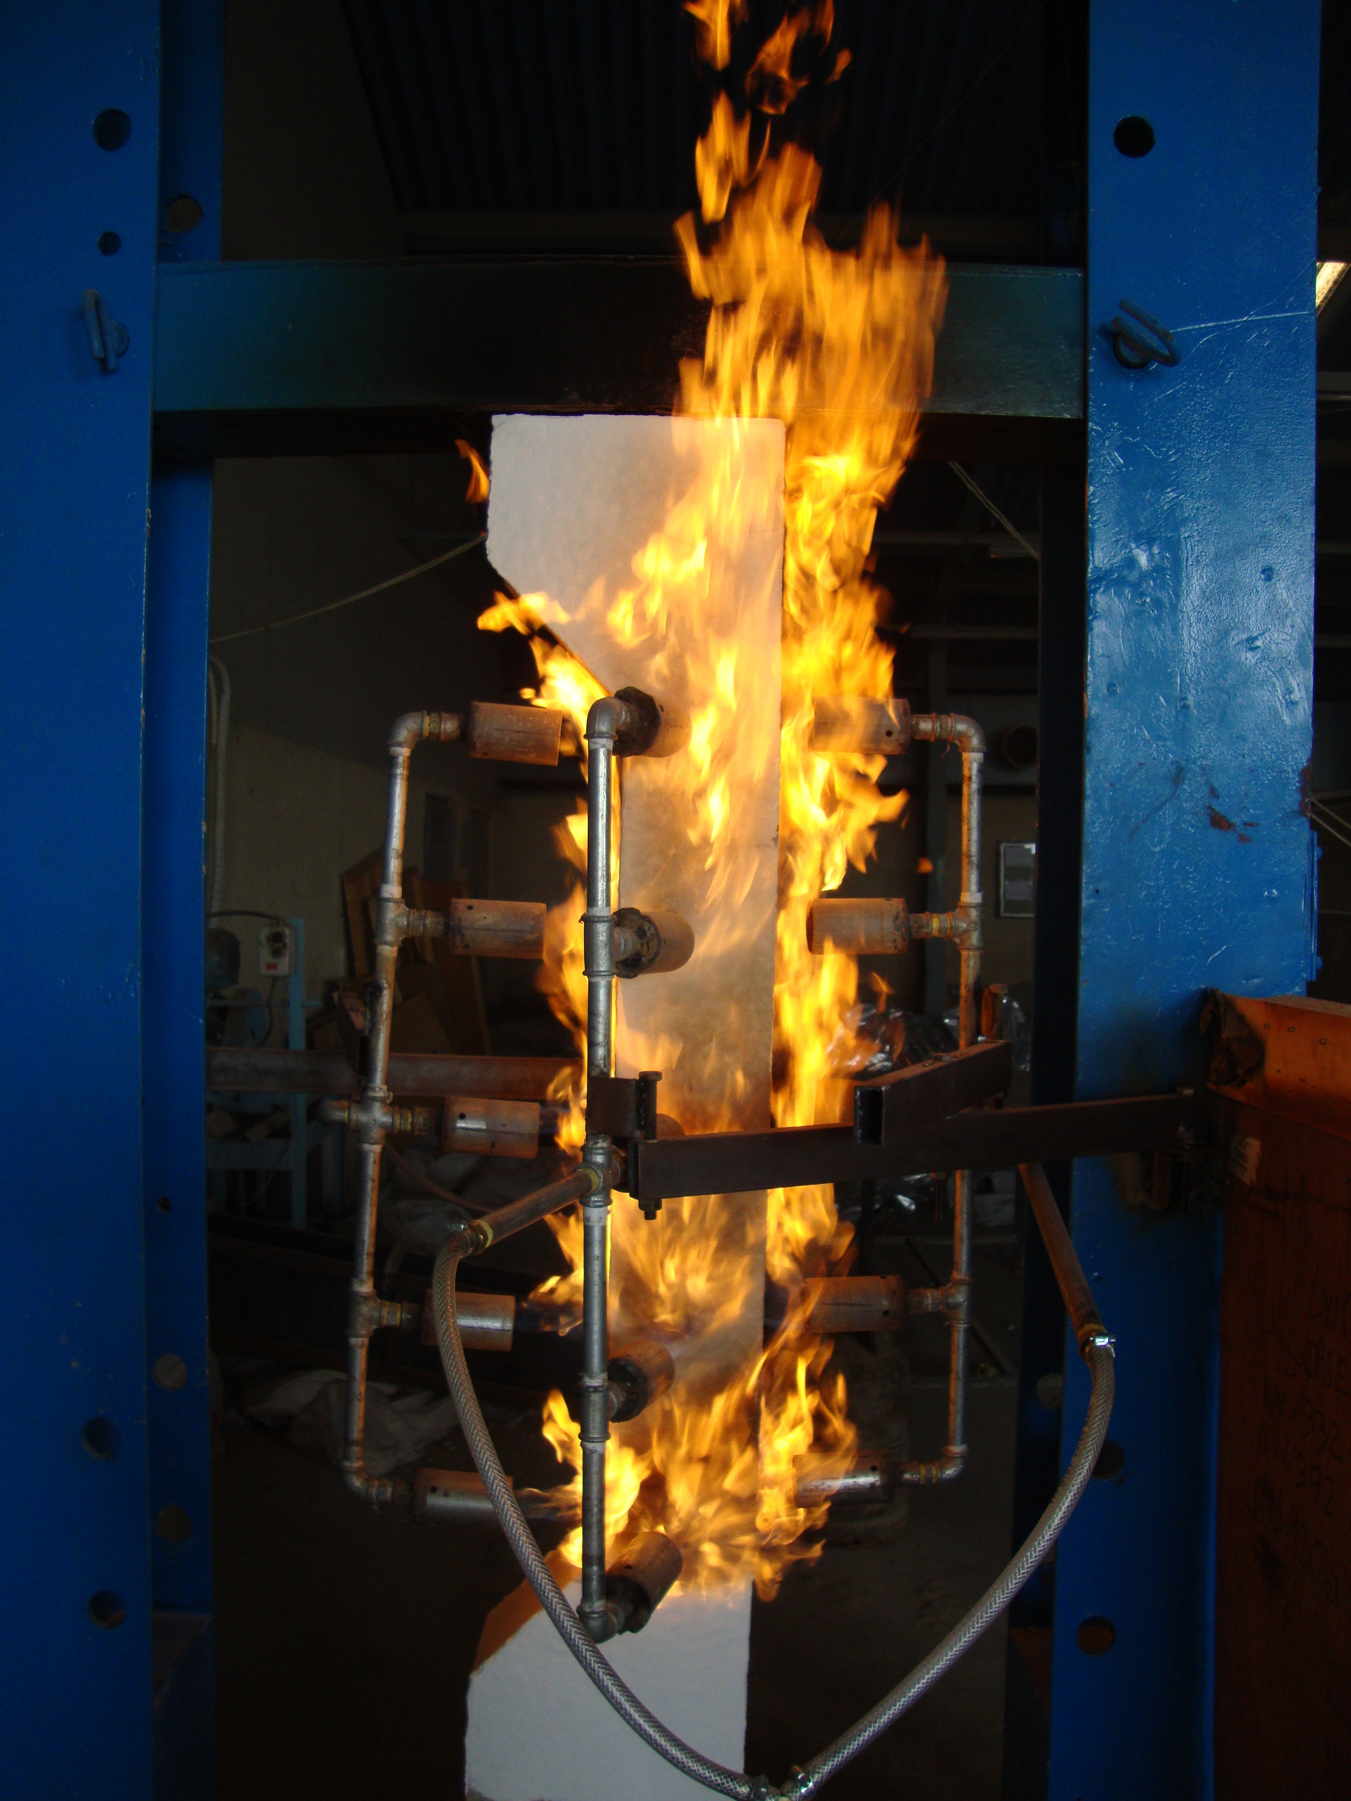
Plate (3): Testing of column specimens under 15% of ultimate load with exposure to fire flame.

RESULTS AND DISCUSSION

Effect of Burning on the Load Carrying Capacity of Columns With Different Eccentricities

The test results of the ultimate load of the reference column specimens and those exposed to fire flame are summarized in Table (8) for both series A and B. It is obvious that the values of ultimate load capacity, decreased for all column specimens when exposed to fire flame.
At fire temperature (400°C), for series A and B and for the column specimens eccentrically loaded at e=30mm, the residual ultimate loads were 89% and 86% for 1.5 hour burning exposure respectively, while the residual ultimate loads were (110-112%), (108-110%) respectively for columns loaded at eccentricity of 80mm. This can be explained by the low reduction percentages in tensile and compressive strength of the concrete member at this low fire temperature exposure. On the other hand, the expansion happening due to this fire exposure can cause an increase in the axial compressive stress affecting on the eccentric (e=80mm) loaded column specimens, which raise the moment capacity of the column and consequently the load capacity.
At fire temperature (600°C), for series A and B and the column specimens eccentrically loaded at e=30mm, the residual ultimate loads were (46-48%), (37-43%) respectively for 1.5 hour burning exposure, while the residual ultimate loads were (46-52%), (45-47%) respectively for columns loaded at eccentricity of 80mm.
At fire temperature (750°C), for series A and B and the column specimens loaded at eccentricity of 30mm, the residual ultimate loads were (28-31%), (23-28%) respectively for 1.5 hour burning exposure, while the residual ultimate loads were (40-42%), (34-38%) respectively for columns loaded at eccentricity of 80mm.
It is obvious from the results that the percentage of residual ultimate load decreases at eccentricity of 30mm for series A and B and for all exposure temperatures of (400, 600, 750 °C). The reduction in ultimate load carrying capacity of the column specimens can be attributed to the fact that the fire flame subjected to the concrete columns causes evaporation of free moisture in the concrete. With the continual exposure to burning, the temperature inside the column increases and the strength of concrete decreases. In certain cases, the pressure generated by conversion of moisture within columns may be too high for the surface layer of concrete to resist, and it may spall causing a reduction in concrete section and compressive strength. This reduction in the concrete compressive strength and yield strength of steel is causing a reduction in load carrying capacity of the column specimens.
Figures (3) and (4) present the effect of fire flame temperature on the interaction diagram for the column specimens for series A and B respectively. It can be noticed that the balanced failure point of the unburnt column specimen is located at the eccentric loaded specimens of (e=30mm). As for the fire burnt column specimens at (400, 600 and 750°C) the balanced failure position extends to the eccentric loaded specimens of (e=80mm). This indicates that fire exposure to column specimens decreases the capacity of these specimens to resist concentric loads more that to resist eccentric loads. This can be attributed to the sharp reduction in concrete compressive strength after burning at temperature of 750°C.

Table (8): Test results of ultimate load and moment capacity for reference columns
and columns exposed to fire flame for series A and B.

Specimens Identification | Temperature Level (°C) | Ultimate Load (kN) | Eccentricity to Width Ratio of Column (e/h) | Ultimate Flexure Load (kN) | Moment Capacity (kN.m)
A₁₂ | 25 | 822 | 0 | --- | ---
A₁₂ | 400 | 712 | 0 | --- | ---
A₁₂ | 600 | 369 | 0 | --- | ---
A₁₂ | 750 | 227 | 0 | --- | ---
A₁₂ | 25 | --- | --- | 34.23 | 6.84
A₁₂ | 400 | --- | --- | 28.62 | 5.72
A₁₂ | 600 | --- | --- | 21.41 | 4.28
A₁₂ | 750 | --- | --- | 12.80 | 2.56
A₂₂ | 25 | 513 | 0.20 | --- | 15.39
A₂₂ | 400 | 457 | 0.20 | --- | 13.71
A₂₂ | 600 | 241 | 0.20 | --- | 7.23
A₂₂ | 750 | 155 | 0.20 | --- | 4.65
A₃₂ | 25 | 196 | 0.534 | --- | 15.68
A₃₂ | 400 | 217 | 0.534 | --- | 17.36
A₃₂ | 600 | 99 | 0.534 | --- | 7.92
A₃₂ | 750 | 80 | 0.534 | --- | 6.40
B₁₂ | 25 | 978 | 0 | --- | ---
B₁₂ | 400 | 816 | 0 | --- | ---
B₁₂ | 600 | 388 | 0 | --- | ---
B₁₂ | 750 | 231 | 0 | --- | ---
B₁₂ | 25 | --- | --- | 36.60 | 7.32
B₁₂ | 400 | --- | --- | 29.51 | 5.90
B₁₂ | 600 | --- | --- | 22.80 | 4.56
B₁₂ | 750 | --- | --- | 14.40 | 2.88
B₂₂ | 25 | 635 | 0.20 | --- | 19.05
B₂₂ | 400 | 547 | 0.20 | --- | 16.41
B₂₂ | 600 | 261 | 0.20 | --- | 7.83
B₂₂ | 750 | 167 | 0.20 | --- | 5.01
B₃₂ | 25 | 229 | 0.534 | --- | 18.32
B₃₂ | 400 | 250 | 0.534 | --- | 20.0
B₃₂ | 600 | 107 | 0.534 | --- | 8.56
B₃₂ | 750 | 85 | 0.534 | --- | 6.80

--- No Values

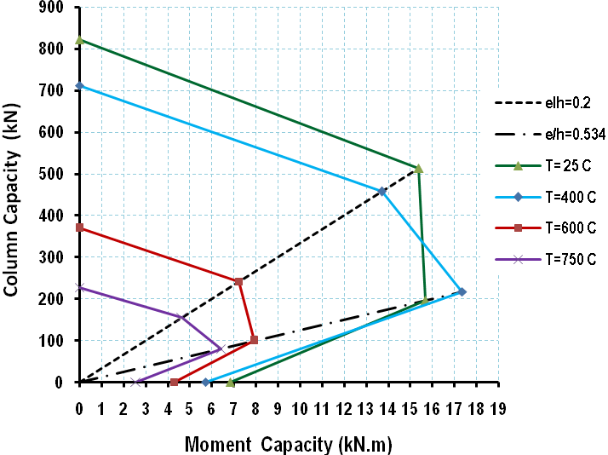
Figure (3): Effect of fire temperature on the interaction diagram of column
specimens for series A and duration of burning 1.5 hour.

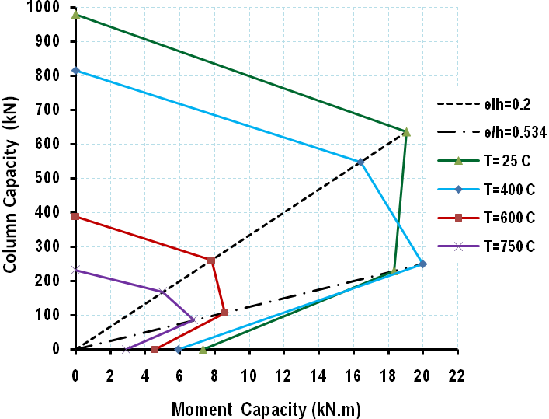
Figure (4): Effect of fire temperature on the interaction diagram of column
specimens for series B and duration of burning 1.5 hour.

Effect of Burning on Load Versus Deflection Results
The load versus midheight lateral deflection relationship of reinforced concrete column specimens loaded at eccentricity of (30 and 80mm) for series A and B are presented in Figures (5) to (8).
Deflection of these column specimens, which occurred immediately when they were loaded and subjected to fire flame, this deflection is called immediate deflection or instantaneous deflection. Deflection measurement was taken continually during the test and the rate of increase in deflection was controlled to provide warning of impending collapse of the column specimens.
From these Figures, it can be seen that the increase in the fire temperature has a significant effect on midheight lateral deflection of column specimens for series A and B. In addition, it can be noted that the increase in the fire temperature decreases the load carrying capacity and increases lateral deflection in column specimens. This can be attributed to the fact that heating causes a reduction in column stiffness, which is essentially due to the reduction in the modulus of elasticity of concrete and the reduction in the effective section due to cracking, which means that load-deflection curves for series A are more sensitive to high temperatures compared with series B. These Figures reveal that the load-deflection relation of the column specimens is almost linearly proportional for the two eccentricities (30 and 80mm) and for temperature exposure (600°C and 750°C).

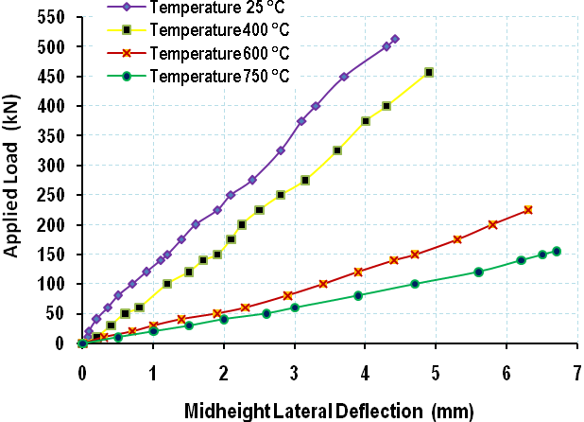
Figure (5): Load versus midheight lateral deflection curve of column
specimen A22 at eccentricity (e=30mm).

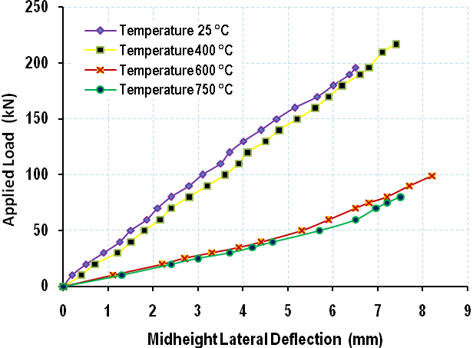
Figure (6): Load versus midheight lateral deflection curve of column
specimen A32 at eccentricity (e=80mm).

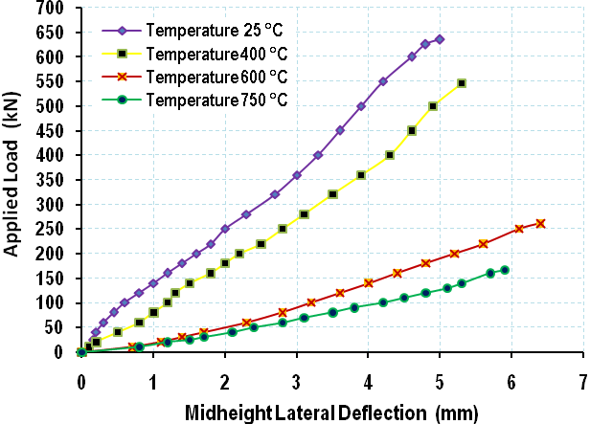
Figure (7): Load versus midheight lateral deflection curve of column specimen B22

at eccentricity (e=30mm).

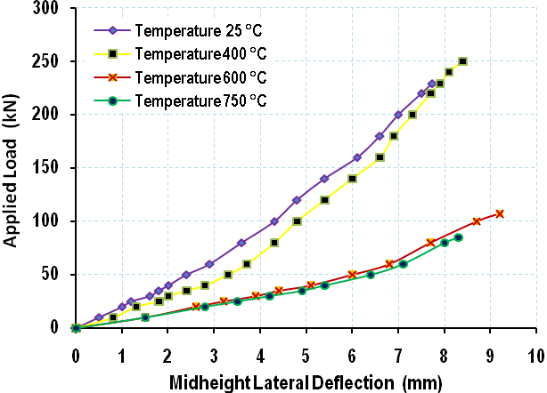
Figure (8): Load versus midheight lateral deflection curve of column specimen B32
at eccentricity (e=80mm).

Axial Deformation of Column Specimens

Effect of burning by fire flame on the characteristics of axial deformation of the column specimens is presented in Figures (9) to (12 ). Two dial gauges were fixed at distance 50mm from the nearest edges of these columns to measure the deformation at these edges due to burning. Also, another one was fixed at the centerline of column specimens to measure the axial deformation due to concentric load. The positive and negative axial deformation values indicate expansion and contraction respectively of the concentric column specimens. It can be seen from these Figures that the deformation of series B is significantly lower than that of series A for the same burning temperature.
There is a significant contraction in the column specimens of series A leading to a gradual (ductile) failure. While, it was found that there is a lower contraction in the column specimens of series B. From these Figures, it can be seen that the concentric column specimens exhibited a small contraction when loaded to 15% of the ultimate load during 25minutes then remain constant for the later period of this applied load, then the columns exhibit a sudden increase in contraction which was identified as failure after applied residual load. While, for column specimens exposed to fire flame temperature (400, 600, and 750°C) also exhibited a small contraction when loaded to 15% of the ultimate load during 25 minutes then remain constant for the later period of this load, thereon noticed a large elongation at the left and right edge of column specimens when exposed to burning, then a sudden contraction was observed when applying the residual load until 95% of ultimate load.
Finally, these Figures present the time versus the vertical displacements in y-direction (expansion or contraction) for column specimens at different stages during burning and loading.
The data of axial deformation was recorded up to 95% of the ultimate load, because the final axial deformation at ultimate load can not be measured due to the immediate type of failure of concrete column specimens.
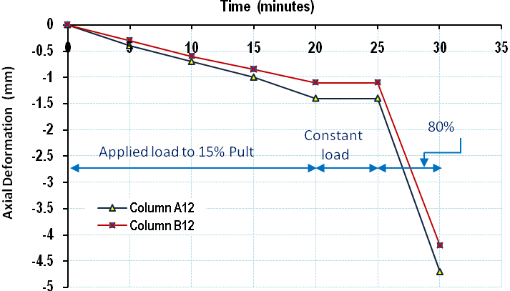
Figure (9): Axial deformation versus time curve at centerline of column specimens
A12 and B12 without burning,25 °C.

P_{ult}

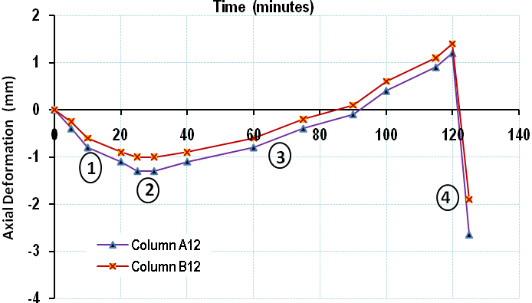
1 Applied load to 15% P_{ult}
2 Constant load
3 Exposed to burning
4 80%P_{ult} and without burning

Figure (10): Axial deformation versus time curve at 50mm from the outer edge of column
specimens A12 and B12 before, during and after burning at 400 °C.

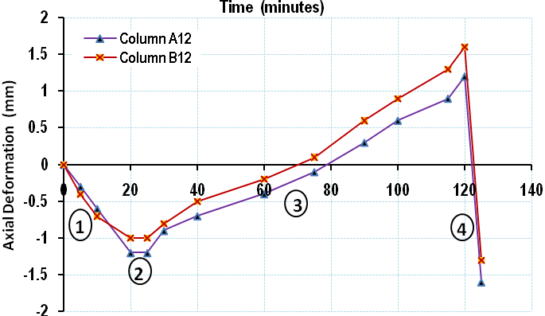
Figure (11): Axial deformation versus time curve at 50mm from the outer edge of column
specimens A12 and B12 before, during and after burning at 600 °C.

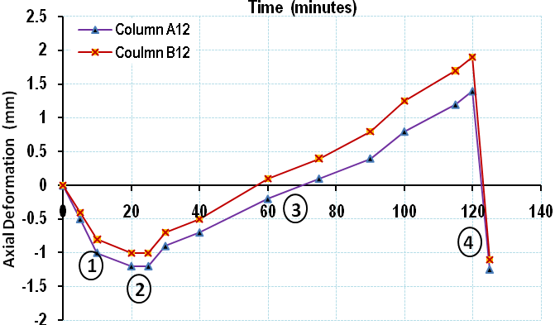
Figure (12): Axial deformation versus time curve at 50mm from the outer edge of column
specimens A12 and B12 before, during and after burning at 750 °C.

COCLUSIONS
- It was found that the ultimate load capacity of column specimens series A and B decreases significantly when subjected to burning by fire flame.
- In this study, it is noticed that the load-midheight lateral deflection relation of column specimens exposed to fire flame temperature around 750ºC are flatter and reveals softer stiffness response than that of the control column specimens. This behavior can be attributed to the continual decrease in specimens stiffness with the increase cracking due to fire flame exposure.
- The experimental results clearly indicate that the concentric column specimens exhibited a small contraction when loaded to 15% of the ultimate load during 25minutes then remain constant for the later period of this applied load, then the columns exhibit a sudden increase in contraction which was identified as failure after applied residual load.
- It was found that the column specimens exposed to fire flame temperature (400, 600, and 750°C) also exhibited a small contraction when loaded to 15% of the ultimate load during 25 minutes then remain constant for the later period of this load, thereon noticed a large elongation at the left and right edge of column specimens when exposed to burning, then a sudden contraction was observed when applying the residual load until 95% of ultimate load.

REFERENCE
- Sakai, K., and Sheikh, S.A., 1989, "What Do We Know About Confinement in Reinforced Concrete Columns", ACI Structural Journal, Vol.86, No.2, Mach-April, PP.192-207.
- Ingham, J., and Tarada, F., 2007, "Turning up the Heat-Full Service Fire Safety Engineering for Concrete Structures", Durable Concrete, October, pp.27-30.
- Jau, W.C., and Huang, K.L., "The Behavior of Reinforced Concrete Corner Columns Under High Temperature", www.Yahoo.Com, Found by Keywords Searches Through Internet, 10p.
- Allen, D.E., and Lie, T.T., 1977, "Fire Resistance of Reinforced Concrete Columns and Walls", National Research Council of Canada, Division of Building Research, Technical Paper No.784 Ottawa, June, pp. 17-33.
- Jae-Hoon, L. and Hyeok-Soo, S., 2000, "Failure and Strength of High Strength Concrete Columns Subjected to Eccentric Loads", ACI, Structural Journal, Vol. 97, No. 1, January, pp. 664-674.
- Kodur, V.R.K., Bisby, L.A., Green, M.F., and Chowdhury, E., 2005, "Fire Endurance Experiments on FRP-Strengthened Reinforced Concrete Columns", National Research Council of Canada, Institute for Research in Construction, Research Report No.185, March, 41pp.
- ACI 318-08, 2008, "Building Code Requirements for Reinforced Concrete", American Concrete Institute, Detroit.
- Neville, A. M., 1995, "Properties of Concrete", Longman Group, Ltd., 4th and Final Edition, 1995, pp.388.
- ACI Committee 211, 1997, "Standard Practice for Selecting Proportions for Normal, Heavyweight, and Mass Concrete (ACI211.1-91)", American Concrete Institute, Michigan, U.S.A.
- Iraqi Organization of Standards, IOS 5: 1984, for Portland Cement.
- Iraqi Organization of Standards, IOS 45: 1984; for Aggregate.

