Computing the Compressive Strength of Concrete Cubes at (7 or 28 days) by Using a Multi Forms Program

Nariman Yahya Othman
Engineering College, Babylon University.
Abstract
This search includes developing a multi forms program to estimate the compressive strength for cubes of concrete (fcu);which are tested in any age from ( 3 – 90 days) and putted back to (7 or 28 days), which are the ages used to estimate the compressive strength of concrete for construction and showing if the samples are conformable according to the Iraqi code (1987) for three specific designed compressive strength (C17, C21 and C25).
The style and mechanism for computing the required compressive strength has been developed by multi forms program which depends on a part of dialog for (compressive strength of cubes (150 mm (6 in)) ,different (w/c) ratios and different ages, storage under moist conditions and the cement used is the ordinary Portland cement) which is established by [Neville].Where the ages in the dialog were (3 days to 20 years) but the part is used is (3 to 90 days). To represent the dialog mathematically it is used three equations, each equation represent a specific (w/c) ratio,( 0.40, 0.53 and 0.71).
The performed program has been developed by using the ( VISUAL BASIC ) which is one of the recent program languages. The language of ( VISUAL BASIC) is used to advantage from its property to treat within windows environment which make it easy for any user.
The results of the multi forms program have been compared with real results for measured cubes, and it is gave a good agreement, which means that the program building is correct because it depends on the dialog of [Neville] which is built on actual data.
المستخلص
يتضمن البحث تطوير برنامج متعدد الواجهات لحساب مقاومة الانضغاط لمكعبات خرسانية تم قياسها بعمر إنضاج (3- 90 يوم) لإرجاع قيم مقاومتها اما بعمر (7 او 28 يوم), وهي الأعمار المعتمدة عادة لمعرفة صلاحية الخلطة الخرسانية لأغراض البناء حسب متطلبات الكود العراقي (1987) والخاص بثلاثة خلطات تصميمية محددة (C17,C21 and C25).
تم تطوير آلية حساب مقاومة الانضغاط المطلوبة باستخدام برنامج متعدد الواجهات معتمداَ على جزء من مخطط معد من قبل ( Neville ) والخاص (بمقاومة الانضغاط لمكعبات خرسانية ذات ابعاد (150مم (6 انج) , مع (نسب (ماء /سمنت) مختلفة, مع اعمار مختلفة وظروف رطبة و نوع الإسمنت كان الإسمنت البورتلاندي الاعتيادي) حيث ان جزء المخطط المستخدم يعتمد الاعمار من (3 – 90 يوم) بينما المخطط الأصلي يبدأ من (3 ايام – 20 سنة). لتمثيل المخطط رياضيا تم اعداد ثلاث معادلات اعتمادا على معطيات المخطط الأصلي كل واحدة منها تمثل مقاومة الانضغاط لنسبة (ماء/ سمنت) محددة وهي (0.40 و 0.53 و0.71).
لتصميم البرنامج تم استخدام لغة (VISUAL BASIC) باعتبارها من اللغات البرمجية الحديثة, حيث استخدمت هذه اللغة لعملها ضمن بيئة (Windows) وسهولة استعمالها من قبل المستخدم.
لقد تم مقارنة النتائج المحصلة من البرنامج مع النتائج المحصلة من فحص مكعبات خرسانية حقيقة في المختبر, وقد وجد أنها متقاربة جدا مما يدل على صحة بناء البرنامج وذلك لاعتماده على المخطط الخاص ب [Neville] والمعتمد أصلا على قياس المقاومة لمكعبات خرسانة حقيقية.

1. Introduction
Concrete is one of the most important materials used in constructions in the world. Massive concreting in huge civil projects like dams, power plants, bridges, and etc…. For decades there was a problem to compute the compressive strength of concrete in (7 or 28 days ) if the cubes of concrete are tested in different age (more or less). For this necessity it was important to find a method to calculate the compressive strength in (7 or 28 days) for the cubes of concrete measured in any other ages.
Therefore, in this search the techniques of (Artificial Intelligence) represented by multi forms program was used to compute the compressive strength for cubes of concrete tested in different ages. The advantage of using the multi forms program is the easily used by the user where this program produced emulation of the abilities of user, give him the advice and answer him on some questions.
2. Literature Review
Some of previous works:
(Tantawi and Gharaibeh,(2006)) established a theoretical model based on a nonlinear regression analysis to consolidated concrete strength at 7 and 28 days by knowing its strength after 6 hr of its casting. Accelerating tests for early determination of concrete strength are used to generate expressions for predictions of hardened concrete strength as composite function of cement content and w/c ratio. By testing more than 200 cubes, the suggested theoretical model shows a good agreement with experimental results.
(Bentezl, Peltzl, and Winpigler (2009)), established that the influence of water-to-cement mass ratio (w/c) on early-age properties of cement-based materials is investigated using a variety of experimental techniques. Properties that are critical to the early-age performance of these materials are tested, including heat release, semi-adiabatic temperature, setting time, autogenously deformation, and strength development. Measurements of these properties using a single cement are presented for four different w/c, ranging from 0.325 to 0.425. Some of the measured properties are observed to vary widely within this range of w/c ratios. The heat release and setting time behaviors of cement pastes are contrasted. While early-age heat release is relatively independent of w/c, the measured setting times vary by several hours between the four w/c investigated in this study, indicating the fundamental differences between a physical process such as setting and heat release which is purely a quantification of chemical reaction. While decreasing w/c certainly increases compressive strength at equivalent ages, it also significantly increases autogenously shrinkage and may increase semi-adiabatic temperature rise, both of which can increase the propensity for early-age cracking in cement-based materials.
(Alilou and Teshnehlab, (2010)), implementation of an artificial neural network has been developed for prediction of compressive strength of concrete. A MISO (Multi Input Single Output) adaptive system has been introduced which can model the proposed phenomenon. The data has been collected by experimenting on concrete samples and then the neural network has been trained using these data. From among 432 specimens, 300 data sample has been used for train, 66 data sample for validation and 66 data sample for the final test of the network. The 3-day strength parameter of concrete in the introduced structure also has been used as an important index for predicting the 28-day strength of the concrete. The simulations in this paper are based on real data obtained from concrete samples which indicate the validity of the proposed tool.
3. Concrete
Concrete is the only material used in construction which can be delivered to the job site in a plastic state. This quality makes concrete can be molded to any form or shape demanded. Concrete provides a wide latitude in surface textures and colors and can be used to construct a wide variety of structures, such as bridges, dams, large buildings, airport runways, irrigation structures, breakwaters, piers and docks, sidewalks, silos and farm buildings, homes, and even barges and ships.
Concrete is usually consists of two major components which are hydraulic cements and inert material. The hydraulic cements are the compound combinations that react chemically with water to harden and developed bonding properties. The primary type of hydraulic cements is Portland cement.
The inert materials are usually composed of fine aggregate, which is a material such as sand, and coarse aggregate, which is a material such as gravel, crushed stone, or slag, ( El-Reedy, (2009)).
When Portland cement is mixed with water, the compounds of the cement react to form a cementing medium. In properly mixed concrete, each particle of sand and coarse aggregate is completely surrounded and coated by this paste, and all spaces between the particles are filled with it. As the cement paste sets and hardens, it binds the aggregates into a solid mass, (Alilou and Teshnehlab, (2010)).
Under normal conditions, concrete grows stronger as it grows older. The chemical reactions between cement and water that cause the paste to harden and bind the aggregates together require time. The reactions take place very rapidly at first and then more slowly over a long period of time, ( Kausay and Simon,(2007)).
4. Compressive Strength of Concrete
The strength of concrete is controlled by the proportioning of cement, coarse and fine aggregates, water, and various admixtures. The ratio of the water to cement is the chief factor for determining concrete strength as shown in Fig.(1). The lower the water-cement ratio, the higher is the compressive strength. A certain minimum amount of water is necessary for the proper chemical action in the hardening of concrete; extra water increases the workability (how easily the concrete will flow) but reduces strength ( Alilou and Teshnehlab, (2010)). (Neville (2000)) mentioned that the strength versus gel /space ratio relationship has a more general application because the amount of gel present in the cement paste at any time is itself a function of age and type of cement. Not only the properties of cement but the (w/c) ratio also affect the rate of gain of strength of concrete. Mixes with a low (w/c) ratio gain strength more rapidly than mixes with higher (w/c) ratios. This is because in the former case the cement grains are closer to one another and a continuous system of gel is established more rapidly
Therefore, the multi forms program is built for three different values of (w/c) ratios to have wide range of results for compressive strength and for ordinary Portland cement.
Compressive strength test results are primarily used to determine that the concrete mixture as delivered meets the requirements of the specified strength,( which is here the requirements of Iraqi code (1987), Table (1)).
5. Built Mathematical Model
The effect of concrete maturity, based on a number of studies of the longtime strength gain of concrete representative of lower bound relationships between age and strength of various classes of concrete, was obtained,(El-Reedy, (2009)).
The compressive strength for each (w/c) ratio are mathematically represented by three equations each one represent the relation between (compressive strength, age of concrete and specific (w/c) ratio for ordinary Portland cement) as shown in figures (2–4) these equations are obtained from the data taken from Fig. (1), and making a fitting curve for each one ,then the equations are respectively for each (w/c ratio) are:

y = 8.8122 ln(x) + 26.838 (w/c = 0.40)………….(1)
y = 9.1624 ln(x) + 11.183 (w/c = 0.53)………….(2)
y = 6.9021 ln(x) + 3.9002 (w/c = 0.71)………….(3)

where :
x : the age of cubes of concrete ,(days).
y : the compressive strength ,(N/mm²) or ( Mpa)
It must be notice that Neville used a log scale in Fig.(1) because the test was for long time interval ( 3 days – 20 years), while in this research the normal scale is used to represent the interval time ( 3 – 90) days because it is short time interval.
The previous equations are used to calculate factors depending on the required age of concrete cubs and the measured age of concrete cubs, as shown :
fact1 = ( 8.8122 ln(x_{req}) + 26.838) / (8.8122 ln(x_{mes}) + 26.838) (w/c = 0.40)…(4)
fact2 = (9.1624 ln(x_{req}) + 11.183) / (9.1624 ln(x_{mes}) + 11.183) (w/c = 0.53)…(5)
fact3 = (6.9021 ln(x_{req}) + 3.9002) / (6.9021 ln(x_{mes}) + 3.9002) (w/c = 0.71)…(6)
where:
fact1,2,3 : the factors,( dimensionless).
x_{req} : the required age, ( days).
x_{mes} : the measured age ,(days).
When the user inter the measured compressive strength of concrete cubes then it will be multiplied by one of the previous factors according to the (w/c) ratio to find the required compressive strength at the required age. The factors for (3,7,28 and 90) days as the measured ages and the (28) day as the required age are listed in, Table (2) and compared with ratios of (fc(3,7,28 and 90) days) to (fc(28) days) listed in, Table (3)and its give a good agreement, this means that the mathematical model for the program is correct.
6. Multi Forms Program
The (VISUAL BASIC) language is a development tool that can be used to build software applications that perform useful work and look great within a variety of settings. Using (VISUAL BASIC), made the user can create applications for the Windows operating system, the web, hand held devices and a host of their environment and setting, because of these advantages the (MFP) was built by using (VISUAL BASIC) language.
The Multi forms program was named by ( MFP ). The mechanism of ( MFP ) was developed to be easily used by the ordinary engineer which has simple knowledge in WINDOWS System.
When the (MFP) has been operated the main window of the program will be appears as showing in Fig.(5), in this figure there is two main operation keys which are (Continue key and Exit key).
If the Continue key be chosen then another windows will be opened and demanded the data which are necessary to estimate the compressive strength at (7 or 28 days) and as showing in Figs.(6 – 7), where Fig (6) which is the primary data window in (MFP) will demand to enter the measured age, the required age and the (w/c) ratios (which are (0.40,0.53 and 0.71) for the intermediate values of (w/c) ratios the (MFP) will always took the higher (w/c) ratio to give a lower compressive strength to make it at the safe side where the relation between the (w/c) ratios and compressive strength is opposites and the relation between (w/c) ratios is not linear . In this window if the entered required age is less than (3 days) or more than (90 days) then a warning message will appear as showing in Fig. (6a),as well as for the (w/c) ratio if it was less than (0.4) or more than (0.71) and as showing in Fig.(6b) to warn that the (w/c) ratio is invalid value. In this window the factor (fact) will be calculated from one of the equations (4-6) depending on the entering required age ,measured age and the (w/c) ratio.
While Fig. (7) which is the secondary data window will demand the mixing ratio which are (1:3:6 , 1:2:4 and 1:1.5: 3) according to the requirements of Iraqi code (1987) and the measured compressive strength for (4) groups ,each group has (3) cubes of concrete. Each one of these windows has a four main operation keys which are ( the Next key which showing the next window in the program, the Back key which showing the previous window in the program, the Help key which showing the windows that having the details that the user needs for the previous windows in the program, as showing in Figs.(8 – 9 ), respectively ,and the Exit key which ends the program); in this window Fig.(7) the entering measured compressive strength will be multiplied by the factor (fact) calculated from the previous window Fig (6) to show the results in Fig.(10) which are the required compressive strength at the required age, and by Calculate key the average of each group of samples and the total average will be calculated and the state of each group and the total groups will be appear if they are conformable to Iraqi code or not depending on the mixing ratio which is entered in secondary data window, Fig (7). At last Fig.(11) showing the help window for the results window.
7. Results and Discussions
By running the (MFP) three practical selected cases, as tabulated in Table (4). For case (1) (MFP) is used to estimate the compressive strength (fc) at (7 days and 90 days) for concrete cubes measured at [(28 days) with (w/c) = 0.53 and mixing ratio = (1: 1.5: 3)] and the results were as showing in figures (12 – 16).
While for case (2) (MFP) is used to estimate the compressive strength (fc) at (7 days) for concrete cubes measured at [(9 days) with (w/c) = 0.50 and mixing ratio = (1: 1.5: 3)] and the results were as showing in figures (17 – 19).
Finally for case (3) (MFP) is used to estimate the compressive strength (fc) at (28 days) for concrete cubes measured at [(31 days) with (w/c) = 0.50 and mixing ratio = (1: 2: 4)] and the results were as showing in figures (20 – 22).
From the results it's found:
1. That ( fc (7) / fc (28) = 0.67, and fc (90) / fc (28) = 1.22), especially for (w/c = 0.53) ratio which is generally used which means that the results have a good agreements by comparing they with the requirements of Iraqi code for the percentage of compressive strength of concrete with age as listed in Table (3).
2. The (MFP) gave an exact result for the requirements of Iraqi code for the different mixing design.
The reason of that little difference in the results, can be return to the building of (MFP) where its depends on the curves of compressive strength (Neville (2000)), where the cubes in perfect conditions of moisture and exact (w/c) ratio while the data used to run the (MFP) was real cubes in real conditions.
8. Conclusions
1. The (MFP) make the calculating of the compressive strength of the concrete cubes is easier. Where it is difficult to calculate by hand.
2. The results found from the (MFP) gave a good agreement with real cases of computing the compressive strength for concrete cubes which make the results calculate by the multi forms program are dependable.
3. Because of the nature the programming of the multi forms program it can be progressing in the future by adding a different suggestion like, the heat degree of the mixing or density of the mixing or even the requirements of another country, etc.

9. References
Alilou, Vahid. K., and Teshnehlab, Mohammed., (2010): (" Prediction of 28-day compressive strength of concrete on the third day using artificial neural networks"), International Journal of Engineering (IJE), Volume (3), Issue (6). http://www.crcpress.com
Bentz1, Dale P., Max A. Peltz1, and John Winpigler,(2009) : ( " Early-Age Properties of Cement-Based Materials: II. Influence of Water-to-Cement Ratio") , ASCE Journal of Materials in Civil Engineering, 21 (9), 512-517.
El-Reedy, Mohamed A., (2009): ("Steel-reinforced concrete structure "),Gulf of Suez Petroleum Company, Cairo, Egypt. http://www.taylorandfrancis.com
Kausay, Tibor and Tamẚs K. Simon (2007) : (" Acceptance of concrete compressive strength"), Concrete Strength , Annual Journal of the Hungarian Group of fib, Budapest , Vol. 8. pp. 54-63.
Neville, A. M., (2000) : ("Properties of concrete" ), Prentice – Hall.
Requirements of Iraqi code (1987).
Tantawi, Hasan M. and Emhaidy S. Gharaibeh,(2006): ( " Early Estimation of Hardened Concrete Strength"), Journal of Applied Sciences 6(3): 543-547.

Table (1): The requirements of Iraqi code (1987)
The sample of designed compressive strength  And the mixing ratio | The designed compressive strength (N/mm²) | The designed compressive strength for a group of three concrete cubes (N/mm²) | The designed compressive strength for a sample of (12) concrete cubes (N/mm²)
C17(1:3:6) | 17 age (28 days)  11.5 age (7 days) | ≥ 14  ≥ 8.5 | ≥ 20  ≥ 14.5
C21(1:2:4) | 21 age (28 days)  14.5 age (7 days) | ≥ 18  ≥ 11.5 | ≥ 24  ≥ 17.5
C25(1:1.5:3) | 25 age (28 days)  17.8 age (7 days) | ≥ 22  ≥ 14.8 | ≥ 28  ≥ 20.8

Table (2): The calculating factors (fact1,2,3) for ordinary Portland cement
Age (day) | 3 | 7 | 28 | 90
(w/c) = 0.4 | 0.65 | 0.78 | 1.0 | 1.25
(w/c) = 0.53 | 0.45 | 0.67 | 1.0 | 1.22
(w/c) = 0.71 | 0.43 | 0.64 | 1.0 | 1.18

Table (3): The ratios of fc(age)/ fc(28) from Iraqi code (1987)
Table (4) : The cases of compressive strength used as data
Age (day) | 3 | 7 | 28 | 90 | 360
Normal hardening ordinary Portland cement | 0.4 | 0.65 | 1.0 | 1.2 | 1.35
Rapid hardening ordinary Portland cement | 0.55 | 0.75 | 1.0 | 1.15 | 1.2

Case  No. | Group | Compressive strength  (N/mm²) |  |  |  | Mixing  design | Measured  Age  (days) | Required  Age  (days) | (w/c) ratio
1 | 1 | 33.77 | 33.86 |  | 32.61 | 1:1.5:3 | 28 | 7  90 | 0.53
1 | 2 | 33.32 | 32.22 |  | 33.65
1 | 3 | 33.45 | 33.54 |  | 33.83
1 | 4 | 32.26 | 33.46 |  | 33.43
2 | 1 | 28.45 | 26.83 |  | 24.7 | 1:1.5:3 | 9 | 7 | 0.50
2 | 2 | 27.74 | 27.20 |  | 28.06
2 | 3 | 27.07 | 25.53 |  | 27.83
2 | 4 | 25.81 | 28.09 |  | 29.11
3 | 1 | 17.94 | 23.98 |  | 20.19 | 1:2:4 | 31 | 28 | 0.50
3 | 2 | 24.46 | 27.71 |  | 27.51
3 | 3 | 23.32 | 20.92 | 19.23
3 | 4 | 24.26 | 28.46 | 27.29

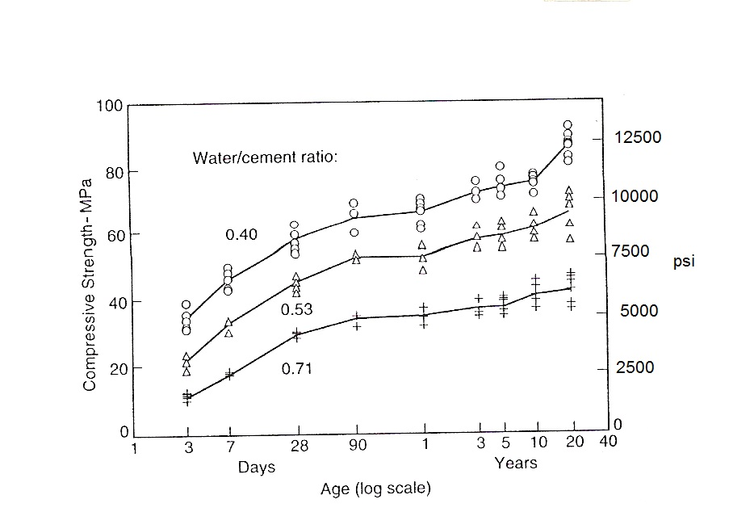

Fig.(1): Development of strength of concrete (by :Neville (2000))

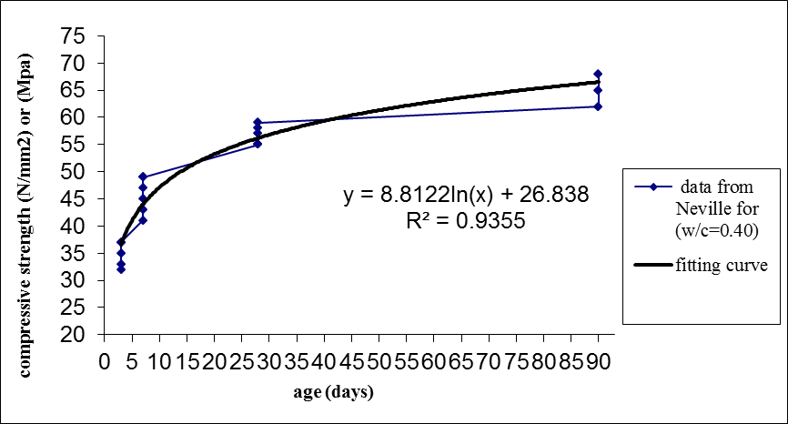
Fig.(2): The fitting curve for the data from Neville for (w/c = 0.40)

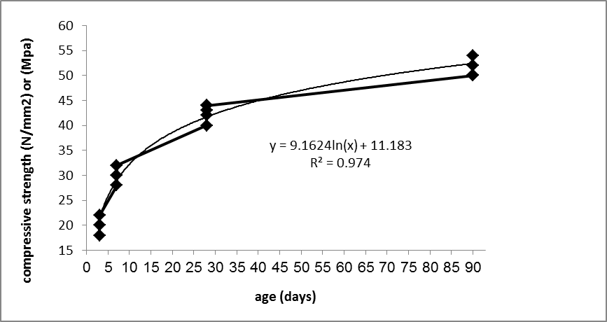
Data from Neville
(w/c = 0.53)

Fitting curve

Fig.(3): The fitting curve for the data from Neville for (w/c = 0.53)

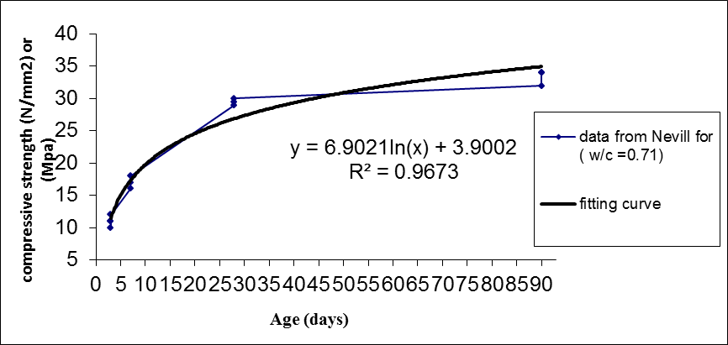

Fig.(4): The fitting curve for the data from Neville for (w/c = 0.71)


MFP

Fig.(5) : Welcome window of (MFP)

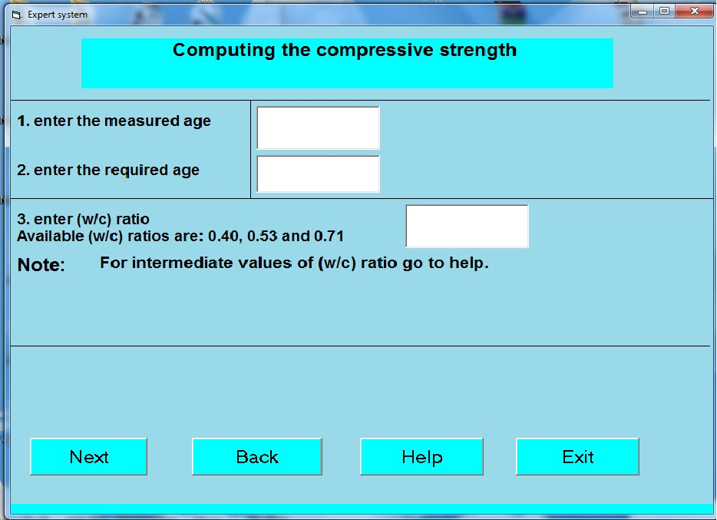
MFP

Fig.(6): Primary data window.


MFP

Fig.(6a): Window has the warning for incorrect required age.

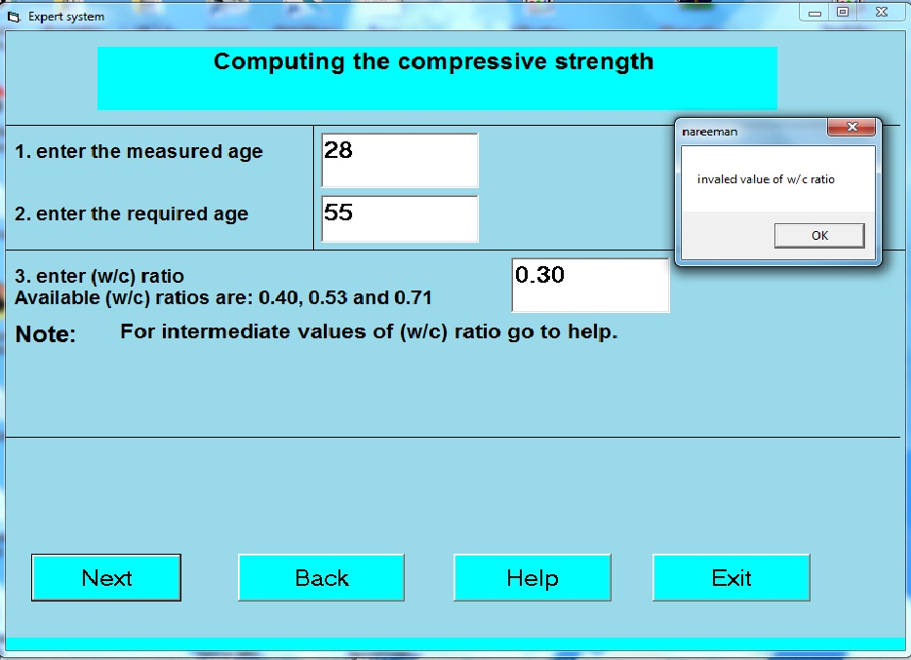
MFP

Fig.(6b): Window has the warning for incorrect (w/c) ratio.
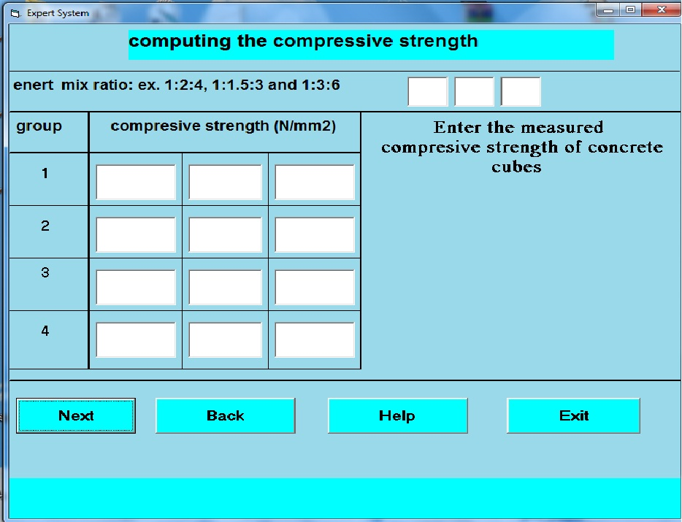
MFP
Fig.(7) : Secondary data window.


MFP
Fig.(8) :Help window for the primary data window.


MFP
Fig.(9) : Help window for the secondary data window.

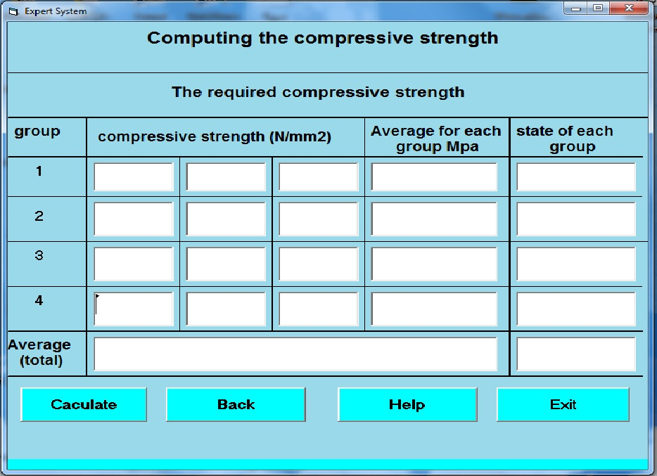
MFP
Fig.(10) : Results window


MFP

Fig.(11) : Help window for the results window.

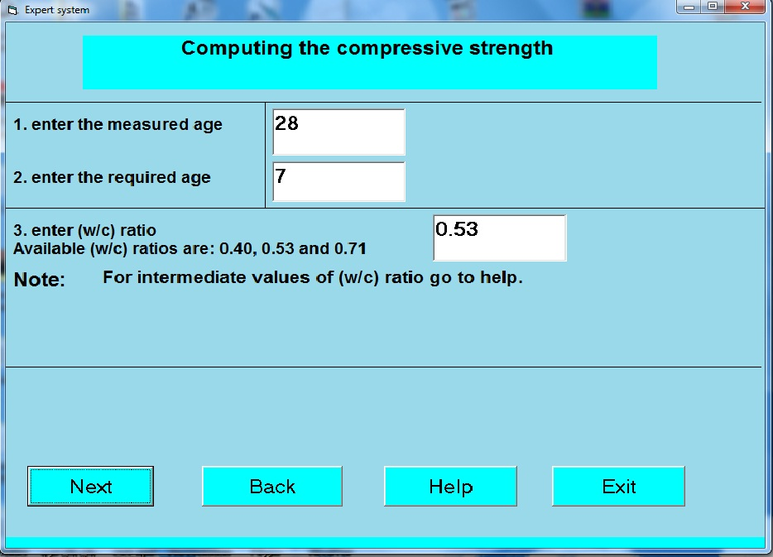
MFP

Fig.(12) : Primary data window for estimating (fc(7)) for case (1).

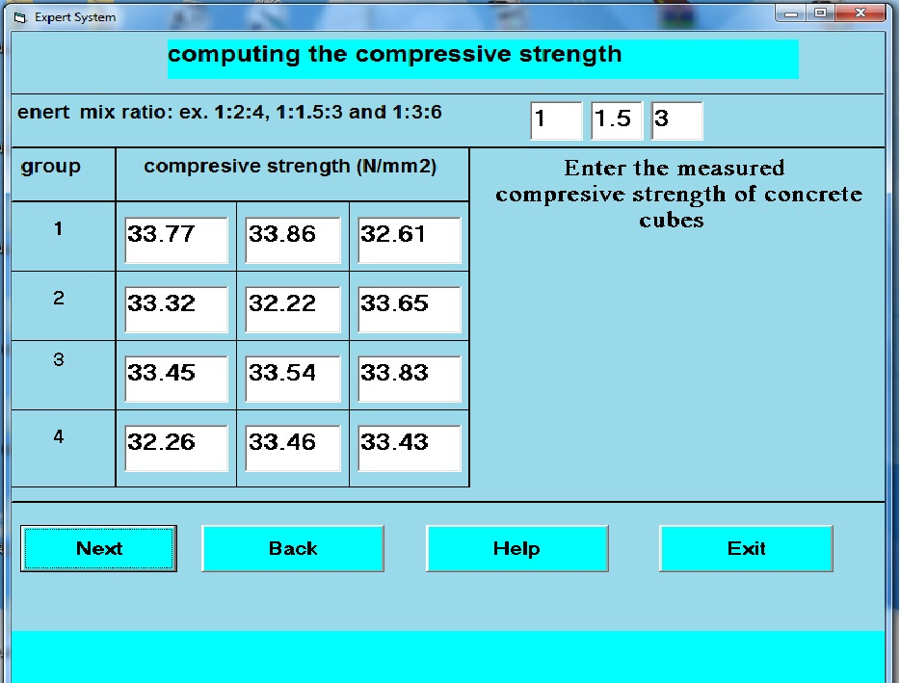
MFP
Fig.(13): Secondary data window (fc(28) for case (1).

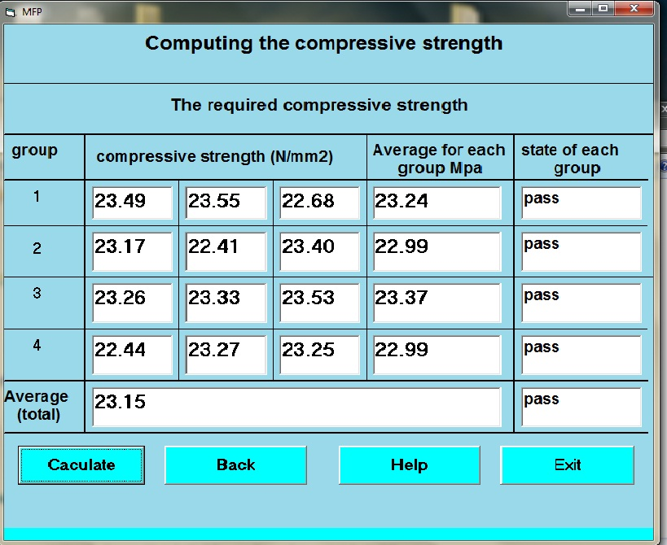
Fig.(14) : Results of (fc (7)) for case (1).
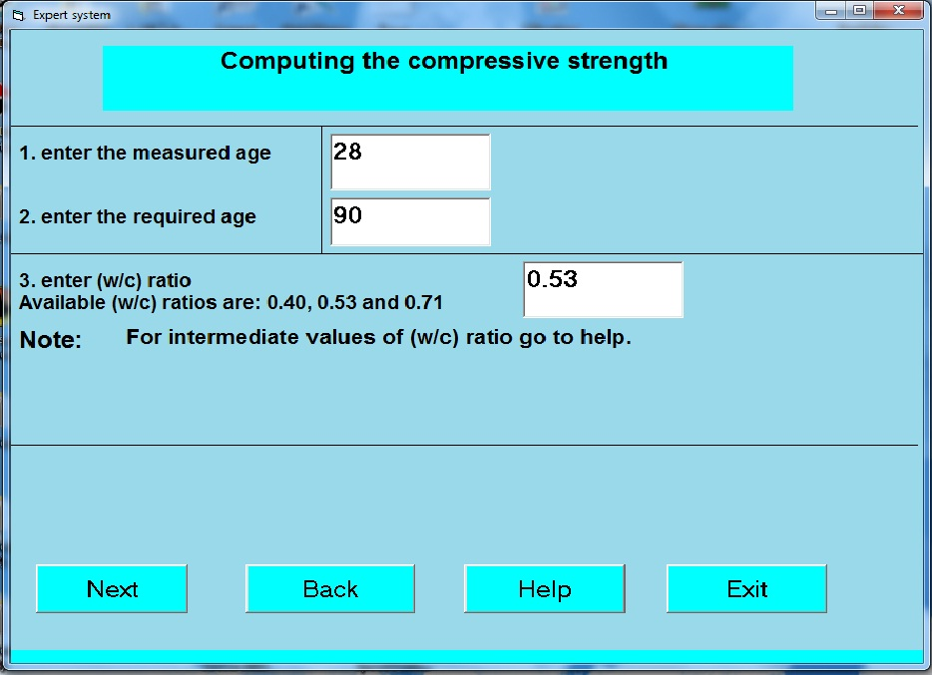
MFP

Fig.(15) : Primary data window for estimating (fc (90)) for case (1).

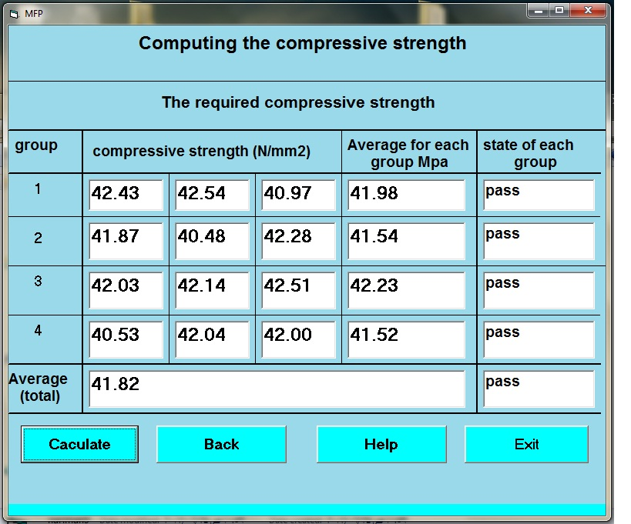
Fig.(16) : Results of (fc (90)) for case (1).
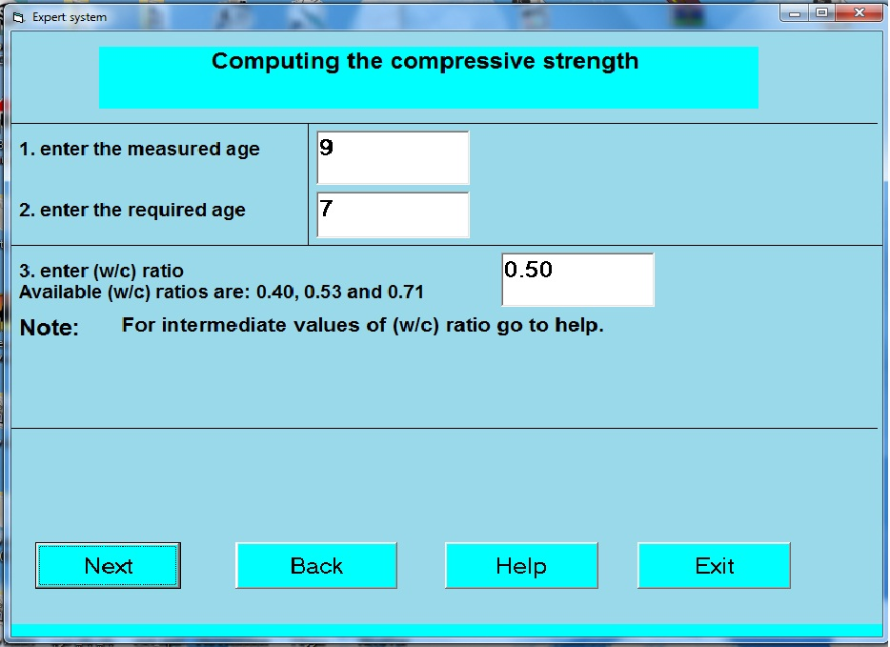
MFP

Fig.(17) : Primary data window for estimating (fc(7)) for case (2).

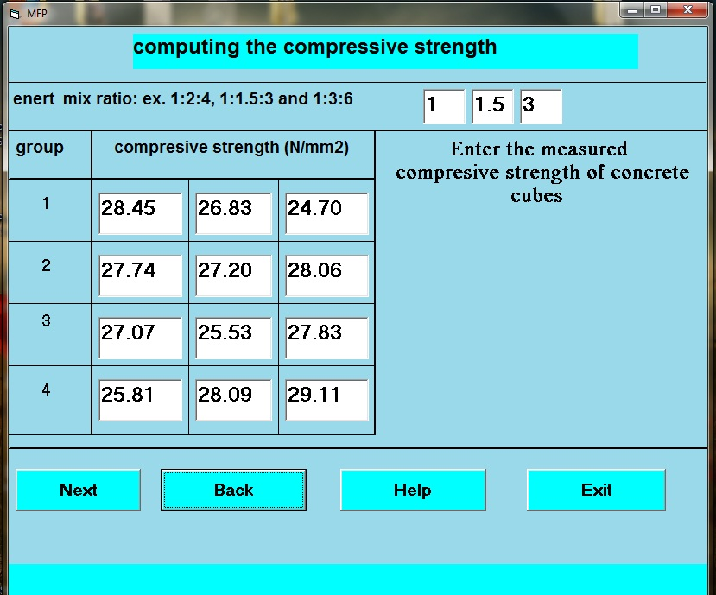
Fig.(18) : Secondary data window (fc (9)) for case (2).

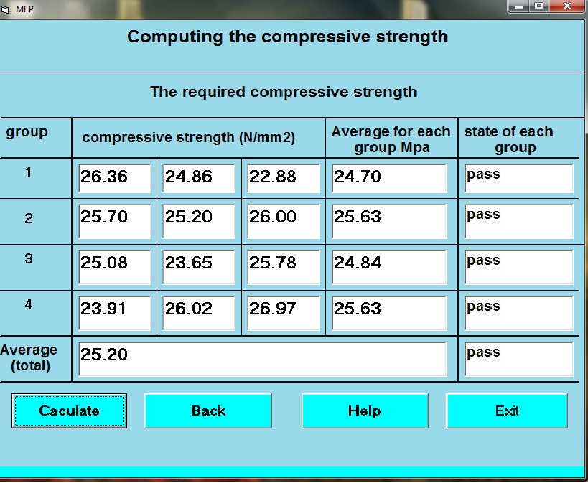
Fig.(19) : Results of (fc (7)) for case (2).
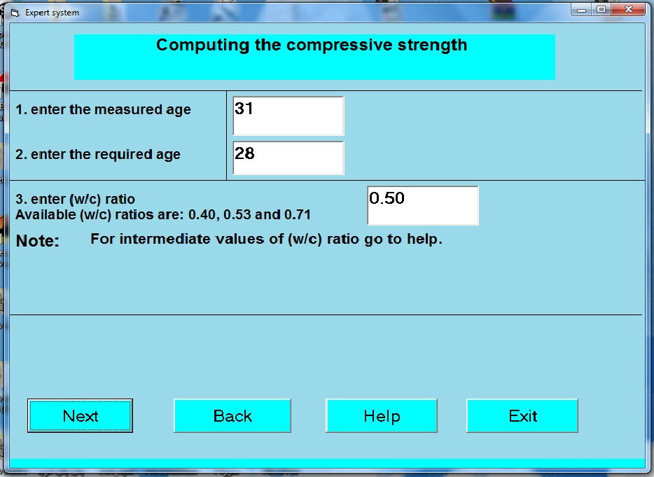
MFP
Fig.(20) : Primary data window for estimating (fc(28)) for case (3).
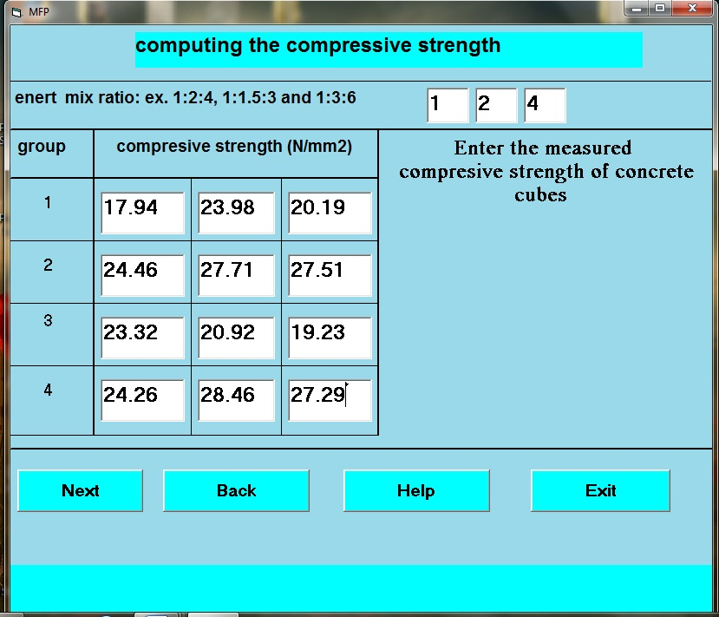

Fig.(21) : Secondary data window (fc (31)) for case (3).
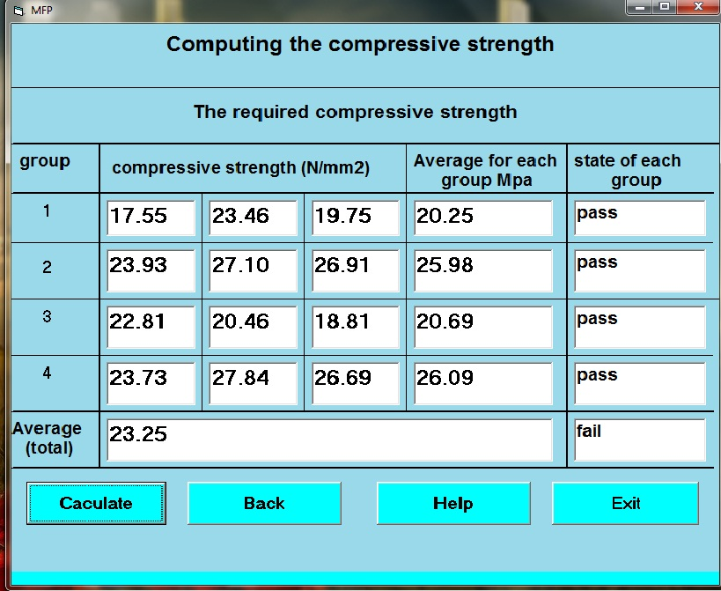

Fig.(22): Results of (fc (28)) for case (3).

