Multi-model Production and Assembly Line Balancing (Caravans Production Workshop)

Sawsan S. Al-zubaidy Fatin F. Abd Alrazaq
University of technology
Abstract
The subject of balancing production lines of the great interest by researchers that because of its significant impact in increasing productivity and rising the efficiency of the production line as well as reduce the time lost, which directly affect production costs. In this research the focus was on approximate methods to solve the problem of balancing multi-model line where the problem was divided into a set of sub-problems solved for the purpose of gradually was used ranked positional weights to solve the problem in addition to the expense of overall efficiency of the multi-model line. The study has been applied in an actual production environment in Al – Fida’a Company which is one of public sectors companies of Iraq Ministry of Industry and Minerals. Four models of caravans with different sizes have been chosen. The balancing of the problem is made for each sub-problem separately and finding the efficiency of multi-model line is reached to 78.8%.
Key words: Assembly Line Balancing Problem, Heuristic Methods, Ranked Positional Weight Rule.
الخـلاصــة
لقي موضوع موازنة الخطوط الإنتاجية الاهتمام الكبير من قبل الباحثين لما له من اثر كبير في زيادة الإنتاجية ورفع كفاءة الخط الإنتاجي, بالإضافة إلى تقليل الوقت الضائع الذي يؤثر بشكل مباشر على كلف الإنتاج.
في هذا البحث تم التركيز على الطرق التقريبية لحل مشكلة موازنة الخطوط التجميعية المتعددة النماذج حيث تم تقسيم المشكلة إلى مجموعة من المشاكل الفرعية لغرض حلها بشكل تدريجي, باستخدام قاعدة ترتيب الاوزارن الموضعية لحل المشكلة مع حساب الكفاءة الكلية للخط المتعدد المنتجات . وقد تم تطبيق هذه الدراسة في شركة الفداء العامة احدى شركات وزارة الصناعة والمعادن في العراق باختيار منتج ( الكرفانات ) كحالة تطبيقية للحالة المقترحة حيث اخترنا اربع موديلات من الكرفانات باحجام مختلفة , وطبقت الطريقة المقترحة لموازنة خط الانتاج وحسبت كفاءة خط انتاج الكرفانات التي وصلت الى 78.8% .
الكلمات الدالة: مشكلة موازنة الخطوط التجميعية, طرق اكتشاف توازن الخط الإنتاجي, قاعدة الأوزان الموضعية المرتبة.
1. Introduction
The assembly line was first introduced by Henry Ford. It was designed to be an efficient, highly productive way of manufacturing a particular product. The basic assembly line consists of a set of workstations arranged in a linear fashion, with each station connected by a material handling device [Sury,1971].
Balancing of assembly line means, the arrangement of production line in the form and style which occurs flow easy and systematic production processes from one workstation to the other the next, so there is no delay or breakdown in any workstation, which would cause a stop next stop them work, in the case of any breakdown, pending the arrival of the materials or parts to complete the manufacturing operations for them [Hitomi,1996]. The aim of the research, developing an approach to solve the problem by dividing it into a set of sub-problems and balancing each one as a single-model problem separately and finally finding the time needed to complete all quantities and calculate the efficiency of the multi-model line.
2. Literature review
The assembly line balancing problem (ALBP) originated with the invention of the assembly line. [Scholl, 2006] was the first to give an analytical statement of assembly line balancing problems. [Salveson ,1955] was the first to publish the problem in its mathematical form. However, during the first forty years of the assembly line’s existence, only trial-and-error methods were used to balance the lines. Since then, there have been numerous methods developed to solve the different forms of the ALBP. [Chehade, Amodeo and Yalaoui ,2009] describe a special type of the assembly line design problem and present hybrid methods based on ant colony optimization. [Moreira, Costa, Ritt and Chaves ,2010] propose a constructive heuristic based on task assignment priority rules for the assembly line worker assignment and balancing problem. [Altekin ,1999] developed a method to balance multi-model assembly line. [Eryuruk, Kalaoglu and Baskak , 2008] used two heuristics assembly line balancing techniques known as the “Ranked Positional Weight” and “Probabilistic Line Balancing”. Were applied to solve the problem of multi-model assembly line balancing. [Gong, Liu, Liu and Cui ,2010] their research compares a multi-model assembly line and assembly cells.
3. Heuristic Methods
Reeves (1995) defined heuristic as “a technique which seeks good (i.e. near-optimal) solutions at reasonable computational cost without being able to guarantee either feasibility or optimality, or even in many cases to state how close to optimality a particular feasible solution is”[ Silver,1980] . Heuristic are often used to solve complex problem. A heuristic could be used to create a solution (also called a constructive heuristic)or to improve an existing solution by exploring the neighboring solutions based on certain rules or strategies [Erel,1998].The heuristic methods can be divided into these rules:
3.1 Largest Candidate Rule
This is the easiest method to understand. The work elements are selected for assigning to stations simply on the basis of the size of their time of element values [Groover,2008].
3.2 Trial and Error Method
This method used to solve the small size problem more than the large size problem cause it losses the time and effort without ensure for reaching to feasible solution because it has multiple feasible choice and difficulties to choose the best [Voss,1999].
3.3 Kilbridge and Westers Rule
This technique has been used to several rather complicated line balancing problems with apparently good success. It is a heuristic procedure which selects work elements for assignment to stations according to their position in the precedence diagram. The elements at the front of the diagram are selected first for entry into the solution [Groover,2008].
3.4 Ranked Positional Weights Rule
The ranked positional weights method was introduced by Helgeson and Birnie (1961) [مازن بكر عادل, 1986]. A ranked positional weight RPW value is computed for each element. The RPW takes account of both the task times’ value of the element and its position in the precedence diagram. Then, the elements are assigned to workstations in the general order of their RPW value.
The procedure of this rule can be summarized by these steps:
- Develop a precedence diagram.
- Determine the positional weight for each work element; a positional weight of an operation corresponds to the time of the longest path from the beginning of the operation through the remainder of the network.
- Rank the work elements based on the positional weight in step 2; the work element with the highest positional weight is ranked first.
- Proceed to assign work element to the work stations where elements of the highest positional weight the rank are assigned first.
- If at any work station additional time remains after assignment of an operation, assign the next succeeding ranked operation to the work station, as long as the operation does not violate the precedence relationship and the station time does not exceed the cycle time.
- Repeat step 4 and 5 until all elements are signed to the work stations. These steps can be presented by a flow chart as shown in figure (1)

Develop a precedence diagram and calculate the PW for each item

Sort items by positional weights descending

Select the unassigned item which has the highest PW

Is the assigned items of the current station violates the Spatial & precedence constraints?

The remaining station time = cycle time - ∑times of an assigned items
Is the item time
the remaining time for the station?

Separate the item for unassigned items and assigned it to the next station
Have all items been assigned?

Eliminate temporality the item for unassigned items

Are there element were not taken into account?

Eliminate temporality the items which are became unassigned items

Take into account the next station

No
Yes
No
Yes
No
Yes
No
Yes
Fig (1) Flow Chart of the Ranked Positional Weights[Groover,2008]
Start
Stop

4. Practical Implementation
The practical part of the work has been applied in an actual production environment in the Public Al – Fida’a Company; the products are chosen for our work are the caravans which are requested by the beneficiary and to cover all the needs of the user.
Four products were selected the types and features can be clarifying as follow:
- Caravan 1.75 * 1.75m consists of (bathroom, air vacuum and external door).
- Caravan 5 * 4 m which is a room with one window and external door.
- Caravan 9 * 3 m which consists of (two rooms, bathroom, two windows , external and internal doors and two air-conditions)
- Caravan 12 * 4 m consist of (two rooms, kitchen, bathroom, three windows, two air-conditions, external and internal doors and accessories).
The total number of tasks for the four caravans is 42 tasks, tasks numbers and descriptions are shown below:
- Cutting of U- Channels.
- Cutting of I- Channels.
- Cutting of L-Sections.
- Cutting of plates.
- Welding (plates and U- Channels) to make leg assembly.
- Welding U- Channels with each other to produce the base.
- Caravan base made by welding leg assembly and the base.
- Welding two pieces of U- Channels to make the holding brackets welded with caravan base.
- The L-Sections is welded to the caravan base to make column structure.
- The roof pipes consist of (U- Channels and L-Sections) is welded to the column structure.
- Internal section produced by welding L-sections and column structure.
- Caravan structure contains of (caravan base, column structure, roof pipes, internal sections and holding brackets) is made by welding them with each other.
- I- Channels and plates are welded to make the air-conditioner box.
- Control step is carried out ensure the caravan structure and air-conditioner box are within the required specification.
- Painting the caravan structure and air-conditioner box.
- Cutting sandwich panel and plywood.
- Covering sides with sandwich panel.
- Covering roof with sandwich panel.
- Covering internal section with sandwich panel.
- Fixing plywood on the floor.
- Making holes for air-conditioner.
- Making holes for external doors.
- Making holes for windows.
- Making holes for internal doors.
- Welding air-conditioner box.
- Installing windows and security protection.
- Covering walls by laminated wood sheet and aluminum corner for all internal staff.
- Establishment of sewage.
- Heater installation.
- Water pumps installation.
- Water tank installation.
- Install sink.
- Install washbasin.
- Install water mixer.
- Install shower.
- Install toilet base (squat toilet or flush toilet).
- Establishment of electrical system.
- Filling all holes with silicon.
- Floor coverings.
- Final finishing of the inside and outside.
- Painting the iron parts out of the caravan.
- Final inspection before delivery.
These tasks are used in production caravans in the multi-model line problem. This problem is splited into four sub-problems. The description of each sub-problem is presented as follows:
4.1 Caravan (1.75*1.75) m
The tasks times of the caravan (1.75*1.75) m can be illustrated in table (1).
Table (1) Tasks Times of Caravan (1.75*1.75)m
Tasks No.  J | 1 |  | 2 | 3 | 4 | 5 | 6 | 7 | 8 | 9 | 10 | 11 | 12 | 13 | 14
i | 1 | 3 |  | 4 | 5 | 6 | 7 | 8 | 9 | 10 | 12 | 14 | 15 | 16 | 17
Times /hr. | 0.25 | 0.75 |  | 0.5 | 0.25 | 2.5 | 0.5 | 0.25 | 0.5 | 0.25 | 0.25 | 0.5 | 1.5 | 1 | 0.5
Tasks No.  J | 15 | 16 |  | 17 | 18 | 19 | 20 | 21 | 22 | 23 | 24 | 25 | 26 | 27
i | 18 | 20 |  | 22 | 23 | 27 | 28 | 33 | 36 | 37 | 38 | 40 | 41 | 42
Times /hr. | 0.5 | 0.5 |  | 0.25 | 0.5 | 1 | 2 | 1 | 1 | 8 | 4 | 2 | 1 | 5
i= 1, J=27 where i= 1,2 … K (no. of products); J =1,2,…n (no. of tasks)
The technological route of the caravan can be presented by a net which is consists of circles and arrows to clarifying the precedence relation between tasks as shown in fig (2).
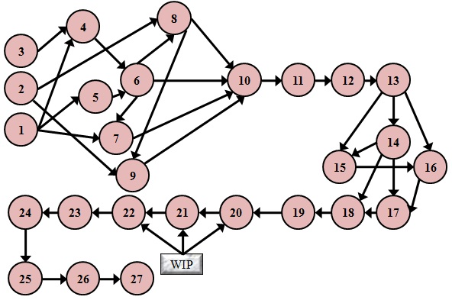

Figure (2) Precedence Graph for Caravan (1.75*1.75) m

4.2 Caravan (5*4)
The tasks time of the caravan (5*4) can be presented by table below.
Table (2) Tasks Times of Caravan (5*4)m
Tasks No  J | 1 | 2 | 3 | 4 | 5 | 6 | 7 | 8 | 9 | 10 | 11 | 12 | 13
i | 1 | 3 | 4 | 5 | 6 | 7 | 8 | 9 | 10 | 12 | 14 | 15 | 16
Times /hr | 0.25 | 0.75 | 0.5 | 0.25 | 3 | 1 | 0. 5 | 0.5 | 0. 5 | 0.25 | 0.5 | 2 | 1
Tasks No  J  i | 14 | 15 | 16 | 17 | 18 | 19 | 20 | 21 | 22 | 23 | 24 | 25
 | 17 | 18 | 20 | 22 | 23 | 26 | 27 | 37 | 38 | 40 | 41 | 42
Times/hr. | 1 | 0.5 | 1 | 0.5 | 0.25 | 1 | 1.25 | 5 | 4 | 2 | 1.25 | 6
i= 2, J=25
The precedence graph for this caravan can be illustrated in figure below.

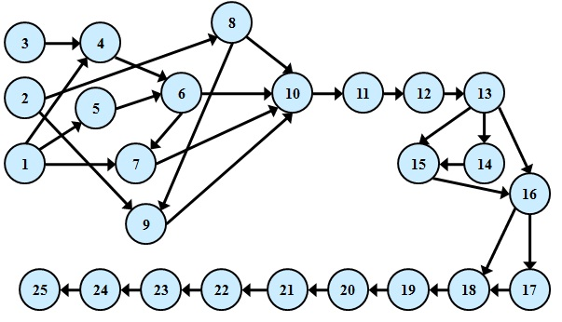

Fig (3) Precedence Graph for Caravan (5*4) m
4.3 Caravan (9*3) m
The tasks times of the caravan (9*3) m can be illustrated in table (3).
Table (3) Tasks Times of Caravan (9*3)m
No  J | 1 | 2 | 3 | 4 | 5 | 6 | 7 | 8 | 9 | 10 | 11 | 12 | 13 | 14 | 15 | 16 | 17 | 18 | 19 | 20
i | 1 | 2 | 3 | 4 | 5 | 6 | 7 | 8 | 9 | 10 | 11 | 12 | 13 | 14 | 15 | 16 | 17 | 18 | 19 | 20
hr | 1 | .25 | .75 | .5 | .5 | 4 | .75 | .5 | .75 | .5 | .75 | .25 | .75 | 2 | 10 | .75 | 6 | 4 | 2 | 5
No  J | 21 | 22 | 23 | 24 | 25 | 26 | 27 | 28 | 29 | 30 | 31 | 32 | 33 | 34 | 35 | 36 | 37 | 38 | 39 | 40
i | 21 | 22 | 23 | 24 | 25 | 26 | 27 | 28 | 29 | 31 | 32 | 34 | 35 | 36 | 37 | 38 | 39 | 40 | 41 | 42
hr | 2 | 1 | 0.75 | 2 | 1 | 2 | 20 | 5 | 2 | 1.5 | 1 | 1.5 | 2 | 1 | 48 | 12 | 10 | 5 | 3 | 24
i= 3, J=40
The technological route of the caravan can be presented by figure (4).
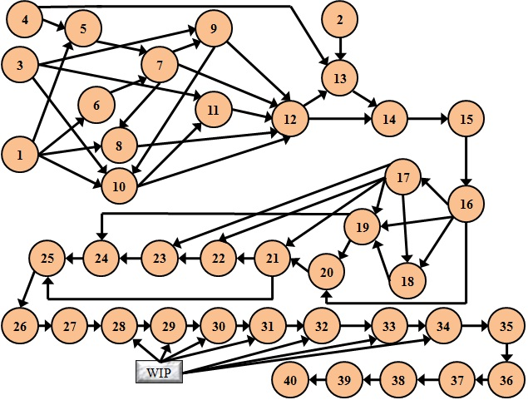

Figure (4) Precedence Graph of Caravan (9*3) m
4.4 Caravan (12*4) m
The table below represented the times for each task to make the caravan (12 *4).
Table (4) Tasks Times of Caravan (12*4)m
No  J | 1 | 2 | 3 | 4 | 5 | 6 | 7 | 8 | 9 | 10 | 11 | 12 | 13 | 14 | 15 | 16 | 17 | 18 | 19 | 20
i | 1 | 2 | 3 | 4 | 5 | 6 | 7 | 8 | 9 | 10 | 11 | 12 | 13 | 14 | 15 | 16 | 17 | 18 | 19 | 20
hr | 1 | .5 | .5 | .75 | .75 | 5 | 1 | .75 | 1 | .75 | 1.5 | .5 | 1.5 | 3 | 12 | 1.5 | 8 | 6 | 4 | 7
No  J | 21 | 22 | 23 | 24 | 25 | 26 | 27 | 28 | 29 | 30 | 31 | 32 | 33 | 34 | 35 | 36 | 37 | 38 | 39 | 40
i | 21 | 22 | 23 | 24 | 25 | 26 | 27 | 28 | 29 | 30 | 31 | 32 | 33 | 34 | 35 | 36 | 37 | 38 | 39 | 40
hr | 4 | 3 | 1.5 | 4 | 3 | 4 | 22 | 7 | 4 | 3 | 2 | 1 | 1.5 | 2 | 1 | 1 | 50 | 14 | 12 | 8
i= 4 , J=42
The technological route of caravan (12*4) can be clarifying by figure (5).
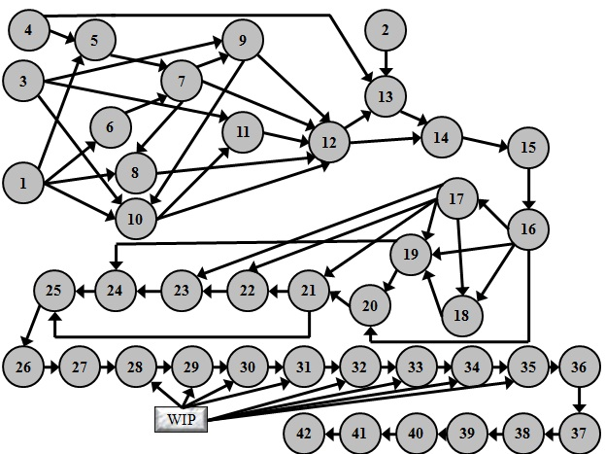

Figure (5) Precedence Graph for Caravan (12*4) m
5. Results
To balancing the multi models assembly line we divided problem into sub problem and balancing each product separately depend on their sequencing by using ready software (production and operations management – quantitative method) (POM-QM) and the final result can be shown below by tables and figures.
Table (5) Summary of Caravan (9*3) m
Cycle Time | 48 hours
Min (theoretical ) no. of workstations | 4
Actual no. of stations | 5
Time allocated (cycle * station) | 240 hours per cycle
Time needed (sum tasks) | 185.75 hours per unit
Idle time | 54.25 hours per cycle
Efficiency | 77.4 %
Balance delay | 22.6 %
The time used in each station presented by figure (6).

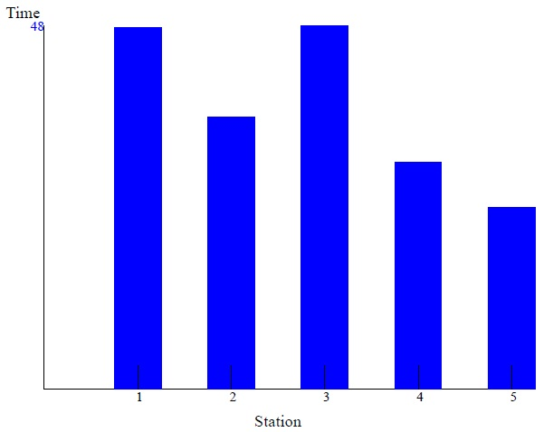

Figure (6) Time Used in Each station of Caravan (9*3) m
Table (6) Summary of Caravan (5*4) m
Cycle Time | 6 hours
Min (theoretical ) no. of workstations | 6
Actual no. of stations | 7
Time allocated (cycle * station) | 42 hours per cycle
Time needed (sum tasks) | 34.75 hours per unit
Idle time | 7.25 hours per cycle
Efficiency | 82.74 %
Balance delay | 17.26 %

The time used in each station presented by figure (7).
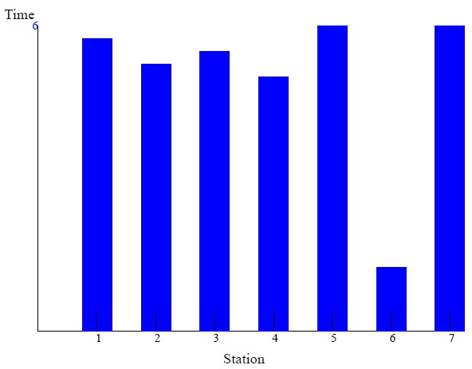

Figure (7) Time Used in Each station of Caravan (5*4) m
Table (7) Summary of Caravan (12*4) m
Cycle Time | 50 hours
Min (theoretical ) no. of workstations | 5
Actual no. of stations | 6
Time allocated (cycle * station) | 300 hours per cycle
Time needed (sum tasks) | 240 hours per unit
Idle time | 60 hours per cycle
Efficiency | 80 %
Balance delay | 20 %

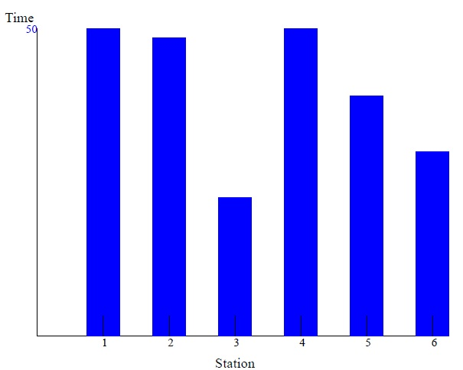

Figure (8) Time Used in Each station of Caravan (12*4) m
And the results of our application which is consists of the batches sizes for each product, the time needed to complete each batch, efficiency for each product and the quantity of each products; table (9) represents these result.
Table (9) Summary of Practical Case
I | Type of Caravan |  |  |  |  |  | M | %
3 | 9*3 | 72 | 4 | 18 | 48 | 864 | 5 | 77.4%
2 | 5*4 | 60 | 4 | 15 | 6 | 90 | 7 | 82.74%
4 | 12*4 | 80 | 4 | 20 | 50 | 1000 | 6 | 80%
1 | 1.75*1.75 | 48 | 4 | 12 | 8 | 96 | 6 | 75.52%

6. Efficiency of the Line
To estimate the efficiency of the multi models lines we apply the rule presented below which multiplying summation of efficiencies and batch time for all products is dividing by summation of batch times for all products as shown below.
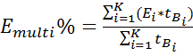 * 100
* 100
= 78.8 %
7. Calculations of the Total Time
The required time to complete all quantity for products should be calculated to make sure that the company can completes all quantity for products during the period or not. Taking in consideration that;
The number of working hour for each day = 8 hr/ day
Hence, summation of the required time to complete one batch of each product (one cycle of batches) is equal to = (96+1000+90+864) = 2050 hr.
Therefore; the number of required working days is equal to 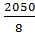 ≈ 257 working days per one cycle of batches.
And the required days to complete all quantity is 257*4 = 1028 day
8. Conclusions
Research in assembly lines balancing problem is still continuous. Balancing the multi models lines problem are presented in this paper. The balancing aims to minimize the lost time and increase the productivity and efficiency of the line. We balancing the line by using RPW rule and we find the multi models problem can be balancing by divided it into sub problem and balancing each product separately as a single model. The efficiency of the multi models problem can be found by balancing each product separately and calculated there efficiency.
9. Recommendation and suggested future work
This research can be used by the company to give future outlook if it can accomplish the demand within the required time or not.
The suggested future work is the assembly line balancing problem in multi-model in the case when unequal batches number. Extend the study to the mixed-model assembly line balancing problem.
References:
Altekin, T. F., (1999) “An Approach to Multi-Model Assembly Line Balancing”, M.Sc. Thesis, METU, ANKARA.
Chehade, H., Amodeo, L. , Yalaoui, F., (2009) “Solving Single and Multi Objective Models for An Assembly Line Design Problem through Ant Colony Algorithms”, Math ware & Soft Computing 16, pp. 133-160.
Erel, Erdal, and Sarin, S.C., (1998) “A survey of the Assembly Line Balancing Procedures, Production Planning and Control”, (9) 34-42.
Eryuruk, S. H., Kalaoglu, F. and Baskak, M., (2008) “Assembly Line Balancing in a Clothing Company”, FIBRES&TEXTILES in Eastern Europe, Vol. 16, No. 1(66).
Gong, J., Liu, W., Liu, X. and Cui, T., (2010) “A Simulation-Based Performance Comparison between Multi-Model Assembly Lines and Assembly Cells in a Just-In-Time Environment”, National Nature Science Foundation under Grant.
Groover, M. P., (2008) “Automation Production Systems and Computer- Integrated Manufacturing”, Lehigh University, Prentice-Hall.Inc.
Hitomi, K., (1996) “Manufacturing Systems Engineering”, Taylor and Francis, Inc., Second Edition.
Moreira, M. C. O., Costa, A. M., Ritt, M., Chaves A. A., (2010)” Simple Heuristics for the Assembly Line Worker Assignment and Balancing Problem”, arXiv: 1003.3676v1 [cs.DS] 18 Mar.
Salveson, M.E., (1955) “The Assembly Line Balancing Problem”, Journal of Industrial Engineering”, (6) 62-69.
Scholl, A., and Becker, C., (2006) “State-of-the-Art Exact and Heuristic Solution Procedures for Simple Assembly Line Balancing”, European Journal of Operational Research, 168,666-693.
Silver, E. A., R. V. and de Werra, D. (1980) “A Tutorial on Heuristic Methods”, European Journal of Operational Research. 5:153-162.

Sury, R. J., (1971) “A spects of Assembly Line Balancing” , International Journal of Production Research,No.9, 8-14.
Voss, S., Martello, S., and Osman, I. H., (1999) “Meta-Heuristics: Advances and Trends in Local Search Paradigms for Optimization”, Kluwer Academic Publishers.
مازن بكر عادل, محمد كامل عليوة, جميل حنا حبشي, (1986) " بحوث العمليات للادارة الهندسية",مديرية دار الكتب للطباعة والنشر.

