Influence of Mineral Filler- Asphalt Ratio on Asphalt Mixture Performance

Hanaa Mohammed Mahan
University of Babylon / College of Engineering
Abstract
Current development in the design of asphalt concrete especially in the upper layers of flexible pavements contains about acceptable proportion of mineral fillers, which contributes towards the mix cohesion, resistant to rutting and improves serviceability. It is well recognized that mineral fillers play an important role in the properties of mastics and hot-mix asphalt (HMA) mixtures. Better understanding of the effects of fillers on the properties of mastics and HMA mixtures is crucial to good mix design and high performance of HMA mixtures. This paper presents a laboratory investigation into the effects of different fillers on some properties of HMA mixtures.
Three filler types , three filler contents and optimum asphalt content (± 0.3) were used to investigate the effect of filler / asphalt ratio on the characteristics of HMA mixtures.
In this study, fifteen sets of bituminous mixtures using different types and amount of mineral fillers were evaluated using the Marshall Mix design method. These mixtures were prepared using Portland cement, hydrated lime, and limestone dust fillers with varying the content by the total mixture and their effects on Marshall Properties were assessed, the best ratio of F/A was (1.4) for all type of mineral filler .
الخلاصة:
اغلب الدراسات والتطورات الحالية في أطار تصميم الخلطات الإسفلتية تتناول تأثير الفلر إلى حد كبير على خواص وأداء مواد التبليط الإسفلتية وبشكل خاص عند الطبقات السطحية . يضاف إلى انه يؤثر على تماسك قوام الخلطة, مقاومة التشوهات الدائمة وأخيرا تحسين خواص الأداء.
يتناول هذا البحث مناقشة النتائج المختبرية التي تم التوصل إليها والتي تبين تأثير اختلاف محتوى ونوع الفلر على خواص الخلطات الإسفلتية وذلك باستخدام ثلاث أنواع من الفلر وبثلاث نسب لكل نوع مع محتوى تصميمي امثل للآسفلت (±0.3) لبيان تأثير نسبة الفلر إلى الإسفلت على خواص الخلطات الإسفلتية .
خمسة عشر مجموعة من النماذج الإسفلتية تم تحضيرها باستخدام الأنواع الثلاثة من الفلر (Portland cement,
hydrated lime and limestone dust) وباستخدام فحص مارشال تم تقييم خواص الخلطة الإسفلتية ودراسة تأثير نسبة الفلر إلى الإسفلت وتم التوصل إلى انه أفضل نسبة هي 1.4 ولمختلف أنواع الفلر.

1:Introduction :
Numerous studies have shown that the properties of mineral filler (especially the material passing No. 200 sieve) have a significant effect on the properties of the HMA
mixtures. The introduction of environmental regulations and the subsequent adoption of dust collection system has encouraged the return of most of the fines to the HMA mixture. A maximum filler / asphalt ratio of 1.2 to 1.5, based on weight, is used by many agencies to limit the amount of the minus 200 material. However, the fines vary in gradation, particle shape, surface area, void content, mineral composition, and physico-chemical properties and, therefore, their influence on the properties of HMA mixtures also varies. Therefore, the maximum allowable amount should be different for different fines.( Kandhal et al, 1998).
The addition of filler to the mixture can improve adhesion and cohesion substantially (filler is a fine material, which passes a 0.063 mm sieve, derived from aggregate or other similar granular material). The bitumen-filler system (mastic), which is thicker and tougher than bitumen alone, improves the adhesive qualities and, in providing a covering film of greater thickness, also means that the aging processes
can be slowed down. The effects of the addition of filler are directly related to their characteristics and the degree of concentration of the filler in the bitumen-filler system.
The advantages that filler offers for the durability of the bituminous mixtures in the case of water action are due, in principle, to its physical characteristics, reducing the porosity of the granular structure and thereby making the access of water and air difficult. Moreover, the chemical nature of filler may mean greater affinity with the
asphalt binder, improving the resistance to the displacement that the water causes the bitumen. Using immersion tests (Craus, Ishai and Sides ,1978)assessed the influence that the type of filler had on the durability of the bituminous mixtures. The authors reviewed the usual criteria of mixture design, with analyses that simulate short periods of exposure to the environment (for example, for the case under study, the residual Marshall stability and the resistance of immersion-compression), noting that mixtures that pass these tests, usually fail completely in service. With the obtained results they were able to modify the existing criteria for the classification of fillers, which had only been based on basic properties without considering the durability factor. From this works, the authors have continued studying the effect of the characteristics of fillers on the durability of the mixtures (Miro et al,2004) .
2:Objectives
The objectives of the study were to investigate the effects of quality and quantity of mineral filler ( Portland cement, limestone dust and hydrated lime) to asphalt ratio on the design properties and performance of hot mix asphalt and give recommended.
3:The Effect of Mineral Fillers on HMA
Mineral fillers are added to asphalt paving mixtures to fill voids in the aggregate and reduce the voids in the mixture. However, addition of mineral fillers has dual purpose when added to asphalt mixtures. A portion of the mineral filler that is finer than the asphalt film thickness mixed with asphalt binder forms a mortar or mastic and contributes to improved stiffening of mix. This modification to the binder that may take place due to addition of mineral fillers could affect asphalt mixture properties such as rutting and cracking. The other portion of fillers larger than the asphalt film thickness behave as a mineral aggregate and serves to fill the voids between aggregate particles, thereby increasing the density and strength of the compacted mixture. In general, filler have various purposes among which, they fill voids and hence reduce optimum asphalt content and increase stability, meet specifications for aggregate gradation, and improve bond between asphalt cement and aggregate [Bouchard, 1992 ]
A research (asphalt institute,1993 ) was conducted on the effects of mineral fillers on rutting potential of bituminous mixtures. The mineral aggregate used in the research was crushed limestone aggregate in combination with different materials passing 0.075mm sieve, such as limestone dust, hydrated lime, and Portland cement. The research was carried out using limestone dust (control mix) and replacing by hydrated lime and Portland cement in different proportions. From various tests conducted, the authors arrive at following conclusions.
• Greater raise in softening point of asphalt mastics was achieved when replacing limestone dust with hydrated lime than Portland cement.
• Mixtures prepared by replacing limestone dust with hydrated lime at higher filler content, acquire higher optimum asphalt content, higher air voids, and lower unit weights than those containing Portland cement. This is attributed to the higher specific surface area and asphalt absorption of the hydrated lime particles than Portland cement.
• Increasing filler content in the mixture enhances the Marshal and Hveem stability, as expected. This is because increasing filler content from 3% to 5.5% fills the voids among aggregate particles thus producing dense mixes, hence increasing stability, whereas increasing filler content beyond 5.5% reduce the contact among coarse aggregate particles, hence reducing the stability.
• While replacing limestone dust by either hydrated lime or Portland cement in the mixes, there was a decrease in resilient modulus values.
• Replacing part of limestone dust by hydrated lime or Portland cement aggravates the resistance of mixes to rutting. The rut depth increases as the percentage replaced increases; where higher rut depth was observed when replacing limestone mixes with hydrated lime than Portland cement.

4:Problem Statement
Researches show that modification made in the ingredients of bituminous mixtures such as type of ingredient materials and relative proportion has altered and sometimes improved the properties of HMA. Among these researches, some studies proved that mineral fillers have important role in the performance of HMA. Depending on the fillers characteristics, it was found that their purpose was not only to fill the voids but also modifying the mixture. This study was, therefore, made to evaluate effect of different types of mineral fillers, namely limestone, Portland cement and hydrated lime at various contents. On the other hand, in the construction of highway pavements, one of the main problems is insufficiency of amount of mineral fillers from crushing of aggregates. Moreover, there is also environmental deterioration resulting from blasting of more quarry areas to produce the required amount of mineral fillers and its mode of production has made it to be expensive. Therefore, it is important to find an alternative type of mineral filler materials. Thus, this study was made with this intention ( Zemichael,2007).

5:Material Characterization and Testing
5.1. Materials
Hot Mix Asphalt generally consists of combination of different size of aggregates with mineral fillers, uniformly mixed and coated with asphalt cement, each having its own particular characteristics, which will be more suitable to specific design and construction purposes. Before designing asphalt paving mixes, selection, proportioning and characterization of individual material are imperative to obtain the desired quality and properties of finished mix. For the current study, crushed aggregates were obtained from the local source ( Nibaee quarry) with maximum nominal size 12.5 mm , asphalt cement used with grade penetration ( 40-50 ), the physical properties of that grade are represented in table( 1).Limestone dust and hydrated lime ( both from lime factory in Karbala) and Portland cement use as mineral filler. Aggregates were sieved and recombined in the laboratory to obtain the selected gradation according to the specification requirements of SCRB / R 9 for surface layer type( I)as shown in table ( 2 ).

Table (1): Asphalt cement physical properties
Tests Method | Recommended | Results
Penetration- ASTM-D-5(1/100) | 40-50 | 44
Ductility –ASTM- D-113 (cm) | Min.100 | >100
Specific gravity –ASTM- D-70 | …. | 1.053
Flash point- ASTM-D-92(C̊) | 235 | 260
Incorporating different amount of mineral fillers, the Job-Mix-Formula (JMF) for the aggregate particle size distribution that would be used for the preparation of mixtures where keeping the coarse aggregate size distribution unchanged and varying distribution in the fines. The specified grading limits and that of obtained for this study are as shown in figure (1).

Table( 2): SCRB / R 9 Aggregate gradation Requirement
Sieve Size |  | JMF for different filler content |  |  | Specification Limits
inch | mm | 5 | 7 | 9 | Specification Limits
3/4 | 19 | 100 | 100 | 100 | 100
1/2 | 12.50 | 95 | 95 | 95 | 90-100
3/8 | 9.50 | 83 | 83 | 83 | 76-90
No.4 | 4.75 | 59 | 59 | 59 | 44-74
No.8 | 2.36 | 44 | 43 | 42 | 28-58
No. 50 | 0.30 | 14 | 13 | 12 | 5-21
No. 200 | 0.075 | 5 | 7 | 9 | 4-10

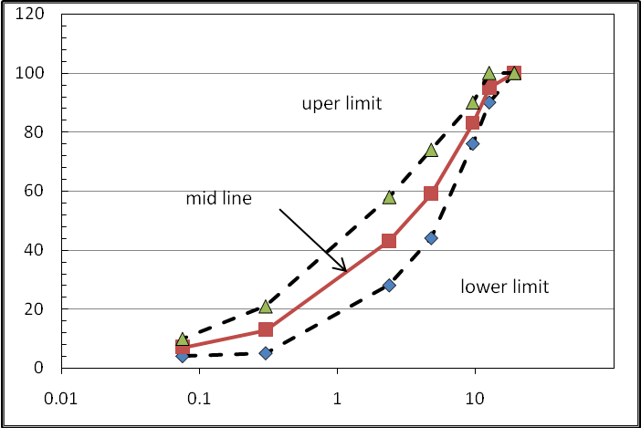
Percentage passing %
Sieve size (mm)

Figure (1) Gradation Limit

5.2.Marshall tests
An Asphalt Institute Marshall Method of Mix Design has adopted for the preparation of mixes(Asphalt Institute, 2003). The Marshall method as presented here is applicable only to hot-mix asphalt cements and containing aggregates with maximum size of 19mm. The method is intended for laboratory design of asphalt hot-mix paving. The Marshall method uses standard cylindrical test specimens of 64mm (2 ½ in.) height x 102 mm (4 in.) diameter. These were prepared using a specified procedure for heating, mixing, and compacting the asphalt aggregate mixtures. The two principal features of the Marshall method of mix design are stability-flow test and density-voids analysis of the compacted test specimens.
The stability of the test specimens is the maximum load resistance in Newton’s (lb.) that standard test specimen will develop at 600C (1400F). The flow value is the total movement or the strain occurring in, the specimen between no load and maximum load during the stability test (Asphalt Institute, 2003).
Stiffness index is an empirical relationship which is the ratio of stability to flow of mixes at 600C , Marshal Mix design criteria for surface layer are represented in Table (3).
Table ( 3 ): Marshall Criteria for Asphalt Concrete Mix Design
Marshall Method Mix Criteria | Light traffic |  | Medium traffic |  |  | Heavy traffic
Marshall Method Mix Criteria | Surface-base |  | Surface-base |  |  | Surface-base
Marshall Method Mix Criteria | Min | Max | Min | Max |  | Min | Max
Compaction, blows/ end | 35 |  | 50 |  |  | 75
Stability, N | 3336 | …. | 5338 |  | ….. | 8006 |  | …..
Flow, 0.25 mm (0.01 in) | 8 | 18 | 8 |  | 16 | 8 |  | 14
Percent Air Voids | 3 | 5 | 3 |  | 5 | 3 |  | 5
Percent Voids Filled With asphalt | 70 | 80 | 65 |  | 78 | 65 |  | 75
Percent VMA for 4% Air voids | 13 | …. | 13 |  | …. | 13 |  | ….

6: Results and Dissection
6:1: Optimum Asphalt Content:
A series of tests for Marshall stability, flow and density -voids analysis are carried out for selecting the Optimum Asphalt Content For mixtures using (mid value of specification limit ) 7 percent Portland cement ( by weight of total aggregate ) , and four different asphalt contents of ( 40-50 ) penetration grade from ( 3.5-6.5) percent ( by weight of total mix ) with an increment intervals of (1) percent. Three specimen are prepared and tested for each mix variable. Marshall test results for selecting optimum asphalt content are shown in figure (2).

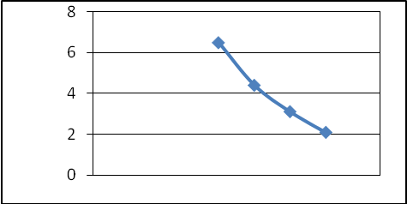
Air voids %
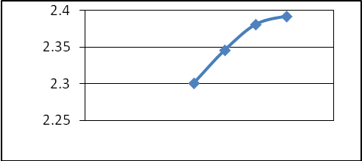
Bulk density, g/cc
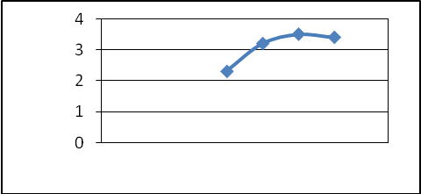
Flow, mm
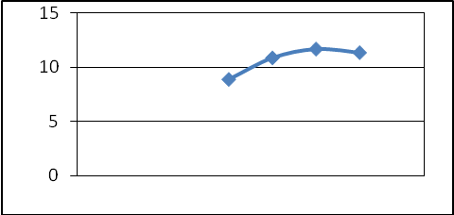
Stability, KN
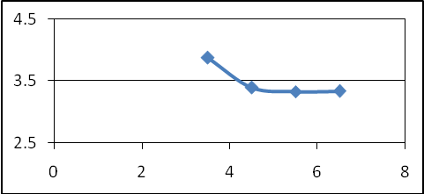
Stiffness ,KN/mm
Asphalt content ,%
Figure (2) : Marshall test properties

From which an optimum asphalt content of 4.7 % is selected , Marshall properties are shown below.
Stability -----------------------------------11.313 KN
Flow------------------------------------------ 3.25mm
Bulk density-------------------------------- 2.35 g/cc
Air voids------------------------------------------ 4.2%
Stiffness---------------------------------- 3.48KN/mm
6:2: Allowed Ratio of F/A and Tolerances :
The F/A ratio corresponding to the selected optimum asphalt content is 1.4 (depending on weight percentages of filler and asphalt in total mix). The allowed tolerances used in specifications are ± 2 percent ( by weight of total aggregate ) for filler content and ± 0.3 percent (by weight of total mix) for asphalt content. The acceptable ranges of filler and asphalt contents are ( 5-9) percent, by weight of total aggregate, and (4.4 - 5.0) percent, by weight of total mix, respectively .filler content tolerance alone , at 4.7% asphalt content , produce a corresponding tolerance in F/A of ( 1.01- 1.82) or ( 1.4 ± 0.4) . while asphalt content tolerance alone, at 7% filler content , produce a corresponding tolerance in F/A ratio of ( 1.33-1.5) or (1.4 ±0.08). It is obviously shown that the variability in F/A is contributed to variation in filler content rather than to variation in asphalt content. thus the corresponding overall allowed tolerances of F/A ratio will be ( 1.08- 1.71) or ( 1.4 ± 0.32) taking into account the combined effect of both filler and asphalt content tolerances.
6:3: Effect of fillers on Marshall Properties of bituminous mixtures
The results of Marshal Tests on bituminous mixes prepared at various filler contents by total mix of the three types of fillers are given in Table (4 ) and indicate the properties of mixtures at their optimum asphalt content for mixes with each filler type and content.
Table (4 ): Marshall Properties of bituminous mixtures
Marshall Properties | Asphalt Content | Filler Type | Filler Content
Marshall Properties | Asphalt Content | Filler Type | 5 | 7 |  | 9
Marshall  Stability, KN | 4.7 | o. p. cement | 8.273 | 11.313 |  | 10.053
Marshall  Stability, KN | 4.7 | limestone | 18.213 | 17.613 |  | 20.213
Marshall  Stability, KN | 4.7 | Hydrated lime | 10.713 | 15.993 |  | 9.903
Flow, mm | 4.7 | o. p. cement | 4.25 | 3.25 |  | 3.75
Flow, mm | 4.7 | limestone | 3.20 | 4.00 |  | 3.40
Flow, mm | 4.7 | Hydrated lime | 3.50 | 3.40 |  | 3.45
Air Voids, % | 4.7 | o. p. cement | 5.30 | 4.20 |  | 1.20
Air Voids, % | 4.7 | limestone | 4.26 | 2.95 |  | 1.90
Air Voids, % | 4.7 | Hydrated lime | 2.33 | 5.85 |  | 4.42
Bulk Density  g/mm | 4.7 | o. p. cement | 2.315 | 2.350 |  | 2.361
Bulk Density  g/mm | 4.7 | limestone | 2.355 | 2.365 |  | 2.321
Bulk Density  g/mm | 4.7 | Hydrated lime | 2.349 | 2.347 |  | 2.332
Stiffness, KN/mm | 4.7 | o. p. cement | 1.946 | 3.480 |  | 2.680
Stiffness, KN/mm | 4.7 | limestone | 5.691 | 4.403 |  | 5.945
Stiffness, KN/mm | 4.7 | Hydrated lime | 3.060 | 4.703 |  | 2.870
Marshall Properties | Filler Content | Filler Type | Asphalt Content
Marshall Properties | Filler Content | Filler Type | 4.4 |  | 4.7 |  | 5.0
Marshall  Stability, KN | 7 | o. p. cement | 12.273 |  | 11.313 |  | 11.253
Marshall  Stability, KN | 7 | limestone | 14.353 |  | 17.613 |  | 11.893
Marshall  Stability, KN | 7 | Hydrated lime | 15.650 |  | 15.993 |  | 13.355
Flow, mm | 7 | o. p. cement | 2.65 |  | 3.25 |  | 3.40
Flow, mm | 7 | limestone | 2.80 |  | 4.00 |  | 3.50
Flow, mm | 7 | Hydrated lime | 3.63 |  | 3.40 |  | 3.00
Air Voids, % | 7 | o. p. cement | 6.70 |  | 4.20 |  | 2.50
Air Voids, % | 7 | limestone | 4.00 |  | 2.95 |  | 3.26
Air Voids, % | 7 | Hydrated lime | 3.41 |  | 5.85 |  | 5.00
Bulk Density  g/mm | 7 | o. p. cement | 2.365 |  | 2.350 |  | 2.387
Bulk Density  g/mm | 7 | limestone | 2.347 |  | 2.365 |  | 2.373
Bulk Density  g/mm | 7 | Hydrated lime | 2.352 |  | 2.347 |  | 2.222
Stiffness, KN/mm | 7 | o. p. cement | 4.631 |  | 3.480 |  | 3.309
Stiffness, KN/mm | 7 | limestone | 5.126 |  | 4.403 |  | 3.399
Stiffness, KN/mm | 7 | Hydrated lime | 4.311 |  | 4.703 |  | 4.451

6:4: Effect of filler type and their content on Unit Weight
As shown previously , variations in filler produces large variability in F/A ratio as compared to asphalt content variations. Also, large fluctuation of asphalt content in properly operating plant is not expected or allowed. For these reasons, the influence of variations of F/A ratio due to filler content variations only will be considered in this study.
The effect of both filler type and their content on the unit weight of compacted mixes is shown in Figure (3). Mixes made with Portland cement filler showed a trend of increase in unit weight as filler content increases, while for mixes made with lime stone increases up to maximum and then decreases as the filler content increases. For mixes made with hydrated lime decreases in unit weight as filler content increases.. The results obtained show a wide variability in unit weight for respective filler type and content, and hence it would be difficult to give an explanation on filler type effects. In fact, the effect of filler content on unit weight, for mixes made by lime stone fillers, is that the values increase up to maximum point then decreases. This is because while filler content increases in the mix, it fills the voids hence increase unit weight. However, at higher content the mix becomes stiffer that needs greater compaction effort the consequently lower dense mixtures obtained. This phenomenon did not work for the mixtures prepared using cement fillers. The unit weight of these mixes simply increases as the filler content in the mix increases. It is difficult to explain why this is happening, but it may be due to that the voids in the mineral aggregate decreases as the filler content increases .
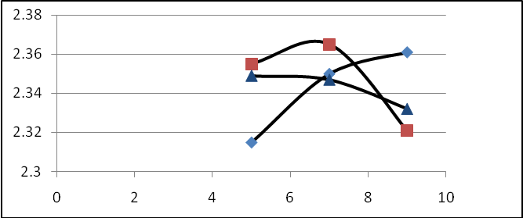
Bulk density ,g/cc
Cement
Limestone
Hydrated lime

Filler content , %

Figure (3): Effect of filler type and content on unit weight at OAC
6:5: Effect of filler type and content on Marshall Flow
As it is clearly shown in Figure (4) below, the Marshall Flow values obtained from the laboratory prepared mixes using all filler types. For mixes prepared using 5%, 7% and 9% hydrated lime , 9% limestone, the flow values obtained are relatively the same. Higher values of flow were also obtained for mixtures prepared using 5% Portland cement and 7% limestone fillers. At higher filler content using limestone and hydrated lime, lower flow values were obtained, that means they are stiffen the mixture more than Portland cement.
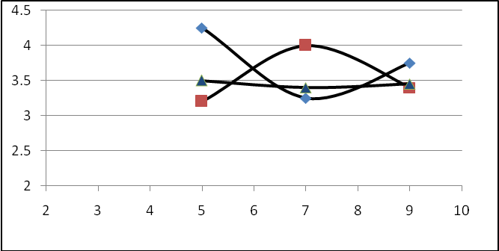
Flow, mm
- Cement
- Limestone
Hydrated lime

Filler content , %

Figure (4): Effect of filler type and content on Marshall flow at OAC

6:6: Effect of filler type and content on Marshall Stability
The stability values obtained by mixes made with limestone are relatively higher than all mixes made with either poretland cement or hydrated limefillers. This can be related with the effective asphalt cement content and voids in mineral aggregate in the mixture. The effective asphalt cement content and voids in mineral aggregate have an important role in the stiffness of mixture, that is lower values of both factors may increase the stiffness of the mixture and increases the stability. Higher stability values were obtained at the 7 % for the all types of fillers relativly as shown in figure (5). whereas increasing filler content beyond 7% for Portland cement and hydrated lime reduce the contact among coarse aggregate particles, hence reducing the stability.
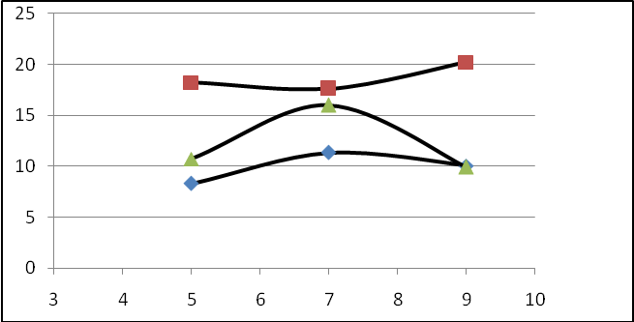
Stability, KN
- Cement
- Limestone
Hydrated lime

Filler content , %

Figure (5): Effect of filler type and content on Marshall stability at OAC

7: Conclusion
The effect of mineral fillers in the properties of asphalt concrete was investigated from which different results are obtained. From the research conducted made on the effects of fillers on bituminous mixtures, the following conclusions are drawn.
- For mixture with normal filler contents (5-9) percent by weigh of aggregate, the corresponding design F/A ratio has been determined to vary between ( 1.01) and (1.82) respectively by weigh percentages of filler and asphalt in total mixture and the best ratio is (1.4) for all type of filler .
- Placing limits on tolerances of the design filler and asphalt contents in addition to enquiring a minimum F/A ratio in specification requirement can cause conflict and need to be avoided .
- The bulk density increases up to some point and then decreases with increasing filler content in the mixture using lime stone ,whereas the inverse case with hydrated lime. While for mixtures with Portland cement filler, the bulk density keeps increasing with the filler content increas.
- The stability values obtained by mixes made with limestone are relatively higher than all mixes made with either poretland cement or hydrated lime fillers.
- Higher stability values were obtained at the 7 % for the all types of fillers relativly. whereas increasing filler content beyond 7% for Portland cement and hydrated lime reducing the stability.

REFRENSES :
- Asphalt Institute, 1993,Mix Design Methods for Asphalt Concrete and other Hot Mix Types, MS-2, Sixth Edition.
- Asphalt Institute, 2003. “Mix Design Method for Asphalt Concrete and other Hot-Mix Types,” Manual series No. 02, Six Edition, Kentucky, USA.
- Bouchard, G. P., 1992, “Effect of Aggregates and Mineral Fillers On asphalt Mixtures Performance", ASTM, STP 1147, Richard C. Meininger, Ed., American Society for Testing and Material, Philadelphia
- Craus, J., I. Ishai, and A. Sides,1978." Some physico-chemical aspects of the effect and role of the filler in bituminous paving mixtures", Journal of Association of Asphalt Paving Technologists, Vol. 47, pp. 558-587.
- Miro R., Martinez A., 2004," Effect of Filler on the Aging Potential of Asphalt Mixtures", Technical University of Catalonia.
- Prithvi S. Kandhal, Y. Lynn and F. Parker, Jr.1998,"Characterization tests for mineral fillers related to performance of asphalt paving mixture" Auburn University, Alabama, NCAT Report No. 98-2 .
- SCRB / R9 .General Specification for Roads and Bridges, Section R /9, Ministry of Housing and Construction , Republic of Iraq,2004.
- Zemichael B. Mehari,2007." Effect of Different Types of Filler Materials on Characteristics of Hot-Mix- Asphalt Concrete", thesis, Addis Ababa University

