Improve Permeability Prediction for One of Iraqi Carbonate Oil Reservoir

Ahmed Z. Al-Yaseri Mohammed Sattam
University of Baghdad University of Babylon
Usama S. Alameedy
University of Baghdad
Abstract
Permeability and porosity are the most difficult parameters to estimate in the oil reservoir because they are vary significantly over the reservoir especially in the carbonate formation. Porosity and permeability can only be sampled at the well location. However, porosity is easy to estimate directly from well log data, but permeability is not. In addition, permeability measurements from core sample are very expensive.
Carbonate reservoir is very difficult to characterize because of their tendency to be tight and heterogeneous due to deposition and diagenetic processes. Therefore, many engineers and geologists try to establish methods to get best characterization for the carbonate reservoir.
In this study, available routine core data from three wells are used to develop permeability model based on Hydraulic Flow Unit Method (RQI/FZI) for one of the Iraqi carbonate oil reservoirs.
The results show that the HFUM is work perfectly to characterize and predict permeability for un-cored wells because the R²≥0.9. It is indicating that permeability can be accurately predicted from porosity if rock type is known.
المستخلص
تعد النفاذية والمسامية من اكثر العوامل صعوبة في التحديد في المكامن النفطية حيث انها تتغاير خصوصا في التكوينات الجيرية منها. ان النفاذية والمسامية يمكن ان تقاس فقط من مواقع الابار النفطية, حيث من السهل ان تقاس المسامية من مجسات الابار بينما لا يمكن ذلك للنفاذية, بالاضافة الى ذلك فان قياس النفاذية من خلال نماذج اللباب تكون مكلفة جدا.
ان من العب قياس خصائص المكامن الجيرية لكونها متراصة وعدم انتظام صفاتها بسبب طبيعة الترسيب والعمليات التحويرية, لذلك فان العديد من المهندسين والجيلوجيين حاولوا اعتماد طرق معينة للحصول على خصائص تلك المكامن الجيرية.
في الدراسة الحالية تم الاستفادة من بيانات اللباب المأخوذة من ثلاثة ابار نفطية لتطوير موديل النفاذية اعتمادا على طريقة وحدة الجريان الهيدروليكي لمكمن جيري نفطي واحد في العراق. اظهرت النتائج ان هذة الطريقة مناسبة تماما لتخمين النفاذية للابار التي لم يتم اخذ نماذج لباب منها مما يشير الى ان استنتاج النفاذية يمكن ان يكون دقيقا من المسامية اذا كان نوع الصخور معلوما.

Introduction
Permeability is the most important parameter in oil reservoir description and characterization. Single phase permeability measurements are important to understand fluid flow through porous media. Permeability can be estimated indirectly using log data or directly with core sample.
Engineers and geologists observed that there is not a specifically defined trendline between porosity and permeability. In addition, their relationship is qualitative and is not directly or indirectly in any way because it is possible to be high porosity without permeability as in clay and shale. Also, it is true to be high permeability with low porosity as in micro-fractured carbonates. However, there often can be found a very useful correlation between them (Tiab and Dolanson, 2004).
Kozeny (1927) proposed the first empirical equation relating measurable rock properties with permeability by using bundle of straight capillary tubes model with constant and uniform surface area. Carman (1939) modified Kozeny equation by describing permeability in packs of uniformly sized spheres. Timur (1968) proposed a generalized equation based on the work of Kozeny.
Amaefule et al. (1993) introduced a new practical and theoretically based technique which has been developed to identify and characterize units with similar pore throat geometrical attributes (hydraulic units). These concept of hydraulic flow units and reservoir quality index considering the pore-throat, pore and grain distribution and other macroscopic parameters.

Field description
Jambur field is located in the north of Iraq to the south east of Kirkuk governorate and to the south of Kirkuk giant oil field. It is elongated from the north-west to the south-east; the surface structure differs from the subsurface structures because of the faults effect. The field is of a very complex nature with two main opposite faults and eight mini faults spreading in the field. It is 30 km in length and 4.5 km in width, it was discovered in 1954 and the production started since that time (Jihad, 2011).



Figure 1: The location of studied field
(after Jihad, 2011)

Dykstra-Parsons Coefficient V_{K}
Dykstra and Parsons used the log-normal distribution of permeability
to define the coefficient of permeability variation (Tiab and Dolanson, 2004).
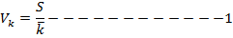

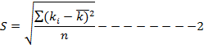
S is the standard deviation for permeability, n is number of samples, k and is the permeability Mean.

The range of this index is 0 < V_{K} < 1:
If the V_{K} = 0 is Ideal homogeneous reservoir, 0 < V_{K} < 0.25 is slightly heterogeneous, 0.25 < V_{K} < 0.50 is heterogeneous reservoir, 0.50 < V_{K} < 0.75 the reservoir is very heterogeneous, 0.75 < V_{K} < 1 the reservoir is extremely heterogeneous, and V_{K} = 1 is perfectly heterogeneous reservoir (Tiab and Dolanson, 2004).

So, for this case study the V_{k}= 11.4 / 12.59 = 0.9. This value of Dykstra-Parsons coefficient shows that the reservoir is extremely heterogeneous. It is true because our reservoir is a carbonate.
Permeability predictive depending on rock type methods
1- Conventional method
Conventional method for rock typing is based on simple regression evaluating permeability from log derived porosity. In most cases, a linear relationship between log permeability and porosity is obtained, but in carbonate formation, it does not close to actual case. Fig.(2) shows the classic permeability-porosity relationship for entire reservoir. As shown in this figure, there is a poor relationship between permeability and porosity (R² = 0.1988).
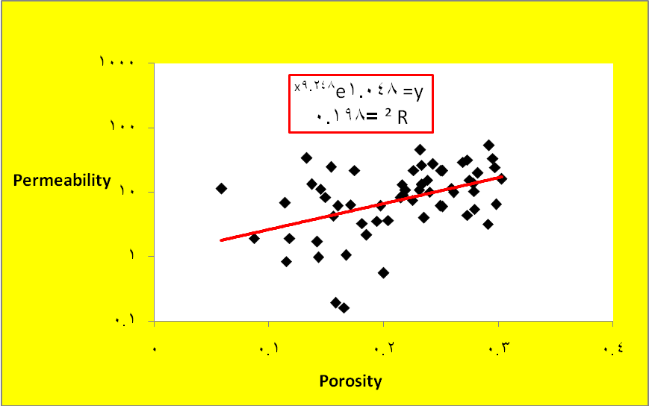

Figure 2: Permeability porosity cross-plot for entire reservoir in this study

2- Winland Method
In this approach a mathematical relationship induced between the petrophysical properties such as porosity, permeability and capillary pressure to pore-throat radius measured in a mercury injection capillary pressure experiment at mercury saturation of 35% (Gunter et al. 1997). The Winland equation is:
Where R₃₅ is calculated pore throat radius at 35% mercury saturation from mercury injection capillary pressure test, k is permeability (md) and Ø is porosity (percentage).The core samples of similar R₃₅ values represent a single rock type.
Petrophysical units would be defined using below classification of R₃₅ values:
Megaport: when the value of R₃₅ is greater than 10 micron.
Macroport: when the value of R₃₅ is between 2 and 10 micron.
Mesoport: when the value of R₃₅ is between 0.5 and 2 micron.
Microport: when the value of R₃₅ is between 0.1 and 0.5 micron.
The figures (3, 4 and 5) show the classic permeability-porosity relationship for well 1, well 2 and well 3 depending on Winland method.
As shown in these figures, there are poor relationships between permeability and porosity (R² ≤ 0.18). Winland method is experimental measurements which means that it does not work for all circumstances.
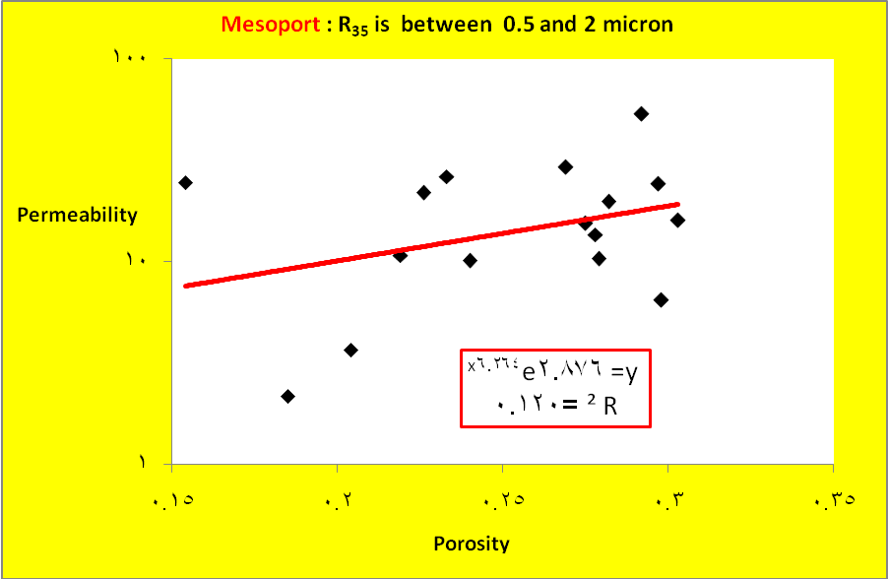
Figure 3: Winland plot between porosity and permeability for well 1.
Figure 4: Winland plot between porosity and permeability for well 2
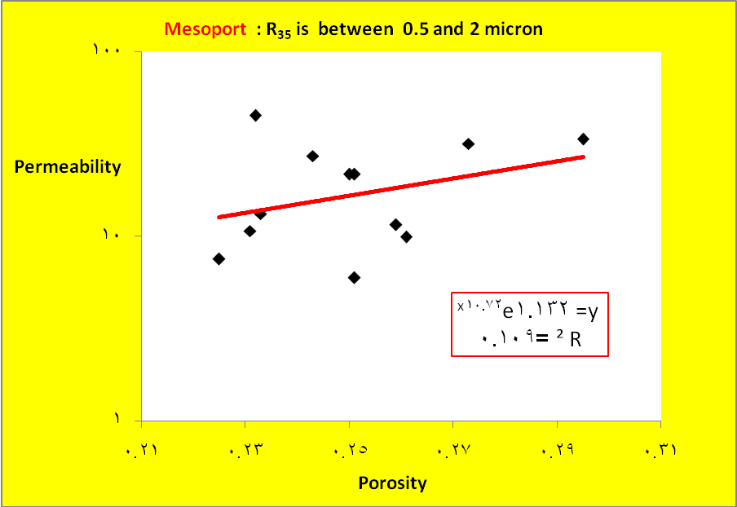
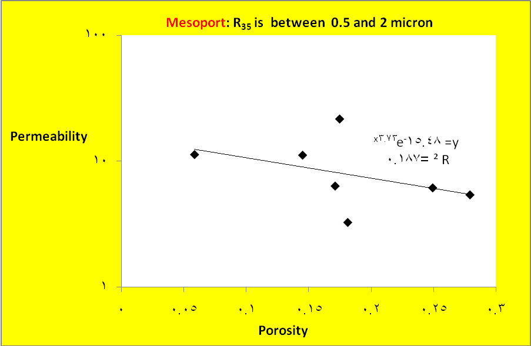

Figure 5: Winland plot between porosity and permeability for well 3

3- Hydraulic flow unit (HFU) method
Geologists and engineers specified the definition of units to shape the description of reservoir zones as storage containers and reservoir conduits for fluid flow.
Literatures confirmed that the flow units, as the resultant of the depositional environment and diagenitic process. The hydraulic (pore geometrical) unit is the representative elementary volume of the total reservoir rock within the geological and petrophysical properties of the rock volume (Bear, 1972). Hydraulic flow units consider as a mappable portion of the reservoir within which the geological and petrophysical properties that affect the flow of fluid are consistent and predictably different from the properties of other reservoir rock volume (Ebanks,1987 ). Hear et al. (1984) defined flow unit as a reservoir zone that is laterally and vertically has similar permeability, porosity, and bedding characteristic. A continuous stratigraphically interval of similar reservoir process that honors the geologic framework and maintains the characteristic of the rock type (Gunter et al.,1997).
A rock types are classified according to the following equations:
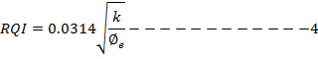
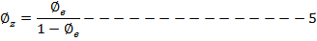
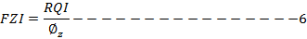
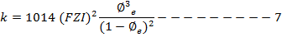
Where k is a permeability (md), Ø_{e} is an effective porosity ( fraction), RQI is rock quality index (µm), Ø_{z} is normalize porosity and FZI is flow zone indicator.
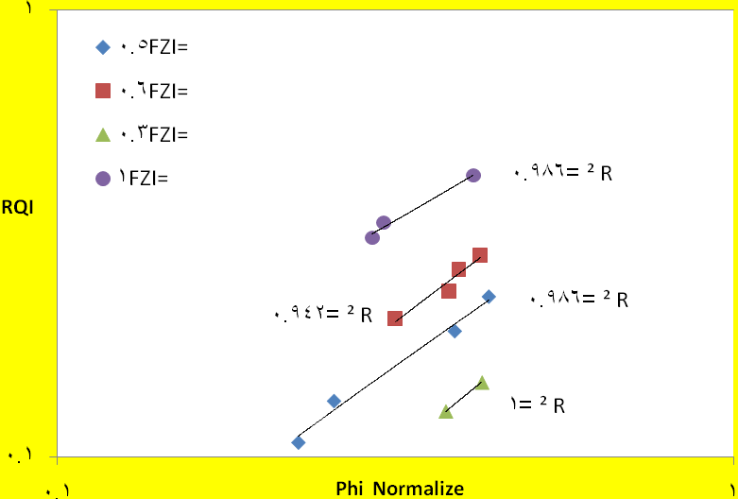
On a log-log plot of RQI vs. Ø_{z}, all samples with similar FZI values will lie on other parallel lines. The values of FZI constant can be determined from the intercept of unit slope straight line at Ø_{z} =1 (Mehdi et al. 2011).
Figure 6: Log-log plot of RQI vs. Ø_{z}, indicating the presence of four flow units for well 1

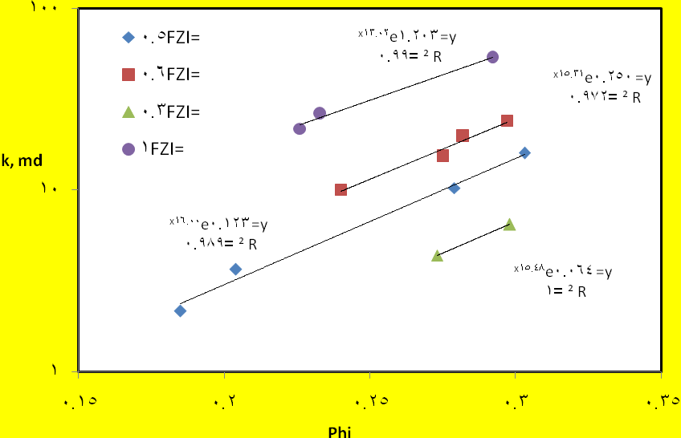

Figure 7: Permeability porosity cross-plot for well 1 depending on FZI

Figure 8: Log-log plot of RQI vs. Ø_{z}, indicating the presence of five flow units for well 2

Figure 9: Permeability porosity cross-plot for well 2 depending on FZI

Figure 10: Compare between measured permeability and predicted permeability depend on Eq.(7) for well 2

Figure 10: Compare between measured permeability and predicted permeability depend on Eq. (7) for well 2

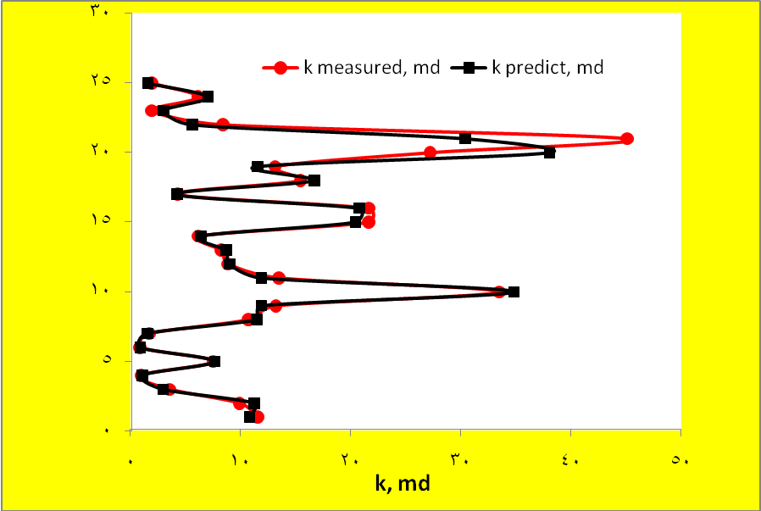

Figure 11: Compare between measured permeability and predicted permeability depend on k vs. phi with FZI for well 2
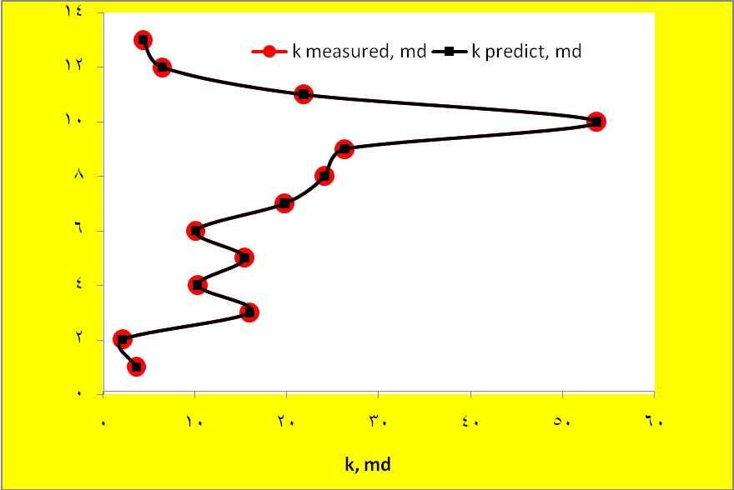
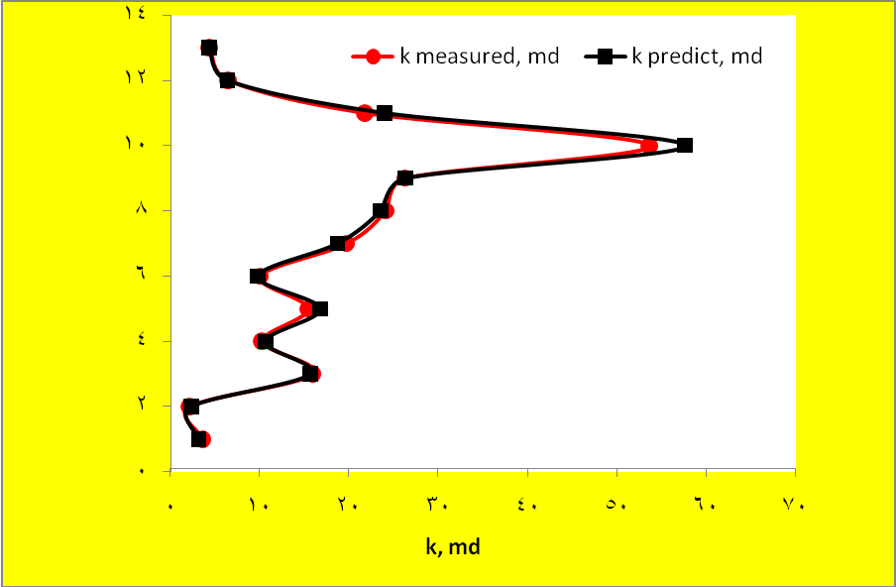
Figure 12: Compare between measured permeability and predicted permeability depend on Eq.(7) for well 1
Figure 13: Compare between measured permeability and predicted permeability depend on k vs. phi with FZI for well 1
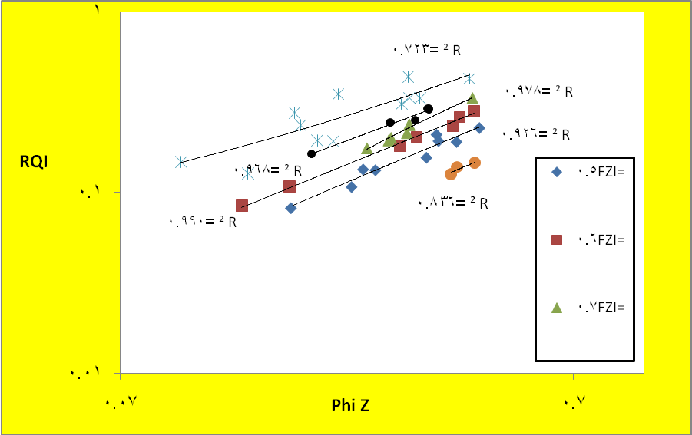
Figure 14: Log-log plot of RQI vs. Ø_{z}, for all wells togather

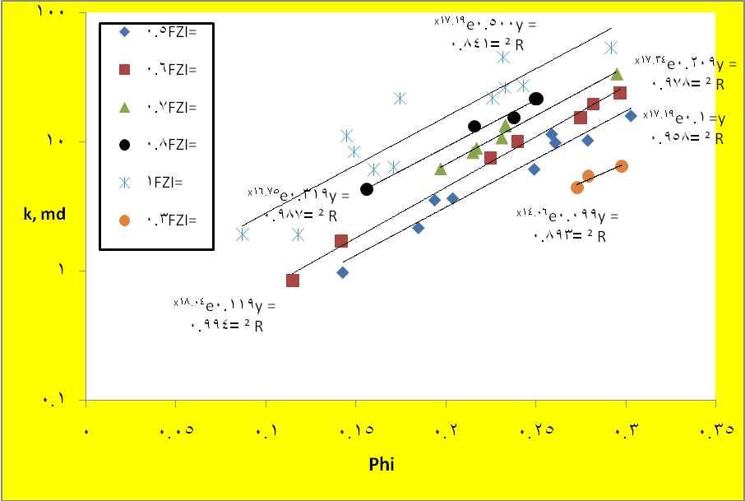
Figure 15: Permeability porosity cross-plot for all well together depending on FZI

Figure 15: Permeability porosity cross-plot for all wells togather depending on FZI

Table 1: Generalized Permeability depends on FZI

Well No. | FZI | Permeability Predicted from  Equations | R²
1 | 0.3 | K=0.064 e^{15.48 Ø} | 1
1 | 0.5 | K=0.123 e^{16 Ø} | 0.989
1 | 0.6 | K=0.25 e^{15.31Ø} | 0.972
1 | 1 | K=1.2 e^{13.26 Ø} | 0.99
2 | 0.5 | K=0.063 e^{19.86 Ø} | 0.983
2 | 0.6 | K=0.096 e^{19.45 Ø} | 0.99
2 | 0.7 | K=0.209 e^{17.346 Ø} | 0.978
2 | 0.8 | K=0.319 e^{16.75 Ø} | 0.987
2 | 1 | K=0.92 e ^{20.36 Ø} | 0.92
All wells  togather | 0.5 | K=0.1 e ^{17.19 Ø} | 0.958
All wells  togather | 0.6 | K=0.119 e^{18 Ø} | 0.99
All wells  togather | 0.7 | K=0.209 e^{17.346 Ø} | 0.978
All wells  togather | 0.8 | K=0.319 e^{16.75 Ø} | 0.987
All wells  togather | 1 | K=0.5 e ^{17.19 Ø} | 0.84
All wells  togather | 0.3 | K=0.099 e^{14.06 Ø} | 0.89

Conclusions
- Hydraulic flow unit method is work perfectly to characterize and predict permeability for un-cored wells as shown in Fig. (6), Fig.(8), and Fig.(14).it indicates that permeability can be accurately predicted from porosity if rock type is known.
- Porosity alone is not enough to explain the permeability variations, even if the porosity-permeability data that were used came from same field.
- This paper shows excellent relationship between porosity and permeability depending on FZI as shown in Fig. (7),Fig.(9). The relationship is excellent because R² ≈ 1 and the presence excellent matching between measured permeability and predict permeability as shown in Fig. (11) and Fig.(13).
- We observed there is (as shown in table(1)) insignificant differences between porosity and permeability equations for each well alone and generalize equations (All wells data together).
- The high FZI values indicate high permeability values.
- There are four Hydraulic flow unit for well 1 and five for well 2.

References
Amaefule, J. O., Altunbay, M. H., Tiab, D., Kersey, D. G. and Keelan D. K. , 1993 “Enhanced Reservoir Description Using Core and Log Data to Identify Hydraulic (Flow) Units and Predict Permeability in Uncored Intervals/Wells.” SOC. Petrol. Eng. Paper No. 26436.
Bear, J. , 1972 "Dynamics of Fluids in Porous Media". Elsevier, New York. Carman, P. C. , 1939" Permeability of Saturated Sands, Soils and Clays," J. Agr. Sci, Vol. 29.
Tiab and Dolanson,2004 "Petrophysics : theory and practice of measuring reservoir rock and fluid transport"; USA 889 Pages.
Ebanks, W. J. , 1987 “The Flow Unit Concept-An Integrated Approach to Reservoir Description for Engineering Projects. Am. Assoc. Geol. Annual Convention.
Gunter, G. W., Finneran, J. M., Hartman, D. J. and Miller, J. D. ,1997 “Early Determination of Reservoir Flow Units Using an Integrated Petrophysical Method SPE 38679. SSPE Annual Technical Conference and Exhibition, San Antonio, TX.
Hear, C. L., Ebanks, W. J., Tye, R. S. and Ranganatha, V. ,1984 "Geological Factors Influencing Reservoir Performance of the Hartzog Draw Field", Wyoming. J. of Petrol. Tech, pp. 1335-1344.
Husain J., 2011 "A Reservoir Simulation Study of Tertiary Reservoir / Jambour Field", Master degree thesis, University of Baghdad.
Kozeny, J., 1927 ‘‘iiber kapiuare Leitung des Wassers im Boden (Aufstieg Versikerung und Anwendung auf die Bemasserung). ” Sitzungsber Akad,
W&s, Wein, Math- Nuturwiss, KL, Vol. 136 (Ila, pp. 271-306.
Mehdi et al., 2011 " Permeability predictive model based on HFU for one of Iranian carbonate tight gas reservoir", The SPE middle east unconventional gas conference in Muscat, Oman, SPE No. 142183.
Timur, A.,1968"An Investigation of Permeability, Porosity, and Residual Water Saturation Relationship for Sandstone Reservoirs," The Log Analyst, Vol. 9,No.4.

