Behavior of Reinforced Concrete Hollow Circular Columns With Steel Fiber Inclusion Under Cyclic Bending

Jabor AL-Jeabory
Babylon University- College of Engineering
Abstract:
Experimental results on the test of 12 hollow circular reinforced columns with steel fiber matrix of 1200mm long with 208mm outer diameter and 80 mm inner diameter are presented .The experimental and analytical study were carried out to establish the influence of variables on the mechanism of confinement provided by lateral hoop reinforcement .The test results showed a direct relationship between absorbed energy and the spacing of lateral reinforcement. The addition of steel fibers with V_{f} = 1% (for the fiber type used) to a hollow circular RC columns enhances the ductility with an increment of (40 to 60) % , allowing these columns to absorb an energy of about (40-50) % greater than that needed to deform a similar columns made of ordinary reinforced concrete to the same load level .
الخلاصة
لقد أجريت دراسة نظرية وعملية على أثنا عشر عمودا مجوفا من الخرسانة المسلحة و التي أضيف الى قسم منها الألياف الحديدية لتحديد طريقة تأثير المتغيرات( المسافات بين الحديد الجانبي و كذلك الألياف الحديدية بنسبة 1%) على قوة تحمل هذة الأعمدة للأحمال الدورية الجانبية. لقد تبين أن مطاوعة هذة الأعمدة فد زادت بنسبة 40-60% وكذلك القدرة على أمتصاص الطاقة قد زادت بنسبة 40-50 % أكثر من مثيلاتها من الأعمدة التي ليس فيها الياف وتحت تأثير نفس الأحمال.
Introduction
The effect of the hollow section should be adequately assessed under the effects of cyclic loading , because the structural response of the hollow member under cyclic loading may be significantly different from that of solid column due to existence of a void section.
For hollow concrete members especially of smaller cross-sectional size, it may be convenient to place the longitudinal and transverse reinforcement in one layer only near the outside face of the cross section and not to tie the concrete through the wall thickness. This leads to a simpler arrangement of reinforcement, but the concrete near the inside face of the hollow section is unconfined and the flexural failure may be brittle. So, the subject of this research came from the idea of finding the avenue that by which the ductility and the ultimate strength of hollow RC members could be increased through treating the defects of such members like the absence of confinement on the inside face, and increasing their flexural and shear capacity under cyclic loading .
The strength performance of hollow circular concrete members seems to be first reported experimentally by Omote 1975. Later investigated experimentally by many researchers Mander et al 1983, Mander 1984, Zahn et al 1990, Kawashima et al 1992, Inoue et al 1996, Yukawa et al 1999, Takahashi and Iemura 2000, Hoshikuma and Priestley 2000, Ranzo et al 2000 , Hadi, M. 2009. In general a few of experimental researches on the performance of the hollow circular columns with one layer of reinforcement have been conducted.
The beneficial effects of steel fibers inclusion into the concrete mixture, in controlling shear cracking and enhancing the shear resistance of reinforced concrete members have been investigated by several researchers Batson et al 1972 Jindal 1982, Lafraugh and Moustafa 1975, Muhidin and Regan 1977, Narayanan and Darwish 1987, Uotomo et al 1986, Kormeling et al 1980, Steffen and Joost 2009, Hameed et al 2009. In general the fiber reinforcement cannot replace the conventional reinforcement . However, Its advantageous characteristics can be exploited by combining it with conventional reinforcement. The efficiency of fibers to realize this purpose were investigated through this research .
Romualdi 1963 argued that , the presence of the fibers delays the cracks initiation by reducing the stress intensity in the vicinity of the tip , so that the energy which tends to cause extension of a crack is dissipated in deboning the fibers
Based on previous studies steel fibers were added with volume fraction of 1% and aspect ratio L/d equal 100 to obtain the superior benefits of steel fibers without workability problems, (Spadea and Bencardino 1997, AL-Jeabory J. 1993, Parasadh.A and Kumar 2005).
The aim of this research was to develop hollow concrete structural members simple in construction ( with on layer of reinforcement ) and with high strength and ductility capacity through compensating the lack in confinement on the hollow section inside face by increasing the concrete strength ,stiffness and deformability capacity .Hence , examining the feasibility of combining conventional reinforcing steel with fibers seemes to be a good option due to its appreciable beneficial effects on the concrete strength .
Research Significance
Hollow circular columns as structural members present several advantages when compared to solid columns due to reduced mass per unit length afforded by the reduced section area. The research attempts to clarify the elastic-plastic characteristics of hollow circular columns of different hoop spacing with and without fiber inclusion when subjected to reversed lateral cyclic load in the presence of axial load.
Shear strength:
The shear strength Vn ,was calculated according to ATC-32 Model and is given by:
Vn = Vc + Vs (1)
Where:
100 P __
Vc =-------- 0.167( k1+-------- ) √ fc’ ξ Ag (2)
85 k2 Ag
Where
k1=1 for displacement ductility µΔ<1 otherwise 0.5
k2=1.38 for P > 0 or
k2=3.45 for p < 0
And ξ Ag is given by

ξ Ag = ʎ(0.8Ag) (3)

( 1+a² )(1-a)
ʎ= --------------------- (4)
(1-a³)
With a= r1/r2, and
r1= internal radius of the section
r2= external radius of the section
And 100/85 is a factor used to transform design in assessment equation.
The contribution of Vs is

π Ah fyh D cot θ
Vs= ---------------------------- (5)
2 S
where θ= 45 degrees is the angle of shear crack with respect to vertical axis .

The Experimental Program
Materials Properties
Selection of the concrete mix properties were accomplished from the results of laboratory test. The laboratory test results of materials were conformed with the Iraqi standard IQS-1984 and ASTM specifications .
There are some restrictions govern the selecting of the maximum size of the aggregate to be used for hollow reinforced concrete members. The specifications recommended that the maximum size must by less than or equal to (1/5) of the minimum dimension of the mould , or (3/4) of the minimum spacing between reinforcement, (ACI 318-2008) .
The mix proportion by weight which used throughout the present study were 1: 1.45 : 2.55 (cement : fine aggregate : coarse aggregate) respectively . The cement used was Ordinary Portland Cement . fine aggregate was a natural river sand with maximum size of 4.75mm and the coarse aggregate was a natural river gravel with a maximum size of 9.5 mm , The water / cement was 0.5 .
The longitudinal steel ratio for all specimens was 1.64% with bars spacing 76mm c/c to ensure a uniform distribution for these bars around the perimeter of the hollow section. the steel fibers content was 1% by volume with aspect ratio L_{f}/D_{f} = 100 .
Test Specimens
The twelve columns of 1200mm long and outer diameter of 210 mm and inner diameter of 80 mm, resulting in a wall thickness of 65 mm (thickness ratio = 30% of section diameter) used in this investigation where reinforced with Ø 10 mm deformed bars as longitudinal reinforcement of fy = 420 Mpa and Ø 6 mm plain bars as lateral hoops of fy = 350 Mpa and fibre inclusion . These reinforcement are illustrated in Fig. 1 and Tables 1. The spacing of lateral reinforcement were varied from 50mm to 200mm . The volumetric ratio was calculated according to ACI code 318-08.( 21.4.4.1 a and 10.9.3) and were verified for research need.
For specimens C1 to C4 the provided lateral reinforcement ratio higher than that required by the designing code to avoid shear failure. specimens C7 and C12 provided with lateral steel ratio less than the required by the code , to investigate the efficiency of the steel fibers in increasing the strength , confinement and ductility of the hollow circular columns , and if it can be used to replace a portion of the lateral hoops . For each lateral reinforcement ratio there was two specimens one conventional RC column and the other with addition of steel fibers .
1200 mm

P
N
N
200_{mm}
200_{mm}
200_{mm}
200_{mm}
P
Hoop φ 6 mm
φ 10 mm6
D = 208mm
80mm
Dial gauges
1200 mm
500 mm
500 mm

P
N
N
200_{mm}
200_{mm}
200_{mm}
200_{mm}
P
Hoop φ 6 mm
φ 10 mm6
D = 208mm
spacing =35mm
hoops @ spacing = S (from design)
spacing =35mm
125mm
950 mm
125mm

Fig. 1 Reinforcement details for hollow circular column

Fig. 1- Reinforcement details of specimens tested
Table 1 Specimens designations, properties and details of tested specimens

Columns  Designations | Lateral  Reinforcement | ρs% | Longitudinal  Reinforcement | ρl% | Fiber  Vol. Vf% | ƒc’  MPa | Avprov.  /Avcode
C1 | Ø6@50mm | 2.10 | 6 Ø10 | 1.64 | 0 | 29.7 | 2.00
C2 | Ø6@50mm | 2.10 | 6 Ø10 | 1.64 | 1 | 37.2 | 2.00
C3 | Ø6@75mm | 1.40 | 6 Ø10 | 1.64 | 0 | 28.9 | 1.33
C4 | Ø6@75mm | 1.40 | 6 Ø10 | 1.64 | 1 | 32.1 | 1.33
C5 | Ø6@100mm | 1.03 | 6 Ø10 | 1.64 | 0 | 26.2 | 1.00
C6 | Ø6@100mm | 1.03 | 6 Ø10 | 1.64 | 1 | 37.0 | 1.00
C7 | Ø6@125mm | 0.82 | 6 Ø10 | 1.64 | 0 | 27.4 | 0.80
C8 | Ø6@125mm | 0.82 | 6 Ø10 | 1.64 | 1 | 32.2 | 0.80
C9 | Ø6@150mm | 0.70 | 6 Ø10 | 1.64 | 0 | 27.4 | 0.67
C10 | Ø6@150mm | 0.70 | 6 Ø10 | 1.64 | 1 | 33.2 | 0.67
C11 | Ø6@200mm | 0.53 | 6 Ø10 | 1.64 | 0 | 27.4 | 0.50
C12 | Ø6@200mm | 0.53 | 6 Ø10 | 1.64 | 1 | 35.2 | 0.50
Concrete was designed to give a compressive strength of 21 MPa at 28 days without fibers and 25 MPa for concrete with 1% by volume fiber content at 28 days.
Specimens were cast vertically in a mould which contained internal tube to form the void of the unit , the inner tube was smeared by oil, then by a tape . The tape was oiled in order to ensure its removing after concrete hardening .
The compaction was done by vibrating table and the specimens were demoulded after 24 hours and cured by jute and kept moisture for 28 days and after that they left under natural conditions until the day of test .
A cube specimens of 150×150×150 mm were used to determine the 28 days compressive strength tested according to BS1881-116 ( 3 cubes for plain concrete and 3 cubes for fiber concrete), also the strength of plain and fiber concrete was fixed for each column in the day of test. Twelve concrete cylinders of (100x200)mm were tested for indirect tension in accordance with ASTM-C496, to obtain the splitting tensile strength of the specimens. A noticeable increase in tensile strength was obtained from the addition of steel fibers with an average increment of 35% and a summary of these results is given in Table 3.
3.5. Testing
All columns were tested using a testing machine of 500 kN capacity of axial load and 250 kN lateral cyclic load. Forces were measured by means of specially constructed load gauges as shown in Fig.2, which were connected to the testing machine used.
Before the deformation measurements were taken the static characteristics of gauges were determined. The scaling of gauges was carried out against existing testing machine.
Five damec gauges were used on each side of the column to measure the lateral displacement with specially mounted electronic gauge at the middle of the column height with accuracy of 0.001 mm . the deformations for all specimens were measured on constant regions as shown in Fig.4 . Deformations of the surfaces in the direction perpendicular to the applied lateral cyclic load were monitored and recorded in a special computer program to draw load – deformation of each column and the absorbed was measured from the area under curve.
Hydraulic jack
Dial gauges
Steel pin reaction

Steel plate

Fig. 2- Testing apparatus
The axial load N was applied through steel plates fitted at the ends of the column by hydraulic jack and held constant at a predetermined level throughout the test(145 kN) .the lateral load P was applied cyclically by a hydraulic jacks through a curved plate (with the same curvature of the column surface) placed at the mid-length of the column , see Fig. 2 . The cyclic lateral load was applied at a quasi-static rate where the specimen subjected to cycles of force reversals under load control cycles until the failure of specimen occurred . The lateral load was applied gradually, realizing as much as possible cyclic loads. The elastic and inelastic cycles were conducted for increasing lateral load level in relation to the maximum load P, with three repeated cycles at each load level. The loading pattern which applied through this investigation was as shown in Fig.3

.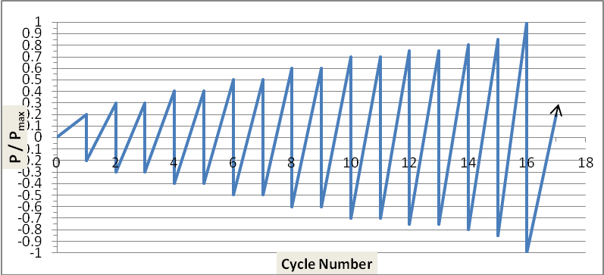
Fig. 3- Loading pattern

P
200_{mm}
200_{mm}
200_{mm}
200_{mm}
N
N
P

500 mm
500 mm
1200 mm
Dial gauges

Fig. 4- Loading and gauge positions
Test Results and Discussion
Plots of the applied load versus the load point displacement for all specimens are presented in Appendix A . These curves show that there is a linear relationship between the applied load and the resulting deflection during the elastic stage, and when the inelastic cycle load applied , the behavior of the ascending curve of the positive half cycle becomes similar to that of the monotonically tested members . The curve shape of the negative half of the reversed cycle is similar to that of the positive half .At the sequence of cycles the relationship becomes nonlinear from the beginning ( because of the reduced flexural rigidity caused by cracks development) . However, the shapes of the ascending and the descending curves for both half of the reversed cycle are similar .The shape of the descending part was less steep for columns contain smaller amount of lateral reinforcement or columns matrix without fiber. This is an indicative of substantially higher toughness , where toughness is a measure of ability to absorb energy during deformation and can be estimated from the area under the load – displacement curves . All specimens developed stable responses up to certain displacement ductility levels, whereas at later stages of testing, cycles get slightly narrower near the origin due to the effect of shear deformations. This is because during the reloading phase a considerable opening of shear cracks reduces the average stiffness (loss of aggregate interlock).
Columns C1 to C4 which contained a high ratio of lateral steel reinforcement , showed a ductile behavior due to the high confinement provided to the concrete. Columns C1and C3 showed a stable behavior with comparatively minor strength enhancement , the strength degradation appeared close to failure . The main reason was the formation of wide , deep crack at the plastic hinge zone .
Based on the hysteretic curves of the columns C2 and C4 the performance was very ductile and stable with significant strength enhancement at the ultimate stage , due to the presence of the steel fibers . The deformation capacity increased where the widening of the main crack at the plastic hinge region resisted by the bridging action of the fibers until pulled out.
Column C5, showed a satisfactory response before the spalling of the cover concrete. The concrete spalling at the outside and the inside face of the column reduced its cross sectional area, thus made the column loss its strength.
Column C6 with moderate steel ratio as in C5 ,and with steel fibers inclusion showed a desirable ductile behavior as shown from its load-displacement hysteresis response (see Appendix A-6) Therefore, it can be concluded that the combination between the moderate steel ratio and the inclusion of steel fibers as 1 % by volume , makes the member response ductile , allowing it to absorb more energy .
Columns C7 and C9 with insufficient lateral reinforcement showed a reasonable response up to a certain stage, then the extending and widening of shear cracks caused a drop in their strength .
The cyclic response of columns C8 and C10 was very satisfactory , in spite of their insufficient lateral steel ratio , due to the presence of the steel fibers which plays an important role through providing confinement to the concrete and enhancing its strength , thereby increasing the ductility and the strength of the columns .
Column C11 shows a very brittle response due to low content of lateral steel , also it was observed that the behavior was not symmetric at the shear failure.
Finally , in spite of low content of lateral steel, the response of member C12 with steel fibers, was relatively satisfying in comparison with the column C11 without fibers .
It is evident from comparison of the test observations that, the inclusion of steel fibers plays an important role in resisting the crack propagation.
The other important advantage is increasing the spalling resistance of the cover concrete at the outside and inside face of the hollow concrete column, . This indicates the effectiveness of confinement provided by the fibers , especially to the inner layer of the hollow concrete section near the void which is subjected to a poor confinement. Table 2 shows the mode of failure , the ductility and the dissipated energy of each column tested.

Effect of Lateral Reinforcement:
The transverse reinforcement in the column is needed to resist the shear forces and provide confinement for concrete core of the column. The columns tested were divided in three groups: the first group was provided with high lateral steel ratio( more than that required by ACI code) included C1 to C4 with lateral reinforcement ratio( ρs) of 2.1% to 1.4% respectively. The second group has a moderate lateral steel ratio ρs= 1.05% for columns C5 and C6. The third group included columns from C7 to C12 which have insufficient lateral reinforcement ratios (less than the required ). These ratios were 0.80%, 0.70%, and 0.525% respectively.
Columns with high amount of lateral reinforcement ratio exhibited a large ductility, whereas, columns with moderate hoop reinforcement plus steel fibers showed higher ductility performance as in specimens C3 and C6. The same tendency show the third group e.g specimen C5 and C8. However, columns with steel fibers inclusion exhibited a ductile performance even with small ratio of lateral reinforcement, while columns with insufficient lateral steel and without steel fibers showed a brittle behavior due to quick development of cracks. The ductility can be calculated by the following equations
Δu
µΔ= ------- (6)
Δy
And
Øu
µØ = -------- (7)
Øy
It was observed that increasing the lateral steel ratio from 1.05% to 1.4% increased the ductility ratio of the column by 30 % and the load carrying capacity by 14.3 % . while by the addition of steel fibers with V_{f} = 1% ( to column with the lateral steel ratio of 1.05% ) , the ductility ratio of the column increased by 23 % and the load carrying capacity by 21 % . whereas increasing the amount of lateral steel ratio from 1.05% to 2.1% increased the displacement ductility by 58 % and the load carrying capacity by about 40 % .
This investigation revealed that , increasing the lateral steel ratio and the addition of steel fibers lead to a combined beneficial effect of steel fibers and lateral reinforcement which result in a better response during cyclic loading . Also tests have shown that a combination of lateral steel and fiber reinforcement forms an effective system of shear reinforcement in a structural member.

Table 2 - The Mode of failure, dissipated energy and ductility of tested specimens

Specimen No. | fc’ M pa | ρl (mm) | ρs | Vf | Dissipt.  Energy  kN.m | Displ.  Ductility  µ | Failure mode
C1 | 29.7 | 6 Ø10 | Ø6@50 | 0 | 97.13 | 7.20 | Flexure
C2 | 37.2 | 6 Ø10 | Ø6@50 | 1 | 135.84 | 9.40 | Flexure
C3 | 28.9 | 6 Ø10 | Ø6@75 | 0 | 80.82 | 5.90 | Flexure
H4 | 32.1 | 6 Ø10 | Ø6@75 | 1 | 110.04 | 7.75 | Flexure
C5 | 26.1 | 6 Ø10 | Ø6@100 | 0 | 64.79 | 4.54 | Flexure-shear
C6 | 37.0 | 6 Ø10 | Ø6@100 | 1 | 104.20 | 6.83 | Flexure
C7 | 27.4 | 6 Ø10 | Ø6@125 | 0 | 44.61 | 3.34 | Shear
C8 | 33.2 | 6 Ø10 | Ø6@125 | 1 | 65.46 | 4.74 | Flexure
C9 | 27.4 | 6 Ø10 | Ø6@150 | 0 | 40.39 | 2.58 | Shear
C10 | 33.2 | 6 Ø10 | Ø6@150 | 1 | 62.33 | 3.99 | Flexure-shear
C11 | 27.4 | 6 Ø10 | Ø6@200 | 0 | 35.32 | 1.87 | Shear
C12 | 35.1 | 6 Ø10 | Ø6@200 | 1 | 58.13 | 2.95 | Flexure-shear

The transverse reinforcement by the circular hoops in the compression members decreases the lateral deformations in the concrete and strengthen it. They prevent the longitudinal reinforcement from buckling and increase its contribution during cyclic loading .
Failure of hollow RC column in shear should be prevented by providing adequate shear reinforcement because of its brittleness, especially when member is subjected to reversed cyclic shear force with flexure . The yielding of lateral hoop reinforcement may be not desirable to induce the full efficiency in ductility improvement . The yielding of shear reinforcement may result in the widening of shear crack width of the concrete column core especially when it is subjected to reversed cyclic shear force which causes a degradation of aggregate interlocking action along the shear crack and of shear resistance of concrete in compression zone . Therefore, a sudden failure of member may occurred under the cyclic loading .
Finally , it was observed that the effect of steel fibers on the ductility and strength of the members becomes more significant in members with low ratio of the lateral steel, where its contribution to the concrete confinement , flexural and shear strength increased.
The role of fibers in reducing the deflection is more pronounced in the post – cracking stages , when the load is increased , especially near the ultimate stages . This can be attributed to the fact that as the load increased , the fibers became more effective at this stage in inhibiting cracks growth , where the bonding stress between the fibers and the concrete leads to increase the tension force resistance in the cracked zone. Hence making crack propagation slower than in members have the same reinforcement amount but without steel fibers and modifying the damage mechanism .

Effect of Axial load Level
Throughout this investigation all the tested columns were subjected to the same value of the axial force , and remain constant through the tests . but due to the difference in the compressive strength values between the columns tested , there was some difference in the axial load ratio ( N / ₍fc′ . Ag ) between columns , especially between the columns with steel fibers and those without fibers inclusion.
When the fibrous specimens is compared with specimens without fibers, it can be found from Table 2, that greater axial force ratio produces a lower displacement ductility ratio. Also by comparison the axial load ratio between the ordinary reinforced columns , it can be concluded that greater axial force ratio produces greater maximum load and a lower ductility ratio , and that is why the experimental maximum load of conventional reinforced columns were more than the theoretical values .
The ultimate strength of columns with lower axial load ratios is reached by the yielding of longitudinal tensile reinforcement until the compression failure of the concrete which produces a ductile fracture mode .While a brittle mode of failure occurred when the axial load ratio is higher through the compression failure of concrete on the compression zone as noticed in column C5 with the higher axial load ratio(see Appendix B). Also columns with insufficient lateral steel and relatively high axial load ratio , their fracture determined by shear. .
Generally, it is well known that deformation performance around the ultimate state is deteriorated due to the applied axial load. Since the concrete area to bear the axial load is small in the hollow section, where the member start to lose its load carrying capacity once the concrete begins spalling. So, the ratio of the axial load is important design parameter that should be considered for hollow reinforced concrete members .
Increasing the amount of the lateral hoops plus the addition of steel fibers were very effective in reducing the strength degradation caused by axial load , due to the increased confinement produced by the hoops to the longitudinal bars which delayed its yielding and reduced its deformation. Also the increased confinement provided to the concrete core of the column by the increased number of hoops or increased number of hoops plus steel fibers inclusion which leads to increase the concrete compressive strength. The increased concrete resistance provided by the fibers exhibited more effectiveness , where it provided confinement to the whole section of the hollow concrete member including the unconfined concrete cover and, the more important the inside face of the concrete which is subjected to a poor confinement in view of the biaxial confinement of hollow sections , in addition to the role of fibers in controlling the cracks . Therefore, the concrete spalling at the outside and inside face of the hollow member due to the compression strains induced by the axial load minimized considerably .
Table 3, presents the experimental and analytical ultimate loads at the midspan for all hollow circular columns , the theoretical ultimate strength calculated based on Whitney stress block for the concrete, using a constant stress in the steel beyond the yield point . It is evident from the table that all columns exceeded the theoretical predictions of the ultimate strength . a considerable increment in the strength capacity obtained through the addition of fibers and increasing the number of circular hoop layers. Generally, the difference in ultimate moment and ultimate load ( ignoring the fiber inclusion) could be a result of absence of strain hardening of steel in calculation.

Table 3 Summery of test results
Col. No | fc’  Mpa | Vf  % | ρs  % | N/  Agfc’ | Mu  Exp kN.m | Mu  Theo  kN.m | Øu  Rad/m  x10-³ | Øy  Rad/m  x10-³ | µø | Δy  mm | Δu  mm | Py | Pu  Theo  kN | Pu  Exp  kN | P  Max  kN | Puexp/  Pu theo
C1 | 29.7 | 0 | 2.10 | 0.14 | 27.61 | 27.08 | 129.14 | 11.897 | 10.85 | 2.05 | 14.76 | 74 | 108.31 | 110.46 | 127.98 | 1.02
C2 | 37.2 | 1 | 2.10 | 0.11 | 34.20 | 29.73 | 213.80 | 11.896 | 17.97 | 2.00 | 18.75 | 83 | 118.93 | 136.72 | 137.88 | 1.15
C3 | 28.9 | 0 | 1.40 | 0.15 | 22.96 | 20.84 | 103.81 | 11.902 | 8.72 | 2.20 | 12.98 | 71 | 83.37 | 91.85 | 114.80 | 1.10
C4 | 32.1 | 1 | 1.40 | 0.13 | 28.70 | 21.93 | 186.26 | 11.902 | 15.65 | 2.20 | 17.05 | 73 | 87.70 | 114.80 | 132.11 | 1.31
C5 | 26.2 | 0 | 1.05 | 0.16 | 20.09 | 17.18 | 94.11 | 11.917 | 7.90 | 2.60 | 11.80 | 62.5 | 68.70 | 80.37 | 105.46 | 1.17
C6 | 37.0 | 1 | 1.05 | 0.12 | 24.40 | 20.03 | 166.83 | 11.902 | 14.02 | 2.20 | 15.03 | 65 | 80.12 | 97.60 | 114.80 | 1.22
C7 | 27.4 | 0 | 0.80 | 0.16 | 18.37 | 15.73 | 78.74 | 11.922 | 6.60 | 2.70 | 9.01 | 62 | 62.90 | 73.48 | 91,85 | 1.17
C8 | 33.2 | 1 | 0.80 | 0.13 | 20.50 | 17.29 | 129.69 | 11.933 | 10.87 | 2.95 | 13.99 | 64 | 69.14 | 82.00 | 104.80 | 1.19
C9 | 27.4 | 0 | 0.70 | 0.16 | 15.50 | 14.60 | 47.24 | 11.926 | 3.96 | 2.80 | 7.23 | 57.5 | 58.38 | 62.00 | 91.85 | 1.06
C10 | 33.2 | 1 | 0.70 | 0.13 | 17.22 | 16.05 | 81.10 | 11.930 | 6.80 | 2.90 | 11.58 | 64 | 64.18 | 68.89 | 98.84 | 1.07
C11 | 27.4 | 0 | 0.53 | 0.16 | 13.19 | 13.18 | 35.43 | 11.955 | 2.96 | 3.40 | 6.35 | 45 | 52.72 | 52.75 | 70.00 | 1.00
C12 | 35.2 | 1 | 0.53 | 0.12 | 15.78 | 14.88 | 58.82 | 11.940 | 4.93 | 3.10 | 9.15 | 48 | 59.50 | 63.10 | 72.36 | 1.06

Conclusions:
1-Test results have shown that a combination of transverse and fiber reinforcement forms an effective system to produce a hollow circular reinforced concrete members with high ultimate strength , ductility and energy absorption .
2-In circular hollow RC members with one layer of reinforcement ,one of the most important problems that should be taken into account is the absence of the confinement in the inside face of the hollow section which have a significant effect on the ductility of the hollow members, thus, to control the strength and ductility capacity of such members ; appropriate confinement near the inside face should be provided, and the compression strains on the inside face should be controlled.
3-The test results confirm that, the inclusion of steel fibers of 1% by volume provide an effective contribution to the confinement of the hollow sections, the most important advantage is treating the lack of confinement on the inside face of the concrete through the bond strength between the fibers and the concrete and playing a seaming role within the concrete tissue which leads to produce a stiffer hollow member with appreciable ductile behavior.
4-Increasing the ratio of lateral steel reinforcement by reducing the spacing of circular hoops improved effectively the cracking , yielding and the ultimate stages of behavior , and enhanced to a large degree the ductility of the tested columns.
5-The results of this study revealed that , the addition of steel fibers with V_{f} = 1% (for the fiber type used) to a hollow circular RC columns gives them a grater ductility with increment percentage of (40 to 60) % , allowing them to absorb an energy of about (40-50) % greater than that needed to deform a similar columns made of ordinary reinforced concrete to the same load level .
6-From the test results, it can be concluded that the use of steel fibers to a conventionally reinforced hollow circular concrete columns increased their ultimate strength by 12 – 25 % with V_{f} = 1% .steel fiber. The presence of steel fibers has altered the failure mode of concrete specimens from a brittle to a more ductile failure..
7-The study confirms that the shear capacity of hollow reinforced concrete columns can be improved significantly by including steel fibers with V_{f} = 1%. Where the addition of small discrete steel fibers in concrete helps to improve the post-cracking tensile strength of concrete. Practically tests have showed that a combination of transverse reinforcement and steel fibers forms an effective system of shear reinforcement in a hollow structural member.

References:
ACI Code 318-08, Building code Requirements For Structural Concrete And Commentry (ACI 318M-08) USA.
AL-Jeabory J."(1993) Fracture and Acoustic Emission Studies On Steel Fibre Reinforced Concrete."PhD. Thesis, University of Wales, Cardiff,.
Batson, G., Jenkins, E., and Spateny, R. (1972), " Steel fibers as shear reinforcement in beams ACI journal, Vol.69, No.10, PP.640-644.
Hadi M.N., (2009) "Reinforced concrete Columns with Steel Fibers", School on Civil Enviromental Engineering, University of Wollongong, Asian Journal of Civil Engineering( building and housing) Vol. 10, No.1 PP.79-95
Hameed, R., Dupart, F., Turatsinze, A., and Sellier, A.,(2009)" Mechanical Properties of Reinforced Fibrous Concrete Beams Under Reversal Cyclic Loading", International Conference on Sustainable Bulit Enviromental Infrastructures in Developing Countries, Oran, Algeria, October .
Hoshikuma, J.-I. and Priestley, M.N.J. , " Flexural Behavior of Circular Hollow Columns with A Single Layer of Reinforcement Under Seismic Loading", University of California, November 2000
Inoue, S. and Egawa, N. (1996), “Flexural and Shear Behavior of Reinforced Concrete Hollow Beams under Reversed Cyclic Loads”, Proceedings 11th World Conference on Earthquake Engineering, Paper No.1359.
Jindal, R. L.(1982)" Shear and moment Capacities of steel fiber reinforced concrete beams."Special Publication SP-81, American Concrete Institute, 1-16.
Kormeling, H.A., Reinhardt, H.W., and Shah, S.P,(91980), "Static and Fatigue Properties of Concrete Beams Reinforced with Continuous Bars and with Fibers", ACI Journal, Vol.77, No.1, January-February, pp.36-43
Kawashima, K., “Dynamic Strength and Ductility of Hollow Circular Rei,nforced Concrete Bridge Pier,” Civil Engineering Journal, Vol. 34, No. 10, October 1992, pp. 34-39 .
Lafraugh, R. W., and Moustafa, S. E.(1975)." Experimental Ivestigation of the use of steel fibers for shear reinforcement, Concrete Technology Associates, Tacoma, Washington, 53.
Muhidin, N. A., and regon, P.E.(1977), "Chopped steel fibers as shear reinforcement in concrete beams" Fiber Reinforced Materials, Institution of Civil Engineers, London, England, 135-149.
Mander, J. B., Priestley, M. J. N., Park, R(1983)., “Behavior of Ductile Hollow Reinforced Concrete Columns,” Bulletin of the New Zealand National Society for Earthquake Engineering, Vol. 16, No. 4, December, pp. 273-290.
Mander, J.B. (1984) , “Experimental Behavior of Ductile Hollow Reinforced Concrete Columns”, Proceedings of 8th WCEE, Vol.VI, pp.529-536.

Narayanan, R. and Darwish, I. Y. S (1987)." The use of steel fibers as shear reinforcement, "ACI Structural Journal , Vol.84, No.3, PP. 216-227.
Omote, Y., "Experimental and Analytical Study on the Non-Linear Response of Reinforced Concrete Chimneys Under Earth quake Motions," PhD thesis, University of Tokyo, 1975
Parasadh.A, D. and Kumar, N.,(2005) " Experimental Study on The Behavior of Steel Fiber Reinforced Concrete " , project report , Hindustan college of engineering , ANNA university , Chennai , April.
Romualdi, J.P., and Batson, G.B., "Behavior of Reinforced Concrete Beams with Closely Spaced Reinforcement", ACI Journal, Vol.60, No.6, June1963, pp.775-789.
Spadea, G. and Bencardino, F.(1997) " Behavior OF Fiber-Reinforced Concrete Beams Under Cyclic Loading ", ASCE, journal of structural engineering, Vol. 123, No.5, May, pp. 660-668 .
Steffen G. and Joost C. W. "Transporting Fibres as Reinforcement in Self-Compacting Concrete" University of Technology, the Netherlands. pp100 – 125. April (2009).
Takahashi, Y. and Iemura, H.,(2000) "Inelastic seismic performance of RC tall piers with hollow section" , Kyoto University.
Uomoto, T., Weeraratne, R. K., Furukoshi, H., and Fugino, H.(1986), " Shear strength of reinforced concrete beams with fiber reinforcement," RILEM Symposium on the Developments in Fiber Reinforced Cement and Concrete Res., Vol.4 No.2 PP. 313-325.
Yukawa, Y., Ogata, T., Suda, K. and Saito, H. (1999) “Seismic Performance of Reinforced Concrete High Pier with Hollow Section”, Proc. of JSCE, No.613/V-42, pp.103-120 .
Zahn, F. A., Park, R. and Priestley, M. J. N.(1990) “Flexural Strength and Ductility of Circular Hollow Reinforced Concrete Columns Without Confinement on Inside Face,”, ACI Structural Journal, Vol. 87, No. 2, March-April, pp. 156-166.

Appendix A
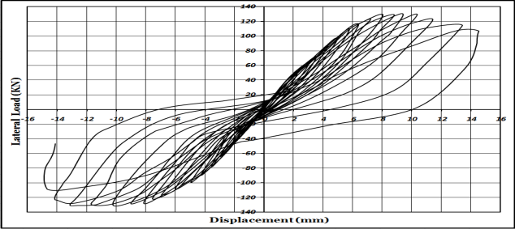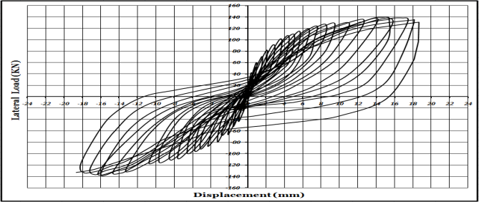
C1 C2
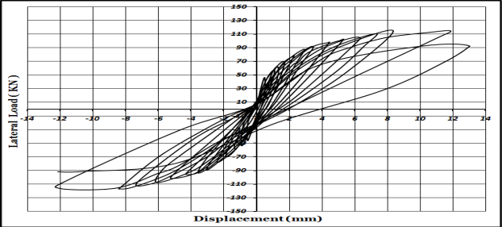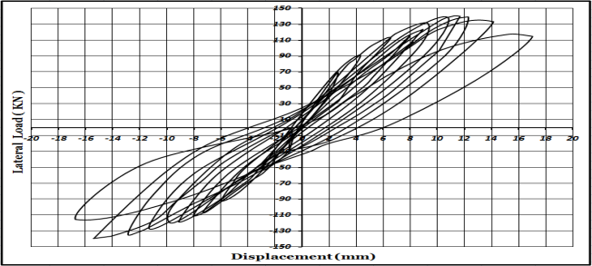
C3 C4 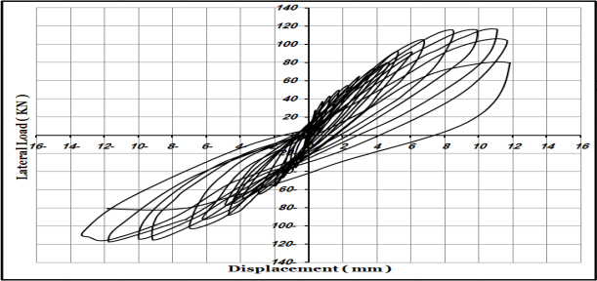 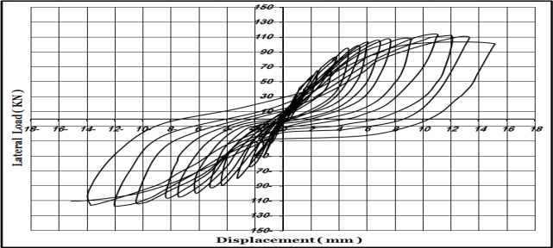
C5 C6
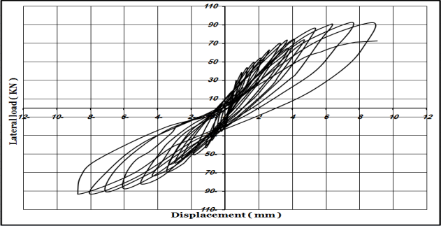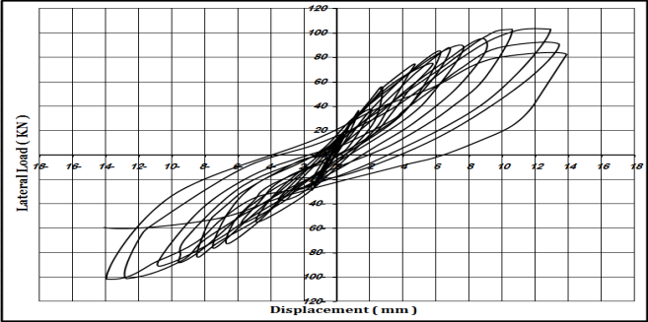
C7 C8 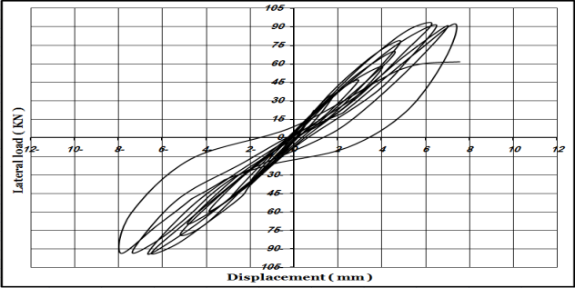 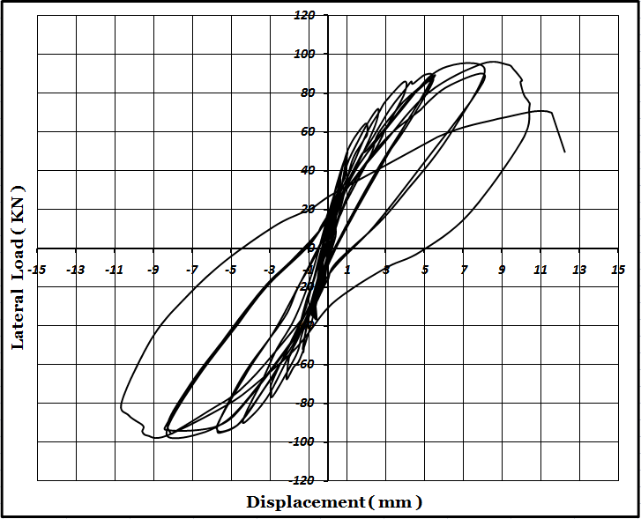
C9 C10
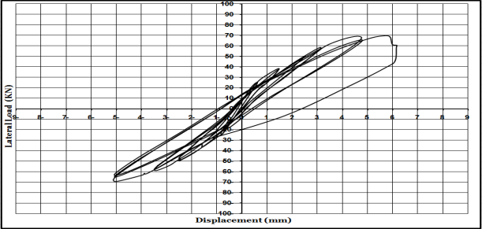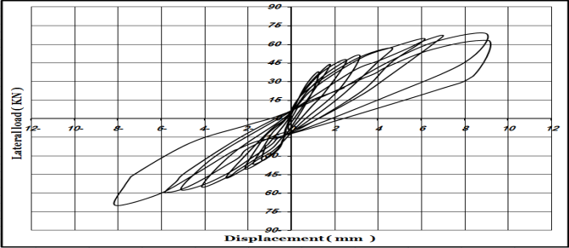
C11 C12

Appendix B

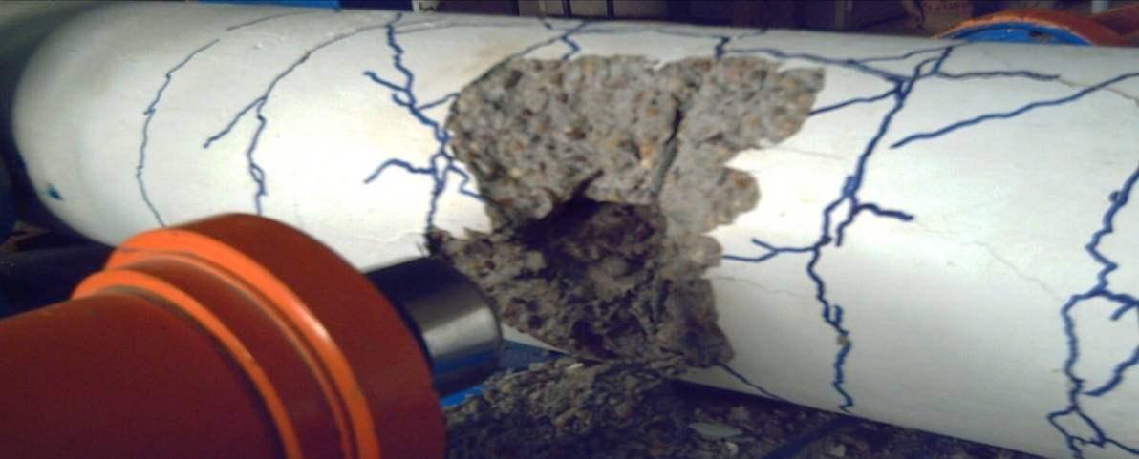

B-1 Failure of column C5

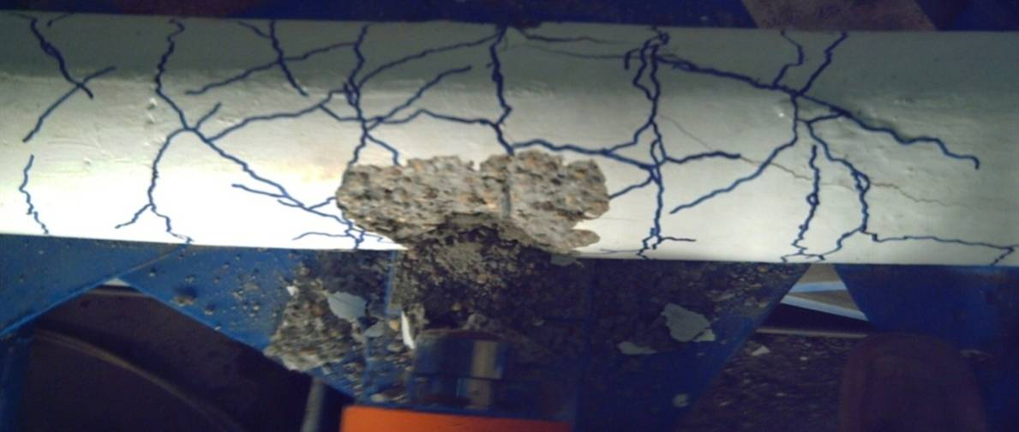

B-2 development of cracks at the upper face of column C5

