Embryonic Study Of Tracheo-Esophageal Region During Embryonic Development In Chick Embryo
.(Gallus Deomesticus L. )
Ali Shalan AL-Araji | Hayder Jawad Mobarak | Amal Ali AL-Taee
Babylone Univ.,College of Scince | AL-Nahrain Univ.,College of Medicine | Babylone Univ.,College of Scince

Abstract:
The aim of this study was to investigate the separation of the trachea-esophageal region (TE) in the chick embryos (Gallus domesticus L.). TE development was followed between stage (14) to stage (19) of Hamburger and Hamilton (H&H). Many debates were found in recent researches as attempts to fill the gaps to complete knowledge about the mechanisms involved during the earlier stages of trachea-esophageal formation.The present deals with the histogenesis of TE region in chick embryos. The histological study revealed different developmental morphology of the pharyngeal lumen in the serial transverse sections. The histological results also demonstrated lateral compression of the wide lumen of the pharynx that is probably produced by the massive bilateral sclerotomal development accompanied by deviation of the anterior cardinal veins and the fusion of dorsal aorta
. الخلاصة:
هدفت الدراسة الحالية الى معرفة اتصال القصبة الهوائية والمريء في اجنة الدجاج. تم متابعة النماء في الراحل الجنينية 14-19 لهامبرغر وهاملتون. توجد في البحوث الاخيرة العديد من المناقشات كمحاولات لمليء الفراغ لاكمال المعرفة حول الميكانيكيات المعقدة خلال المراحل الاولى من تكون القصبة الهوائية والمريء.عنيت الدراسة الحالية بالتكوين النسجي لمنطقة القصبة الهوائية والمريء. اظهرت الدراسة النسجية اشكال نمو مختلفة لتجويف البلعوم في المقاطع المستعرضة المتسلسلة. كما اظهرت النتائج النسجية انضغاطا" جانبيا" للتجويف البلعوم المتسع والتي من المحتمل انها نتجت من النماء الكبير للبدينات الهيكلية الجانبية المرافق لانحراف الاوردة الاصلية الامامية والتحام الابهر الظهري.

Introduction:
When the newborn baby takes its first breath, air travels down the trachea into the lungs. When it suckles, milk passes along the esophagus into the stomach. The critical functions of breathing and eating thus depend on two distinct epithelial tubes—the dorsal esophagus and the ventral trachea—that develop from a common progenitor—the anterior foregut tube. Defects in foregut development underlie the relatively common spectrum of human malformations referred to as esophageal atresia and tracheal esophageal fistula. While the pathological nature of these abnormalities is obvious, the molecular and cellular basis of these anomalies and even of normal tracheal and esophageal development, are poorly understood (Jianwen et al., 2006).
Material and Methods
Chick embryos: Fertilized chick eggs were obtained from a local hatchery and incubated at 38°C. Chick embryos were removed out and were staged according to the criteria of Hamburger and Hamilton (1951). The embryos were fixed in Bouin’s solution. About 2-3 embryos of different stages were used for each of the histological techniques (Robert,1965).
Method for Histological Staining:
Tissue processing was done according to Bancroft and Steven (1982). The micrographs of the relevant stained sections were subsequently taken with the aid of a light microscope (at magnification 4X).

Results:
The Histological Descriptions:
The histological description of developing pharynx did follow a stage wise morphological differentiation. The ontogeny of the pharyngeal lumen and respiratory primordial were seen to evolve in a daily manner to conform the tri-luminal configuration of the esophagus and the tow lung buds.
Transverse sections of chick embryos during the 2nd day of incubation (stages 14, 15 and 16):
The serial transverse sections of the chick embryo at stages 14,15 &16 of Hamburger and Hamilton showed the head mesenchyme at the cranial region of the embryo separating the parts of the neural tube. The notochord, dorsal aorta, optic cup, lense vesicle and anterior cardinal veins were also seen (Fig. 1A).
More caudal sections in the head region showed the elliptical cranial end of the foregut tube at the central portion of the head mesenchyme. These sections also showed the lumen of the bilateral dorsal aorta and the first aortic arche around this pharyngeal part of the foregut tube. The anterior cardinal veins seen dorsal to the dorsal aorta, on the sides of the brain vesicles. The primordia of the eye is seen on the sides of the brain (Fig. 1B).
The next serial transverse sections showed a special shape of the pharynx with bilateral pharyngeal pouches and a ventral deep pouch that is separated from the Rathke’s pouch (oral cavity) by the oral plate. The mesenchyme of the pharyngeal arches were seen containing the lumen of the aortic arches. The otic primordia were also seen. The lumen of the bilateral dorsal aorta lies just dorsal to the pharynx. The dorsal roof of the pharynx showed a mid-line shallow pouch in between the lumen of the dorsal aortae (Fig. 1C).
The dorso–ventral and bilateral pouches of the pharynx in the cervical region accompanied by widening of the lumen of the pharynx that appeared diamond in shape (Fig. 1D).
The diamond pharyngeal lumen was surrounded by the bilateral dorsal aorta dorsally and the heart ventrally, the section also show the otic capsule (Fig. 1E). The transverse sections beyond the lens and the otic capsule revealed the differentiating somatic structures; namely the dermomyotome and the sclerotome. The anterior cardinal veins were seen to be deviated away lateral word from the wall of nerve tube. (Fig.1F).
More caudal sections in the cervical region of the embryo showed the union of the bilateral dorsal aorta to form a single midline dorsal aorta which start to be separated from the dorsal pharyngeal roof by mesenchymal tissue. This region showed also the dissappearance of the dorsal shallow pouch of the roof of the pharynx, the roof of the pharynx is more flattened in this region. The ventro-lateral deviation of the anterior cardinal veins is more in these sections, these veins became just lateral to the fused dorsal aorta. The lumen of the bilateral pharyngeal pouches is obliterated (Fig. 1G).
The bilateral pharyngeal pouches disappeared in the next caudal serial sections, the ventral deep pouch is then the only to be seen in these sections. The pharynx appeared as a triangular tube with the apex pointed ventrally toward the embryonic heart. The anterior cardinal veins lie more ventro-lateral to the single dorsal aorta (Fig. 1H).
The next caudal serial sections showed the foregut tube next to the pharynx that is marked by a dorsal and ventral mesogastrium.
Transverse sections of chick embryos during the 3rd day of incubation (stages 17, 18 and 19):
The serial transverse sections showed anteriorly the head mesenchyme containing the bifurcated dorsal aorta and separating the spinal cord from the brain vesicles. The notochord and the developing somite were also seen, the anterior cardinal veins seen just lateral to the bifurcation of the dorsal aorta, the ganglia of the cranial nerves , the pharyngeal cleft and pharyngeal arches were also seen (Fig. 2A)
The next caudal sections showed the elliptical anterior part of the pharynx enclosed by the dorsal aorta and the aortic arches of the pharyngeal arches. The pharyngeal pouches and pharyngeal clefts were also seen (Fig. 2B).
The next serial sections showed an enlarging pharyngeal cavity surrounded by the single dorsal aorta dorsally and the aortic arches on the sides. The lumen of the pharynx in these sections showed many bilateral pharyngeal pouches and a shallow dorsal and ventral pouches, the ventral pouch protrude in between the maxillary prominences of the head mesenchyme. The dorsal pouching of the pharyngeal roof is formed of a stratified epithelia that is the thickest of the pharyngeal walls, the wall of ventral pouch is the thinner. The mesenchyme between the single dorsal aorta and the dorsal pharyngeal roof appeared to be more extensive at this embryonic stage. The developing paraxial mesoderm of the somites is well developed. The anterior cardinal veins were seen ventrolateral to the single dorsal aorta (Fig. 2C).
The next serial transvese sections were marked by prolongation of the dorsal pharyngeal pouch that protrude more dorsally in between the anterior cardinal veins forming a slit-like diverticulum . These veines deviated more ventral away from the single dorsal aorta. The mesenchyme around the dorsal pouching pharyngeal roof appear to be condensed in comparison to the adjacent mesenchyme (Fig. 2D).
The bilateral pharyngeal pouches then disappeared in the next caudal serial sections, the slit–like pharyngeal lumen was seen to be wider dorsally than ventral and is surrounded by a condensed mesenchyme. This part of the pharynx is surrounded by the mesothelium lining of the body cavity that form an oval mass having the same width as that of the dorsal aorta (Fig. 2E).
The next sections were marked by enlargement of the oval mesenchymal condensation surrounding the pharynx that became slightly wider than the lumen of the dorsal aorta. This condensed mesenchyme is more condensed. The ventral part of the slite-like pharyngeal lumen is replaced by transversely aligned tube of the trachea (Fig. 2F,G&H ). More caudal sections showed the bilateral lung buds bifucating from the trachea, each lung bud dublicated in more caudal sections to from the bronchial tubes (Fig. 2I).
Discussion:
The main issue of this study was to investigate the possible mechanisms that are correlated to the development of the trachea and the esophagus. The need for such a study was in the view of the previous reports that considered unknown mechanism for the developmental changes of these structures (Elisabeth et al, 2010; Ioannides, 2010). The results of our study did not agree with some of these previous reports that the foregut divides into a ventral respiratory and a dorsal parts. The tracheal primordium is an out bud from the foregut but not a part of it.
The pathologic mechanism leading to anomalies such as esophageal atresia or tracheo-esophageal fistula is unknown because the underlying mechanism of trachea-esophageal separation or formation is not well investigated (Elisabeth et al., 2010)

The Trachea-esophageal Development in Chick:
Developmental changes occurring at this region conclude that the first indication of the formation of the respiratory system as an outgrowth from the pharynx. In chicks of 3 days, a mid- ventral groove is formed in the pharynx, beginning just posterior to the level of the forth pharyngeal pouches and extending caudal. This groove deepens rapidly and by closure of its dorsal margins becomes separated from the pharynx except at its cephalic end ( Dudek and Fix, 1998).
The tube thus formed is the trachea, and the opening which persists between the cephalic end of the trachea and the pharynx is the laryngeal glottis. The original entodermal evagination gives rise only to the epithelial lining of the trachea, the supporting structures of the tracheal walls being derived from the surrounding mesenchyme (Sadlar,2010).
The tracheal evagination grows caudal and bifurcates to form a pair of lung-buds. As the lung-buds develop they grow into the loose mesenchyme on either side of the mid-line. The adjacent splanchnic mesoderm is pushed ahead of them in their caudo-lateral growth and comes to constitute the outer investment of the lung-buds. The entodermal buds give rise only to the epithelial lining of the bronchi, and the air passages and air chambers of the lungs. The connective tissue stroma of the lungs is derived from mesenchyme surrounding the lung-buds, and their pleural covering from the investment of splanchnic (visceral) mesoderm. Immediately caudal- to the glottis is a narrowed region of the fore-gut which becomes the esophagus, and further caudally a slightly dilated region which becomes the stomach (Sadlar, 2010).

Pharyngeal and tracheo-esophageal morphogenesis:
In this study, the histological criteria of the tracheo- esophageal region were described by studying the serial transverse sections of the chick embryos.
There were many debates about the trachea-esophageal development and septation. In (1951), Hamilton reported one of the old descriptions that the embryonic primordia of the larynx and trachea appeared as a laryngotracheal groove that communicates at first along its entire length with the pharynx (caudal to the pharyngeal pouches) at the third day of incubation (stages 18). Later on (at 96 hours (stages 22), the caudal part of the groove is converted into a tube ventral to the anterior end of the esophagus, this tube represented the beginning of the trachea.
These morphogenetic descriptions go with the finding of this study, however; the significance of the transverse alignment of the ventral tube of the trachea was misjudged as this could definitely reveals a change in the axis of that developing part from the dorso-ventral alignment of the pharynx to that of the transverse trachea. Also the morphological criteria of the structures surrounding the tracheo-esophageal development were not reported as a relevant event that could interrelate to trachea-esophageal formation.
The descriptions of Hamilton (1951) concluded that the anterior part of laryngotracheal groove will form the larynx and that the trachea is elongated with the elongated esophagus, at the sixth day (stages 28, 29) the trachea is a long tube that branching caudally into bronchi. At the 8th day (stages 34), the lumen of the larynx, trachea, and the bronchi is obliterated transiently, and recanalization occur later on.
Among the debates of the tracheo-esophgeal formation, it was reported that the differentiation of the primitive foregut into ventral trachea and dorsal esophagus is thought to be the result of a process of septation. This hypothetical appraisal suggested that a lateral ridges appeared in the lateral walls of the foregut, which fuse in the mid-line in a caudo-cranial direction forming the tracheo-esophageal septum that separated the trachea and the esophagus (Rosenthal,1931; Smith,1957; Qi and Beasley, 2000).
This study on the trachea-esophageal region did not show any approval for a possible trachea-esophgeal septum formation. The barrier between the trachea and the esophagus was found to be resulting from the mesenchymal tissues separating the ventral tracheal bud from the dorsal esophagus. This hypothesis of the inward growing bilateral ridges leading then to septum formation probably goes with the effect of the lateral body folding on the trachea-esophageal region that may promoting such a growth, however; the idea or the possibility of such a bilateral inward growth is opposed by the transverse outward axis of the tracheal growth shown in this study that must occur just ventral to this hypothetical inward septum formation.
The hypothesis of Zaw-Tun (1982) is in agreement with the results of this study, he reported that the tracheo-esophageal septum is in fact the floor of the pharynx that results from the ventrocaudal out-growth of the respiratory primordium from the caudal end of the laryngeal sulcus of the foregut.
The trachea is more likely developed as a bud from the ventral wall of the caudal pharynx, this bud expands in bilateral or transverse directions un-matching the dorso-ventral orientation of the slit-like pharyngeal morphology. This conclusion achieved from the results of this study supported the view of Harjeet et. al. (2004) stated that a diverticulum (tracheobronchial diverticulum) arises from the laryngotracheal groove which extends caudally anterior to the esophagus. The pouch separates from the pharynx and esophagus and constitutes a tube, the upper part of which becomes the larynx and the caudal part develops into trachea. However, the cranial connection with the esophagus persists. The tube is named as laryngotracheal tube. The caudal portion of the tube bifurcates to form the principal bronchi(Harjeet and Jit, 2004)
In contradiction to the model of septation described above, Zaw-Tun (1982) was not able to verify the importance of the tracheo-esophageal septum for the differentiation of the foregut in a study of human embryos. This author proposed an alternative model instead, he suggested that the respiratory tract developed simply by further growth of the lung bud in a caudal direction. The establishment of such a model is a support to the conclusions achieved in this study.
By using scanning electron microscopy (SEM), Kluth et al. (1987) studied the development of the foregut in chick embryos. They could not demonstrate the formation of the tracheoesophageal septum. In a sequence of SEM photographs of staged chick embryos, they described the differentiation of the primitive foregut into esophagus and trachea as a process of "reduction of size" of a foregut region which they called "tracheo-esophageal space". This reduction is caused by a system of folds develops in the primitive foregut. These folds approach each other but do not fuse. Finally, the former tracheoesophageal space becomes the pharyngotracheal duct of laryngeal primordium. According to the results of this study, the interpretation of Kluth et al. could represent compromised view that formulate a possibility between the models of septation and that of growth. The reduction of the size of the foregut may occur caudal to the pharynx due to obliteration of the pharyngeal lumen affected by the lateral body folding resulting in a smaller esophageal lumen. The non-fusion of the folds described by these authors is a fact that excludes the hypothesis of reduction of size of the foregut region.
The more recent and even the old literatures suggested that it is not so clear whether the trachea arises as an outgrowth of the caudal part of the laryngotracheal groove ("tracheal outgrowth" hypothesis) (Sasaki et al.,2001, Zaw-Tun, 1987).This model does not require the existence of lateral ridges or septum, or the trachea is derived from the caudal part of this groove.

The Association of The Developmental Structures Around The Trachea-esophageal Region:
The Lateral Body Folds:
The lateral body folds are among the most significant structural event that may be related to trachea-esophageal region. It was reported that the lateral body folds become deeper during the process of the embryonic rotation. These lateral body folds are a continuation of the lateral folding in the head region, and are occurring by the folding of the splanchopleural and somatopleural mesoderm leading to gut tube formation (Howard, 1952).The mechanical effect of the lateral folding may be a causative factor that leads to bilateral inward compression on the developing structures in the trachea-esophageal region. This force could promote the union of the dorsal aorta to form a single dorsal aorta, and it could play a role in bilateral compression of the pharyngeal walls to form the slit-like shaped pharynx caudal to the pharyngeal pouches. The role of a mechanical forces were reported by many authors to affect the development of some structures in this region including the developmental changes of pharyngeal arches occurring in association with developmental changes of structures in the neck (Hamilton, 1952; Freidberg, 1989).
From the result of this study, the transverse growth of the tracheal bud may not being affected by the bilateral inward forces of the body folds because the timing of the tracheal bud (during 3rd) occurs after the compaction effect that of the lateral body folding at the 2nd.
The Anterior Cardinal Veins:
The anterior cardinal veins are the great blood vessels of the head that become the internal jugulars in the course of development. The anterior cardinal veins are formed before the posterior cardinal. At the stage 12 of H&H, they lie at the base of the brain, dorsal to the dorsal aorta and extend forward in the region of the diencephalon. Up to about 48 hours the anterior cardinal veins lie median to the cranial nerves, but between this time and 72 hours the cranial nerves become median to these veins.
This positional changes of the anterior cardinal veins goes with results of this study, the causative factor contributing to this phenomenon was not discussed previously.
The clear transposition of the anterior cardinal veins from a dorsal and medial position into a more lateral and ventral region may be produced by the sclerotomal growth (Elizabeth et al., 1997 ; Pouget et al., 2008). Initially the anterior cardinal veins were dorsal to the pharynx in close contact with wall of the neural tube, these veins deviated laterally and ventrally to reach the sides of the pharynx. The ventral deviating cardinal veins may also associated with compression of the mesenchyme ventral to them, and this mesenchyme compressing the pharynx and the structures surrounding and forming an oval mesenchymal mass of condensed mesenchyme around the pharynx . The compressed pharyngeal lumen acquires a slit – like lumen.
The condensed oval mesenchyme proliferation probably leading to narrowing and then obliteration of the ventral part of the slit- like pharyngeal lumen. The tubular trachea buds out from the patent dorsal part of the pharynx.
The Dorsal Aorta:
The dorsal aorta above the pharynx receive the aortic arches, and the right and left dorsal aorta unit posteriorly just behind the fourth pharyngeal pouch to form a single dorsal aorta (Sadlar,2010; Jaffredo et al.,2010). It was also reported that the formation of the respiratory system beginning just posterior to the level of the forth pharyngeal pouches (Dudek and Fix, 1998), this tracheal diverticulum developed from the ventral groove of the pharyngeal slit that is called laryngotracheal groove (Ioannides, 2010; Sadlar,2010).
The lateral body folds occur passively by the effect of the rapid growth of the somites, the sclerotome is a part of the developing somites (Elizabeth et al., 1997 ; Christ et al., 2004; Wiegreffe et al., 2007 ; Pouget et al., 2008).
It seems that the region behind the forth pharyngeal pouch is the most vulnerable part of the embryo that may be affected by the bilateral compression of the body folds. This compression leads to fusion of the right and left dorsal aorta and to compression of the pharyngeal lumen to become slit-like, the tracheal diverticulum develoed from the ventral aspect of this slit.
The Sclerotomes
The results of this study suggested that the trachea arises as an outgrowth of the caudal part of the pharynx. The histological results demonstrated lateral compression of the wide lumen of the pharynx that is probably produced by the massive sclerotomal development during the third day of incubation.
It was reported that the somite cells that are ventral and median and at the core of the somites extend from the intermediate mesoderm to about the center of the neural tube, these cells become mesenchymal constituting the sclerotomes that spread toward the notochord and the space between the dorsal aorta. It was reported that the most posterior sclerotomes are developing while the intermediate and anterior sclerotomes show successively later stages. The sclerotomes are entirely mesenchymal extending along the sides of the neural tube. The notochord and the sclerotomes are the primordial of the vertebral column. The scleotomes of the first four somites contribute to the formation of the occiput bone (Lim et al., 1987; Sadlar, 2010). In the chick embryo, the somites are not formed anterior to the level of the otocyst. The more anterior part of the mesoderm of the head never segmented in chick. In an amniote vertebrates, there are number of cephalic somites (Walker and Warren, 1987). The axial mesoderm of the head in chick embryo is an anterior continuation of that of the trunk. It terminates at the anterior end of the foregut. In the anterior part of the head it is mesenchymal .
Experimental Methodologies to Expalian Trachea-esophageal Formation:
Some of the studies on the trachea-esophageal formation involves unlogic concepts for experimental trials to verify the possible underlying mechanisms. Among these was the study of Kleckner et al. (1984). These authors studied the effect of hyperflexing the chick embryos at critical stages in the development of the foregut, in order to test the theory that esophageal atresia and tracheoesophageal fistula result from embryonic hyperflexion. There were no significant disturbances of either tracheal or esophageal growth(Kleckner et al., 1984).
This study was directed toward making comprehensive informations about the trachea-esophageal morphogenesis depending on the meticulous microscopic examination, these information will be then compared to the conclusions reported in the previous studies.
To examine the developmental process of the normal trachea and esophagus and their maldevelopment leading to tracheoesophageal fistula (TEF), a study was performed on the three-dimensional (3-D) image reconstruction of the developing foregut in normal and adriamycin (ADM)-induced TEF rats. Microscopic images of serial sections of embryos were traced and reconstructed using a 3-D construction imaging system. In the normal embryos, the lung bud appeared just below the pharyngeal foregut on day 11 and it elongated caudally to shape into the trachea as they grew. A 'tracheoesophageal septum" did not emerge. In the TEF embryos, although the lung bud appeared in a similar position on day 11, the trachea and esophagus did not separate and only a common foregut tube elongated caudally, then bilateral bronchial primordia emerged directly from it. The trachea seemed to be formed only by caudal elongation of the lung bud in the normal embryos. In the ADM-induced TEF embryos, the upper foregut appeared to develop only into the trachea, and this maldevelopment may be implicated in the abnormal interaction between the foregut and the surrounding mesenchyme (Sasaki et al., 2001).
The results of the above study supports that of this study in that the respiratory primordium is a form of a bud from the foregut, and that a'tracheoesophageal septum" did not develop.A study described the origin and development of esophageal atresia with tracheoesophageal fistula and vertebral anomalies using the rat embryo and produced by Adriamycin administration. Anomalies of tracheal development occurred in association with abnormalities of the primordial of the vertebral column (Merei et al., 1998). Although the above study concludes a relation between the abnormal developing vertebral column and the abnormal trachea-esophageal development, it is in agreement with the present study that suggested an important role of the vertebral primordial (as the sclerotomes) with the configuration of the

t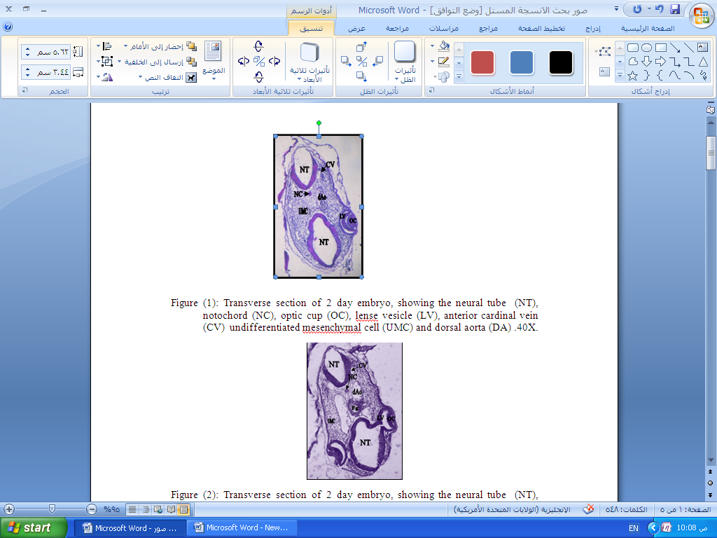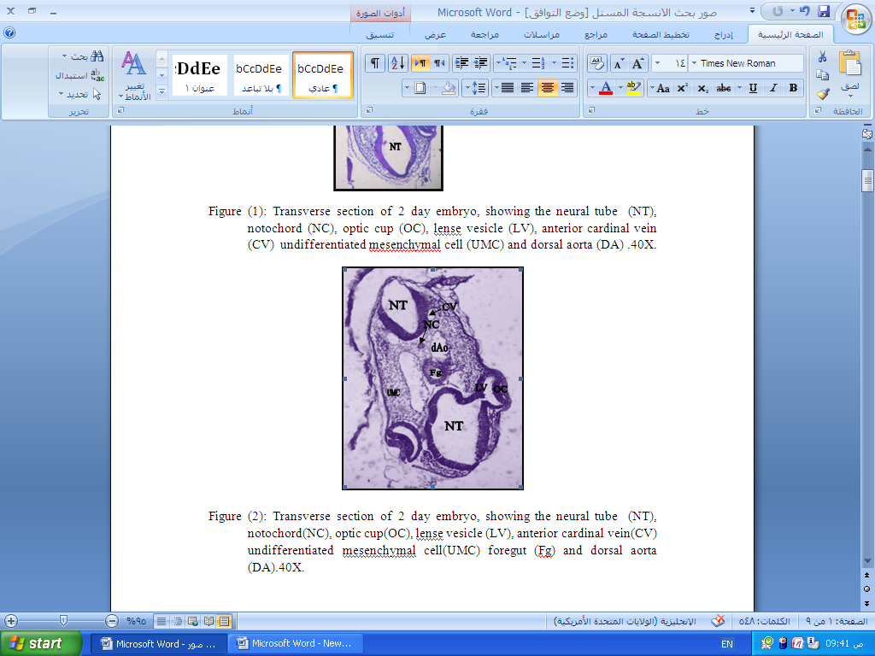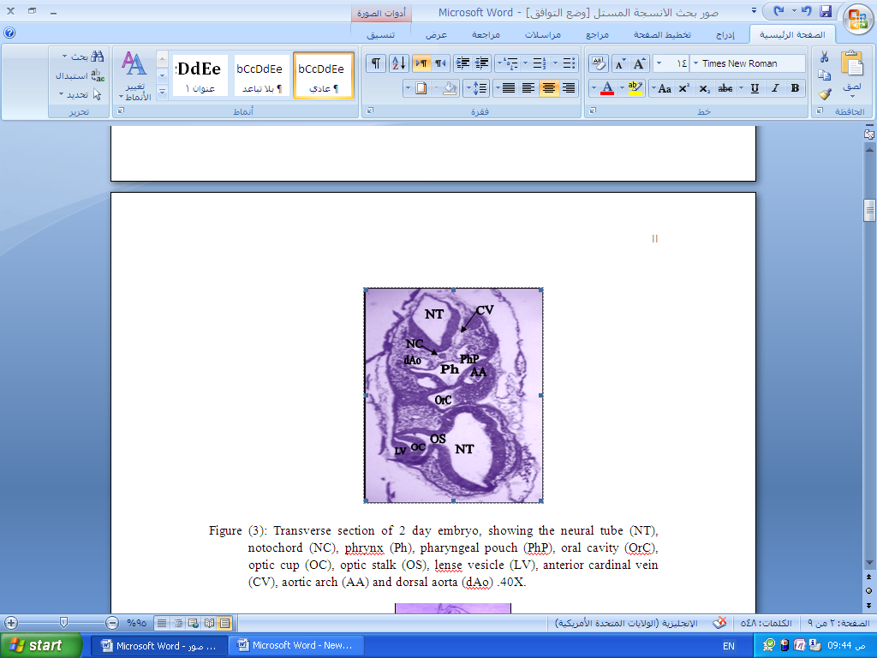 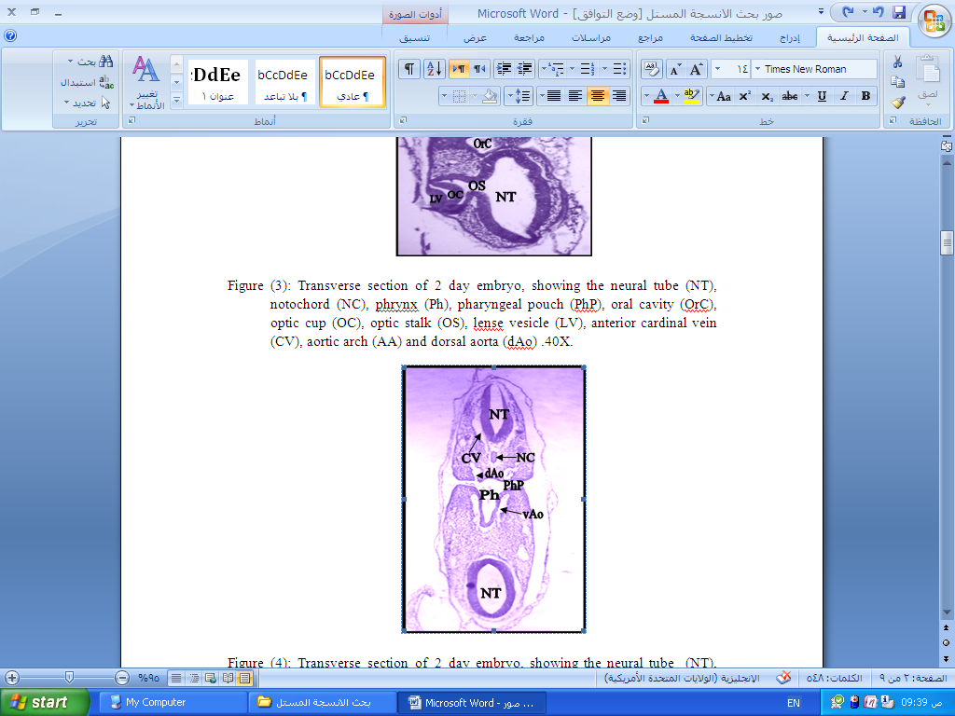
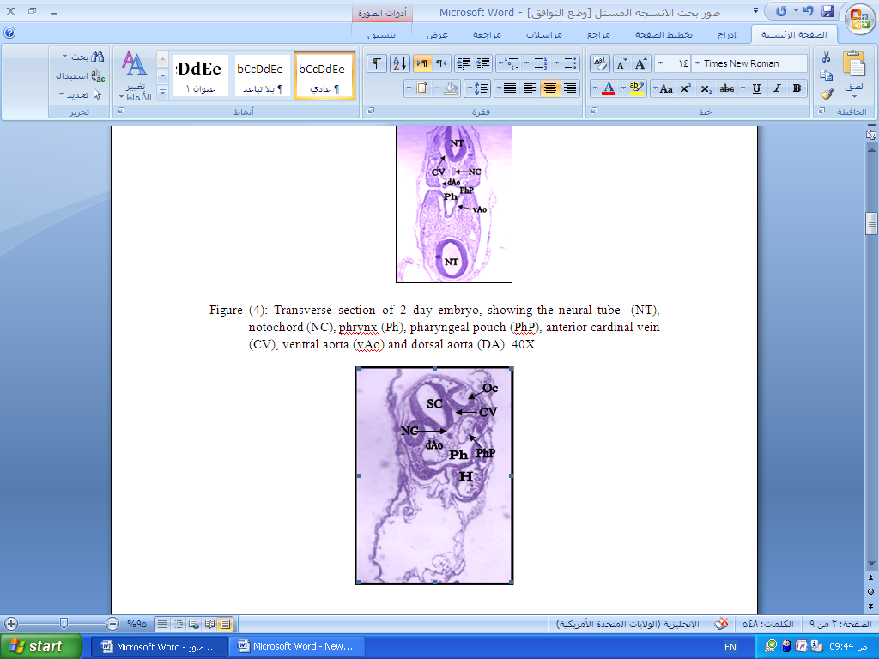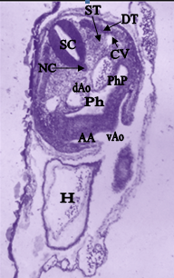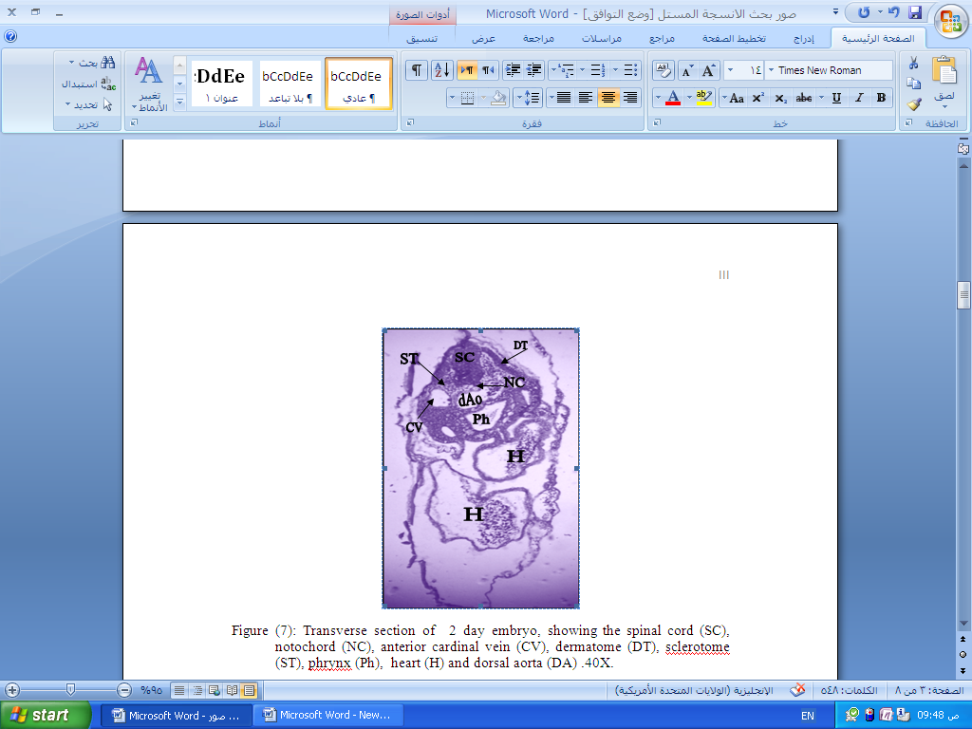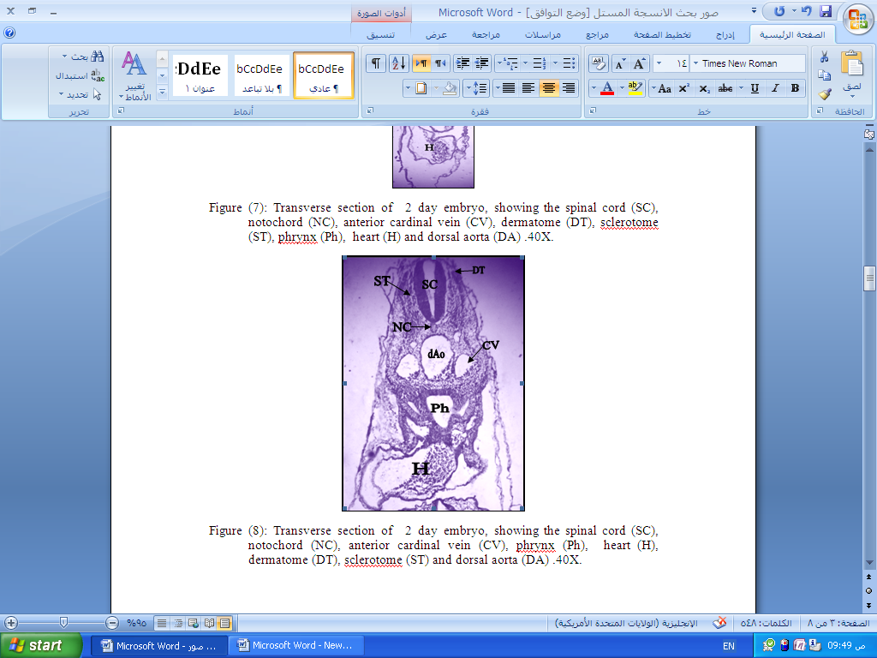
Figure (1A-H): Transverse section of 2 day embryo (14,15 &16) staining with Haematoxyline &Eosin,, showing the neural tube (NT), notochord (NC), optic cup (OC), lense vesicle (LV), anterior cardinal vein (CV) undifferentiated mesenchymal cell (UMC), foregut (Fg), pharynx (Ph), pharyngeal pouch (PhP), oral cavity (OrC), optic stalk (OS), anterior cardinal vein (CV), spinal cord (SC), otic capsule (Oc), heart (H), aortic arch (AA), ventral aorta (vAo) and dorsal aorta (dAo), dermatome (DT), sclerotome (Sc), aortic arch (AA).4X.

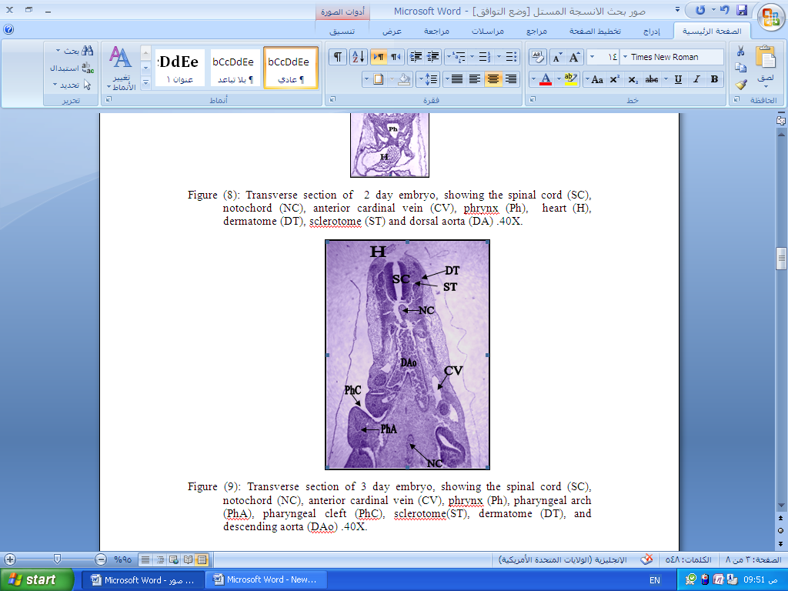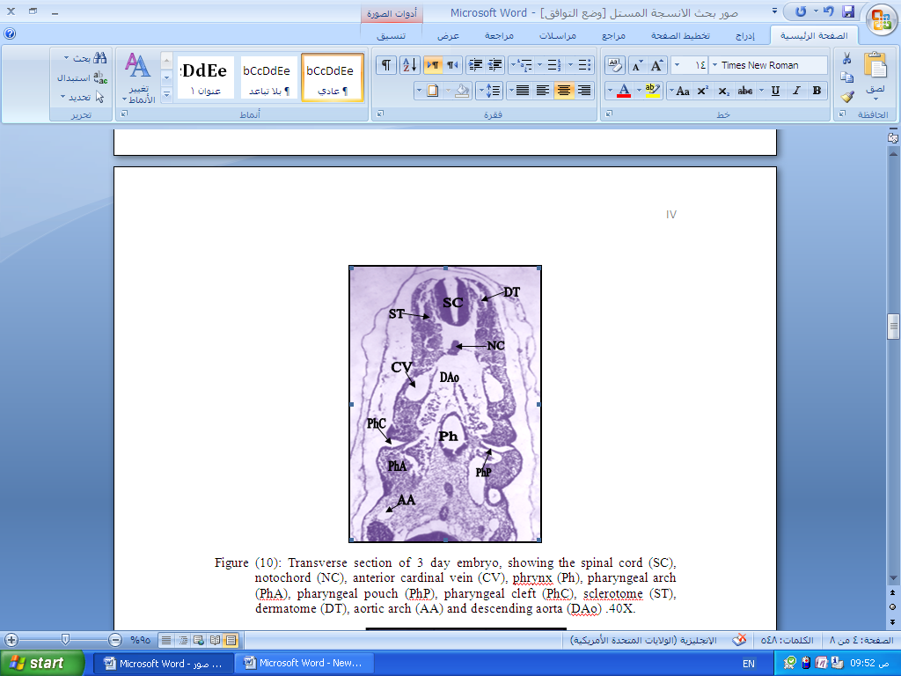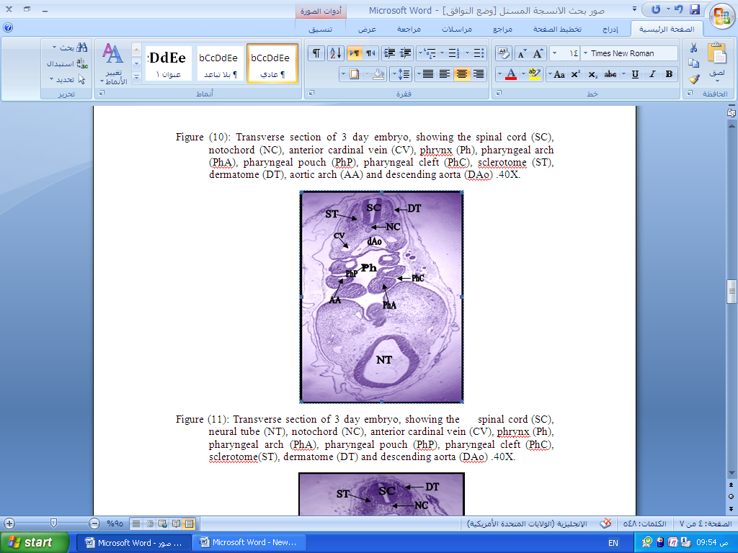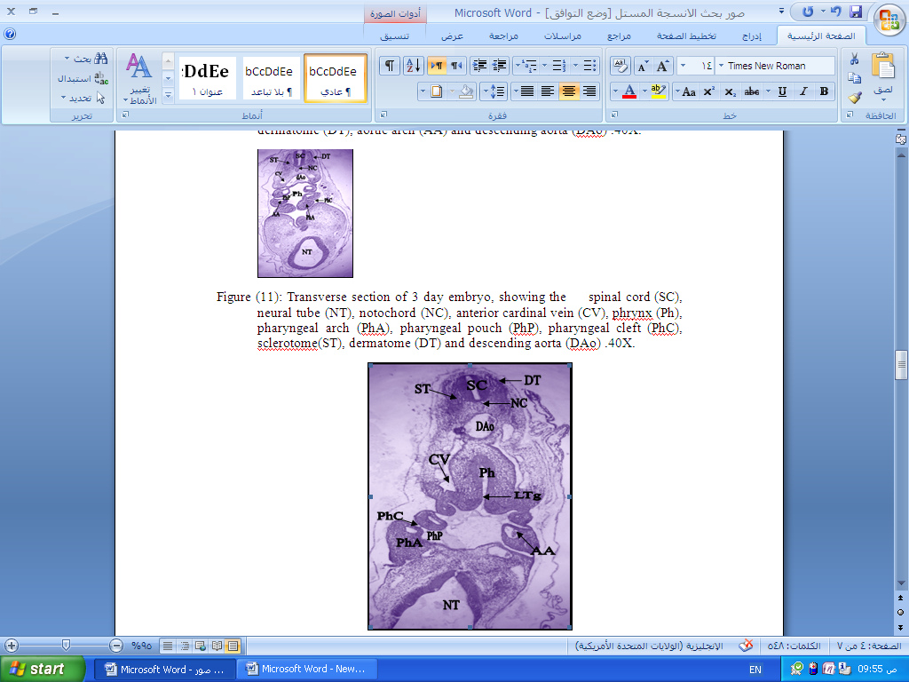
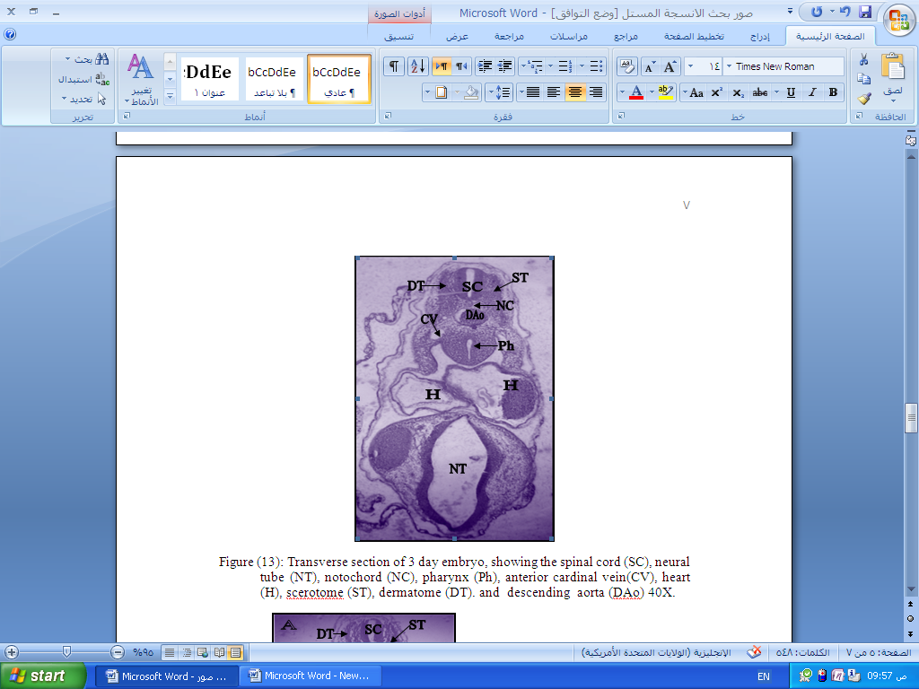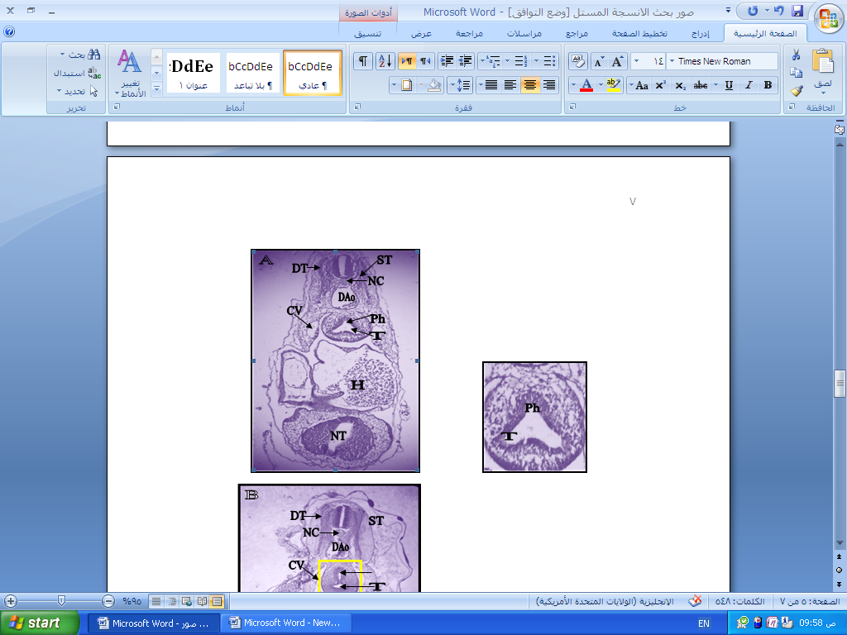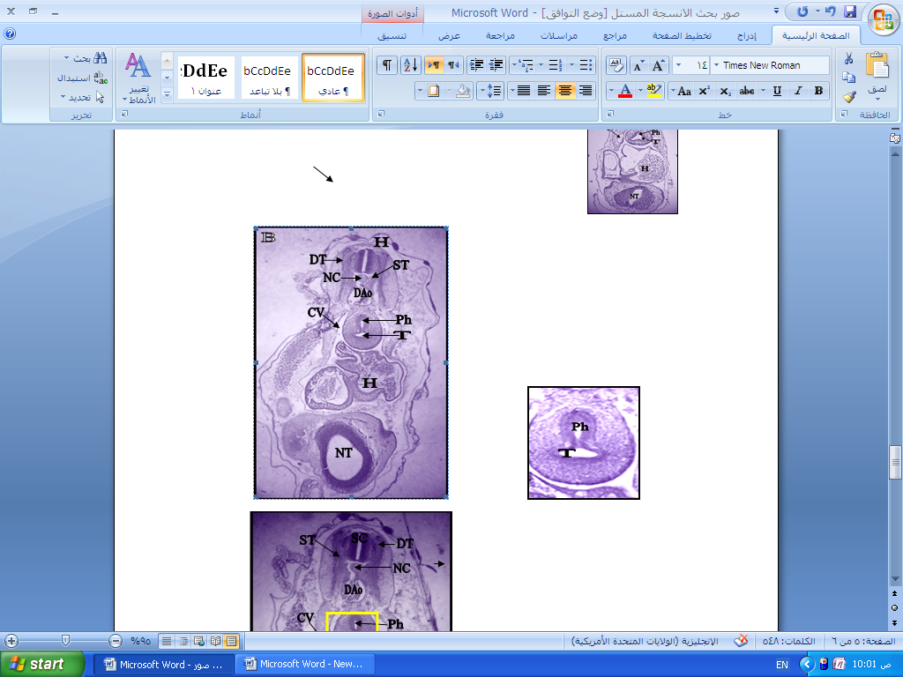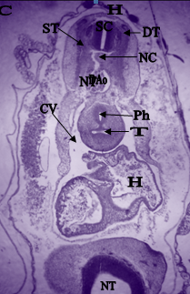
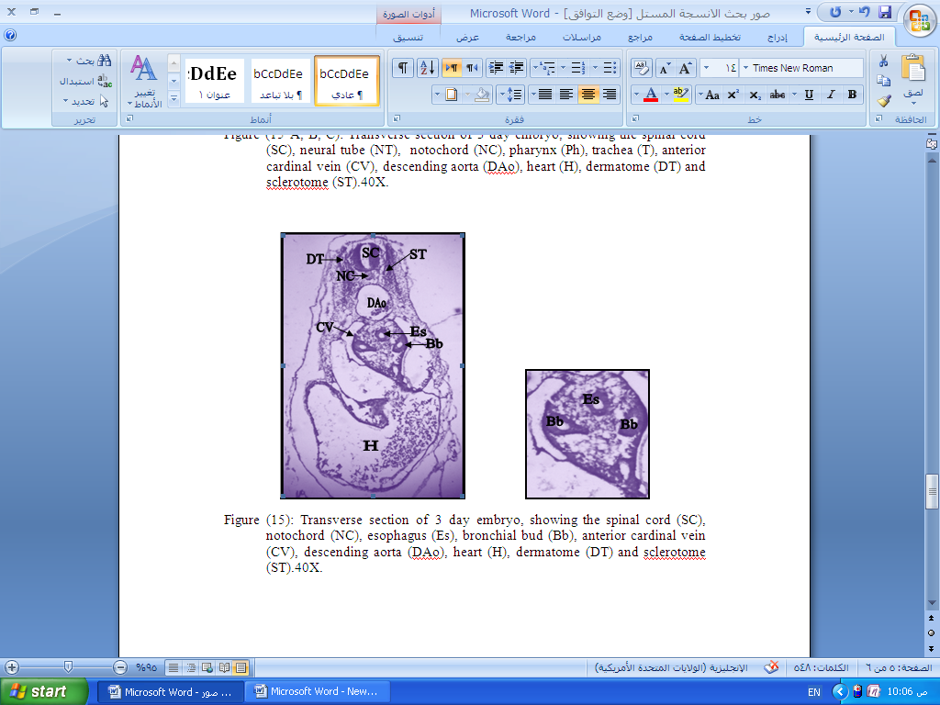
Figure (2A-I): Transverse sections of 3 day embryo (17,18 &19) staining with Haematoxyline &Eosin, showing the spinal cord (SC), notochord (NC), anterior cardinal vein (CV), phraynx (Ph), pharyngeal arch (PhA), pharyngeal cleft (PhC), sclerotome(ST), dermatome (DT), descending aorta (DAo), pharyngeal cleft (PhC), sclerotome (ST), dermatome (DT), aortic arch (AA), laryngotracheal groove (LTg), heart (H), trachea (T), esophagus (Es) and bronchial bud (Bb) .4X.

References:
Bancroft, J.D., and Steven, A.(1982). Theory and practice of histological techniques, 2nd ed. Edinburg: Churchill Livingston.
Christ, B., Huang, R. and Scaal, M. (2004). Formation and differentiation of the avian sclerotome. Anat. Embryol. 208, 333-350.
Dudek, A.R.W., and Fix, J.D. (1998). Embryology, Browed Review Series-2nd ed. Wolters Klumer Company. Lippincott Williams &Wilkins.
Elizabeth M., Kensicki, M. and Eisen ,J. S. (1997). Sclerotome development and peripheral nervous system segmentation in embryonic zebrafish. J. Development 124, 159-167
Elisabeth, M. J., Janine, F. F., Annelies, K. and Dick, T. (2010). Etiology of esophageal atresia and trachea-esophageal fistula. Curr. Gastroenterol. Rep. 12(3): 215-222.
Faure, F. and Barbara, P.S. (2011). Molecular embryology of the foregut. JPWN. Vol.52.
Freidberg, J. (1989). Pharyngeal cleft sinuses and cysts, and other benign neck lesions. Pediatr. Clin. North. Am. 36:1451.
Hamburger, V. and Hamilton , H. L. (1951). A series of normal stages in the development of the chick embryo. J. Morphol., 88, 49-92.
Hamilton, H.L. (1952). Lillies development of the chick, an introduction to embryology. Third ed. Newyork. Henry Holt and Company.
Harjeet, S.D. and Jit, I. (2004). Development of the human trachea. Postgraduate Institute of Medical Education and Research, Chandigarh, Abstract : The development of the human trachea was studied, J.Anat. Soc. India. 53 (1) 1-3.
Ioannides, A.S., Massa, V., Ferraro, E., Cecconi, F., Spitz, L., Hendeson, D., J. and Copp, A. J. (2010). Foregut separation and trachea-esophageal malformation: The role of tracheal outgrowth, dorso- vental patterning and programmed cell death. Dev. Biol. Vol. 337 (2): 351- 362.
Jafferdo, T.H., Richard, C.H.; Pouget , C., Teillet, M.A., Bollerot, A., Gautier, R., and Drevon, C.(2010). Aortic remodeling during hemogenesis: is the chicken paradigm unique? Int. J. Dev. Biol. 54: 1045-1054.
Jianwen, Q., Murim, C., Joshua, W., Ziel, J., K. , and Brigid L.M.H. ( 2006). Morphogenesis of the trachea and esophagus: current players and new roles for noggin and Bmps. J. Different. Vol. 74: 422-437.
Kleckner, S.C., Pringle, K. C., and Clark, E.B.( 1984). The effect of chick embryo hyperflexion on tracheoesophageal development. J. Pediatr. Surg. Aug;19(4):340-4.
Kluth, D., Steding, G., and Seidl, W .( 1987). The embryology of foregut malformations. J. Pediatr. Surg. May; 22(5): 389-93.
Lim, S.S. and Low, F.N. (1977). Scanning and electron microscopy of the developing alimentary canal in the chick. Am. J. Anat. 150: 149-174.

Merei, J., Hasthorpe, S., Farmer, P. and Hutson, J.M.(1998). Relationship between

esophageal atresia with trachea-esophageal fistula and vertebral anomalies in mammalian embryos. 33, (1): 58-63.
Pouget, C., Pottin, K. and Jaffredo, T. (2008). Sclerotomal origin of vascular smooth muscle cells and pericytes in the embryo. Dev Biol 315: 437- 447.
Qi, B.Q. and Beasley, S.W. (2000). Stages of normal trachea-bronchial development in rat embryos: resolution of a controversy. Dev. Growth Differ. 42:145-153.
Qi, B.Q., Beasly, S.W., and Williams, A.K. (2001). Evidence of a common pathogenesis for foregut duplications and esophageal atresia with trachea-esophageal fistula. Anat. Rec. Vol. 264: 93-100.
Robert, S.R.(1965). Experimental embryology techniques and procedures. Burgess Publishing Comp. Minneapolis, Minnesota. 3rd ed. P.405-443.
Rosenthal, A.H. (1931). Congenital atresia of the esophagus with trachea-esophageal fistula: report of eight case. Arch. Pathol. 12:765-772.
Sadlar, T.W. (2010). Langmanُ s medical embryology. 10th ed. Twin Bridges, Montana.
Sasaki, T., Kusafuka, T. and Okada, A.(2001). Analysis of the development of normal foregut and trachea-esophageal fistula in an adriamycin rat model using three-dimensional image reconstruction. Surg. Today 31:133-139.
Smith, E.I. (1957).The early development of the trachea and esophagus in relation to atresia of the esophagus and trachea-esophageal fistula. Contr. Embryol. Carneg. Instn. 36: 41-57.
Walker, Jr. Warren, F., (1987). Functional Anatomy of the Vertebrate San Francisco: Saunders College Publishing.
Wiegreffe, C., Christ, B., Huang, R. and Scaal, M. (2007). Sclerotomal origin of smooth muscle cells in the wall of the avian dorsal aorta. Dev. Dyn. 236: 2578-2585.
Zaw-Tun, H.A.(1982). The tracheo-esophageal septum--fact or fantasy? Origin and development of the respiratory primordium and esophagus. Acta-Anat-Basel.; 114(1): 1-21.

