Designing Optimal Binary Search Tree Using
Parallel Genetic Algorithms
Bahaa Mohsen Zbeel
College Of Fine Art Babylon University

Abstract :-
Evolutionary algorithms (EAs) are modern techniques for searching complex spaces for on optimum . Genetic algorithms (GAs) are developed as random search methods, which have not so sensitivity on primary data of the problems. They can be used in estimation of system parameters in order to obtain the best result. This can be achieved by optimization of an objective function. Genetic programming is a collection of methods for the automatic generation of computer programs that solve carefully specified problems, via the core, but highly abstracted principles of natural selection. In this paper, genetic algorithms and parallel genetic algorithms have been discussed as one of the best solutions for optimization of the systems. Genetic and parallel genetic algorithms have been investigated in Visual basic 6 Environment Then an optimal binary search tree has been selected as a case study for decree sing of searching time. Also a dynamic programming method has been accelerated by using of a parallel genetic algorithm. In this case, by increasing the size of data, speed-up index will be increased.
Key words:
Optimization, Genetic Algorithm, Parallel Genetic Algorithm, Optimal Binary Search Tree

الخلاصة :-
نعتبر الخوارزميات التطورية (EAs) تقنيات حديثة للبحث في الفضائيات المعقدة لوصول الى نتائج مثلى . الخوارزميات الجينية (GAs) قد بينت كطرق بحث عشوائية بحيث لا تكون حساسة بشكل كبير للبيانات الرئيسية للمسائل العاملة عليها . ممكن ان تستخدم في تخمين معاملات نظام من اجل الحصول على نتيجة افضل . ممكن تحقيق ذلك بتحسين دالة الهدف . البرمجة الجينية هي مجموعة من الطرق للتوليد الآلي لبرامج الحاسوب والتي ممكن ان تحل بشكل دقيق مسائل محددة أساسا باستخدام المبادئ الخاصة بالاختيار الطبيعي ، في هذا البحث ، الخوارزميات الجيني والخوارزميات الجينية المتوازية قد نوقشت كإحدى افضل الحلول لتحسين النظام ، وقد استخدمت اللغة visual basic (6) كأداة لبرمجة النظام وقد اختيرت افضل شجرة بحث ثنائي من حيث اقل وقت للبحث فيها وقد استخدمت طريقة البرمجة الدينامية وسرعت باستخدام الخوارزميات الجينية المتوازية .
كلمات مفتاحية :-
التحسين ، الخوارزميات الجينية ، الخوارزميات الجينية المتوازية ، شجرة بحث ثنائي مثلى .
1. Introduction
Genetic algorithms are a part of evolutionary computing, which is a rapidly growing area of artificial intelligence. Their basic working mechanism is as follows: the algorithm is started with a set of solutions (represented by chromosomes) called population. Solutions from one population are taken and used to form a new population. This is motivated by a hope, that the new population will be better than the old one [A. Kalynpur, M. Simon 2001, M. Obitco 2006 , J. Fernandez 2006].
Everything around us is part of some system. Researchers have tried to model it into the system computer. The models were not complex enough to solve interesting problems. Thus the models were not practical [Laurrens Jan Pit 1995]. A system is a black box with a set of input parameters.
The system developers measure the parameters of each subsystem separately, and exhibit all them as a set of the system's parameters, but ignore the effect of sub-systems on each other and disorders signals. In addition, the parameters should be set
so that the system conclude the best. For doing of this matter, it is needed to optimize the output function of the system. It means that we should minimize or maximize it, and consequently increase its performance. The goal of this research is achieving a solution that these values are obtained faster without involving in internal properties of the system. The optimal binary search tree has been considered as a case study. Generally, there are three general methods for optimization and searching of these optimal points [David E. Goldberg 1989] : The Calculus Based Searching method, Enumerative Searching method and Random Searching method. The calculus based searching method is divided to two branches : Direct and Indirect. In direct way, the optimal points are btained by solution of some linear equations or non linear ones. In indirect way, a limited of optimal pointes are obtained, then they are optimized by Hill Climbing methods. In the enumerative searching method, the searching space of the problem is processed and the value of objective function of the system is obtained for each point, and finally optimal points are selected. Dynamic programming method is of these cases. In random searching method, the space of searching problem is searched by random for finding of optimal points. Genetic algorithm is a guided random algorithm [David E. Goldberg 1989].
The two first methods aren’t cost effective and they don't effect if searching space of the problem is expanded. Parallel algorithms are used to increase the speed and performance of the optimization methods. The genetic algorithms are appropriate for this purpose because of : 1) Independency to primary values of the parameters 2) Independency to system's objective function properties (continuous, derivative, etc.) 3) Searching of greater space of the parameters values. The most important characteristics of these algorithms is parallelism. It causes the increasing of the speed and performance of the system and decrease the system's response time. Sometimes due to existing the several objective functions in the system, using of genetic algorithm will increase the system’s speed and will decrease the system's response time.
2. Genetic Algorithms
Genetic algorithm can be viewed as a biological metaphor of Darwinian evolution [Laurrens Jan Pit 1995]. It is a random searching method which creates a new generation of the answers by selecting a collection of answers randomly, and improves them in each stage, until finally it achieves an acceptable answer between these answers. This algorithm have some components[Chong Fuey Sian,"A 1999, David E. Goldberg 1989, Marek Obirko 1998, Ricardo Bianchini 1993]. These components are :
Chromosome, Genetic population, fitness function, genetic operations, and genetic algorithm parameters. By running of genetic algorithm, some chromosomes from genetic algorithm are selected as parents. Next generation of chromosomes are created by using the operators, and therefore the next genetic population is composed. This is done by Select operator [Laurrens Jan Pit 1995, P. C. Chu and J. E 1995, Thomas Bak 1996].
Only selection of the parents is not enough for producing of the next generation of chromosomes, but we should search for some methods for returning of the produced chromosomes to the Genetic Population. This is also done by Replacement operator. To doing of this case, after selecting the parents from Current population, they are placed in the Intermediate population.

The genetic operation will be done on them until a new population of the chromosomes will be created, then they will be placed in the Next population [Laurrens Jan Pit 1995]. Permutation operator is used for recombination [Laurrens Jan Pit 1995, Marek Obirko 1998]. The permutation operator is also another operator which will cause innovation in the chromosomes of a genetic population. It also stops monotony in genetic population and stops involving the algorithm in the local minimize or maximize points
3. Parallel Genetic Algorithms
For the first time, Holland, 1963, recognized the parallel nature of genetic algorithms, and in 1976 Bethke calculate the complexity of doing the Genetic algorithm on parallel machine, but he didn't simulate or implement it. Then in 1981, Grefenstette presented some parallel implementation of genetic algorithms[David E. Goldberg 1989]. The way in which GAs can be parallelized depends on the following elements[M. Nowostawski, R. Poli 1999]:
• How fitness is evaluated and mutation is applied
• If single or multiple subpopulations (demes) are used
• If multiple populations are used, how individuals are exchanged
• How selection is applied (globally or locally)
There have been some attempts to develop a unified taxonomy GAs which would greatly help addressing this issue[R. Bianchini 1993]. There are several motivations for parallelism of the genetic algorithms. One of them is intending for increasing speed and performance of genetic algorithms using the parallel computers. The other one is able to apply genetic algorithms for solving of greater problems in a reasonable time and make it near to its own biologic structure in the nature. Also parallel genetic algorithms show a high performance for solving the problems with multi-objective functions.
3-1. Classes of parallel Genetic Algorithms
The parallel genetic algorithms are categorized to four classes : Global[Laurrens Jan Pit 1995], Coarse-Grained [S. Lin, W. F. Punch 1994], Fine- Grained[T. Maruyama, T 1993], and Hybrid[Laurrens Jan Pit 1995]. A global genetic algorithm considers all the population as a one. The population individuals are evaluated to obtaining their fitness. Also the genetic operations act in parallel. The goal in this class is parallelism of the genetic algorithm. These kinds of algorithms are implemented in two forms : shared memory machines and distributed memory machines. In implementation of the shared memory machines, the individuals of the genetic population will be stored in a common memory, and each processor can access this memory. These processors get some of individuals, and apply the genetic operators on them, and return them to the common memory. Synchronization is necessary between processors in starting of producing each generation. In the implementation of the distributed memory machines, the genetic population is stored in the memory of a processor called Master (or Farmer). This processor sends the individuals of the population to other processors called Workers (or Slaves). The workers evaluate individuals and collect the results. They also produce the next generations by using of genetic operators. This method has two problems : 1) A great time is consumed to evaluating and the master is unemployed. 2) If the master crash, the system will be stop. This model is presented in three forms Synchronous, Asynchronous and Semi-Synchronous. In the synchronous model, the processors are synchronized in the starting and ending of
each generation, therefore the master processor should wait for a slower processor. In asynchronous or semi-synchronous models, the master processor doesn't wait. In here, the master processor selects the individuals of the current population. Therefore the processors will work asynchronously. The coarse-grained genetic algorithm divides the genetic population to separate sub-populations. The separate genetic algorithm is applied on the each subpopulation. The individuals are exchanged between subpopulations in order to optimize the answers at special times. In other words, they migrate between subpopulations. In most of the times, the size of subpopulations will be taken equal. These kinds of algorithms usually are implemented on MIMD computers with distributed memories. Some samples of these machines are such as : CM-5, NCUBE, Intel's paragon, and etc.[ Chong Fuey Sian 1999]. A point which should be noted is that in this class, the communication between processors is very lower than the calculated work which each processor do on their own sub-population. A new operator called Migration operator, is presented here. This operator exchanges the individuals between the sub-populations[Markus Schwehm 1996]. The following actions is done by this operator :
• Selecting the emigrants: In this stage, the
emigrants of each sub-population are selected.
• Sending the emigrants: In this stage, the
emigrants of a sub-population are sent to the other one.
• Receiving the emigrants: In this stage, the emigrants are received from a sub-population.
• Merging the emigrants: In this stage, the
emigrants are merged in a sub-population. By this operator, sending and receiving of the individuals can be done in parallel message passing way. In this way, selecting and merging of the emigrants cause a population of the best answers in each sub-population. Migration models are presented in two forms: Island
model and Stepping-Stone model. In island model, the individuals are allowed to migrate to each sub-population while in stepping-stone model, the migration limited to the neighborhood sub-populations. In Island model, the individuals have freedom to migrate, but the overhead of communication and delay are too much, while in steppingstone model, the freedom of migration is limited but the overhead of communication is decreased. The fine-grained genetic algorithm divides the genetic population into several small sub-population (Deme), and sometimes it behaves with each individual separately. In this algorithm, each one of the demes or individuals can place on a separate processor and each individual can mates with its neighborhoods. These kinds of algorithms also can be implemented on the parallel computers. The first attempt in this field was done by Robertson in 1987 on SIMD computers, and this algorithm was named ASPARAGOS [Chong Fuey Sian 1999, M. Gorges-Schleuter 1985]. In these kinds of algorithms, against of the coarse-grained genetic algorithms, the communication between processors is more than the calculation work of each processor. Also using these algorithms prevents from soon dominant of super individuals on population. The hybrid genetic algorithm is a combination of two previous algorithms. In here, two levels are considered for execution of algorithm which in each level, a class of parallel genetic algorithms is applied. In 1994, Gruau
presented the hybrid genetic algorithm for the first time, and used it for Neural Networks [Erick Cantu-Paz 1995].
3-2. Parallel population Models
Parallel population models state the following things
• How a population is divided to different subpopulations?
• How information is exchanged between subpopulations?
These models are divided into three general parts[Markus Schwehm 1996] : Global, Regional, Local. In the global model, the population is not structured, the select operation is general, the fitness of each individual is calculated related to all the individuals, and each one of individuals can be selected as a parent for reproduction. In regional model, the population is divided to several sub-populations (Region). The fitness of each individual is calculated related to the individuals of its sub-population, and the parents are selected from that region. In the local model, the population has a neighborhood structure. The fitness of each individual is determined related to its local neighborhood, and parents are selected from the same neighborhood. Table1 shows the summary of related works with these three models [Markus Schwehm 1996]. Table 1:

Summary of Related Works with three Models

Reference | Global Model | Regional Model | Local Model
GREFENSTETTE(1981)  MANDERICK et al.(1989)  MACFARLANE et al. (1990)  GORGESSCHLEUTER(  1992)  DORIGO et al. (1993)  WHITLEY(1993)  CANTU-PAZ(1995) | Master-Slave  R-Algorithm  Farming  Panmixia  -  Global Pop.  Global Par. | Network  Coarse Grain  Migration  Model  Migration  Model  Island Model  Island Model  Coarse Grain | Fine Grain  Diffusion Model  Diffusion Model  Neighborhood  Model  Cellular GA  Fine Grain
• They do less functional evaluation for finding the
optimized solutions.
• They are able to find several solutions.
• They can be synchronous or asynchronous.
• Their implementations accommodate with parallel architectures.
• They are fault tolerant.
• They are nearer to biological simile of evolution.
4. Designing of Optimal Binary Search Tree using the Parallel Genetic Algorithms
• Definition: A binary tree T is the structure defined on a finite set of nodes that either contains no nodes, or is composed of three disjoint sets of nodes: a root node, a binary tree called its left sub-tree, and a binary tree called its right sub-tree [T. Cormen 2001].

• Definition: A binary search tree (BST) is a binary tree whose nodes are organized according to the binary search tree property: keys in the left sub tree are all less than the key at the root; keys in the right sub-tree are all greater than the key at the root; and both sub-trees are themselves BSTs. For any set of keys, there are many different binary search trees. The time required to seek a given key can vary from tree to tree depending on the depth of the node where the key is found, or the length of the branch searched if the key is not present. An optimal binary search tree is a binary search tree with minimum expected comparisons for special set of keys and their possibilities. The number of comparisons is called Searching Time.
Suppose key1 , key2 , key3 , … key n are n keys, Pi
is the possibility of key i and C i is number of the
comparisons for finding of i key , then optimization of
Binary Search Tree is minimizing of the following relation. It calculates the average searching time for n keys in a binary search tree.

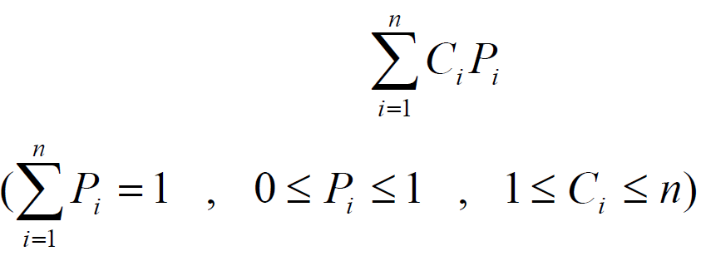

4-1. Dynamic Programming for Solving Problems
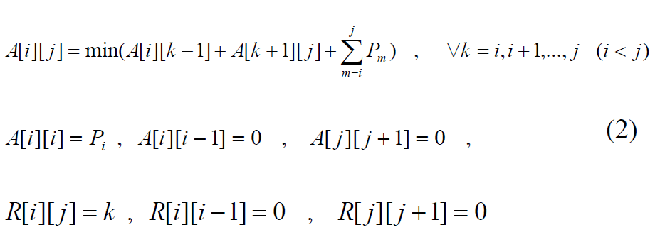
Suppose tree t1 is an optimal one for a case that key 1 is in the tree's root, tree t2 is an optimal one for a case that key 2 is in the tree's root, and tree tn is an optimal one for a case that n key is in the tree's root. Then we should search for a k , so that k key is in the tree's root and searching time the tree for it be minimum. The same work is repeated in left and right sub-trees, until an Optimal Binary Search Tree is formed. This is shown with the.
following equation :

This equation calculates the minimum searching time. It means we should find a k so make the time minimized. A is the cost function of the problem or in other words is the minimum searching time, and R shows the tree's root in each stage. The execution cost of this algorithm is equal with the cost of filling 2(m + n(n +1) / 2) + 2 memory fields, because without considering the main diameter of matrixes, we should fill n fields in the first line, n −1 fields in the second line, …, and 1 field in the last line of each matrix. And if the elements of main diameters are considered, so we can reach to above equation. In addition, we should choose the minimum values between different k s which has cost of O(n) in the worst case. Then in total, the cost of this algorithm is O(n2 ) ×O(n) = O(n3 ) . Of course, we can optimize this way, and in result decrease

time cost to O(n2 ) [John H. Holland 2005]. The above way was presented in 1959 by Gilbert and was obtained in 1982 by Yaeu [John H. Holland 2005].
4-2. Genetic and Parallel Genetic Algorithms for
solving the Problems In the genetic algorithm, a collection of possible answers are considered as C i s, and it is tried to find an optimal answer from them. Each array is considered as an answer (or a chromosome). Each gene of this chromosome, determine value of C for a key. And the internal number of each gene is value of C i for key i. More over, we should consider the following case for each gene.
• 1 < Ci < n
• maximum number of 1s are 1, and maximum number
of 2 s are 2 , maximum number of 3 s are 4 , and in general, maximum number of k s are 2k (regarding number of leaves in a level of complete binary tree).
• If the number of nodes for one level is m , so the
number of next level can not be more than 2m .
If this procedure is used, then coding of the problem will be difficult, and in each stage of the algorithm, the above conditions should be controlled, that leads to lose the time. On the other hand, in this kind of coding, the solution depends to specifications of the problem. For removing this fault, instead using the objective function directly, we can use another evaluation function, and change the genetic population chromosomes (equation 2).
For this purpose, by using genetic and parallel genetic algorithms, it is tried to make the dynamic programming of this problem faster and better. We use this solution, because of easy implementing the dynamic programming of this problem in parallel form. And the other hand, the introduced cost function can be used as the fitness function, and the chromosomes of the genetic population can be used as ks. Therefore instead using directly the objective function and obtaining Ci s, we try to obtain suitable k by using of genetic algorithm in each stage of the dynamic programming. We can decrease the algorithm execution cost by parallelism of this algorithm.
Fig. 2 and Fig. 3 state a summary of this method.
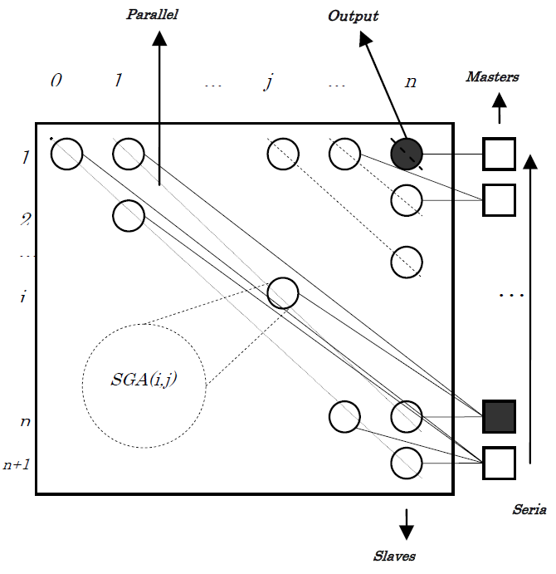

input : the number of keys (n) and set of their
possibilities (Array p)
Output : the optimal search time (t) and the set of
multipliers (Array c)
Parameters :
• genetic population size (popsize)
• length of the chromosome (lchrom)
• maximum of the generation number (maxgen)
• possibility of Crossover operator (pcross)
• possibility of the Mutation operator (pmutate)
• primary value of producing of random number (seed)
Properties :
• type of coding: Binary coding
• type of the Select operator: Roulette wheel
• type of the Crossover operator: Single point
• type of the Mutation operator: Inverting of selected
bits
• Condition of terminating of genetic algorithm:
maximum number of generations
• Objective function: a[i, k −1] + a[k +1, j]
• Fitness function: 1/(a[i, k −1] + a[k +1, j])
• Model of parallel population: Global
• Parallel architecture : Shared Memory
• Class of Parallel Algorithm : Global
(Semi-Synchronous Master-Slaves)
Fig. 2 Properties of Genetic Algorithm for the solution of Optimal Binary Search Tree

input(n,p)
input(popsizepercent ,maxgen ,pcross, pmutate, seed)
fork forall i:=1 to n do
fork a[i,i-1]:=0
fork r[t,i-1]:=0
fork w[i,i]:=p[i]
fork a[i,i]:=p[i]
r[i,i]:=i;
fork a[n,n+1]:=0
r[n,n+1]:=0
join
join
for d:=1 to n-1 do
forall i:=1 to n-d do
j:=i+d
k:=SGA(i,j)
fork r[i,j]:=k
w[i,j]:=w[i,j-1]+w[j,j]
a[i,j]:=a[i,k-1]+a[k+1,j]+w[i,j]
SGA(i,j):
popsize:=(j-i+1) * popsizepercent / 100
lchrom:=log j +1
gen:=0
initialize(gen)
repeat
gen:=gen+1
generate(gen)
k:=min(individuals)
oldpop:=newpop
until gen=maxgen
return(k)
generate(gen):
j:=1
repeat
fork mate1:=fitness_and_select(oldpop)
mate2:=fitness_and_select(oldpop)
join
fork newpop[j]:=crossover_and_mutation
(mate1,mate2,pcross,pmutate)
newpop[j+1]:=crossover_and_mutation
(mate1,mate2,pcross,pmutate)
join
j:=j+2
until j > popsize
make_c(i,j,l):
k:=r[i,j]
if k<>0 then{
fork c[k]:=l
fork make_c(i,k-1,l+1)
make_c(k+1,j,l+1)}
t:=a[1,n]
output(c,t)
Fig. 3 The Genetic Algorithm for the solution of Optimal Binary Search Tree
In the mentioned algorithm, first the number of keys, array P include possibilities of keys, and the genetic algorithm parameters are received from input, and then some entries of matrixes such as a , r , w are initiated. This work is done according to second part of equation 2. The matrix w stores the set of keys possibilities. In next part of the algorithm, matrixes entries are filled in the form of diagonal and parallel with the main diameter. This work is also done according to the first part of equation2. As it is obvious from Figure1, a master process is created for each secondary diameter and also main one. These processes create a worker for each element of diameters. Each worker process executes a simple genetic algorithm until the value of optimal k is calculated, and the obtained key is placed in matrix r . The master processes also are created as serial and according to the figure2. Finally, output array C is created according to matrix r , and the optimal searching time, a[1,n], is sent to the output. In executing of the genetic algorithm, the binary coding has been used. Each chromosome shows a value for k , and because of this, it's length shouldn't be more than Log j +1 for each process. On the other hand, the maximum of the genetic population for each process will be j − i +1. But for increasing the speed of the algorithm execution, we only apply a percent of the population. Here, the type of crossover is the common single point method. For creating the intermediate
population and selecting the parents, the Roulette wheel has been used. Since the minimum value should be selected from the current population, the inverted objective function has been used. Therefore in the Roulette wheel, the optimal value allocates itself most of share, and in result the possibility of its selection will be more. Regarding to the problem structure, the global method is used. And because the processes work independently, and only they are synchronized in end of each stage, so class of this algorithm is global and semi-synchronous. Ignoring the part related to the genetic algorithm in the main body of the program, the algorithm execution has time cost O(n), because the internal loop is executed in parallel. Notice in here, a processor is allocated to each process. If the number of processes is N , so this cost will be O(n2 / N) . Also in the genetic algorithm, there is a main loop which creates some generation of chromosomes, that it's the execution cost is O(max gen) . Creating the primary population and making the chromosomes depends on the length of chromosomes. The time cost of creating a chromosome is O(chrome) , and it's maximum will be happened in last stage of the algorithm. This value approximately is equal with Log2 n Due to the number of these chromosomes are equal with the genetic population, so time cost of creating a population is O( popsize×lchrom) . The maximum size of genetic population is also n × popsizepercent . If the chromosomes are created in parallel, so this value will be O( pop size) . In general, the executing cost of the genetic algorithm will be O(max gen× popsize) , and finally the total time cost will be O(n2 ×max gen× popsize / N) . Now if there are enough processors, and operations are done in parallel, so the above cost will be simplified as follows : O(n ×max gen× pop size percent) If above parameters are suitable, then the algorithm cost will be decreased, else the cost will be increased. It means that : max gen× pop size percent < n .Of course we should note that suitable performance of the algorithm depend on communication delay in the Network, time of creating and synchronizing of the processors, and the random distribution function used in the algorithm. Also the cost of consumed memory will be as follow :
O(n2 + max( pop size)×max(chrome)) Because the algorithm has applied three matrix of (n +1)× (n +1) and one record conclude a multi chromosomes population.
5. Experimental Results
A Timer control in visual basic design environment are used as method for simulate parallel processing environment to implement the presented genetic algorithm .
visual basic (6) is a simple high level language and machine independent language , and could simulate parallel architectures by its .
visual basic uses the global variables as common data structure , and it uses the internal variables of block (or subroutine or a function) as a local case .
each parallel processing activity require its processor , in the research , the processor is simulated by timer control in visual basic (6) programming language .
Here, results of different implementations of the algorithm are presented. Fig.4 shows four different implementations of the program. These diagrams show the speed-up and number of processors for different values of the genetic parameters. As it is seen, for less values of n, speed-up is small, and when it is increased, so the number of processors will be increased.

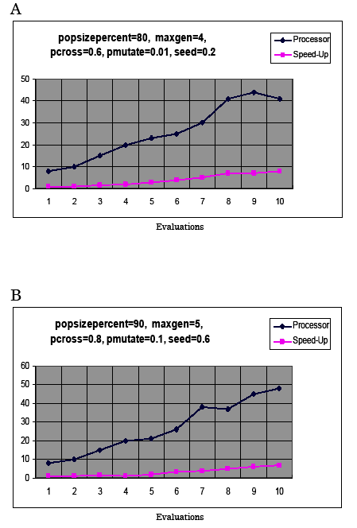

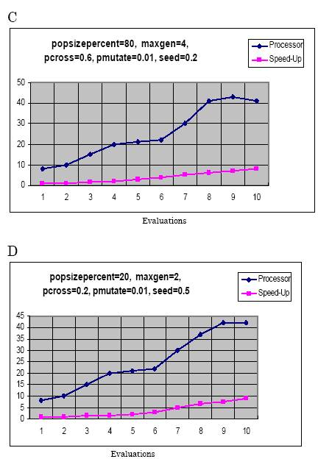

Fig. 4 Four different implementations of the Program

Fig.5 also shows speed-up of these four samples witheach other. As it is seen, when n
grows, the speed-up of sample 4 increase which it's genetic parameters are low, while the speed-up of sample 2 decrease which it's genetic parameters values are high.

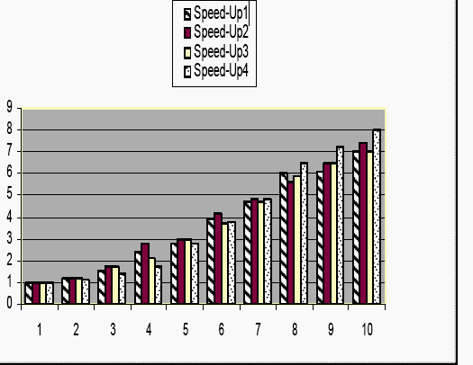

Fig. 5 Speed-up of the four Samples of Program
Fig.6 shows outputs of the algorithm execution with the same input values and different genetic parameters (fig.1 and fig.2). As it is seen, the different executions of this algorithm with the same inputs produce different outputs. And the output value decrease when greater genetic parameters are selected.
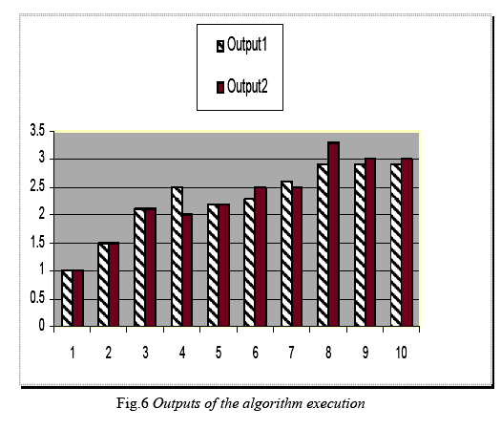

6. Conclusion and future works
In this paper, a parallel genetic algorithm was presented for solution of the optimal binary search tree. To implement of this algorithm and obtaining the experimental results, a timer control in visual basic (6) design environment was used . First, a dynamic programming method was implemented, and then a genetic algorithm was added to it. Finally, by using of its parallel model and creating a semi-synchronous architecture of master/slave shared memory global genetic algorithm, the problem of optimal binary search tree was solved.
In general, we can refer to the following results:
• The simulation results show that speed-up will be increased when the number of inputs grows.
• The simulation results show that overhead of the algorithm execution is high when data is less, and their execution time is equal with usual methods.
• The simulation results show that executing of the genetic algorithm with the greater input has high speed.
• Optimizing the dynamic programming method using parallel genetic algorithms, increases the speed of the algorithm execution.
The works which can be done in this way are:
• Implementing other parallel genetic algorithms such as coarse grained and hybrid one.
• Implementing the parallel genetic algorithms on the different topologies.
• Finding the suitable values for parallel genetic algorithm parameters so that we reach to an answer with a high speed.
• Presenting a method for adjustment of population with parallel hardware.
References
Baase S., and . Gelder , A, 2000 “Computer Algorithms”, Introduction to Design andAnalysis, Addison- Wesley, Pages 321-322
Bianchini, R., and Brown, C. ,1993 “Parallel Genetic Algorithms on Distributed-Memory
Architectures”,Technical Reports,The University of Rochester,New York 14627.,Page 436
Budd, T. 2001 , “Classic Data Structures in Java”, Addison-Wesley,. Pages 63 -65
Chu , P. C and . Beasley , J. E, 1995 "A Genetic Algorithm for the Set Partitioning Problem",
The Management School Imperial College, Page 1,4-5
Cormen T, Leiserson, C. Rivest, R. and Stein , C, 2001, “Introduction to Algorithms”, 2nd
ed, MIT Press,. Pages 113 , 114,115
David. , E. Goldberg, , 1989 "Genetic Algorithms in Search, Optimization, and Machine
Learning", Addison-Wesley,. Pages 31- 33
Erick Cantu-Paz, , 1995., "A Summary of Research on Parallel Genetic Algorithms", University of Illinois at Urbana-Champaign, Pages 1-12
Fernandez, J., 2006 , “Genetic Programming Network”, http://www.geneticprogramming.com.
Goodrich , M. and Tamassia, R.. 1998. “Data Structures and Algorithms in Java”, Wiley, Pages 23- 25
Hansen , S., and McCann, L. I., 2002 “Optimal Binary Search Tree Meet Object-Oriented
Programming”,Computer Science Department,University of isconsin,WI53141,Pages
25,26.
Holland , John H. , 2005, “Genetic Algorithms”, http://www.econ.iastate.edu/tesfatsi/holland.GAIntro. htm Pages 2- 4
Kalynpur , A., M. Simon, , 2001, “Pacman using Genetic Programming and Neural Networks”, Project Report for ENEE 459E, pages 421-430
Laurrens , J. Pit, , 1995 "Parallel Genetic Algorithms", Master Thesis, Leiden University,. Pages 44-46
Lin, S, Punch, W. F., and Goodman, E. D. 1994 , “Coarse-Grain Parallel Genetic Algorithms:
Categorization and New Approach”, in Proceedings of the Sixth IEEE Symposium on
Parallel and Distributed Processing,. Pages 1020-1022
Marek, S. Obirko, 1998"Genetic Algorithms",.Pages 130 -135
Markus P. Schwehm, 1996., "Parallel Population Models for Genetic Algorithms",University of Erlangen-Nurnberg, Pages 2-8.
Maruyama, T. Hirose , T and Konagaya, A. 1993, “A Fine-Grained Parallel Genetic
Algorithm for Distributed Parallel Systems”, in Proceedings of the Fifth International
Conference on Genetic Algorithms, Stephanie Forrest, Ed., San Mateo, CA, Pages 20-22
Nowostawski , M and . Poli , R, 1999. “Parallel Genetic Algorithm Taxonomy”, Submitted to
Publication to: KES’99, Pages 51-52
Obitco, , M. 2006 , " Introduction to Genetic Algorithms”, Czech Technical University,
http://cs.felk.cvut.cz/~xobitko/ga Pages 98 – 102
Ricardo, P. Bianchini and Christopher, T,. Brown, 1993 "Parallel Genetic Algorithms on
Distributed Memory Architecture", Prentice-Hall, Pages 15, 16, 17
Robinson, A. , 2001, “Genetic Programming: Theory, Implementation, and the Evolution of
Unconstrained Solutions”, Division III Thesis, Hampshire College,. Pages 311-322
Schaefer , M., 2006 "Optimal Binary Search Tree" Department of Computer Science, DePaul
University, Chicago, Illinois 60604, USA,. , Page 198
Schleuter, M. Gorges, 1985, "ASPARAGOS : an Asynchronous Parallel Genetic Optimization Strategy", in Schaffer, Pages 422-427
Sedgewick R., 1998, “Algorithms”, 2nd ed. Addison-Wesley, Pages 41 – 43
Sian, F.. 1999 , "A Java Based Distributed Approach to Genetic Programming on the
Internet", University of Birmingham School of Computer Science,. ,. Pages 11-16
Thomas , M. Bak 1996, "Evolutionary Algorithms in Theory and Practice", Oxford University,. Pages 311- 313

