Morphological study of graphite surface and structure by scanning tunneling microscope

Ghaleb ABD AL- WAHAB ALI – DAHASH
University of Babylon, College of Science for Girls,
Laser physics Department

Abstract
In this research ,the relation between the images of scanning tunneling microscopy and all of the current and voltage tip for graphite surface has been studied .The results show that the best value of voltage of the tip that led to better relation between the tip and graphite surface is (100 mV) while, the best value of the current between graphite surface and the tip is ( 1nA ) .The increasing of the current value leads to appear direct contacts between the tip and the sample surface .For this reason, the ability of the analysis depends on the number of points or atoms (number of data) per unit area that arrives the sensor in the device ,where by increasing it , the quality of the image is increased .The images of STM show the arrangement of hexagonal atoms and different resolution .
الخلاصة
تم في هذا البحث دراسة العلاقة بين تفاصيل صور المجهر النفقي الماسح وكل من تيار وفولتية الرأس المدبب لسطح الكرافيت . بينت النتائج أن أفضل فولتية للرأس المدبب والتي تؤدي إلى أفضل تفاعل بين الرأس المدبب وسطح الكرافيت هي بحدود( 100 eV ( .أما أفضل تيار بين سطح الكرافيت والرأس المدبب هي بحدود (1nA ) , وان زيادة قيمة التيار تؤدي إلى حدوث تماس مباشر بين السطح والرأس المدبب , وعليه فان قابلية التحليل تعتمد على عدد النقاط أو الذرات ( عدد البيانات) لوحدة المساحة الواصلة الى المتحسس في الجهاز والتي بزيادتها تؤدي إلى زيادة وضوحية الصورة. بينت صور المجهر النفقي الماسح ترتيب الذرات السداسي الشكل وبقدرات تحليل مختلفة.
Introduction
Scanning tunneling microscopy (STM) has developed into one of the most ubiquitous tools in surface science and the range of phenomena studied by this technique is nowadays remarkably broad. These include surface topography, electronic and vibrational properties, film growth, contact charging, molecular manipulation, and many other phenomena ranging from the micrometer scale down to the subnanometer scale. Concerning surface chemical reactivity, the use of STM and scanning tunneling spectroscopy (STS) has proved fundamental for probing local surface modifications associated with chemical reactivity at the solid–vacuum interface and to follow, when possible, the mobility of reaction intermediates and final products on surfaces in real time. Owing to the complexity of the studied systems in terms of both surface morphology and variety of chemical reactivity, collaboration between experiment and theory has emerged as a necessary tool in order to arrive at sustainable models and a successful rationalization of experimental findings .(Wendt et al. 2005) (Enevoldsen et al. 2008). One material that has been the focus of many STM studies is highly oriented graphite because it can be easily imaged with atomic resolution.(Mate et al. 1989). At a more fundamental level, however, it is well-recognized that STM images of HOPG can exhibit two anomalous features including giant (>1 A) vertical corrugations and a large asymmetry in the observed heights of adjacent carbon sites (typically only alternate atoms are detected). Large vertical corrugations have been explained in terms of a model that considers elastic interactions, mediated by a contamination layer, between the tip and the graphite surface.(Mamin et al.1986). This research focuses on a form of graphite called highly oriented pyrolytic graphite (HOPG). HOPG is highly oriented with respect to the layer-stacking
direction. HOPG has been chosen for this research because it can be easily cleaved to expose a fresh conductive surface and can also serve as a substrate for other materials that can be imaged by STM. In addition, atomic-level images of HOPG can be used to calibrate the STM for high-resolution imaging.

Theoretical part

With the invention of the STM in 1982 by Binnig and Rohrer et al.( Binnig et al. 1982) it became possible to investigate not only the topography of a conducting sample with atomic resolution in real space, but also the local electronic properties. The principle of the STM is based on the quantum-mechanical effect of electron tunneling. This allows an electron to tunnel through a potential barrier even though its classical kinetic energy is lower than the barrier height. This specific process can occur between two materials which are separated by a gap, forming a potential barrier for the electrons. Commonly conductors and/or semiconductors are used as substrates; however, it is noteworthy to mention that ultrathin layers of an isolating material can also be imaged by STM (Simic-Milosevic et al.2008),( Ramoino et al. 2006).
A metallic tip (e.g., platinum iridium (90:10), or tungsten) is used as the probe and approached towards the surface until a tunneling current flows, when a voltage is applied between the tip and the sample. This occurs when the gap between the tip and the surface is in the order of roughly 1 nm. After the tunneling contact is established, the tip scans over the surface, actuated by a piezoelectric scanning unit, whose extension can be controlled in three
dimensions x, y and z. This can be realized by applying a specific voltage to the piezoelectric elements of the scanner. Such a microscope is typically capable of recording micrographs of an area of a few nm up to several μm.
The distance-dependent nature of the tunneling current is essential for the discrimination of very small surface corrugations (i.e., atomic corrugation of a single crystalline metal surface), since even small changes generate a large change in the tunneling current. The quantum mechanical treatment predicts an exponential decay for the wave function of the electron in the barrier. For a rectangular barrier, the probability of the tunneling process decreases exponentially with the distance d between the tip and the sample and with increasing barrier height. The tunneling current I_{T} can be estimated by Eq.(1) (at low voltage and temperature; the tunneling direction is specified by the polarity of the applied bias voltage) (Hansma PK et al 1987):

I_{T} ~ U exp (-2dk) where k = √ 2m_{e}Φ/ħ² ............(1)

Φ is the average barrier height 1/2(Φ_{sample} + Φ_{tip}) between the two electrodes, m_{e} is the electron mass and k is the inverse decay length. Due to the exponential dependency of the tunneling current a vertical resolution of up to 0.01 Å can be achieved. The lateral resolution is lower by a factor of roughly 10; it is determined by the radius of the tip, which ideally exhibits the dimension of only one tip atom.(florian 2010).
A three-dimensional STM data set of a surface can be recorded with two different operation modes(Hansma PK et al 1987) . Firstly, in both modes, the scanning tip is navigated close to the surface, so that at a certain bias

voltages (typically U _{Bias} ~ 5 mV to 2V) a tunneling current (typically 5 pA to 2 nA) is detectable. In the constant current mode, the tip is scanned over the surface, while the tunneling current IT, between the tip and the surface, is sensed. A feedback loop controls the height of the tip z(x, y) (realized with the
z-piezo actuator), in such a way that the current remains constant. Thus, an image consists of a map z(x, y) of tip height versus lateral position x, y.
Alternatively, in the constant height mode the tip is scanned across the surface at constant height and constant bias voltage. In this case, the tunneling current I(x,y), measured at discrete scan positions x,y constitutes the data set. This mode is advantageous as it allows high scan speeds (low record time per image) and thus avoids large thermal drifts. However, it is limited to very flat surfaces or/and very small scanning areas, as massive surface defects or extended contaminations can cause a crash of the tip. Since electron tunneling occurs from or into electronic states near the Fermi level, which can exhibit a complex structure, it is obvious that the electronic structures of the surface and the tip play a major role determining the tunneling current. Note that the energy range of this process is given by the applied bias voltage.

Experimental part
We used PHYWE Compact STM System that consists of: as in Fig (1)
1 - Control unit with mounted scan head
2 - Magnifying cover glass (10X Magnification)
3 - USB cable
4 - Power cord and adapter
5 - Measure Nano Software
6 -Laptop with USB port, Windows XP or higher
7 -Ethno and soft cleaning cloth
8 - adhesive tape

Fig. (1) Components of the PHYWE Compact STM.

We put the sample down on to the sample holder guide bars first (a) and released it gently on to the approach motor's support (Be careful: the magnet that holds the sample holder in its place can drag the sample off the sample Holder, make sure we bring the sample behind it). And then Pushed the sample holder carefully in the direction of the tip (b), but don't let it touch the tip (1cm distance). as in Fig (2) and Fig (3) ( Phywe catalog 2010).

Fig (2) View of how we put the sample on the motors device

B A
Fig.(3) The sample holder carefully push in the direction of the tip (a) and put the cover glass on your microscope after the manual coarse approach (b).

Now we can chose the voltage bias and current(by setting) ,especially sure not to damage the tip! Be sure to position it so the very center of the sample surface (not the edges) is centered under the tip. Used the magnifying lens to watch the tip and sample carefully under magnification while we gently used the black knob on the sample holder to move the sample closer to the tip. Decrease this distance to about 1mm. (we will get a chance to bring them closer together later under electronic control, so don’t risk crashing the tip!) After done this, gently placed the clear plastic cover back on. we can use its built-in magnifier to check our tip-sample distance again. Then we can start the scan for any area on the surface of the sample.

Results and Discussions :
The best voltage value of the tip that led to better interaction between it and the surface of graphite is 100mV. As an increase in the value of voltage the tip leads to increase the area of interaction between the tip and the surface of the sample (attracts electrons from the long distances ), which leads to confusion in the different positions of atoms and its borders, and reduce the value of the voltage means reducing the interaction between the tip and the cloud of electronic surface of the sample (and is the basis of the work) means loss of image.
- The best value of the current between the surface of a graphite sample and the tip is 1nA and the largest value leads to approach the tip to a distance very close to the sample surface, leading to increased
probability of direct contact between the tip and sample surface, stages. On the contrary, the lowest value of the current means a greater distance between the tip and the surface of the sample and the possibility of electronic interaction of the cloud is less .
- There is no difference in the clarity of images when scanning the sample from the bottom up or vice versa
- When increased dimensions of the image, that lead to difficult to get a clearer picture (atoms unique) because the system collects data by scanning lines .
- Equal inter-distance and the scanning depends on interaction between electronic group for one atom and tip ,therefore it found more than one atom in the same scan line, that means impossible to distinguish between them and the image appears in the form of lines of atoms as shown in the pictures Fig ( 4).
Also, the picture with very small dimensions ( <1nm ) lack of clarity as well, because the data collection process (interaction of the tip with cloud of electronic on the surface of the sample ) are repeated on the same atom, which means that the tip is filmed (interaction with the cloud) atom more than once and from different places and in the every same time, this leads to the emergence of areas of deformation on the same atom and the disappearance of a gradual of the boundaries of the atoms with the decrease in dimensions as shown in pictures Fig(5),(6).

5. From the form of lines, and since the interaction is not exactly clear, the best image possible, get them to the surface of the sample when the distance between the scan lines approach to atoms diameter on the surface. To treat this case and to get the possible clearest picture in the required dimensions, must change the value of the distance intra- scan lines to fit the dimensions of the image (by up lines). If increased picture dimensions, should be minimize the distance between scan lines to value about within diameter of surface atoms.
6- It is known in the normal cameras, the quality of the image depends on the ability of analysis of the camera and determined by the number of elements of photography that make up the detector camera, but in a scanner tunnel, the element of photography is one and is the tip and the ability of the analysis depends on the number of points (the number of data ) collected by the supplement to the device the more the number of points per unit area increased the quality of the image as in Figure (7). But this is a lot of the number of data at the interval time required to complete the recording of a complete picture of the area identified on the surface of the model, and reduce the time required for data collection is limited to a maximum smaller a (0.03sec), which depends on the speed of electronics device in the data collection as well as speed feeding back to the part of the crystal responsible for the movement of the head on the Z axis to simulate the details of the surface of the model, as well as the reduction in the time leading to the loss of some data.

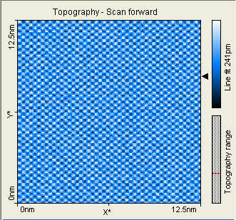
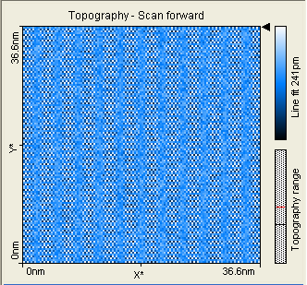
Picture1
Picture2

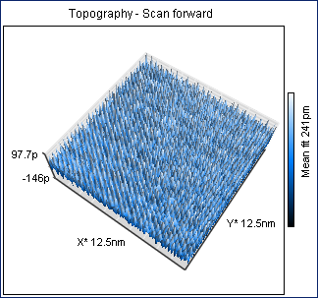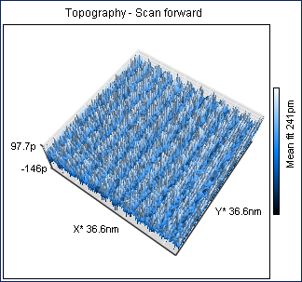

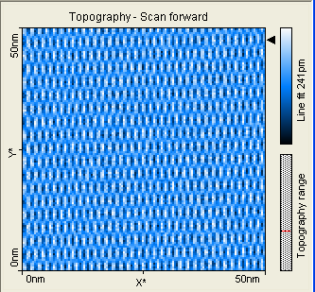
Picture3

Fig (4) shows STM images of graphite with different scale

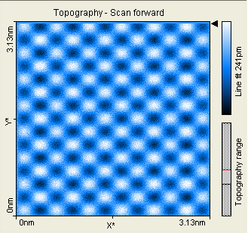
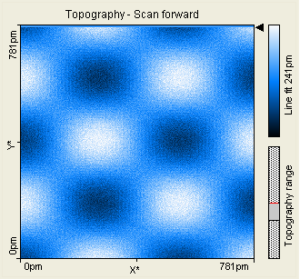
Picture4
Picture5

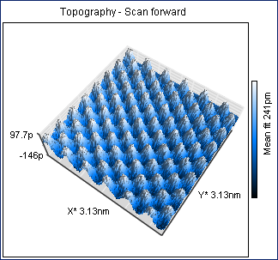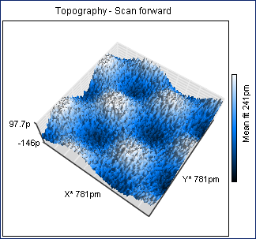

Fig (5) shows STM images with different magnification <1nA

Resolution (128 ) point/ line

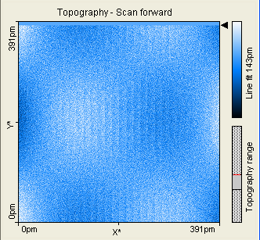
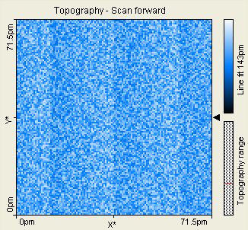
Picture 6

Picture 7

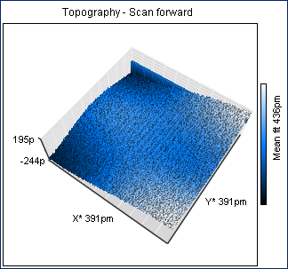

Fig (6) Shows STM images with different magnification

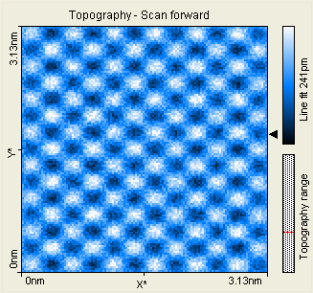
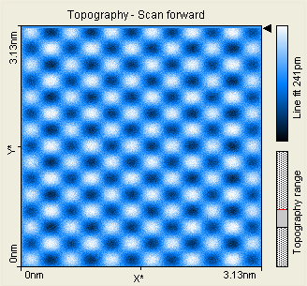
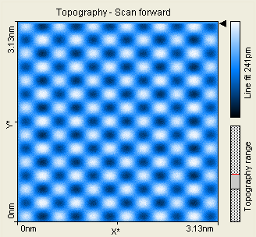
Picture 8

Picture 9

Picture 10

Fig (7) Shows STM images with different magnification
Resolution (128 ) point/ line

Conclusions
In the present work we can conclude that the tunneling current depend on the spread and overlap of electronic wave functions between the tip and the carbon atoms and then the lowest value of the current means a greater distance between the tip and the surface of the sample and the possibility of electronic interaction of the cloud is less .The inter-distance and the scanning depends on interaction between electronic group for one atom and tip ,therefore it found more than one atom in the same scan line, that means impossible to distinguish between them and the image appears in the form of lines of atoms. The best value of the current between the surface of a graphite sample and the tip is 1nA and the largest value leads to approach the tip to a distance very close to the sample surface, leading to increased probability of direct contact between the tip and sample surface. A lot of the number of data at the interval time required to complete the recording of a complete picture of the area identified on the surface of the model, and reduce the time required for data collection is limited to a maximum smaller a (0.03sec), which depends on the speed of electronics device in the data collection as well as speed feeding back.

References
Binnig G, Rohrer H, Gerber C, Weibel E (Surface Studies by Scanning Tunneling Microscopy) (1982) Phys Rev Lett 49pages 57-61.
Florian Buchner, (STM Investigation of Molecular Architectures ofPorphyrinoids on a Ag(111) Surface), Doctoral Thesis accepted by
Friedrich-Alexander-University of Erlangen-Nürnberg, (2010)Germany. phywe catalog – operation manual of STM (2010)
Georg H. Enevoldsen, Henry P. Pinto, Adam S. Foster, Mona C. R. Jensen, Angelika Kühnle, Michael Reichling, Werner A. Hofer, Jeppe V. Lauritsen, and Flemming Besenbacher (Detailed scanning probe microscopy tip models determined from simultaneous atom-resolved AFM and STM studies of the TiO₂(110) surface) (2008) Phys. Rev. B, 78, 045416.
Hansma PK and Tersoff J. Scanning tunneling microscopy (1987) J. Appl Phys 61:R1
Mamin, H. J.; Ganz, E.; Abraham, D. W.; Thomson, R. E.; Clarke, (Contamination-mediated deformation of graphite by the scanning tunneling microscope) J. Phys. Rev. B (1986), 34, 9015.
Mate, C. M.; Erlandsson, R.; McClelland, G. M.; Chiang, S.( Direct measurement of forces during scanning tunneling microscope imaging of graphite )Surf. Sci. (1989), 208, 473-486.
Ramoino L, von Arx M, Schintke S, Baratoff A, Güntherodt H-J, Jung TA Layer-selective epitaxial self-assembly of porphyrins on ultrathin insulator (2006) Chem Phys Lett 417 pages 22 -27
Simic-Milosevic V, Heyde M, Nilius N, König T, Rust H-P, Sterrer M, Films: Flat and Charged or Upright and Neutral) (2008) J. Am. Chem. Soc. 130 pages 7814-7815.
Wendt, S., Schaub, R., Matthiesen, J., Vestergaard, E.K., Wahlstrem, E., Rasmussen, M.D., Thostrup, P., Molina, L.M., Laegsgaard, E., Stensgaard, I., Hammer, B., and Besenbacher, F.( Oxygen vacancies on TiO₂(1 1 0) and their interaction with H₂O and O₂: A combined high-resolution STM and DFT study) (2005) Surf. Sci., 598, Pages 226-245.

