Monitoring of drinking water quality in Baghdad city by using polymerase chain reaction(PCR)
امنة نعمة الثويني اشواق باسم جاسم
معهد الهندسة الوراثية والتقنيات الاحيائية
احسان مهدي الصقر
وحدة الابحاث البايلوجية

Abstract:
The monitoring of water Iraq quality with regard to detection of microbial contamination, mainly depend on time consuming conventional culture methods. Therefore to ensure continuous good water quality supply, sensitive and good detection methods are important to be available always, specifically polymerase chain reaction (PCR), for direct quick, sensitive and accurate detection for the presence of microbial pathogens in drinking water directly without the need for culturing and isolating the pathogens. 300 water sample were taken from different regions in Baghdad city (270)samples were positive for the fecal and total coliform with routine diagnosis methods, in the same time (200) sample were positive for E.coli The PCR amplification assay detected the presence of bacteria in (250) out of 300 water samples depending on the Uid, LacZ genes. Twenty(20) out (300) water samples showed a positive result for the MF and negative result for PCR using primer pair specific for the genus TC and E.coli .

الخلاصة
تعتمد مراقبة نوعية مياه الشرب في العراق بصورة اساسية على الطرق التقليدية القديمة والتي تجري باستخدام الاوساط الزرعية وطرائق التشخيص البدائية.لذا دعت الضرورة الى اللجوء الى الطرائق الجيدة والحساسة للمراقبة مؤشرات التلوث . طبقت الدراسة الحالية تقنيات الهندسة الوراثية وخاصة سلسلة التفاعل المتبلمرة,في مراقبة مؤشرات التلوث سيما للمياه المجهزة للمنازل في بعض مناطق بغداد.وهي طريقة حديثة من حيث التطبيق وسريعة ودقيقة من حيث الوقت والجهد اللازم للانجاز.دون الحاجة الماسة الى زرع عينات الماء لفترات طويلة لاجل العزل والتشخيص. تم جمع 300 عينة ماء شرب من مختلف مناطق بغداد (270) عينة منها كان موجبا لوجود بكتريا الكوليفورم الكلية والبرازية,في نفس الوقت 200 عينة كانت موجبة لبكتريا الايشريشيا القولونية . اكدت الدراسة وجود 250 عينة ماء موجبة للفحص بطريقة السلسلة المتبلمرة من مجموع 300 عينة ماء شرب, 20 منها موجبة بطريقة تخمر الانابيب وسالبة بطريقة السلسلة المتبلمرة.

INTRODUGTION:-
Three major groups, viruses, bacteria and protozoa known to cause widespread waterborne diseases worldwide ,They transmitted through many routes in the water environment and water supply (WHO ,2006) . Bacteria are major microbial group responsible for waterborne disease outbreaks ( Roy et al.,2006) had indicated in their study that there were many kinds of bacteria that can be recognized in water resources, many of which are enteric in origin (Shigella spp. ,Vibrio cholera, Campylobacter jejuni, Escherichia coli, Salmonella , E. coli, Aeromonas spp., Pseudomonas spp., Protus, Enterobacter, and finally group of coliform. Coliform bacteria are commonly used as indicators for the presence of pathogenic bacteria such as Salmonella, Aeromonas spp., V.cholera and others( Ashbolt , 2004) . Detection and isolation of coliform bacteria requires cultivation on simple liquid media and this need 24 to 72 hours , which it means time consuming and the reliable result well be available but the pathogens might have spread wide in the water distribution system. Therefore new simple efficient methods for detection of coliform and pathogenic bacteria in polluted water and monitoring of water resources which is necessary for human consuming ,and even animals and plant requirements is need( Bartram et al.,2004). Many methods have been developed for detection and isolation of most pathogens in water such as molecular methods which is Compared to the traditional culture techniques, sensitive, specific, fast provides results within 24-48 hr , and without the need for complex cultivation ( Desouky et al.,2003) Polymerase chain reaction (PCR) developed for the diagnosis of available non cultural bacteria by detection of its DNA in addition to strict and opportunistic bacteria, such as V.cholera, Salmonella, Aeromonas, E,coli O157:H7 in raw and treated water ( Straub and Chandlerb , 2003 ; Al-thwanii et al.,2009 ;Al-thwanii and Al-Aubaidi ,2010). Up to our knowlage the current study, is the first of its kind in Iraq , developed modified rapid, sensitive and specific method (PCR) and multiplex pcr for detecting certain pathogenic bacteria in drinking water samples from different regions in Baghdad city.
MATERIALS AND METHODS
Collection of Water Samples: Three hundred water samples were taken from different Parts in Baghdad city, during the 1st of may 2010 to the end of may 2011. One litter of each sample was collected in a sterile bottles with screw cap , containing sodium thiosulphate 0.1% to neutralize the residual chlorine, and transported in an cooling container to the laboratory within 2-6 h for bacteriological analysis. analyzed immediately and /or stored at 4°C for up to24h to use.

Bacteriological Examination:-
- Traditional methods:-
Most water samples were examined for determination of total coli form(TC) , fecal coli form (FC), and E.coli by using the membrane filter technique (MF) , tube fermentation test and presence /absence method for determination . In case of traditional methods each membrane filter was transferred on to the surface of the solidified agar medium via sterile forceps. Incubated at 37 cº for 24 h ( Bosch , 1998).

- Molecular Identification of Bacteria:-
1- DNA extraction:-Extraction of DNA was carried out by using genomic DNA kit (Gene aid , Taiwan). Total genomic DNA was isolated directly from water samples according to Delabre et al.,1998 with few modifications as follow:
- water samples were concentrated by filtration through 0.45-μm-pore size nitrocellulose filters.
- The filters were then vortexes in peptone broth for recovering bacteria and then incubated at 37°C for 24 h.
- suitable volume of growth liquid were centrifuged at 4500 g for 20 minute. The pellet was extracted with protocol of genomic DNA extraction kit.
- DNA preserved with 50-100µl of TE solution in ependroff tubes at 20-cº.
2- PCR amplification:--
- Conventional PCR:-
PCR assay was performed to detect the Uid A , LacZ, genes which is specific for the identification of the E.coli and Coli form respectively . By using Specific primers as shown in Table (1),according to(Asmak et al. ,1990),These primers synthesized by Cinnagen company.
Table (1) the sequence and concentration of forward and reverse prime
Primers Type | Primers Sequence | Concentration in picomoles | Product size
E.coli
LacZ Forward | ATGAAAGCTGGCTACAGGAAGGCC | 30262.27 | 264bp
LacZ Reverse | GGTTTATGCAGCAACGAGACGTCA | 35265.50 | 264bp
Coliform
UidA Forward | AAAACGGCAAGAAAAAGCAG | 35748.79 | 147bp
UidA Reverse | ACGCGTGGTTACAGTCTTGCG | 34867050 | 147bp

PCR reaction was conducted in 100µl of reaction mixture containing 50 µl of green master mix,5 µl of each primer,10 µl DNA template and and 30 µl of deionized water Table(2).

Table (2) the mixture of conventional PCR working solution
Working solution
Water  Forward primer  Reverse primer  DNA  Master mix  Final volume | 30  5  5  10  50  100 µl
Table (3) PCR program for Uid A ,LacZ fragment amplification
Thermocycler conditions | Temperature^{( °}C ) | Time ( min )
Initial denaturation  Denturation  Primmer annealing  Primmer extension  Final extend | 94  94  55  72  72 | 3  1  1  1  3
Cycles number : 35 cycle

Amplification was conducted using thermocycler eppendrof programmed with 25 cycler for initial denaturation 95°c for 3 min. , denaturation for 94°c 1min.,Anneling 50°c 1min,Extention72°c1min Table(3) .
- Multiplex PCR:
The mixture of multiplex PCR reaction including two specific genes (LacZ,UidA) which have been used to detect the presence of E. coli and Coli form bacteria in the same water samples at the same time . This step well help as for rapid diagnosis to ensuring contamination of water samples with these types of bacteria as indicator for the presences of pathogenic bacteria such as Salmonella, V.colera, Aeromonas spp. ,and E.coli O157:H7.The same specific primers selected for the reaction of conventional PCR analysis of these genes (Table1), were used in the multiplex PCR with modification of mixing the two selected primers in the same tube of PCR for the same sample and used Multiplex Master mix instead of Master mix (16), ( Table 4).

Table (4) the mixture of Multiplex PCR working solution
Working solution
Water  Mix primers  DNA  Multiplex Master mix | 30µl  10µl  10µl  50µl
Final volume 100 µl

3 -Gel Electrophoresis: PCR products and the ladder marker were resolved by electrophoresis on 2% w/v agarose gels. DNA samples were loaded in the tray of Gels and 100 bp marker was included in every gel and run in TBE(1X) buffer, Gels were stained with ethidium bromide (0.5 μgml-1) and analyzed using UV eliminator The molecular weight identification of resolved band was based on their correspondence to the ladder bands (Sambrook et al.,1989).
And discussion:- Result
To estimation quality of drinking water, all samples were bacteriologically examined for fecal and total coliform ,E.coli using MF technique and PCR .
Tow handred seventy(270) Filtered water samples were all positive for the fecal and total coliform detection with routine diagnosis methods. For further diagnosis (200) samples were positive for fecal and total coliform and in the same time positive for E.coli which lied in the range of detection limit .This may be due to presence of fecal contamination from human Origen from early period. These routine used in most water monitoring and quality have limitations such as long duration of incubation which reach 24-72 h, long period for preparation of different diagnosis media this lead for west of time and effort. Detection of live bacteria only, miss diagnosis of slow-growing or stressed bacteria[2]. This may be due to unfavorable conditions for bacterial growth during culturing of water samples or the development of non- culturable phase (5).
In the same time all samples were analyzed for conventional and Multiplex PCR for detection of lacZ (264 bp) and uidA (147 bp). (250) sample gave positive results with PCR for the tow kinds of bacteria in the routine methods Fig(1).

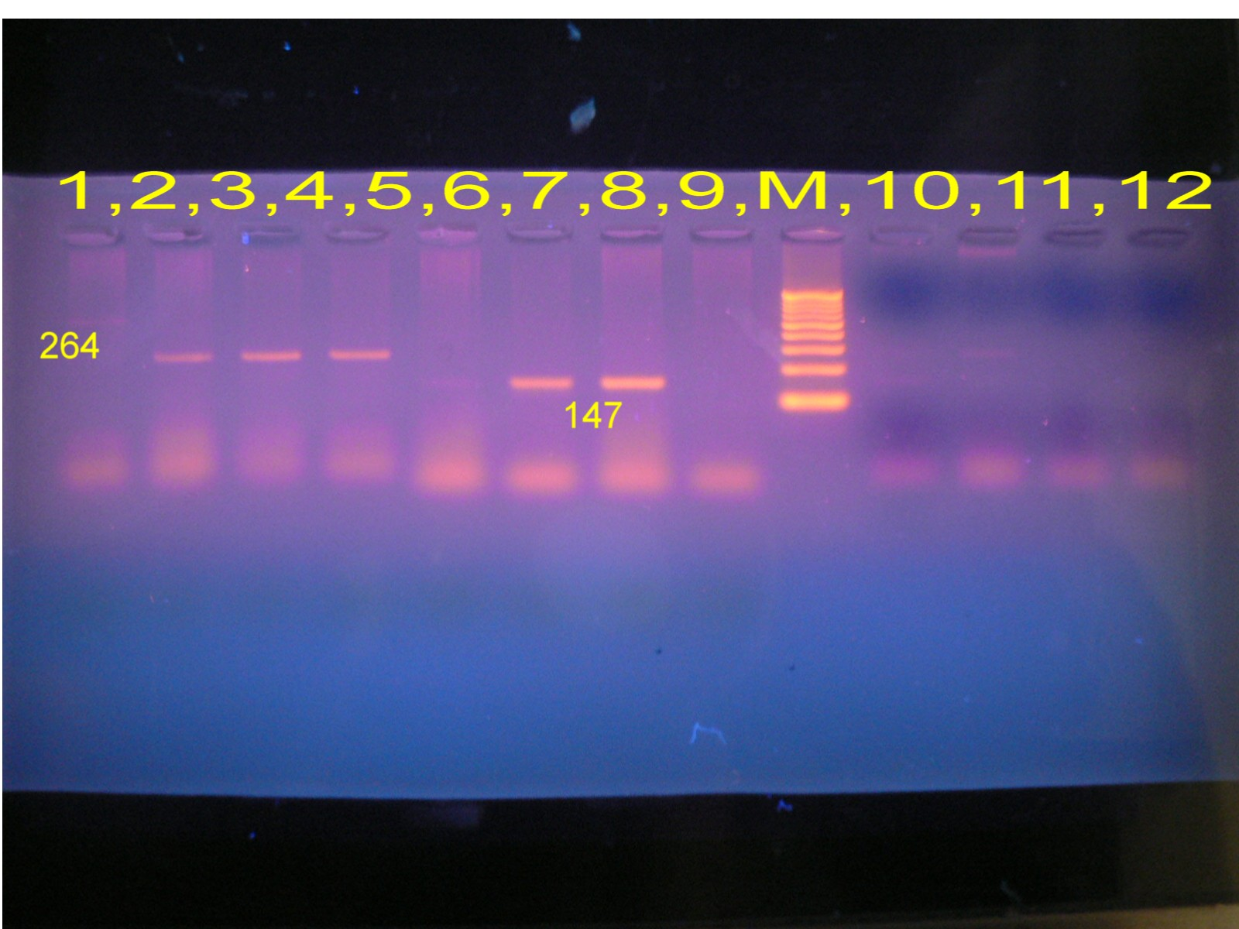

300
100

Fig(1):Conventional PCR for detection of Uid A147pb , LacZ 264pb genes, Lan:1 negative,Lan:2,3,4,positive for LacZ 264pb,lan :6 negative,lan:7,8 positive for Uid A147pb.,M:Marker DNA lader
Since detection of bacteria in raw and Tap water , needs amplification and detection of specific extracted DNA sequences in one organism to improved the speed and specificity of detection( Alexander et al.,2005)In our study primers for detection of the lacZ gene have been used for conformation isolation of coliform which represent the expression product (ß-galactosidase) of this gene ( Roy et al.,2006) . UidA gene for the detection of E. coli which encoding ß-D- glucuronidase (GUD)enzyme. Only(30 )water sample didn't match with these results, which is negative for routine detection and positive for PCR analysis, and (20) water samples were negative for PCR analysis. This is my due to possible loss or damage of extracted DNA because of reaction circumstances like high extension period ,and maybe due to presence of inhibitors in the samples.

Clear correlation was appeared between PCR technique and traditional culturing method (MF), when all positive water samples with MF give appositive amplification results with conventional PCR, except twenty water sample which was over the detection limit (consider polluted water samples in traditional methods but give negative results with PCR) . Detection of total coliform and E. coli In multiplex amplification indicate positive results in ( 50 ) from the (250) water samples which were positive for the two test fig.(2).
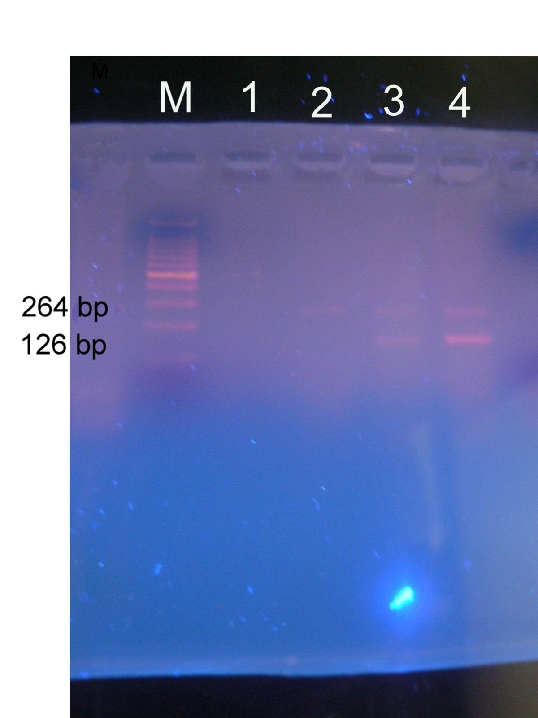
100
100
147 pb
264حح pppb
500pb
147

Fig. 2: Multiplex PCR detection for total coliform and E. coli: Lane M-100 bp DNA ladder; Lane 1 and 2 negative amplification; Lanes 3-4 positive amplification ,each lane contains 2 bands of LacZ 264pb, Uid A147pb.

Multiplex PCR technique was used for distinguish between total coliform and E. coli and non-coli form strains, the results in our study showed a high degree of specificity because the non-coli form strains did not represent any specific amplification when examined with UV eliminator.

REFERENCES
Alexander, L., B. Wolfgang and M. Harald( 2005).Diversity of bacteria growing in natural mineral water after bottling. Appl. Environ.Microbiol., 71(7): 3624-3632.
Al-thwanii ,A.,N, Al-aubaidi,R.,M.,(2010).Comparative study between Vibirio cholera isolated from patients and from surface water in Iraq using puls filed gel electrophoresis. Iraqi J.Biotech.9(4):838-848(2010).
Al-thwanii ,A.,N,Al-Saqar,I.,M.,Jasem,B.,aShwaq,et al.(2009).Using plasmid scanning in epidemiological investigations for Salmonella typhi bacteria in polluted water supply and patients in Al-sader city. Iraqi J.Biotech.8(1):419-427(2009).
Ashbolt, N.J., 2004. Microbial contamination of drinking water and disease outcomes in developing regions. Toxicology, 198: 229-238.
Asmak,K.B.,L.D.Josef,H.,LawrenceandM.Ronald(1991).Detection o E.coli and Shigella ssp. In water by using the polymerase chaine reaction and gene probes for Uid.Appl.and Env.Mic.57(4):1013-1017.
Bosch, A., 1998. Human enteric viruses in thewater environment. Int. Microbiol., 1: 191-196.
Delabre, K., P. Cervantes, V. Lahoussine andM.R.D. Roubin (1998). Detection of viable pathogenic bacteria from water samples by PCR.OECD Workshop on Molecular Methods for Safe Drinking Water. France.
Desouky, A.H., Z.H. Kheiralla, S. Zaki, A.A. Rushdy and W. Abd-El-Raheim, (2003). Multiplex- PCR and PCR-RFLP assays to monitor water quality against pathogenic bacteria. J. Environ. Monit., 5: 865-870.
Roy, S.L., E. Scallan and M.J. Beach. (2006). The rate of acute gastrointestinal illness in developed countries. J. Wat. Health., 4(2): 31-70. water. J. Wat. Health., 4(Suppl. 2): 165-186.
Sambrook , J ., Fritsh , F.E., and Maniatis, T.((1989) Molecular cloning : A laboratory manual . 2nd edition . Cold Sprin, NewYork.
Strauba, T.M. and D.P. Chandlerb( 2003). Towarda unified system for detecting waterborne pathogens. J. Microbiol. Methods., 53: 185-197.J. Appl. Sci. Res., 3(10): 1084-1093, 2007 1093.
World Health Organization (WHO).( 2006).Guidelines for drinking-water quality: Firstaddendum to third edition. Vol. 1. Geneva.

