Main properties of urease partially purified from seeds of Syrian mesquite (Prosopis farcta)

Nazar Abdulameer Hamzah
University of AL-Qadisiya/ College of Science/ Dept. of Biology

Abstract
Novel sources of urease from leguminosae were selected for activity test, one the them (Prosopis farcta) showed high specific activity (36.52 U mg⁻¹). The active uerase extract then subjected to series of purification steps involved salting out, DEAE, CM ion exchange and size exclusion chromatography. Specific activity were 52.44, 193.27, 230.55, 433.33 U mg⁻¹ respectively. Main features of urease were detected included estimation of molecular weight (95.500 kDa(, optimum pH for activity (8) and stability (7-8), optimum temperature for activity (45ºC) and stability (25-30 ºC).

الخلاصة
تم اختبار فعالية اليوريزمن مصادر جديدة لنباتات العائلة البقولية حيث وجدت اعلى فعالية نوعية في نبات الخرنوب (36.52 وحدة/ملغم). نقي المستخلص الفعال بعدة خطوات شملت التمليح الخارجي، المبادل الايوني السالب والموجب والترشيح الهلامي حيث كانت الفعالية النوعية 52.44، 193.27، 230.55 و433.33 وحدة/ملغم على التوالي. حددت الخصائص الرئيسية لانزيم اليوريز مثل حساب الوزن الجزيئي (95,500 كيلو دالتون)، الاس الهايدروجيني الامثل للفعاليه (8) والثبات (7-8)، درجة الحرارة المثلى للفعاليه (45 مᵒ) والثبات (25-30 مᵒ) .

Introduction
Ureases (EC 3.5.1.5, urea amidohydrolase) are metalloenzymes depend on nickel (Ni+²) in its activity. Urease act as catalyzer for breakdown of urea to form two molecules of NH₃ and one of CO_{2.} (Allison et al., 2006; Balasubramanian and Ponnuraj 2008). The rate of reaction is 8 × 10¹⁷ faster than the reaction without enzyme (Callahan et al., 2005). Ureases are widely distributed in plants especially in legume (Canavalia ensiformis and Glycine max), fungi, and bacteria (Menegassi et al., 2008). In spite of presence of urease in high concentrations in seeds of several species of the leguminosae, Cucurbitaceae, Asteraceae, and Pinaceae (Bailey and Boulter, 1971), also found in lower concentrations in the vegetative organs in other families (Hogan et al., 1983; Polacco and Winkler, 1984). In a recent study (Carlini and Polacco, 2008) indicated ability of urease to kill the insects and antifungal activity. Urease also used for determination of urea in blood (Achakzai et al., 2003). According to these results, our study focused on finding a new source of urease for extraction, purification and characterization which may be used in future as insecticide, antifungal or in medical applications.

Materials and Methods

Plant Material
Seeds of leguminosae (Alhagi graecorm, Prosopis farcta, Melilotus indica, Albizia lebbeck, and Sesbania) were collected from its plants distributed in different regions of Babylon province. The seeds then washed many times by distilled water, dried at room temperature and stored at 4ºC until use.

Enzyme Extraction
Urease was extracted according to methods of El-Shora (2001). The plant seeds (50 g) were blended with 100 ml of chilled 50 mM phosphate buffer pH 8 containing 10 mM ß-mercaptoethanol. The homogenate was collected by filtration through four layers cheesecloth, and the filtrate was centrifuged at 10000 rpm for 30 min. The precipitate was ignored and supernatant was used for estimation of enzyme activity.

Estimation of Enzymes Activity
The urease was assayed following the method described by Achakzai et al. (2003).

Determination of Proteins
Protein concentration in the leguminosae seeds extract was determined by the method of Lowry (1951).

Purification Steps
In order to purify of urease, several crude extracts saturated separately with different amounts of ammonium sulfate on magnetic stirrer to obtain final concentrations of 20, 30, 40, 50, 60, 70, 80 and 90%. After centrifugation (30 min at 6000 rpm and 4ºC), the pellet resuspended in 50 mM phosphate buffer pH 8.0 and dialyzed against same buffer. The resulting solution that has activity was chromatographed on DEAE Cellulose column (1.5×30 cm) pre-equilibrated by same buffer used in dialysis at flow rate 25ml/h at 4ºC. The unbounded fractions (2ml) have no activity were collected. Urease (purified) fractions were eluted (2ml) from the column with linear gradient of sodium chloride (0-1M) dissolved in equilibrium buffer. The eluted fractions pooled and passed through CM Cellulose column was prepared as in DEAE Cellulose. Urease (purified) in unbounded fractions (2ml) were collected and bounded were eluted (2ml). The fractions of urease were pooled then loaded onto a Sephacyle S-200 (1.5×50cm) pre-equilibrated by same buffer as above except molarity equal to 0.2M and pH7. Fractions were collected (2ml) with flow rate 25ml/h. Activity and proteins were assayed in each step of purification.
Enzyme Properties

Molecular weight of urease was calculated by gel filtration using Sephacyle S-200 prepared as above and different standard proteins. Urease then estimated according its elution compared with elution of standard proteins. Optimum pH and stability of urease using different pH value ranging from 3-11. Optimal temperature and heat stability using different temperature value ranging from 20-80ºC were also determined.

Results and Discussion

Test of Urease Activity
Many leguminosae members were used for investigation of urease activity to choose the legume seeds with highest specific activity for later experiments. Data in table 1 showed that the values of specific activity were varied among seeds. Crude extract of Prosopis farcta recorded the highest activity (36.73 U mg⁻¹) while Sesbania had lowest activity (0.78 U mg⁻¹). Urease extraction without reducing agent resulted in sharp decrease in activity (results not shown) that may indicate an important role of cysteine in enzyme activity. Adams and Rinne (1981) referred to urease in legumes contain considerable cysteine and methonine and so is a sulfur-rich proteins. No, articles are available about the activity of crude extract in our selected legumes, but some researches presented similar studies. Al-Khafaji (2007) used 0.2M phosphate buffer pH7.5 to detect the activity in different species of leguminose that exploit as food. Legumes seeds (29 species) were examined for their urease production. All of the tested species contained detectable urease activity (Rosenthal, 1973). Another study used seeds of some species of Palmaceae as a source of urease and reported increase of activity at pH8 (Al-Shikirchy, 2004).

Table 1. Urease activity in some species of leguminosae
Legume seeds | Activity  (U ml⁻¹) | Protein  (mg ml ⁻¹) | Specific activity  (U mg⁻¹)
Prosopis farcta | 124.90 | 3.42 | 36.52
Alhagi graecorm | 41.64 | 2.81 | 14.81
Melilotus indica | 14.68 | 2.03 | 7.23
Albizia lebbeck | 25 | 6.66 | 3.75
Sesbania | 3.52 | 4.5 | 0.78

Urease Purification
Different ways for urease clarification in seeds have been described, especially using chromatography. Ammonium sulfate precipitation used as pre-purification and followed by ion exchange chromatography. Ammonium sulfate usually used the salting out of enzymes, have benefits of the precipitation effect caused by high concentrations of salts. Salting out useful for the fractionations of protein, and its concentration, useful for the prevent growth of bacterial growth (Barros et al., 2001). Results of this study revealed that the ammonium sulfate precipitated urease at (50%) produced 52.44 U mg⁻¹ specific activity and recovery 51.48% (figure 1 and table 2). The advantages of precipitation are, absence large heat of solution ammonium sulfate result in heat generated is easily dissipated and protects most proteins against denaturation (Deutscher, 1990). Balasubramanian and Ponnuraj (2008) added ammonium sulfate to 30% then raised to 55% as first step for urease purification from extraction of pigeon pea (Cajanus cajan).

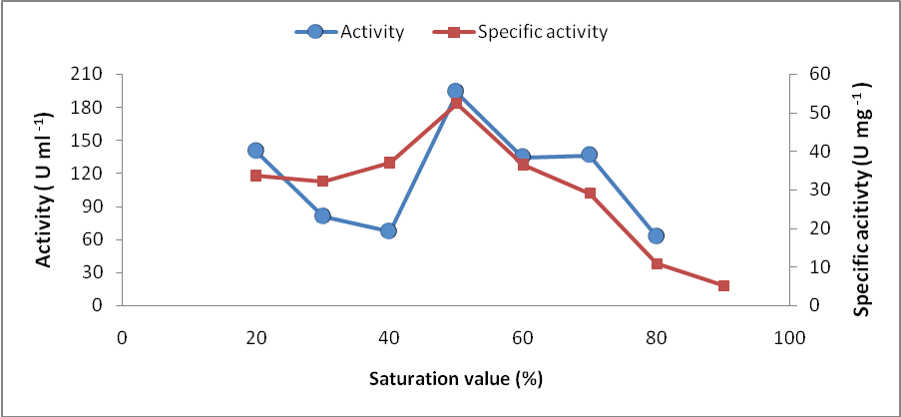

Fig 1. Activity and specific activity of urease of Prosopis farcta using salting out by ammonium sulfate

The choice of two kinds of ion exchange chromatography was due to unknown pI of extracted urease. Using anion exchanger (DEAE Cellulose), results (figure 2) showed three peaks of proteins absorbance without urease activity in washed fractions while in elution showed five peaks of absorbance with urease activity in first peak (fractions 51-63). According to these results, urease perhaps has negative charge and pI lower than its pH. To confirm this presume the eluted fractions that have activity were subjected to cation exchanger (CM Cellulose), results showed presence of urease activity in washed fractions.
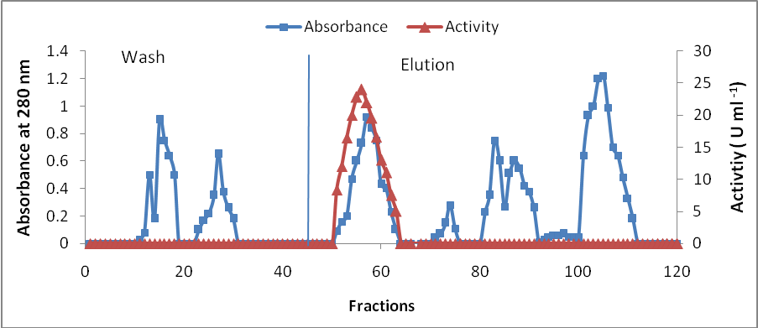

Fig 2. DEAE Cellulose chromatography of urerase of Prosopis farcta with dimension 1.5×30 cm, pre-equilibrated by 50 mM phosphate buffer pH 8.0 at flow rate 25ml/h.

The specific activity and recovery of washed urease were 230.55 U mg⁻¹ and 24.35% respectively (Table 2). Scopes, (1994) and Bollag et al, (1996) recommended using both anion and cation exchange matrix that may lead to remove most other contaminated proteins.
Final step of purification was determined by Size exclusion Sephacryl S-200 technique to obtain more enzyme purity. Three peaks of proteins were recorded and activity was fixed and matched with fractions 60-65 of third peak (Figure 3). Specific activity, purification factor and recovery were 433.33, 11.79 and 8.32 respectively (table 2). References that deal with anions exchange and Size exclusion chromatography for urease purification reviewed by (Al-Shikirchy, 2004) and (Al-Khafaji, 2007).

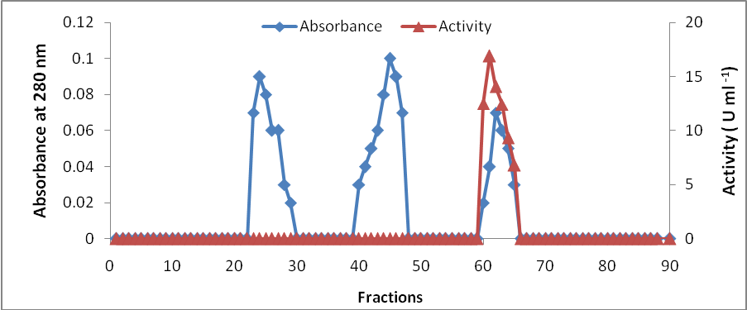

Fig 3. Size exclusion chromatography of urease of Prosopis farcta, with dimension 1.5×50cm pre-equilibrated by 0.2M phosphate buffer pH7 at flow rate 25ml/h.

Table 2. Purification summary of urease of Prosopis farcta
 | Total proteins  (mg) | Total activity  (U) | Specific activity  (U mg⁻¹ ) | Purification factor | Recovery  (%)
Raw Urease | 51 | 1874.4 | 36.75 | 1 | 100
50% (NH₄)₂SO₄ | 18.25 | 965 | 52.44 | 1.42 | 51.48
DEAE Cellulose | 2.86 | 552.76 | 193.27 | 5.25 | 29.48
CM Cellulose | 1.98 | 456.5 | 230.55 | 6.27 | 24.35
Sephacryl S-200 | 0.36 | 156 | 433.33 | 11.79 | 8.32
Urease properties
After purification of urease characterization, was achieved involving different features, the important one was molecular weight. Figure 4 showed that urease had molecular weight equal to 95.500 kDa. This result disagreed with Gorin et al. (1962) who revealed that urease was very specific to urea and had relatively large molecular weight of 473 kDa, but in another physicochemical study of urease isolated from Canavalia ensiformis, Glycine max and Gossypium hirsutum indicated that molecular were weights 90.7, 93.6, 98.3 respectively (Menegassi et al., 2008).
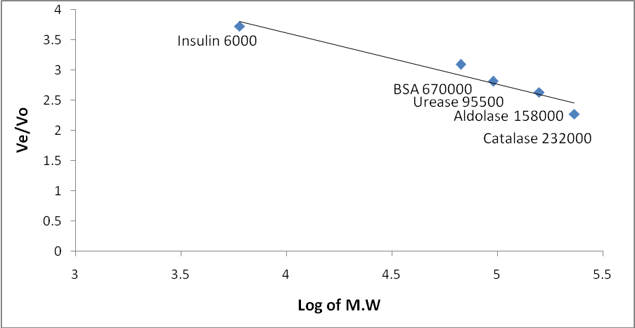

Fig 4. Molecular weight of urease of Prosopis farcta

In the present study, optimal pH showed urease had highest activity at pH8 (12.97 U ml⁻¹) while at extreme pH value activity was absent. Another interest activity was 11.2 and 12.06 U ml⁻¹ falls in pH 7.5 and 8.5 respectively (figure 5). In fact, alteration in pH perhaps alter the distribution of charges at active site and in the whole surface of the protein molecule. Urease may found polar amino acid residues at its active site whose charge depends on pH. Activities of enzyme tend to decrease at extremes of pH usually exhibiting increase at some intermediate values (Illanes, 2008).

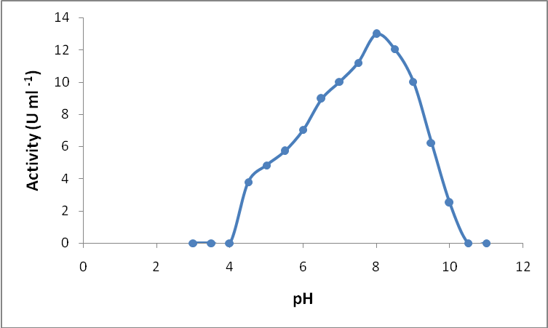

Fig 5. Optimum pH of urease activity of Prosopis farcta

The stability of urease presented is in figure 6 after 60 minutes of incubation. The enzyme maintained its activity (100%) at pH ranging from 7-8 where as retained activity decreased at below and above this range. Change in incubation pH may lead to change in protonation of amino acid at active site, protonation is often reversible processes may not influence the urease activity at pH 7-8. Otherwise, change in pH also results in change the charge of structurally important groups often cause irreversible change to the native structure of urease subsequently decreasing in activity in another’s pH value of incubation (Bisswanger, 2008).
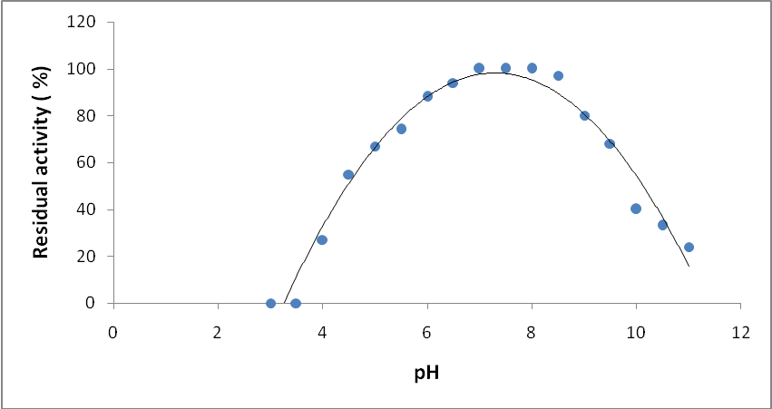

Fig 6. Stability pH of urease of Prosopis farcta
Thermal influence on urease activity (figure 7) showed increase of enzyme activity with increase of temperature until it reach to maximum at 45ºC (22.94 U ml⁻¹), after this value activity declined gradually until reach to minimum at 80ºC (1.15 U ml⁻¹). Loss of considerable activity of urease at high temperature (70-80ºC) may be due to the fact that most of enzyme denatured when exposure to high heat resulting in change in enzyme conformation (Leskovac, 2004).
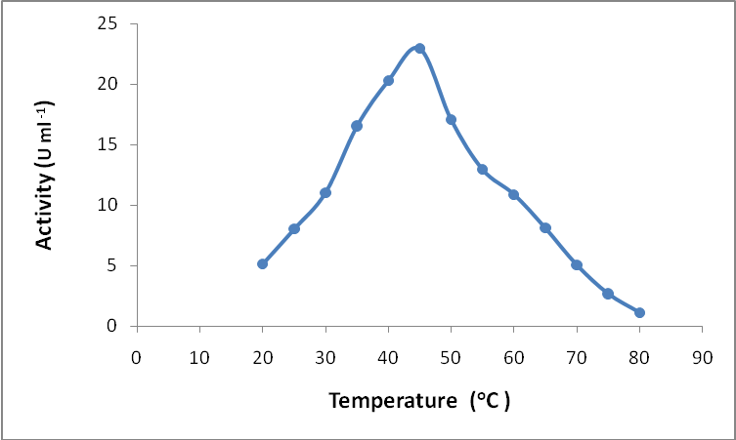

Fig 7. Thermal activity of urease of Prosopis farcta

Results of thermal stability of urease when incubated for 40 minute showed that the activity proportion was unaffected at temperatures ranged between 20-35ºC and decreased slightly (5%) at 40ºC, while the minimum residual activity located at 80ºC (Figure 8). Most plant enzyme are semi-stable at temperature ranged from 30 - 40°C, and able to stand temperatures up to 40°C, but above 40°C protein composition begin to distorted (Bonner, 2007).

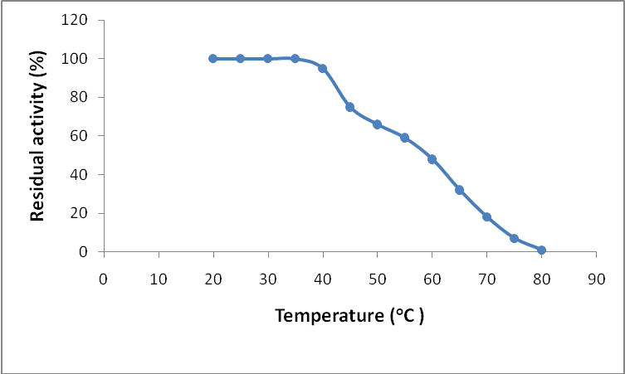

Fig 8. Thermal stability of urease of Prosopis farcta

References
Adams, C.A. and Rinne, R. W. (1981). The occurrence and significance of dispensable proteins in plants. New Phytol., 89: 1-14.
Achakzai, A. K.; Kayani, S. A.; Yaqoob, M. and Nabi, A. (2003). Effect of fertilizer and inoculation on lipase and urease activity of mature soybean cv. willaims- 82 seed. Asian journal of plant science. 2(9): 692-695.
Al-Khafaji, M. A. (2007). Purification, characterization and immobilization of urease extacted from seeds of Colocynth Citrullus colocynth. Ph.D. dissertation, Baghdad university. (In Arabic).
Allison, S. D.; Nielsen,C.; Hughes, R. F. (2006). Elevated enzyme activities in soils under the invasive nitrogen-fixing tree Falcataria moluccana. Soil Biology and Biochemistry 38: 1537–1544.
Al-Shikirchy, F.H.M. (2004). Extraction, purification and characterization of urease from zahdi dates plam seeds (Phoenix dactylifera L.). MSc. thesis, Baghdad university. (In Arabic).
Bailey, C.J. and Boulter, D. (1971). The subunit structure of Jack bean urease. Biochem. J., 113: 669-677.
Balasubramanian, A. and Ponnuraj, K. (2008). Purification, crystallization and preliminary X-ray analysis of urease from pigeon pea (Cajanus cajan). Acta Crystallographica. 64: 662-664.

Barros, R. M.; Ferreira, C. A.; Silva, S. V. and Malcata, F. X. (2001), Quantitative studies on the enzymatic hydrolysis of milk proteins brought about by cardosins precipitated by ammonium sulfate. Enzyme and Microbiology and Technology 29: 541-547.
Bisswanger, H. (2008). Enzyme kinetics: Principle and methods. 2nd ed., WILEY- VCH Verlag GmbH and Co. KGaA, Weinheim. p 153.
Bollag, D.M. ;Rozycki, M. D. and Edelstein, S.T. (1996). Protein Methods.2nd ed., Wiley-Liss. Inc., pp. 239-240.
Bonner, P. L. R. (2007). Protein purification. 1st ed., Taylor and Francis Group. p 28
Callahan, B.P.; Yuan, Y. and Wolfenden, R. (2005). The burden borne by urease. J. Am. Chem. Soc. 127: 10828–10829.
Carlini, C.R. and Polacco, J. C. (2008). Toxic properties of urease. Crop Sci., 48:1665–1672.
Deutscher, M. P. (1990). Guide to protein purification. In“ Methods in Enzymology”. edited by Abelson N, J. and Simon, M. I. (Academic Press, Inc.). 182: 290-292.
El-Shora, H.M. (2001). Properties and immobilization of urease from leaves of Chenopodium album (C₃). Bot. Bull. Acad. Sin., 42: 251-258.
Gorin, G.; Fuchs, E.; Butler, L.G.; Chopra, S. L. and Hersh, R.T. (1962). Some properties of urease. Biochemistry. 1: 911-916.
Hogan, M. E.; Swift, I. E. and Done, J. (1983). Urease assay and ammonia release from leaf tissues. Phytochemistry, 22: 663-667.
Illanes, A. (2008). Enzyme biocatalysis: Principles and application. 1st ed., Springer. p134.
Leskovac, V. (2004). Comprehensive enzyme kinetics. 1st ed., Kluwer Academic Publishers. P317
Lowry, O. H.; Rosebrough, N.J; Farr A.L.and Randall, R.J. (1951). Protein measurement with the folin reagent. J. Biol. Chem., 193: 265-275.

Menegassi, A.; Wassermann, G. E.; Olivera-Severo, D.; Becker-Ritt, A. B.; Martinelli, A H. S. ; Feder, V. and Carlini, C. R. (2008). Urease from cotton (Gossypium hirsutum) seeds: Isolation, physicochemical characterization, and antifungal properties of the protein. J. Agric. Food Chem., 56: 4399– 4405.
Polacco, J. C. and Winkler, R. C. (1984). Soybean leaf urease: A seed enzyme. Plant Physiol., 74: 800-803.
Rosenthal, A. G. (1973). The interrelationship of canavanine and urease in seeds of the lotoideae. Journal of Experimental Botany 25(4):609-613 (Abstract).
Scope, R. K. (1994). Protein purification: Principle and practice. 3rd ed., Springer- Verlag. NewYork.

