Isolation and Identification of Acinetobacter baumannii Clinical Isolates using Novel Methods
Zuhair Sadiq Al Sehlawi
College of Dentistry /Kufa university
Ali Muhsin Almohana Azhar Ammran Al Thahab College of Medicine /Kufa university College of Science/ Babylon university

Abstract:
Acinetobacter baumannii has emerged over the last decade as a significant opportunistic pathogen. Although it is generally associated with benign colonization of hospitalized patients. The purpose of this study was undertaken to isolate and identify of A. baumannii from clinical infections using different laboratory methods.
A total of 520 clinical samples (wound pus, urine, respiratory secretion, blood) were collected from February to June, 2011. A. baumannii isolates were preliminary identified according to the morphological characteristics and traditional biochemical test. Then confirmed by using API 20E and API 20 NE multi-test system. Isolates were further identified on molecular level using 16S rRNA specific gene by polymerase chain reaction (PCR). All PCR positive isolates were examined to grow on CHROMagar Acinetobacter/MDR medium and their antibiotics susceptibility.
A total of 335 Gram negative bacilli isolates were obtained according to the morphological characteristics and traditional biochemical test. Only 23(6.8%) were identified as suspected A. baumannii. Ten (43.4%) isolates revealed very good identification level by API 20E system. While, API 20 multi-test system for non enteric bacteria identified only 12(52.1%) isolates belonged to A. baumannii. The same isolates harbored positive bands in PCR experiments with specific primers for16S rRNA gene. A. baumannii isolates were distributed as 6(50% ) recovered from urine, 4(33.3%) from lower respiratory secretion and only two (25%) were obtained from wound pus, no A. baumannii isolates were isolated from blood samples in this study. Hence, 6 (50%) of isolates were gave overnight pure growth on CHROMagar Acinetobacter/MDR medium with resistant to representatives of three or more classes of antibiotics. The present findings suggest that the PCR using16S rRNA gene CHROMagar were gold standard method for detection of multi-drug resistant A. baumannii isolates among patients in Najaf hospitals.
الخلاصة:
هدفت الدراسة إلى عزل وتشخيص بكتريا Acinetobacter baumannii من إصابات سريريه مختلفة باستخدام الطرق المختبرية التقليدية والجزيئية والعزل على الأوساط الخاصة. جمعت 520 عينة سريريه (مسحات الجروح, الادرار, افرازات المجاري التنفسية, الدم) خلال الفترة من شباط إلى حزيران من العام 2011 من المرضى الراقدين والمراجعين لثلاث مستشفيات رئيسية في النجف . تم التشخيص الأولي لعزلات بكتيريا A. baumannii اعتمادا على الخصائص المظهرية للبكتريا وفعاليتها الكيموحيوية . كما تم إجراء الفحوصات التأكيدية للتشخيص باستخدام أنظمة التشخيص للاختبارات الكيموحيوية المتعددة API 20E و API 20 NEالخاصة بالبكتريا المعوية وغير المعوية . تم تشخيص بكتريا A. baumannii ولأول مرة على المستوى الجزيئي باستخدام تقنية تفاعل البلمرة المتسلسل PCR للتحري عن وجود ألجين الوراثي المشفر للجزء الرايبوسومي S16 من الحامض النووي rRNA الخاص بهذه البكتريا. زرعت العزلات الحاملة للجين على الوسط التشخيصي CHROMagar Acinetobacter/MDR كطريقة تأكيدية وتشخيصية للعزلات المتعددة المقاومة للمضادات الحيوية بالمقارنة مع طريقة الاقراص. تم عزل 335 عزلة بكتيرية سالبة لصبغة غرام حسب نتائج الفحوصات المظهرية والكيموحيوية . كان من بينها 23 (6.8%) عزلة مشتبه بها تابعة لبكتريا A. baumannii . أبدت نتائج التشخيص باستخدام نظام API 20E إن 10 (43.4 %) كانت تابعة لنفس البكتريا وبمستوى تشخيصي عالي , في حين أظهرت 12(52 %) عزلة نتائج موجبة باستخدام نظام API 20NE. كما كشفت تجربة PCR للتحري عن ألجين الوراثي 16S rRNA إن العزلات الموجبة لفحص API 20NE كانت حاملة لهذا الموروث. ستة عزلات (50%) منها كانت مقاومة لاكثر من ثلاث اصناف من المضادات الحياتية ,كما و أعطت نموا واضح على الوسط التشخيصي CHROMagar Acinetobacter/MDR . خلصت الدراسة إلى وجود بكتريا A. baumannii كمسبب مرضي بين المرضى في مستشفيات النجف, و اعتبر كل من تقنيتي PCR و CHROMagar طرق مثلى لتشخيص بكتريا A. baumannii المتعددة المقاومة للمضادات الحيوية.

Introduction
Acinetobacter baumannii is an important opportunistic pathogen has potential spread among hospitalized patients and persist in the hospital environment (Bergogne- Berezin & Towner, 1996). Currently, A. baumannii is becoming an important emerging nosocomial pathogen worldwide and is responsible for 2-10 % of all the Gram-negative infections (Richet, and Fournier, 2006). These microorganisms are known principally for their role as causative agents of nosocomial pneumonia, bacteraemia, urinary tract infection, wound infections, and secondary meningitis (Bergogne- Berezin & Towner, 1996). Although some cases of community acquired infection have been described, the importance of Acinetobacter spp. lies mainly in their role in the ability to colonize almost any surface and to acquire antibiotics resistance (Fernandez-Cuenca et al., 2004). In vitro studies have also demonstrated that it can cause lethal infections in immunosupressed animals, with a death rate between 75% and 100% (Rodríguez-Hernández et al., 2000). The genus Acinetobacter is now defined as Gram-negative nonfermenting coccobacilli, strictly aerobic, no motile, catalase positive, and oxidase negative. Acinetobacter spp. generally form smooth and sometimes mucoid colonies on solid media, with a colour ranging from white to pale yellow or greyish-white (Dijkshoorn et al., 2007).
Presently, at least 24 genomic species (DNA group) have been described within the genus Acinetobacter. Strains belonging to some of the genomic species are very similar that identification by phenotypic characterisation has always been difficult (Barbe et al., 2004). It has been reported that most of the isolates of clinical origins are closely related to the Acinetobacter calcoaceticus-Acinetobacter baumannii (Acb) complex ( Misbah et al., 2005).
As Acinetobacter spp. are widespread in nature, typing methods are needed to differentiate strains in epidemiological studies (Towner, 2006). An accurate identification of Acinetobacter spp. at the species level is important for the selection of the appropriate therapy because differences in antimicrobial efficacy against strains from different species has been demonstrated (Lin et al., 2008). Differentiation of the genus Acinetobacter from other related bacteria is accomplished by a combination of nutritional tests, including most commercially available diagnostic devices and systems. On the other hand, phenotypic identification to the genomic species level is more difficult because commercial identification systems do not separate between the different genospecies.
Biotyping methods are based on biochemical tests and can be used for comparative typing of strains (Dijkshoorn et al., 2007). Among them, the API 20NE is currently used in hospital laboratories and although it is reliable, it usually requires complementation with other biochemical analysis such as growth at 44 ºC to identify A. baumannii (Bernards et al., 1996). Nowadays, molecularly identification of Acinetobacter spp. using the 16S rDNA-based method and pulsed-field gel electrophoresis random are the most widely accepted methods as large public-domain sequence databases are available for comparison (Misbah et al., 2005). Hence, the proposed aim of this study is to isolate and identify A. baumannii isolates from hospital settings in the Najaf city.

Materials and Methods
Isolation and Traditional Identification of Isolates
A total of 520 clinical samples included (lower respiratory secretions (n= 220), , urine (n= 150), wounds secretions (n= 110) and blood (n= 40)) were collected from patients in three separate hospitals (Al-Sader Medical City, Al-Hakeem General Hospital, Al-Furat Teaching Hospital) in Najaf over five months period starting from February to June, 2011. Isolates were recovered from clinical samples after culturing on MacConkey's agar (Himedia, India) and incubated for overnight at 37ºC, non lactose fermenting bacteria (colorless or slightly beige) were subcultured and incubated for additional overnights. Suspected bacterial isolates which their cells are Gram negative coccobacillary or diplobacillus and negative to oxidase which further identified by the traditional biochemical test according to Holt et al. (1994) and MacFaddin (2000).
API 20 Multi Test System
The identified Acinetobacter spp. isolates were confirmed by API 20E and API20 NE multi-test systems (BioMerieux ,France). These tests were used according to manufacturer's protocol for Enterobacteriaceae and non enteric bacteria. Wells of biochemical test were inoculated with overnight 0.5 McFarland bacterial suspension and incubated at 37ºC for 24 hrs. The results were read after addition of reagents, as 7 digit number that identify by API 20 analytical index. .
PCR Amplification
DNA was extracted from the isolates by salting out method according to Pospiech and Neumann. (1995). DNA extract was used as template for the polymerase chain reaction (PCR) amplification. Amplification reaction mixtures (25 µl) containing 12.5 µl of GoTaq® Green master mix 2X (Promega, USA), 2.5 µl (10 µM) for each forward (AGAGTTTGATCCTGGCTCAG) and reverse (TACCAGGGTATCTAATCCTGTT) (Misbah et al., 2005) gene primers (Kapa, USA), 5 µl of DNA template (100 µg) and 2.5 µl of PCR grad water (Promega) Amplification of the 16S ribosomal RNA was performed in a DNA thermal cycler, GeneAmp 9700, Thermal Cycler (Applied Biosystem, Singapore) with the following cycling programme: Initial denaturation at 95ºC for 3 min, and 30 cycles of denaturation at 95ºC for 1 min, annealing at 55ºC for 1 min, extension at 72ºC for 1 min and a final extension at 72ºC for 5 min. The resulting PCR amplicons were examined by electrophoresis and visualization by gel documentation system (BioDocAnalyze Live; Biometra biomedizinische Analytic GmbH, Germany) on 2%agarose gels containing ethidium bromide.

CHROMagar Acinetobacter/MDR Technique
The supplements were prepared according to the manufacturer recommendations by dissolving 100 mg/ml of supplement, separately, in sterile D.W., vortexed, homogenized and added in proportions of 10 ml/l of final melted orientation CHROMagar Acinetobacter/MDR (CHROMagar, France) after cooled at 45ºC, then poured in plates and used freshly.

Antimicrobial susceptibility testing
Isolates were plated on Mueller–Hinton agar and their susceptibilities to different antibiotics were tested by disk diffusion method according to the Clinical and Laboratory Standard Institutes guidelines (2010).

Results
A total of 335 non-repeat Gram negative bacilli isolates were collected from the 520 clinical samples. Based on the morphological characterization and biochemical behavior, 23 (6.8%) isolates were identified as suspected A. baumannii, which detected as non-lactose fermenter and oxidase negative coccobacilli (appeared as pale or beige colonies on MacConkey agar). They were isolated from patients with lower respiratory tract (5.1%), urinary tract (9.5%) and wound (6.2%) infections (Table 1).

Table (1): Gram negative bacteria isolated from clinical samples
Clinical  sample | No. of samples | No. of Gram negative bacilli isolates | No. (%) of suspected  A. baumannii
Lower respiratory secretion | 220 | 135 | 7(5.18%)
Urine | 150 | 115 | 11 (9.5%)
Wound secretion | 110 | 80 | 5 (6.2%)
Blood | 40 | 5 | 0%)) 0
Total | 520 | 335 | 23 (6.8%)

However, the frequency of the A. baumannii isolates and their sites of isolation are listed in Table (2). It was found that 10 (43.4%) isolates were specified as A. baumannii at very good identification level by API 20E system. While, 12 (52.1%) of A. baumannii isolates were verified by using API 20NE system at excellent identification level (Figure 1).
In the same manner, out of 23 Acinetobacter spp. suspected isolates, the results of PCR using A. baumannii 16S rRNA gene confirmed that 12 (52.1%) of isolates were harbored positive gene bands (Figure 2). Adversely, table (3) shows a clear decrement in the percentage of isolation 6/12 (50%), when using CHROMagar Acinetobacter/MDR as a specific medium (Figure 3). Consequently, this medium was good indicator to multi-drug resistant isolates (resistant to more than 3 antibiotic classes).
Table (2): Number and source of A. baumannii isolates identified by multi-test systems
Clinical  sample | No. (%) of suspected  Acinetobacter spp. | No. (%) of A. baumannii isolates detected by multi-test systems
Clinical  sample | No. (%) of suspected  Acinetobacter spp. | API 20E* | API 20NE*
Lower respiratory secretion | 7 | 3(42.8%) | 4(57.1%)
Urine | 11 | 6(54.5%) | 6(54.5%)
Wound secretion | 5 | 1(20%) | 2(40%)
Total | 23 | 10(43.4%) | 12 (52.1%)*

*E:enterobacteriaceae, NE: non enteric bacteria; L.S.D. (0.05) = 4.031
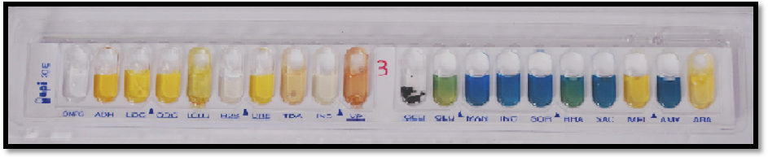
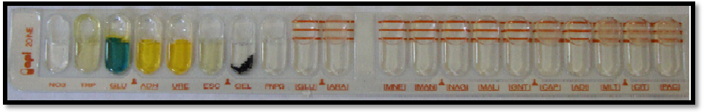
(A)
(B)
Figure (1): Multi-tests systems for identifying of A. baumannii isolates. (A) very good identification level of A. baumannii by API 20E system with 7 digit number (0004042) according the analytical profile index. (B): Identification of A. baumannii by API 20NE.

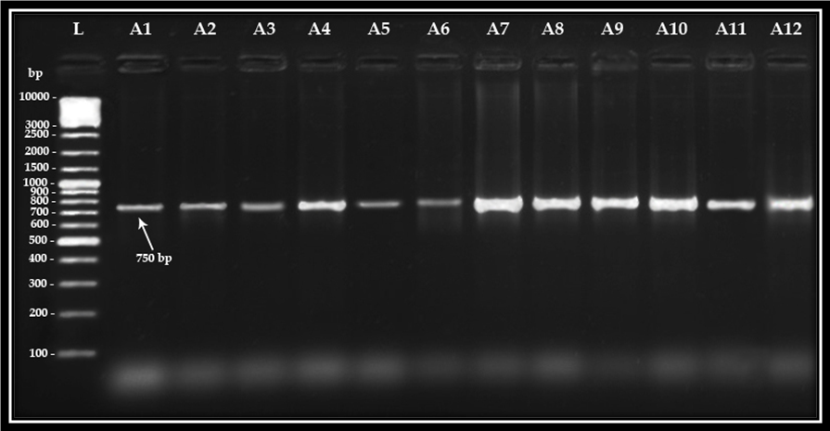
Figure (2): Ethidium bromide-stained agarose gel of PCR amplified products from extracted DNA of A. baumannii isolates and amplified with primers of 16S rRNA gene. The electrophoresis was performed at 70 volt for 1.5 hr. Lane (L), DNA molecular size marker (l0000 bp ladder), Lane (A1-A12) show positive result with positive bands of 750 bp.

Table (3) : Antibiotic susceptibility profiles of multi-drug resistant A. baumannii isolates
Isolate code number | Growth on CHROMagar Acinetobacter/ MDR medium | Antibiotic resistant pattern by disk diffusion method
A1 | - | CTX, CAZ, ATM, FEP, TE, PRL, TIC
A2 | - | CTX, FOX, FEP, TEP, CIP, PRL
A3 | + | Ac, CTX, CI, CAZ, ATM, FOX, MEM, FEP, TOB, AK, CN, CIP, GT, LEV , TE, PRL, TIC, PY
A4 | + | Ac, CTX, CI, CAZ, ATM, FOX, MEM, FEP, TOB, AK, CN, CIP, GT, LEV , PRL, TIC, PY
A5 | - | CTX, CAZ, ATM, FEP, PRL, TIC, PY
A6 | + | CTX, CAZ, ATM, FOX, FEP, TOB, AK, CN, TEP, TE, PRL, TIC, PY
A7 | - | CTX, CAZ, ATM, FEP, TIC, PY
A8 | - | CTX, CAZ, ATM, TIC, PY
A9 | + | AC, CTX, CI, CAZ, ATM, FOX, IPM, MEM, FEP, TOB, AK, CN, TEP, CIP, GT, TE, PRL, TIC, PY
A10 | + | AC, CTX, CI, CAZ, ATM, FOX, IPM, MEM, FEP, TOB, AK, CN, TEP, CIP, GT, LEV ,TE, PRL, TIC, PY
A11 | - | CTX, CAZ, ATM, PRL, TIC, PY
A12 | + | CTX, CAZ, ATM, FOX, MEM, FEP, TOB, AK, CN, TEP, CIP, TE, PRL, TIC, PY
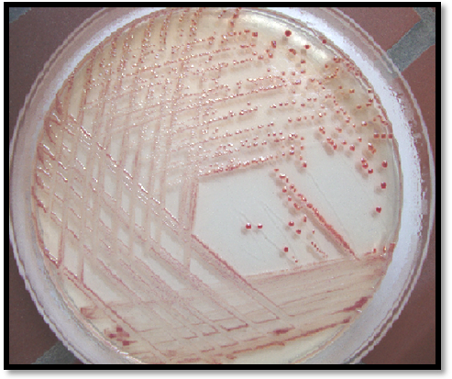
PY, Carbenicillin; PRL, Piperacillin; TIC, Ticarcillin; AC, Amoxi-clav; CFX, Cefexime; FOX, Cefoxitin; CAZ, Ceftazidime; CTX, Cefotaxime; CI, Ceftriaxone; FEP, Cefepime; IMP, Imipenem; MEM, Meropenem; ATM, Aztreonam; AK, Amikacin; CN, Gantamycin; TOB, Tobramycin;;CIP, Ciprofloxacin; LEV, Levofloxacin; GT, Gatifloxacin; TE, Tetracyclin; TEP, Trimethoprime

Figure (3): Identification of A. baumannii isolates using CHROMagar Acinetobacter/MDR medium. Colonies appeared as metallic reddish after incubation at 37ºC for 24hr.
Discussion

In this investigation, the bacterial isolates obtained as a pure and predominant growth from clinical samples were only considered for the present study. All these bacteria were identified based on colonial morphology, and comparison of the biochemical characteristics with standard description in Bergeys manual of determinative bacteriology (Holt et al., 1994) and MacFaddin (2000). However, culture morphology and biochemical characteristics of the isolates that they behave as a typical A. baumannii, when they screened with additional biochemical test .
One purpose of this study was to evaluate the dissemination of A. baumannii and to ascertain the detection rate of this microorganism from the Gram-negative pathogens in patients with significant infections. Moreover, Table (1) revealed that among 335 Gram-negative bacteria only 23 (6.8%) isolates were identified as suspected A. baumannii. So, in a large study of 584 Acinetobacter isolates realized by Seifert et al. (Seifert et al., 1993), over 70% of the strains were classified as A. baumannii. However, Fontana et al. (2008) found that the A. baumannii was the most frequent pathogen (7%) among Gram negative bacteria isolated from patients of intensive care units in France hospitals. Although, it has always been considered a microorganism of low virulence, recently, suggest that sometimes it can be highly pathogenic and cause invasive diseases (Joly-Guillou, 2005). However, The members of this genus are normal inhabitants of human skin, throat, respiratory and intestinal tract of hospitalized patients; other reservoirs include the medical equipment within the hospital environment as well as the patients and staff (Towner, 2006).
This study indicated that most common isolates were isolated from patients with urinary tract infection (9.5%), then wound (6.2%) and lower respiratory tract (5.1%) infections ( Table 1). The dissemination of A. baumannii in clinical and samples may be due to its ability to cause different nosocomial infections and resistance to a wide range of antibiotics. Also, some authors claim that the source of infection perhaps from endogenous routes rather than the exogenous routes via sink taps and hands of hospital personnel (Thomson et al., 2004). In addition to that A. baumannii survives desiccation better than other Acinetobacter spp. with its ability to form biofilm that involved in cell attachment on epithelial cell and smooth surfaces of medication instruments like urinary catheters and lung tubes.(Musa et al., 1990 ; Peleg et al., 2008) The present study revealed that no significant differences (P ˂ 0.05) between A. baumannii isolates were specified by API 20E system10 (43.4%) and A. baumannii isolates were verified by using API 20NE system 12 (52.1%) (Table 2). This may be resulted from the identification of Acinetobacter spp. to the species level by the conventional identification tests remains difficult in the clinical microbiology laboratory (Monnet and Freney, 1994). Therefore, in this study the multi test API 20E system was used to confirm species identification and to avoid the variability in findings of manual biochemical tests. However, These phenotypic characteristics included in commercial identification systems with 20 biochemical tests (API 20E and NE) are not considered a sufficiently reliable identification method (Bergogne-Berezin, 2001). Worth mentioning, in this study the variability in identification of A. baumannii may not because the insufficiently of the tests systems, but due to some properties of A. baumannii. Obviously, it has typical Gram-negative cell wall is difficult to distain and occasionally can be confused with Gram-positive cocci, together with variations in cell size and arrangement (Allen and Hartman, 2000) .
On the other hand, phenotypic identification to the Acinetobacter genomic species level is more difficult because commercial identification systems do not separate between the different genospecies (Bergogne-Berezin and Towner, 1996). Recently, more precise and accurate identification requires DNA-based methods, which are increasingly used. Moreover, this study used the PCR technique as an accurate tool for identification depending on16S rRNA gene as housekeeping gene for A. baumannii. However, the results of PCR had been confirmed that the 12 (52.1%) of (API 20 NE positive) isolates were harbored positive gene bands (Figure 3). PCR results was in accordance the identification by API 20 NE system (Table 2). Perhaps, the biotyping methods are based on biochemical tests can be used for comparative typing of strains (Peleg et al., 2008). Among them, the API 20NE is currently used in hospital laboratories and although it is reliable, it usually requires complementation with other biochemical analysis such as growth at 44 ºC to identify A. baumannii (Bernards et al., 1996)
An accurate identification of Acinetobacter spp. at the species level is important for the selection of the appropriate therapy because differences in antimicrobial efficacy against clinically important strains from different species. Therefore, CHROMagar Acinetobacter/MDR medium (Figure 2) was also evaluated for detection of A. baumannii isolates. Only 6 (50%) of isolates able to gave overnight heavy growth onto this medium (Table 3). The decrement in percentage of identification by this test may because the high selectivity of this medium to multi-drug resistant isolates, with inhibition of antibiotic susceptible A. baumannii isolates. However, because the originality of this method, there is no available studies previously used this technique. Table (3) also revealed that 50% of isolates to resist the major antibiotic classes.
Multi-drug resistance (MDR) clinically, is the ability of disease causing microorganism to withstand a wide variety of antimicrobial compounds (Mooij, 2009). Hence, a strain is considered a MDR if an isolate is resistant to representatives of three or more classes of antibiotics. However, transference of resistance determinants by mobile genetic elements including plasmids, transposons, and gene cassettes in integrons between and across different bacterial species are important factors that can contribute to the increase in multi-resistant strains (Livermore, 2007).
Based on this observation, the ability of A. baumannii isolates for fully resistant to antibiotics could be caused by either; predominate exposure of present isolates to suboptimal levels of antibiotic, prolong use of broad-spectrum antibiotics, exposure to isolates carrying resistant genes, lack of hygiene in clinical environments and usage of antibiotics in foods and agriculture. but the occurrence of alarming MDR A. baumannii isolates may be threat to arise of extensive and pan-drug resistant (XDR and PDR) isolates in the future.

References:
Allen, D. M. and Hartman, B. J. (2000). Acinetobacter Species, In Mandell, G. Bennett, J. and Dolin, R. (ed.), Principles and Practice of Infectious Diseases. Churchill Livingstone, Philadelphia.
Barbe, V.; Vallenet, D.; Fonknechten, N.; Kreimeyer, A.; Oztas, S.; Labarre, L.; Cruveiller, S.; Robert, C.; Duprat, S.; Wincker, P.; Ornston, L. N.; Weissenbach, J.; Marliere, P.; Cohen,
Bergogne-Berezin, E. (2001). The increasing role of Acinetobacter species as nosocomial pathogens. Curr. Infect. Dis. Rep., 3: 440–444.
Bergogne-Berezin, E. and Towner, K. J. (1996). Acinetobacter spp. as nosocomial pathogens: microbiological, clinical, and epidemiological features. Clin. Microbiol. Rev., 9: 148–165.
Bernards, A. T.; van der Toorn, J.; van Boven, C. P. A.; and Dijkshoorn, L.(1996). Evaluation of the ability of a commercial system to identify Acinetobacter genomic competent bacterium. Nucleic Acids Res., 32:5766-5779.
Clinical and Laboratory Standards Institute. (2010). Performance Standards for Antimicrobial Susceptibility Testing; 20th Informational Supplement. Approved standard M07-A8. Clinical and Laboratory Standards Institute, Wayne, Pa.
Dijkshoorn, L.; Nemec, A. and Seifert, H.(2007). An increasing threat in hospitals: multidrug-resistant Acinetobacter baumannii. Nature Rev. Microbiol., 5:939- 951.
Fernandez-Cuenca, F.; Pascual, A.; Ribera, A.; Vila, J.; Bou, G.; Cisneros, J. M.; Rodriguez-Bano, J.; Pachon, J. and Martinez-Martinez, L.(2004). Clonal diversity and antimicrobial susceptibility of Acinetobacter baumannii isolated in Spain. A nationwide multicenter study: GEIH-Ab project (2000). Enferm. Infecc. Microbiol. Clin., 22:267-271.
Fontana, C.; Favaro, M.; Minelli, S.; Bossa, M.C.; Testore, G.T.; Leonardis, F.; and Favalli, C. (2008). Acinetobacter baumannii in intensive care unit: A novel system to study clonal relationship among the isolates. BMC Infect. Dis., 8:8-79.
Holt, J.G.; Krieg, N.R.; Sneath, H.A.; Stanley, J.T. and Williams, S.T. (1994). Bergeys Manual of Determinative Bacteriology. 9th ed., Baltimore; Wiliams and Wilkins, USA.
Joly-Guillou, M. L. (2005). Clinical impact and pathogenicity of Acinetobacter. Clin. Microbiol. Infect., 11:868-873.
Lin, Y.; Sheng, W.; Chang, S.; Wang, J.; Chen, Y.; Wu, R.; Hsia, K. and Li, S.(2008). Application of a microsphere-based array for rapid identification of Acinetobacter spp. with distinct antimicrobial susceptibilities. J. Clin. Microbiol. 46:612-617.
Livermore, D.M. (2007). Introduction: the challenge of multiresistance. Int. J. Antimicrob. Agents., 29 Suppl. 3: S1-7.
MacFaddin, J.F. (2000). Biochemical Tests for Identification of Medical Bacteria (3rd ed.), Lippincott Williams and Wilkins, USA.
Misbah, S.; Hassan, H.; Yusof, M. Y.; Hanifah, Y. A. and AbuBakar, S. (2005). Genomic species identification of Acinetobacter of clinical isolates by 16S rDNA sequencing Singapore Med. J., 46(9) : 461.
Monnet, D. and Freney, J. (1994). Method for Differentiating Klebsiella planticola and Klebsiella terrigena from other Klebsiella species. J. Clin. Microbiol., 32:1121-1122.
Mooij, M.J. (2009). Mobile Genetic Elements of Nosocomial Pathogen. M.Sc. Thesis.Academic Proefshrift. Vrije University.
Musa, E.; Desai, N. and Casewell, M. (1990). The survival of Acinetobacter calcoaceticus inoculated on fingertips and on formica. J. Hosp. Infect., 15:219-227.
Peleg, A.; Seifert, H. and Paterson, D. (2008). Acinetobacter baumannii: Emergence of a successful pathogen. Clin. Microbiol. Rev., 21:538-582.
Pospiech, T. and Neumann, J. (1995). In genomic DNA isolation. Kieser eds. John Innes Center. Norwich NR4 7UH. U.K.
Richet, H. and Fournier, P. E.( 2006). Nosocomial infections caused by Acinetobacter: a major threat worldwide. Infect. Control Hosp. Epidemiol. 27:645-646.
Rodríguez-Hernández, M. J.; Pachón, J.; Pichardo, C.; Cuberos, L.; Ibáñez- Martínez, J.; García-Curiel, A.; Caballero, F.; Moreno, I. and Jiménez-Mejías, M. (2000). Imipenem, doxycycline and amikacin in monotherapy and in combination Acinetobacter baumannii experimental pneumonia. J. Antimicrob. Chemother. 45:493-501.
Seifert, H.; Baginsky, R.; Schulze, A. and Pulverer, G. (1993). The distribution of Acinetobacter species in clinical culture materials. Zentralbl. Bakteriol. 279:544-552.
species. Eur. J. Clin. Microbiol. Infect. Dis., 15:303-308.
Thomson, N. et al., (2004). The role of prophage-like elements in the diversity of Salmonella enterica serovars. J. Mol. Biol., 339 (2): 279-300.
Towner, K. (2006). The Genus Acinetobacter. Prokaryotes,6:746-758.

