Imunocytochemistry Detection of M1CA Gene Receptor in Human Patients with Brucellosis

Mohammad Sabri A. Razzaq , Mohammad A. K. AlSaadi
College of Medicine-University of Babylon
Abdul Kareem S. Al-Yassari
College of Vet. Medicine- of Al-Qassim Green University
Abstract:
Background: The most relevant cytokine involved in the response against the genus Brucella is interferon gamma (IFN-γ) that is mainly produced by NK cells and stimulated by the binding between their receptors NKG2D receptor and its ligand M1CA gene expressed on Brucella – host infected cells.
Aim: To evaluate the relationship between host susceptibility for Brucella infection and the expression of MICA gene which demonstrated by imunocytochemitsry staining technique .
Methods: Rose Bengal test was applied for 340 patient serum then Brucella blood culture was carried out for Rose Bengal positive samples. Imunocytochemistry technique was used to check the expression of MICA gene receptor on human infected cells. Moreover, the level of IFN-γ was measured in patient sera by using of ELISA technique.
Results: Rose Bengal Test (RBT) revealed that 155 patients were positive. Brucella- Blood culture revealed that only eight samples gives positive for blood culture. Five samples expressed MICA gene receptors. The level of IFN-γ revealed a significant increasing(p ≤ 0.05 ) in positive samples for MICA gene receptors as compared to negative samples for MICA gene receptors.
Conclusion: There is a good relationship between the expression of MICA gene receptor and immune response against Brucella that represented by an increasing of IFN-γ.
Key words: Human Brucellosis, MICA gene receptor, IFN-γ.
الخلاصة :
تم أجراء الدراسة في سبعة مستشفيات هي م . الهاشمية العام , م .الحلة الجراحي، م .الولادة والأطفال،م. مرجان ،م. القاسم العام ، مختبر الصحة المركزي ، المختبرات الأهلية / محافظة بابل خلال الفترة من شهر كانون الأول 2010 إلى شهر كانون الثاني 2012 . تم فحص 340 نموذج دم من المرضى وتحت أشراف الطبيب الأختصاصي بعد أجراء الفحص المختبري (RBT) وتم التعامل مع الحالات الموجبة للمرضى المشتبة بأصابتهم بحمى مالطا ، تراوحت اعمار المرضى بين 9 – 70 سنة للذكور والاناث وأظهر هدف الدراسة المناعية الجينية M1CA gene )) وجود ترابط وثيق بين المسقبل ( NKG2D ) و (M1CA ligand ) والذي اظهر مدى حساسية أو مقاومة الأصابة بجرثومة البروسيلا للأنسان وتم التعامل مع نماذج الدم بفصل خلايا اللمفوسايت وتثبيت الشريحة والسلايد بأستخدام طريقة التصبيغ المناعي لمستقبلات خلايا الدم المناعية (, CD8 NK , T cells) وأظهرت الدراسة خمسة نماذج للمرضى موجبة للتصبيغ المناعي وثلاث حالات لم تصبغ من مجموع ثمانية نماذج للمرضى اللذين تم عزل جرثومة البروسيلا منهم واظهر المرضى زيادة معنوية في مستوى افرازكاما - انترفيرون.

Introduction:
Brucellosis is a zoonotic disease affecting animals and man in many parts of the world, animals are considered as natural reservoir of human Brucellosis, (Young, 1995 ; AKina et al., 2010). Brucellosis is a multi-system disease that is endemic in many Mediterranean countries. The disease is transmitted to human by consumptions of infected unpasteurized dairy products, aerosol or by direct contact with infected animals (AKinci et al., 2001) ,or through ingestion of uncooked meat Meantime (Young, 1995). Occupational disease is contracted by exposure of abattoir workers and veterinarians to infected animals especially aborted fetuses, fluid, membrane, or urine (Ropson et al., 1993).
Immune response to Brucella infection depends mainly on cell mediated immunity and to a lesser extent humeral immunity. Cell mediated immunity play an a critical role in Brucella infection (Montaraz et al., 1986;Raya et al.,1989). Macrophages, neutrophils, natural killer cells, and γδT cell are dependable for the innate immunity in the early phase of infection, and adaptive immunity against Brucella depends on α β T cells (Araya et al., 1989). Brucella organism induces production of antibody, this can give some protection against secondary infection, but is not believed to be a chief contribution to healing from primary infection (Baviov et al., 1982).
According to (Heremans et al.,1963 ; Corbeil et al., 1988), explained low concentrations of IgM or IgG antibodies in naturally infected species appear to promote lysis of Brucella by the classical complement pathway. While Higher of 1gG antibody levels present during active infection likely promotes bacterial intracellular localization and phagocytosis by macrophages (Hoffmann and Houle, 1995). Intracellular numerous cell surface component of Brucella has been assessed significant activity to stimulate immune response (Oliveira and Splitter, 1996). Interferon-gamma(IFN-γ) plays an important role in mediating resistance to primary and secondary Brucella infection(Baldwin., 1993; Zhan and Cheers,1993). T lymphocytes from untreated brucellosis patients are activated in vivo and show Th1 cytokine production polarization, with strikingly high serum IFN-γ levels (Rodríguez-Zapata et al.2010) . As with immunity to other intracellular pathogens, immunity to B. abortus depends on antigen- specific T-cell–mediated activation of macrophages, which are the major effectors facilitating killing and inhibiting replication of Brucella. The Th1 cell induced - cytokines, like IFN- γ, are important for the ctivation of macrophages and in resistance to in vivo and in vitro Brucella infections (Zhan et al., 1993)) . gamma interferon (IFN-γ_)induces macrophage activation and intracellular killing of Brucella infection in animals model(Copin et.al., 2007).
MICA gene receptor is a member of the « major histocompatibility complex (MHC) class I chain-related genes » or MIC family , MICA function MICA gene encodes a cell surface highly glycosylated protein that is expressed exclusively in the basolateral membrane of intestinal epithelium cells . and epithelium-derived tumours (Groh, 1996; Groh, 1999 ) . MICA gene with Brucella was played important role at susceptibility and protection in human Brucellosis . The MICA chain is stress-induced when infection with Brucella occurrence in acute or chronic cases. The mechanisms by which Brucella evades intracellular killing are incompletely understood. Nevertheless, Brucella organisms ultimately become sequestered within monocytes and macrophages of the reticuloendothelial system (RES), such as lymph nodes, liver, spleen and bone marrow. Brucellosis is a systemic infection that can involve any organ or tissue of the body. When clinical symptoms related to a specific organ predominate, the disease is termed “localized”. Commonly, localization involves organs of the RES. Macrophages are the first target of Brucella invasion, and the bacteria can survive within this naturally hostile intracellular environment (Pizarro-Cerda,1998). Macrophages are significant in transporting Brucella to tissue throughout the host, where they can survive in a variety of cell types (Arenas, 2000). poor diagnosis and lack of treatment can result in life-threatening complications (Boschiroli et al.,2001).
This study aimed to illustrate the role of M1CA gene in the susceptibility of host to Brucella infection based on the level of IFN- γ which is considered as the marker for cell-mediated immunity against Brucella .
Materials and methods
Subjects:
Human patients: A total of (340) blood samples clinical blood samples were collected from patients suffering from Brucellosis that diagnosed throw clinical signs and symptoms. Patients were admitted to seven hospitals in IRAQ: Babylon Hospital for Maternal and Pediatrics, Al-Hilla Surgical Teaching Hospital, Al-Qassim general Hospital , Al-Hashimia general Hospital , Marjan Hospital , Central health laboratory, and private labs . during the period from Dec.- 2010 to Jan.-2012.
Controls: Thirty persons (17 male & 13 females) apparently healthy individuals were negative for PRT & wed as control group.
Rose Bengal test: Rose Bengal test (RBT) was carried out for all the samples as recommended by (OIE, 2009).
Brucella culture: Brucella culture was applied for patients with positive results for RBT by using of freshly drawn blood samples (5) ml according to (Alton.,1998). Molecular Brucella identification by using the primers(B4/B5) specific for B. melitensis and B. abortus . based on (Baily et al., 1992 ).
Detection of MICA gene receptor: Lymphocyte separation and slide preparation according to Isopaque-ficol technique originally described by (Boyum ,1968;Marian and Catherine, 1998).
Kits used for imunocytochemitsry staining techniques.
1-Mouse specific HRP/DAB detection IHC Kit. (ab64259) company / abcam/UK, as following components.(table1).
2-Mouse monoclonal [1D11] to NKG2D kit.(ab35033) company / abcam /UK

Table (1) components detection IHC Kit
components | Identifier 15ml
ab64259 | 1×1unit
Hydrogen Peroxide Block | 1×15ml
Protein Block | 1×15ml
Biotinylated goat anti-mouse IgG (H+L) | 1×15ml
Streptavidin Peroxidase | 1×15ml
50×DAB Chromogen | 1×0.5ml

Gamma interferon estimation: The cellular immune response for patients was evaluated by estimation of IFN-γ using ELISA method as recommended by manufacture company (Ray Biotech, USA).
Results and Discussion:
Brucella isolation and identification: 155 patients out of 340 patients were positive for RPT, eight of which were positive for blood culture.
When, blood culture carried out for patients positive for RBT , only 8 of them gives Six of positive blood culture were diagnoses as B. melitensis where as two of them were dignosed as B. abortus by PCR technique. Several studies indicated the role of PCR as a golden standard for the identification of Brucella (Al-Nakkas et al., 2005 and Al-Ouqaili, 2006).
M1CA gene receptor Assay: Demonstration of M1CA gene was carried out for 8 patients with positive culture for Brucella there is a significant differences(p≤0.05) between the patients expressed MICA gene receptor and patients without MICA gene receptor table(2) .
Table(2) Scoring of binding between M1CA gene receptor and NKG2D ligand for positive patients with Brucellosis.
Patients No. | Scoring positive  Imunocytochemistry | Types of Brucella Isolates
1 | 8% | B. melitensis
2 | 11.1% | B. melitensis
3 | 7.6% | B. melitensis
4 | 6.6% | B. melitensis
5 | 12.5% | B. abortus

Five patients were positive for M1CA gene receptor assay according to the estimated scores of binding between M1CA gene receptor & KNG2D legend dor positive patients with brucellosis (table 2) indicated by the presence of brown color on the surface of lymphocytes (figure 1) or the whole of host T-lymphocytes and NK cells (figure 2).
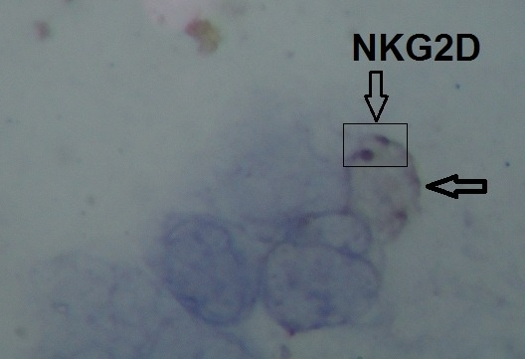
A control group showed, no staining and no binding score with immunoperoxidase staining. The stained cells were blue in color which indicated for negative result figure (2) white arrow.

Figure(1): lymphocytes, lymphocyte-specific stain(black arrow), the NKG2D receptors are stained with immunoperoxidase stain ,white arrow is negative 1000 X.

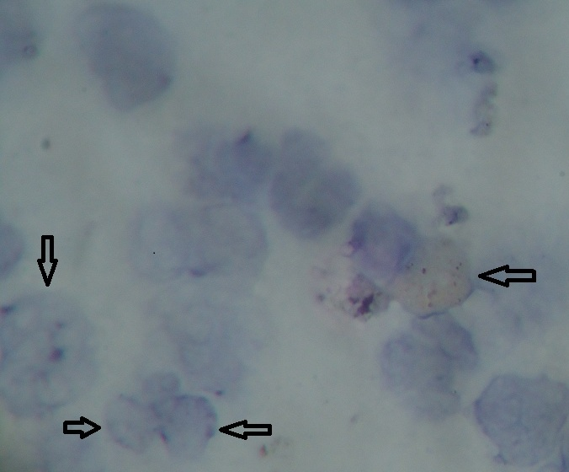

Figure(2): lymphocytes, lymphocyte-specific staining. Immunoperoxidase whole brown cells (black arrows),white arrows is negative , black arrows is faintly stain ,1000X.

According to our knowledge , no similar studies were carried out to investigate the MICA gene receptors in patients with Brucellosis in Iraq and Middle east region . Bravo, et al. (2007) studied the polymorphism of M1CA gene for Brucella infection in human .and showed that the polymorphism in MICA-A4 allele and MICA-A5 allele increase the susceptibility to Brucella infections. Moreover, in this study ,the patients with positive Brucella culture and positive MICA gene receptor expressed normal immune response against Brucella represented by significant level of IFN-γ compared with negative patient for MICA gene receptor (table 3). Fernandes-Prada et al. ,(2001) indicated that M1CA gene receptor plays a central role in the killing of Brucella. In1997,Mizuki et al. Concluded that MICA is a possible candidate gene for the Behçet’s disease. Also Hepatitis B, Hepatitis C may be associated with MICA polymorphisms related with MICA15 .(Aurélie Frigoul and Marie-Paule Lefranc.,2005). Junko Shojima et al.,(2009).found that MICA is one of the promising candidate molecules that might be involved in susceptibility to Pulmonary Mycobacterium avium Complex Infection disease. Bing Mei et al.,(2009) found that the MICA locus might modify host susceptibility to Chlamydia trachomatis infection.
The association of a specific MICA allele with C. trachomatis IgG antibodies among women with infertility. Kerrie Tosh et al (2006) study has provided strong evidence that there is a role for the truncated MICA protein, encoded by the MICA_5A5.1 allele, in leprosy susceptibility in South Indian families. where they are recognized by the NKG2D receptor on gd T cells, CD81 ab T cells and natural killer cells, all of which contribute to defense against Mycobacteria. Holger Kirsten.,(2009) present evidence for linkage and association of MICA-250 (rs1051794) with RA independent of known hladrb1 risk alleles, suggesting MICA as an RA susceptibility. These findings make MICA an interesting candidate gene for association studies in RA.
Level of Gamma Interferon: the mean levels of IFN-γ estimated by ELISA technique were (17.716 , 7.449 , 5.25 Pico mol / ml), in patients with expression of M1CA gene receptor, patients without expression of M1CA gene receptor, and healthy controls respectively. The results indicated the good association between the expression of M1CA gene receptor and the production of IFN- by TH1 cells and NK cells .There is no available data to compare the results among the three studied groups. However, results were compatible to a large extent to (Ahmed et al.,1999 ) found that IFN-. γ and IL-12 increased in patients with brucellosis as well as the TH1 response is also activated. The IFN- γ plays a central role in the eradication of intracellular pathogens including Brucella by reducing the number in mice by inducing antimicrobial activity in macrophages.( Jiang, and Baldwing,. 1993 ). The level of IFN- γ was significantly higher (P≤0.05) in brucellosis-positive cases than in negative cases and controls.

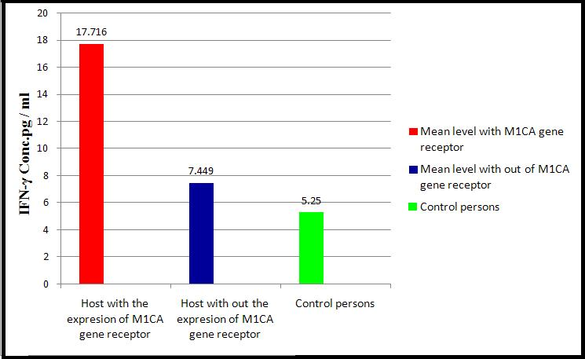

Figure (3): IFN-γ concentration in patients with brucellosis.

The findings of the current work strongly indicated the role of MICA gene receptor in the resistance against Brucella infection which expressed by significant increasing of IFN- γ in patients with MICA gene receptor expression as compared with patients without expression of this receptor.
References:
-Abdussalam, M. and Fein, D.A (1976). Brucellosis as a world problem. Dev. Biol.Stand., 31: 9-23.
-Ahmed, K.; Al-Matrouk, K. A.; Martinez, G.; Oishi, K.; Rotimi, V. O. and Nagatake, T. (1999). Increased serum levels of interferon-gamma and interleukin-12 during human brucellosis. Am. J. Trop. Med. Hyg. 61:425-427.
-Alton, G.G. and Forsyth, J.R. (1998). Brucella. ch.28 In Medmicro. (Internet).
-Arenas, G.N. (2000). Intracellular trafficking of Brucella abortus in J 774 macrophages. Infect Immun, 68(7): p. 4255-4263.
-Araya, L. N.; Elzer, P. H.; Rowe, G. E.; Enright, F. M. and Winter, A. J. (1989). Temporal development of protective cell-mediated and humoral immunity in BALB/c mice infected with Brucella abortus. J. Immunol. 143:3330-3337.
-Al-Nakkas, A.; Mustafa, A. and Stephen, G. (2005). Large-scale evaluation of a single- tube nested PCR for the laboratory diagnosis of human brucellosis in Kuwait. J. Med. Microbiol. 54 p. 727-730.
-Al-Ouqaili, M. T. (2006). Molecular, Bacteriological and Immunological Aspects in the Diagnosis of Human Brucellosis. Ph.D. thesis in medical microbiology. College of Med. Univ. of Baghdad.
-Baviov, H. ;Hogarth,M. ; Mckenzie, F. C. and Cheers. C. (1982). In vivo and in vitro effect of monoclonal antibody to antigen on immunity infection . cell . immune. 71: 127-130.
-Boschiroli, M.L.; Foulongne, V. and O'Callaghan, D. (2001). Brucellosis: a worldwide zoonosis. Curr. Opin Microbiol. 4(1): p. 58-64.

-Baily, G.G.; Krahn, J.B.; Drasar, B.S. and Stoker, N.G. (1992). Detection of Brucella melitensis and Brucella abortus by DNA amplification. J. Tropical Med. Hyg. (95) No. 4 p. 271-275.
- Baldwin CL, Jiang X, Fernandes DM, (1993). Macrophage control of Brucella abortus: influence of cytokines and iron. Trends Microbiol 1: 99–104.
-Bing Mei, Qizhi Luo, Kun Du, Zhi Huo, Fuyan Wang, and Ping Yu1 (2009). Association of MICA gene polymorphisms with Chlamydia trachomatis infection and related tubal pathology in infertile women. Human Reproduction, Vol.24, No.12 pp. 3090–3095, 2009
- Copin, R., P. De Baetselier, Y. Carlier, J. J. Letesson, and E. Muraille.2007.MyD88-dependent activation of B220-CD11b_LY-6C_ dendritic cells during Brucella melitensis infection. J. Immunol. 178:5182– 5191.
-Corbeil, L.B.; Blau, K.; Inzana, T.I.; Neilsen, K.H.; Jacobson, R.H.; Corbeil, R.R. and Winter, A.J. (1988). Killing of Brucella abortus by bovine serum. Infect. Immun. 56: 3251.

-Davidson, M.; Shimshony, A. and Roob, R.M. (1990): Protection of Brucellosis-freeareas from reinfection. In: "Advances of Brucellosis Research". Texas A and M University Press, College Station, Texas, 778434, USA, pp. 407-427.
-FAO. (2009). Brucella melitensis in Eurasia and the Middle East. FAO
Animal Production and Health, WHO and OIE Technical Bulletin.
-Fernandez-Prada, C. M.; Nikolich, M.; Vemulapalli, R.; Sriranganathan, N.; Boyle, S. M.; Schurig, G. G.; Hadfield, T. L. and Hoover, D. L. (2001). Deletion of wboA enhances activation of the lectin pathway of complement in Brucella abortus and Brucella melitensis. Infect. Immun. 69:4407-4416.
-Forbes ,B. A., Daniel, F. S. and Alice, S. W. (2007) . Bailey and Scotts
Diagnostic microbiology. 12 ed. Mosby. Elsevier Company, USA.
- Godfroid, A.; Cloeckert, A.; Liautard, J.; Kohler, S.; Fretin, D.; Walravens, K.; Garin-Bastuji, B. and etesson, J. (2005). From the discovery of the Malta fever’s agent to the discovery of a marine mammal reservoir, brucellosis has continuously been a re-emerging zoonosis. Vet. Res. 36:313–326.
-Golding B, Zaitseva M, H. Golding H, (1994). The potential forrecruiting immune responses toward type 1 and type 2 T cell help. Am J Trop Med Hyg 50 (suppl 4): 33–40.
-Groh V, Bahram S, Bauer S, Herman A, Beauchamp M and Spies T. (1996). Cell stressregulated human major histocompatibility complex class I gene expressed in gastrointestinal epithelium. Proc. Natl Acad. Sci. USA.; 93:12445-12450.
-Groh V, Rhinehart R, Secrist H, Bauer S, Grabstein KH and Spies T. (1999). Broad tumorassociated expression and recognition by tumor-derived gamma delta T cells of MICA. Proc. Natl Acad. Sci. USA.; 96:6879-6884.
-Hoffmann, E.M. and Houle, J.J. (1995). Contradictory roles for antibody and complement in the interaction of Brucella abortus with its host. Crit. Rev. Microbiol. 21: 153.
- Holger Kirsten, Elisabeth Petit-Teixeira, Markus Scholz, Dirk Hasenclever Helene Hantmann, Dirk Heider, Ulf Wagner, Ulrich Sack, Vitor Hugo TeixeiraBernard Prum Jana Burkhardt, Céline Pierlot, Frank Emmrich, François Corneli, Peter Ahnert, (2009). Association of MICA with rheumatoid arthritis independent of known HLA-DRB1 risk alleles in a family-based and a case control study. Arthritis Research and Therapy Vol 11 No 3.
-Heremans, J.F.; Vaerman, J.P. and Vaerman, C. (1963). Studies on the immune globulins of human serum. II. A study of the distribution of anti-Brucella and anti-diphtheria antibody activities among YSS. YIM and YA, globuline fractions. J. Immunol. 91: 11-17.
-Ilian Radka Komitova1, Rumiana Nenova2, Iskra Tomova2, Snejanan Ivanova3Bojkovski4 Maced J. (2010). Med Sci electronic publication ahead of print, published on September 10, as doi:10.3889/MJMS.1857-5773.2010.0138.
-Junko Shojima, a Goh Tanaka,1,a Naoto Keicho, Gen Tamiya, Satoshi Ando, Akira Oka, Yoshikazu Inoue, Katsuhiro Suzuki, Mitsunori Sakatani, Masaji Okada, Nobuyuki Kobayashi, Emiko Toyota, Koichiro Kudo, Akira Kajiki, Hideaki Nagai, Atsuyuki Kurashima, Norihiro Oketani, Hiroshi Hayakawa, Tamiko Takemura, Koh Nakata, Hideyuki Ito, Takatomo Morita, Ikumi Matsushita, Minako Hijikata, Shinsaku Sakurada, Takehiko Sasazuki, and Hidetoshi Inoko (2009). Identification of MICA as a Susceptibility Gene for Pulmonary Mycobacterium avium Complex Infection The Journal of Infectious Diseases 2009; 199:1707–15
-Jiang, X. and Baldwing, C. L. (1993). Effect of cytokines on intracellular growth of Brucellea abortus Infect. Immun. 61:124-130.
- Kerrie ToshMuthuswamy RavikumarJordana Tzenova Bell1Adrian V.S. Hilland Ramasamy Pitchappan (2006). Variation in MICA and MICB genes and enhancedsusceptibility to paucibacillary leprosy in South India. Human Molecular Genetics, 2006, Vol. 15, No. 19 2880–2887
-Ko, J and Splitter, G.A. (2003). Molecular host pathogen interaction in Brucellosis: Current Understanding and Future Approaches to Vaccine Development for Mice and Humans. Clin Microbiol Rev. 16(1): 65–78.
-Marie-Rose Abdo, Pascale Joseph, Jérémie Mortier, François -Turtaut, Jean-Louis Montero, Bernard Masereel, Stephan *Köhler, Jean-Yves Winum (2011). Anti-virulence Strategy against Brucella suis: Synthesis, Biological Evaluation and Molecular Modeling of Selective Histidinol Dehydrogenase Inhibitors. Org Biomol Chem. Apr 1;: 21461427.
- Aurélie Frigoul and Marie-Paule Lefranc. (2005). MICA: Standardized IMGT allele nomenclature, polymorphisms and diseases . Recent Res. Devel. Human Genet., 3(2005): 95-145 ISBN: 81-7736-244-5.
-Mizuki N, Ota M, Kimura M, Ohno S, Ando H, Katsuyama Y, Yamazaki M, Watanabe K, Goto K, Nakamura S, Bahram S and Inoko H. (1997). Triplet repeat polymorphism in the transmembrane region of the MICA gene: A strong association of six GCT repetitions with Behçet disease. Proc Natl Acad Sci USA.; 94:1298-1303.
-Mosman, T. R. and Coffman, R. L. (1989). Th1 and Th2 Cells differentiation patterns of lymphokin secreation to different functional properties . Annu. Immunol. 7:145-150.
M.J. Bravo, J.D. Colmenero, J. Martin, A. Alonsoand A. Caballero (2007). Polymorphism of the transmembrane region of the MICA gene and human brucellosis. Journal compilation 69 (358-360).
-Oliveira, S. C., and Splitter, G. A. (1996). Immunization of mice with recombinant L7/L12 ribosomal protein confers protection against Brucella abortus infection. Vaccine 14:959-962.
-OIE. (2009). Caprine and Ovine brucellosis. Chapter 2. 7. 2. OIE Technical Manual.
-Pizarro-Cerda, et al. (1998). Virulent Brucella abortus prevent lysosome fusion and distributed within autophagosome-like compartments. Infect Immun, 66(5): p. 2387-2392.
-Raya, L. N.; Elzer, N. ; Rowe, G. C. ; Enright, F. M. and Winter ,A. J. (1989). Temborol development of pritative cell medieled and humoral immunity , B. A. C. B. /C. mice lemtor with Brucella abortus . Jornal 143:3330-3355.
-Riley, L. K., and Robertson, D. C. (1984). Ingestion and intracellular survival of Brucella abortus in human and bovine polymorph nuclear leukocytes. Infect. Immun. 46:224-230.
-Ridler, A.L. (2004): An outbreak of Brucella ovis in stud rams prior to sale. Proceeding of the society of sheep and beef cattle. Veterinarian., pp. 221-224.
- RodríguezZapata, M;Matías, MJ.; Prieto, A.;, Jonde, M.A., Monserrat, J.; Sảnches, L.; Reyes , E .;Hera,A.;and Alvarez-Mon,M(.2010).Human brucellosis is characterized by an intense Th1 profile associated with a defective monocyte function .Infection and Immunity .78(7):3272-3279
-Tran, H. T.; Metcalf , D. and Cheers, C. (1995) . Antibacterial activity of peritoneal cells from transgenic mice producing high level Gm- Csf. Immunity. 71: 377-382.
-WHO/OIE/FAO/CDS. (2006). Brucellosis in humans and animals. 7:166.
-Xavier, M.N., Paixmo, T.A., Poester, F.P., Lage, A.P., Santos, R.L. (2008). Pathology, immunohistochemistry, and bacteriology of tissues and milk of cows and fetuses experimentally infected with Brucella abortus. Journal of Comparative Pathology. doi:10.1016/j.jcpa..10.004.
-Yagupsks , P. (1999). Defection of Brucella in blood culture J. clin. Microbiol. 37:3437-344.
Young, E. J.; Borchert, M.; Kretzer, F. L. and Musher, D. M. (1985). Phagocytosis and killing of Brucella by human polymorphonuclear leukocytes. J. Infect. Dis. 151:682-690.
-Young , E . J. (2000). Brucella species. p2386 -2893. In: mandell , G. L. ; Bennett , J E and Donil, (els). Prenceples and practice of infectious disease . 5th ed. Churchill Livingstone Edinburgh.
-Young, E.J. (1995). An Overview of Human Brucellosis. J. Clinical Infectious Diseases. 21: 283-290.
-Zohreh Aminzadeh, Babak Farrokhi, Hossein Akhavan Zanjani, Farshid Aliyari, Zivar Baiati,Fatemeh Navaei and Jamal Mirzaei, (2010). Journal of Infectious Diseases and Immunity Vol.2(3) pp.41- 43.
-Zhan Y, Cheers C, (1993). Endogenous gamma interferon mediates resistance to Brucella abortus infection. Infect Immun 61:4899–4901.
- Zhan Y, Cheers C, (1995). Endogenous interleukin-12 is involved in resistance to Brucella abortus infection. Infect Immun 63:1387–1390.

