Density Functional Theory Calculations of Di-amino naphthalene
H. Ibrahim Abbood
Physics department, College of Science, Babylon University -Iraq.
E-mail: hamedaltamimi95@yahoo.com

Abstract
Theoretical study for calculating molecular structure parameters of naphthalene and its simplest derivatives with electron-donating groups (di-amino) in different positions were performed using density functional theory DFT. Based on B3LYP with 6-31(d, p) basis set was used to investigate the effect on the structure and electronic properties for the positional variation of the amino substituent in the naphthalene by performing Gaussian 03 program. The optimized structures, total energies, electronic states, energy gaps, ionization potentials, electron affinities, chemical potential, global hardness, softness, global electrophilictity, dipole moment and dipole polarizability were calculated. The harmonic vibration frequencies calculated and compared with available experimental data. The results show a decrease in gap energies of naphthalene and the presence of the electron-donating groups leads to easy oxidation.
Keywords: DFT, Ionization potential, electron affinity, energy gap, and IR spectrum.
الخلاصة
دراسة نظرية لحساب معاملات التركيب الجزيئي للنفثالين ومشتقاتها البسيطة مع مجاميع ثنائي أمينو الواهبة للإلكترون في مواقع مختلفة وذلك باستعمال طريقة دالة الكثافة. بالاعتماد على دالة لي-ينك-بار ذات المعاملات الثلاث مع مجموعة أساس 6-31G(d,p) تم فحص تأثير وجود مضافات الآمينو في مواقع مختلفة على الخواص التركيبية والالكترونية للنفثالين وذلك باستعمال برنامج Gaussian 03. تم حساب التراكيب المثلى, الطاقات الكلية, الحالات الالكترونية, فجوات الطاقة, جهود التأين, الألفات الالكترونية, الجهود الكيميائية والاستقطابية للجزيئات قيد الدراسة. تم حساب ترددات الاهتزاز للجزيئات ومقارنتها مع البيانات العملية المتوفرة. بينت النتائج ان فجوة الطاقة للنفثالين تتناقص بوجود المجاميع الجانبية المضافة للحلقة .
Introduction
Aromatic compounds are a large class of conjugated π-electron systems of great importance in many research areas, such as materials science, astrochemistry
[R. Ruiterkamp et al ;2005] and molecular electronics [A. V. Kukhta;2003, H. S. Nalwa;2006, A. V. Kukhta;2005 ]. In the last case molecules with electron-accepting (high electron affinity) and electron-donating (low ionization potential) properties strongly effecting charge-transporting properties of thin ﬁlms based on these materials are often used. In contrast to inorganic materials that consist of covalent or ionic bonds of atoms over the entire solids, organic materials are based on independent molecules and are characterized by weak intermolecular interactions. As a result, characteristics of energy levels and energy transformation for single molecules and condensed media differ a little, while the difference among these characteristics for inorganic compounds is much stronger. Thus, the properties of individual molecules can be used to describe molecular solids in the 1st approximation. Molecular electronics is one of the most important developments in modern-day technology [A. V. Kukhta.et al;2005].
Naphthylamine is the starting material in the dye manufacturing and rubber industry. Naphthylamine can be oxidized by chromic acid into naphthoquinone which is the fundamental ring structure related with vitamin K. Di-amino naphthalene used for determination of selenium. Also used for the detection of nitric oxide via a sensitive fluorometric assay of nitrite (NO₂⁻), di-amino naphthalene used also in the production of polymers and in organic semiconductor [R. T. Morrison and R.N. Boyd;2005].
Organic semiconductors have been portably used since the time of their discovery [C.W. Tang, S.A. Van Slyke;1987] due to their ﬂexibility, low cost [B. Zhenan;2007], and intrinsic properties such as light emission. Some applications of organic semiconductors include: organic light emitting diodes (OLEDs), photovoltaic cells, thin film transistors and biosensors. It is important to mention that most of the materials used for these applications contain conjugated p systems [D. Glossman-Mitnik, et al;2008].
The theoretical study of the electronic structure has proved to be very conducive to predict physicochemical properties of a large number of donor-acceptor systems. Moreover, theoretical calculations such as geometry optimizations are very important for understanding the pathways of electron and/or energy transfer processes in photoactive assemblies [B.A. Selah;2009]. The substituent attached to the molecular framework can enhance or diminish the reactivity. The mechanistic conclusions based on the linear relationships with free energy have been extremely fruitful. Accordingly, changes in reactivity in one reaction series caused by changes in substitution are related to changes in equilibrium or reactivity in another series caused by the same changes in substitution [B.A. Saleha and H.A. Aboodb;2011].
The goal of this work is the theoretical investigation of the effect of substitution groups (di-amino) on structural and electronic properties and the reactivity of naphthalene molecular and the evaluation of their dipole polarizability by DFT method.
Computational details
Figure 1 represents the molecules under study. All the computational studies were carried out using the density functional theory (DFT) methods implemented in the Gaussian 09 suite of programs [M. J. Frisch, et al;2009]. The molecular properties of the compounds have been computed by DFT using the standard 6-31G(d,p) basis set. In the DFT calculations the Lee, Yang and Parr correlation functional [C. Lee, et al;1988] is used together with Becke’s three parameters [A.D. Becke;1988] exchange functional B3LYP. Conformational analysis of the molecules has been performed to have an idea about the lowest energy structures of the species.
The geometry optimization was performed at the B3LYP density functional theory with the same basis set [M. J. Frisch, et al;2009 : A.D. Becke;1993]. Harmonic vibration frequencies were computed at the same level of theory. The hybrid functional B3LYP has shown to be highly successful for calculation the electronic properties such as ionization potentials, electronic states and energy gaps [J. Engelberts, et al;2005: J. C. Santos, et al;2004:J.C.Santos,etal;2005]. The DFT partitions the electronic energy as, where, and are the electronic kinetic energy, the electron nuclear attraction and the electron-electron repulsion terms respectively. The electron correlation is taken into account in DFT via the exchange correlation term, which includes the exchange energy arising from the anti-symmetry of the quantum mechanical wave function and the dynamic correlation in the motion of individual electrons; it makes DFT dominant over the conventional HF procedure [P. Udhayakala, et al;2011].
The geometry optimized structures are obtained by restricted closed-shell formalism and without any symmetry restriction, and vibration analysis for each structure does not yield any imaginary frequencies, which indicates that the structure of each molecule corresponds to at least a local minimum on the potential energy surface [S. Gümüs;2011].
In this investigation, the more relevant electronic potential (IP), electron affinities (EA), chemical potential (μ) it is the negative of electro-negativity (χ), hardness (η), softness (S), electrophilic index (ω) and the electric dipole polarizability (⍺) were calculated. The ionization potential is calculated as the energy difference between the energy of the molecule derived from electron-transfer (radical cation) and the respective neutral molecule; IPv = E_{cation} - E_{n}, where the subscript (v) refers to vertical. The EA was computed as the energy difference between the neutral molecule and the anion molecule: EA = E_{n}-E_{anion} [K. Sadasivam, R. Kumaresan;2011]. The HOMO and LUMO energy was also used to estimate the IP and EA in the framework of Koopmans’ theorem: and [A. Demetrio, et al;2007].
Within the framework of the density functional theory, one of the global quantities is chemical potential (μ), which is measures the escaping tendency of an electronic cloud, and equals the slope of the Energy versus N (number of electrons) curve at external potential ν(r) [M. Oftadeh, et al;2011]:
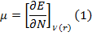
Finite difference approximation to Chemical Potential gives,
(2)
The theoretical definition of chemical hardness has been provided by the density functional theory as the second derivative of electronic energy with respect to the number of electrons N, for a constant external potential ν(r) [M. Oftadeh, et al;2011]:
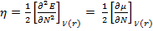 (3)
Finite difference approximation to Chemical hardness gives,
(4)
For Insulator and semiconductor, hardness is half of the energy gap (, and the softness is given as [A. Demetrio, et al;2007]:
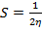 =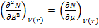 (5)
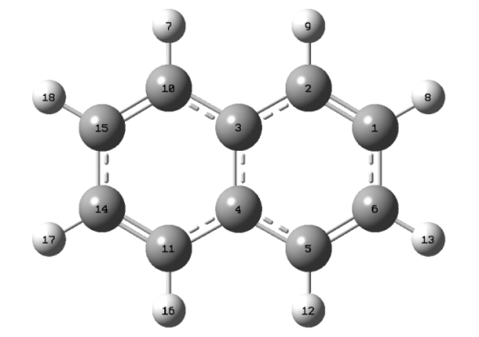
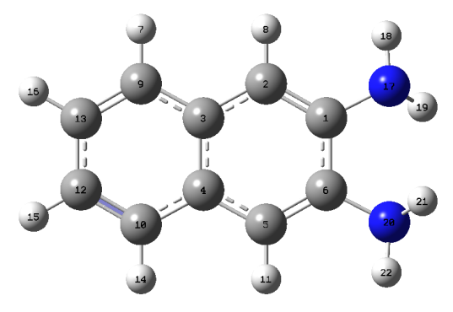
1(naphthalene) 2(1,6-diaminonaphthalene)

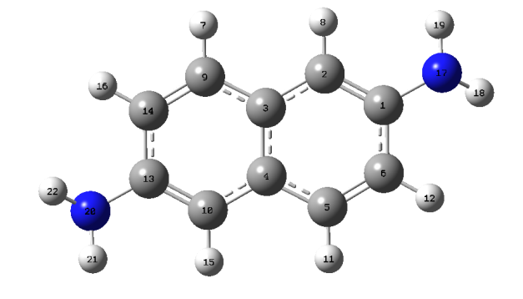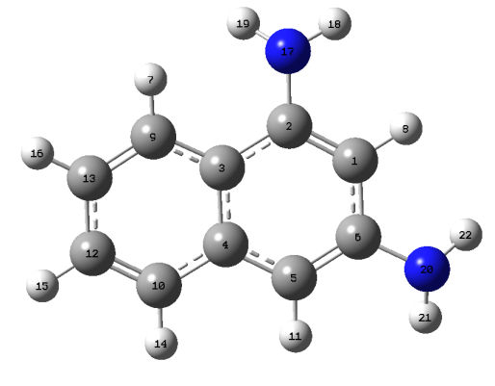
3(1,13-diaminonaphthalene) 4(1,6-diaminonaphthalene)
5(2,5-diaminonaphthalene) 6(2,10-diaminonaphthalene)
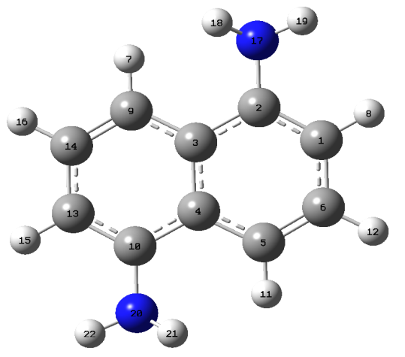
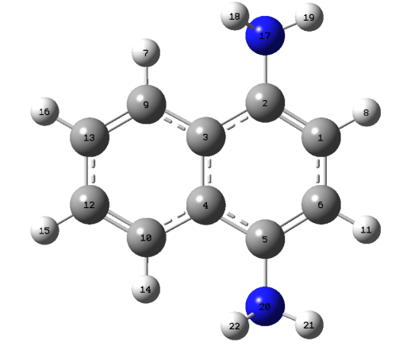
Figure 1. Structures of naphthalene and di-amino naphthalene studied in this work.
Electrophilic index is a measure of energy lowering due to maximal electron flow between donor and acceptor. Electrophilic index (ω) is defined as [S. Gümüs;2011],
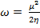 (6)
One of the other global properties is the electric dipole polarizability, which is a measure of the linear response of the electron density in the presence of an inﬁnitesimal electric field F, and represents a second-order variation in the energy [M. Oftadeh, et al;2011] :
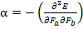 _{a, b} = x, y, z (7)
If some of applied molecules are planar and some are not, it will be useful to report polarizability quantities that are invariant to the choice of coordinate system. One of them is the mean polarizability is evaluated using the equation [S. Gümüs;2011].
(8)
Where are the eigenvalues of the polarizability tensor.

Results and discussion
Molecular geometry
The optimized structure parameters of molecules calculated by DFT-B3LYP levels with the 6-31G( d, p) basis set are listed in the table 1 in accordance with the atom numbering scheme given in figure 1. Table 1 compares the calculated bond lengths and angles for (1 – 6) molecules with those experimentally available from X-ray diffraction data [N. Ketkar et al;1981].
From the theoretical values, we can find that most of the optimized bond angles are slightly larger than the experimental values, due to the theoretical calculations belong to isolated molecules in gaseous phase and the experimental results belong to molecules in solid state.

Table1: Optimized geometrical parameters of molecules, bond length R (), Interaxial angles (degree).
Molecules | bond length | This work | Expt.[24] | Interaxial angles | This work | Expt.[ N. Ketkar et al ;1981]
1 | R(C₃– C₄) | 1.426 | 1.412 | A(C₁₀ – C₃ – C₄) | 120.441 | 119.5
1 | R(C₃ – C₁₀) | 1.430 | 1.422 | A(C₁₅ –C₁₀ – C₃) | 121.804 | 120.2
1 | R(C₁₄ – C₁₅) | 1.445 | 1.417 | A(C₁₀– C₁₅- C₁₄) | 119.098 | 120.5
1 | R(C₁₁ – H₁₆) | 1.400 | 1.392 | A(H₇ – C₁₀ – C₃) | 120.155 | 117.0
1 | R(C₁₅ – H₁₈) | 1.087 | 1.092 | A(H₁₈ –C₁₅– C₁₀) | 118.469 | 119.9

Table 1 (continued)
Molecules | bond length | This work | Expt. | Interaxial angles | This work | Expt.
2 | R(C₁– C₂) | 1.378 |  | A(C₂ – C₁ – C₆) | 119.606
2 | R(C₁ – C₆) | 1.437 |  | A(C₁ – C₆– N₂₀) | 116.860
2 | R(C₁ – N₁₇) | 1.420 |  | A(C₁ – C₂ – H₈) | 119.476
2 | R(C₂ – H₈) | 1.088 |  | A(C₁ –N₁₇ – H₁₆) | 113.145
2 | R(N₁₇- H₁₈) | 1.013 |  | A(H₂₁ –N₂₀ – H₂₂) | 110.370
3 | R(C₁ – C₂) | 1.384 |  | A(C₂ – C₁ – C₆) | 118.689
3 | R(C₉ – C₁₄) | 1.374 |  | A(C₆ – C₁ – N₁₇) | 119.25
3 | R(C₁ – N₁₇) | 1.402 |  | A(C₁ – C₂ – H₈) | 119.877
3 | R(C₂– H₈) | 1.088 |  | A(C₁₃ – N₂₀ – H₂₂) | 114.269
3 | R(N₁₇ -H₁₈) | 1.012 |  | A(H₂₁ – N₂₀ – H₂₂) | 110.885
4 | R(C₁ – C₂) | 1.382 |  | A(C₂ – C₁ – C₆) | 121.722
4 | R(C₉ – C₁₃) | 1.379 |  | A(C₁ – C₂ – N₁₇) | 120.614
4 | R(C₆ – N₂₀) | 1.397 |  | A(C₂ – C₁ – H₈) | 119.390
4 | R(C₁ – H₈) | 1.088 |  | A(C₆ –N₂₀– H₂₂) | 115.030
4 | R(N₁₇–H₁₈) | 1.011 |  | A(H₂₁ – N₂₀ – H₂₂) | 111.609
5 | R(C₁ – C₂) | 1.381 |  | A(C₂ – C₁ – C₆) | 121.604
5 | R(C₁ – C₆) | 1.411 |  | A(C₆ – C₅ – N₂₀) | 121.679
5 | R(C₂ – N₁₇) | 1.410 |  | A(C₉ – C₁₃ – H₁₆) | 119.999
5 | R(C₁₃–H₁₆) | 1.086 |  | A(C₂– N₁₇ – H₁₉) | 117.223
5 | R(N₁₇–H₁₉) | 1.013 |  | A(H₂₁ – N₂₀ – H₂₂) | 109.247
6 | R(C₁ – C₂) | 1.386 |  | A(C₂ – C₁ – C₆) | 120.887
6 | R(C₁ – C₆) | 1.408 |  | A(C₁₃ – C₁₀ – N₂₀) | 120.802
6 | R(C₁₀ -N₂₀) | 1.400 |  | A(C₉ – C₁₄ – H₁₈) | 120.028
6 | R(C₁ – H₈) | 1.087 |  | A(C₂– N₁₇ – H₁₉) | 113.506
6 | R(N₁₇–H₁₉) | 1.012 |  | A(H₂₁ – N₂₀ – H₂₂) | 110.704

Computed Energies
Table 2 shows the values of the total energy and electronic states for the analyzed structures and the energy gap ( of the studied molecules. The total energy for all studied molecules as a linear function of NH₂ side group number adding to the molecule. The final total energy of the product is the collection of total energy of all small molecules which build the product molecule, that means:
E_{tot} ≈ E_{tot} (naphthalene) + n E_{tot} (NH₂) (9)
Where n is the number of NH₂ subgroups.
It is clear that from Table 2, the total energy for all di-amino naphthalene molecules is approximately the same in which this refer to that the total energy is independent on the position of the di-amino radical in the ring, and it is observed that substitution of di-amino groups causes increasing the HOMO and LUMO energy, it is known that the electron donating substituent increasing the LUMO and HOMO energies [P. Ravi, et al;2011], and energy gap decreased. Therefore, the presence of substituent decreases the energy gaps improves the conductivities and also enhances the solubility of these molecules.
The LUMO-HOMO energy gaps of di-amino naphthalene molecules is small than that of the original molecules, with decreasing energy gap, electrons can be easily excited from the ground state [X. Ming-Hua, et al;2008: Z. Wang, et al;2008]. This effect of the side group was the largest in molecule 5 it has energy gap of (3.991eV). The energy gap of naphthalene(4.821eV) is agreements with experiment value (4.45eV). Table 2 shows also the symmetry of study molecules, the molecule 1 is planar with inversion center and have D_{2h} symmetry (high symmetry), and have higher electro-negativity, while molecule 5 is planer and have C_{s} symmetry (low symmetry), and have lower electro-negativity.
Table 2: Total energy, electronic states and energy gap for molecules.
Molecule | Total Energy(a.u) | Symmetry | Electronic States(eV) |  | Energy Gaps (eV)  Our data | Energy Gaps ( eV )  Expt.
Molecule | Total Energy(a.u) | Symmetry | HOMO | LUMO | Energy Gaps (eV)  Our data | Energy Gaps ( eV )  Expt.
1 | -385.905 | D_{2h} | -5.800 | -0.979 | 4.821 | 4.45[A.V. Kuhta;2008]
2 | -496.624 | C₂ | -5.200 | -0.520 | 4.680 | -
3 | -496.620 | C_{i} | -4.646 | -0.600 | 4.046 | -
4 | -496.621 | C₁ | -4.784 | -0.513 | 4.271 | -
5 | -496.616 | C_{s} | -4.604 | -0.613 | 3.991 | -
6 | -496.619 | C₂ | -4.786 | -0.484 | 4.302 | -

Important electronic variables
The properties that are displayed in figures (2) – (7) for each variable are computed by two different ways: The first one being energy-vertical is based on the differences of total electronic energies when an electron is added or removed in accordance with the neutral molecule. The second one is based on the differences between the HOMO and the LUMO energies of the neutral molecule and is known as orbital-vertical (Koopmans’ theorem).
The calculated properties for each variable as shown in figures (2) – (7) clearly reveal that these di-amino naphthalene compounds have a tendency to donate electrons instead of capturing them. The ionization potential for the di-amino naphthalene molecules group is higher than that for the original molecule, but the 5 molecule has the lowest value of ionization potential, this indicates that the di-amino naphthalene molecule needs small energy to become cation comparing with the others. The strength of a donor molecule is measured by its electron affinity which the energy released when adding one electron to LUMO. A donor must have a low EA, adding the radical to the ring leads to reduce the ability of the electron affinity for the molecule; EA for molecule 5 is the lowest, as we see in figure 5. The calculation value of IP, EA and energy gaps for molecules 1 is a good agreement with experimental value 7.439 ± 0.006 eV, - 0.530 ± 0.005 eV[A.V. Kuhta, et al;2008], respectively.
Figure 2 : The calculated ionization potential for molecules under study.

Figure 3: The calculated electron affinity for molecules under study.

Figure 4: The calculated chemical potential for molecules under study.

Figure 5: The calculated absolute hardness for molecules under study.

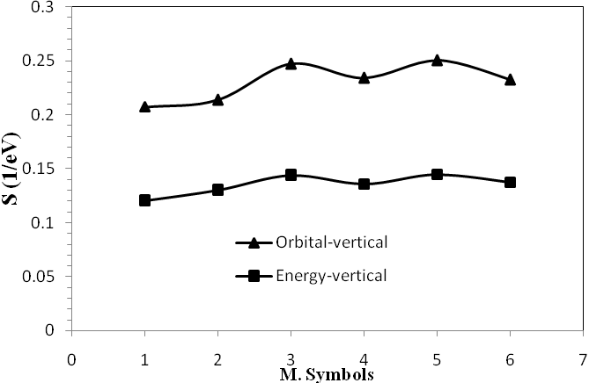
Figure 6: The calculated absolute softness for molecules under study.

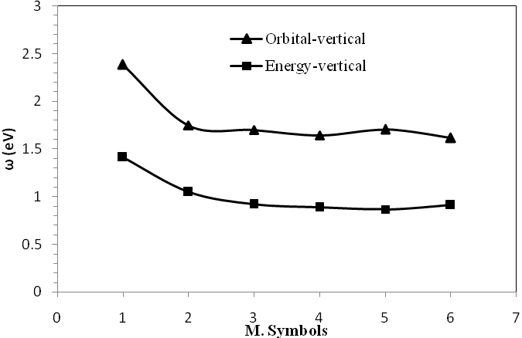
Figure 7: The calculated electrophilic index for molecules under study.

Few interesting observations have been made from the results that are shown in table 3 obtained through the energy-vertical and orbital-vertical methods. The electron affinities computed from the energy of the lowest unoccupied molecular orbital (LUMO) are higher for all study molecules than that of the energy-vertical method. The ionization potential that results from the highest occupied molecular orbital is smaller for all study molecules than that of the energy-vertical method. From the previous investigations, it has been found that for almost all the commonly used exchange-correlation functional such as B3LYP, B3PW91, Koopman’s theorem is not satisﬁed accurately [K. Sadasivam, R. Kumaresan;2008].
The two results obtained by the calculation of electro-negativity and electrophilicities also agreed very well with the difference in the result. This could be the reason for the low hardness values obtained from the orbital-vertical method than from the method of energy-vertical. Koopman’s theorem neglects the relaxation effect by using the frozen-orbital approximation. However, this error is frequently compensated by the oppositely directed error due to the electron correlation effect, neglected in the Hartree - Fock (HF) method. Therefore, the Koopmans’ theorem is a crude but useful and fast approach [U. Salzner, et al;1997]. The behavior of electro-negativity, softness and electrophilic index for the studied molecules shows the magnitude large than these for the original ring, adding the radicals give the molecule more softness.
The molecules dipole moment represents a generalized measure of bond properties and charge densities in a molecule [K. Sadasivam, R. Kumaresan;2008]. Molecule with electron accepter group due to better charge distribution and increasing distance have higher dipole moment [M. Oftadeh, et al;2011], from Table 4 molecule 2 has higher dipole moment (9.5 Debye) .
The results of the calculated polarizability for (1 – 6) molecules in table 3 showed that all substitution groups leads to increase the average polarizability and cause more reactive then the original molecules (1). The molecules 2 and 3 have average dipole polarizability equal 122.463 and 124.260 a.u, they have the highest polarizability and have highest reactivity. This due to the ring delocalizing electron resonance from the phenyl groups [M. Oftadeh, et al;2011].
Table 3: calculated dipole moment μ (Debye), components of ⍺_{i} (i = xx, yy, zz) and average of the dipole polarizability in a.u. for molecules.
molecules | μ | ⍺_{xx} | ⍺_{yy} | ⍺_{zz}
1  2  3  4  5  6 | 0.000  2.247  0.0035  2.904  2.423  2.248 | 154.374  199.617  207.654  184.873  165.502  148.538 | 111.105  126.434  124.664  137.501  150.016  167.261 | 33.242  41.345  40.460  40.512  41.532  41.126 | 99.574  122.463  124.260  120.963  119.017  118.975

Infrared Spectra
The IR spectra of (1- 6) molecules are provided in figure 8. The (C – H) stretching vibrations of aromatic molecules in the region (2900 – 3250) cm⁻¹ which is characteristic region for ready identification of (C – H) stretching vibrations and particularly the region (3100 – 3250) cm⁻¹ for asymmetric stretching and (2900 – 3100) cm⁻¹ for symmetric stretching modes of vibration [K. Sadasivam, R. Kumaresan;2008].
The present work gives the frequency values at 3170, 3180, 3139.45 and 3206 cm⁻¹ for naphthalene which are consistent with experimental results of 3012, 3065, 3106 and 3136 cm⁻¹, and the aromatic molecules frequency has both in-plane (1100 – 1700) cm⁻¹ and out-of-plane (below 1000 cm⁻¹ ) (C – H) bending vibrations, the in-plane vibration for naphthalene calculated at 894.6 cm⁻¹ and 962.48 cm⁻¹ which a good agreement with experimental results 878.3 and 954.9 cm⁻¹, and the out-of-plane (C – H) deformation vibrations calculated at 617.407 cm⁻¹ and 758.48 cm⁻¹ is agreement with experimentally predicted in 603 cm⁻¹ and 726 cm⁻¹[A. L. Mattiode, et al;2005].
It is clear from figure 8 that the IR spectra for di-amino naphthalene molecules characters from the IR spectrum of naphthalene by multiply the vibration mode due to existing of (N – O) , (C – N) bonds, (C = C) stretching and (C – H) stretching, for (2 – 6) molecules the stretching of (C – N) bond has been observed at (1305 – 1410) cm⁻¹ , the (C – H) stretching stay in the region (3100 – 3265) cm⁻¹, the stretching of (C – N) bond has been observed at (1300 – 1410) cm⁻¹ and the stretching of (C = C) bond at the range (1400 – 1500) cm⁻¹, while the bending of (N – O) bond appeared at (1550 – 1685) cm⁻¹. The stretching (N – O) bond for molecules 5 are calculated at 1644.06 cm⁻¹ while the experimental value at 1743 cm⁻¹[27]. The electron density on the aromatic ring was delocalized the presence of the -NO₂, which reduced the strength of (C = C) bond and depending on the position of nitro group. The torsion vibrations appear at very low frequency for (2 – 6) molecules at below 60 cm⁻¹.

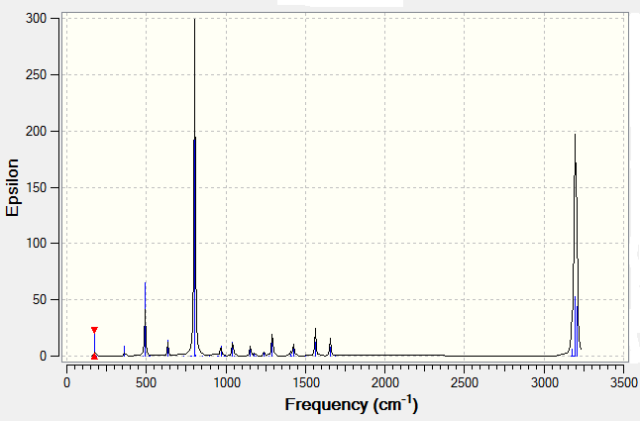
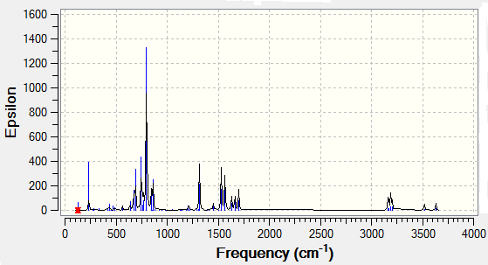

1 2

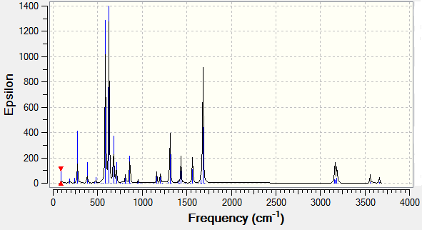
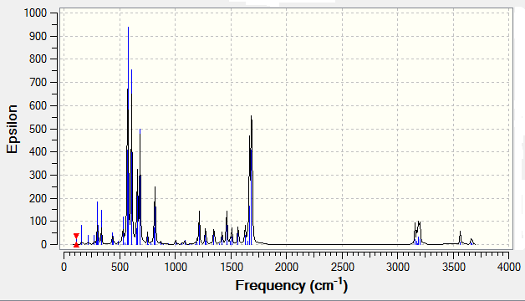

3 3 4
4

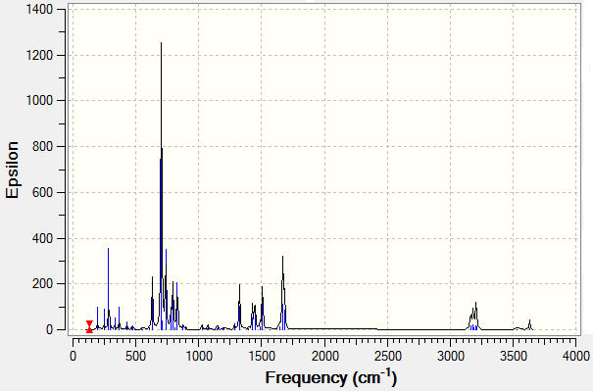
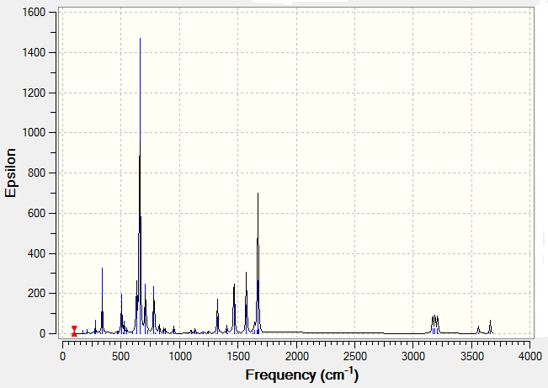

6

5

Figure 8: The calculated IR spectral frequencies for molecules under study.
Conclusions
Density functional theory method has been used in this work to study the geometry optimization and the electronic properties of naphthalene and di-amino naphthalene by using B3LYP functional. Ionization potential, electron affinity, electronegativity, chemical hardness, softness and electrophilic index have been calculated by using two ways: energy vertical method and orbital vertical method, the important conclusions are:
The geometry optimization of naphthalene molecule has been found in a good agreement with experimental data, while for the other di-amino naphthalene molecules it has not been found a reference data. The total energy for all di-amino naphthalene molecules are the same, this is indicates that the total energy for the molecular system is independent on the position of the amino group added to the ring, and the total energy was decreased with this adding.
The energy gap of naphthalene molecule was decreased with adding amino group to the molecule, this is refer to that there are small excitation energies of excited states for the new molecules. The electronic properties calculated for naphthalene molecule are in a good agreement with experimental data. The average polarizability and dipole moments are increased with adding the amino radical and this cause to more reactive molecules than naphthalene. The results of infrared spectrum show a good agreement with experimental data for naphthalene, adding the amino group leads to increasing the vibrational modes, and high stretching vibration wave numbers and its gave suitable positions for amino with carbon atoms in the ring. Molecule 2,6-diaminonaphthalene is the best option for n-type organic semiconductors because of its better HOMO-LUMO ratio and other electronic properties.

References

Becke, A.D. J. Chem. Phys. 98, 5648, (1993).
Becke, A.D. Phys. Rev. A 38, 3098, (1988).
Demetrio A. Da Silva, V. Coropceanu, D. Fichou et al., Phil. Trans. R. Soc. A, 365, 1435-1452, (2007).
Engelberts J., R. Havenith, J. Van Lenthe, L. Jenneskens, P. Fowler, Inorg. Chem, 44, 52266 , (2005).
Frisch M. J., G. W. Trucks, H. B. Schlegel et al., Gaussian 09, Revision A.02, Gaussian, Inc., PA, Wallingford CT. 2009.
Glossman-Mitnik D. , D.Barraza-Jiménez , Alberto Flores-Hidalgo ,Luz María Rodriguez-Valdez, Journal of Molecular Structure: THEOCHEM 863, 99–104 (2008). .
Gümüs, S. Turk. J. Chem., 35, 803-808, (2011).
Ketkar N. et al., J. Mol. Struct. 77, 127, (1981).
Kuhta, A.V. I. N.K. Kuhta, N. A. Kuhta, O. L. Neyra, E. Meza, J. Phys. B: At. Mol. Opt. Phys. 41, 205701, (2008).
Kukhta , A. V J. Appl. Spectrosc., 70, 165, (2003).
Kukhta, A. V. I. N. Kukhta, N. A. Kukhta, O. L. Neyra and E. Meza, J. Phys. B: At. Mol. Opt. Phys. 41, 205701, (2008).
Kukhta, A. V. Mol. Cryst. Liq. Cryst. 427, 71, (2005).
Lee, C. W. Yang, R.G. Parr, Phys. Rev. B 37, 785, (1988).
Mattiode, A. L. D. M. Hudgins, C. W. Bauschlicher Jr. L. J. Allamandola, Advances in Space Research, 36, 156 – 165, (2005).
Ming-Hua, X. SU Ning-Hai, S. WU, Chinese J. Struct. Chem., 27, 421-425, (2008).
Morrison R. T. and R.N. Boyd, "Organic Chemistry", 6th Edition, New York University, USA, 2005.
Nalwa H. S. (Ed), "Handbook of Organic Electronics and Photonics", (Los Angeles, CA: American Scientiﬁc Publishers), 2006
Oftadeh, M. S. Naseh, M. Hamadanian, Computational and Theoretical Chemistry 966, 20- 25, (2011).
Ravi, P. G. M. Gory, S. P. Tewari, and A. K. Sikder, Journal of Energetic Materials, 29, 209-227, (2011).
Ruiterkamp, R. N. L .J Cox, M. Spaans, L. Kaper, B. H. Foing, F. Salama and P.Ehrenfreund, Astron. Astrophys, 2005.
Sadasivam, K. R. Kumaresan, Computational and Theoretical Chemistry 963, 227- 235, (2011).
Saleha, B.A. H.A. Aboodb, R. Miyamotoc and M. Bortoluzzi, J. Iran. Chem. Soc., 8 653-661, (2011).
Salzner, U. J. B. Lagowski, P.G. Pickup, and R. A. Poirier, J. Comput. Chem. 18, 1934, (1997).
Santos, J. C. J. Andres, A. Aizman, P. Fuentealba, J. Chem. Theory Comput, 1, 83, (2005).
Santos, J. C. W. Tiznado, R. Contreras, P. Fuentealba, J. Chem. Phys, 120, 1670, (2004)
Selah, B.A. J. Mol. Struct. THEOCHEM 915, 47, (2009).
Tang, C.W. S.A. Van Slyke, Appl. Phys. Lett. 51, 913, (1987).
Udhayakala, P. T. V. Rajendiran, S. Seshadri, and S. Gunasekaran, J. Chem. Pharm. Res., 3, 610-625, (2011).
Wang, Z. S.WU, J.Serb. Chem. Soc. 73, 1187-1196, (2008).
Zhenan B. (Ed.), Organic Field-Effect Transistors, CRC Press, Abingdon, 2007.

