Some Bayes' Estimators for Laplace Distribution under Different Loss Functions
Huda. A. Rasheed , Nadia, J. Al-Obedy
Al-mustansiriya University: College of Science, Dept. of Math.
Tasnim H.K. Al-Baldawi
University of Baghdad: College of Science, Dept. of Math.

Abstract
The object of the present paper is to compare maximum likelihood estimator and some Bayes' estimators for the scale parameter of Laplace distribution. Two prior information functions are considered; the extension of Jeffreys prior and a new suggested prior which we call the modified inverse gamma prior. Two loss functions were considered: the squared and the modified squared error loss functions. We explore the performance of these estimators numerically under different conditions. The comparison was based on a Monte Carlo simulation study. The efficiency for the estimators was compared according to the mean square error (MSE) and the mean percentage error (MPE).
The results of comparison by MSE and MPE showed that the Bayes' estimator of the scale parameter with the modified inverse gamma prior was the best particularly when 𝜆 is large. The maximum likelihood estimator was the second best estimator. While comparison with respect to loss functions showed that Bayes' estimators under modified squared error loss function gives better results than the squared error loss function.

Key words: Laplace distribution, Loss functions, Jeffreys prior information, modified inverse gamma prior information.

خلاصة
يهدف البحث الى مقارنة مقدرات الارجحية العظمى مع بعض مقدرات بيز لمعلمة المقياس لتوزيع لابلاس. أخذنا بالأعتبار دالتين للاسبقية هما:دالة اسبقية جفريز الموسعة ودالة أسبقية جديدة مقترحة أطلقنا عليها تسمية دالة أسبقية معكوس كاما المحورة. أخذنا بالأعتبار كذلك دالتين للخسارة هما: دالة الخسارة التربيعية ودالة الخسارة التربيعية المعدلة. جرت المقارنة بأستخدام أسلوب مونت كارلو للمحاكاة بأستخدام معياري متوسط مربعات الخطأ (MSE) ومتوسط الخطأ النسبي(MPE) في مقارنة كفاءة المقدرات.
وقد أظهرت نتائج المقارنة ان مقدر بيز ذو دالة الاسبقية المقترحة كان الافضل عند قيم λ الكبيرة وان طريقة الأرجحية العظمى كانت في المرتبة الثانية من حيث الكفاءة. بينما أظهرت نتائج المقارنة بالنسبة لدوال الخسارة أن دالة الخسارة التربيعية المعدلة أعطت نتائج افضل من دالة الخسارة التربيعية.
Introduction
The difference between Maximum Likelihood estimation and Baysian estimation is that in maximum likelihood estimation the parameters are not random variables.
In Bayesian analysis the unknown parameter is regarded as being the value of a random variable from a given probability distribution, with the knowledge of some information about its value prior to observing the data x₁, x₂… x_{n} [Ross (2009)].
Laplace distribution also referred to as the double exponential distribution has wide applications. It can be used to model the difference between the waiting times of two events generated by two random processes. It can also be used to describe breaking strength data, modeling the differences in flood stages, etc. [Krishnamoorthy (2006)].
Julia and Vives-Rego (2008) presented an application of the skew-Laplace distribution to flow cytometry data. Abbasi (2011) has dealt with the aspect of the Bayesian inference of the discrete Laplace distribution; she made comparison between the Bayes' estimator and the maximum entropy estimator for discrete Laplace distribution. Ali,S.(2010) submitted Baysian analysis of simple and mixture of Laplace distribution; he presented an overall comparison using various types of informative and non informative priors under different types of loss functions.
In this study we present comparison of maximum likelihood estimator and some Bayes' estimators for the scale parameterb, of Laplace distribution. It is arranged as follows: Maximum likelihood estimator, Bayes' estimators with the extension of Jeffreys prior and new suggested prior called the modified inverse gamma prior are presented under the squared and modified squared error loss functions. Comparison was made through a Monte Carlo simulation study on the performance of these estimators. The results are summarized in tables and followed by the conclusions.

Laplace Distribution
The classical Laplace distribution with mean zero and variance σ² was introduced by Laplace in 1774. The distribution is symmetrical and leptokurtic [Wu F. (2006)].
This distribution has been used for modeling data that have heavier tails than those of the normal distribution.
Let us consider x_{1,} x_{2, …,} x_{n} to be a random sample of n independent observations from a Laplace distribution having pdf:

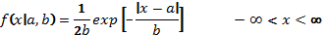 (1)
, b > 0
where a is the location parameter and b is the scale parameter.
The cumulative distribution function is given by:

Maximum Likelihood Estimator
The likelihood function for the Laplace pdf is given by:

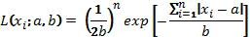

By taking the log and differentiating partially with respect to b, we get:

(2)
Then the MLE of b is the solution of equation (2) after equating the first derivative to zero.
Hence:
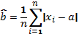

Bayes' Estimators
Bayes' estimators for the scale parameter b, was considered with two different priors and under two loss functions:
The squared error loss function
The modified squared error loss function
Following is the derivation of these estimators:

i) The extension of Jeffreys prior information, which is given by:
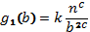 , where k a constant, (3)
The posterior distribution for the parameter b given the data (x₁, x₂… x_{n}) is:
Let
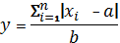
Then the posterior distribution become as follows:

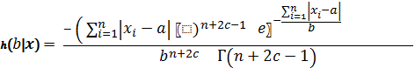 (4)
According to the squared error loss function, the corresponding Bayes' estimator for the scale parameter b of Laplace distribution with the posterior distribution (4) is such that:
where
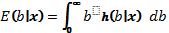 (5)
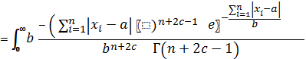db
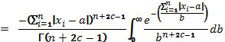
Let
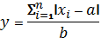
Then

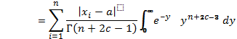
Hence,
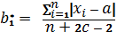 (6)
Now, according to the modified squared error loss function, the corresponding Bayes' estimator for the scale parameter b of Laplace distribution with the posterior distribution (4) is such that:
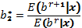
where
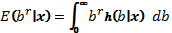 (7)

Substituting (4) in (7), we get:
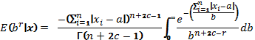
Let
Then
Hence,
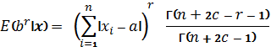 (8)
In the same manner, we find the numerator of as follows:
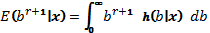
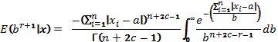
Hence,

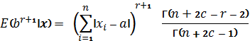 (9)
And from (8) and (9), we get:
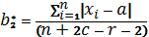 (10)

ii) Modified inverse gamma Prior Information
This is a new suggested prior; we call it modified inverse gamma prior information because of its analogy with the inverse gamma distribution. It is given by:
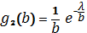 , where 𝜆 > 0 (11)
The posterior distribution for the parameter b given the data (x₁, x₂… x_{n}) is:
Let
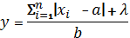
Then the posterior distribution become as follows:
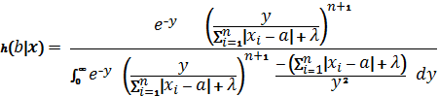
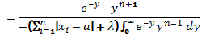

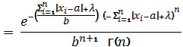 (12)
According to the squared error loss function, the corresponding Bayes' estimator for the scale parameter b of Laplace distribution with the posterior distribution (12) is such that:
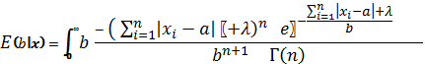db
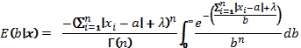
Let
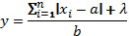
Then
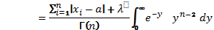
Hence,
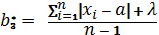 (13)
And finally according to the modified squared error loss function, the corresponding Bayes' estimator for the scale parameter b of Laplace distribution with the posterior distribution (11) is such that:
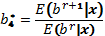

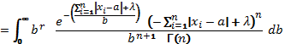

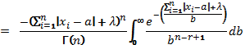
Let
Then

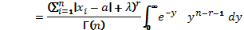
Hence,
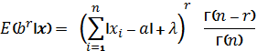 (14)
In the same manner, we find the numerator of as follows:
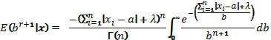
Hence,
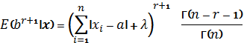 (15)
And from (14) and (15), we get:

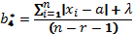
Simulation and Results
In the simulation study, we generated R = 3000 samples of sizes n = 20, 50, and100 from Laplace distribution with b =1, 3. In order to compare the Bayes' estimators under two different loss functions and two priors, we chose the values of the extension of Jeffreys constants; (c = 2, 5) and (r = 1.5, 3), and for the quasi-exponential prior (𝜆=1, 3). After estimating the value of b, comparison was made depending on the calculation of the mean square error (MSE) and the mean percentage error (MPE) as an index for precision to compare the efficiency of each of the five estimators, where:
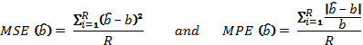
The results were summarized and tabulated in the following tables for each estimator and for all sample sizes.

Table 1: E (b), MSE and MPE of the estimated scale parameter with
b= 1, c = 2, 𝜆 = 3
n | Criteria
 |  |  |  | r=1.5 | r=3 |  | r=1.5 | r=3
20 | E(b) | 0.6924 | 0.6295 | 0.6755 | 0.7289 | 0.8868 | 0.9628 | 1.0553
20 | MSE | 0.1259 | 0.1632 | 0.1351 | 0.1082 | 0.0475 | 0.0423 | 0.0518
20 | MPE | 0.3193 | 0.3746 | 0.3335 | 0.2908 | 0.1831 | 0.1667 | 0.1757
50 | E(b) | 0.6929 | 0.6663 | 0.6860 | 0.7070 | 0.7683 | 0.7925 | 0.8184
50 | MSE | 0.1062 | 0.1224 | 0.1102 | 0.0982 | 0.0661 | 0.0562 | 0.0470
50 | MPE | 0.3077 | 0.3340 | 0.3145 | 0.2940 | 0.2348 | 0.2127 | 0.1904
100 | E(b) | 0.6919 | 0.6783 | 0.6884 | 0.6887 | 0.7292 | 0.7404 | 0.7520
100 | MSE | 0.1010 | 0.1093 | 0.1030 | 0.0968 | 0.0795 | 0.0737 | 0.0681
100 | MPE | 0.3081 | 0.3217 | 0.3116 | 0.3011 | 0.2709 | 0.2597 | 0.2483

Table 2: E (b), MSE and MPE of the estimated scale parameter with

b= 1, c = 5, 𝜆 = 1

n | Criteria
 |  |  |  | r=1.5 | r=3 |  | r=1.5 | r=3
20 | E(b) | 0.6924 | 0.4946 | 0.5226 | 0.5539 | 0.7815 | 0.8485 | 0.9280
20 | MSE | 0.1259 | 0.2714 | 0.2458 | 0.2190 | 0.0825 | 0.0639 | 0.0541
20 | MPE | 0.3193 | 0.5055 | 0.4776 | 0.4467 | 0.2496 | 0.2142 | 0.1911
50 | E(b) | 0.6929 | 0.5973 | 0.6132 | 0.6299 | 0.7275 | 0.7504 | 0.7749
50 | MSE | 0.1062 | 0.1710 | 0.1589 | 0.1468 | 0.0867 | 0.0755 | 0.0647
50 | MPE | 0.3077 | 0.4027 | 0.3868 | 0.3701 | 0.2740 | 0.2522 | 0.2297
100 | E(b) | 0.6919 | 0.6406 | 0.6497 | 0.6589 | 0.7090 | 0.7199 | 0.7311
100 | MSE | 0.1010 | 0.1343 | 0.1281 | 0.1218 | 0.0908 | 0.0848 | 0.0788
100 | MPE | 0.3081 | 0.3594 | 0.3504 | 0.3411 | 0.2911 | 0.2802 | 0.2690

Table 3: E (b), MSE and MPE of the estimated scale parameter with
b= 3, c = 2, 𝜆 = 3

n | Criteria
 |  |  |  | r=1.5 | r=3 |  | r=1.5 | r=3
20 | E(b) | 2.0772 | 1.8884 | 2.0266 | 2.1866 | 2.3445 | 2.5454 | 2.7841
20 | MSE | 1.1333 | 1.4686 | 1.2158 | 0.9740 | 0.7420 | 0.5748 | 0.4871
20 | MPE | 0.3193 | 0.3746 | 0.3335 | 0.2908 | 0.2496 | 0.2142 | 0.1911
50 | E(b) | 2.0787 | 1.9988 | 2.0581 | 2.1211 | 2.1824 | 2.2513 | 2.3247
50 | MSE | 0.9557 | 1.1014 | 0.9920 | 0.8838 | 0.7799 | 0.6791 | 0.5824
50 | MPE | 0.3077 | 0.3340 | 0.3145 | 0.2940 | 0.2740 | 0.2522 | 0.2297
100 | E(b) | 2.0756 | 2.0349 | 2.0653 | 2.0966 | 2.1269 | 2.1596 | 2.1934
100 | MSE | 0.9087 | 0.9834 | 0.9273 | 0.8714 | 0.8176 | 0.7632 | 0.7095
100 | MPE | 0.3081 | 0.3217 | 0.3116 | 0.3011 | 0.2911 | 0.2802 | 0.2690

Table 4: E (b), MSE and MPE of the estimated scale parameter with
b= 3, c = 5, 𝜆 = 1
n | Criteria
 |  |  |  |  | r=1.5 |  | r=3 |  |  | r=1.5 | r=3
20 | E(b) | 2.0772 | 1.4838 |  | 1.5677 |  | 1.6618 |  | 2.2392 | 2.4311 | 2.6591
20 | MSE | 1.1333 | 2.4428 |  | 2.2119 |  | 1.9712 |  | 0.8911 | 0.6918 | 0.5567
20 | MPE | 0.3193 | 0.5055 |  | 0.4776 |  | 0.4467 |  | 0.2766 | 0.2377 | 0.2075
50 | E(b) | 2.0787 | 1.7920 |  | 1.8396 |  | 1.8897 |  | 2.1415 | 2.2092 | 2.2812
50 | MSE | 0.9557 | 1.5388 |  | 1.4304 |  | 1.3211 |  | 0.8483 | 0.7439 | 0.6430
50 | MPE | 0.3077 | 0.4027 |  | 0.3868 |  | 0.3701 |  | 0.2873 | 0.2657 | 0.2433
100 | E(b) | 2.0756 | 1.9219 |  | 1.9490 |  | 1.9768 |  | 2.1067 | 2.1391 | 2.1725
100 | MSE | 0.9087 | 1.2088 |  | 1.1525 |  | 1.0961 |  | 0.8533 | 0.7981 | 0.7435
100 | MPE | 0.3081 | 0.3594 |  | 0.3504 |  | 0.3411 |  | 0.2978 | 0.2870 | 0.2759

Discussion
In general, comparison by MSE and MPE shows that Bayes' estimator for the scale parameter b of the Laplace distribution with the suggested modified inverse gamma prior and under the modified squared error loss function, was the best estimator, particularly when 𝜆 is large.

We can also notice that, in Bayes' estimators, each of MSE and MPE decreases as r increases, but they both get worse as c increases from 2 to 5.
In the comparison between maximum likelihood and Bayes' estimators, results showed that maximum likelihood estimator gave better results than Bayes' estimators only with the extension of Jeffreys prior information.

And finally, comparison of MSE and MPE with respect to the loss functions; results shows for all sample sizes and both priors that Bayes' estimators under the modified squared error loss function gives better results than estimators under the squared error loss function.
References:
Abbasi, N. (2011): "Comparison of Bayes' estimator and Maximum Entropy estimator for discrete Laplace distribution" Int. J. Contemp. Math. Sciences: Vol.6, No. 9, pp 447- 452.
Ali,S. (2010): " Statistical inference foe the simple and mixture of Laplace distribution via Baysian approach", Msc. dissertation;Quaid-l-Azam University.Pakistan Journal of Statistics and Operation Research.
Julia,O. and Vives-Rego, J. (2008): " A microbiology application of the skew-Laplace distribution. SORT 32(2), pp. 141 – 150.
Krishnamoorthy, K (2006):" Handbook of statistical distributions with applications"; Chapman and Hall/ CRC
Ross, M. Sh. (2009):"Introduction to probability and statistics for engineers and scientists", 3rd Ed. Academic Press.
Wu, F. (2008):" Applications of the normal Laplace and generalized normal Laplace Distributions" Msc. thesis, University of Victoria.

