Removal of Cadmium (II) Ion from Wastewater using Natural and Modified myrtus communis leaves
Jameel M. Dhabab , Kadhem A. Hussien , Hiend A. Abbas
Department of Chemistry, College of Science, Al-Mustansyria University, Baghdad,
Abstract
A new simple method was developed for the removal of cadmium ions from wastewater by using natural and modified dried leaves of myrtus communis .The effects of varying adsorbent weight, hydrogen ion concentration, contact time and temperature of adsorption were studied. Optimal conditions were obtained (pH was6, weight of adsorbent was2g, particle size was 300µm, temperature was25°c, contact time was 90 minute and concentration of cadmium ions was 10 mg/L). , in order to compare the results obtained from the natural and modification experiments. The result showed that the natural adsorbent gave about 78.12% removal for Cd(II) at a pH of 6.0 while KMnO₄ modified adsorbent gave 98.06% removal for Cd(II) at the same conditions. The equilibrium data for the adsorption of cd(II) ion on myrtus communis leaves tested using the Freundlich,Temken and Langmuir adsorption isotherms. The Langmuir isotherm was observed more suitable for Cd(II) adsorption on natural myrtus communis leaves , while The Freundlich isotherm was found to be more suitable for Cd(II) adsorption on modified myrtus communis . To evaluate the mechanism of adsorption, pseudo-first order and second order kinetic models were used. The adsorption mechanism was found fit the second order. The thermodynamic parameters were given and showed that ΔH° was endothermic-positive value, ΔG° was found (a spontaneous process-negative value) and ΔS° was found positive value-in KMnO₄ modified adsorbent while ΔH° was exothermic-negative value, ΔG° was found (a spontaneous process-negative value) and ΔS° was found negative value on natural myrtus communis. FTIR was used to identify the activity of adsorption process.
Key words; adsorption, cadmium, Langmuir model, Freundlich model, myrtus communis.

الخلاصة:-
تهدف الدراسة إلى إيجاد طريقة بسيطة لإزالةِ أيونات الكادميومِ مِنْ مخلفات المياه الصناعية (التي تحوي معقدات الكادميوم) باستعمال مسحوق الأوراقِ المُجَفَّفةِ الطبيعيةِ والمعدلة من نبات الياس (Myrtus Communis). تم دراسة الظروف المثالية لعملية الإزالة ( pH=6 , وزن المادة المازة = 2gm , الحجم الحبيبي = 300µm , درجة الحرارة = 25 C° , زمن التماس = 90min , والتركيز الابتدائي لايونات الكادميوم = 10 mg/L ) . تم تطبيق هذه المعطيات على عيناتِ ذات تركيز (50 mg/L) وكانت كفاءة الإزالة بنسبة (78.12% ) باستخدام النبات الطبيعي وبنسبة (98.06%) باستخدام النبات المعدل بمحلول KMnO₄. أثبتت الدراسة الايزوثيرمية انطباق نموذج Langmuir للايزوثيرم في حالة استخدام مسحوق النبات الطبيعي , لكن نموذجَ Freundlich كان الأكثر انطباقاً في النبات المعدل. دُرست حركيات التفاعل بتطبيق قانون المرتبة الأولى الكاذبة إضافة إلى قانون المرتبة الثانية للتفاعل ووُجد أن التفاعل من المرتبة الثانية. بينت الدراسات الثرموديناميكية إن العملية ماصة للحرارة من قيم ΔH° الموجبة , وتلقائية من القيم السالبة لـ ΔG° , بينما دلت القيم السالبة لـΔS° على زيادة العشوائية أو اللاانتظام لعملية الإزالة في حالة النبات الطبيعي بينما كانت العملية باعثة للحرارة في حالة النبات المعدل أو المحور. استخدمت مطيافية الأشعة تحت الحمراء لتشخيص المجاميع الفعالة على السطح الماز المستخدم.

Introduction
The problem of removing pollutants from water is an important process and is becoming more important with the increasing of industrial activities. About 97% of water contamination is generated by chemicals, paper, petroleum and primarily metal sectors (Ankica et al., 2011). Cadmium (Cd) is a toxic heavy metal of significant environmental and occupational concern (Waalkes, 2000). It is introduced into water from smelting, metal plating, cadmium nickel batteries, phosphate fertilizers, mining, pigments, stabilizers, alloy industries and sewage sludge (Zeid et al., 2011). Cadmium has been classified as a human carcinogen and teratogen, impacting the lungs, kidneys, liver and reproductive organs (Sharma, 2008). The harmful effects of cadmium include a number of acute and chronic disorders, such as renal damage, emphysema, hypertension and testicular atrophy. Hence, it is essential to remove Cd (II) from water and wastewater prior to transport to prevent cycling into the natural environment. The most important technologies employed to remove cadmium such as precipitation, ion exchange (Moussavi, 2010), electrolysis, separation by membrane, adsorption (Ahmadpour et al., 2009), etc . But these methods are often prohibitively costly, having inadequate efficiencies at low metal concentration. These constraints have caused the search for alternative methods that would be efficient for metal sequestering. Such a possibility offers a method that uses sorbents of biological origin for removal of heavy metals from aqueous solution based on metal binding capacities of various biological materials of little or no. Now attention have directed towards the use of modified agricultural waste and by-products for the removal of heavy metals from industrial effluent. Some agricultural waste products have been shown to have the potential as inexpensive sorbents. Due to their low cost, after these materials have been expended, they can be disposed of without expensive regeneration (Olayinka et al., 2009),Some studies on the use of adsorbent such as sawdust and teak tree bark, waste tea, coconut shell and dry plants on the removal of metals from aqueous solutions have been reported (Jimoh et al., 2011 ; Hanan et al., 2010). The adsorption capacities of these materials have been shown to be dependent on experimental conditions such as pH, metal concentration and adsorbent loading. The aim of this research is to investigate the use of natural and modified myrtus communis leaves (MC) in the removal of metals from aqueous solutions. Myrtus communis leaves are a low cost adsorbent which is a waste material. Myrtus communis leaves have a high sorption capacity due to its high tannin content (Vahid et al., 2012). The research involved the improvement of the sorption capacity of this low cost absorbent by modification with KMnO₄. The study also involved the examination of experimental conditions such as pH of the solution, temperature, contact time and adsorbent loading on the removal of Cd(II) from aqueous solutions. The Freundlich and Langmuir adsorption isotherms were used to investigate the adsorption process. Kinetic study was also carried out to evaluate the order of adsorption.

Experimental:
Chemical and instrumentation;
Chemicals:
Stock solution; stock solution of cadmium (1000 mg/L) was prepared by dissolving (2.74 gm.) of Analr (99.9%) (Cd (NO₃)₂.4H₂O) (Obtained from Fluka) in (1) liter of distill-deionized water. The resulting solution was diluted to 100 mg/l and standardized against 0.1N EDTA to obtain the exact concentration of cadmium ion. Other chemicals are 0.1 M HCl and NaOH and both solutions were standardized before use. All measurements were triplicate. Blank values were considered and subtracted from all measurements. .
Preparation of natural myrtus communis (MC); MC leaves were collected from gardens of AL-mustansriy University, Baghdad, Iraq. The leaves were extensively washed with deionized water to remove dirt ,dried in an oven at 80Cº for a period of 3hr, then ground and screened to obtain the average particle size 300,500,700µm.The powder was stored in glass bottles.
Preparation of modified myrtus communis; KMnO4 treatment of myrtus communis leaves was carried out by dipping and heating methods. myrtus communis leaves was put into 0.1 M KMnO₄ solution, 5:1 (w/v, g/L) for 22 hour at room temperature. Separate the plant powder by filtration, and then washed with distilled water until the washing was free of color and the final pH of effluent was made 7. Dry the final plant The mixture was heated to 80 C° for 3hr , the sample was cooled to room temperature , ground, and then sieved to (300,500,700) µm and stored in a glass bottle and used for experiments as need.

Instrumentations:
All the following instruments were calibrated by using standard solutions or reference material to obtain the satisfaction:
1- Atomic absorption spectrophotometer used was Shimadzu AA-6200.
2- FT-IR spectrophotometer – Shimadzu.
3-pH meter was Research pH meter Radiometer, Copenhagen, Denmark .
4-Shaker was BS-11 digital, JEIO TECH, Korea.
Procedures:
Preparation of standard solution: Cd (NO₃)₂.4H₂O (Merck) was used for preparation of 1000mg/L of Cadmium ions. Dilute solutions of cadmium (10, 20, 30, 40, and 50mg/l) were prepared from cadmium stock solution.
General Procedure for optimization:Carryout batch adsorption for cadmium concentration(10-50mg/l) with MC powder (0.5-3g) at pH (2-6)using series with Irlenmair flask (50ml),at temperature (25-70°c) and shaking different labeled flask( for 30-120min).finally the concentration of cadmium ions were measured after adsorption by flam atomic spectrophotometric (Shimadzu AA-6200 ) ,calculated values, capacity of adsorbent, thermodynamic constant and percentage removal for MC.
Optimum conditions:In order to obtain maximum removal of cadmium ions optimum conditions have to be used. Such studies are described as follows:
1-Effect of Contact Time: add 50 mg/L of cadmium solution (50mL) to ( 1 g ) of natural and modified of the adsorbent (MC) in to different labeled flask ,fixing the pH at 6 for all measurement . Shake all flasks at constant temperature 25°c for different times (30-120min). After each agitation time, the content of each flask was then filter, the equilibrium concentration of metal in each of the filtrate was determined by using Flame Atomic Adsorption Spectrophotometer. Obtain maximum time for removal of cadmium ions.

2-Effect of pH: Prepare different solutions containing fixed amounts of cadmium ions (50mg/l), fixed volume (50 mL), fixed adsorbent (1g), and fixed time (90min) but varying pH (2-6) using of waste solution of the metal was transferred into different 50 ml Erlenmeyer flask, corked and label. 1.0g each of the adsorbent was weighed into the different labeled flasks and in shaker for different pH (2-6) using0.1N (HCl or NaOH) to adjust the pH meter .determine the concentration after adsorption and obtained maximum pH.

3-Effect of Temperature Same procedure maintained previously used (time, concentration of cadmium, pH, and particle size), but variable temperature (25-70 Cº). Measured the concentration of cadmium ions after adsorption and obtain maximum temperature.
4-Effect of initial concentration Similarly prepare different solutions containing fixed (time, temperature, pH, and particle size), but variable initial concentration (10-50mg/l). Measured the concentration of cadmium ions after adsorption and obtain maximum removal of cadmium.
5-Effect of Adsorbent weight Prepare series of solutions containing fixed (time, temperature, pH, and particle size), but variable amounts of natural and modified adsorbent (0.5-3g). Measured the concentration of cadmium ions after adsorption and obtain maximum adsorbent weight.
6-Effect of particle size Obtain different solutions containing fixed (time, temperature, pH, and weight of adsorbent) but variable of particle size of natural and modified adsorbent (300-700 µm). Measured the concentration of cadmium ions after adsorption and obtain maximum percentage removal.
All calculations of all parameters using the equation below;
q_{e} = V(C_{i}- C_{e})/m… (1) (Elaigwu et al., 2009)
Where q_{e} is the equilibrium cadmium ions sorption capacity (mg/g), V is the suspension volume (l), m is the mass of durian material (g), C_{i} is the initial cadmium ions concentration (mg/l) and C_{e} is the cadmium ions concentration at the equilibrium.
Results and Discussion:
Characterization of Myrtus Communis Leaves (MC)
before subjecting MC for adsorption studies identification functional group was carried out using FTIR spectrophotometer in the range of 400-4000cmas shown in Fig.1.The spectrum displays a number of adsorption peaks (1045.35 and 1230.50 cm); these assigned to alcoholic C-O and C-N stretching vibration (Pretsch et al., 1981). Absorption at ( 2929.67-2856.38 cm) can be assigned to CH and –CH₂ stretching, respectively (Muller, 1976). 1739.67cm⁻¹was found due to keton groups and binding this group with cadmium ions (all these bands due to organic complex for Cd(ІІ).
Optimization of adsorption process: In order to obtain maximum removal of cadmium ions from waste water conditions have to be found , these are ,contact time ,pH , weight of adsorbent , concentration of cadmium , particle size and temperature. The following are procedures for these studies:
Effect of contact time; fix (pH at 6, cadmium concentration at 50mg/L, weight of natural and modified leaves at (1) gm and temperature at (25 c°) . The only variable in this optimization was contact time. Use different times (15- 120 min) carry out batch adsorption of each solution .The results for the effect of contact time on adsorption of Cd(II) ion as shown in Figure2. The results shows that for an initial metal ion concentration of 50 mg/ L for Cd(II) ion, there was a progressive increase in the amount of metal ions bound as the contact time increased for both modified and unmodified MC (Obah, 2009).Furthermore, a comparison of the modified substrate was able to adsorbed more than the unmodified substrate. This was because the functions groups donated proton and made the adsorbent surface become protonated and upon contact with the metal ions, it adsorbed more rapidly. Thus KMnO₄ modification increases the binding capability of the substrate to the metal ion on adsorption (El-Ashtoukhy et al., 2008).

Effect of pH; To find the optimal pH for the effective adsorption of Cd(II) onto MC It was found the uptake of metal ions increased with the increase in pH from 2.0 to 6.0, Figure 3show that. At lower pH values Cd(II) removal was inhibited, possibly as a result of the competition between hydrogen and metal ions on the sorption sites, with an apparent preponderance of hydrogen ions, which restricts the approach of metal cations as in consequence of the repulsive force. As the pH increased, the active sites in MC would be exposed, increasing the negative charge density on the MC surface increasing the attraction of metal ions with positive charge and allowing the adsorption onto the MC surface. In this study, the Cd(II) ions at pH 6.0 would be expected to interact more strongly with the negatively charged binding sites in the adsorption, The decrease in Cd(II) adsorption above pH 6.0 was probably due to the precipitation of Cd(II) ion as cadmium hydroxides and not due to adsorption (Akl, 2012). The percentage of metal removal was78.12% in the case of natural MC while The percentage of metal removal was 94.84 % for modified of MC.
Effect of weight of adsorbent;The adsorbent weight effect on the percent removal at equilibrium conditions was investigated. It was observed in Fig4 that the amount of Cd(II) on( MC)adsorbent varied with varying adsorbent weight. The amount of Cd(II) increases with an increase in adsorbent weight from (0.5 to 3 g). The percentage of metal removal was increased from 30.6 to 59.68% for an increase in MC weight from 0.5 to 3 g at initial concentration of 50 mg/L in the case of natural MC while The percentage of metal removal was increased from 90.52 to 96.04% for modified of MC in the same condition. The increase in the adsorption of the amount of solute is obvious due to increasing MC surface are (Manjeet et al., 2009).
Effect of concentration of cadmium ions;The variation in the amount of metal ion on to the MC leaves with increasing initial metal ion concentration is illustrated in Figures 5. The result showed that the sorption capacity increased with increase in metal ion concentration for both modified and unmodified sample. Although modified substrates was able to bind more Cd(II) ion than unmodified. This is as a result of the incorporation of function group on the adsorbent surface which enhances the binding ability of the sorbent and as such increasing the number of binding sites. Besides, higher initial concentrations lead to an increase in the affinity of the metal ions towards the active sites and so at low concentrations, adsorption sites took up the available metal more quickly Hence any further increase in the concentration of the metal ion will consequently lead to decrease in amount sorbed .The plausible reason for this might be attributed to the fact the adsorption sites of the adsorbent get saturated once it exhausts its binding capability (Jimoh, 2010).

Effect of particle size; The %removal of Cd(II) in various of adsorbent size(300,500.700 )μm. The effect of adsorbent size was studied by using natural and modified adsorbent at 25C° and dispersed in 50 ml of 50 ppm Cd(II) solution. The adsorption process was performed at room temperature and pH 6. The results indicated that the decrease in adsorbent size had an effect on increasing the adsorption capacity of Cd(II) on both natural and modified MC.The increase in adsorption capacity possibly caused by the larger surface area from the smaller adsorbent size. Consequently, the high adsorption capacity occurred when the adsorbent size is small (Saifuddin et al., 2005). The percentage of metal removal was 51.6% in the case of natural MC in 300µm while The percentage of metal removal was 95.02% increased for modified of MC in the same condition.
Effect of temperature; The extent of Cd(II) ion adsorption on natural and modified MC various temperatures is shown in Figure 6. As observed from the figure in the case of modified MC temperature rise therein resulted to an increase in the removal of the metal as expressed as a percentage. The enhancement of the adsorption capacity when temperature is increased could be due to increased mobility and diffusion of ionic species (Bull, 2008). Since diffusion is an endothermic process, it would be expected that an increased solution temperature would result in the enlargement of pore size causing the micro-pores to widen and deepen and create more surface for adsorption . removal efficiency was 98.06% for modified MC while in natural MC The increase of biouptake with decreasing temperature had confirmed the exothermic nature of biosorption process which the desolvaton of the sorbing and the change of the pore size (Mohammad et al., 2010).Removal percentages of Cd (II) ion on natural MC at an initial concentration of (50) ppm and at pH=6 (73.08%).

Adsorption models
Studies of adsorption isotherms are essential for the description of how a sorbate distributes itself between the liquid phase and the solid phase, and are useful to optimize the experimental conditions for obtaining maximum sorbate uptake (Emmanuel et al., 2007). Three different common models of isotherm were studied (Langmuir, Freundlich and Temkin isotherms).
The Langmuir model (Langmuir, 1918) was applied to the equilibrium uptake data obtained for sorption of Cd(II) ions from their solutions, Langmuir isotherm equation (Jamil et al., 2010):
q_{e} = (q_{max}bC_{e})/(1+bC_{e})………………(2)
And second model is Freundlich isotherm which is given in equatin bellow;
q_{e} = K_{F} C_{e}……………….(3)
Where q_{e} and q_{max}are the equilibrium and maximum sorption capacities (mg/g biosorbent),C_{e} is equilibrium concentration (mg/l solution), b is the equilibrium constant, K_{F} and n are Freudlich constants characteristic of the system . Disobeyed above equations another model is also used which gives more elaborated results (Temkin isotherm)
; Which is mentioned in the following equation;
Q_{e} =B₁lnK_{t} + B₁lnC_{e}……… (4)
Where
B₁ =RT/b…………….. (5)
The adsorption data can be analyzed according to equation (4). A plot of q_{e} versus lnC_{e} enables the determination of the isotherm constants K_{T}andB₁. K_{T}is the equilibrium binding constant (l/mol) corresponding to the maximum binding energy and constant B₁ is related to the heat of adsorption.
The experimental data and Fig( 7,8)could fit the Langmuir isotherm better than the Freudlich isotherm on natural MC while Freudlich isotherm fit better than the the Langmuir isotherm on modified MC .
Adsorption kinetics: Various models have been used to analyze the kinetics of the sorption process. The pseudo-first-order rate equation of the Lagergrenis, one of the most widely used for the biosorption of solutes from a liquid solution (Elaigwu et al., 2009 ; Yu et al., 2007) and is represented as
ln (1-q_{t}/q_{e})= -k₁t……………. (6)
Another model for the analysis of biosorption kinetics is pseudo-second-order. The rate law for this system is expressed as
t/q_{t} = (1/k₂q_{e})+(t/q_{e})……(7)
Where q_{t} and qe are the grams of solute sorbed/g biosorbent at any time and at equilibrium, respectively, and k₁ and k₂ are the rate constants of pseudo-first-order sorption and pseudo-second-order sorption, respectively.
Pseudo first order and pseudo second order kinetics models were tested, and the results shows that the pseudo second order obtained the better fit for both natural and modified MC (k 0.624 andR² 0.975,k 0.41 and R² 0.993) for natural and modified MC respectively. The rate of adsorption process is shown in Figure9. The equilibration time showed a fast adsorption rate at the first 15 min of the sorbate-sorbent contact time. This was a larger surface area of the adsorbent which was available for the adsorption of the cadmium ions. This result was in accordance with those extensively reported in the literature (Argun et al., 2007).

Calculation of thermodynamic parameters
The value enthalpy ΔH° and entropy ΔS°_were calculated from the slope and intercept of the linear Van’t Hoff plot, respectively, using the relation:

ΔG°=-RT ln K ………….(8)
Log K= (ΔS°/2.303R)-(ΔH°/2.303 RT) ………… (9)
ΔG°=ΔH°- TΔS° …………. (10)
K is the equilibrium constant, T is the absolute temperature and R is the gas constant the rate of adsorption process is shown in Figure10. The negative values of ΔH° on natural MC indicate that the process is exothermic on natural MC but the positive values of ΔH° indicate that the process is Endothermic on modified MC. On the other hand, the values of ΔH° are within the range of physiosorption process. The negative values of ΔG° Table (1) show the adsorption is favorable and spontaneous, on the other hand the positive and weak values of ΔG° indicates that the process is feasible but non spontaneous especially at higher Cd(II) concentration and temperature. The negative values of ΔS° indicate that the molecules of the adsorbent are highly ordered at the liquid solid interface (Israa, 2010).

Application of natural and modified MC
The proposed method was applied for waste water taken from factories of batteries, cement and Babylon batteries (exist near Baghdad), and in applying this method complete removal of cadmium was achieved (100% removal) this fact show in Table (2). This percentage is expected because our method is able to remove 78.12% of 50 mg/l cadmium on the natural MC and98.06% on the modified MC, therefore the efficiency of removal of such concentration much lower of 50mg/l, indicates that existed method is very potential.
Conclusions:
The present study revealed that natural and KMnO₄-modified MC could be employed as a cheap and effective adsorbent for the removal of Cd(II)from aqueous solutions. KMnO4 treatment changed the pore size distribution, introduced MnO2, produced more acidic and basic groups, and improved the adsorption capacity. The adsorption of Cd(II) ion from aqueous solutions onto MC-KMnO4 was found to be dependent on the solution temperature. Equilibrium data agreed well with Freundlich isotherm model while natural MC agreed with Langmuir isotherm and the adsorption kinetics could be predicted by pseudo-second-order kinetic model.

Table (1) : the thermodynamic parameters for adsorption process with natural and modified adsorbents
Adsorbent | Temperature  K° | ΔH°  KJ.mole⁻¹ | ΔG°  KJ.mole⁻¹ | ΔS°  KJ.mole⁻¹.K⁻¹
Natural myrtus  communis | 303 | -11.82 | -2.34 | -32.08
Modified myrtus communis | 303 | 30.97 | -6902.4 | 124.29

Table (2): practical applications of removal of cadmium ions from Iraqi factories wastewater by using of natural and modified myrtus communis leaves as adsorbents.
Factory | Optimum conditions |  |  |  |  | Conc. before treatment (mg/L) | Conc. after treatment (mg/L) | R%
Factory | pH | Contact time (min.) | Temperature (C°) | Weight of adsorbent (gm) | Particle size (µm) | Conc. before treatment (mg/L) | Conc. after treatment (mg/L) | R%
Babylon batteries | 6 | 60 | 30 | 1 | 300 | 0.041 | 0.0 | 100
Kufa cement | 6 | 60 | 30 | 1 | 300 | 0.112 | 0.0 | 100
Babylon tiers | 6 | 60 | 30 | 1 | 300 | 0.040 | 0.0 | 100

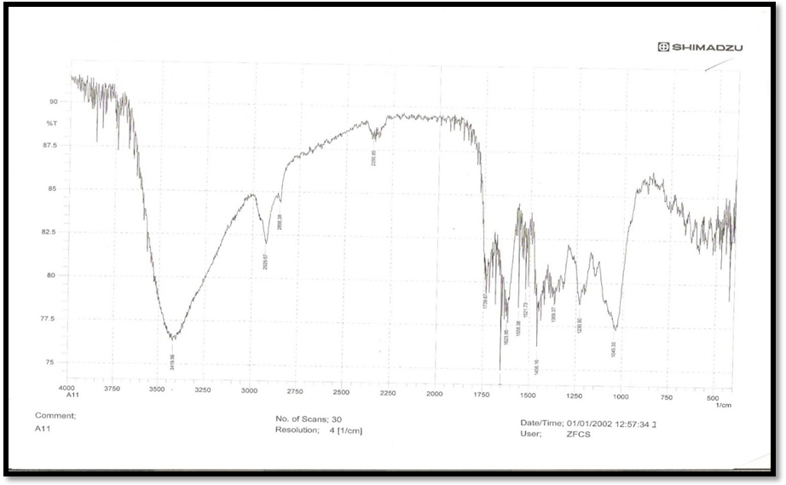
Fig (1)FTIR Of Myrtus Communis leaf powder

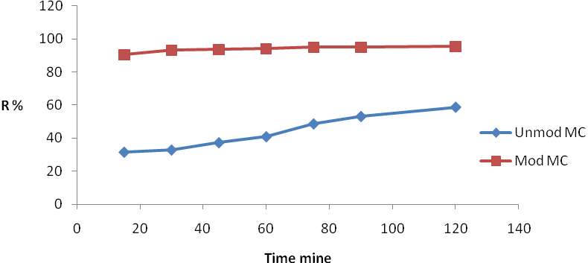
Fig (2) Effect of contact time of adsorption of Cd(II) on unmodified and modified MC

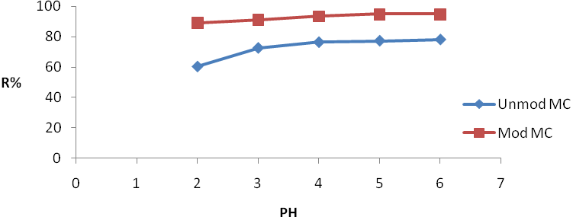
Fig (3) Effect of pH of adsorption of Cd(II) on unmodified and modified MC

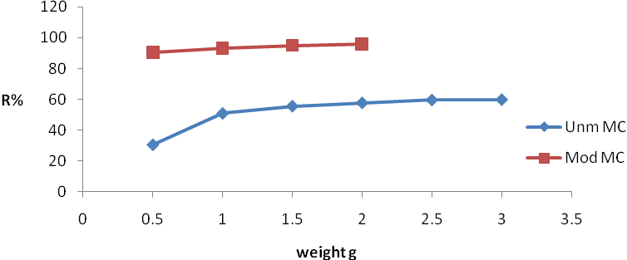
Fig (4) Effect of adsorbent weight of adsorption of Cd(II) on unmodified and modified MC

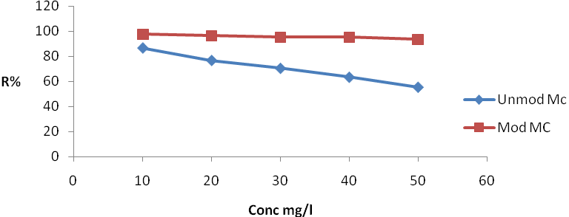
Fig (5) Effect of initial concentration of adsorption of Cd(II) on unmodified and modified MC
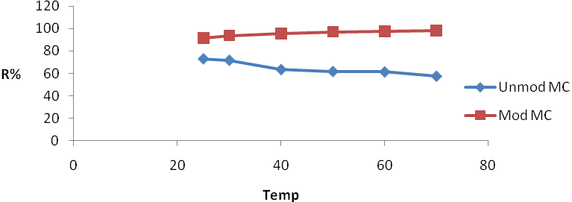
Fig (6) Effect of Temptature of adsorption of Cd(II) on unmodified and modified MC

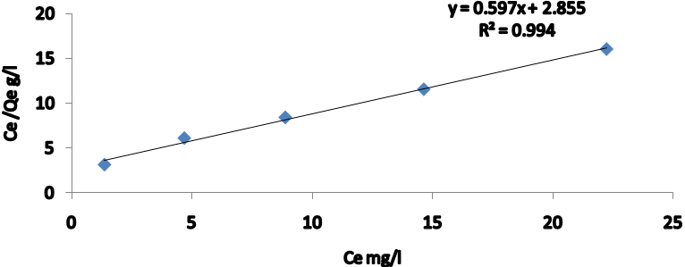
Fig(7) langmuir isotherm for the adsorption of Cd(II) ion on natural MC at25c°under optimum condition

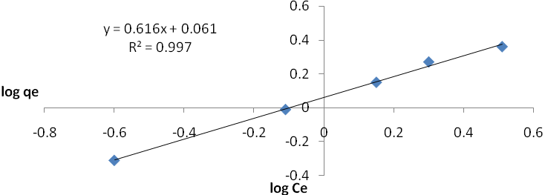
Fig(8) Freundlich isotherm for the adsorption of Cd(II) ion on modified MC at 25c°under optimum condition

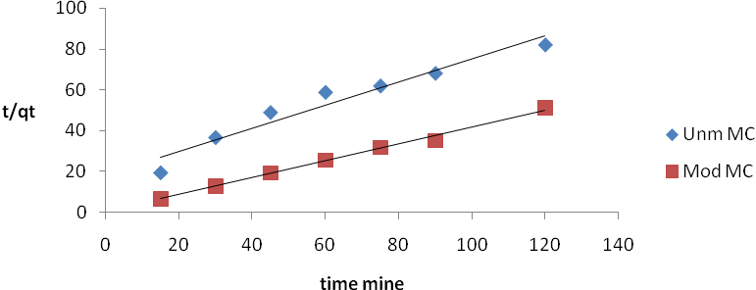
Fig( 9) second order for adsorption process with natural and modified MC as adsorbent

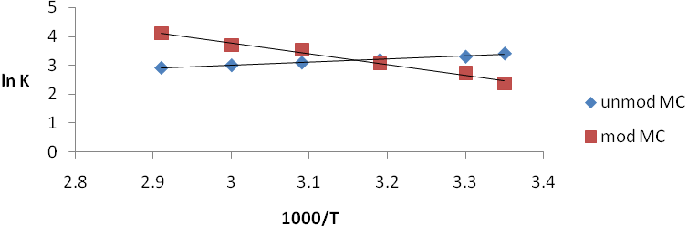
Fig(10) plot of Van,t Hoff equation for adsorption process with natural and modified MC as adsorbent

References
A.Ahmadpour,M.Tahmasbi,T.Rohani Bastami ,J,Amel Besharati, 2009, "Rapid removal of cobalt ion from aqueous solution by almond green hull", Journal of Hazardous Materials ,166 925-930.
Akl M. Awwad and Nidà M. Salem,2012, "Biosorption of copper (II) and lead (II) ions from aqueous solutions by modified loquat (Eriobotrya japonica) leaves (MLL)", Journal of Chem. Eng. And Materials Science, 3(1), 7-17.
Ankica R, Jadrakan M and Anita S, 2011 "Removal of Ni(II)from aqueous solution by low cost adsorbent", ISSN 1848-0071.
Argun, M.E., Dursun, S., Ozdemir, C. and Karatas, M., 2007, "Heavy metal adsorption by modified oak sawdust: Thermodynamics and kinetics", Hazard Mater. 141:77-85.
Bull. Chem. Soc. Ethiop, 2008, "Removal of lead(II) ions from aqueous solution using activated carbon from Militla Ferruginea Plant leaves", 22(3), 349-360. ISSN 1011-3924.
E.-S.Z. El-Ashtoukhy, N.K. Amin, O. Abdel wahab, 2008, "Removal of lead (II) and copper (II) from aqueous solution using pomegranate peel as a new adsorbent", 162–173.
Emmanuel KA, Romaraju KA and Somasekhara R, 2007, "Removal of Mn(II) from aqueous solutions using Bombax malabarium fruit shell substrate", Elec. J. Chem. 4 (3) 419-427.
G. Moussavi, B .Barikbin, 2010, "Biosorption of chromium (VI) from industrial waste water on to pistachio hull waste biomass", chemical Engineering Journal ,162, 893-900.
Hanan E. Osman, Reham K. Badwy, Hanan F. Ahmad, 2010, "Usage of some Agricultural by-Products in theremoval of some heavy metals from industrial waste water", Journal of Physology 2(3): 51–62.
ISRAA G. ZAINAL, 2010, "Biosorption of Cr(VI) from Aqueous Solution Using New Adsorbent Equilibrium and Thermodynamic Study", Journal of Chemistry, ISSN: 0973-4945.
Jamil Anwar , Umer Shafique , Waheed-uz-Zaman , Muhammad Salman , Amara Dar , Shafique Anwar, 2010, "Removal of Pb(II) and Cd(II) from water by adsorption on peels of banana", journal homepage, Bioresource Technology, 101, 1752–1755.
Jimoh Oladejo Tijani, Muriana Musah and Izuelumba Blessing, 2011, "Sorption of Lead (II) and Copper (II) ions from Aqueous Solution by Acid Modified and Unmodified Gmelina Arborea (Verbenaceae) Leaves", Journal of Emerging Trends in Engineering and Applied Sciences (JETEAS) 2 (5):734-740.
Jimoh T, 2010, "Pre-concentration and Removal of Heavy Metals from Aqueous Solution by African Spinach(Amaranthus hybridus L) stalk and Pawpaw (Carica papaya) seeds",
Manjeet Bansal, Diwan Singh, V.K.Garg and Pawan Rose, 2009, "Use of Agricultural Waste for the Removal of Nickel Ions from Aqueous Solutions Equilibrium and Kinetics Studies", InternationalوJournal of Civiland Environmental Engineering,
Mohammad, M., Maitra, S., Ahmad, N., Bustam, A.,Sen, T.K. & Dutta, B.K, 2010, "Metal ion removal from aqueous solution using physicseed hull", J. Hazard. Mater, 179(1-3).
Muller .K.,andPregosin,P.SFourier Transform, 1976, NM/EA Practical Approach.
O. K. Olayinka, O. A . Oyedeji and O. A. Oyeyiola, 2009, "Removal of chromium and nickel ions from aqueous solution by adsorption on modified coconut husk", Journal of Environmental Science and Technology Vol. 3 (10), pp. 286-293.
Oboh I, Aluyor E, Thomas A, 2009, "Biosorption of heavy metal ions from aqueous solution using a biomaterial", Leonardo Journal of Sciences, 14: 58-65.
Pretsch ,E.,Clem ,T.,Seihl,J.,andSimon,W, 1981, "Spectra Data for Structure Determination of organic Compounds", Berlin:Springer-Verlag.
S. E. Elaigwu, L. A Usman ,G. V. Awolola, G. B. Adebayo, R. M. K. Ajayi, 2009, "Adsorption of Pb(II) fromAqueous solution by Activated Carbon prepared from Cow Dung" :Adv.in.Appl.Sci.,3(3):442-446.
Saifuddin M, Nomanb H., Kumaran P, 2005, "Removal of heavy metals from industrial waste water using chitosan coated oil palm shell charcoal", Electronic Journal of Biotechnology, 8(1): 20-30.
Sharma, Y.C., 2008, "Thermodynamics of removal of cadmium by adsorption on indigenous clay", 145, 64–68.
Vahid R.,Sharareh N.,and Ahmeneh T.,Essential, 2012, "oil chemical composition changes affected by leaf ontogeny stages of myrtle (Myrtus communis L.)" ,Int.J.Med.Atom.Plants,ISSN 2249-4340 Vol.2,No.1,pp.114-17.
Waalkes, M.P.,2000, "Cadmium carcinogenesis in review" J. Inorg. Biochem,79, 241–244.
Yu, L., Tong, M., Sun, X. and Li, B, 2007, "Cystine modified biomass for Cd (II) and Pb (II) biosorption" Hazard Mater, 143:277-284.
Zeid A. Al Othman, Ali Hashem and Mohamed A. Habila, 2011, "Kinetic, Equilibrium and Thermodynamic Studies of Cadmium (II) Adsorption by Modified Agricultural Wastes", ISSN 10443-10456.

