Finding Accurate And Comprehensible Knowledge Discovery In Database Model
Abbas M. AL-Bakry
Collage of Computer Technology, Babylon University, Iraq.

Abstract
Available data in scientific fields mainly consist of huge datasets which gathered by a different techniques. These data are saved in much diversified and often incompatible repositories, such of these data are in bioinformatics, geoinformatics, astroinformatics and Scientific World Wide Web sites. From the other hand, the lack of reference data is very often to give a poor performance of learning. One of the key problems in supervised learning is due to the insufficient size of the trained dataset. Therefore, we suggest developing a theoretical and practical valid tool for analyzing small of the data sample which remains as a critical and challenging issue for the researches. In this work we suggest to design and develop instructions and tools for knowledge discovery from any type of database domain, based on the state of the art information. The proposed method to construction data, determining the best features for each dataset, generating association rules then classifying and simplifying these rules.
الخلاصة
ان البيانات المتوفرة في الحقول العلمية تتكون كم هائل من القيود والتي يتم جمعها بتقنيات مختلفة. ان هذة البيانات تحفظ بطرق غير مناسبة ومن الأمثلة على هذه البيانات ( المعرفية الحيوية والبيانات الجغرافية وايضا مواقع الشبكة العنكبوتية). ومن جانب اخر النقص في البيانات المرجعية يعطي كفائة ضعيفة للتعلم. ان المشكلة الرئيسيه في عملية التعلم بوجود المشرف يعود الى عدم كفاية البيانات المدربه. لذا تم اقتراح تطوير اداة نظرية وتطبيقية لتحليل البيانات الصغيرة والتي مازالت تمثل تحدي في المجال البحثي. ان هذه الورقة تمثل اقتراح لتصميم وتطوير ادوات وايعازات لأستكشاف البيانات من قواعد البيانات المختلفة وذلك بالأعتماد على المعلومات المهمة. الطريقة المقرحة هي في هيكلة البيانات و تحديد افضل الصفات لكل قيد بيانات وتوليد القواعد الموزعة ومن ثم تصنيف وتبسيط مجموعة القواعد الناتجة.
Key words: Knowledge Discovery, Data sets, GPDCM, Random Forest.

1. Introduction
Collection and store various types of datasets are continually increasing, the demands for advanced techniques and tools to understand and make use of these large data keep growing, there is no existing field is capable of satisfying the needs. Data Mining and Knowledge Discovery, which utilizes methods, techniques, and tools from diverse disciplines, emerged in last decade to solve this problem. It brings knowledge and theories from several fields including databases, machine learning, optimization, statistics, and data visualization and has been applied to various real-life applications. Even though data mining has made significant progress during the past fifteen years, most research effort is devoted to developing effective and efficient algorithms that can extract knowledge from data and not enough attention has been paid to the philosophical foundations of data mining. Knowledge Discovery in Databases (KDD) is the non trivial process of identifying, novel, potentially useful and ultimately understandable patterns in the data [Usam96]. KDD process is an interactive and iterative multi-step process which uses six steps to extract interesting knowledge according to same specific measures and thresholds, these steps include (data selection, clearing, enrichment, coding, data mining and reporting)[ Mann97]. These steps are extended by [Mitr02] to include ( Developing, creating, data cleaning and preprocessing, data reduction, choosing the data mining task, choosing the data mining algorithm(s), data mining, interpreting mined patterns and finally consolidating discovered knowledge). ata mining is not just a single method or single technique but rather a spectrum of different approaches which searches of patterns and relationships of data [Mitr03].
Data mining is concerned with important aspects related to both database techniques and AI/machine learning mechanisms, and provides an excellent opportunity for exploring the interesting relationship between retrieval and inference/reasoning, a fundamental issue concerning the nature of data mining.Data mining is becoming more widespread every day, because it empowers companies to uncover profitable patterns and trends from their existing databases. Companies and institutions have been spent millions of dollars to collect megabytes and terabytes of data but are not taking advantages of the valuable and actionable information hidden deep within their data repositories. Companies that do not apply these techniques are in danger of falling behind and losing market shares because their competitors are used data mining and are thereby gaining the competitive edge [Kona00]. We propose Genetic Programming Data Construction Method (GPDCM) to pre-process insufficient size of database, by using three different types of genetic programming crossover (node crossover, branch crossover and mixed crossover) apply in parallel way. After that, reduction diminution of dataset by Principal Component Analysis(PCA)[ Jeri08] that used to find best features from these available in the database after filtering their(i.e., after performing pre-processing of both types of database “huge” and “insufficient size “).Then training the FP-Growth algorithm[Xind09, DANI06] (association data mining algorithm) to generation association rules from the best features, where Fp-growth can be define as powerful computational tools in a generation association rules compare with a priori algorithm base on FP-tree. After that, perform the matching between association rules and their class base on ad-boost. And finally, we apply the simplification procedure of the classification base on association rule (CARBase).
2. Current Status
Nomura and Miyoshi, 1998 [Nomu98] proposed an automatic fuzzy rule extraction method using the hybrid model of the FSOM and the GA with numerical Chromosomes.
McGarry, Tait, Wermter, and MacIntyre, 1999 [McGa99] showed that the weights and cluster centers could be directly interpreted as antecedents in a symbolic IF..THEN type rule.
Mitra S. and Sankar Pal, 2000 [Mitr00] described a way of designing a hybrid decision support system in soft computing paradigm for detecting the different stages of cervical cancer.
Sankar Pal, Mitra S. and Mitra P., 2001 [PalS01] presented methodology that described for evolving Rough-Fuzzy Multi layer perceptron with modular concept using a genetic algorithm to obtain a structured network suitable for both classification and rule extraction.
Isao Okina., 2002[Isao02] examine the approach of using causal network (CN) model for extraction of uncertain knowledge. Ken McGarry, 2002 [McGa00] presented the results of ranking and the analysis of rules extracted from RBF neural networks using both objective and subjective measures. The interestingness of a rule can be assessed by a data driven approach.
Hussein K.,2002[Huss00] suggest algorithm to discover terminated item sets and explain how you can maintenance to terminated item sets to extract dynamic rule miner.
Mutthew G. and Larry B., 2003 [Mutt03] describe a way of feature construction and selection using the traditional genetic programming, genetic algorithm and stander c4.5 on number of databases to improve the classification performance of the well-known induction algorithm c4.5.
Nian Yan., 2004[Nian04] introduced the classification of data mining approaches and focused on back propagation neural network and its enhanced applications. The multilayer neural network has been applied in building the classification model.
Malone, McGarry K., and Bowerman C., 2004 [Malo04] demonstrated the use of ANFIS to optimize expert’s opinions. The ANFIS model offers the advantage of enabling use of initially approximate data in an effective manner whilst, following training, allowing fuzzy rules to be extracted which represent the optimized fuzzy membership functions.
Malone J., McGarry K., Bowerman C. and Wermter S., 2005 [Malo05] have proposed a technique for the automatic extraction of rules from trained data sets.
Mahdi A.,2005[Mahd05] suggest a techniques which can discovery knowledge from any database via soft computing techniques which involve fuzzy set, neural network and genetic algorithm by build DBRule Extractor system.
Georgios K, Eleftherios K and Vassili L., 2006[Geor06] Proposed a web search algorithm aims to distinguish irrelevant information and to enhance the amount of the relevant information in respect to a user's query. The proposed algorithm is based on the Ant Colony Optimization (ACO) algorithm.
Jiaxiong Pi., 2007[Jiax07] explore the relationship by examining time series data indexed through R*-trees, and study the issues of (1) retrieval of data similar to a given query (plain data retrieval task), and (2) clustering of the data based on similarity (data mining task). Along the way of examination of our central theme, we also report new algorithms and new results related to these two issues. We have developed a software package consisting of a similarity analysis tool and two implemented clustering algorithms: K-Means-R and Hierarchy-R. .
Ulf Johansson., 2007[UlfJ07] Use two novel algorithms based on Genetic Programming. The first algorithm named GEMS is used for ensemble creation, and the second G-REX is used for rule extraction from opaque models. The main property of GEMS is the ability to combine smaller ensembles and individual models in an almost arbitrary way.
Wen Xiong and Cony Wang., 2009[WenX09] proposed a hybrid approach based on improved self adaptive ant colony optimization (ACO ) and random forest(RF) to select feature from microarray gene expression data. It can capture important feature by preselect ion and attain near-optimum or optimum by confining the size of ant’s solution to accelerate convergence of ant colony. Finally, it constructs optimum by restricted sequential forward selection applied to near optimum.

3. The related problems
Intelligent Data Analysis provides learning tools of finding data patterns based on artificial intelligence. KDD has a long history of applications to data analysis in business, military, and social economic activities. The main aim of KDD is to discover the pattern of a data set, the size of the data set is closely related to one methods of analysis. The classic approach is used certain statistical techniques to deal with data sets of more than 30 samples and by dimension reduction to reveal the pattern. With the rapid increase of Internet development and usage, the amount of data has been enormous. The term “Data Warehouse” has been used to describe such quantities of data and the corresponding methodologies for analysis are under the title of “data mining.” In contrast to the huge amount of data sets. Consider severe earthquakes, random terrorist attacks, and nuclear plant explosions; the occurrences of such events are relatively few that the conventional statistic assumptions cannot be verified and thus the methods fail to be applied. The ability to predict such kinds of events remains a challenge for the researchers. This leads to the necessity of recovering a pattern by constructing data. It is an art and science for intelligent data analysis. This work intends to address the following issues: What are the major subjects (GPDCM, KDD, DM, Ad-boost, and Simplification Procedure) of this field? What is the central theme? What are the connections among these subjects? What are the longitudinal changes of KDD research? Can you building universal approach? How you can deal with different database in many domains? How you can give intelligent analysis of any database?

4. The Development System
The suggest work handle the different challenges posed by data mining. The main constituents of KDD, at this juncture, include GPDCM, PCA, Ad-boost and two of the fast data mining algorithms (RF, FP-Growth). Each of them contributes a distinct methodology to addressing problems in its domain. This is done in a cooperative, rather than a competitive manner where this work uses five types of processing each one can be represent by Pi(i=1,2,3,4,5) . The block diagram of the proposed system shows in figure (1).

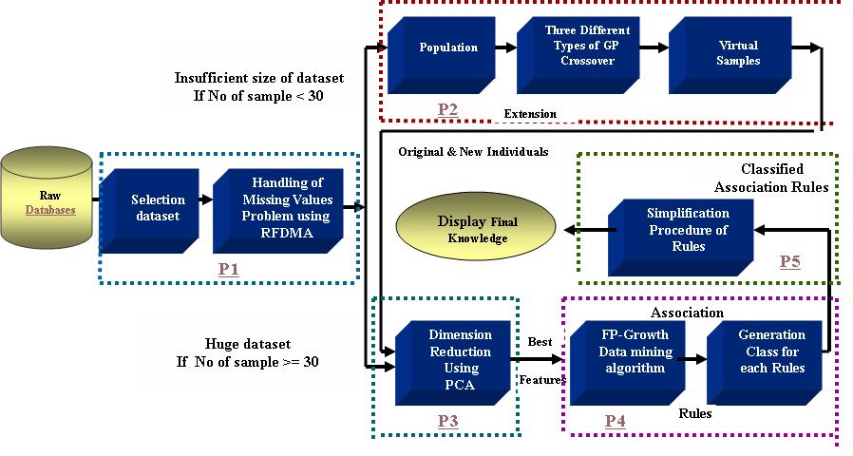

Fig. 1 The Block Diagram of the Proposed system

4.1. Genetic Programming Data Construction Method (GPDCM)
Lack of reference data is very often responsible for poor performance of learning. Therefore, How to develop a theoretically and practically valid tool for analyzing small data sample remains a critical and challenging issue for researches and it consider one of the open problems. Data construction methods can be roughly divided into two groups, with respect to the construction strategy: hypothesis-driven methods and data-driven methods [HuJY98].
Hypothesis-driven methods construct new attributes out of previously-generated hypotheses (discovered rules or another kind of knowledge representation). In general they started by constructing a hypothesis, for instance a decision tree, and then examine that hypothesis to construct new attributes [Paga00]. By contrast, data-driven methods do not suffer from the problem depending on the quality of previous hypotheses. They construct new attributes by directly detecting relationships in the data.
The process of attribute construction can also be roughly divided into two approaches, namely the interleaving approach and the preprocessing approach.
In the preprocessing approach the process of attribute construction is independent of the inductive learning algorithm that will be used to extract knowledge from the data. In other words, the quality of a candidate new attribute is evaluated by directly accessing the data, without running any inductive learning algorithm. In this approach the attribute construction method performs a preprocessing of the data, and the new constructed attributes can be given to different kinds of inductive learning methods. In the interleaving approach the process of attribute construction is intertwined with the inductive learning algorithm. The quality of a candidate new attribute is evaluated by running the inductive learning algorithm used to extract knowledge from the data, so that in principle the constructed attributes’ usefulness tends to be limited to that inductive learning algorithm. An example of data construction method following the interleaving approach can be found in [Zhen00].
In this work we follow the data-driven strategy and the preprocessing approach, mainly for two reasons. First, using this combination of strategy-approach the constructed data have a more generic usefulness, since they can help to improve the predictive accuracy of any kind of inductive learning algorithm. Second, data construction method following the preprocessing approach tends to be more efficient than its interleaving counterpart, since the latter requires many executions of an inductive learning algorithm.
This work proposes a GPDCM for creating more visual samples from the original small dataset; the main idea is depend on the represent each individual as decision tree. After that, we use tournament selection then apply the genetic operations (reproduction, crossover and mutation) where there are three types of crossover operations each one lead to differ result therefore the work focuses on this point as in next sections.
4.1.1. The Node Crossover
The following are the steps of how we can implement the crossover.
Step1: Select two parents from population.
Step2: Select randomly one crossover node from the first parent and search in random the second parent for an exchangeable.
Step3: Swap the crossover node.
Step4: The child is a copy of the modified its first parent.

4.1.2. The Branch Crossover
The following are the steps of how we can implement the branch crossover:

Step1: Select two parents from population.
Step2: Select random one crossover node from the first parent and search randomly in the second parent for an exchangeable.
Step3: Cutoff the branch with the crossover nodes.
Step4: Calculate the size of the expected child (remind size of first parent + size of branch cutted from the second parent).
Step5: If the size of child is accepted created the child by appending the branch cutoff from the second parent otherwise try again starting from (STEP 2).

4.1.3. The Mixed Crossover
The following are the steps of how we can implement the mixed crossover:
Step1: Select two parents from the population.
Step2: Select randomly one crossover node a terminal node in the second parent.
Step3: Generate the child by replacing the branch with the crossover node in first parent with the terminal node selected from the second parent.

The fitness function used in this work is the information gain ratio [Frei02], which is a well-known attribute-quality measure in the data mining and machine learning literature. It should be noted that the use of this measure constitutes a data-driven strategy. As mentioned above, an important advantage of this kind of strategy is that it is relatively fast, since it avoids the need for running a data mining algorithm when evaluating an attribute (individual). In particular, the information gain ratio for a given attribute can be computed in a single scan of the training set
As a result, if the population consist of 20 individuals (No of records in database or No of parents) and each crossover between two parents yields one child this mean generation 10 children when apply node crossover, 10 children when apply branch crossover, 10 children when apply mixed crossover at first iteration of GPDCM.
The size of new population =the size of old population + No of children for all the three crossover approaches. The size of new population=20 +30=50 individuals. While the size of population in second iteration =50+75=125 individuals. See figure3.

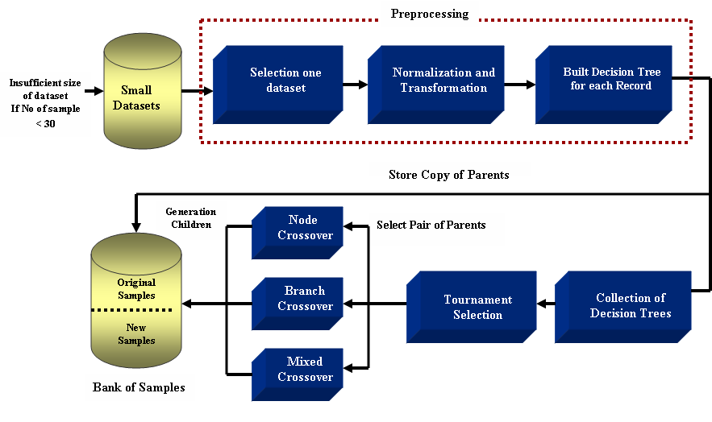

Fig. 3 the Block Diagram of the GPDCM

Each individual generation by any crossover method is test if it is valid or not by given the value (-1) for each operation and (+1) for each operand and find the summation of these values if the result is +1 the expression is valid otherwise is not valid. The generation process is continues and until depend on the value of some statistical measures such as mean, standard deviations and Roc Curve analysis.

4.2. Find the Best Features using Principal components analysis
The use of too many predictor variables to model a relationship with a response variable can unnecessarily complicate the interpretation of the analysis and violates the principle of parsimony: that one should consider keeping the number of predictors to a size that could easily be interpreted. Also, retaining too many variables may lead to overfitting, in which the generality of the findings is hindered because the new data do not behave the same as the training data for all the variables.
Further, analysis solely at the variable level might miss the fundamental underlying relationships among predictors. For example, several predictors might fall naturally into a single group (a factor or a component) that addresses a single aspect of the data.
Dimension reduction methods have the goal of using the correlation structure among the predictor variables to accomplish the following:
- Reduce the number of predictor components
- Help to ensure that these components are independent
- Provide a framework for interpretability of the results.

Definition 1: Principal components analysis (PCA) seeks to explain the correlation structure of a set of predictor variables using a smaller set of linear combinations of these variables. These linear combinations are called components.

Suppose that the original variables X1, X2, . . . , Xm form a coordinate system in m-dimensional space. The principal components represent a new coordinate system, found by rotating the original system along the directions of maximum variability. When preparing to perform data reduction, the analyst should first standardize the data so that the mean for each variable is zero and the standard deviation is 1. Let each variable Xi represent an n × 1 vector, where n is the number of records. Then represent the standardized variable as the n × 1 vector Zi , where Zi = (Xi − μi ) /σii , μi is the mean of Xi , and σii is the standard deviation of Xi . In matrix notation,this standardization is expressed as Z =(V1/2)−1(X − μ), where the “–1” exponent refers to the matrix inverse, and V1/2 is a diagonal matrix (nonzero entries only on the diagonal), the m × m standard deviation matrix:

Let ∑ refer to the symmetric covariance matrix:

Where, i ≠ j refers to the covariance between Xi and X j :

The covariance is a measure of the degree to which two variables vary together. Positive covariance indicates that when one variable increases, the other tends to increase. Negative covariance indicates that when one variable increases, the other tends to decrease.
Note that the covariance measure is not scaled, so that changing the units of measure would change the value of the covariance.
The correlation coefficient ri j avoids this difficulty by scaling the covariance by each of the standard deviations:
Then the correlation matrix is denoted as ρ:

4.3. Computing Principal Components Analysis the PCA

The process for computing the PCA can be represented in the following steps:

Step1: Compute the standardized data matrix Z =[Z1, Z2, . . . , Zm] base on Zi = (Xi − μi ) /σii from the original dataset.

Step2: Compute Eigenvalues. Let B be an m × m matrix, and let I be the m × m identity matrix (diagonal matrix with 1’s on the diagonal). Then the scalars (numbers of dimension 1 × 1) λ1, λ1, . . . , λm are said to be the Eigenvalues of B if they satisfy |B − λI| = 0.

Step3: Compute Eigenvectors. Let B be an m × m matrix, and let λ be an Eigenvalues of B. Then nonzero m × 1 vector e is said to be an eigenvector of B if Be = λe.

Step4: The ith principal component of the standardized data matrix Z = [Z1, Z2, . . . , Zm] is given by Yi = e^{T}iZ, where ei refers to the ith eigenvector (discussed below) and e^{T}i refers to the transpose of ei . The principal components are linear combinations Y1, Y2, . . . , Yk of the standardized variables in Z such that (1) the variances of the Yi are as large as possible, and (2) the Yi are uncorrelated. The first principal component is the linear combination Y1 = e^{T}1Z = e11Z1 + e12Z2 + ··· + e1m Zm, which has greater variability than any other possible linear combination of the Z variables. Thus:

  - The first principal component is the linear combination Y1 = e^{T}1Z, which maximizes Var(Y1) = e^{T}1ρ e1.
  - The second principal component is the linear combination Y2 = e^{T}2Z, which is independent of Y1 and maximizes Var(Y2) = e^{T}2ρ e2.
  - The ith principal component is the linear combination Yi = e_iX, which is independent of all the other principal components Yj , j < i , and maximizes Var(Yi ) = e^{T}iρ ei.

The criteria used for deciding the number of components extracted are as in the following:
- Eigen value criterion
- Proportion of variance explained criterion
- Minimum communality criterion
- Scree plot criterion
The Eigen value criterion states that each component should explain at least one variable’s worth of the variability, and therefore the Eigen value criterion states that only components with eigen values greater than 1 should be retained. For the proportion of variance explained criterion, the analyst simply selects the components one by one until the desired proportion of variability explained is attained. The minimum communality criterion states that enough components should be extracted so that the communalities for each of these variables exceed a certain threshold (e.g., 50%). The scree plot criterion is the maximum number of components that should be extracted is just prior to where the plot begins to straighten out into a horizontal line.

4.4. FP-Growth algorithm
After, we get the best features for database base on PCA (i.e., reduce number of features). We using FP-Growth algorithm to discover the frequent item sets and generation all association rules of that database.
FP-Growth adopts a divide and conquer strategy by (1) compressing the database representing frequent items into a structure called FP-tree (frequent pattern tree) that retains all the essential information and (2) dividing the compressed database into a set of conditional databases, each associated with one frequent item set and mining each one separately. It scans the database only twice. In the first scan, all the frequent items and their support counts (frequencies) are derived and they are sorted in the order of descending support count in each transaction. In the second scan, items in each transaction are merged into an FP-tree and items (nodes) that appear in common in different transactions are counted. Each node is associated with an item and its count.
Nodes with the same label are linked by a pointer called a node-link. Since items are sorted in the descending order of frequency, nodes closer to the root of the FP tree are shared by more transactions, thus resulting in a very compact representation that stores all the necessary information. Pattern growth algorithm works on FP-tree by choosing an item in the order of increasing frequency and extracting frequent itemsets that contain the chosen item by recursively calling itself on the conditional FP-tree, that is, FP-tree conditioned to the chosen item. FP-growth is an order of magnitude faster than the original Apriori algorithm.

4.5. Classification base on Association Rules
Tree net data mining algorithm used to find best class fro the association rules result from FP-Growth (i.e., find the class base on volt principle) as follow:
Step1: initialize equal weights for all N rules in association rule database (ARD). w = {wj = 1/N | j = 1, 2, . . . , N}
Step2: set number of iteration equal K
Step3: for i=1 to K do
Step4: Great training set Di by sampling (with replacement) from (ARD) according to w.
STEP 5: Train a base classifier Ci on Di.
Step 6: Apply Ci to all rules in the original training set, D.
Step 7: Calculate the weighted error

Step 8: If > 0.5 then
Step 9: Reset the weights for all N rules: w = {wj = 1/N | j = 1, 2, . . . ,N}: Go back to Step 4.
STEP 10: end if
STEP 11:
Step 12: Update the weight of each rule as follow:

13: end for
Step 14:

4.6. Simplifying Procedure

Simplification procedures usually lead to a more interpretable rule-base with the cost of degradation in the classification base on association rules (CAR) performance. Existing procedures for simplifying rule-bases include: deleting rules with a small effect on the output determined using the singular value decomposition; deleting similar, contradictory or inactive rules; using the correlation between the inputs to delete or simplify the rules; restricting the number of antecedents; and using evolution strategies to search for a simpler rule-base.
In this section, we describe a procedure for simplifying a classified association rules. For each rule xk ak
Step 1: For each k [1 : m], if |ak| is small, remove the atoms containing xk in the rules If-part, and remove ak from the Then-part of all the rules.
Step 2: If a specific atom (e.g., ‘x1 < 7’) appears in all the rules, then delete it from them all. It is easy to verify that in such a case, this atom has no effect on the output.
Step 3: If the ith atom of Rule j is ‘x_{i} is positive value(or negative value), and in all the other rules the ith atom is ‘xi is negative value (or positive value), then:
- Remove all the atoms, except for atom i, from the If-part of Rule j
- Delete the ith atom from all the other rules
- Place Rule j as the first rule, and add an Else clause followed by all the other rules.
Step 4: Define one class as the default class, delete all the rules whose output is this class, and add the clause: “Else, class is the default class” to the rule-base.

5. Experimental Results
Table II. Correlation Matrix of Diabetes Dataset

 | TIMSPREG | PLASMAG | DBLDPRS | TRICEPS | H2SERUM | BODYMASS | PEDIGREE | AGE
TIMSPREG | 1.0000 | 0.1295 | 0.1413 | -0.0817 | -0.0735 | 0.0177 | -0.0335 | 0.5443
PLASMAG | 0.1295 | 1.0000 | 0.1526 | 0.0573 | 0.3314 | 0.2211 | 0.1373 | 0.2635
DBLDPRS | 0.1413 | 0.1526 | 1.0000 | 0.2074 | 0.0889 | 0.2818 | 0.0413 | 0.2395
TRICEPS | -0.0817 | 0.0573 | 0.2074 | 1.0000 | 0.4368 | 0.3926 | 0.1839 | -0.1140
H2SERUM | -0.0735 | 0.3314 | 0.0889 | 0.4368 | 1.0000 | 0.1979 | 0.1851 | -0.0422
BODYMASS | 0.0177 | 0.2211 | 0.2818 | 0.3926 | 0.1979 | 1.0000 | 0.1406 | 0.0362
PEDIGREE | -0.0335 | 0.1373 | 0.0413 | 0.1839 | 0.1851 | 0.1406 | 1.0000 | 0.0336
AGE | 0.5443 | 0.2635 | 0.2395 | -0.1140 | -0.0422 | 0.0362 | 0.0336 | 1.0000

Table III. Correlation Matrix of Diabetes Dataset

Factor | Eigen value | Variance | Cumulative
1 | 1.44848 | 46.081 | 46.081
2 | 1.30536 | 41.528 | 87.609
3 | 0.27192 | 8.651 | 96.259
4 | 0.09984 | 3.176 | 99.435
5 | 0.01775 | 0.565 | 100.000
6 | -0.02709
7 | -0.10687
8 | -0.25555

to test performance of the proposed methodology, we apply it on two small types dataset (Heart, Iris) and two huge dataset (Diabetes, DNA). Table I shows the results of each small dataset generation by GPDCM

table I. rResult of each small dataset

Name of DB | #  Sample | #  Features | #  Class | Max #  Generation. | Total #New Samples | #New True Samples
Heart | 24 | 14 | 2 | 3 | 375 | 278
Iris | 29 | 5 | 3 | 2 | 180 | 121
#NTS=T#NS –N#NS
Where
T#NS: total Number of New Samples,
N#NS: Neglected Number of New Samples
(Ex: #NTS of Heart=375-97 =278)

A. Result of Diabetes Dataset
We use Diabetes dataset as example to test the method, where these dataset consist of 768 samples and 8 features belong to two classes. Figure 4 explain 35 records of that dataset. Table II shows the Correlation Matrix of these dataset while, Table III explains egien value for each feature (Principal Factor Analysis).
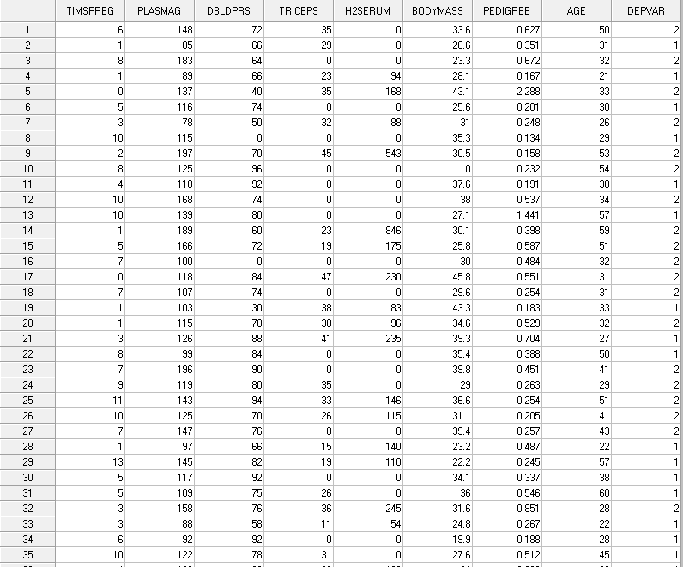
Fig. 4 First 35 record in the Diabetes Dataset
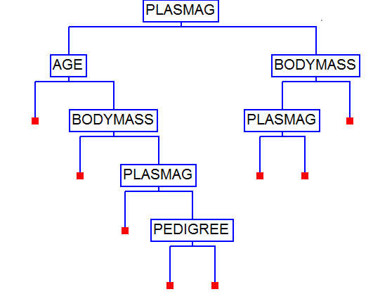
Fig. 5 Main Tree Split Variables of Diabetes Dataset
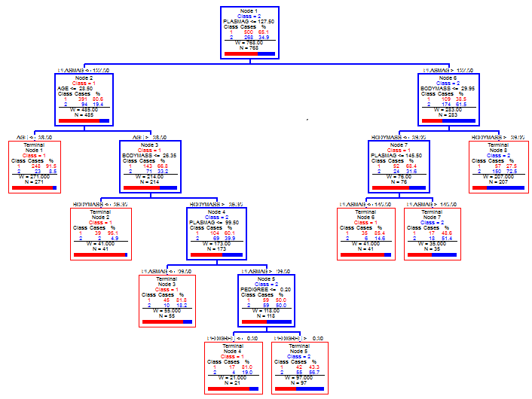

Fig. 6 Main Tree of lassificationbase on ssociation Rules

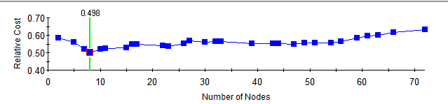

Fig. 7 The relationship between Number of Nodes and Relative Cost

The generated Knowledge Base :
Rule1: IF PLASMAG<=172.5 AND AGE<=28.50 THEN CLASS 1
Rule2: IF PLASMAG<=172.5 AND AGE>28.50 AND BODYMASS<=26.35 THEN CLASS 1
Rule3: IF PLASMAG<=172.5 AND AGE>28.50 AND BODYMASS>26.35 AND BODYMASS<=99.50 THEN CLASS 1
Rule4: IF PLASMAG<=172.5 AND AGE>28.50 AND BODYMASS>26.35 AND BODYMASS<=99.50AND PEDIGREE <=0.20 THEN CLASS 1
Rule5: IF PLASMAG<=172.5 AND AGE>28.50 AND BODYMASS>26.35 AND BODYMASS<=99.50AND PEDIGREE > 0.20 THEN CLASS 2
Rule6: IF PLASMAG>172.5 AND BODYMASS<=29.95AND PLASMAG <= 145.5 THEN CLASS 1
Rule7: IF PLASMAG>172.5 AND BODYMASS<=29.95AND PLASMAG >145.5 THEN CLASS 2
Rule8: IF PLASMAG>172.5 AND BODYMASS>29. 95THEN CLASS 2
B. Results of the DNA Dataset
We use DNA dataset as another example to test the method, where these dataset consist of 2000 samples and 181 features belong to three classes. Figure 8 explain 35 records of that dataset. Table V shows the Correlation Matrix of these dataset while, Table IV explains Principal Factor Analysis for each feature.

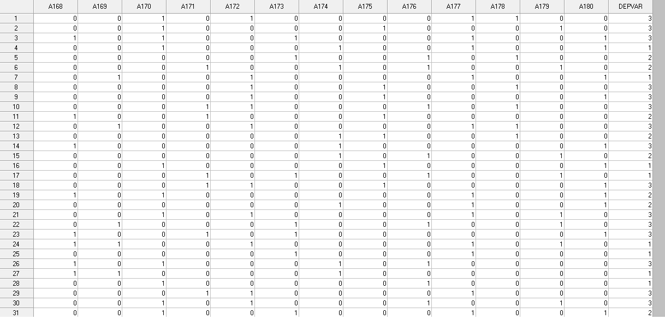

Fig. 8 First 31 record in the DNA Dataset

TableV. Correlation Matrix of DNA Dataset

Fig. 11 Main Tree of Classification of DNA Dataset

Factor | Eigen value | Variance | Cumulative
1 | 1.69511 | 27.138 | 27.138
2 | 1.37372 | 21.993 | 49.130
3 | 1.01262 | 16.211 | 65.342
4 | 0.45369 | 7.263 | 72.605
5 | 0.44395 | 7.107 | 79.712
6 | 0.38872 | 6.223 | 85.936
7 | 0.3307 | 5.294 | 91.230
8 | 0.25676 | 4.111 | 95.340
9 | 0.18103 | 2.898 | 98.239
10 | 0.10788 | 1.727 | 99.966
11 | 0.00214 | 0.034 | 100.000
12 | -0.00108 | . | .
13 | -0.17904 | . | .
14 | -0.21039 | . | .
15 | -0.22791 | . | .
16 | -0.25475 | . | .
17 | -0.31549 | . | .
18 | -0.31921 | . | .
19 | -0.31984 | . | .
20 | -0.36296 | . | .
Table VI . Correlation Matrix of DNA Dataset

The generated Knowledge Base
Rule1: IF A85<=0.50 AND A93<=0.50 THEN CLASS 1
Rule2: : IF A85<=0.50 AND A93>0.50 AND A105 <=0.50 AND A97<=0.50 THEN CLASS 3
Rule3: IF A85<=0.50 AND A93>0.50 AND A105 <=0.50 AND A97>0.50 AND A100<=0.50 THEN CLASS 3
Rule4: : IF A85<=0.50 AND A93>0.50 AND A105 <=0.50 AND A97>0.50 AND A100>0.50 AND A74<=0.50 THEN CLASS 1
Rule5: IF A85<=0.50 AND A93>0.50 AND A105 <=0.50 AND A97>0.50 AND A100>0.50 AND A74>0.50 THEN CLASS 3
Rule6: IF A85<=0.50 AND A93>0.50 AND A105 >0.50 AND A94<=0.50 AND A95<=0.50 THEN CLASS 1
Rule7: IF A85<=0.50 AND A93>0.50 AND A105 >0.50 AND A94<=0.50 AND A95>0.50 THEN CLASS 3
Rule8: IF A85<=0.50 AND A93>0.50 AND A105 >0.50 AND A94>0.50 THEN CLASS 3
Rule9: IF A85>0.50 AND A105<=0.50 AND A83 <=0.50 AND A88<=0.50 AND A75<=0.50 AND A82<=0.50 AND A63<=0.50 AND A89<=0.50 THEN CLASS 2
Rule10 IF A85>0.50 AND A105<=0.50 AND A83 <=0.50 AND A88<=0.50 AND A75<=0.50 AND A82<=0.50 AND A63<=0.50 AND A89>0.50 THEN CLASS 3
Rule11: IF A85>0.50 AND A105<=0.50 AND A83 <=0.50 AND A88<=0.50 AND A75<=0.50 AND A82<=0.50 AND A63>0.50 THEN CLASS 3
Rule12: IF A85>0.50 AND A105<=0.50 AND A83 <=0.50 AND A88<=0.50 AND A75<=0.50 AND A82>0.50 AND A93<=0.50 THEN CLASS 3
Rule13: IF A85>0.50 AND A105<=0.50 AND A83 <=0.50 AND A88<=0.50 AND A75<=0.50 AND A82>0.50 AND A93>0.50 AND A95<=0.50 AND A94<=0.50 THEN CLASS 1
Rule14: IF A85>0.50 AND A105<=0.50 AND A83 <=0.50 AND A88<=0.50 AND A75<=0.50 AND A82>0.50 AND A93>0.50 AND A95<=0.50 AND A94>0.50 THEN CLASS 3
Rule15: IF A85>0.50 AND A105<=0.50 AND A83 <=0.50 AND A88<=0.50 AND A75<=0.50 AND A82>0.50 AND A93>0.50 AND A95>0.50 THEN CLASS 2
Rule16: IF A85>0.50 AND A105<=0.50 AND A83 <=0.50 AND A88<=0.50 AND A75>0.50 AND A97<=0.50 THEN CLASS 3
Rule17: IF A85>0.50 AND A105<=0.50 AND A83 <=0.50 AND A88<=0.50 AND A75>0.50 AND A97>0.50 AND A94<=0.50 THEN CLASS 1
Rule18: IF A85>0.50 AND A105<=0.50 AND A83 <=0.50 AND A88<=0.50 AND A75>0.50 AND A97>0.50 AND A94>0.50 THEN CLASS 3
Rule19: IF A85>0.50 AND A105<=0.50 AND A83 <=0.50 AND A88>0.50 THEN CLASS 3
Rule20: IF A85>0.50 AND A105<=0.50 AND A83 >0.50 AND A88<=0.50 AND A89<=0.50 AND A97<=0.50 AND A100<=0.50 THEN CLASS 2
Rule21: IF A85>0.50 AND A105<=0.50 AND A83 >0.50 AND A88<=0.50 AND A89<=0.50 AND A97<=0.50 AND A100>0.50 AND A63<=0.50 THEN CLASS 2
Rule22: IF A85>0.50 AND A105<=0.50 AND A83 >0.50 AND A88<=0.50 AND A89<=0.50 AND A97<=0.50 AND A100>0.50 AND A63>0.50 AND A93<=0.50 THEN CLASS 2
Rule23: IF A85>0.50 AND A105<=0.50 AND A83 >0.50 AND A88<=0.50 AND A89<=0.50 AND A97<=0.50 AND A100>0.50AND A63>0.50 AND A93>0.50 THEN CLASS 1

Rule24: IF A85>0.50 AND A105<=0.50 AND A83 >0.50 AND A88<=0.50 AND A89<=0.50 AND A97>0.50 AND A93<=0.50 THEN CLASS 2
Rule25: IF A85>0.50 AND A105<=0.50 AND A83 >0.50 AND A88<=0.50 AND A89<=0.50 AND A97>0.50 AND A93>0.50 AND A100<=0.50 AND A73<=0.50 THEN CLASS 2
Rule26: IF A85>0.50 AND A105<=0.50 AND A83 >0.50 AND A88<=0.50 AND A89<=0.50 AND A97>0.50 AND A93>0.50 AND A100<=0.50 AND A73>0.50 THEN CLASS 1
Rule27: IF A85>0.50 AND A105<=0.50 AND A83 >0.50 AND A88<=0.50 AND A89<=0.50 AND A97>0.50 AND A93>0.50 AND A100>0.50 AND A94<=0.50 AND A95 <=0.50 THEN CLASS 1
Rule28: IF A85>0.50 AND A105<=0.50 AND A83 >0.50 AND A88<=0.50 AND A89<=0.50 AND A97>0.50 AND A93>0.50 AND A100>0.50 AND A94<=0.50 AND A95 >0.50 THEN CLASS 2
Rule29: IF A85>0.50 AND A105<=0.50 AND A83 >0.50 AND A88<=0.50 AND A89<=0.50 AND A97>0.50 AND A93>0.50 AND A100>0.50 AND A94>0.50 THEN CLASS 2
Rule30: IF A85>0.50 AND A105<=0.50 AND A83 >0.50 AND A88<=0.50 AND A89>0.50 THEN CLASS 3
Rule31: IF A85>0.50 AND A105<=0.50 AND A83 >0.50 AND A88>0.50 THEN CLASS 3
Rule32: IF A85>0.50 AND A105>0.50 AND A93<=0.50 AND A89>0.50 THEN CLASS 3
Rule33: IF A85>0.50 AND A105>0.50 AND A93<=0.50 AND A89<=0.50 AND A83>0.50 THEN CLASS 2
Rule34: IF A85>0.50 AND A105>0.50 AND A93<=0.50 AND A89<=0.50 AND A83<=0.50 AND A75>0.50 THEN CLASS 3
Rule35: IF A85>0.50 AND A105>0.50 AND A93<=0.50 AND A89<=0.50 AND A83<=0.50 AND A75<0.50 AND A73>0.50 THEN CLASS 3
Rule36: IF A85>0.50 AND A105>0.50 AND A93<=0.50 AND A89<=0.50 AND A83<=0.50 AND A75<0.50 AND A73<=0.50 AND A63>0.50 THEN CLASS 3
Rule37: IF A85>0.50 AND A105>0.50 AND A93<=0.50 AND A89<=0.50 AND A83<=0.50 AND A75<0.50 AND A73<=0.50 AND A63<0.50 THEN CLASS 2
Rule38: IF A85>0.50 AND A105>0.50 AND A93>0.50 AND A94<=0.50 AND A98<=0.50 AND A95<=0.50 THEN CLASS 1
Rule39: IF A85>0.50 AND A105>0.50 AND A93>0.50 AND A94<=0.50 AND A98<=0.50 AND A95>0.50 AND A97<=0.50 THEN CLASS 3
Rule40: IF A85>0.50 AND A105>0.50 AND A93>0.50 AND A94<=0.50 AND A98<=0.50 AND A95>0.50 AND A97>0.50 THEN CLASS 2
Rule41: IF A85>0.50 AND A105>0.50 AND A93>0.50 AND A94<=0.50 AND A98>0.50 AND A75<=0.50 THEN CLASS 2
Rule42: IF A85>0.50 AND A105>0.50 AND A93>0.50 AND A94<=0.50 AND A98>0.50 AND A75>0.50 THEN CLASS 1
Rule43: IF A85>0.50 AND A105>0.50 AND A93>0.50 AND A94>0.50 AND A88<=0.50 THEN CLASS 2
Rule44: IF A85>0.50 AND A105>0.50 AND A93>0.50 AND A94>0.50 AND A88>0.50 THEN CLASS 3

6. Conclusions
This paper suggests solution of the three still open problems: first how you can find the actual value of the missing values depend on develop of Random forest data mining algorithm. Second solve the problem of taken intelligent analysis of small size of dataset (i.e, insuffizent size of dataset) by propose new method for generation data called GPDCM. Third how you can get accurate and comprehensible rule base these done by three steps: first using PCA to reduction dimensional of database. Second FP-Growth data mining algorithm using to generating association rules from the best features of database. Third, classification that association rules by TreeNet algorithm.

References
[Usam96] Usama F., Gregory P. and Padhraic S., "Knowledge discovery and data mining: Towards a unifinying framework ". pages 82-88, Portland, Oregon, USA, August 1996.
[Mann97] Mannila H., "Data mining: Machnine learning, statistics and databases ", in Proc. Of 8th Int. Con. On science and statistical database management, p 2-9, Stockholm, Sweden, 1997.
[Mitr02] Mitra S., Mitra P., and Pal S., Data Mining In Soft Computing Framework: A Survey, IEEE Transactions On Neural Networks, Vol.13, No. 1, January 2002.
[Mitr03] Mitra S., "Data Mining: Multimedia, Soft Computing, and Bioinformatics," John Wiley & Sons, Inc., Hoboken, New Jersey, 2003.
[Kona00] Konar A., “Artificial Inelegant and Soft Computing: Behavioral and Cognitive of the Human Brain,” CRC Press, Florida, 2000.
[Brei00] Breiman, Leo., "Random Forests". Machine Learning 45 (1): 5–32. 2001: doi:10.1023/A:1010933404324.
[Jeri08] Jeril “ Tree Net an exclusive implementation of jerome Friedman’s MART methodology”., Salford Systems, version 2.0., 2008.
[Xind09] Xindong WU and Vipin K. “The top Ten Algorithm in Data Mining”
Taylor & Francis Group, LLC, 2009
[Dane06] DANIEL T. LAROSE,“Data Mining Methods and Models” Department of Mathematical Sciences Central Connecticut State University 2006.
[Nomu98] Nomura T. and Miyoshi T., “An Adaptive fuzzy rue extraction using Hybrid Model of Fuzzy Self-Organizing Map and The Genetic Algorithm With numerical Chromosomes,” Kyoto 619-02, Japan,1998.
[McGa99] McGarry K., Tait J., Wermter S., MacIntyre J. “Rule Extraction from Radial Basis Function Networks,” Proceedings of the International Conference on Artificial Neural Networks. p. 613-618, Edinburgh, UK, September 1999.
[Mitr00] Mitra P., Mitra S., and Sankar K., “Staging of Cervical Cancer with Soft Computing,” IEEE Transactions On Biomedical Engineering, Vol.47, No. 7, July 2000.
[PalS01] Pal S., Mitra S., and Mitra P., “Rough fuzzy MLP: Modular evolution, rule generation and evaluation,” IEEE Trans. Knowledge Data Eng., 2001.
[Isao02] Isao Okina “Extracting uncertain knowledge in database using Binary Causal Network Model”, Ph.D thesis Linköpings university , Sweden, 2002.
[McGa00] McGarry K. “The Analysis of Rules Discovered by the Data Mining Process,” 4th International Conference on Recent Advances in Soft Computing, Nottingham, UK, December 2000
[Huss03] Hussein K., "Knowledge Discovery in database by using data mining" Ph.D. Thesis, University of Technology, 2002.
[Mutt03] Mutthew G. and Larry B., "Feature construction and selection using genetic programming and a genetic algorithm", LNCS, P 229-237, 2003.
[Nian04 ] Nian Yan : Classification Using Neural Network Ensemble with Feature Selection., Ph.D thesis Linköpings university , Sweden, 2004.
[Malo04] Malone J., McGarry K. and Bowerman C., “Using an Adaptive Fuzzy Logic System to Optimise Knowledge Discovery in Proteomics,” International Conference on Recent Advances in Soft Computing, pp. 80-85, November 2004.
[Malo05] Malone J., McGarry K, Bowerman C., Wermter S. “Rule Extraction from Kohonen Neural Networks. Automated Trend Analysis of Proteomics Data Using Intelligent Data Mining Architecture,”Neural Computing Applications Journal, 2005.
[Mahd05] Mahdi A.," Extracting Rules from Databases Using Soft Computing", M.Sc Thesis, University of Babylon, 2005.
[Geor06] Georgios K, Eleftherios K and Vassili L " Ant Seeker: An algorithm for enhanced Web Search", IFIP International Federation for information processing, Vol 204 , Artifical Intellegent Application and Innovations ,pp. 649-656, 2006.
[Jiax07] Jiaxiong Pi, Yong Shi and Zhengxin Chen, From similarity retrieval to cluster analysis: The case of R*-trees, IEEE Symposium on Computational Intelligence and Data Mining (CIDM) 2007
[UlfJ07] Ulf Johansson, “Obtaining Accurate and Comprehensible Data Mining Models – An Evolutionary Approach”, Ph.D thesis Linköpings universitet SE-581 83 Linköping, Sweden, 2007.
[Eric09] Erica C. And Falk H., " Using “Blackbox” Algorithms Such as TreeNet and Random Forests for Data-Mining and for Finding Meaningful Patterns, Relationships, and Outliers in Complex Ecological Data", Information science reference, Hershey • New York, 2009
[WenX09] Wen Xiong, Cong Wang, A Hybrid Improved Ant Colony Optimization and Random Forests Feature Selection Method for56 v/’ Microarray Data. IEEE Computer Society , Fifth International Joint Conference on INC, IMS and IDC, 2009
[Huyj98] Hu, Y-J. A Genetic Programming Approach to Constructive Induction . In Proceeding of 3rd Annual Genetic Programming Conference, pp. 146–151, 1998.
[Paga00]. Pagallo, G. & Haussler, D. Boolean Feature Discovery in Empirical Learning. In Machine Learning 5, pp. 71–99.1990.
[Zhen00] Zheng, Z. Constructing X-of-N attributes for decision tree learning. Machine Learning 40 1-43.2000
[Smit02] S. Mitra, P. Mitra, and S. K. Pal, Data Mining In Soft Computing Framework: A Survey, IEEE Transactions On Neural Networks, Vol.13, No. 1, January 2002.
[Frei02] Freitas.A. Data Mining and Knowledge Discovery with Evolutionary Algorithms. Springer, 2002.

