Electronic Structure Of ermanabenzenes:Using B3-LYP Density Functional Theory

Hamed Ibraheem Aboud
Physics Department-College of Science -University of Babylon
Huda Bukheet Hassan
Physics Department-College of Education- University of Babylon

Abstract
The electronic distribution ,energies and infrared spectra for benzene and Germanabenzenes molecules group were studied using density function theory at B3LYP/6-31G** level .The calculations include the total energy ,geometrical structure , ionization potential, electron affinity, chemical potential, hardness and energy gap. From the results, it is found that the new aromatic molecules are more stable than benzene, these Germanabenzenes have small total energy and small energy gap .these calculations have been performed using Gaussian 03 program.
الخلاصة
تم دراسة التوزيع الالكتروني والطاقات وأطياف الأشعة تحت الحمراء للبنزين ومجموعة جزيئات Germanabenzenes باستخدام نظرية دالة الكثافة عند المستوي .B3LYP/6-31G**. تشمل الحسابات الطاقة الإجمالية ، البنية الهندسية ، جهد التأين ، الألفة الالكترونية ، الجهد الكيميائي ، الصلابة وفجوة الطاقة. من النتائج، تبين أن الجزيئات الحلقية الجديدة هي أكثر استقرارا من البنزين، وان هده الجزيئات تمتلك طاقة كلية صغيرة وفجوة طاقة صغيرة أيضا. وقد تم تنفيذ هذه الحسابات باستخدام برنامج Gaussian 03.

Introduction
The study of aromatic molecules and the inorganic benzene are an interesting field in applied physics and chemistry .Aromatic compound are those possessing the ring structure of benzene or other molecular structures that resemble benzene in electronic configuration and chemical behavior[Robert T and Robert N,2007] .There are many compounds that, at first appearance ,bear little resemblance to benzene ,but have a basic similarity in electronic configuration ,and they are aromatic ,too[Peter,2005].
In this study, the possible aromatic character of various Germanabenzenes has been theoretically studied. The relatively π-bonding ability of germanium versus carbon results in interesting structural and electronic features within the benzenoid framework of Germanabenzenes. The principle of aromaticity has general acceptance among the chemical community .However, the criteria used to validate it are controversial [A.R.katritzky,et al, 1998],[P.V.R.Schleyer, et al,2001], because there is no well-established definition of these principles in quantitative way [J.Poater,et al,2003], [F.Fuster,et al,2000][P.Lazzeretti,2004],[V.Steiner and P.w.Fowler,2004]. many ways of techniques to evaluate aromaticity have been proposed ,some are based on structure or energetic behavior ,such as ,the harmonic oscillator model of aromaticity (HOMA)[T.M.Krygowski and M.K.Cyranski,1996],or the aromatic stabilization energy (A.S.E) [V.I.Minkin, et al,1994],others are based on the analysis of electron delocalization [J.Poater,et al,2003].

Computational Details
The molecular properties for the new molecules are computed under the Becke three parameters with Lee-Yang-Parr functional [B3LYP] level with large 6-31G** basis set .The optimization of molecular geometries and vibrational analyses have been done using Gaussian 03 [M.J.Frisch,et al,2003] package of programs.
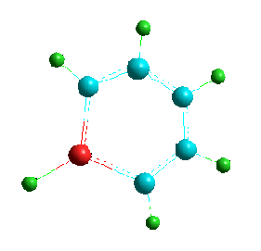
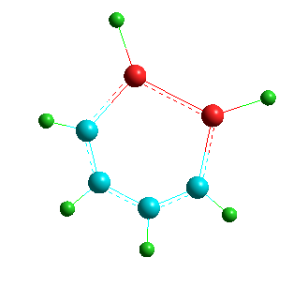
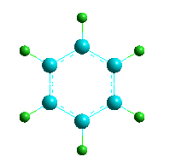

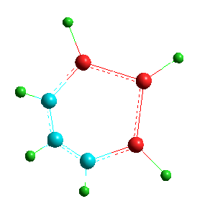
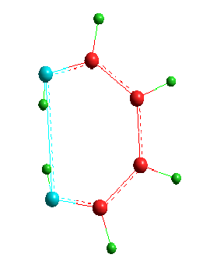
Benzene Monogermanabenzene Digermanabenzene
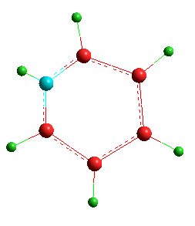

Trigermanabenzene
Tetragermanabenzene Pentagermanabezene
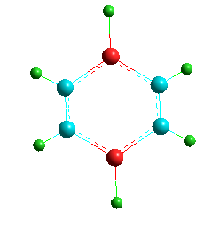
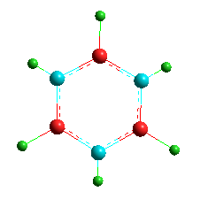
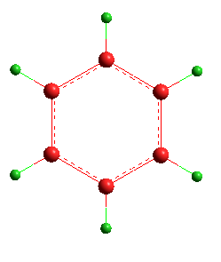

Hexagermanabenzene 1,4 Digermanabenzene 1,3,5 Trigermanabenzene

Figure (1) shows the structure of studied molecules.

Results and Discussion
Table (1) presents the total energy and symmetry for all studied molecules .The benzene molecules was included as reference.
Table(1)
Total energy and Symmetry for molecules.
Molecule | Total energy (a.u) | Symmetry
C6H6 | -232.258 | D6h
GeC5H6 | -2269.1 | CS
Ge2C4H6 | -4305.98 | C2V
Ge3C3H6 | -6342.88 | CS
Ge4C2H6 | -8379.78 | CS
Ge5C1H6 | -4305.95 | CS
Ge6h6 | -6342.83 | C2V
1,4GeC4H6 | -12453.6 | CS
1,3,5GeC3H6 | -10416.7 | CS

We know that the weaker sp²hybridization of germanium atom comparing with carbon atom is an explanation of the usually different bonding behavior of both atoms. Therefore, the lack of stabilization of molecules can be due to the differences in the C-H bond with respect to the Ge-H bond .on the other hand ,for planar molecule containing the Ge₆ ring 0ther atoms (hydrogen atoms) presenting a bond to germanium atom similar to the C-H bond have been analyzed .However ,the decreasing of total energy with adding the germanium atoms gives molecule becomes more stable. The electronic properties for studied molecules are listed in table (2) .These properties include the computed ionization potentials (IP) ,electro affinity(EA),chemical potentials(K),hardness (η),electrophilicities(w),and energy gap (E_{gap}) . All in eV unit . From results,one can see that the ionization potentials for allnew molecules are smaller than that for benzene, but di-germanabenzene has the least ,this mean that this molecule needs to small energy to become cation comparing with other molecules .The electron affinity for di-germanabenzene is the largest and all new Germanabenzenes molecules have more electron affinity then benzene ,this means that these molecules need to large energy to become anion compared with benzene. It is found that the forbidden energy gap for all Germanabenzenes molecules group is less than that for benzene. The Pentagermanabezene Ge₅H₆ is a new electronic material with approximately half value of energy gap for benzene.

Table (2)
The calculated electronic properties for studied molecules
Molecules | IP(eV) | EA(eV) | K(eV) | η(eV) | W(eV) | Egap(eV)
C₆H₆ | 9.24 | -2.48 | 3.37 | 5.8 | 0.97 | 6.65
GeC₅H₆ | 6.99 | -1.21 | 2.88 | 4.10 | 1.01 | 4.79
Ge₂C₄H₆ | 6.61 | 0.86 | 3.74 | 2.87 | 2.43 | 4.27
Ge₃C₃H₆ | 7.87 | 0.21 | 4.04 | 3.82 | 2.13 | 4.32
Ge₄C₂H₆ | 8.01 | 0.49 | 4.25 | 3.76 | 2.40 | 3.45
Ge₅CH₆ | 7.34 | 0.63 | 3.98 | 3.35 | 2.37 | 3.25
Ge₆H₆ | 6.86 | 0.90 | 3.88 | 2.98 | 2.53 | 3.39
1,4GeC₄H₆ | 7.34 | 0.61 | 3.54 | 4.20 | 2.35 | 3.56
1,3,5GeC₃H₆ | 7.74 | -0.66 | 3.97 | 3.36 | 1.49 | 4.72

The total dipole moment in Debye for studied molecules are listed in table (3). These results explain the symmetry for each molecule.
Table (3)
The total dipole moments for studied molecules
Molecules | C₆H₆ | GeC₅H₆ | Ge₂C₄H₆ | Ge₃C₃H₆ | Ge₄C₂H₆ | Ge₅C₁H₆ | Ge₆H₆ | 1,4GeC₄H₆ | 1,3,5GeC₃H₆
Dipole moment | 0 | 0.28 | 0.03 | 0.07 | 0.20 | 0.16 | 0 | 0 | 0.002

Figure(2) show the vibrational frequencies of benzene using B3LYP/6-31G** in this study appear peaks at (691,1066.3,1528.28and 3202.34) cm⁻¹.These results have been found in good agreement with experimental data [Hai-Bo Yi,et al,2009].The strong peak computed by used DFT method observed at 691 cm⁻¹ and weak peak at (1066.3) cm⁻¹ are due to bending of (C-H) bond ,the peak observed at (1528)cm⁻¹is due to stretching of (C-C) bond It is found from figure (2) that the IR spectrum for Germanabenzenes group molecules are the same number of vibration mode for benzene due to that the number of vibration mode is (3n-6) ,where n is the number of atoms .Generally ,we found that the two stretching vibration ,the symmetric and asymmetric ,the symmetric stretching is happened when the bonds of the same atoms vibrate in the same phase ,but the asymmetric stretching is happened when the bonds vibrate in different phases.
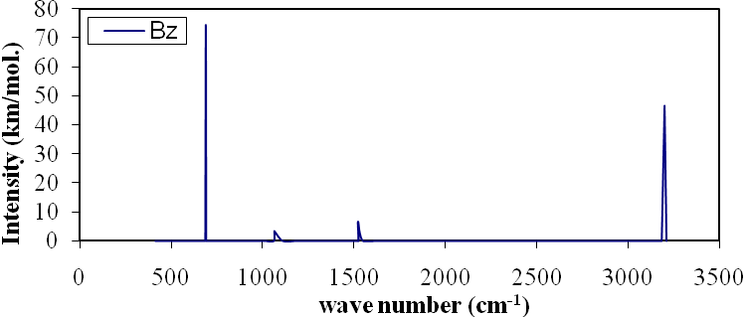
Figure (2) Show the IR Spectrum of benzene molecule.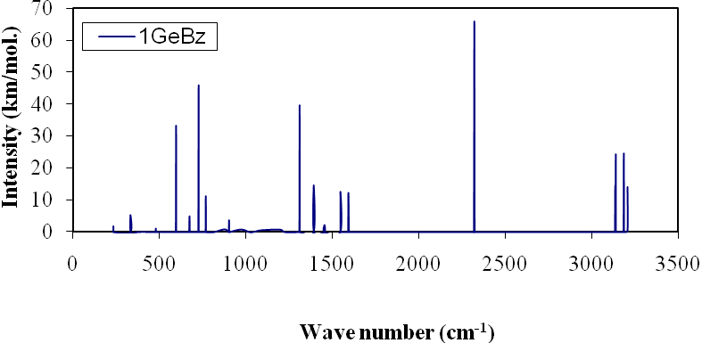
Figure (3) Show the IR Spectrum of C₅H₆Ge molecule.

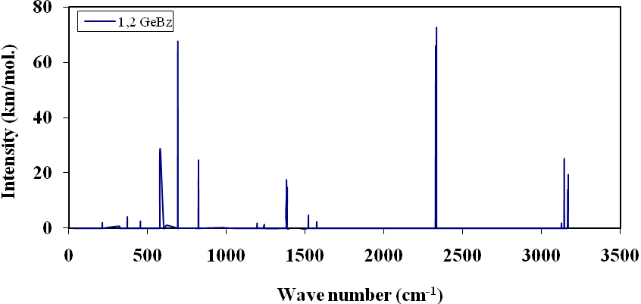
Figure (4) Show the IR Spectrum of C₄H₆Ge₂ molecule.
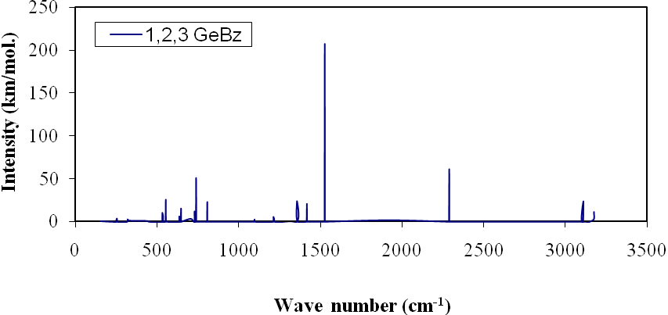Figure (5) Show the IR Spectrum ofC₃H₆Ge₃ molecule.

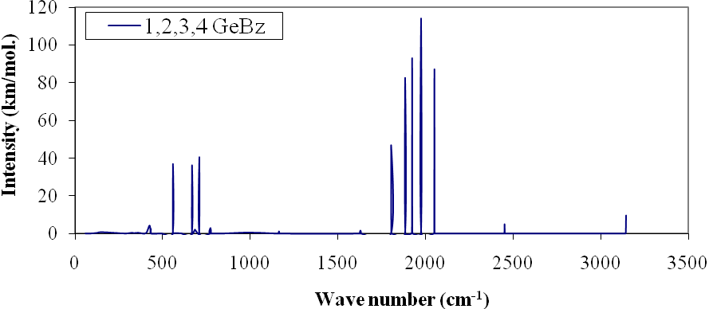
Figure (6) Show the IR Spectrum ofC₂H₆Ge₄ molecule.
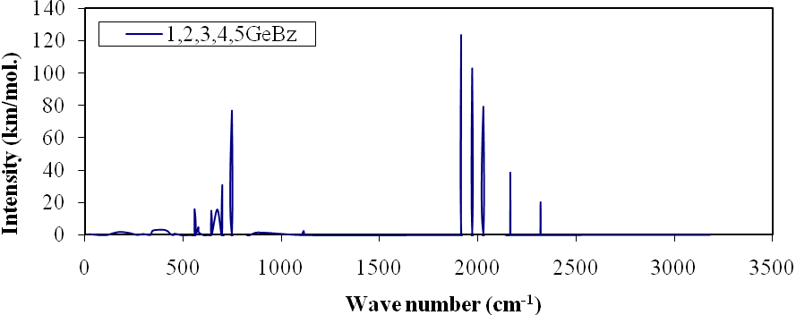
Figure (7) Show the IR Spectrum ofCH₆Ge₅ molecule.

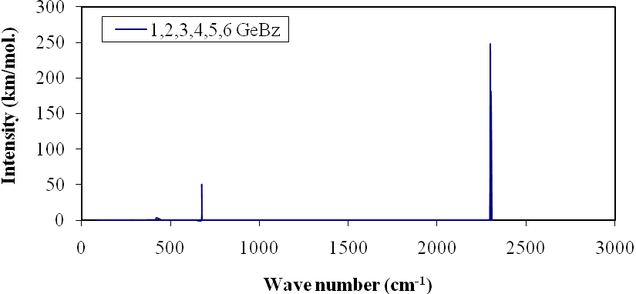
Figure (8) Show the IR Spectrum ofGe₆H₆ molecule.
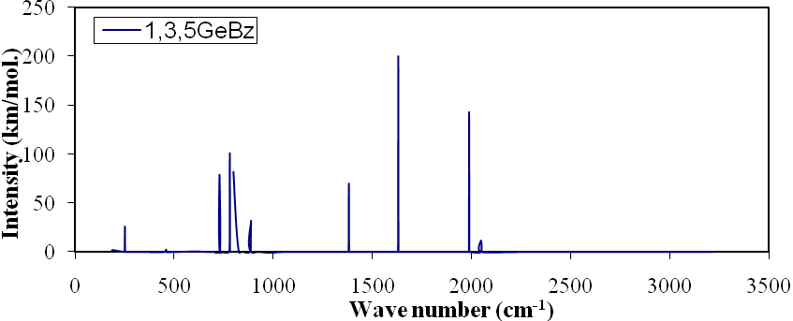
Figure (9) Show the IR Spectrum ofC₃H₆Ge₃ molecule.

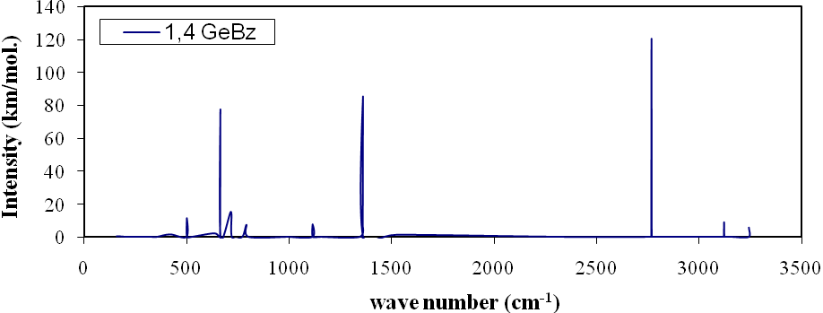
Figure (10) Show the IR Spectrum ofC4H6Ge2 molecule.

Conclusions:
The electronic structure and vibrational analysis for Germanabenzenes molecules group are studied using density functional method .The DFT is a powerful method for this study and the functional B3LYP is a suitable function and an efficient for studying the aromatic molecules .from the obtained results ,one can see that:
1-The symmetry for studied molecules and the geometric structure for benzene are in a good agreement with those experimentally .And for a new aromatic molecules, the present study supplies new data.
2- A good agreement results comparing with experimental data for total energy of benzene ,while for other Germanabenzenes molecules group they have not been found a similar studies .
3-The ionization potentials for Germanabenzenes are smaller than that for benzene, while the electron affinities are larger values for Germanabenzenes than benzene.
4- One of the important results is the smallest energy gap for new aromatic Germanabenzenes. This may be lead to a new electron material with more reactive.
5- This study satisfy the main principle for vibrating modes .the I R spectrum calculations show that the B3LYP16 -31G**gives large approach observed peaks computed experimentally for benzene .And for other molecules this study supplies new data for the spectrum

.
References
Katritzky, A.R. M. Karelson, S. Sild, T. M. Krygowski and K. Jug, (1998), Theoretical Study of Aromaticity In Inorganic etramer clusters",J.Org.Chem.635228.
F. Fuster, A. Savin and B. Silvi, (2000), "Aromaticity (Editorial)", J. Phys. Chem. A 104 852.
Hai-Bo Yi, Han Myoung Lee and Kwang S. Kim, (2009), "Interaction of Benzene With Transition Metal Cations: Theoretical Study of Structures, Energies, and IR Spectrum", Journal of Chemical and Computation(JCTC), Vol.5, P1709-1717.
. Poater J, X. Fradera, M. Duran and M. Sola, (2003), "Introduction: Delocalization-π and σ (Editorial)", Chem. Eur. J, 9,400.
Poater, J. X. Fradera, M. Duran and M. Sola, (2003), "Crocker, Not Armit and Robinson, Begat the Six Aromatic Electrons", Chem. Eur. J, 9,1113.
M. J. Frischetal, (2003),"Gaussian 03", Gaussian Inc, Pittsburgh, PA.
. Schleyer, P. V. R M. Manoharan, Z. Wang, B. Kiran, H. Jiao, R. Puchta and N. Hommes, (2001), " Density Functional and MP2 Calculations on the Water Monomer and Dimer", Org. Lett. 32465.
. Schleyer, P. V. R (2001), " Molecular Shape, Capacitance and Chemical Hardness", (2001), Chem Rev, 101, 1115.
Lazzeretti, P. (2004), " Chemical Hardness and Density Functional Theory", Chem. Phys, 6,217.
Peter R. S. Murray, (2005), " Principles of Organic Chemistry", 2nd Edition, Oxford. Robert T and Robert N, (2007), " Organic Chemistry", 6th Edition, New York University, USA.
Krygowski T. M. and M. K. Cyranski, (1996)," Polyanionic Hexagons", Tetrahedron 52, 1713.
Minkin, V. I. M. N. Glukhovtev and B. Y. Simkin,(1994), " Aromaticity and Antiaromaticity Electronic and Structural Aspects, John Wiley and Sons, New York.
Steiner V. and P. W. Fowler, (2004)," Profile of Maytenus Aquifolium Action Over Free Radicals Reactive Oxygen Species", Phys. Chem. Chem. Phys, 6,261.

