Density Functional Investigations Of Some Hydroxi Benzene Molecules Group
Rawa Mezher Obiad
Physics Department- College of Science- University of Babylon

Abstract :
Three molecules included [ benzene (BZ) ,Bentahydroxibenzen , and hexahydroxibenzen] have been studied .The optimized structures , energies , dipole moment , and vibrational frequencies for these molecules have been investigated using density functional theory at B3LYP/6-31G** level . These calculations have been performed using Gaussian 03 program . Benzene molecule calculations have been performed for comparison and to know the addition effect of different number for OH radical on the molecular properties of benzene .
الخلاصة
تم دراسة ثلاثة جزيئات تضمنت ] البنزين ,بنتاهيدروكسي البنزين ,هكساهيدروكسي البنزين[ . التراكيب الهندسية المثلى , الطاقات , عزم ثنائي القطب و أطياف الاهتزاز لهذه الجزيئات تم دراستها باستخدام نظرية دالة الكثافة عند المستوي B3LYP/6-31G** . الحسابات تم تنفيذها باستخدام برنامج Gaussian 03 . حسابات جزيئه البنزين تم تنفيذها لغرض المقارنة و معرفة تأثير الإضافة لأعداد مختلفة من جذر OHعلى الخواص الجزيئية للبنزين .
- Introduction :
Aromatic compounds are those possessing the ring structure of benzene or other molecular structures that resemble benzene in electronic configuration and chemical behavior [Robert T. and Robert N. ,2007]. There are many compounds that , at first appearance , bear little resemblance to benzene , but have a basic similarity in electronic configuration , and they are aromatic , too[ Murray , 2005][ Robert , 1997].
Aromaticity is a chemical property in which a conjugated ring of unsaturated bonds, lone pairs, or empty orbitals exhibit a stabilization stronger than would be expected by the stabilization of conjugation alone. It can also be considered a manifestation of cyclic delocalization and of resonance. This is usually considered to be because electrons are free to cycle around circular arrangements of atoms , which are alternately single- and double-bonded to one another. These bonds may be seen as a hybrid of a single bond and a double bond , each bond in the ring identical to every other. This commonly-seen model of aromatic rings , namely the idea that benzene was formed from a six-membered carbon ring with alternating single and double bonds (cyclohexatriene), was developed by Kekule[ Schleyer , 2001][ Balaban ,et al, 2005].The model for benzene consists of two resonance forms, which corresponds to the double and single bonds' switching positions [ Schleyer, 2005].

- Theoretical Methods and Computational Details :
Density functional theory have been used to calculate the molecular properties for these molecules at [Becke three parameters with the Lee - Yang – Parr functional (B3LYP ) ] level with 6-31G** basis sets . All calculations were carried out using the Gaussian 03 package .

- Results and Discussion :
In table(1) , are displayed the optimized structures of the molecules under study .The optimized structures for the benzene has been found in a good agreement with the experimental data , and they have not been found similar studies for other molecules . It is obvious from table (1) that benzene molecule is an plane molecule opposite to other molecules .

Table (1) : Average Bond Lengths in (A˚), ª : [Robert T. and Robert N. ,2007] ,
^{b}:[ Lide,2005]
Molecule | (Bond) Label | Current Study B3LYP/6-31G** | Exp.^{a,b}
BZ | R_{C ̶ C} | 1.396 | 1.390
BZ | R_{C ̶ H} | 1.086 | 1.10
1-6OHBZ | R_{C ̶ C} | 1.397
1-6OHBZ | R_{C ̶ H} | 1.087
1-6OHBZ | R_{C ̶ O} | 1.377
1-6OHBZ | R_{O ̶ H} | 0.966
1-5OH BZ | R_{C ̶ C} | 1.3956
1-5OH BZ | R_{C ̶ H} | 1.3797
1-5OH BZ | R_{C ̶ O} | 1.3154
1-5OH BZ | R_{O- H} | 0.967

Table (2) lists the calculated total energies (E_{tot}), ionization potentials (IP) , electron affinities (EA) , chemical potentials (K) , hardness(ɳ) , electrophilicities (ω) , and energy gaps (E_{gap})for the molecules under study .
The decrease of total energy with addition of OH radical gives molecule becomes more stable with the increase of added OH radicals number .This relation is a linear function , it was found an equation associates the total energy for any of hydroxi group molecules and the number of OH radicals :
$$E_{\text{tot}}≈E_{\text{tot}}(\text{benzene})+{\text{nE}}_{\text{tot}}(\text{OH})$$
where, $E_{\text{tot}}(\text{benzene})=−\text{229}$ a .u in B3LYP/6-31G**,
n is the number of OH radicals , and E_{tot}(1-5) Bentahydroxi = - 603.313 a .u

It is clear from table(2) that the ionization potential for the hydroxi benzene group molecules is less than the ionization potential for benzene molecule , this mean that these molecules need to small energy to become cation comparing with benzene molecule . the electron affinity for the hydroxi benzene molecule group is more than the electron affinity for benzene molecule, these values mean that these molecules need to large energy to become anion comparing with benzene molecule . It is obvious from this table that the two molecules have a chemical potential less than that for benzene molecule , that mean the electrons in these molecules have a large escaping tendency . Also the hardness of all molecules is smaller than for benzene molecule. The electrophilicity for (1-5) OHC₆H₆ and (1-6) OHC₆H₆ is less than for benzene. It has been found that the forbidden energy gap for the benzene molecule decreases with the addition of OH .
Table (2) : Computed Energies for Molecules under Study.
Molecule | E_{tot} in a.u | IP in eV | EA in eV | K in eV | ɳ in eV | ω in eV | E_{gap} in eV
BZ | -229 | 9.2479 | -2.478 | 5.8348 | 5.8566 | 0.953 | 6.79638
BENHBZ | -603 | 5.6114 | -3.078 | 1.2584 | 4.3584 | 0.163 | 5.689074
HEXHBZ | -777 | 5.0339 | -3.105 | 0.9534 | 4.0723 | 0.108 | 1.0141452

The dipole moment of studied molecules has been found in this work. These results explain the symmetry for each molecule . Table (3) shows the total dipole moment for each molecule.

Table (3) : The Total Dipole Moment (µ) for Molecules under Study in Debye .
Molecule | BZ | TETBZ | HEXBZ
µ | 0 | 1.5801 | 2.8466

Figure(1) shows the computed energies for studied molecules. It had been estimated from figure (1) that the energies of these molecules are increase compared with benzene .

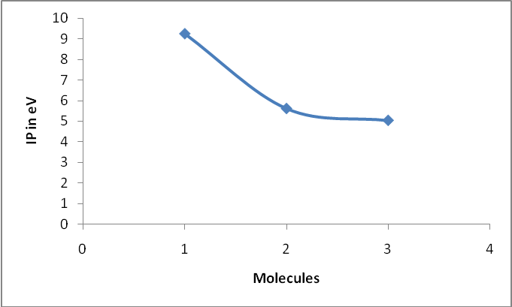
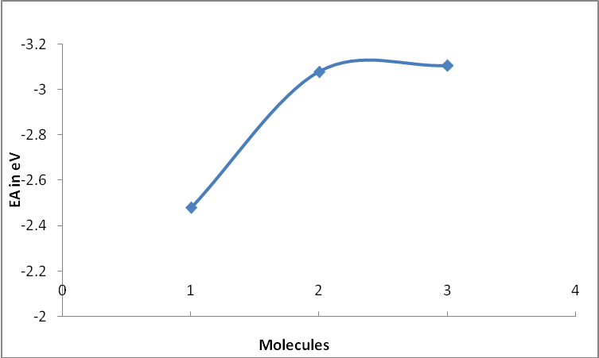

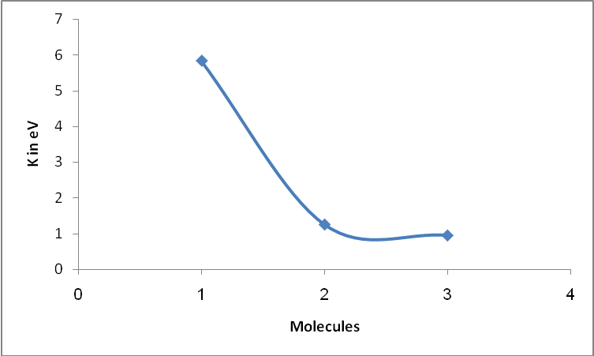

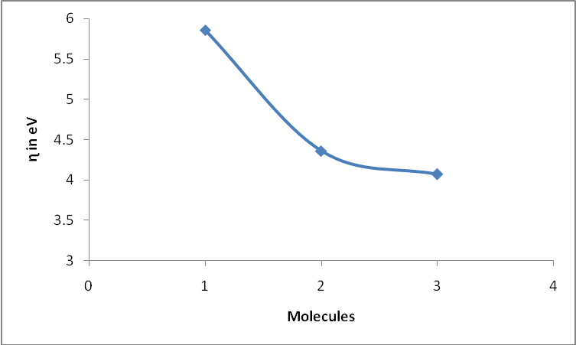

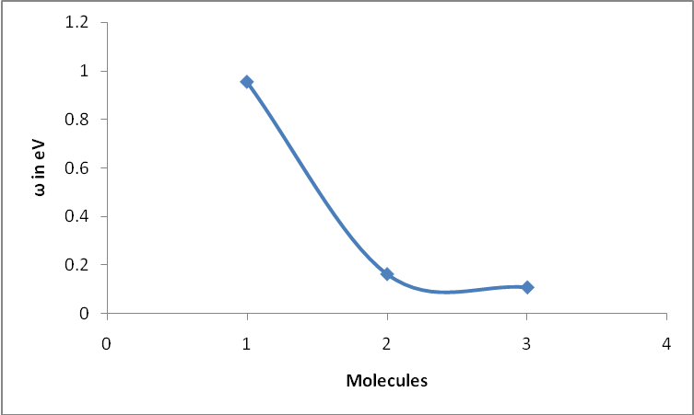

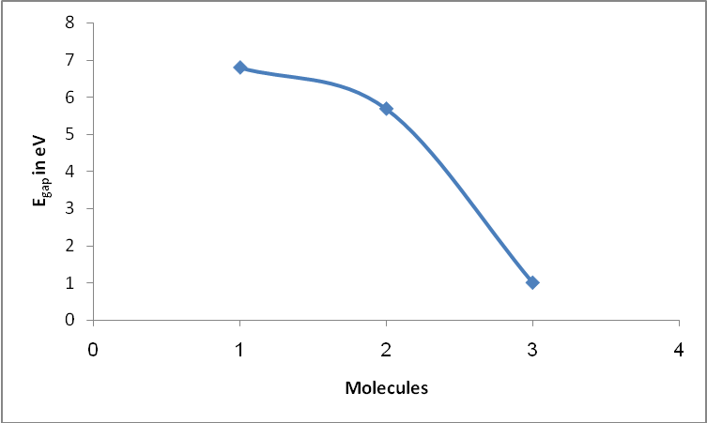

Figure(1`) The computed energies for molecules(1(BZ),2(BENHBZ),3(HEXHBZ)) under Study.

Figure (2) show the vibrational frequencies calculated of studied molecules using
B3LYP/6-31G** method.
Figure(2a) appear peaks at ( 694.57, 1066.8 , 1524.8 and 31972.87) cm⁻¹. These results have been found in good agreement with experimental data [Yi ,et. al.,2009] , where the peaks had been observed at (673 , 1038 , 1469 , and 3210) cm⁻¹ .The strong peak computed by B3LYP/6-31G** observed at 694 cm⁻¹ and weak peak at 1066 cm⁻¹ are due to the bending of (C---H ) bond , the peak observed at 1528 cm⁻¹ is due to the stretching of (C---C) bond , the peak at 3202 cm⁻¹ is due to the stretching of (C---H) bond
It is clear from figure (2b) that the IR spectrum for BentHBZ molecule characters from that of benzene molecule by multiply the vibration mode due to existing of (O---H) bonds and (C---O) bonds , the stretching and bending of these bonds caused to new peaks or band of peaks to be appeared , the stretching (C---O) bond has been observed at (132.6-274.1) cm⁻¹ , and the bending (O---H) bond has been observed at (943.6–1426.5) cm⁻¹ , while the stretching of (O---H) bond appeared at (3785–3849) cm⁻¹ .There are two types for stretching vibration symmetric and asymmetric , the symmetric stretching is happened when the bonds of the same atoms vibrate in the same phase , and the asymmetric stretching is happened when the bonds vibrate in different phases .
So it is clear from figure (2c) that the IR spectrum for HexaHBenzene group molecules characters from that of benzene molecule by multiply the vibration mode due to existing of (O---H) bonds and (C---O) bonds , the stretching and bending of these bonds caused to new peaks or band of peaks to be appeared , the stretching (C---O) bond has been observed at (186.9-264.77) cm⁻¹ , and the bending (O---H) bond has been observed at (312.74-400.31) cm⁻¹ , while the stretching of (O---H) bond appeared at (749.544-1583) cm⁻¹ and at (3786.8-3804.7).

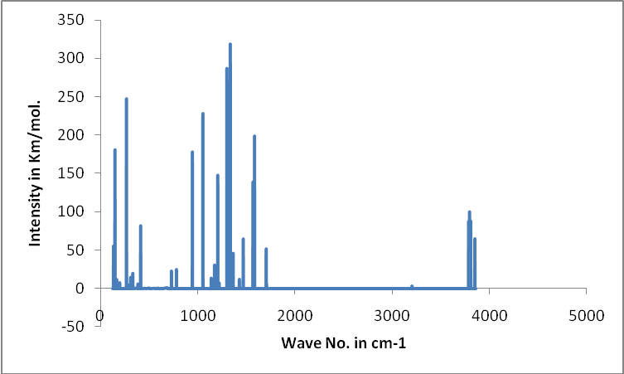
(b)
TETA
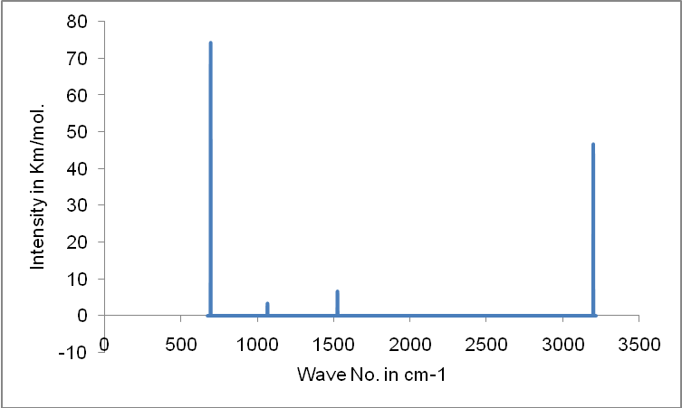 (a)
Bz

BZ

(b)
Benta

BZ

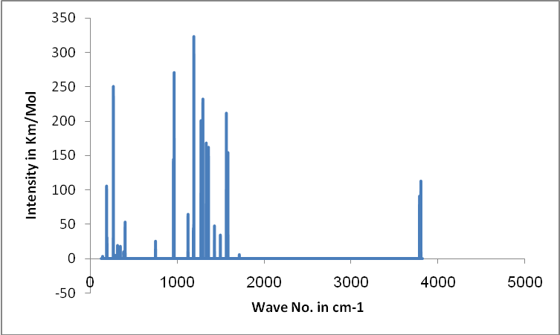
(c)
HEXA

Figure (2) The observed spectral frequencies for the molecules under
study
Conclusion
Density functional method used in this study , is presented powerful method for studying the physical properties and electronic structure of aromatic molecules , and B3LYP functional level is an efficient of theory for studying these molecules , They have been found that :
- The geometry optimization for benzene hydroxi have been found in a good agreement with experimental data , while for other studied molecules it has not been found a reference data , so the current work supplies new data for these molecules .
- The energies calculated by the (B3LYP/6-31G**) method has been found in good agreement with the previous study (B3LYP/3-21G**) , the comparison has been applied only on benzene molecule , but for other molecules they have not been found a similar studies , thus this study also supplies new data in this aspect . The hardness and electronic chemical potential for Bentahydroxibenzene and Hexahydrobenzene are lowering values comparing with benzene . A hard molecule has a large energy gap and a soft molecule has a small energy gap . Therefore , these molecules are soft with small energy gaps , thus their electron density changed more easily than benzene , and according to that , these molecules may be more reactive .
- The energy gap , HOMO , and LUMO for benzene molecule using B3LYP/6-31G** have been found in good agreement with previous study B3LYP/3-21G** , with respect to the addition of OH radicals on benzene molecule has showed a significant effect on the energy gap. The molecular electronic states HOMO and LUMO have indirect relation to the effects of correlation radicals – ring through the calculations of hardness and chemical potential . These two molecular states are increasing for two hydroxibenzene studied in this work .One of the important results obtained in this study is the decreasing of the forbidden energy gap for all molecules , a small energy gap means small excitation energies of manifold of the excited states .
- The total dipole moment calculation has been found in good agreement with previous study for benzene molecule using B3LYP/3-21G** . Dipole moment describe the properties of whole molecules , therefore , it has no effects which may be related to the adding the radicals .
- In IR spectra calculations , it has been used B3LYP/6-31G** method , this study supplies new data for IR spectrum . Adding the radicals lead to increasing the vibrational modes and highest stretching vibrational wave numbers and this gave suitable positions for OH with carbon atoms in benzene ring .
References :
Balaban A. T. , Schleyer P. V. R. and. Rzepa H. S. ,( 2005), "Crocker, Not Armit and Robinson, Begat the Six Aromatic Electrons", Chemical Reviews, Vol.105, P.3436-3447.
Lide D. R, (2005) , “ CRC Handbook of Chemistry and Physics ” , National Institute of Standards and Technology , CRC Press LLC ,USA.
Murray R. S. (2005) , “ Principles of Organic Chemistry “ , 2nd Edition , Oxford .
Robert J. B. , (1997) , “ Essentials of Organic Chemistry ” , Georgia Southern University , USA .
Robert T. M. , Robert N. B. , (2007) , “ Organic Chemistry ” , 6th Edition ,New York University , USA .
Schleyer P. V. R., (2001) , "Aromaticity (Editorial)", Chemical Reviews , Vol.101, P.1115-1118 .
Schleyer P. V. R. , (2005) , "Introduction: Delocalization-π and σ (Editorial)", Chemical Reviews, Vol.105,P. 3433-3435 .
Yi H. , Lee H. M. , Kim K. S. ,( 2009) , “ Interaction of Benzene with Transition Metal Cations : Theoretical Study of Structures , Energies , and IR Spectra ” , Journal of Chemical Theory and Computation (JCTC ) , Vol.5 , P.1709-1717 .

