Modeling And Evaluation Of Queuing Systems
Thahair A. Abulah
collage of science / Diyla University

Abstract
In this paper, two types of queuing systems are modelled and analyzed. These systems are: single waiting line and multi channel queue and multi queue and multi channel queue. The performance of the two systems is analyzed using the simulated and analytical method. The waiting time of the two systems is evaluated. Hence, the optimum system is determined.
الخلاصة
تم في هذا البحث, نمذجة وتحليل نظامين من انظمه صفوف الانتظار. هذه الأنظمة هي نظام صف الانتظار ذي طابور واحد ومتعدد قنوات الخدمة ونظام صف الانتظار متعدد صفوف الانتظار ومتعدد قنوات الخدمة. جرى تحليل أداء هذين النظامين باستخدام طريقه المحاكاة التحليلية .ولقد تم تقيم زمن الانتظار في النظامين وغلى ضوء ذلك تم تحديدي النظام الأمثل.

Keyword: Modelling ,multi waiting line multichannel queue, single waiting line multichannel queue, simulation.

1.Introduction
In the single waiting line multi channel queue, there is one long waiting line in front of service station and the customer in the head of line go to one of servicer that is idle[2].
But the multi waiting line and multi channel queue have several waiting line separate from other in front of servers and become single server. Average number of queue, waiting time, waiting probability was estimated [3]. Simulation and analytic was used to module the queuing systems and gather data and analyze the performance of the queuing system such as average queue length, waiting time , probability(wait) and other factor.
The result of this is used to advice the owner of fast food restraint to convert the queue system to one waiting line multi channel instead of multi waiting line.
1.2.Multi Channel Single waiting line Queuing System.
Figure (1) show the multi channel single waiting line, there is only one line queue (single waiting line), this system is used in banks and post offices, the customer at the head of queue will go to the server that is idle. The system is the first-come-first-server displine[2].
The main concept of this configuration is [2];
No queuing if n<=S or of customer is the number at most equals to the number of facilities serving.
There is a queue if n>S or the number of customer is greater the number of facilities serving.
Where n is the number of customer in the system and S is the number of server.
The disadvantage of the system is that the queue length seems to be long.
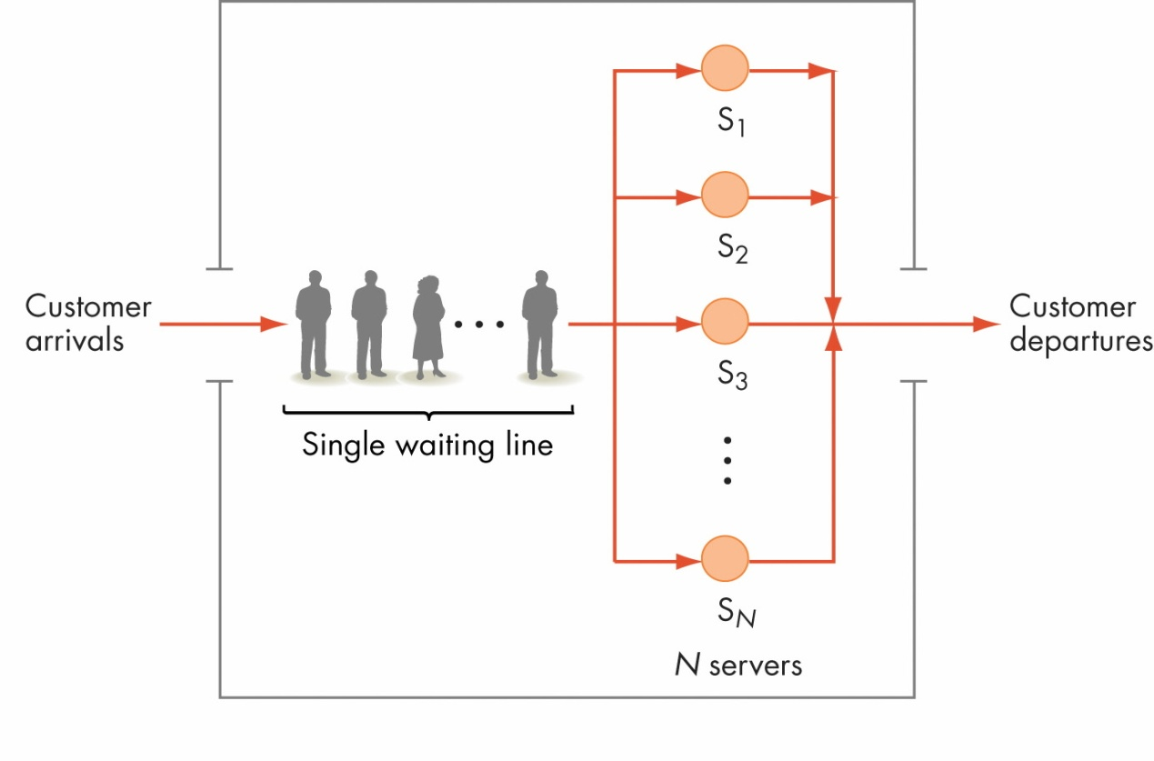
Fig 1 Multi channel waiting line[3].
µn=nμ for n>s where μ is a mean service rate of every channel.

The utilization factor for whole system is the ratio between the mean arrival rate λ and maximum possible rate of service of all the channels.
In multi-channel (S station) each servicing point has a mean rate μ and the elements come at a mean rate λ. The probability that there are n elements in system, when it is equipped with two or more stations and n is less than S, is:

p =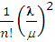 ...............(1)
when the number of element equals or is greater than the number of stations S, this probability becomes:
p =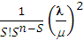 ............................................(2)
the probability of having no elements in a multi-channel system is:
p =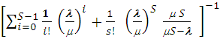 ...................................(3)
the above formulas can be applied only if S> or <1 . in the opposite case
S ≤ , ≥ 1) the queue will increase indefinitely in size .
In the multi channel system, the probability that an element approaching the station has to wait to be serviced coincides with the probability that there is S or more, elements in the system:
p =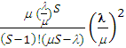 p ....................................................(4)
where n is any (number of elements) for S (included) up to n.
the mean length of the waiting line (number of units Lq), or average queue length excluding the elements under service, is obtained by multiplying equation (4) by ration 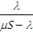 , which yields:
Lq = 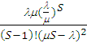 p ..................................(5)
the average number of elements in the multi- channel system is :
Ls = p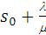 .......................................(6)
the average waiting time of an elements which has average in the system (wq) is:
is :
Wq = p ..........................................................(7)
The total average time that an element (arrival) spends the system Ws is:

WS = p + ......................................................(8)

1.3.Multi waiting line and Multiple-Channel queuing system[1]

Figure (2) shows the multi waiting line multiple-channel queuing. This system is used in fast food restaurant. In this type of queuing system the customer can feel very little time to get service, when they see small queue in front of each severer.
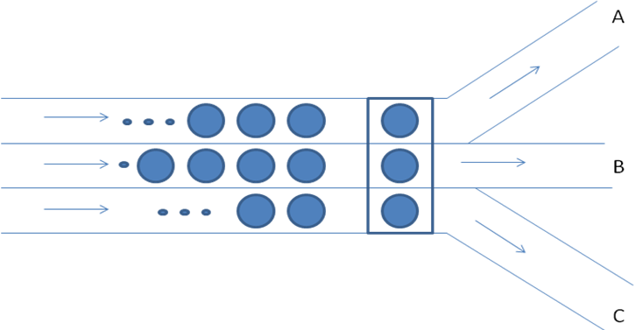
Fig (2) Multi waiting line multi channel queue[1].

The main concept of this configuration is [ 1]:
In the single channel, the probability the arrival will not have to wait for service is:
P0 =1- .......................................(9)
While the probability that an arrival has to wait for service is:

Pn=1-P0=1-(1-)= .......................................................(10)
Ls = 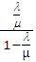 .................................... ...(11)
Lq=Ls- ................................................................. .. ...(12)

Ws= ................................................................... ...(13)

Wq= ................................................................... .. .(14)
2.The problem:
What happen if the owner of fast food restaurant change the queue from multi waiting line multi channel to single waiting line multi channel queue and the owner of bank changes from single queue to multiple queue. This problem means measuring the performance of each system such as average waiting time, probability waiting , probability of idle server, average service time, average length of queue, and other performances that influence on the customer waiting time. This problem can be evaluated using two approaches.
5.Discrete Simulation event approach
In the simulation approach, two type of event arrival and departure are used. In the first step data was collected but it is not possible then random number generator is used to generate random variables. The result of simulation is used to find the effective performances of each system and compare them, as shown in algorithms of (3.1.a and 3.1.b).
In order to convert single waiting line to multi waiting line queue for n servers the arrival rate must be divide by n because the arrival customers are distributed to the n channels. But when the multi line is changed to single line the arrival rate must multiplied by n. The service rate remains unchanged if the system is converted from one to the other.
3.1.Algorithm for new customer arrival and Departure for single channel
A. New Customer Arrival Algorithm :
Input: Customer Arrival time
Record the time that this customer entered the restaurant
Check if any one of the N servers S1, S2,…,SN is currently idle
If everyone is busy then
Put this customer at the end of the waiting line by 1
Increase the waiting line by 1
Mark that server Si is now busy
Determine how long it will take to serve this customer, call that value Tserver
Output: Scheduling time
Schedule a customer departure event for (current time+Tserve)
Increase the total time that server Si has worked by Tserve
End new customer Arrival
B. Customer Departure from Server Si:
Input: customer departure time
Determine the total time that this customer spent in the restaurant
If there is someone in line then
Take the next customer out of line decrease waiting line by 1
Determine how long this new customer will take to be served,
Call that value Tserve
Output: Scheduling time
Schedule a customer departure event for (current time+Tserve)
Increase the total time that server Si has worked by Tserve
Else
Make this server as idle
End customer departure
3.2 Data
The first stage of the solution is the data collection.This paper is taken from[ 5,4] as follows:
Queuing type | Arrival time(sec) | Service time(sec)
Multi waiting line | 48 | 70
Single waiting line | 30 | 130

Then, algorithms(3.1.A and 3.1.B) and Excel Microsoft application are used with these data to get the result of evaluation.
4. Result of simulation
Depending on equations (15) and (16), the following results are obtained [4].

Total time customers wait in queue(hr)
Average waiting time=--------------------------------------------------
Total number of customers …(15)
Number of customers who wait
Probability (waiting)=--------------------------------------------
Total number of customers …..(16)
1.Table (2) show the simulation results of changing from multi waiting line to single waiting line. Note that the average queue, average time queue and the waiting probability respectively are reduced.

Table 2 multi waiting line
Multi waiting line | 1.44 | 95.13 | .67
Single waiting line | .678 | 9.77 | 0.45
2. Table 3. Show the simulation result of changing single waiting line to multi waiting line. Note that the average queue, average time queue and the waiting probability respectively are worsted.
Table 3 Single waiting line
Single waiting line | 3.12 | 107.23 | 0.67
Multi waiting line | 0.57 | 803.64 | 0.77
5. Analytic of Approach
Equation (6) is used to find the probability(wait) and equation(7) to find the average number of customer in the queue, and equation (8) to find the average waiting time for single waiting time.
Also equation (9-14) are used to find the performance of multi waiting line.
However Microsoft excel application is used to find the analytical result as shown in table (4) and table(5).
Results
Tables 4 and 5 shows the simulation results.
Table 4 results of converting multi to single waiting line
M/M/c Queue |  |  |  |  |  |  | M/M/1 Queue
lambda | 16.000 | (arrival rate) |  |  |  |  | 48
Mu | 70.000 | (service rate) |  |  |  |  | 70
C | 3.000 | (number of servers) |  |  |  |  | 1
Rho | 0.076 | (utilization) |  |  |  |  | 0.685714286
L | 0.229 | (mean number in system) |  |  |  |  | 2.181818182
W | 0.014 | (mean time in system) |  |  |  |  | 0.045454545
wQ | 0.800 | (mean time in queue) |  |  |  |  | 0.05974026
LQ | 0.600 | (mean number in queue) |  |  |  |  | 1.496103896
P0 | 0.796 | (probability of an empty system) |  |  |  |  | 0.314285714
Pn | 0.204 | (probability (wait) |  |  |  |  | 0.685714286

Table 5 Results of converting single to multi waiting line .
lambda | 10.000 | (arrival rate) |  |  |  |  | 30
Mu | 130.000 | (service rate) |  |  |  |  | 130
C | 3.000 | (number of servers) |  |  |  |  | 1
Rho | 0.026 | (utilization) |  |  |  |  | 0.230769231
L | 0.077 | (mean number in system) |  |  |  |  | 0.3
W | 0.008 | (mean time in system) |  |  |  |  | 0.01
wQ | 0.000 | (mean time in queue) |  |  |  |  | 0.017692308
LQ | 0.000 | (mean number in queue) |  |  |  |  | 0.069230769
P0 | 0.926 | (probability of an empty system) |  |  |  |  | 0.769230769
Pn | 0.074 | (probability (wait) |  |  |  |  | 0.230769231

6.Conclusion
This paper has evaluated two type of queue system single waiting line multi channel and multi waiting line and multi channel. The performance of this system was analyzed by computing the average queue, average waiting time, and probability of queuing systems by using discrete event simulation and analytical approaches.
Both approaches proves that the owner of fast food using the multi waiting line channel must convert to single waiting line because of bad performance of the first system such as probability of waiting and waiting time.
The result of evaluation disagree with people concept that multi waiting line is better than single waiting line because of small size queues for getting rapid services.

Reference
Abdurrzzag Tamtam, Multi-channel queue problems approach, science conference (2010).
Husnulhulug, queuing theory model on figuration, accessed at june, http:// blog.unm.ac.id/ (2010).
Jerry Banks, Invitation to computer science, Java Version, third addition, 2007.
Jerry Banks, John S. Carson, Barry L. Nelson, David M. Nicol, Discrete-Event System Simulation, 5th Edition Published by Prentice Hall, 2010.
zhang Laifu; Discrete–event simulation of queuing systems; Science conference, Singapore(2000).

