Chemical Spray Deposition for Tellurium Thin Film
Janan H. Saadee
College of Engineering- Baghdad University
Abstract
In this work, a chemical spray pyrolysis thin film of Tellurium has been reported. The film is deposited on thin glass substrate at temperature of 498 ± 283 K to study its structure and electrical properties. The electrical properties are studied through variation of resistivity with temperature in the thermal range of 313 to 473 K as well as measurement of electrical conductivity and activation energy are performed. The results of Hall's effect showed that the prepared film is P-type. X-ray diffraction spectrum has shown that the prepared film has polycrystalline structure and peaks for Tellurium hexagonal structure. Also, the microstructure analysis using optical microscope illustrated the contrast of topography of this thin film which showed highest homogeneity and regularity.

ألخلاصة
تم فى هذا البحث أستخدام طريقة الرش الكيميائي الحراري لتحضير غشاء التلريوم الرقيق وترسيبه على قواعد زجاجيه رقيقه مسخنة الى درجة حرارة 498± 283 كلفن لدراسة خصائصه التركيبيه والكهربائيه . حيث تم دراسة الخصائص الكهربائية لهذا الغشاء من خلال تغيير المقاوميه مع درجة الحرارة ضمن المدى الحرارى 313 الى 473 كلفن وحساب التوصيلية الكهربائية كداله لدرجة الحرارة التي اعتمدت في تحديد طاقات التنشيط. بينت نتائج تأ ثير هول ان الغشاء المحضر يمتلك توصيلية كهربائية من النوع الموجب كما و بينت نتائج حيود الأشعة السينية ان الغشاء المحضر ذات تركيب متعدد البلورات (Polycrystalline). و قمما للتلريوم ذات تركيب سداسي(Hexagonal structure). أظهرت نتائج تحليلات التركيب الدقيق باعتماد المجهر الضوئي العاكس أن الغشاء المحضر ذات تجانس وانتظام عاليين،
1. Introduction
In the last years, the interest for the study of the electronic transport and optical properties of Tellurium thin films has been intensified due to their importance for various practical applications such as infrared detectors, thermoelectric devices, thin film transistors, and solar cells (Athwal, et al, 1988; Rusu, 2001). Recently researches have shown that Tellurium films may be used for detection of harmful gases at room temperature such as NO₂, CO, NH₃, and H₂S using thermal vacuum evaporation method deposited on ceramic substrate ([Sen, et all , 2008; Tsiulyanu, et al, 2011). Sen Shashwati et al. have shown that the prepared tellurium thin film has p-type conduction due to lattice defects acting as acceptors. There is a need for development of a low cost solar cells which would permit utilization of solar energy. Chemical spray deposition (spray pyrolysis) is a low cost process which has recently been utilized to prepare thin polycrystalline films of a wide variety of compound semiconductor by a number of investigators among them (Boone, et al, 1982; Thiyagarajan, et al, 2009). The advantages of this method compared with vacuum deposition techniques are the very low equipment costs that are involved. For coating large areas, the low deposition efficiency of spray pyrolysis has an adverse effect on the cost of material. Only a small fraction of the material supplied will be deposited onto substrate (Sefert, 1984). Also, this method is to prepare thin films for compositions with high melting temperature, which is difficult to be prepared by other techniques like CdTe (Boone, et al, 1982). In this work, chemical spray pyrolysis is used to prepare Tellurium thin film on a glass substrate. We report here a detail instigation of the structural and electrical properties of this film. 2. Experimental Details
The spray pyrolysis technique consists of spraying a solution containing a soluble salt of Tellurium onto a heated substrate. For Tellurium thin film preparation, A Tellurium dioxide TeO₂ with molecular weight of 159.6 gm/mol is dissolved in Hydrochloric acid (HCl) with concentration of 37%. The acid was added and mixed with 0.199 gm from TeO₂ in order to prepare solution with 0.05 M after that a distillation water was added to obtain solution of Tellurium salt according to the following chemical reaction equation (Encyclopedia of chemical technology, 1980):
TeO₂ + 4 HCl ═ TeCl₄ + 2H₂O
and
TeCl₄ ═ Te + 2Cl₂ at 498 ± 283 K
This solution was sprayed onto a heated glass substrate using Nitrogen as a carrier gas. The glass substrate rested on stainless steel surface which was heated indirectly by an electrical resistance heater. The entire apparatus was located inside a glove box. The stainless steel surface temperature was monitored with thermocouples to provide a reference. The exact temperature of the substrate surface was unknown and varied as a function of the heater temperature, the spray rate and the surface coverage. The substrate was Borosilicate with dimensions of 26 mm x 20 mm and thickness of 0.4 mm. The substrate temperature during deposition approximately 498 ± 283 K depending on spray rate. The time of one spray is 1-2 seconds and stop time for another spray is 30 seconds with gas rate flow of 35 L/min to yield a thin film of thickness of 380 nm by using weighting method. A photograph of the spraying pyrolysis system (University of Technology) used in this work is shown in fig. 1.
A series of experiments were conducted in order to measure X-ray diffraction and determine the crystalline structure of the prepared thin film using X-ray diffraction instrument with the specifications of Source Cu-Kα and wavelength of 1.54050 Aº. The spacing plane is calculated and the results were compared with the standard ASTM X-ray powder file data as illustrated in table 1. The electrical conductivity of the prepared film is measured using Keithley 619 electrometer and the electrical resistance was measured as a function of temperature within the range from 313 to 473 K. From the results of resistance measurements, the resistivity is calculated using the following formula:

ρ = (RWt/L) (1)

Where L is the distance between thin film poles (in cm), W is the width of the pole (in cm), t is the thickness of thin film (in cm) and R is the resistance of the thin film (in Ω). The conductivity of the prepared thin film is calculated from the resistivity using the following formula:
σ = L/ ρ = (L/RWt) (2)

Also, activated energy can be calculated from the plot of (ln σ ) versus the inverse of the temperature (1/T). The slope of the plot determines the activated energy as given the following formula:
σ = σ_{o} exp - (E_{act}/2K_{B}T) (3)
and
E_{ac} = 2K_{B}. slope (4)
From measurement of Hall's effect, we can calculate Hall's coefficient (R_{H}) using the following formula:
R_{H} = (V_{H} / I_{x}). (t/ B_{z}) (5)

Where (V_{H} / I_{x}) is the slope of the linear relationship between Hall's voltage and external current, t film thickness (in cm), and B_{z} is the density of the applied magnetic field (in Tesla). From the calculated R_{H}, we can obtain the carrier concentration given by (Jones,1987):
P = (1/ R_{H}.e) (6)

Where e is electron charge. The mobility of the carrier charge is calculated from the following formula:
μ_{H} = σ.R_{H} (7)

Where σ is the electrical conductivity at room temperature (Ω.cm)⁻¹

3. Results and Discussion
To get a better insight into the nature of the prepared film, X-ray diffraction study was made to determine its structure and to identify the components and phases. The X-ray diffraction pattern of sprayed Te is shown in fig.2. It is clear from the figure, the spectrum of Te exhibits sharp peaks at 2θ equal to 23º, 27.5º,38.1º,40.4º,47º,49.6º,56.9ºwhich correspond to diffraction from (100), (101), (102), (110), (200), (201), and (202) planes of the hexagonal Te phase respectively ( Rusu, 2001). Both peaks highest and peaks position are in good agreement with ASTM X-ray powder file data for hexagonal Te (4,0554). Also, fig.2 shows that the film was polycrystalline in nature and only one phase was indicated in the film. The topographical properties of the film was investigated by optical reflection (Leitz-Metallux3) with magnification factor of 200 and shown in fig. 3. The process of deposition of Te showed that the film is silver colored. Experimental results obtained here, however, suggest that Tellurium film was homogenous. The electrical properties of the prepared thin film were studied through variation of the resistivity with the temperature in a thermal range from 313 to 473 K as well as measurement of electrical conductivity as shown in fig. 4. From relationship (2) and fig. 4, at low temperature, the conductivity increases slowly and their after a rapid increase is observed ( Rusu, 2001). The increasing in the electrical conductivity as the temperature increases is a behavior of semiconductor. This is because of increasing in carrier concentration due to the breakage in electrons covalent bonds. On the other hand, the increasing of conductivity with temperature is due to that the prepared thin film is polycrystalline so that with increasing temperature, the grain volume increases accordingly which leads to increase the probability of producing tunnels by electrons from one grain to another. This reduces the scattering in the grain boundary. Fig. 5 shows the plot of the ln of conductivity versus the inverse of the temperature (1/T) of Tellurium film. As shown, the film exhibits three activation energies with values of 1.7 ev, 0.17 ev, and 0.157 ev respectively. We observed increasing in the activation energy with increasing temperature . This is due to that the conductivity of the thin film and the activation energy increase with temperature as given in formula (3). The variation in Hall voltage with the current is shown in fig. 6. It is clear that the film has electrical conductivity of P type (Sen, et al, 2008) and the calculated Hall coefficient using formula (5) has positive value. From the plot we observe that the increasing in the current passing through the film causes increasing in the induced voltage in the presence of normal magnetic field, From formula (6), the concentration of charge carrier is calculated to be 1.52x10¹³cm⁻³. .
4. Conclusions
In this work, Tellurium thin film is prepared by using chemical spray pyrolysis. With the aid of the X-Ray diffraction we observed that the prepared film has polycrystalline structure with peaks for Tellurium with hexagonal structure. Also the experimental results have shown electrical conductivity increases with increasing temperature within thermal range 313 to 473 K . The increasing in electrical conductivity as the temperature increases is a behavior of semiconductors and Tellurium film exhibit three activation energies of 1.7 ev, 0.17 ev, and 0.157 ev respectively. Hall's effect showed that the prepared film was of P-type and the calculated concentration of charge carrier is 1.52x10¹³cm⁻³. The obtained results give possibility to use the prepared film in manufacturing near IR detectors and selective surface devices. Also, such film may have application in solar energy collector because of high absorptivity of sun light. The obtained results of this work are in good agreement with the known patterns of standard X-ray diffraction data file (Table 1).
5. References
Athwal, S., Kaur, J. and Bedi, R. K., (1988), "Transport Properties of Tellurium Films Prepared by Hot Wall Epitaxy" Thin Solid Films, Vol. 162, p. 1-6.
Boone, L., Van, P., and Berry, K., (1982), " Deposition of CdTe by Spray Pyrolysis" Thin Solid Films Vol. 87, P 259-264.
Encyclopedia of chemical technology, (1980), " Tellurium and Tellurium
Compounds", Vol. 22, pp. 658-673, John Wiley & Sons Inc., New York,. Jones, A., Kenneth, (1987), "Introduction to Optical Electronics", John Wiley and Sons, New York, , pp. (152-181).
Rusu, M., (2001), " On the Electrical and Optical Properties of the Stratified
Tellurium Thin Film" Journal of Optoelectronics and Advanced Materials,
Vol. 3, No. 4, pp 867-872.
Sefert, W., (1984), " Properties of Thin In₂O₃ and SnO₂ Films Prepared by Corona
Spray Pyrolysis and A Discussion of Spray Pyrolysis Process", Thin Solid Films, Vol. 121, pp. 275-282.
Sen, S., Bhandarkar, V., and Muthe, K.,( 2008), " Tellurium Thin Films Based Gas Sensor" Technical Physics and Protoyype Engineering Division, Issue No. 297, Thiyagarajan, M., Beevi, M., and Ahusuya, M., (2009) "Nano Structural of Zirconium Sulphiide Thin Films" Journal of American Science, Vol. 5, No. 6, p. 6-12. Tsiulyanu, D., and Mocreac, O., (2011), "Impedance Spectroscopy of Sensitive to
Harmful Gases Tellurium Thin Films" Journal of Non-Oxide Glasses, Vol. 3, No. 2, p 43-50.

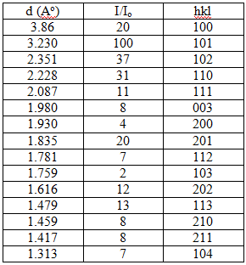
Table 1: 4-0554 MINOR CORRECTION
X-Ray Powder File Data for Hexagonal Te

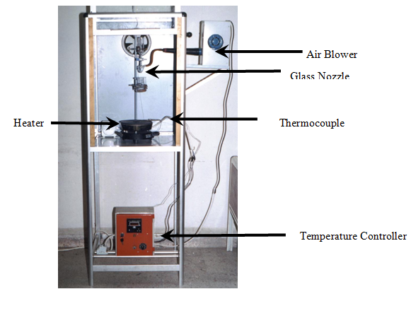
Figure 1 A photograph of the spraying pyrolysis system.

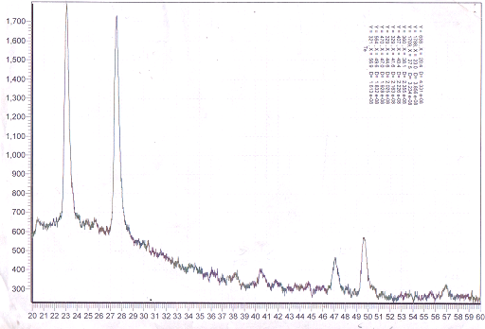
Figure 2: X-Ray diffraction of Tellurium thin film.

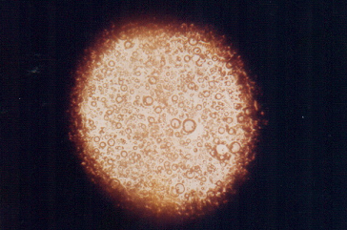
Figure 3: The topographical surface of Tellurium thin film. (x200 magnification)
Figure 4: Variation of conductivity of Tellurium thin film with temperature.
Figure 5: Plot of the Ln of conductivity
Vs. 1/T of Tellurium thin film.
Fig 5: Variation in Hall voltage of Tellurium film with current
Figure 6: Variation in Hall voltage of Tellurium thin film with current.
Fig 1: A photograph of spraying pyrolysis system

