Analyzing Domestic Refrigeration Cycle Performance Working With R409a As An Alternative For R134a

Mustafa Ahmed Abdel-Hussein
Dept of Machines and Equipments University of Technology
Abstract:
An experimental comparison have been conducted between R134a and R409a working in a domestic refrigeration cycle experimentally, the results showed that R409a have better C.O.P. and less power consumption for various ambient temperatures and degrees of superheating and sub-cooling. Also, the superheating affected the cycle performance as ambient temperature increases especially for R409a, while the condenser sub-cooling causes the cycle performance improvement at lower ambient temperature
الخلاصة
تم اجراء مقارنة عملية بين مائعي التثليج R134a و R409a في دورة تثليج انضغاطية منزلية لدراسة مدى تاثر كفاءة الدورة عند درجات حرارة خارجية مختلفة و اخذا بنظر الاعتبار تأثير التسخين و التبريد الموضعي كلا على حدة , اظهرت النتائج ان المائع R409a يعطي معامل اداء اعلى ومعدل استهلاك قدرة اقل من المائع R134a . كذلك لوحظ بان التسخين الموضعي يؤثر بشكل اكبر عند ارتفاع درجة حرارة المحيط للمائع R409a اكثر منه للمائع R134a , اما اثر التبريد الموضعي للمكثف فقد اظهر تحسنا" في معامل اداء الدورة واستهلاك اقل للقدرة عند درجات الحرارة الاقل .

Introduction:
Domestic refrigerators are widely used for food storage, commercial and non-commercial applications throughout the world. As a result many environmental effects related to refrigerants especially destroying the ozone layer and also affect the world’s global warming problem. Despite the HFC R134a nowadays is considered the main refrigerant for domestic applications for its good properties similar to the old CFCs and zero ozone depletion potential (ODP) effect, its high global warming potential (GWP) around (1300) [B.O. Bolaji , 2010] leaded to the searching for new alternatives, especially the HCs which are mainly zero ODP and low GWP.
B.O. Bolaji , 2010 investigated the HC R152a as an alternative to R134a that is zero ODP and GWP =140, he concluded that R152a refrigerant have slightly better refrigeration capacity and COP than R134a.
Experiments were carried out for the isobutene R600a as another alternative to R134a in a domestic refrigeration cycle by B.J. Nabhan, 2008 , she concluded that R600a can be used instead of R134a with slightly better performance characteristics such as shorter capillary tube, less operating pressures and less power consumption which results a higher obtained C.O.P.
K. Mani and V. Selladurai, 2006 made experimental study on a refrigeration system with R290/R600a refrigerant mixture as drop-in replacement for R-12 and R-134a. The system initially operates with R12. Experimental results showed that the mixture had 19.9% to 50.1% higher refrigerating capacity than R12 and 28.6% to 87.2% than R134a.The refrigerant R134a showed slightly lower refrigerating capacity than R12. The mixture consumed 6.8% to 17.4% more energy than R12.
M.G. He et al., 2007 investigated the performance of the mixture (R-152a/R-125) as an alternative for R-12 and R134a in a vapor compression refrigeration cycle, the mixture ratio was 85% to 15% of the two refrigerants respectively, they concluded that the mixture have a higher C.O.P. and compressor discharge temperature and lower evaporator and condenser operating pressures as compared to R-12 and vice versa to R134a.
The new R409a [HCFC-22, HCFC-142b, HCFC-124] (60/ 15/ 25) of % mass [DUPONT, 2004] is compatible with gaskets, seals, and lubricants used in old R-12 refrigeration systems, R409a is non flammable (A1 class.), has similar C.O.P. to R-12, and slightly higher compression ratio and temperature rise through compressor
In this paper, the investigation of the appropriate capillary tube selection for a domestic refrigerator designed for R134a charged with R409a taking into consideration the effect of partial super-heating and sub-cooling each separately, and the ambient temperature on the pressure drop refrigeration cycle, C.O.P., and power consumption for the two refrigerants.
The test rig layout:
A domestic refrigerator (5 ft³) shown in figure (1a&b), converted for R134a operation shows the distribution of measuring instruments used in analyzing refrigeration performance characteristics using the two refrigerants.
The main system specifications are as follows:
- The Evaporator:
Natural convection type, net area = 896 cm², material: Aluminum.
- The Condenser:
Natural convection type, net area = 3000 cm², material; Aluminum
- The Compressor:
Reciprocating type, Manufacturer: colanti corporation, refrigerant: R134a, oil type: polyester.
- Capillary tube: copper, the original system capillary tube specifications are (1.5) & (2.1) inner and outer diameter in millimeters respectively.
To verify the suitable size for the capillary tube when charging R-409a with the same R-134a charge (50 gm), the selection was made to avoid excessive capillary resistance [ASHRAE,1998] that causes abnormal compressor discharge pressure rise and suction pressure drop as well as obtaining similar evaporator pressure drop , this was achieved at capillary tube dimensions (1.8) and (2.5) mm.

The Measuring devices:
1- Pressure measurement:
Four Bourdon gauges were used to measure the pressure of the refrigerant at the following locations:-
A- HPG reads from 0 to 35 kg/cm², two located at compressor & condenser outlet.
B- LPG reads from -30cm Hg to 15 kg /cm², two located at compressor and evaporator inlet.

2- temperature measurement:
Five thermocouples type (k) reads from -50ºC to 1000ºC distributed as follows:
Two at compressor inlet & outlet.
One at condenser outlet.
One at evaporator inlet.
One for ambient temperature reading.
These thermocouples readings were taken via digital thermometer shown in figure
(1-a)
The temperature was measured by inserting the thermocouple node onto the pipes and then was insulated to neglect the ambient temperature effect.

3- Power measurement:
Digital clamp meter was used to measure the current and voltage input to compressor.

Superheating and sub -cooling:
- Superheating:
In order to change the required cooling load, an electric heater (dummy load) of 300 watt consumption is adjusted in the deep freeze compartment that rejects heat (as superheating effect) to the evaporation side of the cycle. This parameter is referred as the superheating temperature effect ΔTsh (freezer temperature rise).
- Sub cooling:
The sub cooling was conducted through converting the condenser from natural convection type to a forced convection via water spreading fan with velocity about 300 r.p.m., it injects water of about 0.8 kg/sec.

Experimental work procedure:
R409a does not work with polyester but compatible with R12 oil; so an oil exchange has been conducted when replacing the refrigerant to ensure similar operating conditions. The system was evacuated from air and humidity using vacuum compressor before system charging. Then, the system was pressurized using (50 gm) of R-134a and the leak test were performed via bubble test through applying soap solution, after that the system was operated till reaches 8 bar compressor discharge , the system was shut down and the leaks were detected and treated. Now the system is ready for operation.
When reaching steady state condition, the measured data were registered. Table (1) shows a sample of tabulated results obtained from system operation.
R134a, T_{amb}=35ºC |  | R409a, T_{amb}=35ºC |  | Reading
No superheating | ∆T_{sh}=5 ºC | No superheating | ∆T_{sh}=5 ºC | Reading
111.8 | 116.2 | 103.6 | 109.1 | Input power (watt)
3.94 | 3.98 | 4.04 | 4.09 | Compression ratio
29.6 | 31.1 | 25.71 | 27.4 | ∆T _{comp} (ºC)
25.6 | 27.7 | 22.0 | 27.3 | ∆T_{cond} (ºC)

Table (1) a sample of experimental data system operation
Results and discussion:
Figure (2) shows the effect of the ambient temperature on the coefficient of performance for the both refrigerants, it could be noticed that R-409a refrigerant has slightly higher C.O.P. than R-134a, also with increased ambient temperature the C.O.P. decreases this is due the decreased cooling efficiency obtained from lower condenser cooling rate.
The superheating affects adversely on C.O.P. for both the refrigerants especially for R-409a (at ∆Tsh>5 °C) as observed from figure (3) since it causes the refrigerant inlet condition to the compressor comes higher in the superheated region.
From figure (4) the evaporator pressure loss decreases with increased superheating for the two refrigerants , the reason for that is when superheating takes effect, the refrigerant comes closer to the liquid saturation line at evaporator exit leads to decreased rate of vaporization it is obvious that R-409a have relatively lower operating pressure than R-134a.
R409a has less power consumption than R-134a as shown in figure (5), also increasing cooling load affects the power consumed for the system with slightly higher for R-134a.due to the fact that more cooling load needs more higher operating cycle to reach the desired storage conditions.
On the other side the sub- cooling affects contrarily the above mentioned performance characteristics shown in figures (6&7), as additional sub-cooling causes more C.O.P. improvement and less power consumption because of decreased operating pressures and temperatures for both refrigerants operating cycle with slightly better correspondence for R409a refrigerant.
Conclusions:
- R409a have lower operating pressures and temperatures at different ambient temperatures and degrees of superheating and sub-cooling.
- This leads for higher C.O.P. for R409a than R134a. for the above conditions.
- R409a requires less power consumption for the same performance requirements.
Nomenclature and list of symbols:

Symbol | Definition
CFC | Chloru Fluoro Carbon
C.O.P. | Coefficient Of Performance
GWP | Global Warning Potential
HCFC | Hydro Chloru Fluoro Carbon
HFC | Hydro Chloru Carbon
HPG | High pressure gauge (kg/cm²)
LPG | Low pressure gauge (kg/cm²)
ODP | Ozone Depletion Potential
r.p.m. | Revolution per minute
∆T_{sh} | Degree of superheating(°C)
∆T_{sc} | Degree of sub-cooling (°C)
∆T_{comp} | Compressor temperature difference (°C)
∆T_{cond} | Condenser temperature difference (°C)

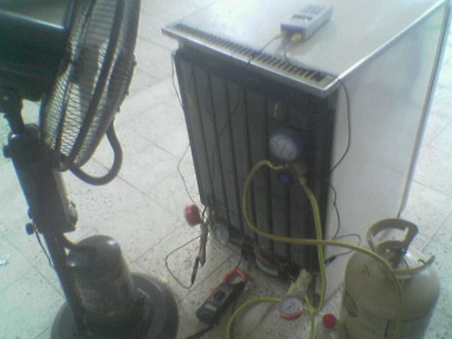

(a)

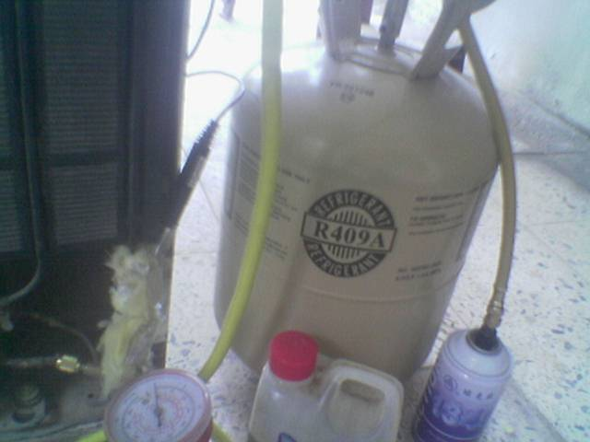

(b)

Figure (1): the experimental test rig

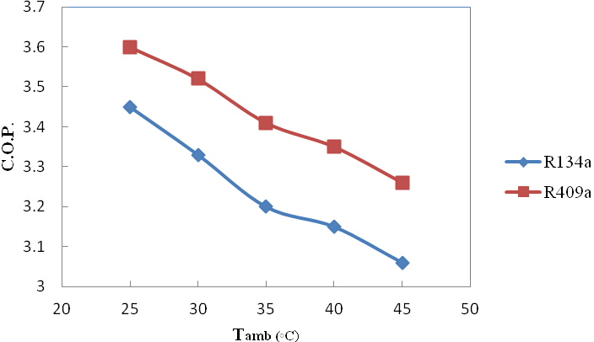
Figure (2): Ambient temperature effect on C.O.P for R409a and R134a

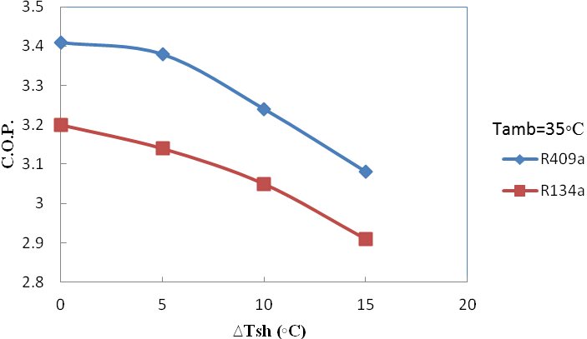
Figure (3): effect of superheating on the C.O.P. for R409a and R134a

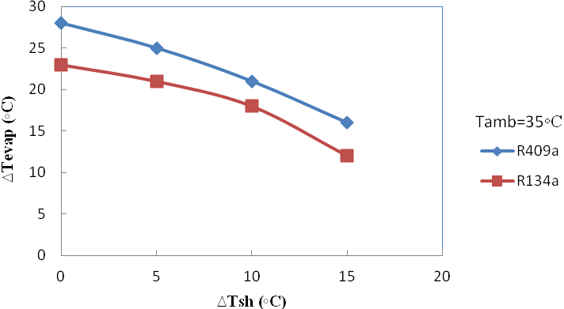
Figure (4): effect of superheating on evaporator temperature drop for R409a and R134a

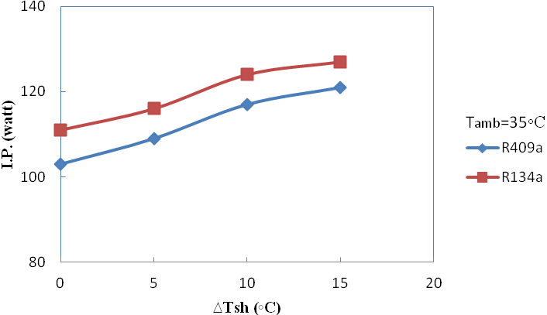

Figure (5): effect of superheating on input power for R409a and R134a

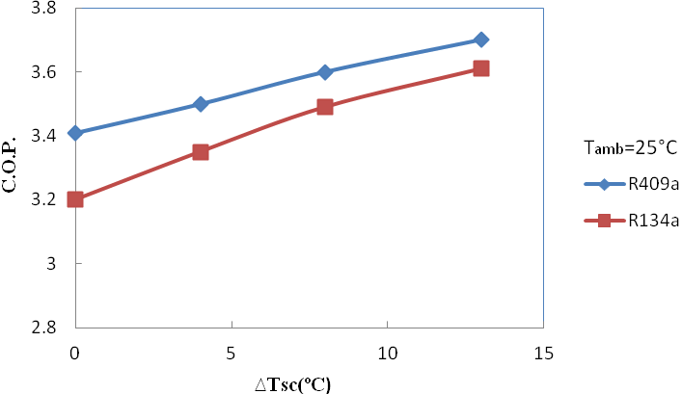

Figure (6): effect of sub cooling on C.O.P. for R409a and R134a

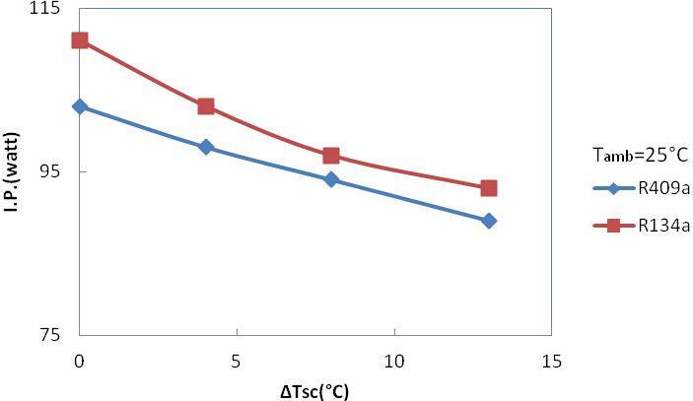
Figure (7): effect of sub cooling on input power for R409a and R134a

References:
ASHRAE handbook, 1998,” Refrigerant- Control Devices”, chapter 45, p: 5.
Bolaji, B. O.and Thammasat, S.A, 2010 “Effect of Sub-Cooling on the Performance of R12 Alternatives in a Domestic Refrigeration System” Int. J. Sc. Tech., Vol. 15, pp:24-38..
DuPont technical report no. P-MP/409A, 2004 “R409a refrigerant properties”, p: 3
He M. G. et al., 2007, “Testing of the mixing refrigerants HFC152a/HFC125 in domestic refrigerator”, J.Th.Sc, Vol.21, pp: 215-227.
Mani, K. and Selladurai, V., 2006, “Experimental analysis of a new refrigerant mixture as drop in replacement for CFC12 and HFC134a”, J.Th.Sc, Vol.20, pp: 67-81.
Nabhan B.J., 2008, “Experimental and Numerical analysis of adiabatic flow of substitute’s refrigerant in capillary tube”. MSc. Thesis, AlMustaniriya Univ., p:1.

