Influence of Titanium & Carbon Additions on the Phosphorous Modification Efficiency in Near Eutectic Al–14Si alloy

Talib Abdulameer Jasim Lamyaa Mahde Asaad
Babylon University /Materials Engineering University of Technology
Machines&Equipments Engineering Department,
Abstract
The influence of Titanium (Ti) & Carbon (C), as gray cast iron master alloy, additions on the structure modification efficiency of the phosphorous (P) in near eutectic Al–14Si alloy and the nucleating mechanism was studied in this work. The results show that the phosphorous modification efficiency can be significantly affected by this addition and the sizes of the primary Si particles can be obviously refined after the addition of trace Ti&C. Micro probe Analyzer (MPA) shows there is a coupling of aluminium phosphides (AlP) and Al₄C₃ particles in the center of primary Si. Moreover, the nucleation mechanism of primary Si by like-peritectic coupling of AlP and Al₄C₃ was presented. The formation mechanism of like-peritectic coupling of these particles was also discussed.
Keywords: Al–14Si alloy; Primary silicon; Modification; Nucleation mechanism
الخلاصة:
في هذا البحث تمت دراسة تاثير اضافة التيتانيوم والكربون،على شكل حديد الزهر الرمادي كسبيكة اشابة، على كفائة الفوسفور في تعديل البنية البلورية لسبيكة الالمنيوم- %14سليكون، كما تم ايضا دراسة سلوك التنوية لهذه السبيكة. لقد اظهرت النتائج بان كفائة تعديل الفوسفور للبنية البلورية تتاثر كثيرا بهذه الاضافة وان الحجم الحبيبي لدقائق السليكون الاولي تاثر هو الاخر بشكل ملحوظ باضافة التيتانيوم والكربون. ويظهرمجس التحليل المايكروي (MPA) ان هناك ارتباط بين دقائق فوسفيد الالمنيوم ودقائق كربيد الالمنيوم في مركز حبيبة السليكون الاولي. علاوة على ذلك فقد تم عرض الية تخليق دقائق السليكون الاولي بواسطة مزدوج شبه بيرتكتك لفوسفيد وكربيد الالمنيوم (AlP and Al₄C₃. تم ايضا مناقشة الية تكوين مزدوج شبيه البيرتكتك لتلك الدقائق.
1. Introduction
The excellent mechanical and casting properties of Aluminium-Silicon alloys promote to use these alloys widely in aerospace and transportation [ M. Harun et al, 1996], [S Nagarajan and B Duttaand, 1999], [ Henghua et al, 2008 ].Al–Si alloys that contain more than 12 wt.% Si exhibit hypereutectic microstructures, normally consisting of the primary silicon phase in the eutectic matrix [Henghua et al 2008]. More attentions are paid to hypereutectic Al–Si alloys than other aluminium alloys for aeronautic, astronautic, vacuum pumps and on automobile owing to their corrosion resistance good thermal conductivity, high wear resistance, lower density, higher thermal stability, and machinability, etc [Tomida et al, 2003]. The brittleness of coarse Si phases (both eutectic and primary silicon particles) is the main reason for the poor properties of AI-Si alloys because coarse silicon crystals have sharp edges that lead to premature crack initiation and fracture in tension [Sanoh, 1994].
As the desirable combination of characteristics of Al–Si near-eutectic and hypereutectic alloys depends on the topography and morphology of primary Si particles to a large extent, the modification of primary Si is being studied more widely. Various methods have been used for the modification of primary Si particles, such as rapid cooling [Nikanorov et al, 2005], low temperature casting, high cooling rate [Peijie Li et al, 2002] and various alloying additions [Teak-soo Kim et al, 2000]. Controls the microstructure using small addition of elements has been the most popular method due to its simplicity. Phosphorous has been the most widely used element for the modification of primary Si in near-eutectic and hypereutectic Al–Si alloys. Al–Ti–C, as a grain refiner of commercial purity aluminum and binary hypoeutectic Al–Si alloys, can be used to refine α-Al dendrites[C.L.Xu et al,2007],[J.R.Davis et al, 2001].
The present work discusses the effect mechanism of TiC particles, which added using gray cast iron and titanium powder with fluxes, on P modification efficiency in near eutectic Al–14Si alloys by using MPA and crystal lattice coherence analysis. This also provides new practical information for the neareutectic and hypereutectic Al–Si production industry.
2. Experimental procedure
The Al–Si alloy used in the experiments was produced by electric resistance-heating furnace using commercial purity aluminum (99.87%) and commercial pure silicon 99.97%. The chemical composition analysis was performed by using x-ray fluorescence spectrometer XRF type (X-Met 3000 TX, horizon 600 series), model 2004 as shown in Table 1. The near eutectic Al–14Si alloy was re-melted in a clay-bonded graphite crucible, heated in an electric resistance-heating furnace at 870 ◦C and held at this temperature for 20 min. under a cover was measured by of flux (45%NaCl + 45% KCl + 10% NaF). Part of the melt was poured into a copper-zinc alloy mould cooled by flowing cold water Figure (1) and sample no.1 was obtained without any additions or further treatment. Sample no.2 was obtained 20 min after the addition of 0.2%Cu₃p master alloy contains 15%P to the melt. Sample no.3 was obtained after 10 min. then a 0.016% of pure titanium powder and 0.058% of gray cast iron (3.47 wt% C) duly packed in aluminium foil and added to the melt. More Ti and cast iron was added until there was 0.16%Ti and 0.58%cast iron in the melt.
Table 1 Chemical composition of prepared samples
Samples | Wt.%Si | Wt.%Cu | Wt.%Mg | Wt.%Ni | Wt.%C | Wt.% p | Wt.%Ti | Al
1 | 14.11 | 0.002 | 0.001 | 0.002 | 0001 | 0.001 | 0.001 | Bal.
2 | 14.21 | 0.070 | 0.001 | 0.001 | 0.001 | 0.030 | 0.001 | Bal.
3 | 14.23 | 0.070 | 0.001 | 0.001 | 0.002 | 0.028 | 0.016 | Bal.
4 | 14.18 | 0.068 | 0.001 | 0.001 | 0.02 | 0.029 | 0.16 | Bal.
After 10 min, the melt was cast to prepare sample no.4. All samples were performed under a cover of flux (45%NaCl + 45% KCl + 10% NaF).
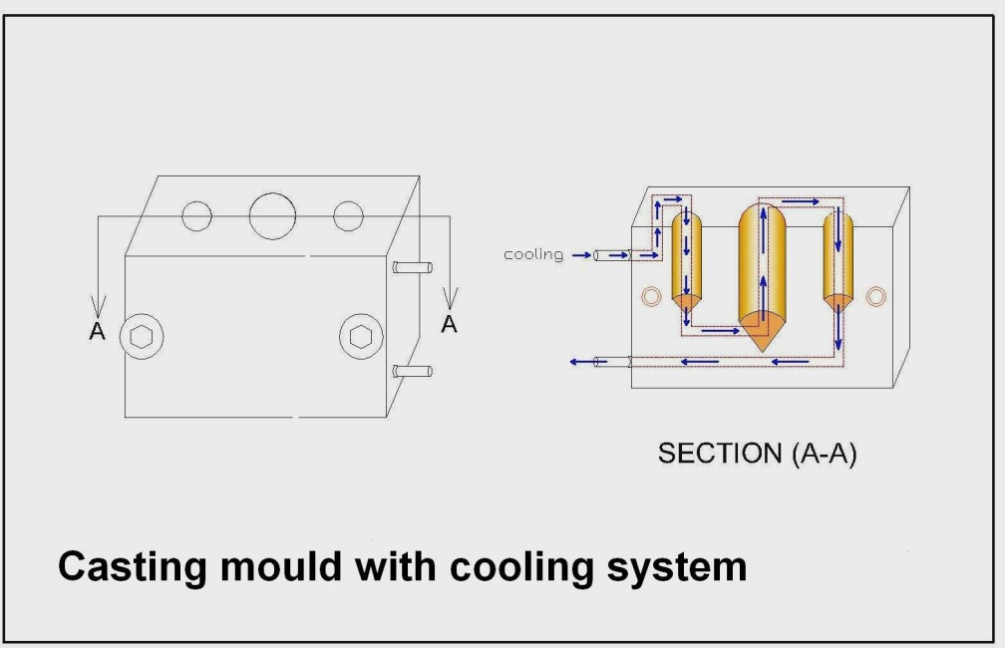
Figure 1 Casting mould
Another four samples were obtained in the same experiment process without the addition of Ti powder and cast iron chips for comparison. 0.2% Cu₃P master alloy was added to the near eutectic Al–14Si alloy and samples were taken after 30, 40, and 50 min, respectively. All the samples were poured into the same type of copper-zinc mould, preheated to 150 ◦C before casting.
The microstructure analysis was carried out on as-cast samples to investigate the morphologies and transformation of the silicon phase. Metallographic specimens were cut directly from 10mm above the bottom of the ingots and mechanically ground and polished using standard routines. The structure and qualitative analysis were conducted by using computerized light optical microscope, type LEICA DMRM connected equipped with a Sony video colour digital camera and also, some samples were investigated using a Hitachi S-3700N SEM equipped with a micro probe analyzer (MPA) and Energy Dispersive Spectrometer (EDS). The images were treated and analyzed with a Kapa Image Base Launcher program, in laboratories of Royal Institute of Technology (KTH) in Sweden
3. Results and discussion
Figure1 shows the microstructures of Al–14Si alloy before and after the addition of Cu₃P master alloy, Ti and C. There are a few primary Si grains in matrix of eutectic , and their sizes are large block-like and unequal, as shown in Figure 1(a).

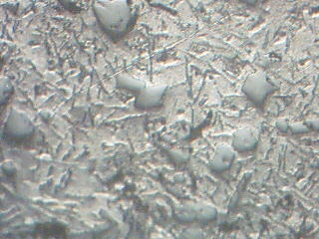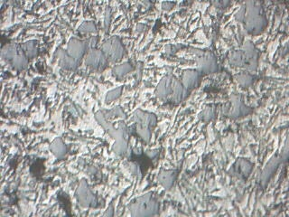
100
100
100
100
Primary Si
eutectic
a
b

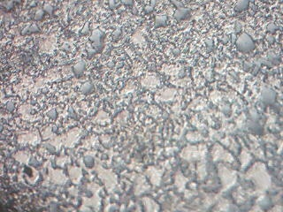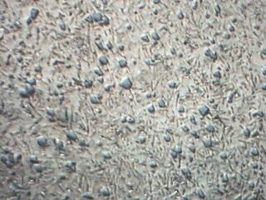
Fine Si- partecles.
c
d
Figure1 Microstructures of eutectic Al–Si alloy before and after the addition of 0.2%Cu₃P, Ti and cast iron master alloys: (a) Al–Si; (b) Al–Si + 0.2% Cu₃P; (c)Al–Si + 0.2% Cu₃P + 0.016%Ti and 0.058%cast iron; (d) Al–12.8Si + 0.2Cu₃P + 0.16Ti and 0.58%cast iron.
After the addition of 0.2% Cu₃P master alloy, there is an obvious phosphorous modification effect and the size of the primary Si decreased significantly. The holding time used in this experiment has no influence on the phosphorous modification effect of phosphorus modified Al–14Si alloy, which is consistent with the previous result [Min Zuo et al, 2009].
The phosphorous modification effect is retained after the addition of 0.2%Cu₃P, and 0.058% cast iron master alloy to the melt. The average size of the primary Si decreased from 60µm to approximately 12µm, indicating that the Ti and C improved the phosphorous modification effect.
In addition, when 10 times the Ti and cast iron master alloy was added to the melt, the positive phosphorous modification effect was retained as before without any poisoning phenomenon.
As mentioned in the literature [C.R. Ho, B. Cantor, 1995], AlP and Si are both diamond cubic with very similar lattice parameters. Primary Si nucleates heterogeneously on the solid AlP particles with a cube-to-cube orientation relationship and solidifies, which promotes the precipitation and refinement of primary silicon. According to this theory, Cu₃P master alloy can modify primary silicon effectively, as shown in figure1 (b).
Figure 2 presents the MPA image of a primary silicon nucleus in sample (4), (Al–14Si with the addition of both Cu₃P and Fe₃C master alloys), and there is a light particle inside the dark nucleus of the primary silicon.

^{15µm}

15µm

^{15µm}

a
b
c
^{SEI}
^{Al}l
^{Si}
e
^{15µm}

^{15µm}

^{15µm}

^{C}
f
^{P}
^{Ti}
d
Figure 2 MPA of a primary silicon nucleus: (a) SEI of the primary Si; (b–f) the X-ray images for respective elements, Al, Si, P, C and Ti.
The X-ray images show that the dark nucleus contains Al and P elements. This indicates that it was AlP compound. While the light particle contains Al and C, without Ti, which indicates that, the particle is Al₄C₃ compound. Furthermore, the Al₄C₃ particle lies in the center of the AlP compound.
Figure 3 shows another nucleus of the primary silicon in sample (4), and the compositions of the magnified nucleus in Figure 4. It is noted that the nucleus contains Al, P and C elements, without Ti.
^{15µm}

Figure 3 Another nucleus of the primary silicon in the Al–12.6Si added Cu₃P and cast iron master alloys.
Furthermore, the P and C are not overlapping each other, while they both overlap the Al, indicating that they are AlP and Al₄C₃ compounds, respectively.
a
b
^{15µm}

^{Al}
^{15µm}

^{Si}
ca
^{15µm}

^{Ti}
f
^{b}
aa
^{SEI}
^{15µm}

^{P}
da
^{15µm}

^{C}
e

^{15µm}

Figure 4 MPA of another primary silicon nucleus: (a) SEI of the primary Si; (b–f) the X-ray images for respective elements, Al, Si, P, C and Ti

This is similar to the result of Figure 2, since the Al₄C₃ compound is not surrounded with AlP compound but .adjacent to AlP compound.
In order to further confirm whether that the P and C elements overlap each other or not, the composition along the line C–D across the primary silicon in Figure 5(a) is illustrated in Figure 5(b). It can be concluded that there are two types of compound, AlP and Al₄C₃, in the nucleus of the primary silicon.
Liquid aluminium is capable of dissolving iron [John A. Taylor, 2000], this leads to thought that the aluminium melt dissolves the cast iron to free iron and carbon at 700°C.
In a pure Al system, a maximum in reactivity was observed in the liquid-state, between 700 and 750 ◦C, and carbon reacts with aluminium to form Al₄C₃ [V.H. Lo´ pez et al, 2003]. And then, Ti and Al combined together to form TiAl₁₃ [G.S. Vinod Kumar et al, 2005].
^{15µm}

^{C}
^{D}
a

^{b}

Figure 5 The distribution of chemical composition along the line across the primary silicon: (a) line (C–D) across the primary silicon; (b) chemical composition distribution along line C–D.
In this work, the melt was heated to a temperature of 780 ◦C. This is below the stable temperature of TiC in the melt. And then some Al₄C₃ compounds were formed through the following reaction:
Ti + 3C + 7Al → Al₄C₃ +TiAl₃ equation (1)
When Cu₃P master alloy is added into the melt, the below reaction can occur at 720°C [Min Zuo et al, 2009], then AlP particles formed.
Cu₃P[1] + Al[l] → 3Cu[l] + AlP[s] equation (2)

Many of AlP particles may not be absorbed by the Al melt because of the lower solubility of phosphorus and the density difference. The undissolved AlP particles don’t act as the nuclei of the primary Si crystals during solidification. It is well understood that there are only Ti, C and the Al in the melt. Thus, the improvement in the phosphorous modification effect is only due to the C. When C as cast iron form is added to the melt, the Al₄C₃ formed can absorb the AlP, coupling together as a like-peritectic reaction to form an AlP-rich transition layer around the Al₄C₃ particles, which can act as heterogeneous nucleating sites for the primary Si grains during solidification. With the dissolved AlP precipitating to Al₄C₃ compound, more AlP will dissolve into the Al melt. Therefore, most undissolved P can provide a modification effect after the addition of Ti and C particles (Al₄C₃ is unstable in air). Thus more AlP particles act as the nuclei of the primary silicon. And then increasing the quantity of the primary Si and decreasing the size, as shown in Figure 1(c) and (d). It can be concluded that the addition of Ti and C particles can significantly increase the absorptivity of P in the melt, greatly improving the modification effect of the Cu₃P master alloy. Heterogeneous nucleation can be regarded as a geometrically modified case of homogeneous nucleation by which the activation barrier is decreased by the presence of a foreign substrate. A purely geometrical calculation shows that when the solid/liquid interface of the substance is partly replaced by an area of low energy solid/solid interface between the crystal and a foreign solid, nucleation can be greatly facilitated. Normally, the potential of the foreign substrate in facilitating the nucleation process is estimated from the following relation:
f (θ) = (2 + cos θ)(1 − cos θ)/4 equation (3)
where θ is the wetting angle between the growing crystal and the foreign substrate within the melt. Under conditions of good solid/solid wetting, i.e. small θ, the foreign substrate can have an important effect on the nucleation process. Good solid/solid wetting is expected when there are planes of low lattice disregistry between the foreign substrate and the growing crystal. Therefore, the need for near-perfect epitaxial of AlP on at least one of the crystal faces of the Al₄C₃ substrate has been suggested as being essential for effective nucleation [Doru Michael Stefanescu, 2008].
It is well known that AlP is a diamond cubic with lattice parameter: a = 5.42 [C.R. Ho, B. Cantor, 1995], as shown in Figure 6. The Al atoms, shown in yellow, form a normal face-centered cubic, while the P atoms, Shown in blue, are distributed in the tetrahedral interstices of the crystal cell, with each P atom surrounded by four proximate Al atoms. Al₄C₃ is hexagonal with the lattice parameters: a = 3.335, c = 24.96, with the Al atoms located on the corner angles of a hexagon and in the centre of the back surface.
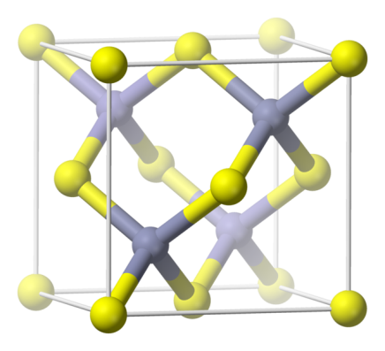

Figure 6 Crystal structure of (AlP) [en.wikipedia.org].
The holding time used in this experiment has no influence on the phosphorous modification effect. When there is a good coherent relationship existing on the interface of two types of phases, one phase can act as very fine heterogeneous nucleating site for the other phase [M.-X. Zhang et al, 2005]. The interatomic distance of the crystal face of the two phases should be close to each other, besides the atomic arrangement of the crystal faces should be similar. When the interface of two phases has a good coherent relationship, the interplanar distances should be also similar to each other. Based on the interplanar distances of Al₄C₃ and AlP crystals, and according to Turnbull–Vonnegut equation, the degree of disregistry δ is below 5% [Min Zuo et al, 2009]. This indicates that Al4C3 compound is a good nucleation substrate for AlP compound, and AlP can easily nucleate. And then a large number of evenly distributed nuclei are available for the primary silicon, so the quantity of the primary Si increases significantly. This leads to obtain fine primary silicon particles.
Conclusions:
- After the addition of 0.2% Cu₃P master alloy, there is an obvious phosphorous modification effect and the size of the primary Si decreased significantly.
- The holding time used in this experiment has no influence on the phosphorous modification effect.
- The phosphorous modification effect is retained after the addition of 0.2%Cu₃P, and 0.058% cast iron master alloy to the melt. The number of primary silicon particles increased and the average size of the primary Si decreased from 60µm to approximately 12µm, and the indicating that the Ti and C improved the phosphorous modification effect.
- When 10 times the Ti and cast iron master alloy was added to the melt, the positive phosphorous modification effect was retained as before without any poisoning phenomenon.
- There is an AlP-rich transition layer around or near to Al₄C₃ compound, which can act as the heterogeneous nuclei for the primary silicon grains, which is a possible mechanism for the improvement of phosphorous modification efficiency after the addition of trace TiC particles.
References
Davis.J.R. & Associates, Alloying, 2001 ASM International, Copyright © 2001,pp 351-404.

Doru Michael Stefanescu, Science and Engineering of Casting Solidification, Springer (2008) 380.
Harun ,M., Talib ,I.A. and Daud ,A.R. (1996), Effect of element additions on wear property of eutectic aluminium-silicon alloys. Wear 194, pp. 54–59.
Henghua ZHANG, Haili DUAN, Guangjie SHAO and Luoping XU, (2008), Refining grains of primary silicon of a hypereutectic aluminum-silicon alloy, Rare Metals, Volume 27, Issue 1, February, Pages 59–63
Cantor C.R. Ho, B. ((1995) Heterogeneous nucleation of solidification of Si in Al-Si and Al-Si-P alloys, Acta Metallurgica et Materialia; Journal Volume:43,3231-3246.
John A. Taylor, The Effect of Iron in Al-Si Casting Alloys, (2000), Cooperative Research Centre for Cast Metals Manufacturing (CAST), The University of Queensland , Brisbane, Australia

Kennedy A.R. *, Weston D.P., Jones M.I., (2001) ,Reaction in Al–TiC metal matrix composites, Materials Science and Engineering A316 ,32–38
Lo´ pez V.H., Scoles A., Kennedy A.R., Lopez V.H., Scoles A., Kennedy A.R., (2003) . The thermal stability of TiC particles in an Al7wt.%Si alloy, Materials Science and Engineering A356 ,316-325
Min Zuo, Xiangfa Liu, Hongshang Dai and Xiangjun Liu,( 2009), Al-Si-P master alloy and its modification and refinement performance on Al-Si alloys, Rare metals, vol. 28. No.4, Aug., P412-417.

Min Zuo, Xiangfa Liu, Hongshang Dai and Xiangjun Liu;( 2009), Al-Si-P master alloy and its modification and refinement performance on Al-Si alloys; Rare metals, Volume 28, Number 4 ,pp 412-417.
Nagarajan , Duttaand ,S, B MK Surappa; (1999)The effect of SiC particles on the size and morphology of eutectic silicon in cast A356/SiCp composites. Composites Science and technology. 59(6);897-902
Nikanorov S.P., Volkov M.P., Gurina V.N., Yu.A. Burenkov, Derkachenko L.I., B. K. Kardashev, L. L.Regel, W.R.Wilcox; (2005) ,Structural and mechanical properties of Al–Si alloys obtained by fast cooling of a levitated melt; Materials Science and Engineering A 390 ,63–69.
Peijie Li,V.I.Nikitin, E.G.Kandalova,K.V.Nikitin; (2002),Effect of melt overheating, cooling and solidification rates on Al-16%Si alloy structure; Materials science and engineering,A332,371-374
Sanoh.,( 1994),Spray formed aluminum alloy finds engine role J. Metal Powder Report, 49(1): 26-31.

Tomida S., Nakata K., Shibata S., Zenkouji, I. (2003),Improvement in wear resistance of hyper-eutectic Al-Si cast alloy by laser surface remelting, Surface and Coatings Technology, Volumes 169–170, 2 June Pages 468–471
Teak-soo Kim, C. Suryanarayana, Byong-Sun Chun; (2000), Effect of Alloying Elements and Degassing Pressure on The Structure and Mechanical Properties of Rapidly Solidified Al-20Si-5Fe-2X (X= Cr, Zr, or Ni) Alloys :Materials Science and Engineering, A278, 113-120.

Vinod Kumar G.S., Murty B.S., Chakraborty M., (2005) , Development of Al–Ti–C grain refiners and study of their grain refining efficiency on Al and Al–7Si alloy, Journal of Alloys and Compounds 396 ,143–150.
Xu C.L., Wang H.Y. , Yang Y,F., Jiang Q. C. ; (2007), Effect of Al-P-Ti-Tic –Nd2O3 modifier on the microstructure and mechanical properties of hypereutectic Al-20%Si alloy: Materials science and engineering A 452-453,341-346 .
Zeren M., Karakulak E., J. (2008) ,Influence of Ti addition on the microstructure and hardness properties of near-eutectic Al–Si alloys, Journal of Alloys and Compounds 450 ,255–259.
Zhang M.-X., Kelly P.M., Easton M.A., Taylor J.A., (2005),Crystallographic study of grain refinement in aluminium alloys using the edge-to-edge matching model, Acta Materialia, Volume 53, Issue 5, March, Pages 1427–1438.

http://en.wikipedia.org/wiki/Aluminium-phosphide (AlP)

