Improvement of Some Electrical Properties for PS-TiO₂ Composite.

Abd-ALraheem Khadim Abdd-Ali Hassan Jassim Mutlak
Faculty of Materials Engineering Department of Electrical Engineering
Israa Ali Hussien
Faculty of Materials Engineering
Abstract :
In this research the effect of filler content on improving some electrical properties of polystyrene filled with TiO₂ powder has been studied. For that purpose, the polystyrene (PS) samples with TiO₂ additive prepared with different percentages (0,5,10,15,20,25,30) wt.% . The results show that the D.C electrical conductivity of such composite improved about 52% when the concentration of TiO₂ is increased.
Also the results show that the dielectric constant, dielectric loss, are improved about 51%,77% respectively,and A.C electrical resistivity are changed with changing the concentration of the filler and frequency of applied electrical field, that means the A.C electrical conductivity of PS-TiO₂ is improved about 86%. The results show good improvement in electrical properties of this research that agreed with theoretical principles.
الخلاصة:
في هذا البحث تم دراسة تاثير اضافة اوكسيد التيتانيوم على تحسين بعض الخواص الكهربائية للبولي ستايرين المقوى بمسحوق اوكسيد التيتانيوم .لذلك تم تحضير عينات من من البولي ستايرين المضاف له اوكسيد التيتانيوم بنسب وزنية مختلفة وهي %wt(30,25,20,15,10, 5,0) .النتائج أظهرت ان الموصلية الكهربائية المستمرة تتحسن مع زيادة تركيز اوكسيد التيتانيوم بمقدار 52% .كما اظهرت النتائج ان ثابت العزل والفقدان العزلي يتحسنان بمقدار 51% ,77% على التوالي وكذلك المقاومة الكهربائية بالتيارالكهربائي المتناوب تتغير مما يدل على إن الموصلية الكهربائية المتناوبة تتحسن بمقدار 86% مع تغيير تركيز اوكسيد التيتانيوم المضاف وتردد المجال الكهربائي المسلط. النتائج اظهرت تحسن جيد في الخواص الكهربائية لهذا البحث مما يتفق مع المبادئ النظرية.
Introduction
Composite materials, which are usually fabricated with an emphasis on properties such as mechanical strength, have also been used in electronic applications One such class of composite materials is particulate- filled conductive polymer matrix composites . Because of the technological importance of these composites, their electrical properties have been widely studied.( (Vishal Singh et al., 2003). Recently polymer matrix-ceramic filler composites are receiving increased attention due to their interesting electrical and electronic properties. Integrated decoupling capacitors, angular acceleration accelerometers, acoustic emission sensors electronic packaging, and organic solar cells are some potential applications(Janne Halme, 2002). Ceramic materials are typically brittle, possess low dielectric strength and in many cases are difficult to be processed requiring high temperature. On the other hand, polymers are flexible, can be easily processed at low temperatures and exhibit high dielectric at low temperatures and exhibit high dielectric break-down fields (Kontos et al., 2007). Polystyrene is a preferred material in electronic technology due to its dielectric and mechanical properties and its low costs .A surprising property of filled polymer composites is their conductivity profile as a function of filler concentration it is found that their conductivity does not increase continuously with increasing filler content, but shows a sudden jump to higher conductivity. This conductivity behavior resulting a sudden insulator – conductor transition is a scribed to percolation process, and the critical filler concentration at which the conductivity jump occurs is called percolation threshold (Bhatlacharya et al., 2008). Kontos et al., (2007) studied The dielectric response of polymer composites consisting of an epoxy resin matrix and rutile TiO₂ ceramic filler The relaxation phenomena recorded include contributions from both the polymeric matrix and the reinforcing phase resin. . The DC electrical conductivity of all samples was evaluated at 0.1 Hz, where a leveling off of the corresponding curves is observed at the relatively high temperatures. DC electrical conductivity increases with increasing temperature following the VTF model . Vishal Singh et al.,(2003) studied Dielectric properties of Al–epoxy composites were characterized as a function of composition, frequency, and temperature The dielectric constant increased smoothly with an increase in the concentration of aluminum An increase in dielectric constant was also observed with an increase in temperature as well as with a decrease in frequency. In general, dissipation factor values for composites with higher concentrations of aluminum were greater than those with lower volume content of aluminum. Also, the dissipation factor showed an increase both with a decrease in frequency and an increase in temperature. Bahaa et al.,(2010) studied the effect of the addition of TiO₂ on some electrical properties of poly-methyl methacrylate . They show that the D.C. electrical conductivity changes when the concentration of additional TiO₂ increases and when the temperature increases. Also the activation energy changes when the additional TiO₂ increases. The aim of this work deals with the effect of TiO₂ on improvement some electrical properties of polystyrene.

Experimental work
The material used in the present paper is the polystyrene as matrix and TiO₂ as a filler with purity about 99.8%. Electronic balances of accuracy 10^{–4} have been used to obtain a weight amount of TiO₂ powder and polymer powder. These are mixed by hand lay up and the microscopic examination is used to obtain homogenized mixture. The weight percentages of TiO₂ are (0, 5, 10, 15, 20,25,30) wt.% The Hot Press method is used to press the powder mixture. The mixture of different TiO₂ percentages have been compacted at temperature 175ºC under a pressure of 100 par for 10 minutes. It is cooled to room temperature, the samples were disc shaped of a diameter of about 15 mm and thickness ranging between (1.055-1.52) mm .The coating unite(Edwared coating System E3C6A) has been used for deposition of thin film Aluminum electrode on both sides of each sample. The volume electrical conductivity σ_{ν} is defined as:(Posh, et al.,1972)

σ_{ν}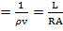 (1)

where:
A = guard electrode effective area.
R = volume resistance (Ohm).
L = average thickness of sample (cm).
In this model the electrodes have circular area A=D2π/4 where D=1.1 cm.
The dielectric properties of PS-TiO₂ composite were measured using (Agilent impedance analyzer 4294A).
In the frequency(f) range (25×102-5×106) Hz at room temperature. The measured capacitance (w) was used to calculate the dielectric constant ,έ(w) using the following expression:
έ(w) =C(w) d/A ε₀ (2)
Where d is sample thickness and A is surface area of the sample . whereas for dielectric loss
ε"(w):
ε"(w) = έ(w) × tanδ(w) (3)
Where: tanδ(w) is dissipation factor
Results and Discussion
Figure 1 shows the electrical volume conductivity enhancement of the composite by increasing the concentration of TiO₂ filler . The increase of conductivity with increasing concentration of TiO₂ is due to the increase of the charge carriers, which increase with the increase of filler contact, where the TiO₂ particles at low concentrations are represented by small darker regions. They become large when the TiO₂ content increases and the networks connect each other as illustrated in the microscopic photographs in Fig. 5 taken for samples of different concentrations (Szczepanik et al.,2009, Srivastava and Mehra, 2009).

-1

Fig(1):Variation of D.C Electrical Conductivity with TiO₂ concentration
for PS-TiO₂ composite

.

The variation of dielectric constant for PS- TiO₂ composites of different Titian concentration as function of frequency at room temperature is shown in figure (2). At low frequency region in addition to polarization due to PS and TiO₂ , the space charge polarization plays a major role in increasing dielectric constant of composite [Hamzah et al, 2009]. The space charge polarization arises from the PS/ TiO₂ interfaces. The dielectric constant increases with weight fraction of TiO₂. The increase in dielectric constant with weight fraction of TiO₂ supports the fact of the space charge polarization contribution. The dielectric constant of composite increases with addition of TiO₂ reflects the formation of capacitance network of TiO₂ (M. Revanasiddappa, 2008).

Fig(2): Variation of Dielectric Constant with frequency for PS-TiO₂ Composite.

The variation of the dielectric loss of PS-TiO₂ composites as a function of frequency at room temperature is shown in figure (3) , the values of dielectric loss are high for frequencies, and decreasing with frequency and increases to reach maximum. The oscillatory behavior of dielectric loss may be due to some relaxation processes which usually occur in heterogeneous system. The relaxation peak at W=3.5 MHz is appears clearly in all low TiO₂ concentration on specimens. The increasing of TiO₂ concentrationincreases the height of the peak and increasing its broadness for these specimens. This is due to the overlapping of relaxation process which are attributed to some structural changes that take place in the composite as result of filler addition . The increasing of the peak height of dielectric loss with increasing TiO₂ concentration indicates the enhancement of conductivity in these specimens , i.e. enhancement of losses (Raghavendra et al,2007, Pillal,1980).

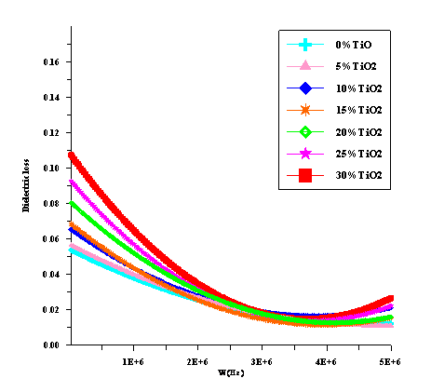
Fig(3): Variation of Dielectric Loss with frequency for PS-TiO₂ Composite.

The variation of A.C electrical resistivity as a function of frequency for (PS-TiO₂) composites at 303K is given in figure (4). The figure shows that in low, intermediate and higher frequency region the electrical resistivity for all (PS-TiO₂) composites is decreasing with The D.C and A.C Electrical Properties of (PS-TiO₂) Composite frequency. We conclude from that the A.C electrical conductivity is increased with increasing the frequency. The increasing of A.C electrical conductivity in high frequency region can be related to the electronic polarization as well as to the hopping of charge carrier over a small barrier height. The figure also indicates that σA.C is increasing with increasing TiO₂wt.% content, a result which supports the suggestion of hopping of charge carrier conduction mechanism. The increasing of A.C electrical conductivity with angular frequency in the low frequency region can be attributed to the interfacial polarization (Hamzah et al., 2009).
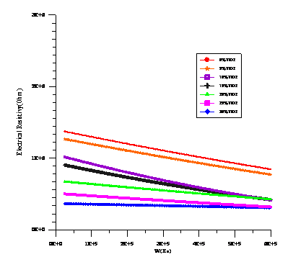
Fig( 4): Variation of A.C Electrical Resistivity with frequency of PS-TiO₂ Composite.
-cm

Conclusion
- The D.C electrical conductivity of the polystyrene increases by
increasing the TiO₂ concentrations and the temperature.
- The dielectric constant decreasing with the frequency and increase with TiO₂ wt.% content .
- The dielectric loss is oscillatory in the whole frequency region and increase with increasing TiO₂ wt.% content .
4.The A.C electrical resistivity of PS-TiO₂ composites is decreasing with
increasing frequency of applied electrical field and TiO₂ wt.% content. We
conclude that the A.C electrical conductivity is increased with increasing the
frequency of applied electrical field and TiO₂ wt.% content. As we mention in
equation (1)
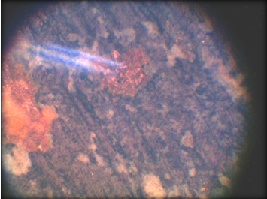
b-
a-
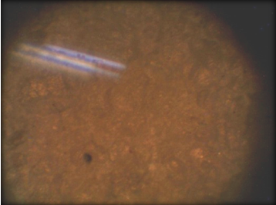
a-

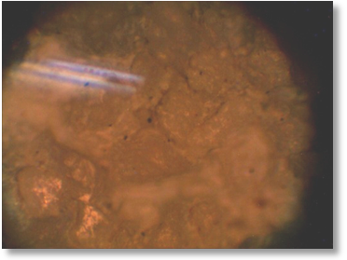
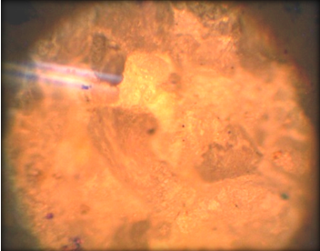
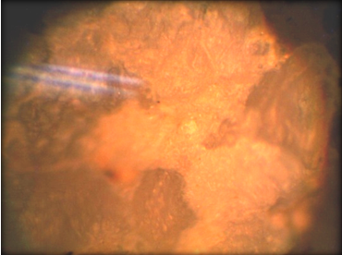
c-
d-
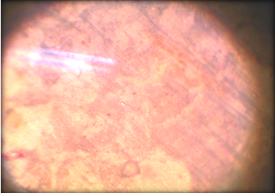
e-
f-

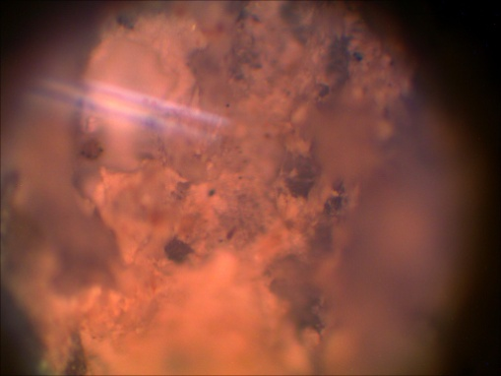

g-

Photomicrographs for Ps-TiO2 composite 5 Fig.
TiO2, b-5% TiO2,c-10%TiO2,d-15%TiO2,e-20%TiO %a-0
f-25%TiO2, g-30%TiO2 600X

Acknowledgments
This work was partially supported by the Ministry of Science and Technology –Iraq –Baghdad/in Ceramic Department, and their staff to achieve all electrical testes .
References
Vishal Singh, A. R. Kulkarni, T. R. Rama Mohan,2003," Dielectric Properties of Aluminum–Epoxy Composites" ,Journal of Applied Polymer Science, Vol. 90,pp. 3602–3608.
Kontos G. A. , Soulintzis A. L. , Karahaliou P. K. , Psarras G. C. , Georga S. N. ,
Krontiras C. A. , Pisanias M. N. , 2007, "Electrical relaxation dynamics in TiO2 – polymer matrix Composites", eXPRESS Polymer Letters Vol.1, No.12 ,pp.781–789.
Janne Halme,2002,"Dye-sensitized nanostructured and organic photovoltaic cells:
technical review and preliminary tests", MSc. Thesis , Helsinki University of Technology, Department of Engineering Physics and Mathematics.
Bhattacharya S., Sachdev V.K., Tandon, 2008,"Electrical properties of Graphite filled polymer composites", 2nd National Con R.P. ference Mathematical Techniques: Emerging Paradigms for Electronics and IT Industries, pp.100-101.
Bahaa Hussein, Marwa Abdul-Muhsen ,Ahmed Hashim ,2010,"Study of some electrical properties for PMMA-TiO2 composites" ,J. of Atti Della, Fondazione Giorgio Ronchi .
Szczepanik M. , Stabik J. , £azarczyk M. , Dybowska A. , 2009, "Influence of graphiteon electrical properties of polymeric composites ", Archives of Materials Science and Engineering, Vol. 37,Issue 1, pp.37-44.
Srivastava N. K. , Mehra R. M. ,2009," Study of the electrical properties
of polystyrene–foliated graphite composite" , Materials Science-Poland, Vol. 27, No. 1,pp.109-122.
Revanasiddappa M. , Syed Khasim, Raghavendra S. C. , Basavaraja C. , Suresh T. and Angadi S. D , 2008, “Electrical Conductivity Studies on Co(II), Cu(II),Ni(II) and Cd(II) Complexes of Azines”, E-J.Chem, Vol .5, No.4, pp.797-801.
Hamzah M., Saion E. , Kassim A. , Mahmud E. and Shahrim I., 2009, "J. for the advancement of Sci", Vol. 1, No. 1, pp. 9-14.
Pillal P. K. C and Rashmi , 1980"Dielectric properties of polystyrene and some Releated polymers ", Britain, Intern. J. polymeric mater , Vol. 8 , pp.255-263.
Posh F. ,Franses J. ,1972, " The Physic Principals " , Mac grew Hill Inc.

