Transmitting Loop Antenna for Efficiency Enhancement

Jabbar S. Hussein Ahmed A. Aouda, Alhussain
Karbala University University College of Engineering
Abstract:
The single-turn loop antenna is a metallic conductor bent into the shape of a closed curve, such as a circle or a square, with a gap in the conductor to form the terminals. A multi-turn loop or coil is a series connection of overlaying turns. The loop is one of the primary antenna structures; its use as a receiving antenna dates back to the early experiments of Hertz on the propagation of electromagnetic waves. It is poor antenna in transmission, so to use such an antenna; it must enhance to get butter performance in power (gain), bandwidth and efficiency. Here, some ways that makes this antenna suitable for transmission by changing the cross-section diameter and the structure of material that made.
الخلاصة:
هوائي الحلقي ذو الحلقة الواحدة هو موصل معدني منحن على شكل منحني مغلق مثل المربع أو الدائري مع فجوة بين الموصلين لصنع التوصيلة. هوائي متعدد الحلقات هو مجموعة من الحلقات مربوطة سوية، يعتبر الهوائي الحلقي من أنواع الهوائيات الرئيسية حيث يستعمل بشكل رئيسي للاستقبال وهو هوائي فقير إذا استعمل للإرسال، لذالك لتحسين هذا الهوائي في حالة الإرسال يجب تحسين القدرة (الربح) وعرض الحزمة وكذالك كفاءة الهوائي. لدينا هنا بعض الطرق لجعل هذا الهوائي يعمل بصورة جيدة على الإرسال بواسطة التحكم بقطر المقطع العرضي للهوائي وكذلك بنوعية المادة المصنوع منها.
1- Introduction:
Loop antennas form another antenna type, which features simplicity, low cost and versatility. Loop antennas can have various shapes: circular, triangular, square, elliptical, etc. They are widely used in applications up to the microwave bands (up to ≈3 GHz). In fact, they are often used as electromagnetic (EM) field probes in the microwave bands, too.
Loop antennas are usually classified as electrically small (C< 0.1λ) and electrically large (C~ λ). Electrically small loops of single turn have very small radiation resistance (comparable to their loss resistance). Their radiation resistance though can be substantially improved by adding more turns. Multi-turn loops have better radiation resistance but their efficiency is still very poor. That is why they are used predominantly as receiving antennas, where losses are not so important. The radiation characteristics of a small loop antenna can be additionally improved by inserting a ferromagnetic core. Radio-receivers of AM broadcast are usually equipped with ferrite-loop antennas. Such antennas are widely used in pagers, too. [Simth2007]
The small loops, regardless of their shape, have a far-field pattern very similar to that of a small dipole (normal to the plane of the loop), which is to be expected because of the equivalence of a magnetic dipole and a small current loop. Of course, the field polarization is orthogonal to that of a dipole.
As the circumference of the loop increases, the pattern maximum shifts towards the loop’s normal, and when C ≈λ, the maximum of the pattern is at the loop’s normal. [Nikolova2003]
2- The loop as a receiving antenna: [Nikolova2003]
The small loop antennas have the following features: High radiation resistance provided multi-turn ferrite-core, Constructions are used,
High losses, therefore, low radiation efficiency, Simple construction, small size and weight.
Small loop antennas are never used as transmitting antennas due to their low efficiency. However, they are very much preferred as receiving antennas in AM radio-receivers because of their high signal-to-noise ratio (they can be easily tuned to form a very high-Q resonant circuit), their small size and low cost.
Loops are constructed as magnetic field probes to measure magnetic flux densities. At higher frequencies (UHF and microwave), loops are used to measure the EM field intensity. In this case, no ferrite rods are used.
It is obvious that the loop has to be oriented properly to optimize the reception. As in Fig. (1), the optimal reception depends not only on the direction from which the incident wave approaches but also on the field polarization.
Fig. (1)The optimal reception of circular Loop Antenna
3-Transmitting Loop:[Edwards2010]
The electromagnetic field of an electrically small loop antenna is the same as that of a magnetic dipole with moment m = I_{o} NA:

…………… (1)

Fig. 2:Loop antenna and accompanying spherical coordinate system
Fig. 3:Far-zone vertical-plane field
pattern of an electrically small loop

in which the plane of the loop is normal to the polar axis of the spherical coordinate system (r, θ, Φ) centered at the loop, as shown in Figure 2. In the far zone of the loop (lim βr → ∞), only the leading terms in Eqs. 2 and 3 are significant, and the field pattern for both E_{Φ} and B_{θ} in the vertical plane is the simple figure eight shown in Figure 3.
The driving-point voltage and current are related through the input impedance of the loop, V = ZI_{o}. For electrically small loops, the impedance is the series combination of the reactance of the external inductance Le with the radiation resistance R^{r} and the internal impedance of the conductor Z^{i} = R^{i} + jwL^{i}:
…(2)

The internal resistance R^{i} accounts for ohmic loss. In the equivalent circuit for the small loop, a lumped capacitance C is sometimes placed in parallel with Z to account for the distributed capacitance between the sides of a single turn and between the turns of a solenoid, as shown in Figure 4. Note that a loop with a truly uniform current distribution would have no capacitance, since from the equation of continuity there would be no charge along the conductor of the loop.
The radiation resistance of the small loop is proportional to the square of the product of the area and the number of turns:
…….(3)
For single-turn loops and solenoidal coils whose turns are not too closely spaced, the internal impedance is approximately
Z^{i} = z^{i} × total length of conductor ……(4)
Fig. (4) Equivalent circuit for input impedance Z of an electrically small loop in which zi is the internal impedance per unit length of a straight conductor with the same cross section as the loop conductor. If the turns of the coil are closely spaced, the proximity effect must also be included in determining Z^{i}.
The external inductance is determined from one of the many formulas available for the inductance of coils:6 For a single-turn circular loop
…….. …..(5)
And for a single-turn square loop
…….…….(6)

The external inductance of a tightly wound single-layer solenoidal coil with (N turns, length lc, and radius b) is often approximated by Lorenz’s formula for the inductance of a circumferentially directed current sheet. Numerical results from this formula can be put in a form convenient for application:
…………..…….(7)
In which the factor K, known as Nagaoka’s constant, is shown as a function of the ratio lc/2b (length of the coil to the diameter) in Figure 5. Note that, for a long coil (lc/2b >> 1), K ≈ 1. The use of Eq. 7 assumes that the turns of the coil are so closely spaced that the winding pitch and insulation on the conductors can be ignored; if highly accurate calculations of (Le) are necessary, corrections for these factors are available in the literature. The radiation efficiency of the electrically small transmitting loop antenna is:
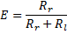
……………………(8)

The ohmic resistance R_{l} is often comparable to or larger than the radiation resistance R_{r}, so the radiation efficiency can be low. It can be increased by decreasing the ohmic resistance of the loop, i.e., by using a conductor of lower resistivity or larger radius.
4- Ferrite loops:[Betke200]
By inserting a ferrite core, the radiation resistance and radiation efficiency can be raised. which has high magnetic permeability in the operating frequency band. Large magnetic permeability µ= µ_{o}µ_{r} means large magnetic flux Ψ_{m}, and therefore large induced voltage V_{oc} . The radiation resistance of a small loop was already derived in:
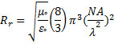
………….(9)

Equation (9) above to include the number of turns, and it was shown that it increases as ~ N² . Now the magnetic properties of the loop will be included in the expression for R_{r} .
The magnetic properties of a ferrite core depend not only on the relative magnetic permeability µ_{r} of the material it is made of but also on its geometry. The increase in the magnetic flux is then more realistically represented by the effective relative permeability (effective magnetic constant) µ_{reff} .
Here A=πb² is the loop area,
Some notes will be made with regard to the properties of ferrite cores.
The effective magnetic constant of a ferrite core is always less
than the magnetic constant of the ferromagnetic material it is made of, i.e. µ_{reff} < µ_{r}. Toroidal cores have the highest µ_{reff} and ferrite-stick cores have the lowest µ_{eff} . The effective magnetic constant is frequency dependent. The magnetic losses of ferromagnetic materials increase with frequency. At very high (microwave) frequencies, the magnetic losses are not negligible. They have to be calculated and represented in the equivalent circuit of the antenna as a shunt conductance Gm.
5- Previous Works:
Several studies about the using loop antenna, here some of them that
intact with the subject we discuss:
5:1-Performance of a superconducting wire loop antenna
The performance evaluation of a superconducting circular wire loop antenna fabricated using YBCO prepared by a novel microwave method is reported. Compared to the conventional antennas, fabricated using copper, this antenna shows a gain enhancement of about 5 dB. The use of the cold wire extrusion principle eliminates the necessity of the low-loss substrate for the fabrication of YBCO antennas, which are normally brittle and of low strength. This high-gain antenna may find applications in satellite technology.[Mukundan2009]
5:2-Investigation of circularly polarized loop antennas with a parasitic element for bandwidth enhancement
It is demonstrated that the bandwidth of circular polarization (CP) can be significantly increased when one more parasitic loop is added inside the original loop. A single-loop antenna has only one minimum axial ratio (AR) point while the two-loop antenna can create two minimum AR points. An appropriate combination of the two minimum AR points results in a significant enhancement for the CP bandwidth. Several loop configurations, including a circular loop, a rhombic loop, and a dual rhombic loop with a series feed and a parallel feed, are investigated. The AR (≤2 dB) bandwidth of the circular-loop antenna with a parasitic circular loop is found to be 20%, more than three times the AR bandwidth of a single loop. For the rhombic-loop antenna with a parasitic rhombic loop, an AR bandwidth (AR≤2dB) of more than 40% can be achieved by changing the rhombus vertex angle. The AR (≤2 dB) bandwidths of the series-fed and parallel-fed dual rhombic-loop antennas with a parasitic element are 30% and 50%, respectively. A broad-band balun is incorporated into the series-fed dual rhombic-loop antenna for impedance matching. The broad-band CP performance of the loop antennas is verified by experimental results.[Ronglin2009]
5:3-Circularly Polarized Loop Antennas with a Parasitic Element for Bandwidth Enhancement:
It is demonstrated that the bandwidth of circular polarization (CP) for a loop antenna can be significantly increased when adding one more parasitic loop inside the original loop. The axial ratio (AR≤2 dB) bandwidth of the circular-loop antenna with a parasitic circular loop is found to be 20%, more than three times the AR bandwidth (about 6.5%) of a single loop. A bandwidth of 30% (AR≤2 dB) with a gain of more than 10 dBi is obtained for a series-fed dual rhombic-loop antenna while abandwidth of 50% for AR ≤2 dB can be realized for the parallel-fed dual rhombic loop.
This type of wideband CP antennas has two important features: i) easy to change the sense of CP; ii) able to implement an antenna array in a coplanar stripline circuit[Li 2006].
5:4-Wideband probe-fed circularly polarized circular loop antenna
A wideband probe-fed circularly polarized circular loop antenna is presented. The wideband performance is achieved by introducing a parasitic loop inside the original loop that is driven by a feed probe. It is found that the 2 dB axial ratio bandwidth can be increased from 6% for a single circular loop to 16% by the introduction of a parasitic loop.
5:5- Development of Wideband Circularly Polarized Square- and Rectangular-Loop Antennas
A new type of wideband circularly polarized (CP) square- and rectangular-loop antennas is developed and discussed. It is shown that the bandwidth for circular polarization of a loop antenna can be significantly increased by adding a parasitic loop inside the original loop. The addition of the parasitic element can create one more minimum axial ratio (AR) point, which can appropriately combine with the original one, leading to a significant enhancement for the AR bandwidth. It is found that the AR (≤ 2 dB) bandwidth of a square-loop antenna can be increased from 6.5% to 20% by adding a parasitic square loop. By replacing the square loop with a rectangular loop, the AR bandwidth can be further enhanced. For a rectangular loop with an aspect ratio of 1/2, a bandwidth of nearly 50% for AR≤ 2 dB is obtained with a gain of 8.5-7.5 dBi. A broadband balun is introduced for impedance matching [LZ1AQ, 2010].

6- Results:[Fiske2006],[Scutt2010],[Adam2002],[Edward2010]
,[Callister 2007],[Hayat 2006]
From figures (5) - (8) below it's found that the efficiency be optimum by two ways: first by choosing a material such that conducting polymer with conductivity σ_{c}≥1(Ω⁻¹m⁻¹) and this polymer is suitable for loop antenna structure with core of air, second by changing the cross-sectional diameter (d) and the loop diameter (b=λ/2).If the cross- sectional diameter in (mm) the higher the conductivity the higher the efficiency, the lower the ohmic resistance and that shown in Fig(5) below. If the structure is made of a material with conductivity less than (1) the higher is (d) the higher is efficiency with lower ohmic resistance as shown in figures below.
-From Figure (5), higher efficiency with high conductivity but low diameter. Where in Figure (6), a higher efficiency with frequency also with lower diameter, in Figure (7), a low ohmic resistor can be gat with higher cross-section diameter. Finally, in Figure (8), a higher efficiency with high diameter for low surface resistor R_{s}.
Form above, a transmitting loop antenna with good efficiency is down in two ways: First higher efficiency with high conductivity but low diameter, Second, a low ohmic resistor can be gat with higher cross-section diameter that give higher efficiency.

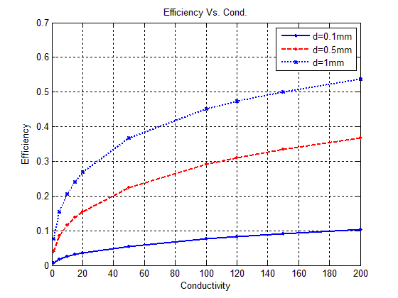
Fig.(5) Efficiency Vs. Conductivity f=1MHz d=5mm

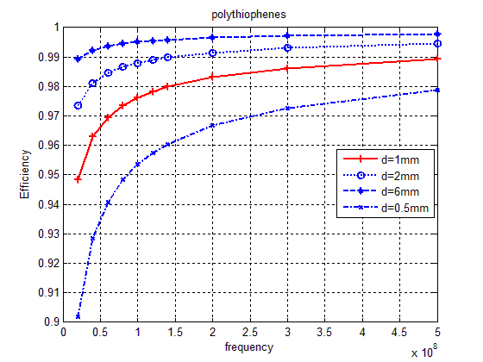
Fig.(6) Efficiency Vs. Frequency*10⁸ (Hz) for different cross-
Sectional diameter.

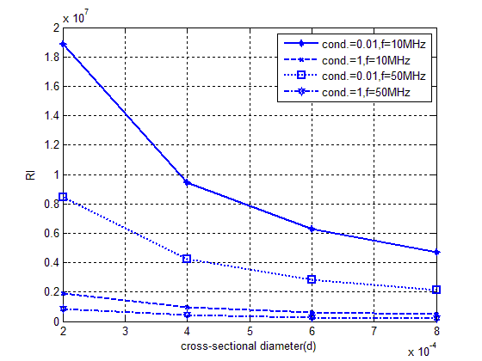
Fig.(7) Ohmic resistance (R_{l}) Vs. (d ) for different type of materials.

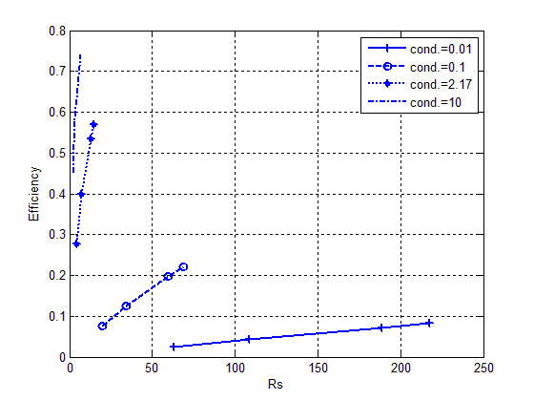
Fig.(8) E Vs. Rs for different values of the conductivity with d=1mm.
7-Conclusions:
As shown in figures above, loop antenna can be used in transmission efficiently, and this down in two method: 1st method, using material such that conducting polymer with conductivity σ_{c}≥1(Ω⁻¹m⁻¹) and this polymer is suitable for loop antenna structure with core of air, where an efficiency about (≈54%) is shown in figure (5).
2nd method, by changing the cross-sectional diameter (d) and the loop diameter (b=λ/2), If the structure is made of a material with conductivity less than (1) the higher is (d) the higher is efficiency with lower ohmic resistance as shown in figures below. Where an efficiency of about (≈95%) is shown in figure (6).
8-References:
Glenn S. Smith 2007 (Loop Antennas )Georgia Institute of Technology
Prof. Natalia K. Nikolova 2003(Lecture of Loop Antennas) McMaster University Hall
Mukundan, P.; Verma, H.K.; Warrier, K.G.K.; Damodaran, A.D.; Jose, K.A.; Narayanan, K.K.; Dey, S.; Mohanan, P.; Nair, K.G.;2009 (Performance of a YBCO superconducting wire loop antenna )Regional Res. Lab., Trivandrum
RongLin Li; DeJean, G.; Laskar, J.; Tentzeris, M.M.; 2009
(Investigation of circularly polarized loop antennas with a parasitic element for bandwidth enhancement)Georgia Electron. Design Center, Georgia Inst. of Technol., Atlanta, GA, USA
Li, R.; Traille, A.; Laskar, J.; Tentzeris, M.M.; 2006(Circularly Polarized Loop Antennas with a Parasitic Element for Bandwidth Enhancement)
Chavdar Levkov LZ1AQ, 2010, (Development of Wideband Circularly Polarized Square- and Rectangular-Loop Antennas)

T.J. Fiske, H.S. Goturk, and D.M. ,Kalyon, 2006(Electric and Magnetic properties of Low density polyethylene filled with ferromagnetic powder).

Glenn R. Scutt, 2010 (High frequency dimensional effects in ferrite- core magnetic devices).

Adam P., Patrick R., 2002(Processible conjugated polymers: from organic semiconductors to organic metals and superconductors.) Prog.Poly. Sci..

R.J.Edwards G4FGQ 2010(Single-Turn Transmitting Loop Antennas of Various Regular Shapes over a Range of Operating Frequencies).

W.D. Callister,2007( Materials Science and Engineering), 7ed.

W.H. Hayet, 2006 (Electromagnetic Engineering),8ed.

