Preparation And Spectrophotometric Studies Of Cu(II)And Ni(II) Complexes With New Ligand 2-(8-Quinolylazo)-4,6-Dimethyl Phenol (QADMP)
Hawraa .M .Farhan
Kufa university ,Science college ,Chemistry department
Abstract
This search involved synthesis of new ligand 2-(8-quinolylazo)-4,6-dimethyl phenol (QADMP) and their complexes with Nickel (II) and Copper (II) were also prepared and studied .The ligand (QADMP) and complexes were characterized by FT-IR and UV-Vis Stability constants of these complexes calculated spectroscopy in addition conductivity measurement . The metal:ligand ratio was 1:2 and 1:1 at different pH .Stability constant and thermal of these complexes calculated using UV-Vis spectrophotometry . All measurements were used to suggest the structure of complexes which is showed that the ligand is tridentate and the complexes were
octahedral

. الخلاصة
تضمن البحث تحضير ليكاند جديد 2- (8- كوينوليل آزو )-6,4- ثنائي مثيل فينول ومعقداته مع أيوني النيكل الثنائي والنحاس الثنائي ودراستهم طيفيا". وتم تشخيص الليكاند ومعقداته بواسطة تقنية الأشعة تحت الحمراء و مطيافية الأشعة فوق البنفسجية المرئية بالإضافة إلى قياسات التوصيلية المولارية . نسبة الفلز الى الليكاند كانت 2:1 و 1:1 عند دوال حامضية مختلفة . استخدمت مطيافية الأشعة فوق البنفسجية المرئية لحساب ثوابت الاستقرار و الاستقرارية الحرارية لهذه المعقدات . كل هذه القياسات استخدمت لاقتراح الإشكال الفراغية للمعقدات والتي تبين ان الليكاند يسلك كليكاند ثلاثي السن ويكون معقدات ثمانية الوجوه.

Introduction
Quinolline azo compounds are a very important class of chemical compounds receivining attention in scientific research [1,2].They have been studied widely because of their excellent spectrophtometric properties in application such as important complexes reagent and have been used in photometric determination and extraction of many metals [3-9]. In this work, we synthesized new azo dye derivative of quinolyl compound and the chelating complexes of this ligand with Cu(II) and Ni(II) .
Experimental
Apparatus and Materials
The absorbance was measured by Uv-visible (Shimadzu ) double beam spectrophotometer with 10mm quartz cells . A FTIR spectrum was recorded by Shimadzu FTIR 8400 spectrophotometer.
The pH and conductivity measurements were carried out with an Inolab 720 Dig pH-meter and conductivity meter, Dig . Electrothermal 9300 for melting point measurements . All materials from B.D.H and Merck.
Procedure
Preparation of 2-(8-quinolyl azo) – 4,6- dimethyl phenol (QADMP).
The ligand (QADMP) was prepared by shibatu procedure [ 10 ] by dissolving the amine (8-amino quinoline ) 0.02 mole ( 2.88 )gm in 25ml of hydrochloric acid and 25 ml D.water and diazotized below 5 ◦C with a solution of NaNO2 (7 gm in 30 ml D. water ) .The diazonium were coup- led with an alkaline solution of 0.02 mole ( 2.44 ) gm of 4,6- dimethyl phenol .The obtained product was filtered ,crystallized from ethanol and dried as following:
Preparation of standard stock solution
- A solution of copper (II) (1x10 ⁻³M) was prepared by dissolving (0.0249 ) gm CuSO4.5H2O in 100 ml D.water .
- A solution of Nickel (II) (1x10⁻³M)was prepared by dissolving(0.0237 ) gm NiCl₂.6H₂O in 100 ml D.water .
- Standard solution of 1x10⁻³ M of (QADMP) ligand prepared by dissolving (0.0277) gm in 100 ml ethanol.
Calibration Curve Solutions
Calibration curves were drawer by mixed the concentration from (1x10⁻⁵ to 1x10⁻⁴ M ) for metal ions and ligand solutions .
Preparation buffer solution
Buffer solutions in ( 5- 10 ) range were prepared by standard method for the pH adjustment by dissolving (0.0077) gm of ammonium acetate in 100 ml D. water and adjusted by acetic acid and ammonia solution and measured by pH- meter .
Preparation of solid metal complex
The complexes were prepared by ( 0.002 mole ) of ligand dissolved in 25 ml of ethanol to (0.001 mole ) of metal chloride dissolved in 25 ml D. water,was mixed for (15 min ), when precipitation occurred . The compl- exes were filtered ,crystallization from ethanol and dried .
The general reaction for the preparation of the metal complexes of (QADMP) ligand is shown below .The chemical molecularand some of physical properties given inTable (1)
Table(1):Physical Data and Conductivity measurement of (QADMP) ligand and complexes.
Compound | M.wt | m.p °C | Color | Yields (%) | Conductivity  ohm⁻¹.cm².mol⁻¹
C17H15ON3 | 277 | 56 | brown | 85 | -
C34H28O2N6Ni | 610.7 | 179 | Red | 70 | 6.95
C17H14ON3ClNi | 370.2 | 176 | Red | 70 | 3.616
C34H28O2N6Cu | 615.5 | 168 | Deep red | 75 | 5.47

Results and discussion
Spectrophotometric Studies
- Electronic Spectra
The electronic spectra for (QADMP )and their complexes recorded in ethanol solvent ,were given in Table (2) the electronic data of the ligand exhibit 3 bands in Uv-region .The band appearing in the range of(357)nm is attributed to π-π* transition of ligand .The other band observed in the region (227-265) nm are attributed to n- π* electronic transition [11]. Electronic absorption spectra of the complexes Cu(II) and Ni(II) chalets show the complexes λmax(518, 510)nm respectively which are attributed to the π-π* and n-π* transitions, were given in Table(2) ,Fig(2,3,4).

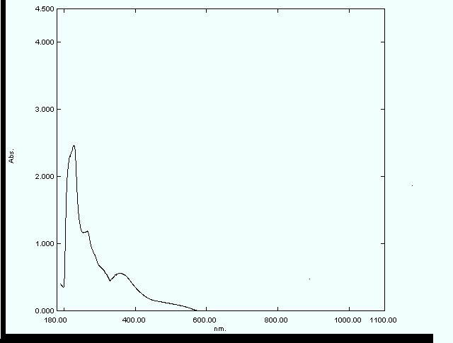
Fig(2):Electronic absorption spectra of QADMP in EtOH

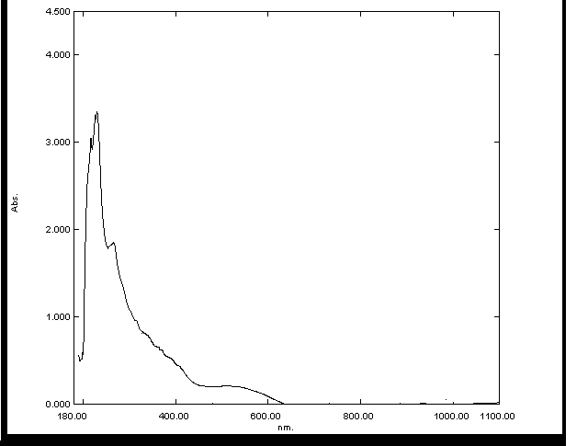
Fig(3): Electronic absorption spectra of Cu(II)-complex.
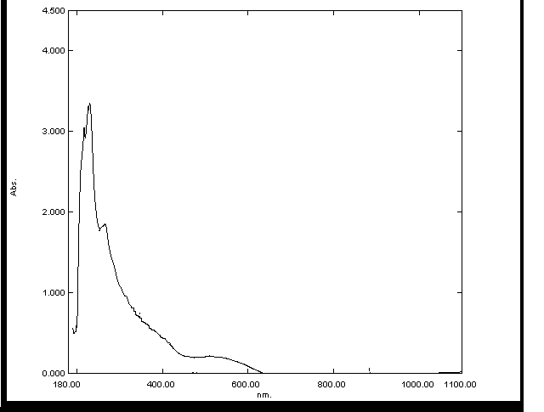
Fig(4): Electronic absorption spectra of Ni(II)-complex.
Optimal Conditions for formation of the complexes
Standard calibration curve of Cu(II) and Ni(II) complexes with ligand (QADMP) was plotted in the concentration range (1x10⁻⁵ – 1x10⁻⁴)M.
The validity of the Beer's law checked under the optimum condition gave a good straight line and the molar absorptive was calculated for each complex at Fig(5,6) .

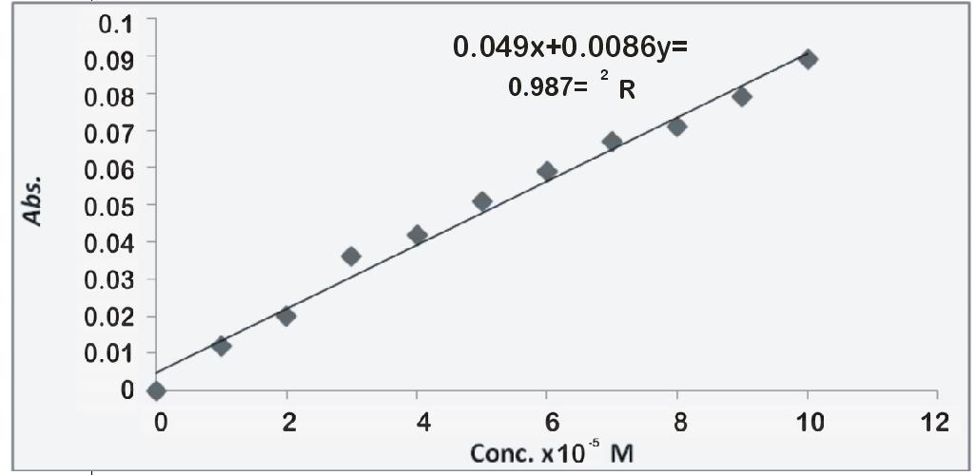
Fig(5):Standard calibration curve of Cu(II)-complex.
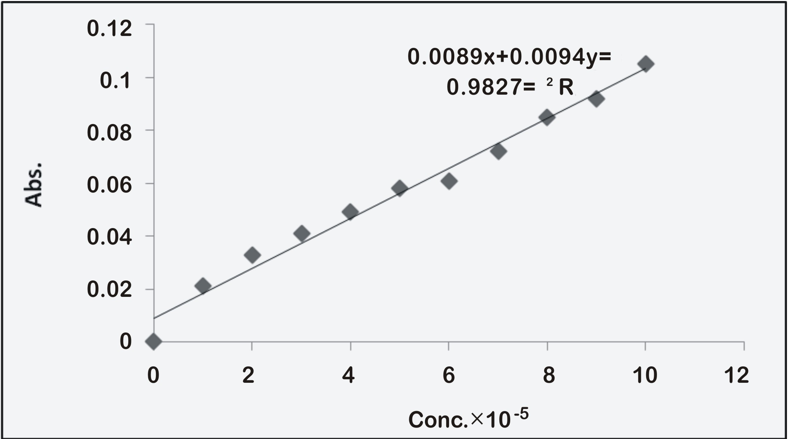
Fig(6):Standard calibration curve of Ni(II)-complex.
The effect of pH on the absorption spectra of Cu(II) and Ni(II) comple- xes were studied by mixing 1x10⁻⁴ M of metal ions with 1x10⁻⁴ M ligand under controlled PH values. That the absorbance gave maximum value at pH=8 for Cu(II) –ligand mixture at λ_{max}=518 nm ,and at pH =5 and 7 for Ni(II) – ligand mixture at λ_{max}=510 nm , (Fig. 7).
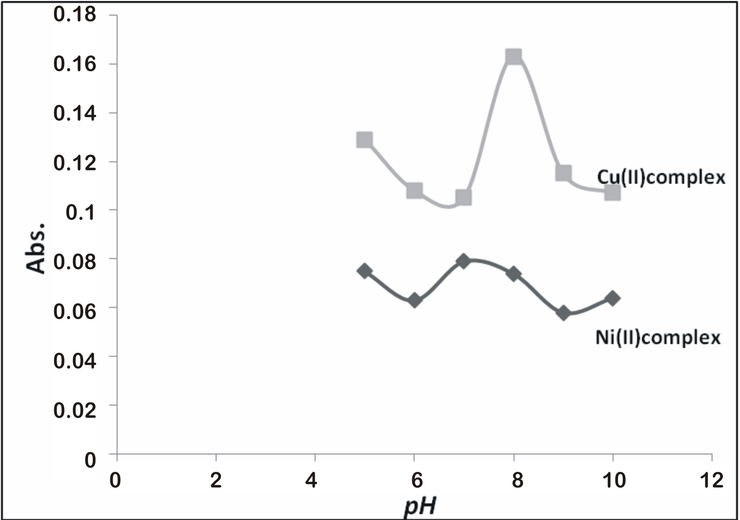
Fig(7):Optimum pH of Cu(II) and Ni(II) – complexes .
Composition and Stability Constant of the Complexes
The molar ratio method [ 12 ] carried out on a series of solution which were previously prepared by mixing (1 ml) of 1X10 ⁻⁴ metal ion with ligand of volume range (0.25-4) ml at optimum pH for each complex , and the graphs plotted for the molar ratio method were shown in Fig (8,9,10).
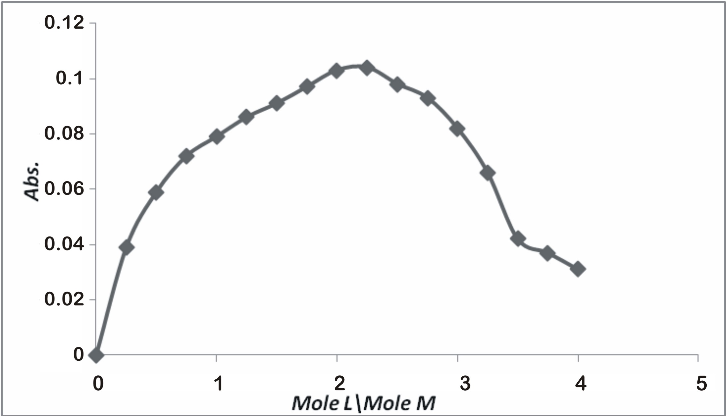
Fig(8):Molar ratio graph of Cu(II)- complex at pH=8
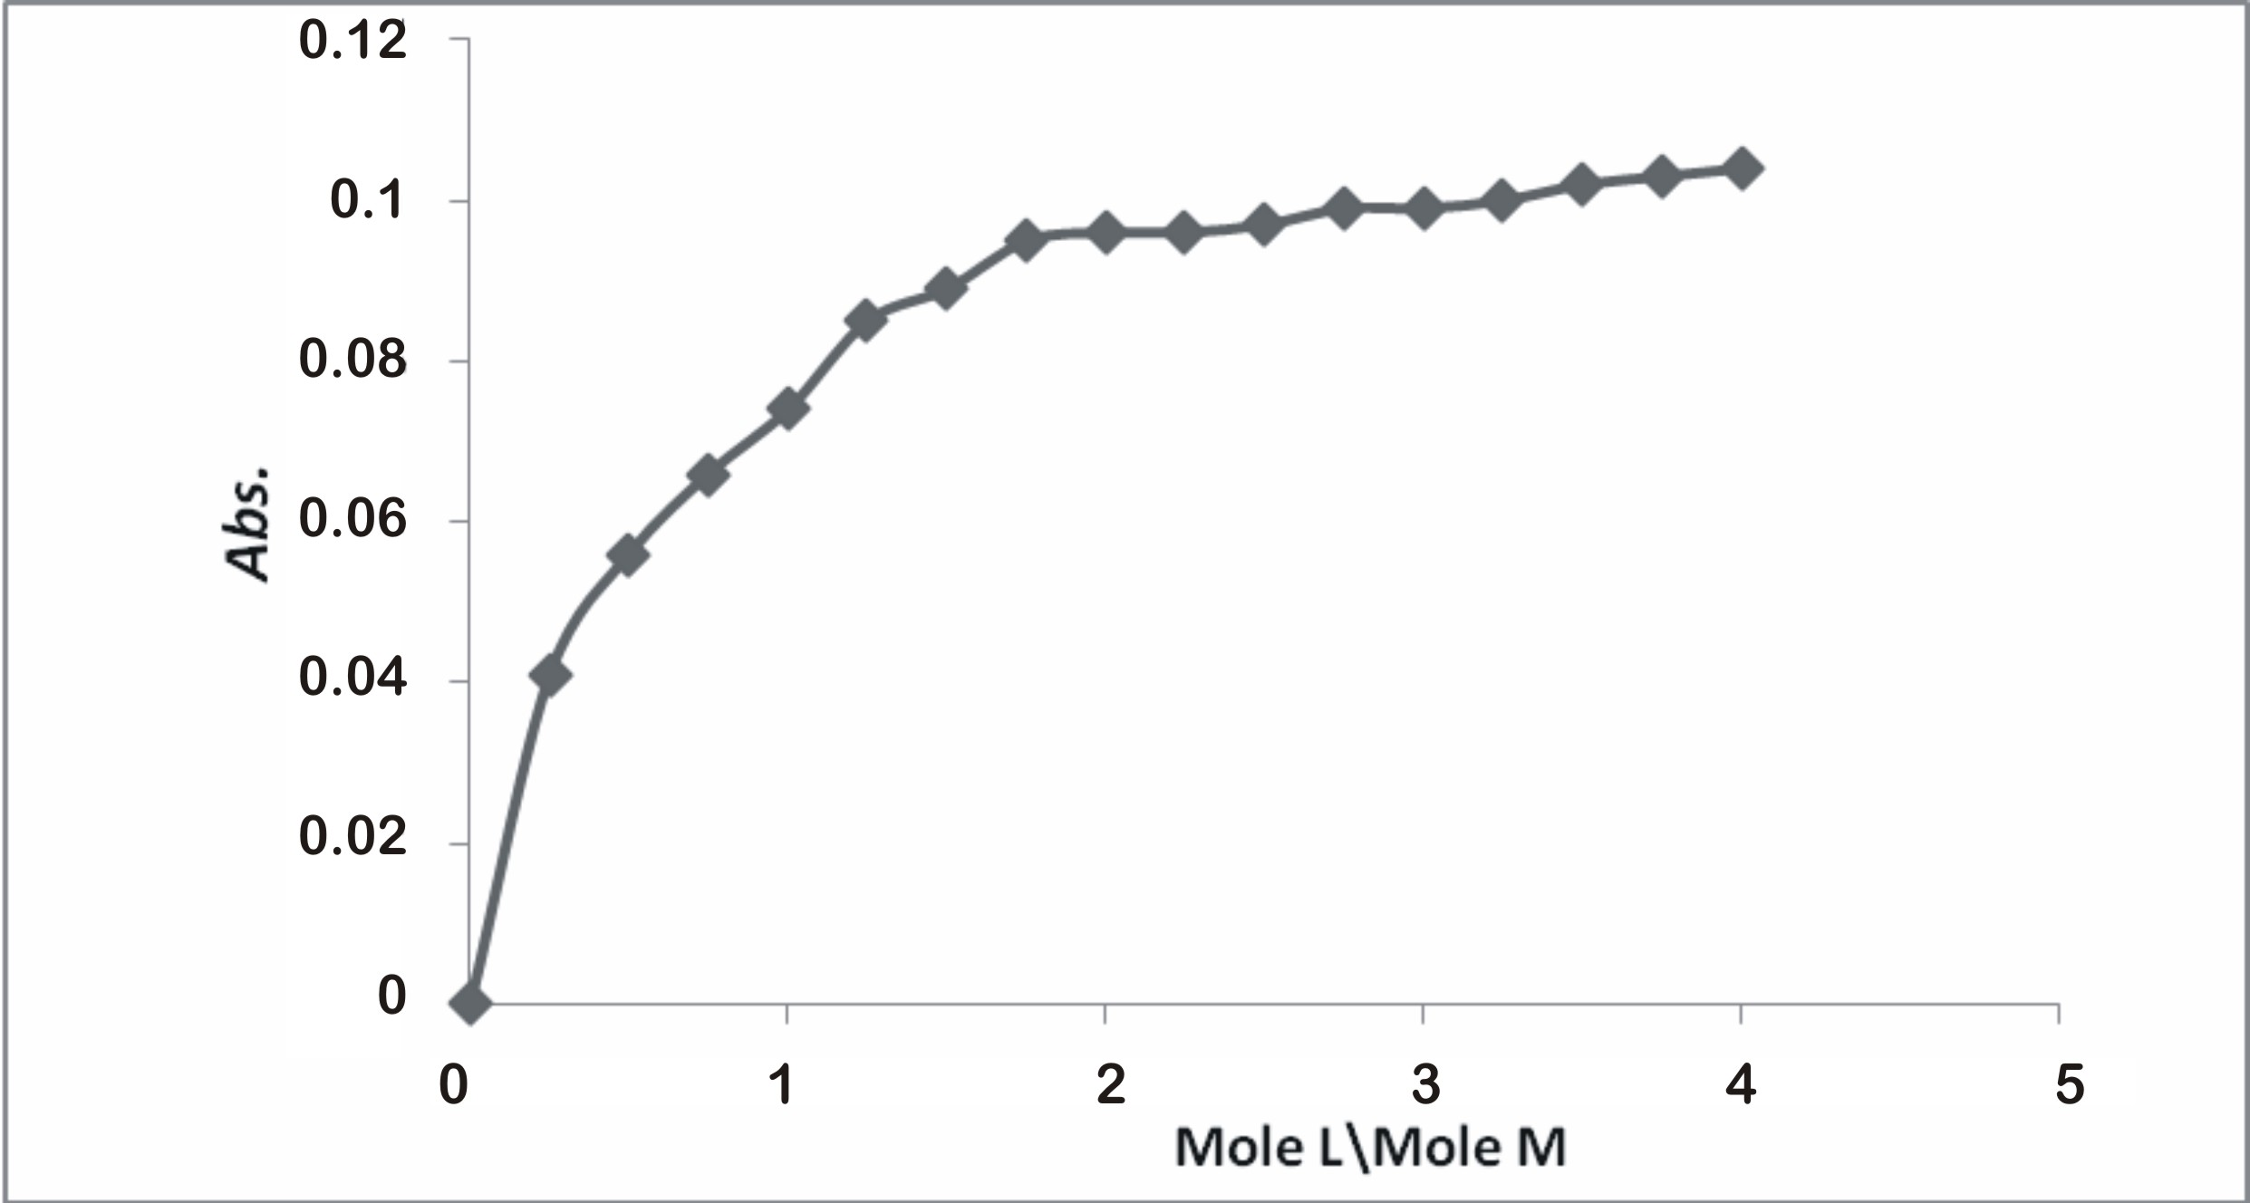
Fig(9): Molar ratio graph of Ni(II)- complex at pH =7
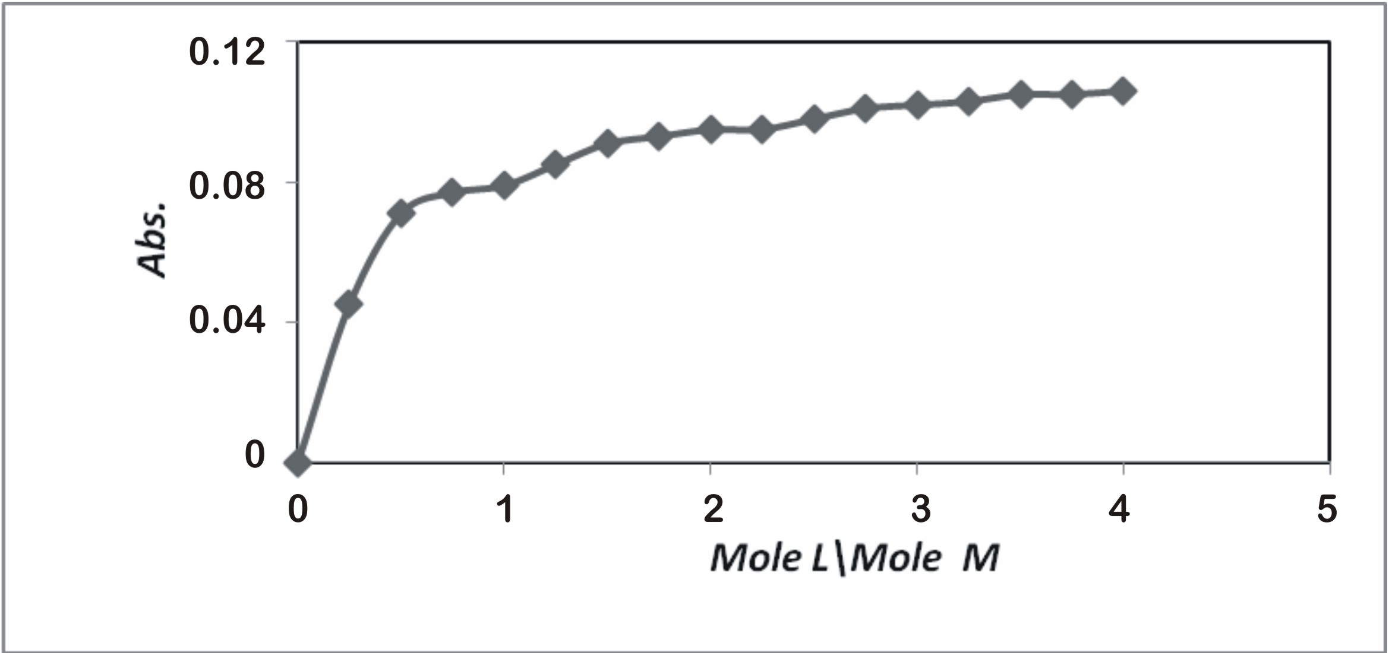
Fig(10): Molar ratio graph of Ni(II)- complex at pH =5
The data indicated that the composition of the formed complexes was as 1:2 ( metal ion : ligand ) for Cu(II) and Ni(II) complexes at pH =7, and as (1:1 ) for Ni(II)-complex at pH =5.
The stability constant of complexes were determined spectrophoto- etrically in aqua's ethanol at 25 °C at λmax and optimum pH of each complex ,value gave in Table (2) .
The effect Time on the complexes stabilities
It was studies by plot the relation between absorbance optimum condition of complexes and the time the range (0-180) min ,Fig(11,12).
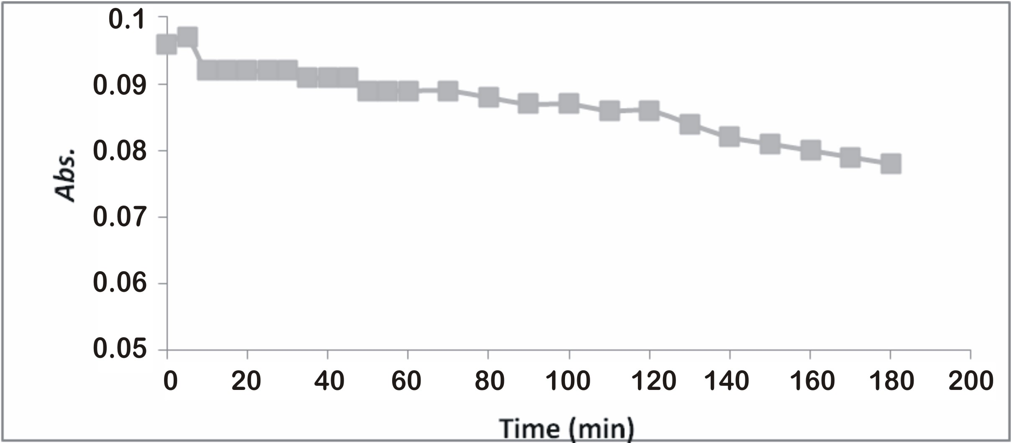
Fig(11): Effect Time on the Cu(II)-Complex at λ_{max}=518 nm.
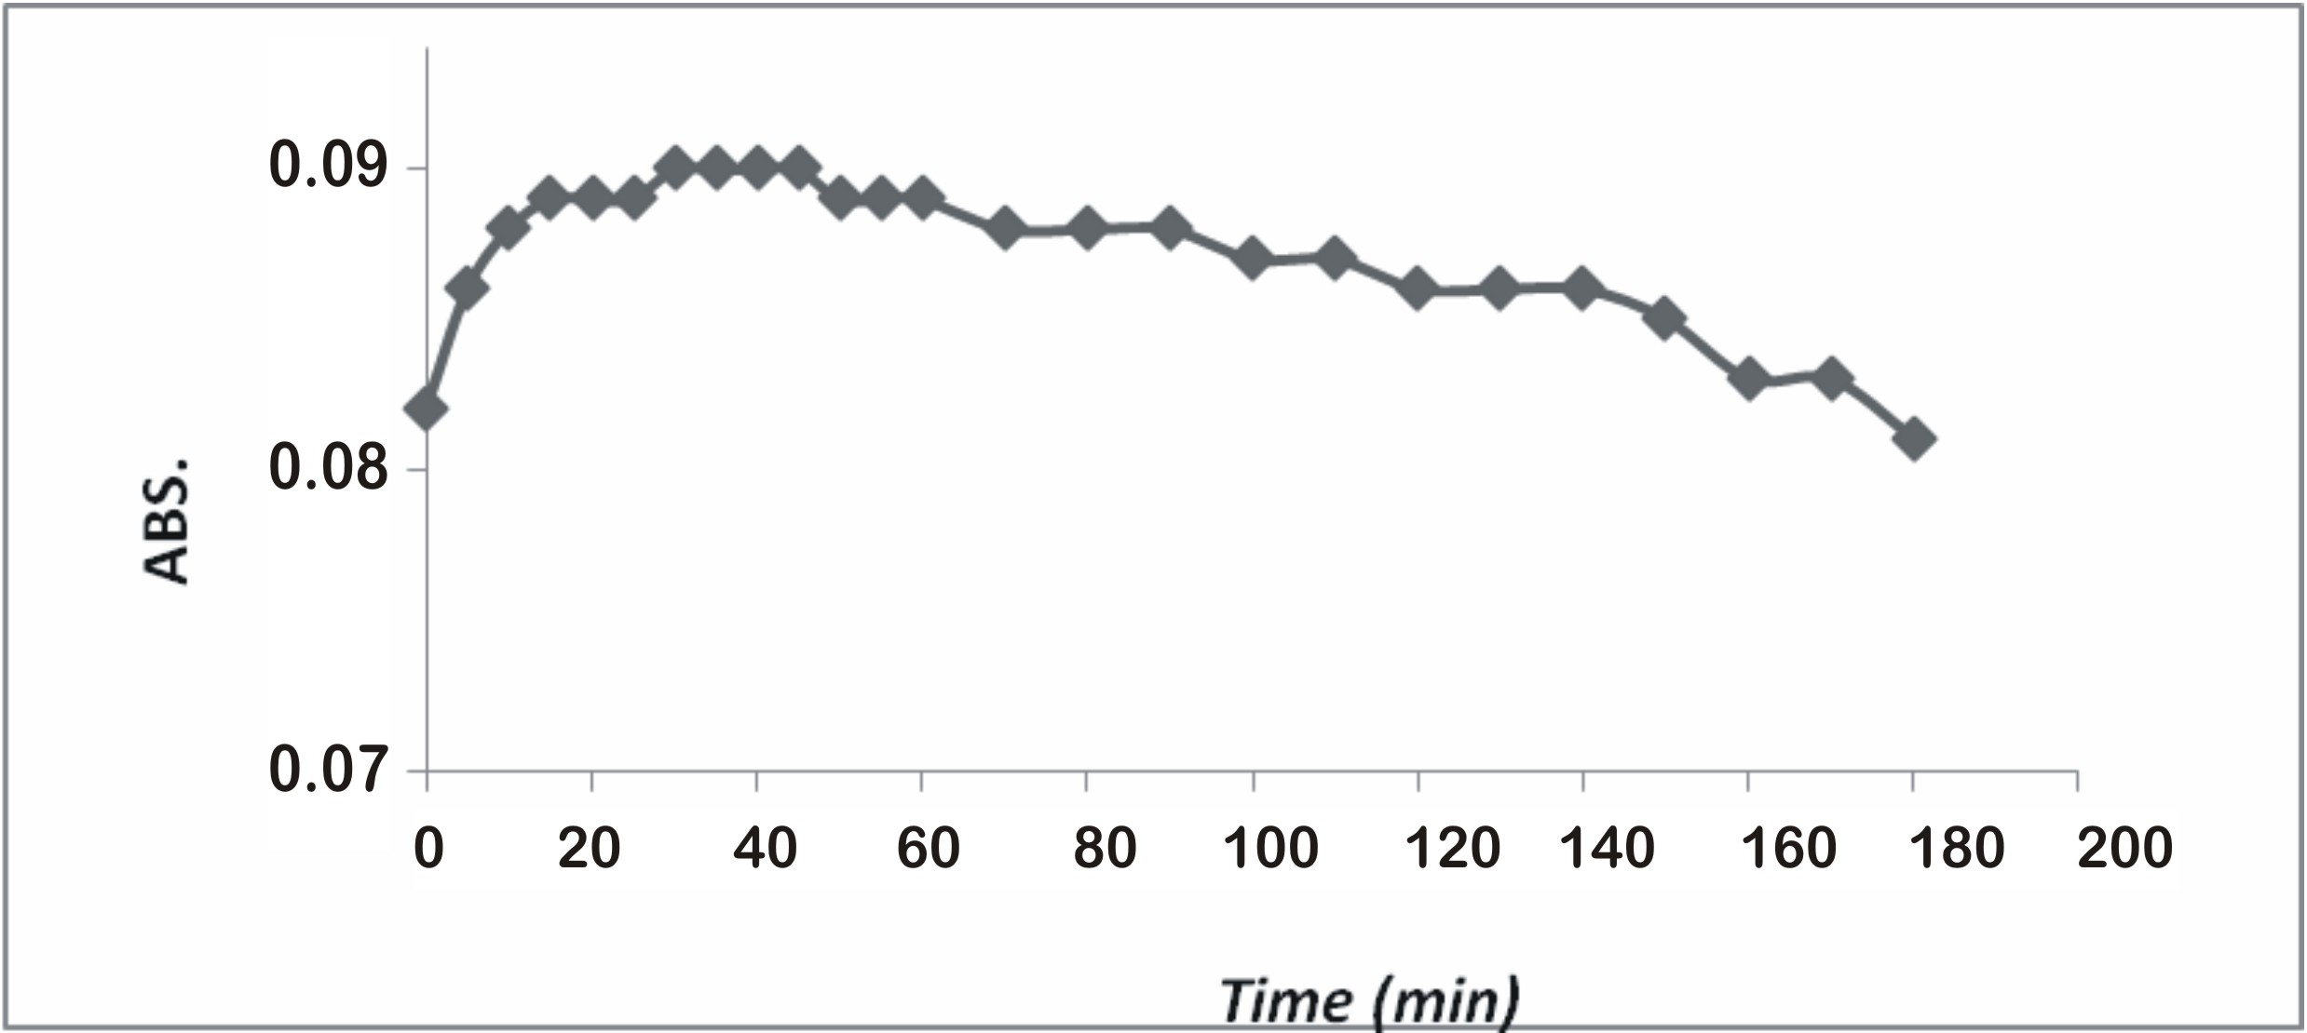
Fig(12):Effect Time on the Ni(II)-Complex at λ_{max}=510 nm.
Thermal Stability of Complexes
Thermal stability of Cu(II) –QADPM and Ni-QADMP complexes was studies at optimum condition in temperature range (20-70) °C, That illustrate decomposition of the complexes after 40°C temperature,
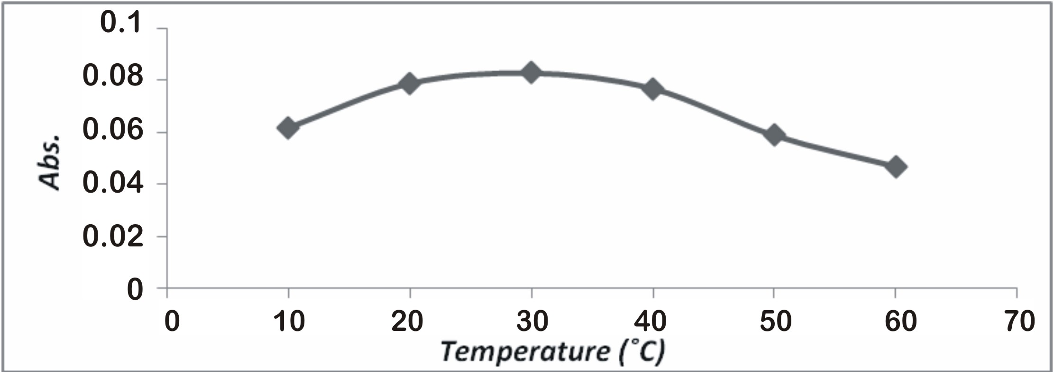
Fig(13):Thermal stability of Cu(II)-complex.
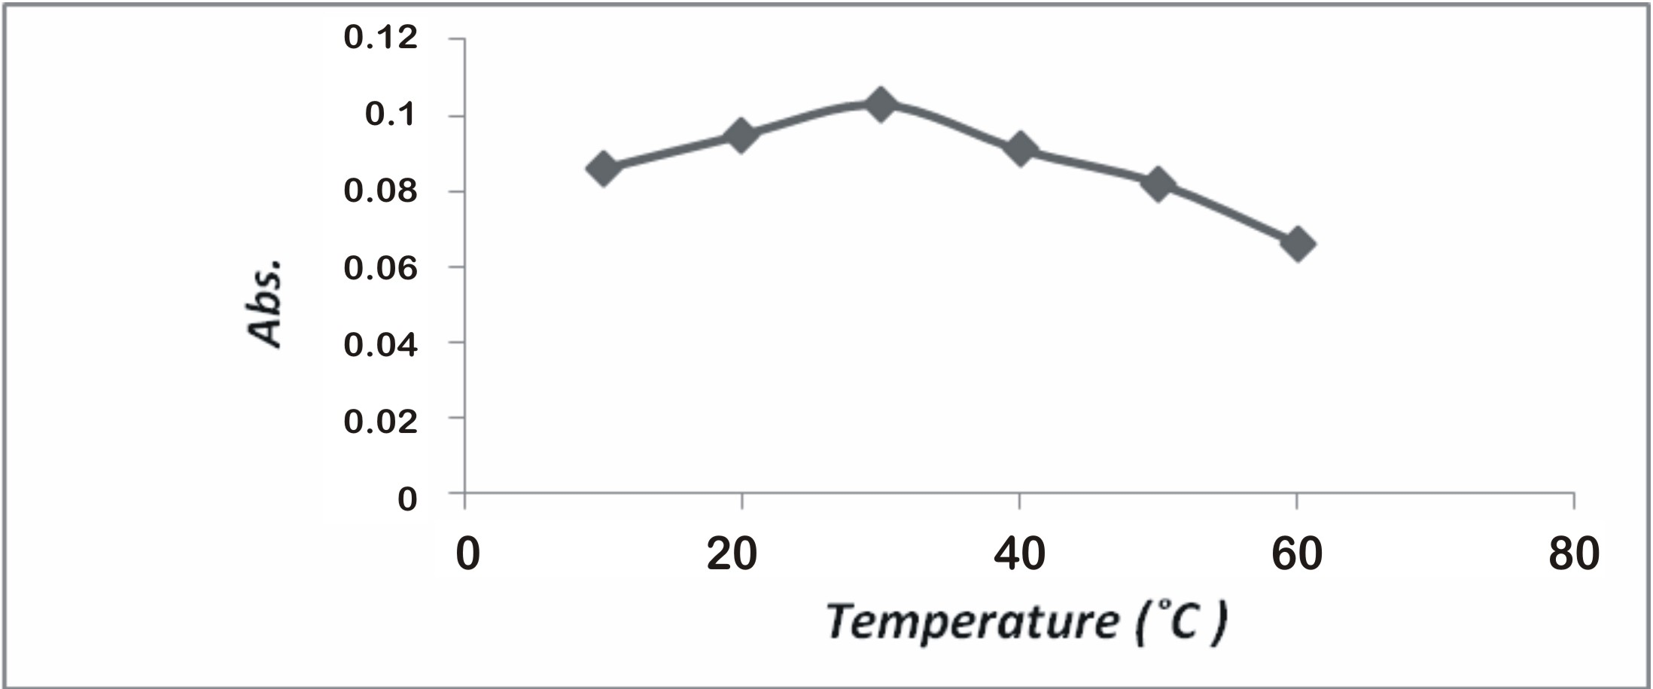

Fig(14):Thermal stability of Ni(II)-complex.
Table (2):-Spectrophotometric Characteristics of the Complexes .
Characteristics | Cu(II)-(QADMP) | Ni(II)-(QADMP)2 | Ni(II)-(QADMP)Cl
λ_{max} (nm) | 518 | 510 | 511
εx10 2 (l.mole-1.cm-1) | 10.03 | 9.6 | 7.9
Berr's law validity (M) | 10⁻⁵-10⁻⁴ | 10⁻⁵-10⁻⁴ | 10⁻⁵-10⁻⁴
Optimum PH | 8 | 7 | 5
Composition (M:L) | 1:2 | 1:2 | 1:1
Stability constant | 6.5 X10 ³ | 1.8 X10 ⁶ | 1.9 X10 ⁵

(b)Infrared Spectra
A detailed interpretation of the IR spectra of (QADMP) ligand and the effect of binding with Cu(II) and Ni(II) ions on the vibration freq -uencies of the free ligand discussed .The IR spectra of the free ligand and its metal chalets were carried out in the 4000-400 cm⁻¹ range (Fig 15-17) .The IR spectra of the ligand shows a broad band at ( 3500-3134) cm⁻¹ ,which can be attributed to the phenolic OH group[ 13] .The involvem- ent of the deprotonated phenolic OH group in complexation is confirm- ed sharp band inthe complexes .The band at 1598 cm-1 in the free ligand is assigned to νN=N of azo group .This band undergoes blue shift on complexation indicating coordination of the azo group[ 14 ].The IR spect -ra of the ligand observed a sharp band at 1498 cm-1 due to ν C-N=N-C- ,this band is shifted to lower (15-25) frequencies in the complexes indic- ating that it has been affected upon coordination to the metal ions [15]. In the IR spectra of all complexes ,the non –ligand observed at 418-463 and 437 -517 cm-1 region can be assigned to the ν(M-N) stretching vibra -tions of the azo and N3 quinoline azo nitrogen ,respectively . The band at 500- 600 cm-1 of complexes as the result of ν(M-O) [16,17 ] . Therefore, the IR spectra indicate that the ligand(QADMP) behaves as monobasic acid and the coordination sites being -OH group , N=N and the N3 atom of the quinoline ring .
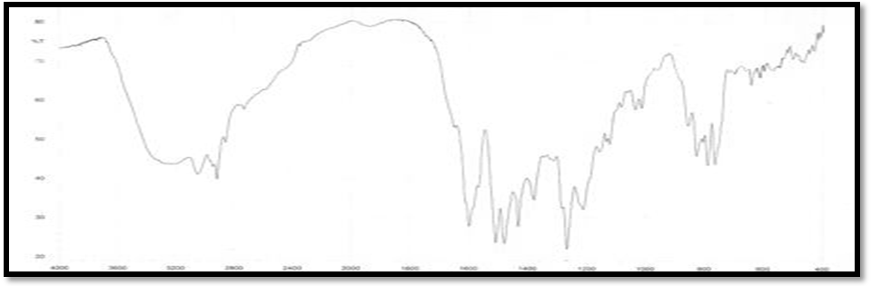Fig(15): FTIR spectra of Iigand(QADMP).
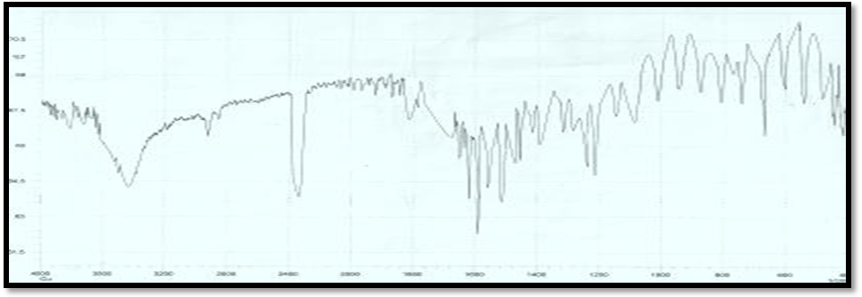Fig(16): FTIR spectra of Cu(II)-complex. 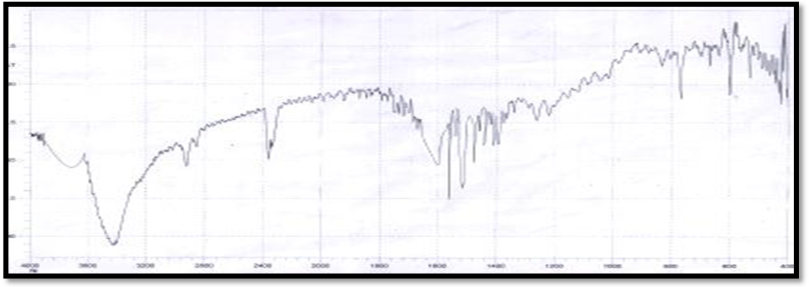
Fig(17) :FTIR spectra of Ni(II)-complex.
(c)Molar Conductance measurements
The molar conductance values of 10-3 M of complexes in ethanol at 25°C were found to be the range ( 0-10) ohm⁻¹ .mol⁻¹.cm² ,which indic-ate the no electrolytic nature of these complexes [18] ( Table 1).
(d) Suggested Structural Formula of Metal Complexes
The structure formula of metal complexes are suggest in Fig (18 ) in cases ,1:2 (M:L) solid complexes were isolated and found to have the general formula [M ( L )2],when (M= Cu(II) and (Ni(II) at pH = 7) and the case 1:1( M: L ) are found to have[ MLCl]when (M=Ni(II) at pH=5), Fig(19)
Fig(18): Suggested structural formula of metal complexes
(M=Cu(II) and Ni(II) at pH=7 )
Fig(19): Suggested structural formula of metal complex
(M=Ni(II) at pH=5)

Refrence
.AL-Shirayda H.A ,I.S.AL-Naimi and K.G.AL-Adely ;Arab Glug .J.S.Res.,10,13(1992).
Denng. R.C and J.Thatcter ;J.Amer.Chim. Soc.90,5917 (1986).
EI-Bindary. A.A and A.Z.EI-Sonbati, Spectrosc.Lett.,32,581,(1999).
Ewing J.W Instrumental Methods of Chemicals Analysis ,5th edition ,MeGraw Hill ,1985.
.Nakamolo. K, Innfrared and Raman spectra of Inorganic and coordination Compounds ,part B,5th Edition ,John Wiley and Sons. Inc, (1997).
Omar M.M and G.G.Mohamed , Spectrochim .Acta . part A ,61,929-936(2005).
Pandey G and K.K.Narang ,Synt.React.Inorg.Met,-Org.Chem.34,291-311(2004).
Rageh N.M ,A.M.AbdElMawgoud and H.M.Mostafa,Chem.Papers , 53, 107(1999).
Shibata. S, M.Furukawa, and R. Nakashima ,Anal.Chem.Acta .,81 ,131 (1979).
Sum Y .i,M.T.Muraki,andT.Suzuki,Histochem-Cell Bio.,1o6,223(1996).
Teranishi H ,K.Takagawa,Y.Arai,K.Wakaki,Y.Sumi,and K.Takaya,J.Occup. Health,44,60(2002).
Watanabe H, and N.Yamaguchi,Bunseki Kagaku,28,154(1979).
Koh.j and A.J.Greaves ,Dyes Pigments ,50,117-126(2001).
Roy. R., P.Chattopadhyay, C.Sinha and S.Chattopadhyay ,Polyhedron 15 ,3361-3369(1996).
Varada T; J.Braz.Chem.Soc. 17,463,(2006).Watanabe H, and N.Yamaguchi,Mikro Chimica Acta II,501-506(1979).
Zhangjie Hvang and Jayuan YIN,Anal.Sci.,19,1449(2003).

