Preparation, Spectral Characterization, Physical Properties And Photochemical Activity Of New Catalysts Coo-V₂O₅
H. Idrees A. Merzah A. Al-Fatlawy
College Of Sciense University Of Babylon
Apstract
The research consist of four main parts:
The first: The cobalt oxide and vanadium oxide were prepared individually. Also different percentage % from their mixtures were prepared as follow: 25% , 50%, 75% and 100% from CoO were precipitate with fixed weight of V₂O₅ 2.0 grams. And the above percentage from V₂O₅ were precipitate with fixed weight of CoO 2.0 gramsThe individual metal oxides and their mixtures with different ratio(different percentage %) were prepared from the solution of nitrate and sulphate of both metals respectively by co-precipitation method by adding sodium carbonate .All metals carbonates transfer to corresponding oxides bycalcification at 773 K using furnace. The second: Includes the spectroscopic studies for metal oxides and their mixture with different ratio using XR-Diffraction, Infra-red spectrometric techniques, Electron Paramagnetic ResonanceThe Third :Some physical properties of these oxides and their mixture were studies such as : porosity, pore size ( Mesh No.) , density and electrical conductivityThe fourth: Involve studding the photochemical oxidation of 1-octanol using the new catalyst
الخلاصة
تشمل الدراسة على اربعة أجزاء أساسية:
الجزء الاول: تحضيراوكسيد الكوبلت و اوكسيدالفيناديوم كلا على انفراد , وتحضير نسب مئوية% مختلفة للاوكسيدين مع بعضهما حيث تم ترسيب 25% ,50%,75% و100%من اوكيسد الكوبلت مع وزن ثابت من اوكسيد الفيناديوم2.0 غرام , كذلك ترسيب النسب اعلاة من اوكسيد الفيناديوم مع وزن ثابت من اوكسيد الكوبلت2.0 غرام من أملاحهما (نترات وكبريتات) على التوالي . حيث يتم ترسيب كاربونات الفلزين كلا على انفراد و كاربونات الفلزين كما في النسب اعلاة. تم تحويل الكاربونات الى الاكاسيد المقابلةوذلك بتقسيتها, باستخدام درجة حرارة 773 كلفن في فرن Furnace .الجزء الثاني: دراسة طيفية العوامل المساعدة المحضرة بواسطة حيود الأشعة السينية RD) X) X-Ray Diffractionومطيافية الاشعة تحت الحمراء Infrared(IR) Spectroscopy كذلك بواسطة رنين البرم المغناطيسي للإلكترون (EPR) Paramagnetic الجزء الثالث: تم دراسة بعض الخواص الفيزيائية مثل المسامة Porosity، حجم المسامة (Mesh No.) Pore Size، الكثافة Densityوالتوصيلية الكهربائيةElectrical Condu..الجزء الرابع: يتضمن دراسة الاكسدة الضوئية المحفزة لل1-اوكتانول ناستخدام العوامل المساعدة المحضرة.
Introduction
Metal oxides are materials widely used in various areas, from electronics and fuel cells to transport, medicine and construction. Due to peculiarities of operation, each pplication demands specific combination of metal oxide properties, such as electro-physical, structural, optical, catalytic (Korotcenkov et al 2009). The cobalt ideswere used by (Brownless et al 1962, Ezzo et al 1983) in manufacture of agnates, eramics, special glass, chemicals dyes and catalysis in thermal cracking. lso the alts of anadium used as catalysts due to different oxidation state (Ishihara et al 002) , H₂SO₄ preparation, reduction of organic pollutants and optical, electrical nstruments, thermal sensors( Surnev et al 2003).The study of composite materials, i.e., mixtures consisting of at least two phases of different chemical compositions, has been of great interest from both fundamental and practical standpoints. The macroscopic physical properties of such materials can be combined so as to produce materials with a desired average response.
Composites have good potential for various industrial fields because of their excellent properties such as high hardness, high melting point, low density, low coefficient of thermal expansion, high thermal conductivity, good chemical stability and improved mechanical properties such as higher specific strength, better wear resistance ( Canbay and Aydogdu 2009). Several researchers shows that the mixtures of cobalt oxides with others metals oxides increases the efficiency of the catalyst such as: CoO-MgO on the surface of ZrO( Boot et al 1996) , Au-Co₃O₄ (Ando et al 1997) and Li-CoO ( Khodakov et al@ al-lille fr.). The mixture of CoO-SiO₂ was studies by XRD (Antolini 1998). Also others research's were studies the mixtures of V₂O₅ with others oxides increases the efficiency of the catalyst such as :V₂O₅- Fe on Al₂O₃ and the alloys with Bi used in solid fuel cell ( Vaidhyanatha et al 1998),V₂O₅-TiO₂ was used in oxidation of tri-tetrachlorobenzene ( Anhuai et al 2004),V₂O₅-Al₂O₃ was used as sensor to NO, CO₂,CO and NO₂ Haber et al 1997), V₂O₅-MoO₃-Nb₂O₃ used in oxidation of isopropyl ( Depaira et al 2006),V₂O₅-SnO₂ used in voltage electrode determination ( Jayalakshmi et al 20070, V₂O₅-W₂O₃ used as sensors for NO₂
( He et al 2005) . The deposition of V₂O₅ on the surface of TiO₂,SiO₂, Zr₂O and Al₂O₃ were studies by XRD, and Uv-Visible spectroscopy and these mixture was used fot oxidation of propane ( Khodakov et al 1999). The aim of this research is to prepare new catalyst composed from CoO-V₂O₅at different ratio, and characterized by XRD, IR and EPR also studied some physical properties and the using of these catalysts in photocatalytic oxidation of primary alcohol.

Experimental
A- Chemicals:
1-Cobalt nitrate: It is supplied by Merch, with purity 99%
2-Vanadium sulphate: It is supplied by Aldrich with purity 99%
3-Sodium carbonate: It is supplied by Chem: Pure Scherman Chemical L.T.D.
4- 1-Octanol: It is supplied by Merch with purity 99.5%.
5- 1-Octanal: It is supplied by Merch with purity 99.5%.
6- KOH: It is supplied by BDH with purity 85%.
7- HCl: It is supplied by BDH with purity 37%.
8- C₂H₅OH: It is supplied by with purity 99%.
9- n-C₆H₁₄: It is supplied by Merch with purity 99%.
10- 2,4-Dinirtophenylhdrazin: It is supplied by BDH with purity 99%.

B-Apparatus:
1- XR-Diffraction: Type 1410120, Philips.
2- F.T.I.R. Spectra 84005: Founier – Trasform , Schemadzn.
3- UV. Visible Spectrophotometer:U.V.-1650 PC, Schemadzn.
4-Atomic Absorption spectrophotometer: Corning Flame Photometer LtD, Halstead England.
5- pH-meter: Multi 740, Inolab, WTW Terminal.
6- Resistance meter: hp3468A, Mutimeter, Hewlette, Packard, U.S.A.
7-Valcanization oven: Muffle furnace size two ,Gallenkamp, England.
8-Oven:Oven BS size two , Gallenkamp, England.

C-Preparation of catalysts:
Cobalt oxide ,Vanadium oxide and their mixture with different ratio 25% , 50%, 75% and 100% from CoO were precipitate with fixed weight of V₂O₅ 2.0 grams. And the above percentage from V₂O₅ were precipitate with fixed weight of CoO 2.0 grams by co-precipitation of metals carbonate from the solution of nitrate and sulphate of both metals respectively, by adding 1.0 molar of sodium carbonate with continuous stirring for 2.0 hours to change the pH of the solution from 2.9 to 8.5 for complete precipitation of metals carbonate at 333K The precipitation were separated by filtration and washed with D.W. to reduce the sodium concentration less than 100 ppm, which determined by atomic absorption. The precipitation was leave 16 hours at 373 K for drying. The precipitation grinded and forming tablets 4 x 10 mm. by using a pressure of 3 tons from a piston and cylinder manufactured for this purpose. The porosity, pore size and density were determined by liquid impregnation (Church and Joshi1 1991 , Bowker1998).
D-Methods:
Photooxidation of' 1 - octanol was carried out in Pyrex static reactor with quartz window to received the irradiation generated from lamp(400 -700) nm. In all experiments 25 cm³ of mixture ( 0. 20 mol. = 8.0 mol. / lit ) 1- octanol with CoO, V₂O₅ or mixed oxides at 298 K. The solution was suspended by a magnetic stirrer as in Figure 1.
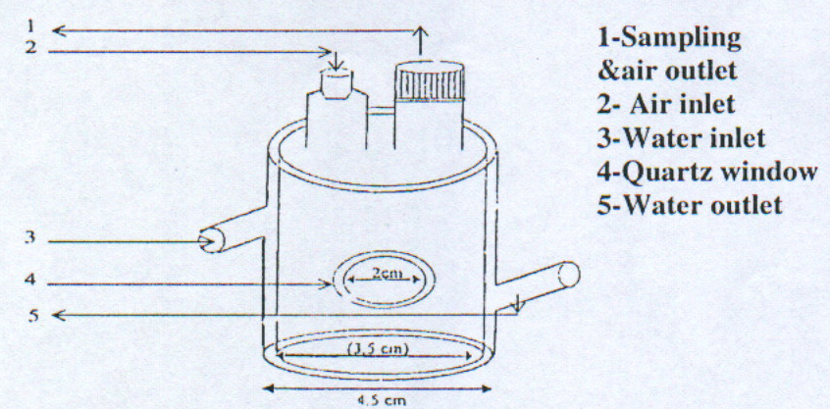

Figure 1 : Photooxidation cell.
Periodically 3.0 cm³ samples of reaction mixture were with drown by pipet and centrifuge to separate solid catalysts. The supernatant liquid analyzed for reaction using uv-visible spectrophotometer
E- Analysis of reaction products: : Uv-visible spectrophotometeric methods were sed to determine the concentration of aldehyde produced from the photocatalytic xidation of 1-octanol by several workers, and is based on the formation of 2 , 4 - nitrophenylhydrozone, followed by the addition of alcoholic KOH to produce a wine colour which could then be spectophotometrically measured. The absorbance was irectly proportional to the amount of reaction products, whose concentration was etermined from a calibration curve. The calibration curve was obtained by using standard aldehyde solution (aldehyde + cohol) in place of reaction mixture. The calibration consisted of absorbance at λ_{max}.. Against of carbonyl compound ole/liter) as in figure 2.
Calibration curve Figure 2:

Result and Discussion
Characterization of new catalysts CoO -V₂O₅:
1-Specroscopical studies:
A-X-ray diffraction:
The X-ray diffraction is an essential tool for the rapid identification and quantification of mineral, compound and other crystalline phase.Table 1 shows the values of 2θ (strongest 3 peaks) for pure V₂O₅ , pure CoO and the prepared new catalysts V₂O₅-CoO . Table 1: 2θ for in the standard V₂O₅ standard CoO and
CoO - V₂O₅ catalyst

2θ |  |  | Metals oxide
45.455 | 44.381 | 44.837 | Pure V₂O₅
29.379 | 31.283 | 36.868 | Pure CoO
29.444 | 29.743 | 28.141 | New catalysts CoO - V₂O₅
So when these values of 2θ of the new catalyst CoO - V₂O₅ compared with 2θ of each standard metals oxide can see the deviation in intensity and the position of 2θ. hese deviations may due to the interaction between pure metals oxide which leads to change in crystals lattice of each oxide as in figure 3

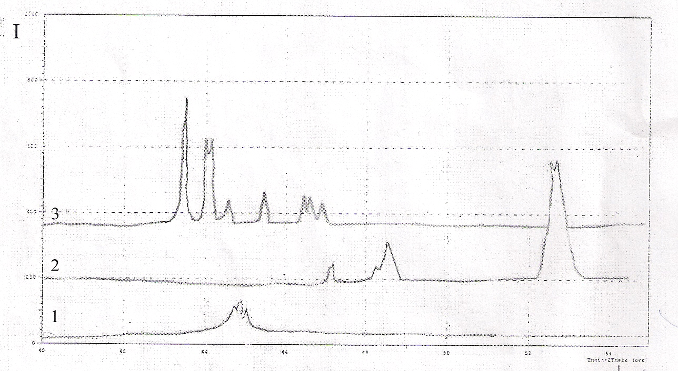
Figure 3: X-ray diffraction spectrum:
1 - V₂O₅ 2 - CoO 3 - CoO - V₂O₅

B-IR Spectroscopy:
Table 2 shows that the λ_{max}. of pure V₂O₅ , pure CoO and λ_{max}. for the new prepared catalysts CoO - V₂O₅ .
Table 2: λ_{max}. of the pure catalysts and the new prepared catalysts .

λ_{max}. |  |  |  |  | Metals oxide
1139.9 | 941.29 | 815.92 | 696.33 | 559.38 | Pure V₂O₅
 |  | 1373.36 | 663.53 | 572.88 | Pure CoO
1139.97 | 941.29 | 815.92 | 696.33 | 559.38 | New catalysts CoO - V₂O₅

The above table shows new λ_{max}. with high intensity which return to the new bonded between crystal lattice of both oxide as in figure 4:
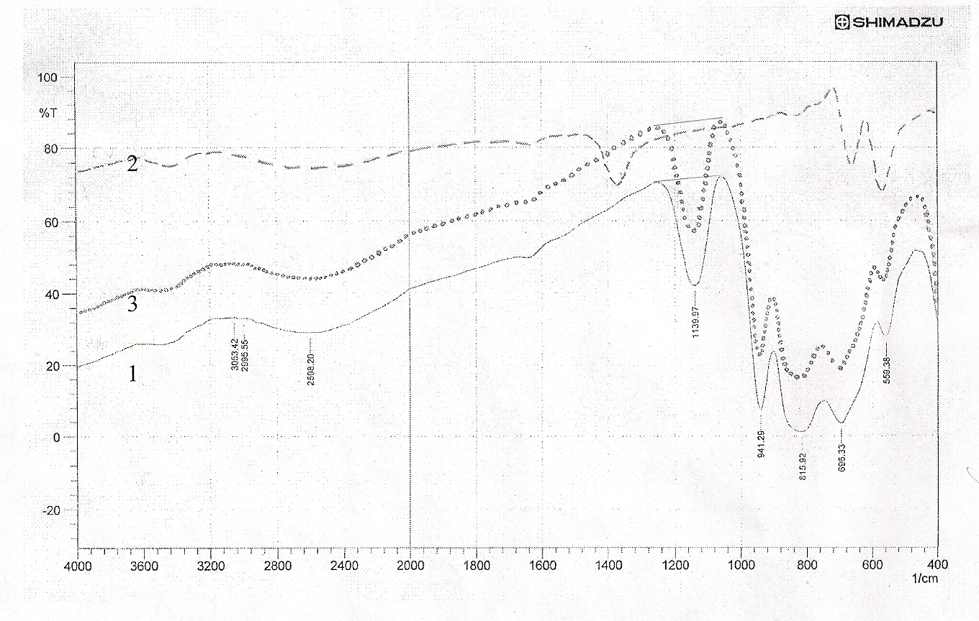
Figure 4: IR-Spectroscopy of:
1 - V₂O₅ 2 - CoO 3 - CoO - V₂O₅
C - Electron Paramagnetic Resonance Spectroscopy: Figure 5-a , b shows EPR spectra of CoO and V₂O₅ individually. Also figure 5-c show EPR spectra of mixed catalyst CoO-V₂O₅, which differ from both figure a and b by intensity of absorbance and the position of peaks this may be due to the overlap between the network of the crystal lattice the two catalysts by covalent or coordination bonds The determination were carried at 333K by EPR, type Jeol JES-3X-Band spectrometer.
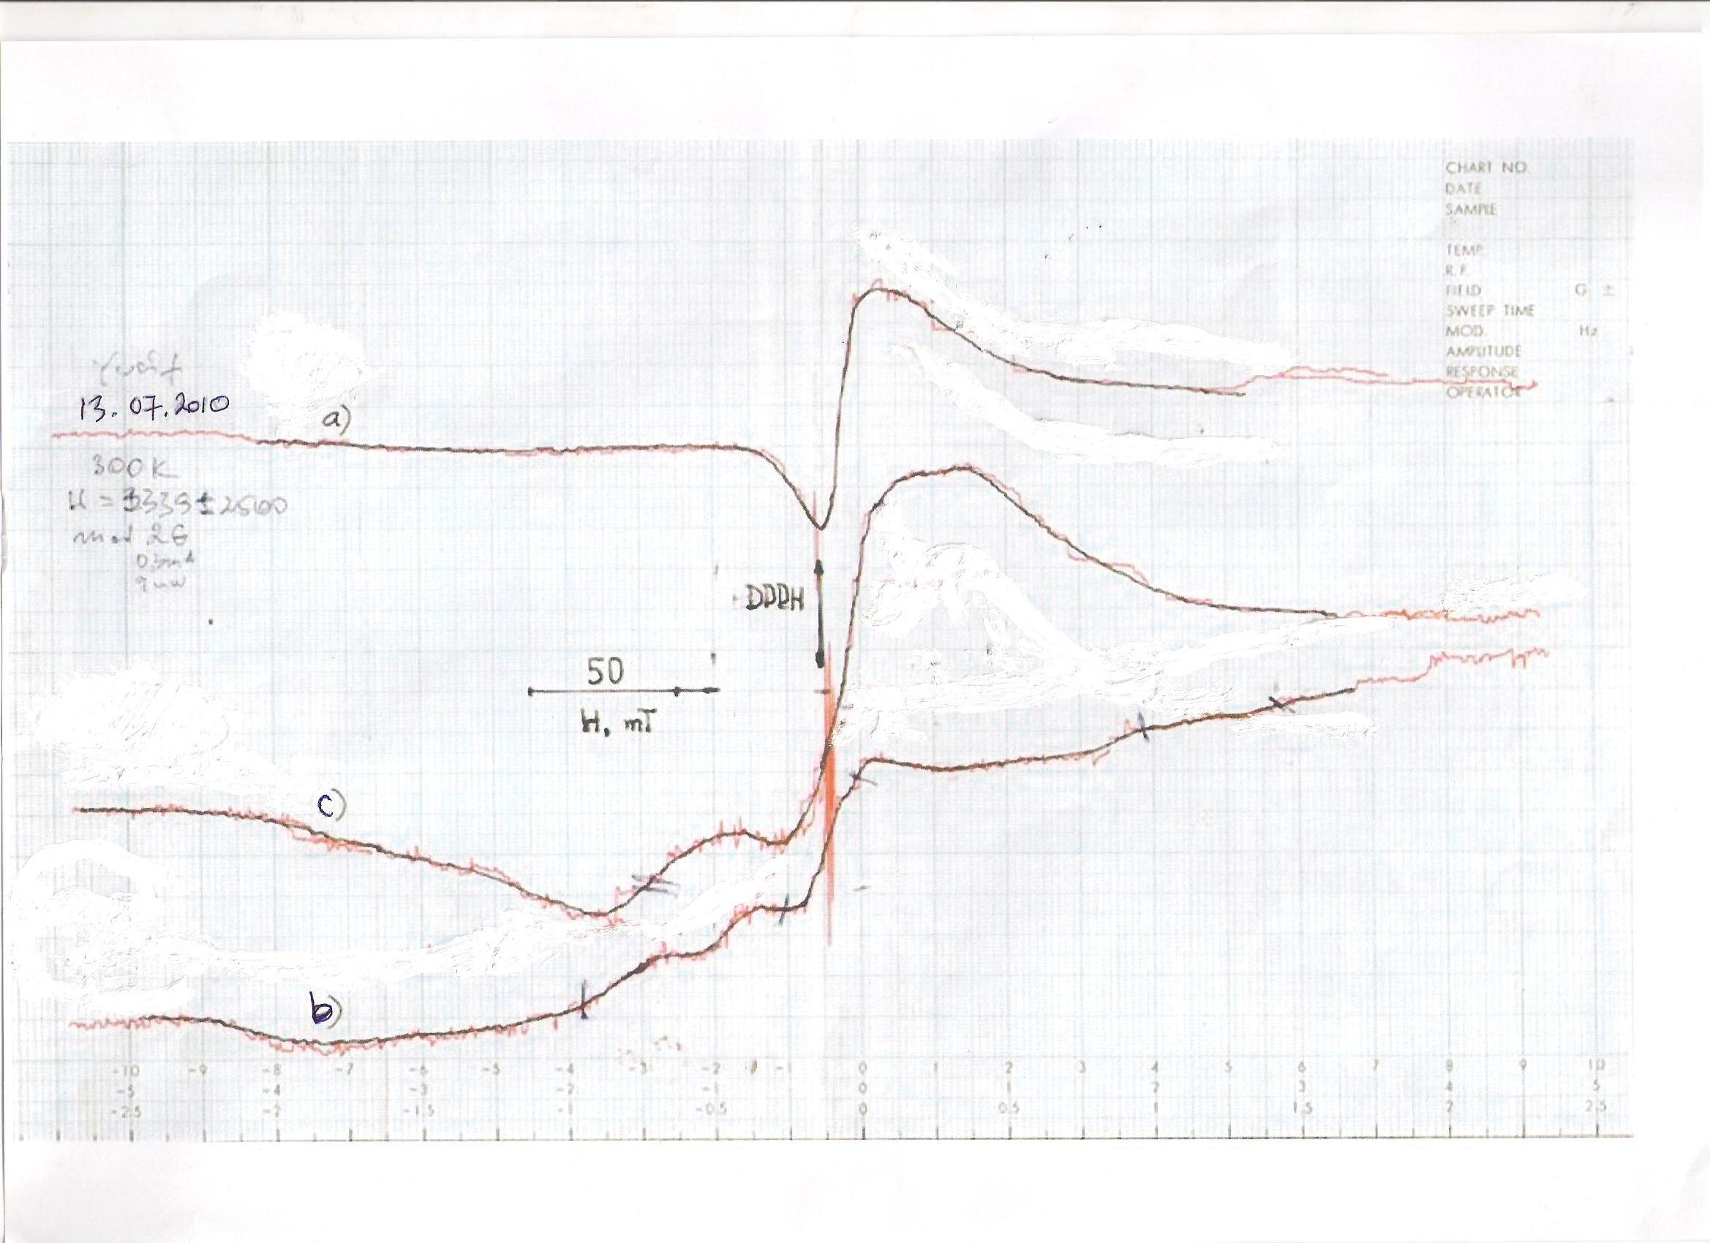
Figure 5: Electron Paramagnetic Resonance spectra:
a - V₂O₅ b - CoO c - CoO - V₂O₅
2-Physicl properties:
A-Porosity:
The porosity defined as the amount of small spaces or voids with in a solid material.The Figure 6-a show that the porosity of naked CoO(fixed weight 2.0 grams), was increased remarkably after the addition successive weight of V₂O₅. Also the porosity of naked V₂O₅ (fixed weight 2.0 grams), was increased after the addition successive weight of CoO as in Figure 6-b.
a
b
Figure 6 :The effect of metal oxide (grams) on the porosity
a - V₂O₅ on CoO b - CoO on V₂O₅
The above Figure shows that the maximum porosity of the mixed catalyst occur at, by mixing equal weight of both metal oxides (2.0 grams of each one). This might be explain that the grains of both metal oxides that were not compacted together completely. The increases of porous in material can absorb much fluid.
B-Pore size:
The pores size defined as the size of the opening in the sample. It is usually stated in nanometers (ηm) and micrometers (μm) and refers to the diameter of particles. Figure 7-a shows that the pores size of naked CoO (fixed weight 2.0 grams), was increased remarkably after the addition successive weight of V₂O₅. Also the pores size of naked V₂O₅ (fixed weight 2.0 grams), was increased after the addition successive weight of CoO as in Figure 7-b. .
b
a
Figure 7 : The effect of metal oxide (grams) on the pores size
a - V₂O₅ on CoO b - CoO on V₂O₅
The above Figure shows that the maximum pores size of the mixed catalyst occur by mixing equal weights of both catalyst (2.0 grams of each one), which may be due to forming spaces between grains, that increase the ability of the analyte molecule to penetrate inside the particle and interact with its inner surface and may gave a high activity of the catalysts
C-Density: :
It is a physical property of matter, which equal to the dry mass M_{D} of the sample divided by the total volume V of the sample. The sample must be dried long enough to remove any moisture from the voids. The relationship between density and porosity is in direct proportionality ⁽¹⁶⁾, that the higher the density, the lower will be the porosity of because the over-lying increase the density , which in turn decrease the amount of pore space ( porosity) of the rock through processes such as compaction. The Figure 8-a shows that the density of naked CoO (fixed weight 2.0 grams), decrease with addition of successive weight of V₂O₅. Also the density of naked V₂O₅ (fixed weight 2.0 grams), was decreased after the addition successive weight of CoO as in Figure 8-b.
b
a
Figure 8 : The effect of metal oxide (grams) on the density
a- V₂O₅ on CoO b- CoO on V₂O₅
The above Figure shows a decrease in the density of both metal oxides, this might be explain that the grains of both metal oxides that were not compacted together completely. The increases of porous in material cause increase in the volume of the sample for a constant weight, which leads to decrease of density.
D-Electrical conductivity::
The ability of materials to conduct an electric current when an electrical potential difference is placed a cross a conductor, its movable charges flow, giving rise to an electric current. Also the conductivity defined as the ratio of the current density J to the electric field strength Е . Its unite of siemens per meter (s.m⁻¹ )σ = J / E Figure 9 - a shows that the electrical conductivity of naked CoO (fixed weight 2.0 grams), was increased remarkably after the addition successive weight of V₂O₅. Also the electrical conductivity of naked V₂O₅ (fixed weight 2.0 grams), was increased after the addition successive weight of CoO as in Figure 9-b.
b
a
Figure 9: The effect of metal oxide (grams) on the conductivity
a- V₂O₅ on CoO b - CoO on V₂O₅
The above Figure show that the maximum electrical conductivity of the mixed catalyst occur by mixing equal weight of both metal oxides (2.0 grams of each one). This might be explain that the degree of doping in solid state semiconductors make a large difference in conductivity, more doping leads to higher conductivity

3 - Photochemical activity:
Several optimization experiments were carried out to determine the conditions necessary for photo-lytic oxidation of 1-octanol to 1- octanal by using individual metal oxide and the preparation of mixed catalysts with visible light for 5 hr.s irradiation for each experiment at 298 K. The results as in Table 3 : Table 3 : The effect of different conditions on photocatalytic oxidation of 1-octanol at 298 K.
Exp.  no. | Hydro-carbons | Experiments  Conditions | Reaction  Products
1  2  3  4  5  6  7  8  9  10  11  12  13  14  15 | 1-octanol  1-octanol  1-octanol  1-octanol  1-octanol  1-octanol  1-octanol  1-octanol  1-octanol  1-octanol  1-octanol  1-octanol  1-octanol  1-octanol  1-octanol | 1-octanol only  1-octanol + air  1-octanol + light  1-octanol + air + light  1-octanol + CoO  1-octanol + CoO + air  1-octanol + CoO + light  1-octanol + V₂O₅  1-octano l + V₂O₅ + air  1-octanol + V₂O₅ + light  1-octanol + mixed catalyst  ( CoO - V₂O₅ ) + air  1-octanol + mixed catalyst  ( CoO - V₂O₅ ) + light  1-octanol + mixed catalyst  ( CoO - V₂O₅ ) + air + light  1-octanol + mixed catalyst  ( CoO - V₂O₅ ) + N₂ + light  1-octanol + mixed catalyst  ( CoO - V₂O₅ ) + H₂ + light | No Products  No Products  No Products  No Products  No Products  No Products  No Products  No Products  No Products  No Products  No Products  No Products  See significant product (Uv-visible  spectroscopic  characterization)  No Products  No Products

The prepared mixed catalysts were improved the photooxidation of 1-octanol to 1-octanal as in experiment number 13.
The activity of mixed catalysts depended on the ability of each metal oxide to absorbed the suitable λ_{max}. and injected its photoelectrons to the conduction band of the other metal oxide. The strong coupling of both catalysts to each other is very essential for this process in presence of air (O₂) and visible light. The products of all experiments in above table were analyzed and characterized by the reaction of all products individually with alkaline potassium 2,4-Dinitrophenylhydrazine give negative reaction, while the products of experiment 13 give positive reaction (pink colour) as in Figure 10. This gives important indication that the air (O₂), mixed catalysts and visible light are essential conditions in the photocatalytic reaction. .
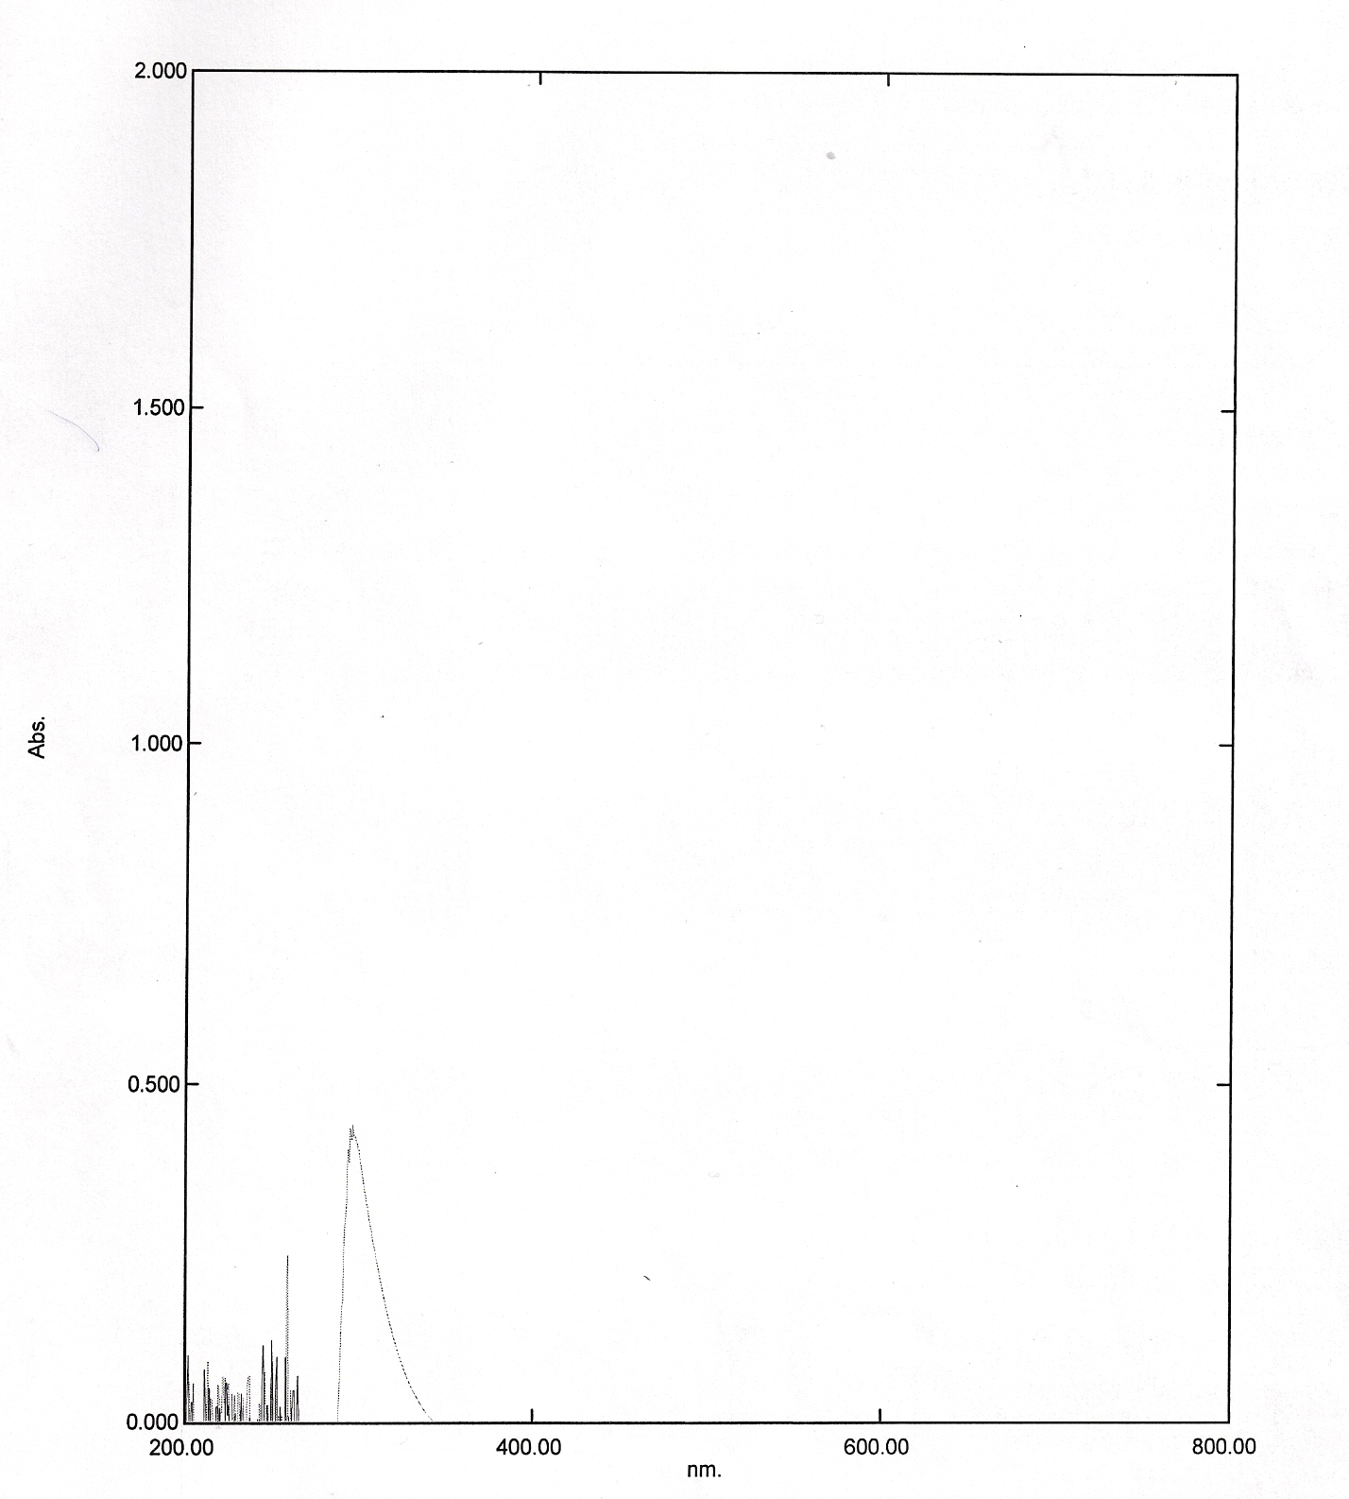

Figure10:Uv-visible spectra of the irradiated solution of experiment 13.

References
Ando, M.; Kobayashi, T.; Iijima S.; and Haruta,M.; Synthesis of Cobalt Oxide Nanotubes from Colloidal Particles Chem., J. Mater., 7, 1779 (1997)
Antolini, E.; Preparation and properties of Li-Co-O compounds J. European Ceram. Soc., 18 , 10 (1998).
Anhuai, L.; Yanjun. G. and Juan, L.; Photocatalytic effect of nature and modified V-bearing rutile Chinese Science Bulletin ; 49, 21(2004).
Boot, L.; Kerkohoffs, M. H.; Linden, B. T.; Dillen, A. J.; Geus, O. W. and Buren F. R.; eparation, characterization and catalytic testing of cobalt oxide and anganese oxide catalysts supported on zirconi ; Fuler J. Appl.Catal. A : General, 137, 69 (1996).
Brownless, R. B.; , Ando, M.; Kobayashi, T.; Iijima S.; and Haruta,M.; Chem., Optical recognition of CO and H₂ by use of gas-sensitive Au–Co₃O₄ composite films J. Mater., 7, 1779 (1997).
Canbay, C. A and Aydogdu, A. and Turkish; MICROSTRUCTURE, ELECTRICAL and OPTICAL CHARACTERIZATION of ZnO-NiO
J. of Science & Technology, 4, No 2, 2009 .
Depaira, J. B. ; Monteiro, W. R. ; Zacharias, M.A.; Rodrigues, J. A. J. and Cortez,G. G. ; Barazilian; Duffus, JH. and Regnl ; Carcinogenicity classification of vanadium pentoxide and inorganic vanadium compounds, the NTP study of carcinogenicity of inhaled vanadium pentoxide, and vanadium chemistry. Regul Toxicol Pharmacol Toxicol Pharmacol 47, 1 (2007).
Ezzo, E. M.; EBeid, F. M.; Yousef,N.A.; and Elalash M.K. ; Conversion of hydrocarbons over cobalt oxide catalysts II: The effect of catalyst pretreatment on the conversion of cyclohexene
Surface Techrology , 19 (1983).
Hancock, W. J.; Sohon, M. D.; and Whitsit J. E.; ''Elemeicts of Chemity, Allyn and Bacon, Inc., U. S. A. (1962) P.335.
Haber, J. ; Witko, M.; and Tokarz, R.; Vanadium pentoxido I. Structures and properties Appl. Catal. A : 157 , 3 (1997).

He, X.; Li, J. and Gao, X. Effect of V2O5 coating on NO2 sensing properties of WO3 thin films
; Thin Films Sensors and a Actnators B: 108 (2005).
Ishihara, T.; Shiokawa, K.; and Arai , H.; Sensors and Acnator, 19(2002).{ Ishihara, T.; Shiokawa, K.; Eguchi, K.; Arai, H.: The mixed oxide Al2O3-V2O5
as a semiconductor gas sensor for NO and NO2, Sensors and Actuators Vol.
19 (1989), p. 259-265}
Jayalakshmi, M.; Rao, M. M.; Venagopal, N.; and Kim, K, B.; Photocatalytic Degradation of Acetone over a V2O5/LaF3 Catalyst
J. of Power Sourees. 166 (2007).
Khodakov, A.; Olthof, B.; Bell, A.T.; and Iglesia. E Structure and Catalytic Properties of Supported Vanadium Oxides: Support Effects on Oxidative Dehydrogenation Reactions”)..; J. Oh Catalysis 181 (1999).
Korotcenkov,G.; Han, S. D.; Cho, B. ; and Tolstoy, V. Structural characterization and phase transformations in metal oxide
fi lms synthesized by Successive Ionic Layer Deposition (SILD) method; J processing and application of Ceramics 3, (2009).

Surnev, S.; Ramsey, M. G.; and Netzer F.P. Growth and structure of ultrathin vanadium oxide layers on Pd (111; Progress in Suface Science, 71 (2003).
Vaidhyanatha, B.; Balagi,K.; and Rao, K. J.; " Microwave - Assisted Solid-State Synthesis of Oxide Ion Conducting Stabilized Bismuth-Vanadate Phases" Chem. Mater (1998) P. 10.

