Natural And Experimental Mammalian Cryptococcal Prostatitis

Ibrahim .M.S.A.Shnawa
Qasim.N.O.Thewaini
Zainab Mohammed Jassim
Department of biology, Collage of Science, University of Babylon ,Hilla-Iraq..
Jawad AL-Msyere
ospitalH alSurgic l Hillla, n Board of HealthBabylo
Abstract
Three human prostatitis patients with pelvic pain, urine retention, dysuria ,renal insufficiency were the tests patients and the attendance of Dr.Jawad AL-Msyere in Hilla Surgical during the period of November 2009 to June 2010 . These cases were showing growth paired encapsulated yeast; their characteristics were consistent with Cryptococcus neoformans .Infective intraurethral dose of 0.2x10⁷ CFU of the C. neoformans suspension to the adult apparently normal rabbits metranidazol preconditional rabbits and baby male rabbits. Urethral discharge and autopsy studies both for reisolation and histopathology were made at the days: 10, 15 and 20 post infection.The C.neoformans specific antibody titer means were 746.66,120 and 66.66 for non conditional adult, metranidazol conditioned adult and baby rabbits respectively at 20 days post infection. C.neoformans were recovered from baby and adult preconditioned rabbits at 10,15 and 20 days post infection from urethra, prostate and testicles of adult and baby rabbits Subacute lapin prostatitis with C.neoformans sequestration were made. Immature and Metranidazol conditiong are good lapin model for C.neoformans prostatitis. . .
الخلاصة
جرى تثبيت ثلاث حالات التهاب بروستات في الإنسان ،أظهرت الم الحوض،احتباس البول ،قلة البول وفشل كلوي وقد شخصت في عيادة الطبيب المختص للفترة من تشرين الثاني 2009 ولغاية حزران 2010 ومثلت هذه الحالات مرضى الاختبار.وعند زرع سائل البروستات لهؤلاء المرضى ظهر نمو متباين الكثافة نقي من المكورات الخبيئة C.neoformans .عندها حضرت جرعات مخمجة من هذه المكورات بمقدار 0.2 مل من عالق يحوي تعداد( ml/ (2x10⁷ CFU وجرعت عبر الاحليل لأرانب بالغة تبدو طبيعية ،أرانب بالغة معاملة بالمترنيدازول 20 mg/ml لمدة خمسة أيام وأرانب رضيعة بمعدل ثلاث أرانب لكل مجموعة وبعد العدوى لفترة 10،15 و 20 يوم كانت عيارات الأضداد المتخصصة بالمكورات الخبيئة في أرانب الدراسة :746.66 ،120 و66.66 في البالغ غير المعامل ،والبالغ المعامل والرضيع على التوالي. جرى ملاحظة ظهور الاحمرار في المنطقة التناسلية والحمى ،قلة الوزن ،والطرح الاحليلي .وعند هذه الأيام جرى عمل الصفة التشريحية واخذ نماذج من الأعضاء التناسلية لإعادة العزل ودراسة التغييرات المرضية النسيجية .أعيد عزل المكورات الخبيئة من الأعضاء المأخوذة في هذه الأيام بعد العدوى .كانت صورة الاستجابة النسيجية التهاب الاحليل شبه الحاد ،التهاب بروستات والتهاب خصى بالمكورات الخبيئة .وتبين بان الأرنب الرضيع والأرنب البالغ المعامل بالمترنيدزول نموذج جيد لمحاكاة التهاب البروستات البشري
Introduction
Mammalian (human) cryptococcosis is usually of subacute or chronic course. It may involve meningies, skin, lung, prostate gland, urinary tract ,eyes ,mycocardium,bones and joints (IICAB,2005) . Cryptococcosis in human being has been considered as sporadic infection with world wide distribution both in immunocompetent and immunocompromized subjects (Mitchell and Perfect, 1995).Mammalian, non human spontaneous cryptococcosis have been reported in cats and rats. (Shnawa and AL-Sadi, 1986; Mitchell and Perfect, 1995). Human renal Cryptococcal abscesses and prostatitis are considered to be less frequent human syndromes (IICAB, 2005).Prostate represents a potential reservoir for C.neoformans that may be responsible for the cases of relapse of meningitis in AIDS patients (Mitchell and Perfect, 1995). Ndimbic etal, 1994 has been reported sequestration of C.neoformans in prostate of immunocompromized subjects.A55 years old man presented with acute urinary retention due to localization of C.neoformans in prostate (Fuse etal, 1995) . Yip etal, 1998 reported cryptococcal prostatitis in chinese patients with NIDM and mesathena gravis patients during Corticosteroid therapy However Chang etal, (2008) reported a case of prostatic cryptococcosis with urine retention and renal insufficiently. Corticosteroids enhance cryptococcosis in mice, guinea pigs, rates and rabbits. Of which the well established model in of rabbit cryptococcal meningitis in which the supposition that this model will mimic human Cryptococcal meningitis in that
1-Immunosuppression is required
2-Infection involves immunologically sequestrated site.
3-Severe cerebrospinal fluid (CSF) leukopenia.
4-Infection is prolonged
5-Dissimination to other organ occure (Mitchell and Perfect, 1995). Thus, in this study a trial for putting forward a lapin model for urogenital cryptococcosis via enhancement with Metranidazol preconditioning. .Material and Methods:
1-Natural Infection:
A:Patients : Dr.Jawad AL-Mesyer, FIBU. Department of Urology, Hilla Surgical Hospital have been referring three patients with chronic prostatitis(Domingue and Hellstrom,1998)during the period of November 2009 to June 2010 .
B- Sampling and processing
The three patients were sampled for prostatic fluid through prostatic messaging (Domingue and Hellstrom ,1998 ).The fluids were tubbed into sterile plane tubes containing 2 ml brain heart infusion broth then transported to the biology department laboratories and immediately streaked on to Blood ,MacConky, Brain heart infusion and Sabroued dextrose agar plates and incubated at 37 cº overnight then up to 72 hrs.From the fluid medium mixture films were prepared onto glass slides and stained for Gimsa ,Gram and India ink negative staining (Mitchell and Perfect ,1995; Domingue and Hellstrom ,1998). Yeast –like colony morphology were observed, purified and biochemically characterized (Mitchell and Perfect, 1995) . .
2-Experimental Infection:
A-Infectious Dose:
Yt Yeast C. neoformans cell suspension of 2x10⁷CFU /ml were prepared from 72 hrs surface growth culture wash and scrabs on to brain heart infusion agar plates .Then used in a rate of 0.2 for each intraurethral dosing per/rabbit. . B-Rabbits:
Rabbits of (Oryctylagus cuniculus) adults of 1.5-2 kg and of babies of 2 week- old, both are male .They were kept adlibitum during experimentation .
Rabbits groups  Adults 3 | Dose  0.2( Iu) of 2x10⁷CFU /ml | Conditioning  No Metranidazol Preconditioned
Adults 3 | 0.2(Iu) of 2x10⁷CFU /ml | Metranidazol Preconditioned with 20 mg/ml for five days(Miller,1980)
Baby 3 | 0.2( Iu) of 2x10⁷CFU /ml | No Metranidazol Preconditioning
IU: Intraurethral route.
C: Fallow up:
At the days 10, 15, 20 post infection, infected animals were checked for pathobiologic changes of infection including fever, weight loss, genital erythrema and urethral discharge .Autopsy were made at 10,15,20 days post infection and samples for genital organs were sampled for isolation and histopathologic studies . .
D: C.neoformans specific Antibody
Five colonies of C.neoformans were grown in brain heart infusion broth for 48 hrs.at 37C° with frequent shaking .The growth was centrifuged at 5000 rpm .Supernate collected and ultrafiltrated with 0.22µ membrane filter (CFC).This CFC was dispensed in appendroph tube. It is a CFC antigen (Murphy etal ,1988.modified). Passive haemagglutination were done as in (Stevens, 2010). . . Results
A: Natural Infection
1-Microscopic morphology:
Mild lymphocytic and monocytic infiltrations along with encapsulated yeast in pairs were noted in the prostatic fluids of the three cases (Table 1). .2-Growth characteristic:
The growth density was scanty on blood agar and moderate on brain heart infusion agar ,Saboroid dextrose agar and serum broth ,No growth was evident on to MacConkys agar .The growth nature was yeast like colonies on to blood agar, brain heart and serum broth. The life cycle stage was non hyphal form in blood, brain heart and saboraued dextrose agars and non budding yeast in serum broth (Table2) . Colonies are dommed, entire edge, creamy color or whitish non easily removed from surface of the medium . .
3-Virulence factors:
The associated yeast pathogens were with natural invivo virulence factors like growth at body temperature 37C°,capsule, sequestration at prostate and induction of an inflammatory responses of mild cellular infiltrations .In experimental lapin infection they were both extracellular and intracellular encapsulated yeasts in pairs with prostate sequestration and induction of mild inflammatory responses .While ,the nature of the invitro virulence factors are consisting of growth at 37C°,forming capsule and urease production (Table 3). .
4-Natural infection pathobiology:
The patients were C.neoformans presented with urine retention, renal insuffiency ,irresponding to therapy with antibacterial antibiotics and manifest lower abdominal pain in pelvic region .Case one, 49 years old –man. leucocyte differential count as M:35,L:35 and N:30. Case two 37 years old man with leukocyte differential count as M:30,L:20 and N:50, while the third case was 60 years old- man with leukocyte differential count as M:15,L:5 and N:80. All of the three cases were with prostate enlargement and yeast sequestration in their prostate (Table 4).
5-Yeast characterization:
They are oval or ovoid in shape with size range from (5-10µm).Arranged in pairs and encapsulated (invivo and invitro) .Non budding, non hyphal forming yeast. Grow at mammalian and human body temperature 37C°, Urease positive .Induce lymphocytic and monocytic infiltration in natural and experimental infections. These characteristic are consistant with C.neoformans (Table 1-4). .
B-Experimental lapin Infection:
1-Pathobiology:
At the days 5, 10, 15 and 20 post infection .The loss of weight were; mild, moderate and sever accordingly. The temperature spike were normal, 38.5, 39,39.5 and 40 C° in accordance with 5,10,15 and 20 days post infection .So for urethral discharge is concerned it was nill,scant,scant and moderate for the period of 5,10 15 and 20 days. No death report was noted . .
2-Choch’s Postulate:
C.neoformans were recovered of same characters of the original isolate used for preparing the infective dose .At the day 10,15 and 20 post infection the urethral discharge were positive for C.neoformans as pure scant to moderate growth .On autopsy at the days 10,15,20 post infection urethra ,testicles as well as prostate were positive for C.neoformans. .
3-C.neoformans specific antibody titers
Twenty days post infection, the C.neoformans specific haemagglutination titer means were 746.66,120 and 66.66 for adult non conditioned, metranidazol conditioned rabbits and baby rabbits respectively (Table5). .
4-Gross pathology:
Erythrema was noted onto the genital organs for both adult conditioned male and baby rabbits. On autopsy, congestion of penis, testicles and prostate were noted. .5-Histopathology:
Tissue section from C.neoformans infected rabbits in 10, 15, 20 days post infection were prepared stained, mounted and examined. Animal in groups 10, 15 were with no apparent changes in both metranidazol conditioned and non conditioned rabbits .In addition to those of 20 days conditioned adults rabbits .The metranidazol conditioned 20 days post infection adult rabbits and baby rabbits were showing C.neoformans induced tissue responses as in the fallowing paragraphs:. .
A: Baby rabbits: The baby rabbits urethra were with thickened mucosa along with mild monocytic and lymphocytic infiltration. C.neoformans were scattered as encapsulated yeast pairs in the submucosa .Testicular tissue showed mild monocytic phagocyte engulfing the yeast bodies together with extracellular yeast bodies distributed in the interstitium This responses are consistant with subacute orchitis.(Figs 6,7,8) . .
B-Adult conditioned Rabbits ;:ale urethra showed thickened mucosa linings. Mild monocytic non phagocytic cell infiltration .This is consistant with sub acute urethritis induced by the test yeast Prostate tissue sections showed epitheliod cells circumscribing. C.neoformans as an early evidence of granuloma formation and C.neoformans sequestration. (Figs1,2,3,4,5) ..
Table 1: Microscopic Morphology of the test yeast
Apperances | character
Ovoid to oval in shape ,arranged in pairs | Shape
Size(5-10µm) | Size
Encapsulated | Cover
Non budding | Bud
Lymphocytic and monocytic response | Response
NTable 2: The growth characteristics of the associated yeast like pathogens
Character | Growth characteristics
Character | MA | BA | BHIA | SDA | SB
Density | - | PSG | PMG | PMG | PMG
Growth nature | - | YLC | YLC | YLC | YLC
Life cycle form | NHF | NHF | NHF | NHF | NBY
Colony orphtype | S,G | S,G | S,G | S,G | EGD

MA:MacConky Agar ,BA:Blood Agar,BHIB:Brain heart infusion garSDA:Sabourd Dextrose Agar SB:Serum broth ,PSG:Pure Scanty Growth MGPure Moderate Growth ,YLG:Yeast Like Growth NHF :Non Hyphal Form, NBY:Non Budding yeast ,EGD:Eern Growth Density
Table 3: The invivo and invitro virulence factors of the test yeast
nvivo/Natural | Virulence factors
nvivo/Natural | Growth at body temperature 37C°
nvivo/Natural | Encapsulated in pairs
nvivo/Natural | Sequestration in prostate
nvivo/Natural | Induce mild lymphocytic and monocytic responses
Invivo/Experimental | Growth at body temperature 37C°
Invivo/Experimental | Encapsulated in pairs
Invivo/Experimental | Intracellular and Extracellular
Invivo/Experimental | Sequestrate in prostate
Invivo/Experimental | Mild lymphocytic and monocytic responses
Invitro | Growth at synthetic complex media 37C°
Invitro | Form capsule in pairs
Invitro | Produce urease

Table 4: The pathobiology of the natural and experimental C.neoformans infection in human and non human mammalian.
A:Natural | Symptoms
A:Natural | Urine retention
A:Natural | Pelvic pain
A:Natural | Dysuria or oligouria
A:Natural | Prostate enlargement
A:Natural | Prostate sequestration of cryptococci
B:Experimental | Weight loss
 | Low grade fever
 | Sluggishness
 | Genital Erythrema
 | Urethral discharge

Table 5 :C.neoformans specific antibody titer in rabbit study groups 20 days post infection.
Rabbits groups | Anti C.neoformans haemagglutinin titer means
Rabbits groups | R1 | R2 | R4 | R¯
Adult non conditioned | 1280 | 640 | 320 | 746.66
Adult metranidazol conditioned | 80 | 110 | 80 | 120
Baby rabbits | 40 | 80 | 80 | 66.66
R 1-3: Replicates R¯: Means (Means of three readings)

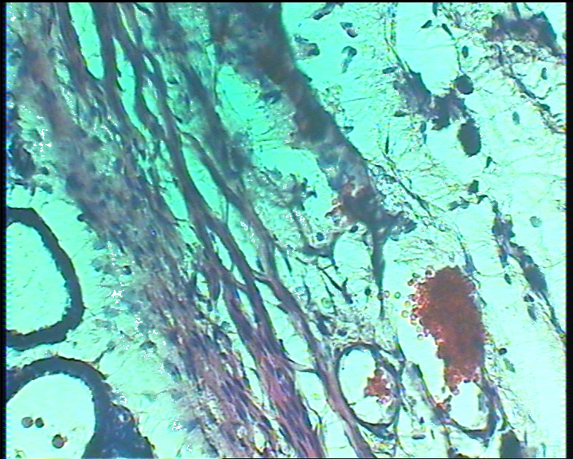
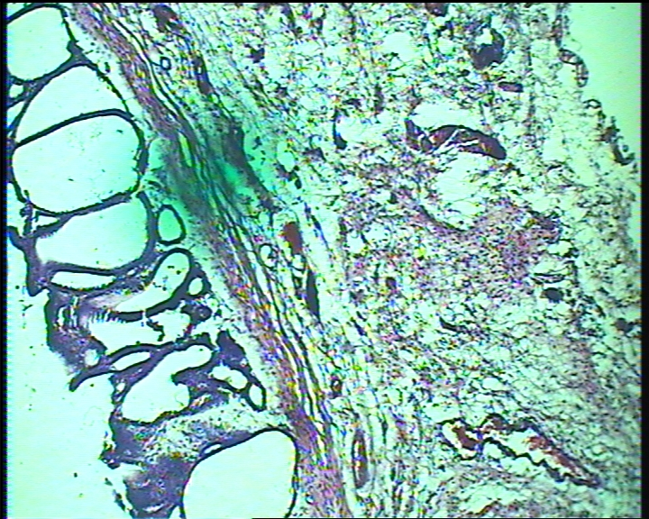

EG

Fig 1: Prostate of Adult conditioned rabbit stained Fig:2 Prostate of Adult conditioned rabbit stained with eosin and haematoxylin 40X showing With eosin and haematoxyline 10X
Epitheloid granuloma(EG) showing inflammatory cells and yeast

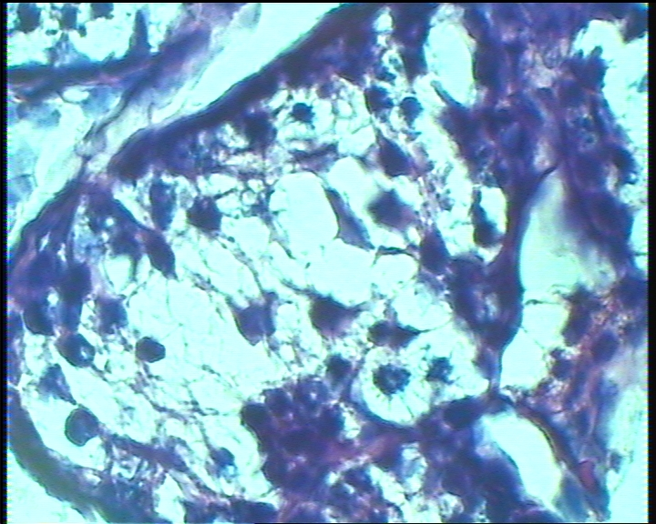
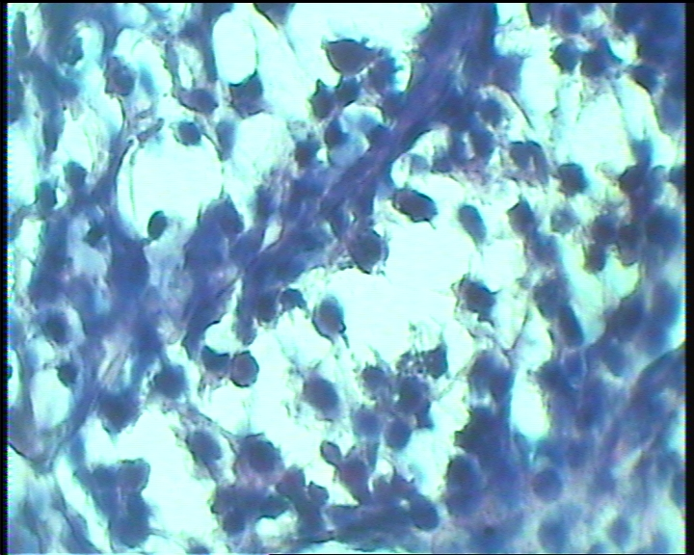
EG
EG

EG
EG

Fig 3: Testis of Adult conditioned rabbit stained Fig:4 Testis of Adult conditioned rabbit stained with eosin and haematoxylin 100X showing With eosin and haematoxyline 40X
Epitheliod granuloma(EG) showing epitheloid granuloma(EG)

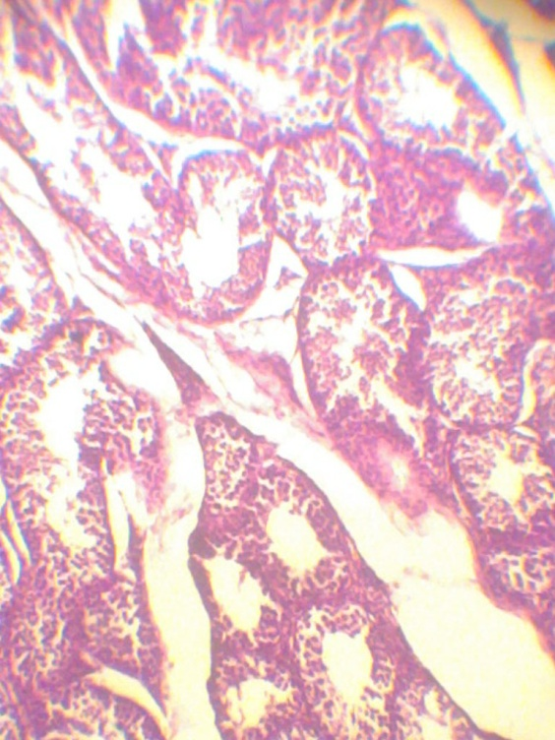
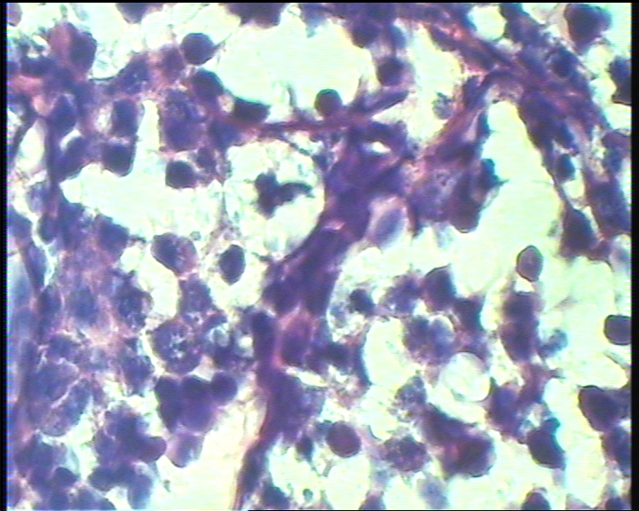
EG

Fig 5: Testis of Adult conditioned rabbit stained Fig:6 Testis of baby rabbit stained with eosin and haematoxylin 100X(showed intracellular With eosin and haematoxyline40X Showed
Microb and epitheliod granuloma
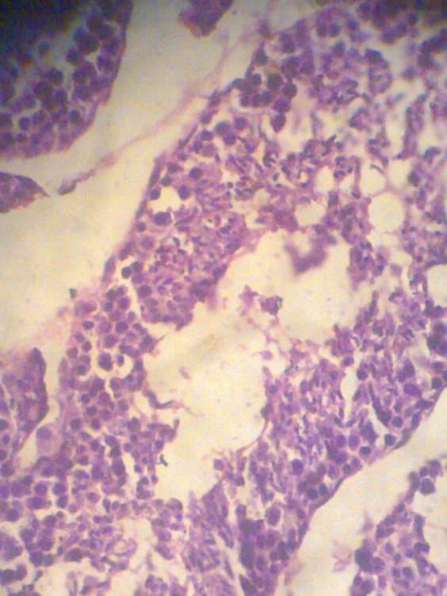
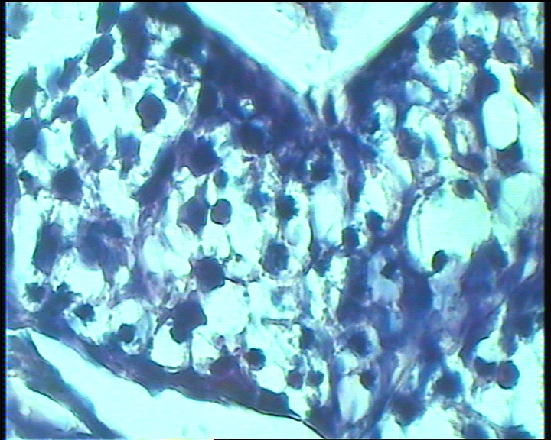

Fig 7: Testis of baby rabbit stained Fig:8 Testis of baby rabbit stained with eosin and haematoxylin 100X With eosin and haematoxyline 100X
Showed infiltration

Discussion
The pair forming, encapsulated yeast like organism (Tables 1-4) are consistant with characteristics of C.neoformans (Mitchell and Perfect, 1995; Kiertiburankul et al ,2004 and Joshi et al,2007 ).Prostate C.neoformans sequestration was judged in natural infection by their presence in prostatic fluid but in experimental infection their presence in prostate fluid as epitheloid granuloma and in urethral discharge (Fuse et al,1995; Kiertiburankul et al ,2004 and Joshi et al,2007).Natural cryptococcal prostatitis reported in human beings through this study has been reported, elsewhere in the world (Fuse et al,1995;Nidimic et al,1994.Yip et al ,1998 and Chang et al,2008).Experimental cryptococcosis prostatitis reported in small mammals through enhancement with corticosteroid has been reported in mice, guinea pigs, and rabbits (Andriole et al 1992, Mitchell and Perfect, 1995) .
Cyclosporine A had been successful immunosuppressant in small mammalian (Brent, 1980).However, it inhibits C.neoformans in vivo (Mody et al, 1988) Thus, five days 20 mg/ml/kg Metranidazol used for precondition rabbits for genitourinary infection (Radhakrishnan and Nall, 2009,Miller,1980), marked humoral immune suppression (Table 5)were noted in conditioned and baby rabbits (Miller,1980). Although it has not been tried for enhancement of lapin cryptococcosis
since they make use of corticosteroid enhancement in cryptococcal meningitis lapin model (Mitchell and Perfect ,1995).Baby rabbits immature immune system (Halliwell and Gorman,1989,Tizard 1992) served as good suitable model for genitourinary cryptococcosis and this model of adult metranidazol conditioned rabbits may mimic human cryptococcal prostatitis in that::.. .
1-Immunologic immaturity and/or immunosuppressant are being required
2-Infection involves immunologically sequester sites. .
3-Infection is being of prolonged duration period up to 20 days as chronic active state.
4-C.neoformans is sequestered in prostate. .
5-Induction of granuloma formation.
Thus on conclusion are many states: :
A-Immature immune system enhances the induction of lapin cryptococcal prostatitis in rabbits .
B-Metranidazol preconditioned enhances adult rabbit cryptococcal prostatitis. .
C-Baby and metranidazol conditioned adult rabbits are being reported as an easy, handable and reproducible mammalian model that simulate human cryptococcal prostatitis . .

.

References
Andriole,V.T.;Miniter,P.;George,D.;Koordick,.andPatterson,T.F. (1992). Animal Models .Usefulness of stuies of fung payhogenseis and drug efficacy in Aspergillosis.Cli.Infect.Dis.14 (51):134-138.
Brent, L. (1980).Cyclosporine A,Clinical and Biological attiributes In,Salman ,J.R.and Sampson,D.(eds).Clinical immnosuppression .Grune and Startton.N.Y.4-8.
Chang ,M.R.; Panigo,A.;Silva,M.M.;Lazera ,M.S.and Wanke ,B.(2008).Prosratic Cryptococosis-Acase report.J.Venon.Animal Toxin.Incl.Trop.Dis14(2):378-385.
Dmingue G.J.SR and Hellstrom,W.J.G.(1998).Prostatitis .Clin.Microbiol.Rev. 11(4):604-613.
Fuse,H.;Ohkawa,M.;Yamaguchi,K.;Hirata,A.Matsubrra(1995).Cryptococcal prostatitis in a patients with Behcet’s disease treated with fuconazole .Mycopathologia 130:147-150.
Halliwell ,REW.and Gorman ,N.I.(1989).Natural Immunology in Veterinary ,Philadilphia W.B.Saunders Co.193-205.
IICAB. (2005).Cryptococcosis .Institute for international cooperation in animal Biologics .An OIE collaborating centre Iowa State University Collage of veterinary medicine.
Johsi,S.;Gowda,S.;Pai,S.A.;Chakravarty,R.D.and Amaranth,S.A.(2007).Cryptococcal Prostatitis and Osteomytitis .Nat.Med.J.Ind.20(1):45.
Kiertiburanakul,S.; Sungkanuparph; Baubt ,B.and Pracharktam,R.(2004). Cryptococcounia as main infection of Disseminated Cryptococcosis and Isolated Urinary tract infection. Jph.J...Infec.Dis.27, 203-205.
Miller, JIJ. (1980).The imidazole as immunosuppressive agent .In,Salamon,J.R.and Sampson,D.(eds).Clinical Immunosuppression Grune and Startton N.Y.,70-73.
Mitchell, T.G.and Perfect, J.R. (1995).Cryptococcosis in the Era of AIDS-Low years after Discovery of Cryptococcus neoformans, Cli.Microbial.Rev.8 (4):515-548.
Mody,C.H.;Toews ,G.B.and Lipscomb, M.F.(1988) Cryptococcus neoformans in a Murine Model .Infec.Immun.56(1) :7-12.
Murphy,J.W.;Mosley,R.L.;Cherniak,R.;Reyes,G.H.;Kozel,T.R. and Reiss,E.(1988).Serological,Electrophoretic and Biological properties of Cryptococcus neoformans antigens.Infec.Immun.56(2).424-431.
Ndimbie,O.K.;Dekker,A.;Martinez,J.and Dixon (1994).Prostae sequestration of Cryptococcus neoformans in immunocompomized patients trated for Cryptococcal meningoencephalities .Histol.Histopathol.9:643-648.
Radhakrishnan, R.and Nallu,R.S.(2009).Development and Characterization induced pelvic pain-Inflammopharmocal.17:23-28.
Shnawa,.IM.S. And AL-Sadi,H.I.(1986).Microbiological and Pthological studies on spontaneous and experimental murine Cryptococcosis Vet.Med.J.34(1):93-105 .
Tizard,I.(1992).Immunity in the fetus and new born. In Veterinary Immunology ,an introduction 4th ed. Philadelphia,W.B.Saunders, 248-260.
Stevens,C.D.(2010).Clinical Immunology and Serology. A laboratory Perspective 3^{ed} ed.
Yip,S.K.H.;Cheng,C.;Wong,MYCandTam,B.H.(1998). Cryptococcal prostatic abscess in an immunocompromized patients .Ann.Acad.Med.27(6):873-876.

