Important Inequalities for Probability Theory

Rawasy Adnan Hammeid
College of Education( Ibn-Hayyan ), Babylon University
Abstract
In the resent years we prove some theorems (Bhaya et.al,2006) about some probabilistic inequalities. In this paper we introduce an improvement to these inequalities.
1. Introduction
The aim of this paper is to prove inequalities for probability theory. This paper is an expository account of some probabilistic inequalities which have contributed to our understanding of several families of Banach spaces of interest in functional analysis. In (Bhaya et.al,2006) we prove the following result:
If and let be independent sub fields of , then for any sequence of integrable functions and for any in we have:
(1.1)
Where p is a positive constant.
2. Martingle inequality
The aim result of this article is to introduce an improvement of the Rosenthals inequality and using it we prove a new type of Martingle inequality.
Before we prove our theorem we need the following lemma:
Lemma 2.1
Let be a probability space, and let and be independent sub fields of . Then for , we have
First let us introduce the following theorem:
Theorem 2.2
Let be independent sub fields of , and . Then for and g in , we have:
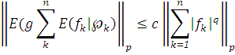
where c is a constant depending on p and q.
Proof:-
Let and be the sub fields of generated by and respectively, then we have and so the the result follows by (1.1) first with respect to for . and then with respect to
for

Remark 2.3
Further results about conditional expectations with respect to independent sub fields in the case may be found in (Bryc et.al,1979) and (Carathors et.al,1988) .
A short proof of theorem 2.2 ( in the case q=1 ) may be found in (Hitczenko ,1990). For general convex functions of theorem 2.2 see (Burkholder ey.al,1972) and (Carsia ,1973) . There is a version of this theorem rearrangement invariant spaces with finite upper Boyd index in (Johnson et.al,1988) .
3. Dilworth inequality type
In (Dilworth ,1991) proved :
Proposition 3.1
Let , and let be independent nonnegative random variable in . Then
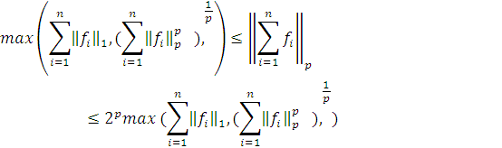
Then he present an extension of this proposition to the range and he introduce some function space on . And he defined
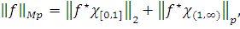
for .
To get
.
In this article we extend Dilworth's theorem and prove the following theorem:
Theorem 3.2
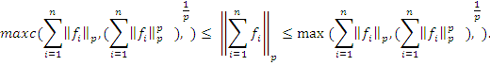
First for the left hand side we have
- Since we can find such that
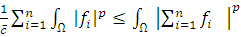.
If then it is clear .
But whenever we can find such that 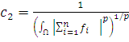 , and 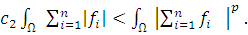
Let
Secondly
- By the inequality 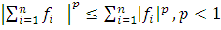 (Carathors et.al, 1988)
We get 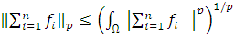
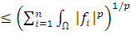.
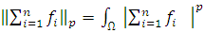 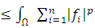.
Since so that
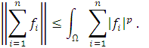
This complets the proof

References
Carsia ,A. M. (1973), Martingle inequalities, W. A. Benjamin, Reading, Mass.
Bhaya E. S., Al-Masudy R.A. (2006), Probability and functional and functional analysis.
Burkholder D. L., Daris B. J. and R. F. Gundy (1972), Integral inequalities for convex functions of operators on Martingls, Proc. Sixth Berkeley symp. Math statist. Probab. Vol.2, univ, of California press. Berkeley pp.223-240.
Carathors N. L. and Dilworth S. J. (1988), Inequalities for sums of independent random variables, proc. Amer. Math.
Hitczenko P. (1990), Best constants in the decoupling inequality for nonnegative random variables, statistics and probability letters 9, 327-329.
Dilworth S. J. (1991), Some Probabilistic inequalities with applications to functional analysis. To appear
Johnson W. B. and Schechtman G. (1988), Martingle inequalities in rearrangement invariant function spaces, Israel J. math , 64, 267-275.
Bryc W. and Kwapien S. (1979), On the conditional expectation with respect to sequence of independent fields , Z. Warsch. View. Gebiete 46, 221-225.

