Laminar Natural Convection In Square Enclosure Containing Different Cross Sections Of Inner Pipes With Internal Heat Generation

Farooq Hassan Ali Alinnawi Ali Safa Nouri Alsaegh
Najlaa Ali Hussein

College of Engineering-Mechanical Engineering Department
Babylon University

Abstract
This paper investigated numerically laminar natural convection inside a square enclosure containing different cross section inner pipes (circular, square and triangular) which have the same peripheral area with internal heat generation. The numerical investigated were carried out by solving the governing equations (Continuity, Momentum and Energy Equations) using Tri-Diagonal Matrix Algorithm (TDMA) by means of the finite- elements method.
The external walls of the square enclosure are kept at hot temperature (T_{h}) while the walls of inner pipes are kept at lower temperature (T_{c}). Flow and heat transfer characteristics through isotherms, streamlines and local Nusselt number have been presented and discussed for external Rayleigh number equal to (10⁶), while internal Rayleigh number is varied from (10⁵) to (10⁸). The working fluid is air with Prandtle number (Pr=0.71). Computational results show that the heat transfer mechanism, the stream line and formation of vortices are dependent on the values of internal Rayleigh number. The effect of different cross section inner pipes on the temperature distribution and stream lines was discussed.
Keywords: Laminar Flow, Natural Convection, Square Enclosure, Internal Heat Generation, Finite Element, Stream Function.
الخلاصة
اجري التحليل العددي لدراسة الحمل الحر الطباقي داخل حيز مربع يحتوي على أنابيب داخلية مقطعها العرضي كان على شكل( دائرة, مربع ومثلث) والتي تمتلك جميعها نفس المساحة المحيطية وبوجود توليد حرارة داخلية. الحل العددي نفذ بحل المعادلات الحاكمة (الاستمرارية, الطاقة و الزخم) باستخدام خوارزمية المصفوفة ثلاثية القطر(TDMA) ، بواسطة طريقة العناصر المحددة.
الجدران الخارجية للحيز المربع كانت بدرجة الحرارة الساخنة (T_{h}) بينما جدران الأنابيب الداخلية تبقى في درجة الحرارة الأوطأ (T_{c}). إن خصائص الجريان وانتقال الحرارة قد تم تفصيلها ومناقشتها من خلال استعراض مخططات توزيع درجات الحرارة و خطوط الجريان ورقم نسلت المحلي (Nu_{l}) حيث فرض رقم رالي الخارجي ليساوي ((Ra_{E}= 10⁶ بينما كان رقم رالي الداخلي (Ra_{I}) يتغير من(10⁵) إلى (10⁸). المائع المستخدم داخل الحيز هو الهواء ليكون رقم برانتل يساوي (.(Pr=0.71 بينت النتائج المحسوبة بأن آلية انتقال الحرارة وخطوط الجريان وتشكيل الدوامات يعتمد على قيم رقم رالي الداخلي Ra_{I})). وكذلك تم مناقشة تأثير المقاطع المختلفة للأنابيب الداخلية على توزيع درجات الحرارة وخطوط الجريان.

1. Introduction
The phenomenon of natural convection in enclosures has received considerable attention in recent years. This attention is due to mainly because this phenomenon often affects the thermal performance in many engineering and science applications such as boilers, nuclear reactor systems energy storage and conservation, fire control and chemical and many others. Lee and Ha (2005) investigated natural convection in horizontal layer of fluid heated below and cold above with a conducting body placed at the center of the layer for the Rayleigh numbers in the range of 10³ ≤ Ra ≤ 10⁶. Aminossadati and Ghasemi (2005) and Islam et al., (2007) investigated numerically natural convection in an inclined differentially heated square enclosure containing internally heated fluid. In both studies, they presented flow and heat transfer characteristics through isotherms, streamlines and average Nusselt numbers for the different values of external and internal Rayleigh number and inclination angles. Roschina et al., (2005) investigated numerically a natural convection of gas with (Pr=0.7) between two horizontal coaxial cylinders with uniform internal heat generation. They have found that the behavior of the system critically depends on three parameter including the inverse relative gap width, Rayleigh number and the modified Rayleigh number which describes heat generation. Zhao et al., (2006) developed convenient practices of solving the conjugate natural convection and conduction in vertical and horizontal enclosures with external and inner heat sources. Their results are produced in terms of the isotherms, stream lines and Nusselt numbers under different thermal boundary conditions. Oztop and Bilgen (2006) studied numerically heat transfer in a differentially heated, partitioned, square cavity containing heat generating fluid. The vertical walls were isothermal, horizontal walls adiabatic and an isothermal partition at the reference temperature was attached to the bottom wall. Their results show the flow and temperature fields and average and local Nusselt numbers at hot and cold walls. Nakhi and Chamkhi (2007) reported a numerical study of steady, laminar, conjugate natural convection around a finned pipe placed in the center of a square enclosure with uniform internal heat generation. The problem is solved numerically by means of the finite- volume method. Their study illustrating the effects of the finned pipe inclination angle and fins length on the streamlines and temperature contours within the enclosure. In addition, they discussed the local Nusselt numbers for various parametric conditions. Jami et al., (2007) investigated a numerical solution of laminar convective flows in a differentially heated, square enclosure with a heat conducting cylinder at its center. The average Nusselt number on hot and cold walls, the flow and temperature fields were discussed in the results. Sathiyamoorthy et al., (2007) studied numerically the natural convection flow in a closed square cavity when the bottom wall is uniformly heated and vertical wall(s) are linearly heated whereas the top wall is well insulated. The governing equations are solved by penalty finite element method with bi-quadratic rectangular elements. The results are obtained for various values of Rayleigh number (10³ ≤ Ra ≤ 10⁵ ) and Prandtl number (0.7 ≤ Pr ≤ 10 ). The streamlines, isotherm contours and local Nusselt number as a function of Rayleigh number are presented. Dalal and Das (2007) investigated numerically steady, laminar natural convection in a two-dimensional enclosure with three flat and one wavy walls. The top wall is heated with a sinusoidal temperature profile and the other three walls are kept at constant lower temperature including the wavy wall. The problem solved using finite volume method in non-orthogonal body – fitted coordinate system. Dalal and Das (2008) solved numerically the problem of natural convection inside square cavity with a wavy right vertical wall and the bottom wall is hearted by a specially varying temperature. Cheng (2009) examine the natural convection heat transfer from a horizontal isothermal cylinder of elliptic cross section in a Newtonian fluid with temperature dependent internal heat generation. The governing equations are solved numerically applying cubic spline collocation method. Shaija and Narasimham (2009) reported a numerical study of the laminar conjugate natural convection heat transfer with and without the interaction of the surface radiation in a horizontal cylindrical annulus formed between an inner heat generating solid circular cylinder and an outer isothermal circular boundary. It is observed that surface radiation reduces the convective heat transfer in the annulus compared to the pure natural convection case and enhances the overall Nusselt number.
The objective of the present work is to study the laminar natural convection inside a square enclosure with uniformly distributed heat generation. The enclosure contains different cross section inner pipes (circular, square and triangular) which have the same peripheral area and the walls of pipes are kept at lower temperature (T_{c}), while the external walls of the square enclosure are kept at hot temperature (T_{h}) . The working fluid is air with Prandtle number (Pr=0.71). The effect of the inner pipes cross section on the fluid flow and heat transfer characteristic were studied. The external Rayleigh number (Ra_{E}) is equal to (10⁶), while the internal Rayleigh number (Ra_{I}) varied from (10⁵) to (10⁸).

2. Numerical Methodology
A schematic diagram of the system considered in the present study is illustrated in figure (1). It consists of square enclosure with side length (L=0.15 m) containing different cross sectional inner pipes (circular, square and triangular) which have the same peripheral area. The diameter of circular pipe (D) is equal to (0.2 L), so the peripheral area can be found which is equal to that of square and triangular pipes. The enclosure have an internal heat generation (Q_{V}). The four external walls of the square enclosure are kept at hot temperature (T_{h}) while the walls of the pipes are kept at lower temperature (T_{c}). The governing equations for two-dimensional steady state laminar incompressible buoyancy-induced one phase flow with internal heat generation and constant fluid properties can be written as follows , Patankar (1980):

Continuity Equation:
$\frac{∂\left({ρV}_{x}\right)}{∂x}+\frac{∂\left({ρV}_{y}\right)}{∂y}=0$ (1)
Momentum Equation:
$\frac{∂\left({ρV}_{x}V_{x}\right)}{∂x}+\frac{∂\left({ρV}_{y}V_{x}\right)}{∂y}={ρg}_{x}−\frac{∂P}{∂x}+\frac{∂}{∂x}\left(μ\frac{∂V_{x}}{∂x}\right)+\frac{∂}{∂y}\left(μ\frac{∂V_{x}}{∂y}\right)$ (2)
$\frac{∂\left({ρV}_{x}V_{y}\right)}{∂x}+\frac{∂\left({ρV}_{y}V_{y}\right)}{∂y}={ρg}_{y}−\frac{∂P}{∂y}+\frac{∂}{∂x}\left(μ\frac{∂V_{y}}{∂x}\right)+\frac{∂}{∂y}\left(μ\frac{∂V_{y}}{∂y}\right)$ (3)
Energy Equation:
$\frac{∂}{∂x}\left({ρV}_{x}C_{p}T\right)+\frac{∂}{∂y}\left({ρV}_{y}C_{p}T\right)=\frac{∂}{∂x}\left(k\frac{∂T}{∂x}\right)+\frac{∂}{∂y}\left(k\frac{∂T}{∂y}\right)+Q_{V}$ (4)
Where V_{x} and V_{y} are the velocity components in the x and y direction respectively, P is the pressure, T is the temperature and Q_{V} is the internal heat generation per unit volume. The value of the internal heat generation depends on the value of the internal Rayleigh number (Ra_{I}). The thermo-physical properties of air ($ρ, μ, \text{cp}, α \text{and} k$) are obtained from tables at film temperature (T_{f}). The commercial code (ANSYS 12.1) was used to solves the above governing equations.
The external Rayleigh number (Ra_{E}) is defined as:
${\text{Ra}}_{E}=\frac{g β (T_{h}−T_{c}) L^{3}}{α ν}$ (5)
While the internal Rayleigh number (Ra_{I}) is:
${\text{Ra}}_{I}=\frac{g β Q_{v} L^{5}}{α ν k}$ (6)
where,
$β=\frac{1}{T_{f}}$ and $T_{f}=\frac{T_{h}+T_{c}}{2}$ (7)
Boundary Conditions:
The physical boundary conditions of the present study can be written as:
- At all solid walls where the fluid interfaces:
V_{X} =V_{Y} =0

The thermal boundary conditions are:
- At all external walls of the enclosure: (T=T_{h}) where its values depends on the value of the external Rayleigh number (Ra_{E}).

- At all surfaces of the different pipes: (T=T_{c}) which is equal to (293 K).

The stream function is computed for 2-D structure and is defined by a way of its derivatives:
$\frac{∂ψ}{∂Χ}=−{ρV}_{Y}$ and $\frac{∂ψ}{∂Υ}={ρV}_{X}$ (8)
In order to investigate the effect of several of parameters on the heat transfer, maximum local Nusselt number along the hot wall of the enclosure is selected as an indicator for the heat transfer rate. The maximum local Nusselt number is defined as:
${\text{Nu}}_{l}=\frac{h_{f}L}{k}$ (9)
and the film coefficient (hf) are obtained from the following equation:
${\left\{q\right\}}^{T}\left\{η\right\} = h_{f}(T_{h}−T_{f})$ (10)
L
T_{h}
T_{h}
T_{h}
T_{h}
T_{c}
g
L
y
x
Q_{v}
T_{h}
T_{h}
T_{h}
T_{h}
T_{c}
T_{c}
T_{c}
g
L
L
x
y
T_{c}
Q_{v}
T_{h}
T_{h}
T_{h}
T_{h}
T_{c}
T_{c}
T_{c}
g
L
L
y
y
Q_{v}
Fig.(1): Schematic Diagram of the Square Enclosure with Different Cross Section Inner Pipes with Volumetric Internal Heat Generation.

3. Numerical Solution
The grid system over the computational domain was created using unstructured quadratic element, which were unevenly distribution and concentrated near the four corner of the square enclosure where higher grid densities are desired as in Figure (2). It provides smooth solution at the interior domain including the corner region. Employing the finite element approach, the governing equations were iteratively solved with the convergence criterion of 10⁻⁸ for each variable. The set of governing equations is integrated over the domain with use of exponential interpolation in the mean flow direction inside the finite element.
The ANSYS (12.1) code used the Tri-Diagonal Matrix Algorithm (TDMA) to solve governing equations (Continuity, Momentum and Energy Equations).

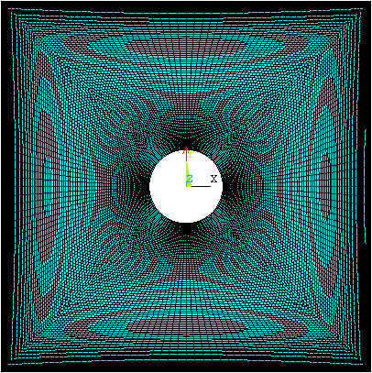
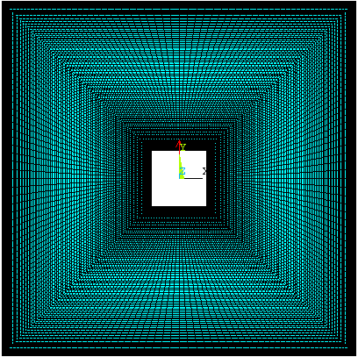
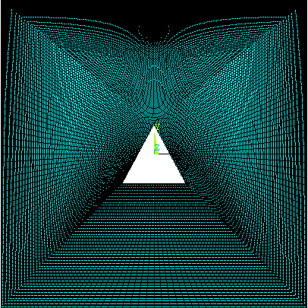
Fig.(2): A Typical Grid Distribution with Quadratic Elements.

A grid independence test is applied to ensure the accuracy of the numerical results and to determine an appropriate grid density. Comparison of the maximum local Nusselt number with the number of nodes is shown in Figure (3). It can be seen that the local Nusselt number is stable when number of nodes equal to (50000) nodes.

Fig. (3): Comparison of the Maximum Local Nusselt Number with the Number of Nodes.

For the commercial code verification, the natural convection problem in square enclosure containing circular cross sectional pipe with low external Rayleigh number (10⁵) and internal Rayleigh number (10⁷) was tested. It can be compared the test case with Nakhi and Chamkha, (2007 ). The comparison gives a good agreement as shown in Figure (4).

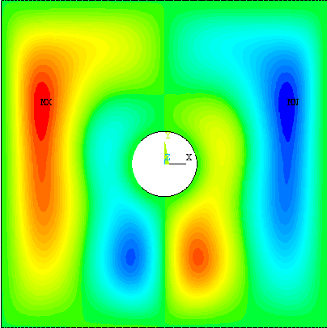
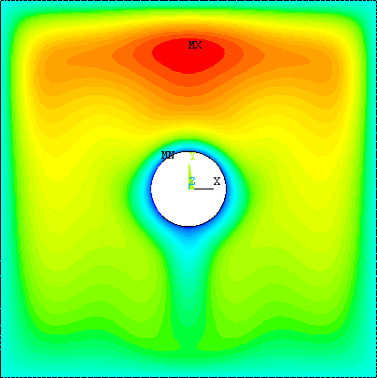
Fig.(4):Comparison of Streamline and Isothermal Contour Between The Test Case and Nakhi & Chamkha, (2007 ).
Test Case
Nakhi and Chamkha, (2007 )
20.54=Ψ∆
20.12=Ψ∆
3.54=θ_{max}
3.95=θ_{max}

4. Results And Discussion
In this investigation, streamlines and isotherms inside the square enclosure containing circular, square and triangular cross section inner pipes are presented. The maximum local Nusselt number along the hot enclosure wall have been also examined and discussed. The internal Rayleigh (Ra_{I}) number is varied from 10⁵ to 10⁸ while the external Rayleigh number (Ra_{E}) is kept at 10⁶.The working fluid is chosen as air with Prandtl number, Pr =0.71.

4.1 Streamlines and Temperature Profiles:
Figure (5) shows the isotherms and streamlines in the square enclosure which have a hot air with Prandtle (Pr =0.71) and this enclosure is cooled by circular, square and triangular cross section inner pipes. The external Rayleigh number (Ra_{E}) is equal to (10⁶) while the internal Rayleigh number (Ra_{I}) equals to (10⁵), i.e. (Ra_{I} < Ra_{E}).

Figure (5-a) shows the isothermal body contours for different cross sections of the inner pipes. At this value of internal Rayleigh number, it can be seen that the behavior of isothermal body contour is the same for the different cross sections of the inner pipes and it is symmetrical to the vertical center line. The thermal boundary layers are continuous around the inner pipes and becomes larger away from it. The lower part of enclosure have a lower temperature, while the isothermal lines are concentrated near the hot lateral wall of enclosure showing high temperature gradient as well as high heat transfer.
Figure (5-b) shows the streamlines of the enclosure which consists of two large symmetrical and counter rotating vortices where the left vortex moves with clockwise direction and the right vortex moves in anti-clock wise direction. It can be seen that the air near the inner pipes walls is almost stagnant due to high viscous effect, and the buoyant force starts to dominate the flow. The air movement is due to the continuous heating of the hot walls which pushed the air upwards near the vertical hot surfaces and move downwards near the vertical symmetry line. It is found that the circular cross section inner pipe has a maximum strength of the streamlines as compared with the other cross sections ( square and triangular).

Figure (6) shows the isotherms and streamlines for the enclosure when the internal Rayleigh number is equal to external Rayleigh number (Ra_{I} = Ra_{E} =10⁶). It can be seen that the behavior of isotherms and streamlines body contour are approximately similar that of the above case when Rayleigh number (Ra_{I} =10⁵), but there is sensible increasing in temperature gradient and intensity of streamlines pattern about (0.1%) due to increasing in internal heat generation. The maximum value of the temperature for all cross section inner pipes is about 307 K.

In figure (7), when internal Rayleigh number is increased to 10⁷ ,i.e. (Ra_{I} > Ra_{E}), it is observed that the effect of convection on the fluid flow and heat transfer in the enclosure increases. The maximum temperature is increases and concentrated near the top wall of the enclosure due to the increasing in the internal heat generation as shown in figure (7-a). It is observed that the maximum value of temperature increased to be 311 K for circular cross section inner pipe while for the square cross section is 308.798 K and for triangular cross section is equal to 309.108 K. It means that the circular cross section inner pipe gives maximum temperature than the other cross sections of inner pipes.

The convection mode of heat transfer is dominant, so the magnitude of the velocity circulating in the enclosure increases and contributes larger distortion of streamlines than those at lower internal Rayleigh number as shown in figure ( 7-b). A pair of weak vortices formed on the top of the enclosure. The vortices at the right top and left bottom corners of the enclosure moves with clock wise direction while the vortices at the left top and right bottom corners of the enclosure moves in anti clock wise direction.

If the Internal Rayleigh number is increased to 10⁸, the isotherms is depressed to the up region of the enclosure as shown in figure (8-a) indicating diffusion dominated of heat transfer and the intensity of temperature contours increasing near the top walls of enclosure due to the increasing in the internal heat generation. It is found that the maximum value of temperature in the triangular cross section is 330.032 K while for square cross section is 329.402 K and for circular cross section the maximum temperature is equal to 328.99 K. From this comparison, it is observed that the circular pipe gives better cooling than the other cross sections of pipes because that the drag force of the square and triangular cross sections to the fluid flow is greater than the circular one due to the acute edge of it.

Figure (8-b) shows four vortex of streamlines, the upper weak vortices is stretched longitudinally and the lower stronger vortex is smallest in size. A counter clockwise circulation are formed under the inner pipe to the right and at the left upper corner of the enclosure while a clockwise direction vortex are formed under the inner pipe to the left and at right upper corner of the enclosure.

4.2 Local Nusselt Number
Figure (9) illustrates the maximum local Nusselt number at hot walls of the enclosure versus different values of internal Rayleigh number (Ra_{I} =10⁵, 10⁶, 10⁷ and 10⁸) and when the external Rayleigh number (Ra_{E}) is kept at 10⁶. At the value of internal Rayleigh number (Ra_{I} =10⁵ and 10⁶), the values of the maximum local Nusselt number are positive which means that the hot wall of the enclosure transfer the heat to the air inside. At internal Rayleigh number (Ra_{I} =10⁷), it can be seen that there is a rapid down in local Nusselt number toward negative values. The local Nusselt number at Ra_{I} =10⁸ becomes negative which means that the hot wall of enclosure absorbs the heat from the interior higher temperature air due to the buoyancy effect generated by the internal heat generation.

5. Conclusions
laminar natural convection inside a square enclosure containing different cross sections inner pipes (circular, square and triangular) with internal heat generation have been studied numerically. The governing equations of continuity, momentum and energy have been solved using Tri-Diagonal Matrix Algorithm (TDMA) by (ANSYS 12.1) commercial code. The isothermal body contour, streamlines and local Nusselt number was presented to investigate the effect of the presence of different cross section inner pipes on the fluid flow and heat transfer in the square enclosure when internal Rayleigh number (Ra_{I} ) is varied from 10⁵ to 10⁸ and external Rayleigh number (Ra_{E}) is kept at 10⁶.
When the internal Rayleigh number (Ra_{I} ) is equal and less than (Ra_{E}), the effect of convection on the fluid flow and corresponding heat transfer is relatively weak and the hot walls of enclosure transfer the heat to the air inside the enclosure and when internal Rayleigh number (Ra_{I}) is larger than external Rayleigh number (Ra_{E}), the effect of natural convection becomes more dominant and as a result the walls of the enclosure absorbs heat from the air inside the enclosure. It can be concluding that the circular inner pipe gives a better cross section of cooling than the other cross sections as the internal Rayleigh number increases more than 10⁷.

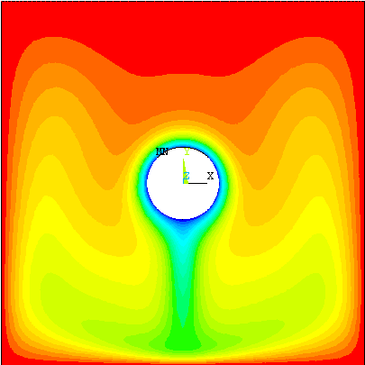
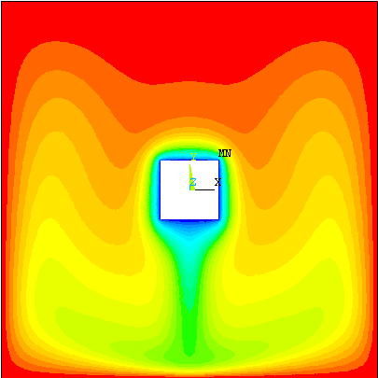
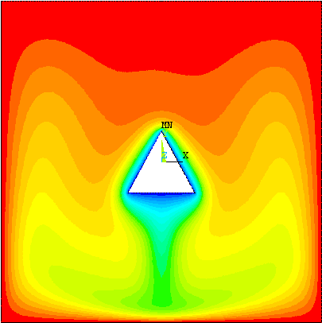
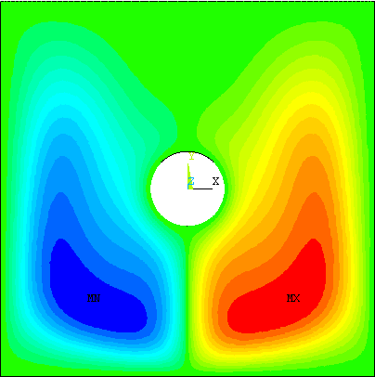
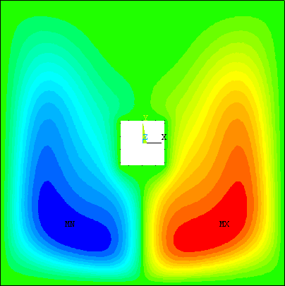
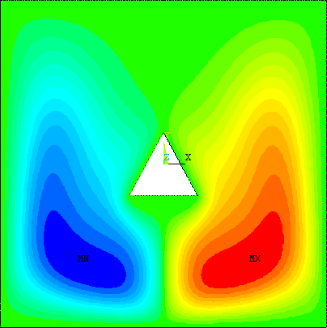
Fig.(5): Isotherms and Streamlines for Ra_{I}=10⁵
(a)
Isothermal Body Contour (Kelvin)

(b)
Stream function Body Contour (m²/s)

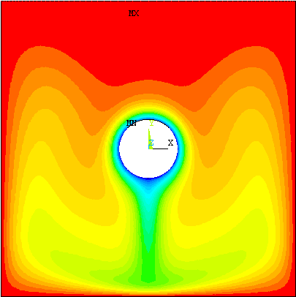
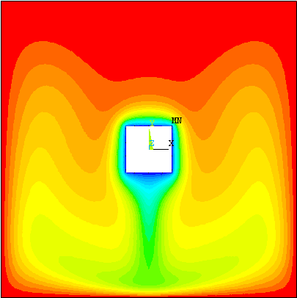
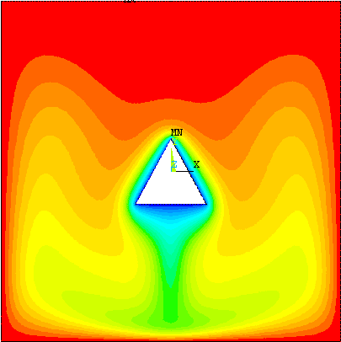
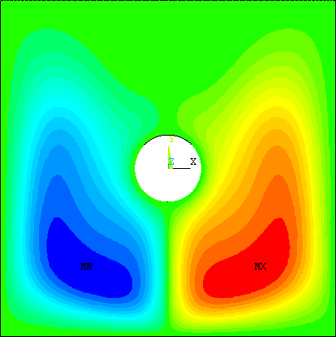
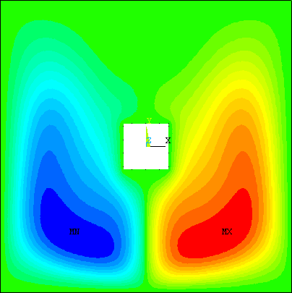
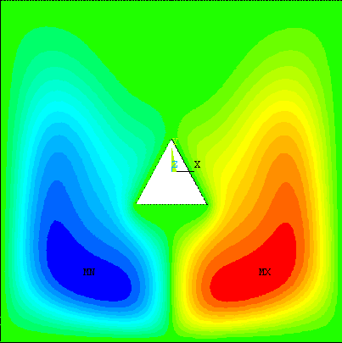
(b)
Stream function Body Contour (m²/s)

(a)
Isothermal Body Contour (Kelvin)

Fig.(6): Isotherms and Streamlines for Ra_{I}=10⁶

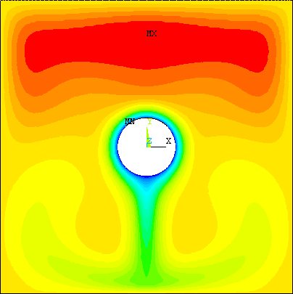
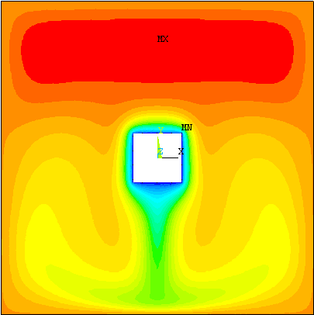
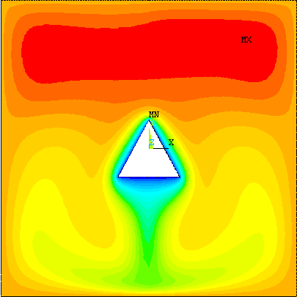
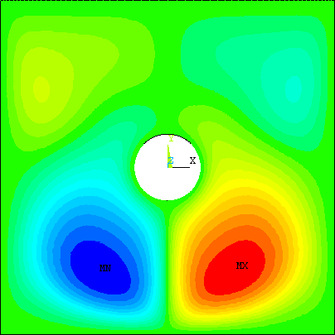
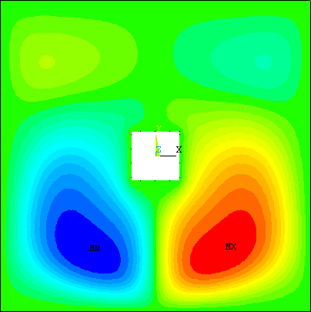
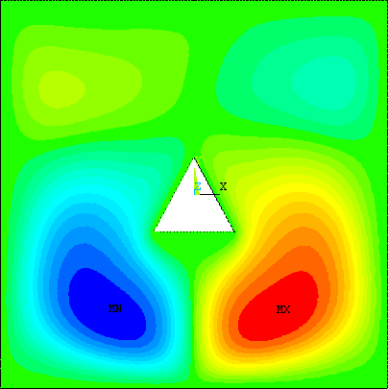
(b)
Stream function Body Contour (m²/s)

(a)
Isothermal Body Contour (Kelvin)

Fig.(7): Isotherms and Streamlines for Ra_{I}=10⁷

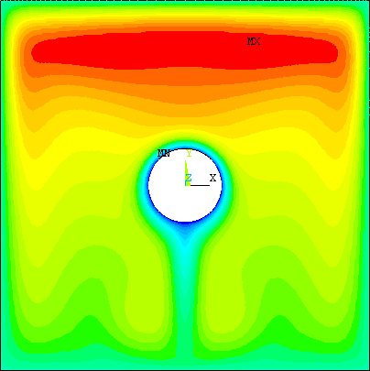
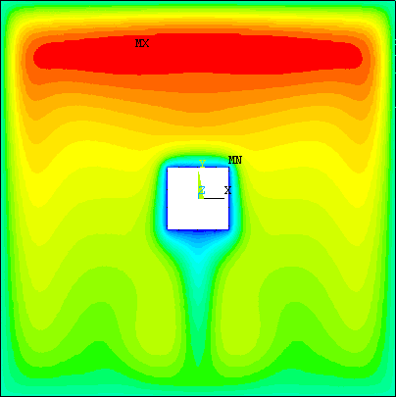
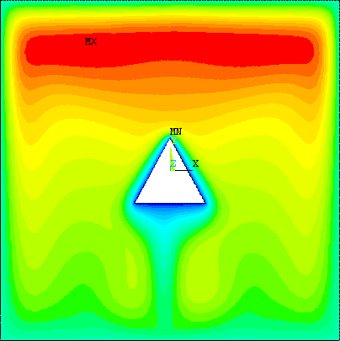
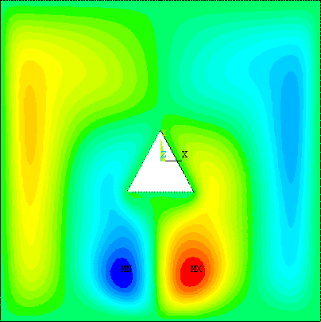
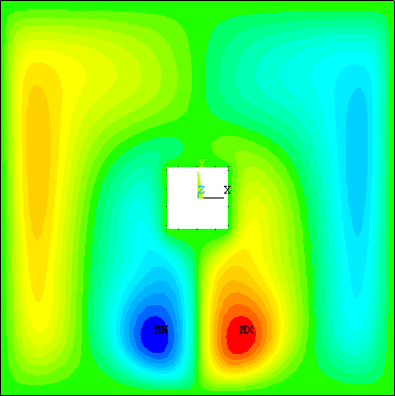
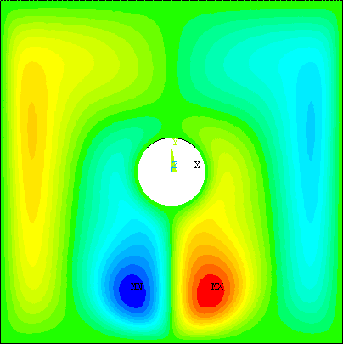
(b)
Stream function Body Contour (m²/s)

(a)
Isothermal Body Contour (Kelvin)

Fig.(8): Isotherms and Streamlines for Ra_{I}=10⁸

Fig. (9) The Variation of the Maximum Local Nusselt Number
with Internal Rayleigh Number (Ra_{I})

6. References:
Aminossadati S.M. and Ghasmi B. " The Effects of Orientation of an Inclined Enclosure on Laminar Natural Convection" Heat and Technology, vol.23, no.2, 2005.
Cheng .Y., " Natural Convection Heat Transfer from a Horizontal Isothermal Elliptical Cylinder with Internal Heat Generation" Int. Communications in Heat and Mass Transfer 36(2009) 346-350.
Dalal A. and Das M. K., "Numerical Study of Laminar Natural Convection in a Complicated Cavity Heated From Top with Sinusoidal Temperature and Cooled From Other Sides" Computers and Fluids 36 (2007) 680-700.
Dalal A. and Das M. K., " Heat line method for the visualization of natural convection in a complicated cavity" Int. Journal of Heat and Mass Transfer 51(2008) 263-272.
Incropera F.P. and Dewitt D.P., “Fundamentals of Heat and Mass Transfer” John Wiley and Sons, New York, 1996.
Islam T., Saha S. and Mamun A.H. " Natural Convection in an Inclined Square Enclosure Containing Internal Energy Sources" Journal of Mechanical Engineering, vol. ME37, June 2007.
Jami M., Mezrhab A., Bouzidi M. and Lallemand P. "Lattic Boltzmann Method Applied to The Laminar Natural Convection in An Enclosure with a Heat-Generation Cylinder Conducting Body" Int. Journal of Thermal Sciences 46 (2007) 38-47.
Lee J.R., Ha M.Y. " A Numerical Study Of Natural Convection in a Horizontal Enclosure with a Conducting Body" Int. J. of Heat And Mass Transfer 48 (2005) 3308-3318.
Nakhi A.B., Chamkha A.J, "Conjugate Natural Convection Around a Finned Pipe in a Square Enclosure with Internal Heat Generation" Int. J. of Heat and Mass Transfer 50 (2007) 2260-2271.
Oztop H. and Bilgen E."Natural Convection In Differentially Heated and Partially Divided Square Cavities with Internal Heat Generation" Int. Journal of Heat and Fluid Flow 27 (2006) 466-475.
Patankar, S.V., “Numerical Heat Transfer and Fluid Flow” , Hemisphere Publishing Corporation, New York, 1980.
Roschina N.A, Uvarov A.V. and Osipov A.I. "Natural Convection in An Annulus Between Coaxial Horizontal Cylinder with Internal Heat Generation" Int. Journal of Heat and Mass Transfer 48 (2005) 4518-4525.
Sathiyamoorthy M., Basak T., Roy S. and Pop I. "Steady Natural Convection Flows in a Square Cavity with Linearly Heated Side Wall(s)" Int. Journal of Heat and Mass Transfer 50 (2007) 766-775.
Shaija A. and Narasimham G.S.V.L., "Effect of Surface Radiation on Conjugate Natural Convection in a Horizontal Annulus Driven by Inner Heat Generation Solid Cylinder" Int. Journal of Heat and Mass Transfer 52(2009) 5759-5769.
Zhao F.Y., Tang G.F., Liu D. "Conjugate Natural Convection In Enclosures With External and Internal Heat Sources" Int. J. of Engineering Science 44 (2006) 148-165.

Nomenclature:
Symbol | Description | Unit
C_{p} | Specific Heat | J/kg.K
g | Gravitational Acceleration | m/s²
h_{f} | Film Coefficient | W/m²
k | Thermal Conductivity of Fluid | W/m.K
L | Side Length | m
Nu_{l} | Local Nusselt Number
p | Pressure | N/m²
Pr=ν / α | Prandtl Number
{q} | Heat Flux Vector | W/m²
Q_{v} | Volumetric Heat Source | W/m³
Ra_{I}= gβ Q_{v} L⁵ / ανk | Internal Rayleigh Number
Ra_{E} = gβΔTL³ / αν | External Rayleigh Number
T | Temperature | K
T_{c} | Temperature of the cold wall (inner pipes)
T_{f} | film Temperature | K
T_{h} | Temperature of the hot wall (enclosure wall) | K
V_{x} | Velocity Component in x-Direction | m/s
V_{y} | Velocity Component in y-Direction | m/s
X | Cartesian Coordinate in Horizontal Direction | m
Y | Cartesian Coordinate in Vertical Direction | m
Greek Symbols
α | Thermal Diffusivity | m²/s
β | Volumetric Coefficient of Thermal Expansion | K⁻¹
μ | Viscosity | N.s/m²
ν | Kinematic Viscosity of the Fluid | m²/s
ρ | Density of the Fluid | kg/m³
Ψ | Stream Function | m²/s
{η} | Unit Out Ward Normal Vector

