Laminar Mixed Convection in A lid-Driven Equilateral Triangle Enclosure
Riyadh S. Al-Turhee | Mohammed Yousif Jabbar |  | Hameed kadhem Hamza
Babylon University, College of Engineering ,Mechanical Department.
Hameed A. Hamza
Chemical Engineering, Ministry of Science and Technology

Abstract
Laminar mixed convection flow in equilateral triangular lid-driven enclosure is numerically investigated by using ANSYS 12.1 program .The horizontal side wall is sliding from left to right with a hot temperature of (T_{h}). The other two inclined walls are considered to be isothermal, cold and its temperature is (T_{c}). The governing equations (energy equation, momentum equation and continuity equation) are solved using the finite element method with ANSYS 12.1 program. The governing parameters are Grashof number (Gr =10⁵,10⁶ and 10⁷) and Richardson number (Ri=0, 1, 10, 100). An air is used as a working fluid with Pr=0.71. The obtained results represent as isothermal contours and stream function. It is obvious from the result that, the motion of the sliding wall has a dramatic effect on the flow and temperature distribution more than the buoyancy force, and then has an effect on heat transfer.
Key words: Mixed Convection, Triangle Enclosure, Lid-Driven, Finite Element, and Stream Function.
الخلاصة
جريان الحمل المختلط الطباقي في سواقه مثلث متساوي الاضلاع تم حلها عدديا باستخدام برنامج الANSYS 12.1 .الضلع الافقي للمثلث ينزلق افقيا من اليسار الى اليمين بدرجه حراره ساخنه (T_{h}). بينما الجدارين المائلين الاخريين تم فرضهما باردين وثابتين درجه الحراره (T_{c}). المعادلات الحاكمه (معادلة الطاقه, معادلة الزخم ومعادلة الاستمراريه) تم حلها باستخدام طريقة العناصر المحدده بواسطة برنامج . ANSYS 12.1 رقم Grashof (Gr =10⁵,10⁶and 10⁷) ورقم Richardson (Ri=0, 1, 10 and 100) تم اعتبارهما متغيرا المسأله. الهواء استخدم كمائع شغل برقم Prandtle (Pr=0.71). النتائج التي تم الحصول عليها مثلت كمخططات حراريه ومخطط انسياب الجريان للمائع. لقد اصبح واضحا من النتائج بان حركه الجدار المنزلق له تأثير كبير مقارنه بقوه الطفو على كل من الجريان و على توزيع درجات الحراره وبالتالي ثاثيرها على أنتقال الحراره.

Nomenclatures:
Symbol | Description | Unit
g | Gravitational acceleration | m/s²
 | Grashof number | -
k | Thermal conductivity of fluid | W/m. °C
L | Side Length | m
Nu | Average Nusselt number | -
p | Pressure | N/m²
 | Prandtle number | -
Ri | Richardson number | -
q | Heat Transfer rate | W/m^{2o}C
{q}^{T} | heat flux factor. | -
{η} | unit outward normal vector | -
h | film coefficient | kJ/kg. ºC
T | Temperature | °C
V_{x} | Velocity component in x-direction | m/s
V_{y} | Velocity component in y-direction | m/s
U | Sliding velocity | m/s
x | Cartesian coordinate in horizontal direction | m
y | Cartesian coordinate in vertical direction | m
Greek Symbols |  | J/kg.ºC
c_{p} | Specific heat | -
α | Thermal diffusivity | m²/s
β | Volumetric coefficient of thermal expansion | K⁻¹
μ | Viscosity | N.s/m²
$${}_{φ}$$ | Variable vector | -
ν | Kinematic viscosity of the fluid | m²/s
ρ | Density of the fluid | kg/m³
ψ | Stream Function | -
Abbreviation |  | -
Fig. | Figure | -

1- Introduction
The problem on laminar mixed convection with lid-driven flows has multiple applications in the field of thermal engineering. Such problems are of great interest, for example in electronic device cooling, high-performance building insulation, multi shield structures used for nuclear reactors, food processing, glass production, solar power collectors, furnace, drying technologies, etc.[ Nasreddine Ouertatani et al. (2009)]
The flow field and heat transfer characteristics of lid-driven cavity flow was investigated in numerous numerical and experimental studies. However, W. Cazemier, et al (1998), computed a proper orthogonal decomposition (POD) of the flow in a square lid-driven cavity at (Re= 22,000) to reduce the coherent structures in this flow and to construct a low-dimensional model for driven cavity flows. The periodic solutions of the dynamical system at (Re=511,800) had approximately the same period and had qualitatively the same behavior. Kuhlmann et al (2001), investigated numerically and experimentally the flow in a rectangular cavities driven by two facing side walls for the case when the walls move steadily with equal speed in opposite directions. The nonlinear behavior was explored by an experiment in which the separation of the moving walls was about twice the distance of the stationary walls. The flow field organized into a row of robust rectangular steady cells which became time-dependent for increasing Reynolds numbers. Mahapatra et al,(2006), used the mathematical modeling aspects of transport phenomena in steady, two dimensional, laminar flow accompanied by heat transfer in a lid-driven differentially heated cavity in presence of radiatively absorbing, emitting and scattering gray medium. For pure mixed convection, Ri=1.0, radiation–conduction parameter (RC=0) and for buoyancy opposing flow, the rate of heat transfer was low compare to rate of heat transfer corresponding to Ri=0.1 or 10. Nasreddine et al,(2009), utilized a numerical methodology based on the finite volume method and a full multi grid acceleration to study the intricate three-dimensional flow structures and the companion heat transfer rates in double lid-driven cubic cavity heated from the top and cooled from below. Numerical values of the overall Nusselt number in harmony with the Re and Ri-intervals are presented and they were comparing afterward against the standard case of a single lid driven cavity. It was discovered that a remarkable heat transfer improvement of up to 76% can be reached for the particular combination of (Re = 400) and (Ri = 1). Cheng and Liu (2010), investigated numerically the effect of temperature gradient orientation on the fluid flow and heat transfer in lid-driven differentially heated square cavity. They were Compute average Nusselt number indicates that the heat transfer rate increases with decreasing Ri regardless the orientation of temperature gradient imposed. Muthtamilselvan et al,(2010), investigated numerically mixed convection flow in a two-sided lid-driven cavity filled with heat generating porous medium . It was found that the variation of the average Nusselt number was non-linear for increasing values of the Darcy number with uniform or non-uniform heating condition. Zhang et al,(2010), solved by Chebyshev pseudospectral method the two-dimensional steady incompressible Navier–Stokes equations in the form of primitive variables. The computational results fit well with the exact or benchmark solutions.Ghasemi and Aminossadati (2010), presented the results of a numerical study on the mixed convection in a lid-driven triangular enclosure filled with a water–Al₂O₃ nano-fluid. The results showed that the addition of Al₂O₃ nano-particles enhances the heat transfer rate for all values of Richardson number and for each direction of the sliding wall motion. Tanmay Basak et al,(2010), studied numerically mixed convection flows in a lid-driven square cavity filled with porous medium using penalty finite element analysis for uniformly heated bottom wall, linearly heated side walls or cooled right wall. Average Nusselt numbers were found almost invariant with Grashof number for low Prandtle number with all Da for linearly heated side walls or cooled right wall. Farhad et al,(2010), executed a numerical investigation of laminar mixed convection flows through a copper–water nano-fluid in a square lid-driven cavity. It was found that at the fixed Reynolds number, the solid concentration affects on the flow pattern and thermal behavior particularly for a higher Rayleigh number. It was observe that the effect of solid concentration decreases by the increase of Reynolds number.Arumuga and Anoop (2010), computed the flow in a two-sided lid-driven square cavity by the Lattice Boltzmann Method (LBM). They were further compare with those obtained from a finite difference method (FDM). Ruairi and Nathan (2010), used Mesh-free methods offer to the potential for greatly simplified modeling of flow with moving walls and phase interfaces. The finite volume particle method (FVPM) was used mesh-free technique base on inters particle fluxes which were exactly analogous to inter cell fluxes in the mesh-based finite volume method. These results established the capability of using FVPM to simulate large wall motions accurately in an entirely mesh free frame work. Sivasankaran et al. (2010), used numerical study had been performed on mixed convection in a lid-driven cavity. The vertical sidewalls of the cavity were maintained with sinusoidal temperature distribution. A finite volume method was used to solve the non-dimensional governing equations numerically. The non-uniform heating on both walls provides higher heat transfer rate than non-uniform heating of one wall.Mohamed and Wael (2010), studied numerically Double-diffusive convective flow in a rectangular enclosure with moving upper surface. Both upper and lower surfaces were being insulate and impermeable. Throughout the study the Grashof number and aspect ratio were kept constant at 10⁴ and 2 respectively while Richardson number has been varied from 0.01 to 10 to simulate forced convection dominated flow, mixed convection and natural convection dominated flow.Cheng (2011), investigated increases in the heat transfer by increase continuously with simultaneously increasing both Grashof and Reynolds numbers, while keeping the Richardson and Prandtl numbers constant. They were also comparing with the reported Nusselt number correlations to validate the applicability of these correlations in laminar flow regimes.
In this paper. A numerical investigation of the laminar mixed convection for the steady state, two dimensional, laminar, and incompressible in equilateral triangle lid-driven enclosure has been employed.
2- Mathematical Analysis
A schematic of the system considered in the present study is showing in Figure (1). It consists of an equilateral triangle enclosure with two fixed inclined walls and one sliding horizontal wall. The two inclined walls of the triangle enclosure are kept at cold temperature while the sliding walls are kept at hot temperature. The governing equations for two-dimensional, steady state, laminar incompressible buoyancy-induced flows with one phase and constant fluid properties which are used in ANSYS 12.1 are:
Continuity Equation:
$\frac{∂\left({ρV}_{x}\right)}{∂x}+\frac{∂\left({ρV}_{y}\right)}{∂y}=0$ …(1)
Momentum Equation:
$\frac{∂\left({ρV}_{x}V_{x}\right)}{∂x}+\frac{∂\left({ρV}_{y}V_{x}\right)}{∂y}={ρg}_{x}−\frac{∂P}{∂x}+\frac{∂}{∂x}\left(μ\frac{∂V_{x}}{∂x}\right)+\frac{∂}{∂y}\left(μ\frac{∂V_{x}}{∂y}\right)$ …(2)
$\frac{∂\left({ρV}_{x}V_{y}\right)}{∂x}+\frac{∂\left({ρV}_{y}V_{y}\right)}{∂y}={ρg}_{y}−\frac{∂P}{∂y}+\frac{∂}{∂x}\left(μ\frac{∂V_{y}}{∂x}\right)+\frac{∂}{∂y}\left(μ\frac{∂V_{y}}{∂y}\right)$ …(3)
Energy Equation:
$\frac{∂}{∂x}\left({ρV}_{x}C_{p}T\right)+\frac{∂}{∂y}\left({ρV}_{y}C_{p}T\right)=\frac{∂}{∂x}\left(k\frac{∂T}{∂x}\right)+\frac{∂}{∂y}\left(k\frac{∂T}{∂y}\right)$ …(4)
Where V_{x} and V_{y} are the velocity components in the x and y direction respectively; P is the pressure and T is the temperature.
Fig. (1), Schematic Diagram of the Equilateral Lid-Driven Triangle.

U

y

x

T_{h}

T_{c}

g

T_{c}

3- Boundary condition
The boundary conditions of the system are :
The two inclined walls are kept at cold temperatureT_{c}. In addition, no-slip velocity boundary conditions are imposed, i.e. U=V=0 along the inclined walls. The temperature at the horizontal wall is kept at hot temperature T_{c} and velocity (U).
4- Numerical Solution
The grid system over the computational domain is created using unstructured quadratic element, which are unevenly distribution and concentrated near the three corner of the triangular enclosure where higher grid densities are desired as in Fig.2. It provides smooth solution at the interior domain including the corner region. Employing the finite element approach, the governing equations were iteratively solved with the convergence criterion of 10⁻⁸ for each variable. The set of governing equations is integrated over the domain using exponential interpolation in the mean flow direction inside the finite element. The ANSYS12.1 program used the Tri-Diagonal Matrix Algorithm (TDMA) to solve differential equations (Continuity, Momentum and Energy Equations), with dimensional form. The (TDMA) method is described in detail by Patanker [1]. The method consists of breaking the problem into a series of tri-diagonal problems where any entries outside the tri-diagonal portion are treated as source terms using the previous values. For a completely unstructured mesh, or an arbitrary numbered system, the method reduces to the Gauss-Sidle iterative method. The set of algebraic equation is solved using Successive Under Relaxation (SUR) technique and 0.1 is taken as under relaxation parameter. A grid independence test is applied to ensure the accuracy of the numerical results and to determine an appropriate grid density. The test is carried out with Richardson number of 100 and Grashof number of 10⁵. It is clear that the grid system of element in one side of 90 is fine enough to obtain accurate results, as shown in Fig. (3).
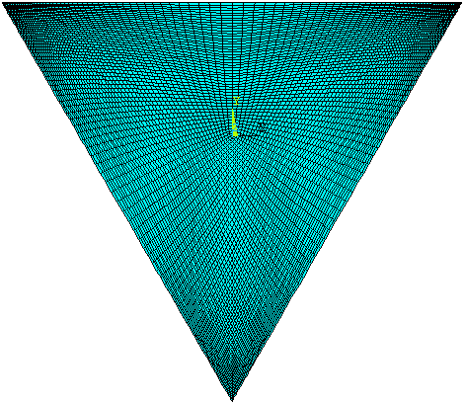
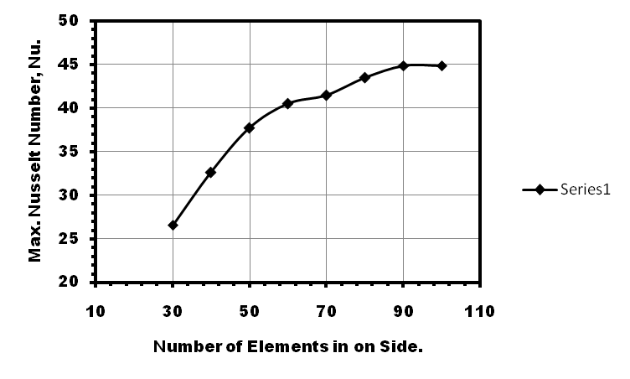

Fig. (3), Grid Independence Test.

Fig. (2), Schematic Diagram of Grid Generation
of Equilateral Triangle Enclosure.

Since the only concerned fluid here is air (Pr=0.71), the effect of the Prandtle number are not studied. However, the effects of Richardson number which is varied from 0-100. The mixed convection flow within this range of Grashof number is inherently in laminar regime and thus justifies, in general, the steady-state assumption. As described in Figure (1), the two inclined walls are kept at cold temperature. In addition, no-slip velocity boundary conditions are imposed, i.e. U=V=0 along the inclined walls. The temperature at the horizontal wall is kept at hot temperature and velocity (U). In order to investigate the effect of various parameters on the heat transfer, the local Nusselt number is selected as in indicator for the heat transfer rate. The film coefficient equation is taken from ANSYS 12.1 program help as follow;

${\left\{q\right\}}^{T}\left\{η\right\}=h(T_{h}−T_{c})$ | … (5)
Then the Nusselt number is defined as [10];
$\text{Nu}=\frac{\text{hL}}{k}$ | … (6)

5- Results and Discussion
5.1- Flow and Temperature Fields
In the present computations, the Richardson number gives a relation between the thermal natural convection and the lid-driven forced convection effects. Then, the Richardson number is varied through Ri= 0, 1, 10, and 100, Reynolds number fixed, while the Grashof number varied through 10⁵, 10⁶ and 10⁷. These variations of Richardson number and Grashof number cover the understood of natural convection dominated to forced convection dominated regimes. Fig. (4a) with Gr=10⁵ shows the isotherms that crowded near the walls at Ri=100 and 10, the temperature lines are parallel to the hot horizontal lid- driven wall and cold inclined walls and tend to be horizontal in the middle of the enclosure the isotherms take this forms because of the buoyancy forces at Ri=10 and 100 is greater than lid force. As the Richardson number decreases, 1 and 0, the lid force pulls the isotherms to the right at same time it is more than buoyancy force specially at Ri=0 here buoyancy force is not seen. Then the distribution of the isotherms patterns are, however, significantly distributed and the peak of the isotherms tried to spread in the right corner of the enclosure.
When the Grashof number increases, 10⁶ and 10⁷, see Figs. (5a and 6a), the isotherm lines don’t change dramatically specially at highest value of Richardson number=100 and 10, because the effect of the Grashof number on the isotherms have an equal effects on the enclosure sides temperatures. The lonely difference, is the isotherms patterns becomes more flattened in the middle of the enclosure if it were compared with the middle of the previous case (Gr=10⁵). This lead to understand that, the heat is tried to transfer by conduction in this region. Inversely, at small value of Richardson number=0 and 1, the lid force (force convection) is larger than buoyancy force (natural convection). Then, the peak of the isotherms was developed and spread gradually until reaches to the middle of the enclosure at Ri=0.
Fig. (4b), when Gr=10⁵, shows that the enclosure with a lid-driven horizontal wall. The stream lines at Ri=100, indicate two flow recirculation in the left and right corner of the enclosure. The two different directions circulations cells, the first as a result of lid-driven motion (right) and the second as a result of the buoyancy effect (left). The clock-wise circulation appears in the right corner under the lid driven wall due to the motion of the sliding wall. The air is pulled by the sheer force of lid-driven side and then impinging with the right inclined side and then return to slip on the left anti-clock wise circulation. As well as, the other strong anti clock wise circulation due to buoyancy effects dominates the flow field. However, when Ri=10, the effect of the lid driven wall becomes more concerned if it is compared with the buoyancy force. Then, the clockwise circulation begins to grow up and expand to the center of the enclosure. Instantaneously, the left buoyancy circulation is eliminated gradually then it is disappeared at Ri=0 and the right circulation take almost cavity size.
With increasing in Gr=10⁶ and 10⁷, Figs. (5b and 6b), when Ri=100 the buoyancy force is high, that making the two center of the cells move toward the left and right corners of the enclosure, respectively.
As Richardson number decreases Ri=10 and Gr=10⁶ (Fig. (5b)), another third weak anti clock wise recirculation is appeared in the middle of the distance between the centers of the left and right circulations. The third circulation is generated as a result of the buoyance force is reduces at Ri=10. This clear the way to the lid force effect to reaches to this empty area and generate this vortex. As the Richardson number decreases ton 1, the third circulation meet with the above right lid vortex forming a large dominant vortex fills all most enclosure size at Ri=0. Then, for the same case, Ri=10, but at Gr=10⁷, Fig. (6b), the third vortex that was appears later diminishes gradually to a very weak clock wise cell near the center of the enclosure. Finally, when the Richardson number decreases to 1 and 0, the left and right circulations appears again clearly specially at Ri=1, and the size of the right circulation in the upper portion of the enclosure is expanded and becomes larger than that in the lower part at Ri=0, see Figs. (5b and 6b).

5.2- Local Heat Transfer Coefficient
The variation of maximum Nusselt number for differential values of Grashof number and Richardson number with a lid driven triangular enclosure is showed in Fig. (7). The figure indicates that at each value of Richardson number the Nusselt number is increased with increasing of Grashof number. This is due to increasing in temperature different between the enclosure sides as Grashof number increases However, for Ri=10 and 100, the increases of the Nusselt number with increases of Grashof number is not as fast as that for Ri=0 and 1. Then, it can be seen from the results the effect of lid-driven flow is more dominant than the effect of buoyancy effect.
6- Conclusion
Laminar mixed natural convection in a lid-driven equilateral triangular enclosure filled with an air as a working fluid is numerically studied by using ANSYS 12.1. The horizontal wall of the enclosure is considered to be hot and slide to the right. But, the other two inclined walls as consider being cold and fixed. The effect of the parameters such as Richardson number and Grashof number on the flow and temperature field are examined. Then, the following points can be concluded from the present study;
- The motion of the sliding wall having a dramatic effect on the flow and temperature distributions inside the enclosure, then, have an effect on the rate of the heat transfer.
- It is observed that the heat transfer rate is increases as the Richardson number increases; because of the convection term becomes dominant more than conduction.
- The results also indicated that the increases of Grashof number makes the peak of the isotherms expanded and fills the most of the enclosure. Also, increases the heat transfer rate and hence maximum Nusselt number.
- Generally, two circulations are seen in almost streamlines and isotherms. The right vortex is due to lid movement and the left is due to buoyancy effects

7- References:
B. Ghasemi a and S.M. Aminossadati, (2010),” Mixed Convection In A Lid-Driven Triangular Enclosure Filled With Nano-fluid.”, International Communications in Heat and Mass Transfer, V(37),P.p 1142–1148.
D.Arumuga Perumal and Anoop K.Dass,(2010),”Simulation of incompressible flow in two sided lid-Driven square Cavities. Part II-LBM”, Perumal & Dass, CFD Letters,Vol.2(1), P.p.25–38.
Farhad Talebi, Amir Houshang Mahmoudi and Mina Shahi, (2010),” Numerical Study Of Mixed Convection Flows In A Square Lid-Driven Cavity Utilizing Nano-fluid”, International Communications in Heat and Mass Transfer V(37),P.p. 79–90.
H. C. Kuhlmann, S. Albensoeder and C. Blohm, (2001),”Flow Instabilities In The Two-Sided Lid-Driven Cavity”, 12th International Couette-Taylor Workshop, Evanston, IL USA, September 6-8,2001.
M. Muthtamilselvan , Manab Kumar Das and P. Kandaswamy, (2010),” Convection in a Lid-Driven Heat-Generating Porous Cavity with Alternative Thermal Boundary Conditions”, Transp Porous Med, V(82),P.p337–346,.
Mohamed A. Teamah and Wael M. El-Maghlany, (2010),” Numerical Simulation Of Double-Diffusive Mixed Convective Flow In Rectangular Enclosure With Insulated Moving Lid”, International Journal of Thermal Sciences ,V(49),P.p. 1625-1638.
Nasreddine Ouertatani a, Nader Ben Cheikh a, Brahim Ben Beyaa, Taieb Lilia and Antonio Campo, (2009),” Mixed Convection In A Double Lid-Driven Cubic Cavity”, International Journal of Thermal Sciences, V (48), P.p.1265–1272.
Ruairi M. Nestor and Nathan J. Quinlan, (2010).” Incompressible Moving Boundary Flows With The Finite Volume Particle Method”, Computer Methods in Applied Mechanics and Engineering, V, (199), P.p.2249–2260.
Patankar, S.V., (1980), “Numerical Heat Transfer And Fluid Flow”, Hemisphere Publishing Corporation, New York.
S. K. Mahapatra, P. Nanda and A. Sarkar, (2006),”Interaction Of Mixed Convection In Two-Sided Lid Driven Differentially Heated Square Enclosure With Radiation In Presence Of Participating Medium” ,Heat Mass Transfer ,V(42),P.P. 739–757.
S. Sivasankaran, V. Sivakumar and P. Prakash, (2010),” Numerical study on mixed convection in a lid-driven cavity with non-uniform heating on both sidewalls”, International Journal of Heat and Mass Transfer 53 , 4304–4315.
T.S. Cheng and W. H. Liu, (2010).” Effect Of Temperature Gradient Orientation On The Characteristics Of Mixed Convection Flow In A Lid-Driven Square Cavity”, Computers & Fluids ,V(39) ,P.p 965–978 .
Tanmay Basak, S. Roy, Sandeep Kumar Singh and I. Pop, (2010),” Analysis Of Mixed Convection In A Lid-Driven Porous Square Cavity With Linearly Heated Side Wall”, International Journal of Heat and Mass Transfer, V (53) ,P.p.1819–1840.
T.S. Cheng, (2011),” Characteristics Of Mixed Convection Heat Transfer In A Lid-Driven Square Cavity With Various Richardson And Prandtl Numbers”, International Journal of Thermal Sciences, V (50) ,P.p. 197-205.
W. Cazemier,a R. W. ,C. P. Verstappen, and A. E. P. Veldman ,(1998),” Proper Orthogonal Decomposition And Low-Dimensional Models For Driven Cavity Flows” ,Physics Of Fluids, Volume 10, Number 7.
W. Zhang, C.H. Zhang, G. Xi, (2010),” An Explicit Chebyshev pseudospectral multigrid method for incompressible Navier–Stokes equations”, Computers & Fluids, V (39) ,P.p178–188, .

(b)
Stream Function

(a)
Isothermal Contours

Ri=0

Ri=1

Ri=10

Ri=100

Fig. (4), Isothermal and Stream Function Contour for Gr=10⁵.

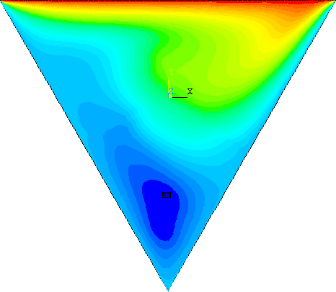
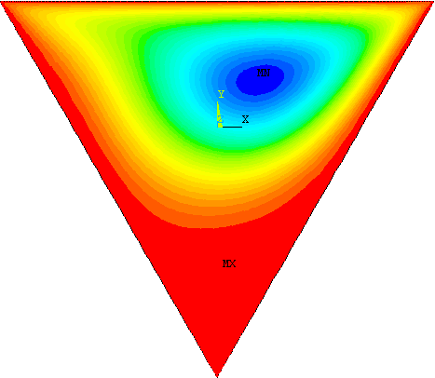
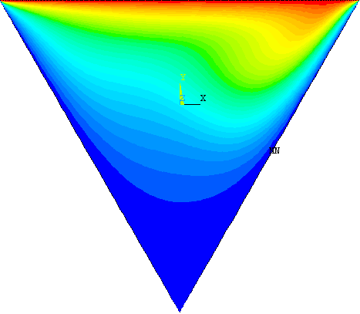
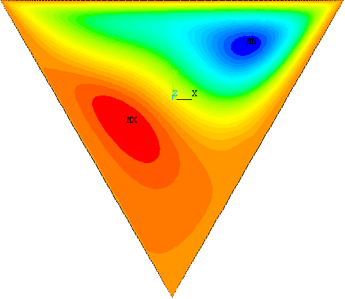
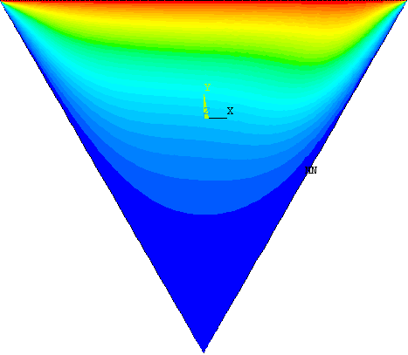
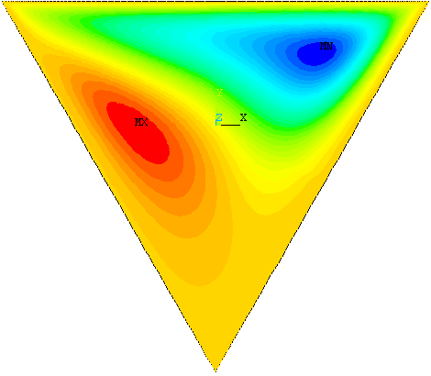
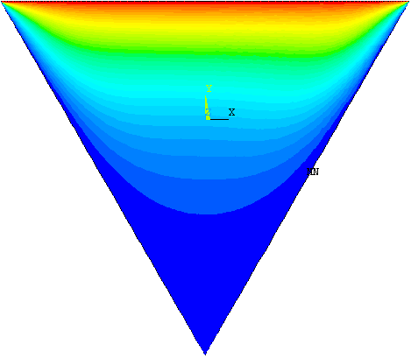
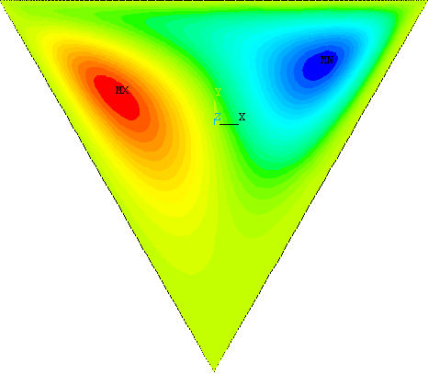

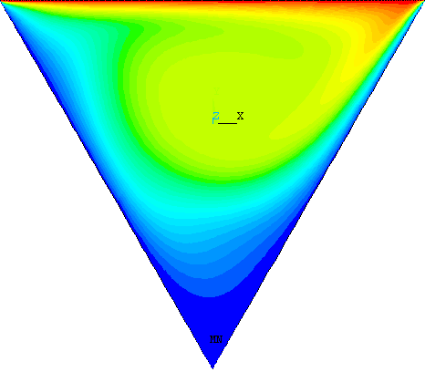
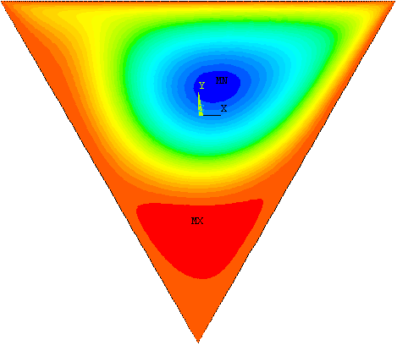
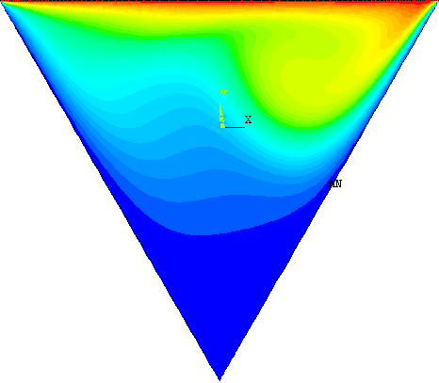
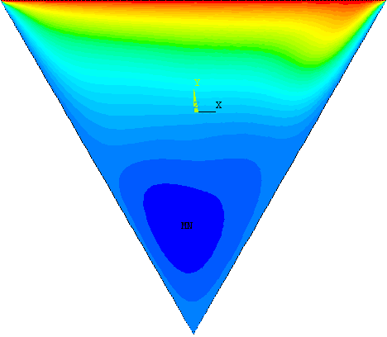
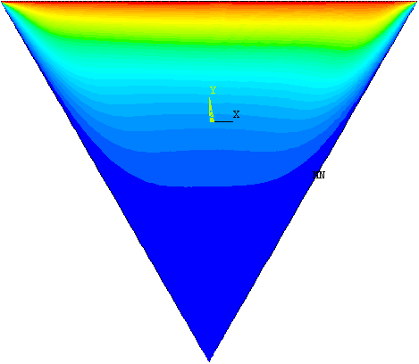
(a)
Isothermal Contour

(b)
Stream Function

Ri=0

Ri=1

Ri=10

Ri=100

Fig. (5), Isothermal and Stream Function Contour for Gr=10⁶.

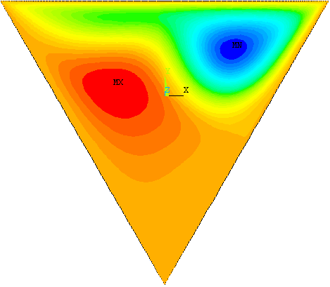

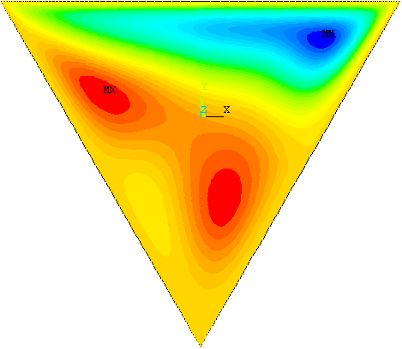

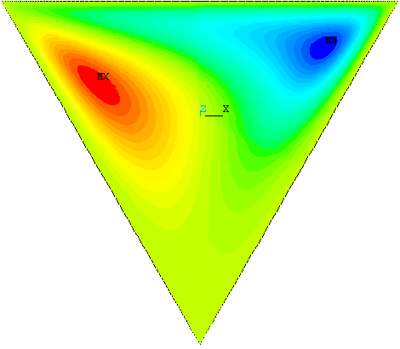

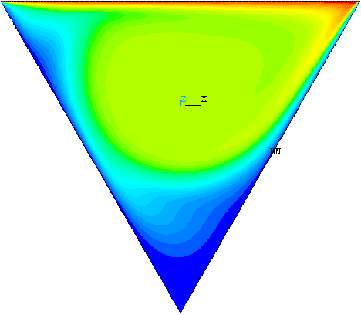
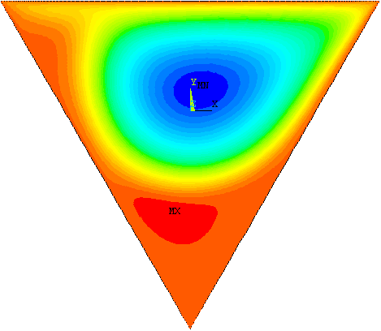
(a)
Isothermal Contours

(b)
Stream Function

Ri=0

Ri=1

Ri=10

Ri=100

Fig. (6), Isothermal and Stream Function Contour for Gr=10⁷.

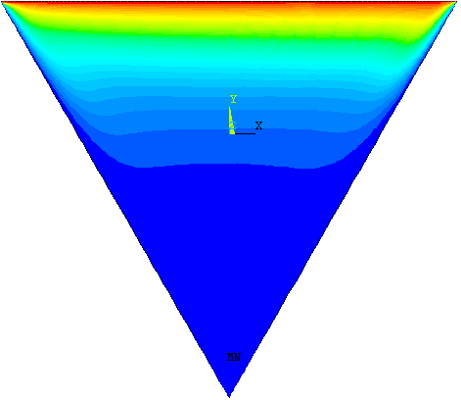
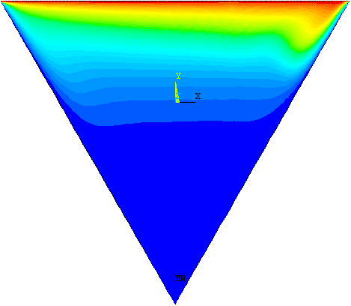
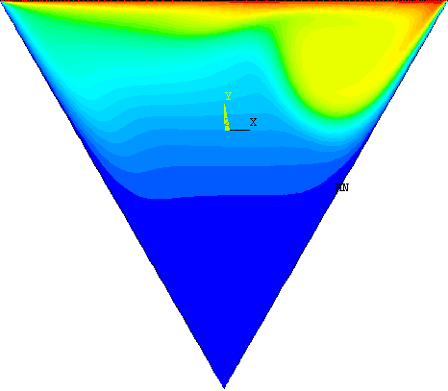
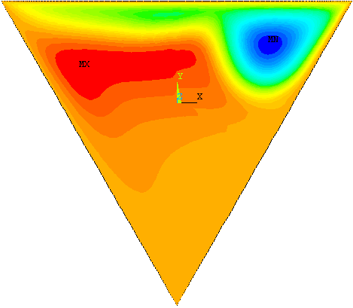
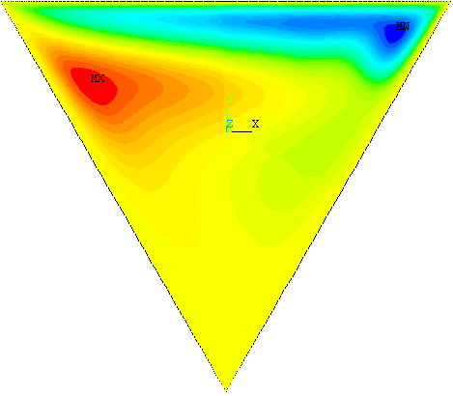
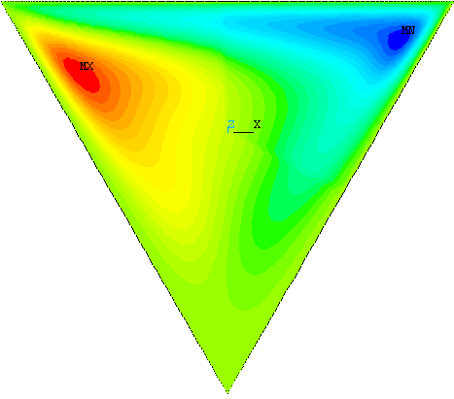
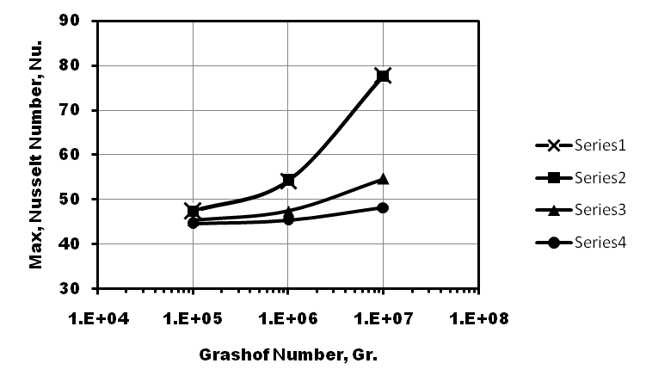

Fig. (7), Variation of Maximum Nusselt Number with Different Richardson Number for Different Grashof Number.

Ri=0
Ri=1
Ri=10
Ri=100

