Improving The Mechanical Properties of No-Fines Concrete
Ammar A. Muttar
AL- Mustansiriya University, College of Engineering, Civil engineering Department

Abstract
In this study the mechanical characteristics of no- fines concrete with or without polypropylene fiber are investigated. The effect of mixture proportions on compressive strength , tensile strength and density presented. Result show that the addition of polypropylene fibers in no- fines concrete can improve the mechanical properties , especially the tensile strength, compressive strength by 19% and 17% respectively compared with the concrete without fibers, and a slight effect on the density. It was found that the strength of no- fines concrete is strongly related to its mixture proportion .A sealed compressive strength of 20.5mpa can readily be achieved with an aggregate /cement ratio of 3:1 / and 0.9 kg/m³ optimum quantity of polypropylene fibers. Adapted from ACI 213R-79, this type of lightweight concrete investigated from this research is considered structural lightweight concrete.

الخلاصة
في هذا البحث تم دراسة الخواص الميكانيكية للخرسانة خفيفة الوزن من نوع خرسانة خالية من الرمل وكيفية تحسين هذه الخواص عن طريق استخدام الياف البولي بروبلين وكذلك دراسة تأثير نسب الخلط على كل من مقاومة الانضغاط ومقاومة الشد. النتائج اظهرت ان اضافة الياف البولي بروبلين للخرسانة الخالية من الرمل تحسن الخصائص الميكانيكية وخصوصا مقاومتي الشد والانضغاط بنسبة 19%و17% على التوالي وتأثير قليل على الكثافة. كذلك أظهرت النتائج بأن مقاومة الخرسانة الخالية من الرمل تتأثر وبشكل كبير بنسب الخلط حيث وجد بأن مقاومة الانضغاط 20.5mpaمن الممكن تحقيقها باستعمال نسب خلط حصى /سمنت بمقدار3: 1وكذلك باستعمال كمية من الياف البولي بروبلين بمقدار 0.9.kg/lm³. اعتمادا على المواصفات المعدة في معهد الخرسانة الامريكي ACI 213R-79 يمكن تصنيف الخرسانة الخفيفة الوزن من نوع خرسانة خالية من الرمل والتي تم انتاجها في هذا البحث على انها خرسانة انشائية خفيفة الوزن .
- Introduction
No-fines concrete is a form of lightweight concrete obtained when fine aggregate is omitted, i.e. consisting of cement, water, and coarse aggregate only .No- fines concrete is thus an agglomeration of coarse aggregate particles, each surrounded by a coating of cement paste up to about 1.3 mm thick. There exist therefore, large voids within the body of the concrete which are responsible for its low strength, but their large size means that no capillary movement of water can take place.
The usual size of aggregate is 10 to 20mm; 5 percent oversize and 10 percent undersize are allowed, but no particles should be smaller than 5mm. flaky or elongated particles should be avoided. The use of sharp- edged crushed aggregate is not recommended as local crushing can take place under load.
The aggregate should be dampened before mixing in order to facilitate uniform coating by the cement paste (A. M. Neville, 1995). Fig.(1) shows example of no-fines concrete.

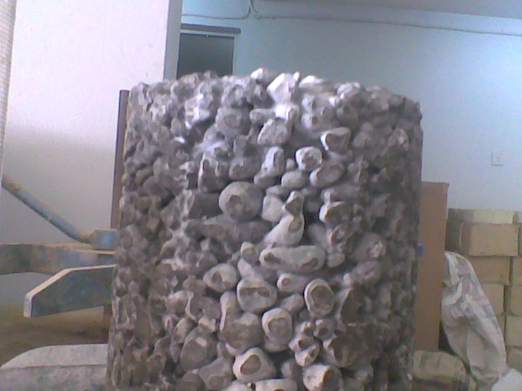

Fig (1) no- fines concrete

The advantages of this type of concrete are lower density (1600- 2000 kg/m³), lower cost due to lower cement content, lower thermal conductivity, relatively low drying shrinkage, no segregation and capillary movement of water , better insulating characteristics then conventional concrete because of the presence of large voids (T. Abadjieva and P. Sephiri, 2000).
The main use of no-fines concrete is in load- bearing walls in domestic buildings and in in-filling panels in framed structures.
Portland cement concrete is considered be relatively brittle material. Fiber reinforced concrete is Portland cement concrete reinforced with more or less randomly distributed fibers. In fiber reinforced concrete, thousands of small fibers are dispersed and distributed randomly in the concrete during mixing, and thus improve concrete properties in all directions. Fibers help to improve the post peak ductility performance, pre- crack tensile strength and eliminate temperature and shrinkage cracks (R. Brown, A.Shukla and K. R. Natarajan, 2002). Polypropylene fiber (short- cut stands of very fine denier monofilament) is added to the concrete during batching. Thousands of individual fibers are then evenly dispersed throughout the concrete during the mixing process creating a matrix- like structure. Small quantities of fibers in the mix may increase the cohesion and prevent sedimentation due to their inter locking network characteristics. The result may be that in some, but not all, cases the quantity of bleed water may be reduced. This will not necessarily have a beneficial effect on plastic shrinkage cracking but may help to limit plastic settlement cracking.
- Mix proportions
The cement: aggregate ratio by volume is in the range 1:3 to 1:4 by volume. The water- cement ratio needs to be kept low, 0.31- 0.35, to ensure the cement paste coats the aggregates and does not run off.
- Materials
3.1 cement
Ordinary Portland cement was used in this work. Test results indicated that the cement conformed to the Iraqi specification no. 5/1984.

3.2 Aggregate
The coarse aggregate was Al-Nebai natural gravel of 19 mm maximum size. The grading and physical properties of coarse aggregate was conformed to the limits of Iraqi specification no. 45/1984.

3.3 High performance micro polypropylene fiber
A high performance 100% virgin polypropylene fiber with no olefin materials, developed as a crack controlling additive for cementitious materials. It is 19 mm length for concrete. It is used to inhibit the formation of small cracks which can occur through plastic shrinkage, premature drying and early thermal changes, in order to provide utilization of the intrinsic properties of the hardened cementitious material. polypropylene fibers complies with the requirements of ASTM C1116- 1997 type III.
The optimum dosage of polypropylene fiber is determined according to the production company and found 0.9 kg/m³. The properties of polypropylene fibers used in this work is illustrated in table (1).

Table(1): properties of polypropylene fibers.
Form | 100% virgin polypropylene fiber
Specific gravity | 0.91 g/cm³
Alkali content | Nil
Sulphate content | Nil
Air Entrainment | Air content of concrete will not be significantly increased
Chloride content | Nil
Elasticity modulus | 3500-4800mpa
Tensile strength | 350N/mm²
Melting point | 160-170c°
Ignition point | 590c°
Cement compatibility | Excellent

3.4 water
Tap water that is suitable for making ordinary concrete should be used.

- Determination of the workability
Workability cab be checked only visually (organoliptically) and no compaction, other than localized rodding, should be used during placing(J. Newman and B.S. Chow, 2003).
- Concrete Mixes
Four types of no- fines concrete mixes were investigated, two types with polypropylene fiber and others without fiber. The proportions of concrete mixtures and some properties of fresh and hardened concrete are shown in table (2).

Table (2) no- fines concrete mixes
index | Aggregate/cement  Ratio by volume | Water /cement  Ratio | Density at 28 days kg/m³ | Dosage of polypropylene fiber kg/m³
A | 3 | 0.31 | 20.25(20.25 kN/m³) | -
B | 4 | 0.35 | 19.86 (19.86 kN /m³) | -
C | 3 | 0.31 | 20.30 (20.30 kN /m³) | 0.9
D | 4 | 0.35 | 19.89 (19.89 kN /m³) | 0.9
- Preparation, casting and curing of the test specimens
The moulds were well cleaned and the internal faces were thoroughly oiled to avoid adhesion with the concrete after hardening. The casting was carried out in one layer without compaction.
The specimens were wrapped with nylon sheets for 24 hours prior to demolding to prevent moisture evaporation from the surface and to avoid plastic shrinkage cracking. After demolding, the specimens were completely immersed in tap water at temperature of 22 1c° and a relative humidity of about 95% for a period of testing.

- Hardened Concrete Testing
7.1 Compressive Strength Test
The concrete compressive strength was measured on 150 mm cube by using a standard testing machine with a capacity of 2000 kn. The test was performed at ages of 3,7,28 days. Each value obtained is an average of three readings measured on three specimens. Load was applied at the rate of 15 mn/m²/min. in accordance with B.S. 1881 part 4: 1970.

7.2 Tensile Strength Test
The splitting tensile strength of 150300 mm cylindrical concrete specimens was measured in accordance with the ASTM C 496- 86 using a standard testing machine of capacity 2000 kn. The test was performed at ages of 3,7,28 days. The splitting tensile strength of the specimen was calculated by the following equation:
T= 2p /πld
Where T= splitting tensile strength (N/mm²).
P= maximum applied load indicated by the testing machine (N),
l= length, (mm), and
d= diameter, (mm).
Each value obtained is an average of three readings measured on three specimens.

7.3 Density test
The concrete density was measured on 150 mm cube in accordance with ASTM C 642-06 standard. The test was performed at 28 day age. The value obtained is an average of the three readings measured on three specimens.

- Result and discussion
8.1 compressive strength
The compressive strength of no- fines concrete with and without fiber is illustrated in table (3) and Fig (2 and 3). Result indicated that no. fines concrete with different aggregate/ cement ratio exhibited continuous strength gain and this conform to normal weight concrete(A.S.A. Mathede, 2005). Fig (4) shows the influence of aggregate /cement ratio on the compressive strength of no- fines concrete at the age of 28 days. Compressive strength of no- fines concrete depending mainly on aggregate/ cement ratio and decease with the increase of aggregate/ cement ratio. This is mainly due to the low mortar content and the high porosity(T.Abadjieva and P.Sephiri, 2000; O.P.Jain, 1966; N.Ghafoori and S.Dutta, 1995). No- fines concrete reinforced by poly propylene fiber, Fig (2 and 3) showed improvements in compressive strength relative to the concrete without fiber. Polypropylene fiber is added to the concrete during batching. Thousands of individual fibers are then evenly dispersed throughout the concrete during the mixing process creating a matrix- like structure. (P.S. Song, S. Hwany and B.C. sheu, 2005; R.A.Mtasher, Dr.A.M Abbas and N.H. Nema, 2011; .H.K Lec and S.Y. Song, 1997) have showed considerable improvement in compressive strength of concrete containing polypropylene fibers.

Table (3) Result of compressive strength test
Index | Aggregate / cement ratio by volume | Water / cement ratio | Dosage of polypropylene fiber kg/m³ | Compressive strength  MPa
 |  |  |  | 3 days | 7 days | 28 days
A | 3 | 0.31 | _ | 12.9 | 14 | 17
B | 4 | 0.35 | _ | 9.6 | 11 | 15
C | 3 | 0.31 | 0.9 | 12.8 | 13.6 | 20.5
D | 4 | 0.35 | 0.9 | 10.1 | 12.3 | 17.6

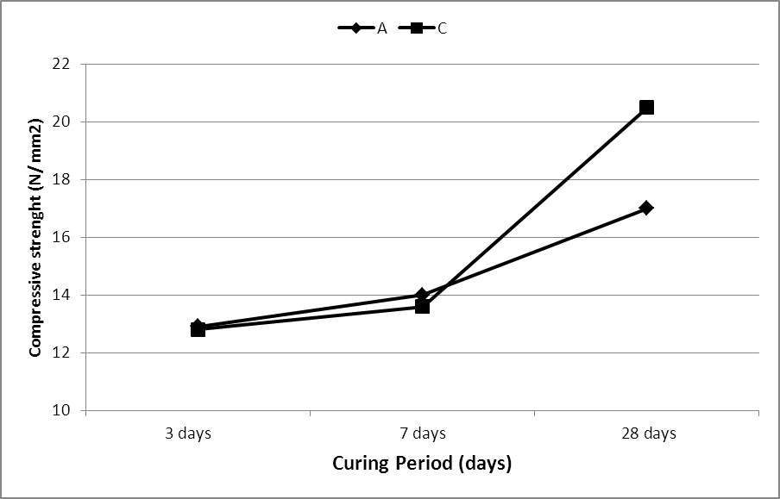

Fig (2) compressive strength of no- fines concrete with and without polypropylene fiber at (3) aggregate/ cement ratio.

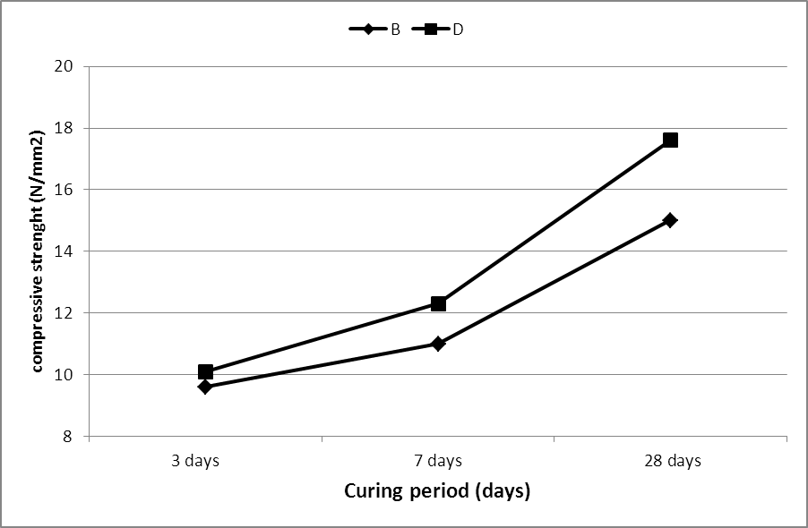

Fig (3) compressive strength of no-fines concrete with and without polypropylene fiber at (4) aggregate/ cement ratio.

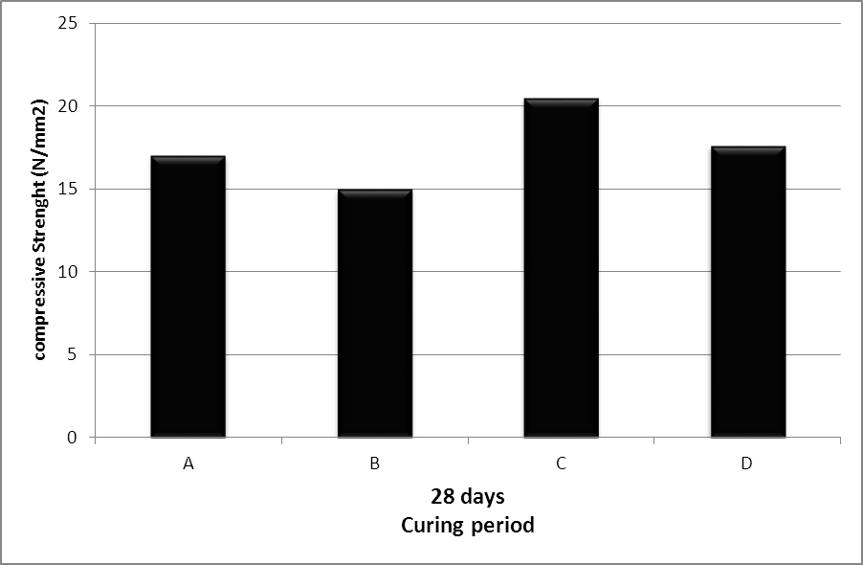

Fig (4) comparison of compressive strength for different types of no-fines concrete

8.2 Tensile Strength
The splitting tension test is the most commonly used test for estimating the tensile strength of concrete. The tensile strength of various types of concrete specimens are presented in table (4) and in Fig (5), Fig (6). Result showed that no-fines concretes specimen exhibited continuous strength gain and this conform to normal weight concrete. Fig (7) show the tensile strength for different types of no- fines concrete at 28 days.
The highest tensile strength at aggregate/ cement ratio 3:1 and they decrease with increase of aggregate/ cement ratio due to increased porosity(T.Abadjieva and P.Sephiri, 2000). No- fines concrete reinforced with polypropylene fiber, Fig (7), showed further improvement in tensile strength over those of the concrete without fiber. The plain concrete structure cracks into two pieces when the structure is subjected to the peak tensile load and cannot withstand further load or deformation. The fiber reinforced concrete structure cracks at the same peak tensile load, but does not separate and can maintain a load to very large deformation. The real advantage of adding fibers is when fibers bridge these cracks and undergo pullout processes, such that the deformation can continue only with the further input of energy from the loading source(R.Brown, A.Shukla and K.R.Natarajan, 2002).

Table (4) Result of tensile strength test
Index | Aggregate/ cement ratio by volume | Water/ cement ratio | Dosage of polypropylene  Fiber (kg/m³) | Tensile strength MPa
 |  |  |  | 3 days | 7 days | 28 days
A | 3 | 0.31 | _ | 2.47 | 2.85 | 3.1
B | 4 | 0.35 | _ | 2.11 | 2.38 | 2.74
C | 3 | 0.31 | 0.9 | 3.04 | 3.52 | 3.82
D | 4 | 0.35 | 0.9 | 2.31 | 2.96 | 3.15

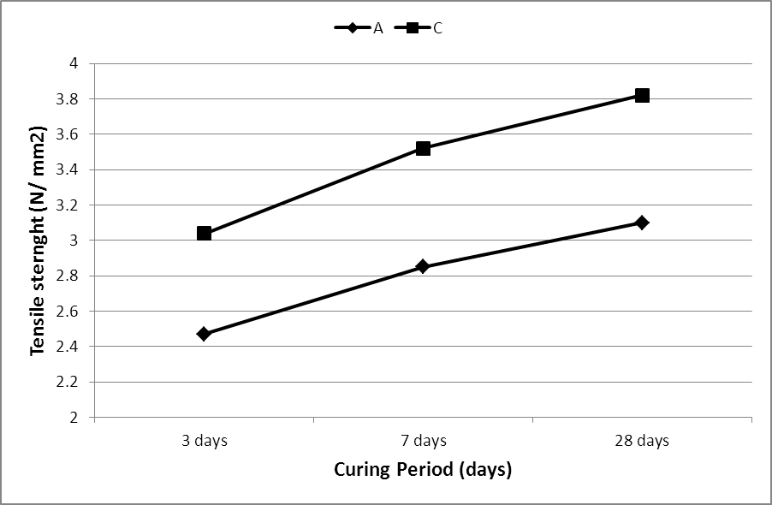

Fig (5) tensile strength of no- fines concrete with and without polypropylene fiber at (3) aggregate/ cement ratio.

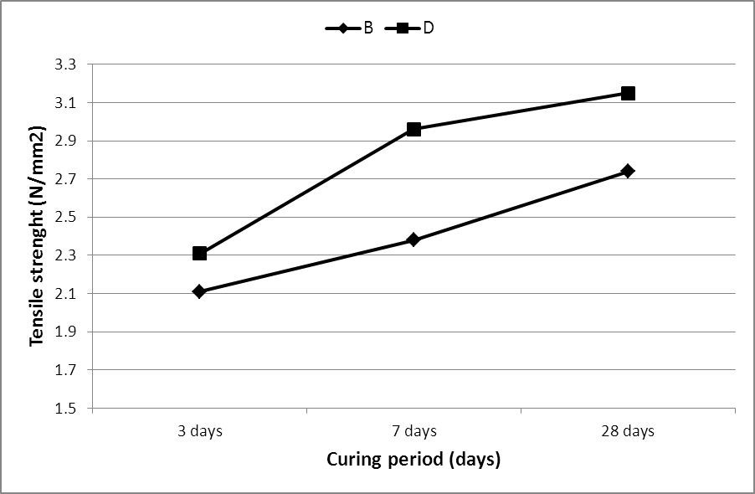

Fig (6) tensile strength of no- fines concrete with and without polypropylene fiber at (4) aggregate/ cement ratio.

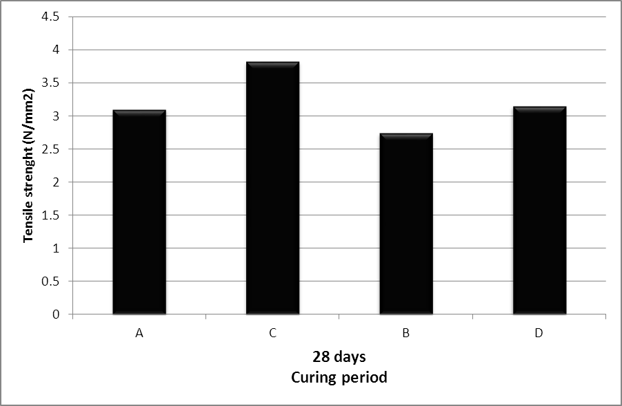

Fig (7) comparison of tensile strength for different types of no-fines concrete

8.3 Density of hardened no-fines concrete
The density of the investigated concrete varies between 1986- 2025 kg/m³ is lower than the density of normal- weight concrete. The decreased density means lower dead load of the structure. Table (2) and Fig (8) showed that the density is decrease with the increase of aggregate/ cement ratio. The increase in density between aggregate/ cement ratio of 4:1 and 3:1 is due to reduction in the amount of coarse aggregate which has a lower specific gravity than that of Portland cement(N.Ghafoori and Sh.Dutla, 1995). Polypropylene fibers, which are well mixed and distributed throughout the concrete, can have a "support" effect, and reduces the water separating out, as well as the aggregate segregation. This greatly reduces the micro porosity content. As a result the density of concrete is a slight increased.

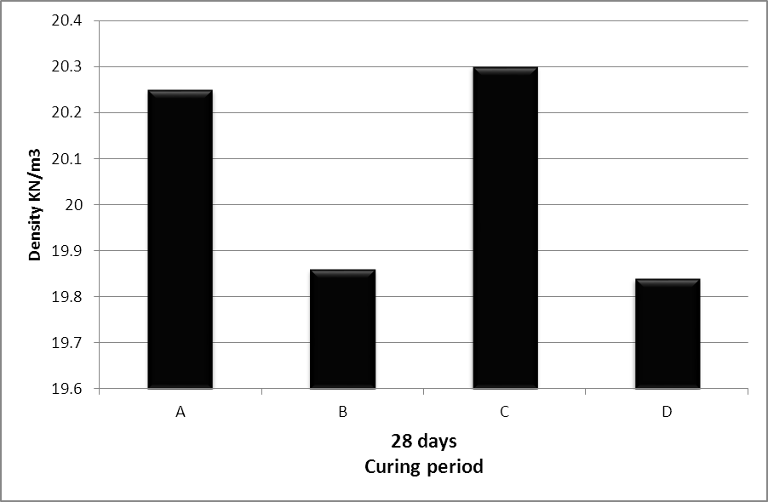

Fig (8) comparison of density for various types of no-fines concrete

- Conclusions
The conclusions presented here are based upon the findings of this investigation
- No- fines concrete is, as the name indicates, concrete consisting of coarse aggregate, cement and water- fines being omitted entirely.
- The addition of polypropylene fibers helps to maximize the intrinsic strength of the concrete.
- Polypropylene fibers actually help inhibit the formation of cracks due to both plastic shrinkage and drying shrinkage.
- Polypropylene fibers used in concrete to improve mix cohesion and reduced bleeding of water.
- Mechanical properties of no-fines concrete is a function of the aggregate: cement ratio and the water- cement ratio.
- The density and strength properties of the investigated no- fines concrete are lower than that of normal- weight concrete, but sufficient enough for structural use.

References
A.M. Neville "Properties of concrete" Fourth and final Edition. 1995.
A.S.A. Mathede "Lightweight aggregate concrete incorporating air entraining agent for insulating purposes" M.Sc. Thesis, University of Technology, Baghdad- Iraq, May- 2005.
H.K. Lec. And S.Y. Song "Performance characteristics of Lightweight Aggregate Cellular concrete containing Polypropylene Fibers" Journal of Reinforced and Plastics and Composites, 1997.
J. Newman and B.S. chow " Advanced concrete Technology" 2003.
N. Ghafoori and S. Dutta "Building and non-pavement Applications of no-fines concrete" Journal of Material in civil Engineering, volume 7, 286 (1995).
N. Ghafoori and Sh. Dutla. "Laboratory Investigation of compacted no- fines concrete for Paving Materials" Journal of Materials in civil Engineering. August 1995.
O.P. Jain "Proportioning no- fines concrete" INDIAN concrete Journal vol. 40 no. May 1966.
P.S. Song, S.Hwany and B.C. Sheu "strength properties of nylon- and Polypropylene- fiber- reinforced concrete" cement and concrete Research volume 35, Issue 8, August 2005, Page 1546- 1550.
R. Brown, A. Shukla and K.R. Natarajan "Fiber Reinforcement of Concrete Structures" University of Rhode Island, September 2002.
R.A. Mtasher, Dr.A.M. Abbas and N.H. Ne'ma "strength prediction of polypropylene Fiber Reinforced concrete" Eng. And Tech. Journal, vol. 29, no. 2, 2011.
T. Abadjieva and P.Sephiri "Investigations on some Properties of no- fines concrete" Department of civil Engineering, University of Botswana, Private Bag 0061, 2000.

