Resistance Of Polymer Concrete To High Temperature

Tumadhir M. Al-Jabiri
University of Al-Qadissiya, College of Engineering, Civil Department

Abstract
In this study, the behavior of epoxy polymer concrete under various temperatures, and percent of epoxy was investigated. The mechanical properties such as, splitting tensile strength, and compressive strength are evaluated under working conditions. Results of (120) specimens with different shapes which represented concrete specimens having compressive strength ranging from (14.5 MPa to 31.5 MPa), and splitting tensile ranging from (1.52 MPa to 3.18 MPa) .The results are compared with the conventional (without polymer admixture) concrete.
The results showed that the compressive and splitting tensile strengths reduce when exposed to high temperature, but the use of epoxy resin apparently led to decrease the loss of the compressive and splitting tensile strengths at this condition. The optimum dosage of epoxy resin can be give best mechanical properties for concrete was (7% by weight of cement). Also there is a different between the percent of reduction in the compressive strength at 700 C^{ο} with respect to strength at 200 C^{ο} and the percent of reduction in the splitting tensile strength at the same condition.
KEY WORDS: concrete, epoxy, temperature, compressive strength, splitting tensile strength.
الخلاصة
يتناول هذا البحث دراسة سلوك الخرسانة الحاوية على الايبوكسي عند تعرضها لدرجات حرارة مختلفة وبنسب مختلفة من الايبوكسي. تم تقييم الخواص الميكانيكية لهذا النوع من الخرسانة مثل مقاومة الانضغاط ومقاومة انشطار الشد تحت الظروف العملية. اخذت النتائج من (120) نموذج وبمختلف الاشكال وبمقاومة انضغاط تتراوح بين (14MPa-31.5 MPa) ومقاومة انشطار الشد تتراوح بين (1.52MPa-3.18MPa) وقورنت النتائج مع الخرسانة المرجعية (بدون ايبوكسي). اظهرت النتائج ان مقاومة الانضغاط ومقاومة الشد تقل عند تعرضها لدرجات الحرارة العالية لكن الخسارة في المقاومة تقل عند استخدام الايبوكسي . ان النسبة المثلى للايبوكسي التي تعطي افضل الخواص الميكانيكية لهذا النوع من الخرسانة هي (7%) من وزن الأسمنت. بالاضافة الى ذلك فان هناك اختلاف في نسبة النقصان في مقاومة الانضغاط للنماذج المعرضة لدرجة حرارة (700ºc) مقارنة بالنماذج المعرضة لدرجة حرارة (200ºc) وكذلك بالنسبة لمقاومة انشطار الشد.
Introduction
Concrete may exposed to elevated temperature by accidental fires occur in building which usually last short periods, but with high intensity sustained. High temperature exposure of concrete takes place in some industrial installations, and in nuclear reactor pressure vessel, which stimulated interest in the physical properties of concrete under high temperature. The resistance of concrete to heat depending upon the materials with which it is made, its condition, and shape size of structural element subjected to heat law conductivity of concrete improves its resistance to high temperature (Hani and Nuri. 1986)
Some researchers have shown that an increase in the length of exposure to a temperature of 150 C^{ο} or higher, from 2 to 120 days, increase the loss of compressive strength. However, the major part of the loss occurs early ⁽Carette and. Malhotra,1986).
In the polymer modified mortars and concretes, both cement hydration and polymer-phase formation by the coalescence of polymer particles proceed well to yield a monolithic matrix phase with a network structure in which the hydrated cement phase and polymer phase interpenetrate into each other , and aggregate are bound by such a comatrix phase (Ohama,1987).

Significant of research
The aim from the producing of this study is to investigate experimentally the behavior of concrete when added the polymer material with different proportion, over different high temperature, therefore provide information on various engineering properties of this type of concrete. Where the type of polymer was an epoxy resin with a hardener, which is commercially available. Also, to compared with conventional concrete.
Experimental Program
Locally available materials were used in this research to produce polymer concrete by added an epoxy- resin to fresh concrete mixes with a percents 5,7, 10, and 15 by weight of cement. The specimens were cast in steel mould in two layers with each layer compacted by using standard steel rod, the concrete surface was finished level. Then the specimens cured in water for 28 days, and dried in oven at temperature of 100 C^{ο} until constant weight was obtained. This investigated was carried out to determine the compressive and splitting tensile strengths after short-team exposure (30 and 60 minutes) to sustain temperature of (200, 400, and 700) C^{ο} under the conditions of work for the conventional and polymer-modified concrete ,where the specimens tested hot.
Materials Used in This Research
- Cement
Ordinary Portland cement manufactured by Kufa cement factory was used in this study. The chemical and physical properties of this type of cement were conformed to the Iraqi specifications No.5- 1984 (المواصفة القياسية العراقية رقم 5, 1984).
- Fine Aggregate
Normal weight natural sand was used as a fine aggregate. Before its incorporation into concrete mix, sand was sieved on 4.75 mm sieve, and used with a saturate surface dry condition. The grading of sand was conformed to the requirement of BS.882-1992 ^{.(} BS.882,1995)as shown in Table (1). Physical and chemical properties of sand used throughout this study are shown in Table (2).
- Coarse Aggregate
Normal weight crushed gravel with a maximum size of (20 mm) was used as a coarse aggregate; its grading is shown in Table (1). The specific gravity, and absorption of the coarse aggregate were (2.63), and (0.84) respectively.
- Epoxy Resin
Commercially available diglycidyle ether of biphenyl A was used as an epoxy resin in this work. The properties of this epoxy resin are given in Table (3)
Table (1) Grading of sand and crushed gravel used in this study
Grading of sand |  |  | Grading of crushed gravel
Sieve size | % passing | % passing BS 882:1992⁽⁵⁾ | Sieve size (mm) | Cumulative passing % | NO.45-1984^{(ASTM,1989)}
4.75 | 100 | 89-100 | 25 | 100 | 100
2.36 | 100 | 60-100 | 20 | 97 | 95-100
1.18 | 82 | 30-100 | 10 | 46 | 30-60
0.60 | 55 | 15-100 | 5 | 2 | 0-10
0.30 | 20 | 5-70
0.15 | 4 | 0-15
Table (2) Chemical and physical properties of sand
Property | Specification | Result | Limit of I.O.S.  NO.45/ 1984^{(ASTM,1989,)}
Bulk specific gravity | ASTM C128-88^{(ASTM,1989 )} | 2.65 | _
Absorption % | ASTM C128-88^{(ASTM,1989)} | 1.2 | _
Dry-loose unite weight Kg/m³ | ASTM C29-89⁽.^{BS.1881,1992)} | 1653 | _
Sulfate content (as SO₃ %) | I.O.S. NO.45-84^{(ASTM,1989)} | 0.08 | 0.5 (maximum)
Materials finer than 75-µm sieve % | I.O.S. NO.45-84^{(ASTM,1989)} | 4.1 | 5 (maximum)
Table (3) Properties of epoxy resin used in this work
Equivalent weight per epoxy | 408 Kg / mole
Molecular weight | 812
Epoxy content | 2.46
Specific gravity at 25^{ο}c | 1.27
n* value | 1.66
Flash point | > 150^{ο}c

Test Procedures
1. Compressive Strength
The compressive strength test was determined according to BS.1881-part 116 -1992^{(BS.1881,1992)}. A cube specimens with dimensions 100 mm were tested by using standard tasting machine with a capacity of 2000 kN. The test was conducted at age of 28 days and the average of three cubes was adopted at each test.
2. Indirect tensile strength
Depending on the ASTM C₄₉₆₋₈₆ ^{(ASTM,1989)} specification the test of indirect tensile strength was done. Cylinders of 100 × 200 mm were used and the load was applied continuously up to failure by using standard tasting machine with a capacity of 2000 kN, and the average of three cubes was adopted at each test with a testing age of 28 days. The indirect tensile strength can be evaluated by using the following equation:
$\text{ft}=\frac{2p}{π\text{DL}}$
…………………………………………….. (1)

Where:
$\text{ft}$= Indirect tensile strength (N/mm²)
p=applied load (N)
D=diameter of cylinder (mm)
L= length of cylinder (mm)
Results of tests and Discussion
The results of the experimental work for this research are listed in Table (4), and then represented in Figures (1) to (6).
Table (4): A- Results of experimental work of this research.

No. | Symbol | % Polymer by Weight of Cement | Mix Proportion | W/C ratio | Water Reduction | Compressive Strength (MPa) |  |  |  |  |  | Splitting tensile strength  (MPa)
 |  |  |  |  |  | Exposure for 0.5 hr. |  |  | Exposure for 1 hr. |  |  | Exposure for 0.5 hr. |  |  | Exposure for 1 hr.
 |  |  |  |  |  | 200 C^{ο} | 400 C^{ο} | 700 C^{ο} | 200 C^{ο} | 400 C^{ο} | 700 C^{ο} | 200 C^{ο} | 400 C^{ο} | 700 C^{ο} | 200 C^{ο} | 400 C^{ο} | 700 C^{ο}
1 | Reference | 0 | 1:1.5:3 | 0.50 | 0 | 24.00 | 21.50 | 18.00 | 20.00 | 16.30 | 14.50 | 2.25 | 2.05 | 1.82 | 1.97 | 1.68 | 1.52
2 | Polymer 1 | 5 | 1:1.5:3 | 0.46 | 8 | 26.00 | 24.80 | 20.50 | 22.40 | 20.60 | 17.00 | 2.70 | 2.54 | 2.25 | 2.25 | 2.15 | 1.98
3 | Polymer 2 | 7 | 1:1.5:3 | 0.44 | 12 | 30.00 | 28.50 | 26.00 | 28.20 | 26.70 | 22.20 | 3.20 | 3.00 | 2.77 | 2.83 | 2.65 | 2.55
4 | Polymer 3 | 10 | 1:1.5:3 | 0.41 | 18 | 31.00 | 29.00 | 26.50 | 28.60 | 26.50 | 21.40 | 3.40 | 3.15 | 2.95 | 2.93 | 2.80 | 2.60
5 | Polymer 4 | 15 | 1:1.5:3 | 0.39 | 22 | 31.50 | 29.00 | 25.70 | 27.90 | 25.40 | 20.80 | 3.50 | 3.18 | 2.90 | 2.92 | 2.77 | 2.57

Table (4): B- Variation of compressive and splitting tensile strengths at 700 C^{ο} with respect to strength at 400 C^{ο}.

No. | Symbol | % Polymer by Weight of Cement | Mix Proportion | W/C ratio | Water Reduction | Compressive Strength  (%) |  | Splitting tensile strength  (%)
 |  |  |  |  |  | Exposure for 0.5 hr. | Exposure for 1 hr. | Exposure for 0.5 hr. | Exposure for 1 hr.
1 | Reference | 0 | 1:1.5:3 | 0.50 | 0 | 25.00 | 27.50 | 19.11 | 16.40
2 | Polymer 1 | 5 | 1:1.5:3 | 0.46 | 8 | 21.15 | 24.10 | 16.66 | 12.00
3 | Polymer 2 | 7 | 1:1.5:3 | 0.44 | 12 | 13.33 | 21.27 | 13.40 | 9.890
4 | Polymer 3 | 10 | 1:1.5:3 | 0.41 | 18 | 14.50 | 25.17 | 13.20 | 11.26
5 | Polymer 4 | 15 | 1:1.5:3 | 0.39 | 22 | 18.41 | 25.44 | 17.14 | 11.98

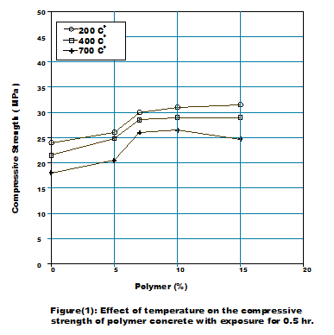
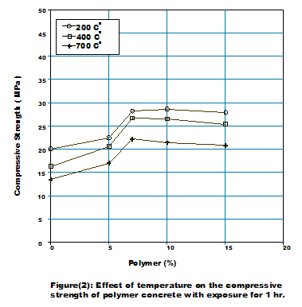

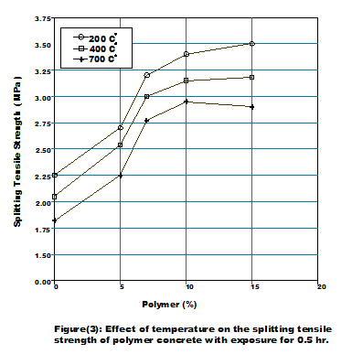
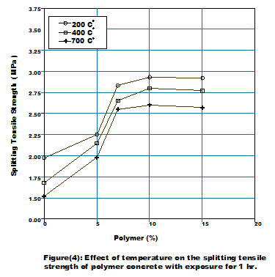

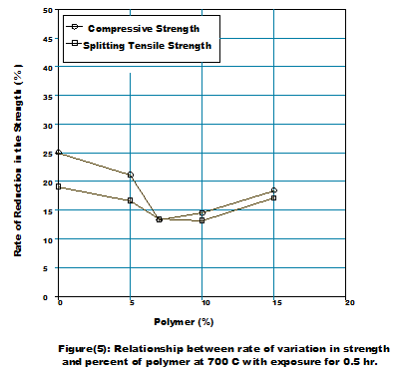
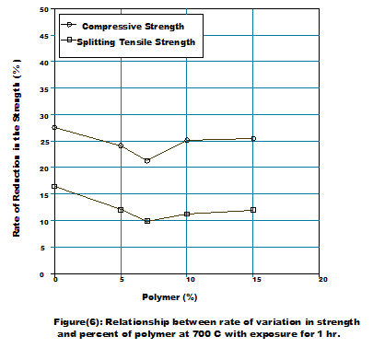

Figures (1) and (2) represents the effect of temperature on the compressive strength for the conventional and polymer concretes with duration of exposure 0.5 and 1 hour respectively.
It can be noticed from these Figures, that the compressive strength decrease with the increase of temperature, and the loss in the strength increase with the increase of duration of exposure to temperatures. This is may be attributed to the breakdown of interfacial bond due to thermal incompatibility between the cement past, the aggregate and the polymer, as well as, to the dehydration of cement past. Despite that, loss of strength by temperature was smaller in polymer concrete compared with conventional concrete, and decrease with the increase of percent of epoxy resin. The superior performance of polymer concrete may be to strong transition zone and 1ess difference in the coefficients of thermal expansion. Also, we can noticed from the Figures mentioned above, the apparently improvements in strength when used epoxy resin. Such improvements are occurred because of three facts, the first is that, the use of resin leads to form a film under ambient conditions to coat cement grains and aggregate particles leading to a strong bond between the cement matrix and the aggregate. The second is that filling of the most pores with polymer would reduce the porosity and hence increase the strength. The last, is that, the resin lead to form a continuous three-dimensional net work of polymer molecules through concrete, which act as a binder system due to good binding of the epoxy resin (ipulanandan, C., and Paul,1988)
Figures (3) and (4) represent the effect of temperature on the splitting tensile strength for the conventional and polymer concretes with duration of exposure 0.5 and 1 hour respectively.
Similar behavior for the compressive strength, can be noticed for the splitting tensile strength, but with less reduction when exposure to high temperatures. This is attributed, further to fixed above, to the introduction of polymer admixture results in modification of the concrete structure, as a double matrix is formed. One matrix is of concrete hydration products, while the other is a polymerized skeleton made by means of the used polymer admixture. The making of the double matrix modified ordinary concrete properties. The most distinct changes are the increase of tensile strength, ductility, bond strength, and improvement of reinforcement concrete structure durability (Ohama, Y., et al,1989).
Figures (5) and (6) represent the relationship between the rate of reduction in the compressive and splitting tensile strengths at 700 C^{ο} with percent of polymer for 0.5 and 1 hour duration of exposure respectively.
The rate of reduction in the compressive and splitting tensile strengths apparently converge when the duration exposure is (0.5) hour, while diverge when the duration of exposure is (1) hour. This may be due to the breakdown of interfacial bond, and dehydration of cement past.
Finally from the tests carried out in this study, we can be noticed, that the percent of polymer (7%), gives best mechanical properties of concrete.
Conclusions
The following points are fixed depending on the analysis of the results obtained from this study.
- the compressive strength of the conventional and polymer concretes decrease with the increase of temperature, and the loss in the strength increase with the increase of duration of exposure to high temperatures.
- The loss of strength due to increase the temperature was smaller in polymer concrete compared with conventional concrete, and decrease with the increasing of the percent of epoxy resin.
- Similar behavior for the compressive strength, was noticed for the splitting tensile strength, but with less reduction when exposed to high temperatures.
- The rate of reduction in the compressive and splitting tensile strengths apparently converge when the duration exposure is (0.5) hour, while diverge when the duration of exposure is (1) hour.
5. The percent of polymer (7%), gives best mechanical properties of concrete.

References
. المواصفة القياسية العراقية رقم 5, 1984, للسمنت البورتلاندي
ASTM C₁₂₈₋₈₈ "Standard Test Method for Specification Gravity and Absorption of Fine Aggregate", Annual Book of ASTM Standards, Vol. 04. 02, 1989, pp.68-71
ASTM C₂₉₋₈₉" Standard Test Method for Unite Weight and Voids Aggregate ", Annual Book of ASTM Standards, Vol. 04. 02, 1989, pp.1-3.
ASTM C₄₉₆₋₈₆ "Standard Test Method for Splitting Tensile Strength of Cylindrical Concrete Specimens", Annual Book Of ASTM Standards, Vol. 04. 02, 1989, pp., 259-262.
BS.1881. Part 116" Method for Determination of Compressive Strength of Concrete Cubes ", British Stander Institution, 1992, 3 pp.
BS.882, "Specification for Aggregate from Natural Sours for Concrete", British Stander Institution, 1992, 8 pp.
G. G. Carette and V. M. Malhotra, "Performance of Dolostone and Limestone Concrete at Sustained High Temperature ",in Temperature Effects on Concrete, ASTM Sp. Tech. Publ. No.858,pp.38-67 (1983 ).
Hani, M. F. and Nuri, "Influence of High Temperature on Compressive and Splitting Tensile Strength of Concrete" ,J. of Building research,Vol.5,No.2,pp.85-102,(1986).
Ipulanandan, C., and Paul, E. ," Mechanical Properties of Epoxy and Polyester Polymers and Polymer Concrete Systems ",Report No. UHCE 88-13, University of Houston, 1988, 165 pp.
Ohama, Y., "Principle of Latex-Modification and Some Typical Properties of Latex-Modified Mortars ", ACI Materials Journal, Vol.84, NO.45, Nov.-Dec.1987,pp.511-51.
Ohama, Y., et al, "Mix Proportioning and Properties of Epoxy -Modified Mortars ", Brittle Matrix Composites 2,Elseyier Applied Science, London , 1989, pp. 516-525.

