Nonlinear Analysis of Strengthened Bridge Deck Panels with Carbon Fiber Sheets

Ahmed N. Mohammed
Dep. of Engineering affairs, Presidency of the Un., University of Babylon

Abstract
Nonlinear analysis of reinforced concrete Bridge Deck Panels strengthened by carbon fiber reinforcement sheets has been investigated in this paper. The ANSYS 12.1 computer program was used for this purpose. The finite element models are developed using a smeared crack approach for concrete , three dimensional solid elements(solid 65) for concrete, One dimensional solid elements(Link8) for steel reinforced bars , and three dimensional layered elements(solid 46) for carbon fiber sheets (CFS). Three-dimensional finite element analysis was conducted to obtain the response of the strengthened Bridge Deck Panels with CFS in terms of applied load –deflection. Comparison with previous experimental studies shows about 90% agreements.

The effects of some influencing parameters including steel reinforcement ratio and carbon fiber sheets thickness on the behavior of strengthened Bridge Deck Panel were studied. The main conclusion was the steel reinforcement ratio is main factor affecting the structural strength.
Key word: Nonlinear Analysis; Concrete Bridge Deck; Carbon Fiber Sheets
الخلاصة
تم في هذا البحث دراسة التحليل اللاخطي لألواح سطح الجسور الخرسانية المسلحة المقواة باستخدام بوليمرات الكاربون حيث تم استخدام طريقة العناصر المحدد للتحليل و ذلك بستخدام برنامج (ANSYS 12.1).تم استخدام مبدأ التشققات الغير منتظمة للخرسانة في نموذج العناصر المحددة الحالي. تم تمثيل الخرسانة بالعنصر الصلد الثلاثي الابعاد (Solid 65 ( و العنصر أحادي البعد (link 8) لتمثيل حديد التسليح كما استخدم العنصر الصلد الطبقي ثلاثي الابعاد ( Solid 46) لتمثيل بوليمرات الكاربون. لقد تم التحليل بطريقة العناصر المحدد ثلاثي الابعاد لتحديد قوة الالواح حيث رسم المنحنیات التي توضح العلاقة ما بین الاحمال المسلطة والهطول الحاصل في هذه الالواح. المقارنة مع النتائج التجريبية لبحوث سابقة اظهرت تطابق حوالي 90%.

درست تأثيرات بعض العوامل مثل نسبة حديد التسليح اضافة الى سمك طبقات بوليمرات الكاربون على تصرف ألواح السطح الخاصة بالجسور. الاستنتاج الرئيسي في هذا البحث هو كون نسبة حديد التسليح هو العامل الرئيسي الذي يؤثر على التحمل الانشائي لهذا النوع من الالواح.

1. Introduction
Reinforced concrete bridge decks receive traffic loads directly. Structural damage can increase, such as residual deformation and numerous cracks, which eventually decreases the life of the deck as well as its load carrying capacity (Sim J. and Oh H., 2004).
Permanent deformations of decks caused by excessive repeated heavy traffic loads are one of the main deterioration phenomena leaded to failure of decks. The deteriorated bridge decks then fail either due to sapling of the concrete or a punching shears failure. During the last decade, many studies have focused on repair and rehabilitation techniques for concrete structures, and more efficient strengthening techniques and design methods have been reported (Sim J.et al., 2005).
Normally, carbon fiber polymer was used for strengthening of RC structures due to high strength and stiffness-to-weight ratio, corrosion resistance, utilization within various factors of design, simple organization of the surface just before applying, decreased duration of the construction time and lots of time remaining after strengthening scheme. Carbon fiber polymer has the essential requirement characteristics which make it usable for installation on the RC elements for structural behavior strengthening by considering de-bonding failure management (Far M. R. et al., 2011).
Modeling the complex behavior of reinforced concrete is a difficult task in the finite element analysis of civil engineering structures. Only recently have researchers attempted to simulate the behavior of reinforced concrete strengthened with FRP composites using finite element method, Kachlakev et al. in 2001 used the ANSYS finite element program to model the RC beams strengthened with FRP composites. Comparisons between the experimental data and the results from finite element models showed good agreement (Santhakumar R. et al., 2004).

2. The Material Model:
The finite element code ANSYS, version 12.1, has been used. Where the concrete, reinforced bars and carbon fiber are modeled as following:
2.1. Concrete Modeling:
The Solid 65 element was used to model the concrete; the solid element has eight nodes with three degrees of freedom at each node – translations in the nodal x, y, and z directions. The element is capable of plastic deformation, cracking in three orthogonal directions, and crushing. The geometry and node locations for this element type are shown in Figure (1) (ANSYS Guide), the multi-linear isotropic material uses von Mises failure criterion. Ec is the modulus of elasticity of the concrete, and ν is the Poisson’s ratio.
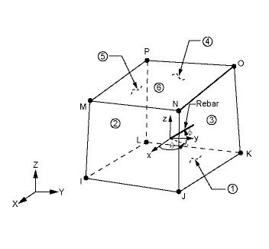

Figure (1) The geometry of Solid 65

The compressive uniaxial stress–strain values for the concrete model was obtained using equations (1), (2) and (3) with which are computed the multilinear isotropic stress–strain curve for the concrete (Kachlakev D. and Miller T., 2001).

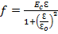 (1)

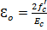 (2)

(3)

The compressive uniaxial stress–strain curve (Figure - 2) is defined by five points where the first point is defined as 0.3 and is calculated in linear range.
The second Point and the next two points are calculated from eq. (1) with ε0 obtained from eq. (2). The last Point is defined at and corresponding it strain.

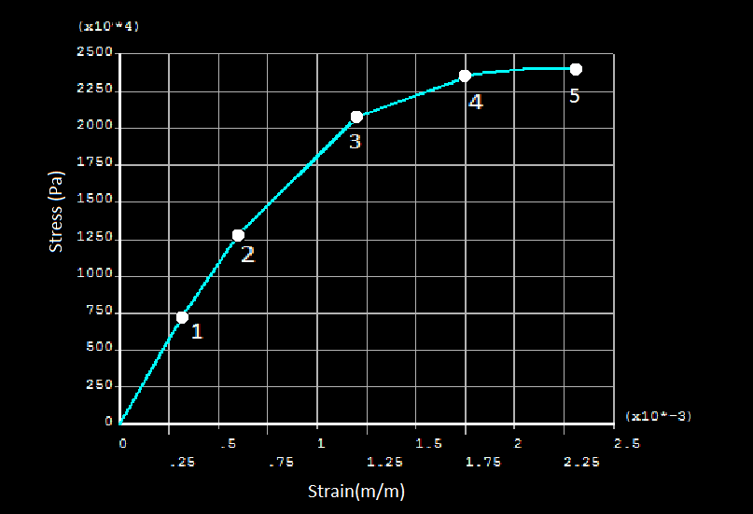

Figure (2) The compressive Uniaxial stress–strain curve for concrete

Implementation of the Willam and Warnke (1975) material model in ANSYS requires that different constants be defined. These constants are:
1. Shear transfer coefficients for an open crack;
2. Shear transfer coefficients for a closed crack;
3. Uniaxial tensile cracking stress;
4. Uniaxial crushing stress (positive);
5. Biaxial crushing stress (positive);
6. Ambient hydrostatic stress state for use with constants 7 and 8;
7. Biaxial crushing stress (positive) under the ambient hydrostatic stress state (constant 6);
8. Uniaxial crushing stress (positive) under the ambient hydrostatic stress state (constant 6);
9. Stiffness multiplier for cracked tensile condition (default 0.6, ANSYS Guide).
Typical shear transfer coefficients range from 0.0 to 1.0, with 0.0 representing a smooth crack (complete loss of shear transfer) and 1.0 representing a rough crack (no loss of shear transfer) (Wolanski A J, 2004).
In this paper the Shear transfer coefficients for an open crack assumed 0.4 and Shear transfer coefficients for a closed crack assumed 1.
The uniaxial tensile cracking stress obtains from equation (4) (ACI 318M-08):

(4)

A value of 1 for constant 3 or 4 also removes the cracking or crushing capability, respectively. If constants 1-4 are input and constants 5-8 are omitted, the ANSYS using it defaults, the defaults of ANSYS are using the following equations to obtain the constants (ANSYS Guide):

(5)

(6)

(7)

Where : Biaxial crushing stress, : Ultimate compressive strength for a state of biaxial compression superimposed,: Ultimate compressive strength for a state of uniaxial compression superimposed. These stress states are only valid for stress states satisfying the condition , where: Ambient hydrostatic stress state where it defined by equation (8).

(8)

Where , and are the principal stresses in the principal directions.

  - Reinforcing Steel Modeling:
A 3-D spar element is a uniaxial tension-compression (link8 element) is used to modeling the reinforcement Steel bars, this element has three degrees of freedom at each node: translations in the nodal x, y, and z directions. As in a pin-jointed structure, no bending of the element is considered. Plasticity, creep, swelling, stress stiffening, and large deflection capabilities are included (ANSYS Guide). The geometry, node locations, and the coordinate system for this element are shown in Figure (3).

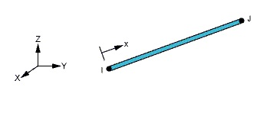
Figure (3) The geometry of Link8

The stress-strain curve of reinforcing steel bar is assumed to be elastic perfectly plastic. The bilinear kinematic hardening model was used to simulate the stress–strain curve of steel as shown in Figure (4) (Belakhdar K., 2008). This model required the modulus of elasticity of steel, the Poisson’s ratio of steel, the yield stress (fy), and tangent modulus where the tangent modulus be assumed zero.

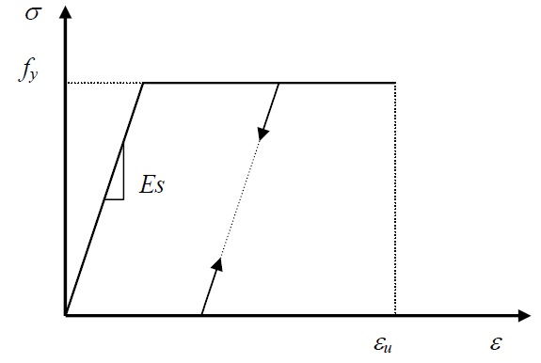
Figure (4) Stress–strain curve of reinforcement steel bars
  - Carbon Fiber Modeling:
The SOLID46 element is used to modeling the CFS, this element is 3-D modeling of Layered solid structures. The element is defined by eight nodes having three degrees of freedom at each node: translations in the nodal x, y, and z directions. This element allows up to 250 different material layers. The geometry, node locations, and the coordinate system for this element are shown in Figure (5). The element is defined by eight nodes, layer thicknesses and layer material direction angles (ANSYS Guide).
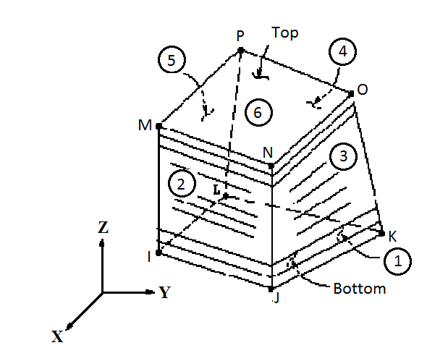

Figure (5) The geometry of Solid 46

The carbon fiber assumes a Linear Isotropic model (Büyükkaragöz A., 2010), where the poison ratio assumed 0.35. The bond between carbon fiber and concrete was assumed perfect.

- Nonlinear Analysis
ANSYS employs the "Newton-Raphson" approach to solve nonlinear problems. In this approach, the load is subdivided into a series of load increments. The load increments can be applied over several load steps illustrates the use of Newton-Raphson equilibrium iterations in a single DOF nonlinear analysis. Before each solution, the Newton-Raphson method evaluates the out-of-balance load vector, which is the difference between the restoring forces (the loads corresponding to the element stresses) and the applied loads. The program then performs a linear solution, using the out-of-balance loads, and checks for convergence. If convergence criteria are not satisfied, the out-of-balance load vector is reevaluated, the stiffness matrix is updated, and a new solution is obtained. This iterative procedure continues until the problem converges. A number of convergence-enhancement and recovery features, such as line search, automatic load stepping, and bisection, can be activated to help the problem to converge. If convergence cannot be achieved, then the program attempts to solve with a smaller load increment (ANSYS Guide).

- Finite Element Model Verification:
The Load–displacement curves obtained from the ANSYS solutions are confirmed by the experimental results of Sim J. et al. (2006) where the Structural Assessment of Externally Strengthened Bridge Deck Panels studied. A deck panel with dimensions of 160 by 240 cm was supported by two girders, as shown in Figure (6). The slab thickness was 18cm; the compressive strength of the concrete was 24MPa and the elastic modulus of concrete was 23.2GPa. The reinforcement was φ16 at 10 cm in the transverse direction and φ16 at 15 cm in the longitudinal direction, the Figure (7) shown the Reinforcements modeling specimen by ANSYS. The yield strength of steel was 300MPa and elastic modulus of steel was 196GPa.
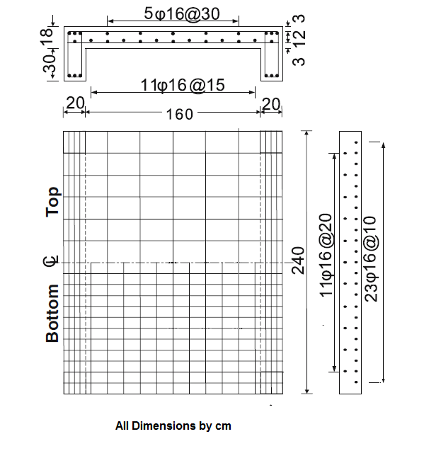
All dimensions are in centimeter

Figure (6) Deck Panel specimen (Sim J. et al., 2006)

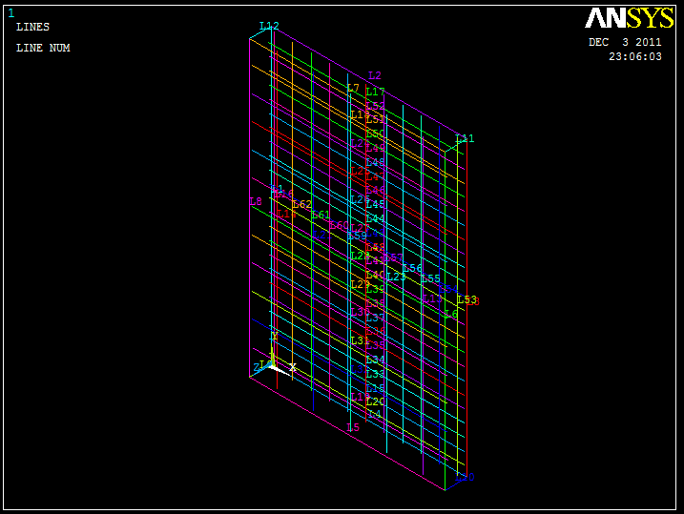
Figure (7) The reinforcements modeling specimen by ANSYS
The carbon fiber sheets with width 10 cm and thickness 0.11mm are place at the bottom of the deck with spacing 10 cm in two directions; the first one along the transfer direction and the other along the longitudinal direction as shown in Figure (8). Carbon fiber sheets attached to the epoxy coated concrete surface by pressing them were completely immersed and no air voids remained between the concrete and the sheet. The ultimate strength of carbon fiber was 3500MPa and the elastic modulus was 231GPa.

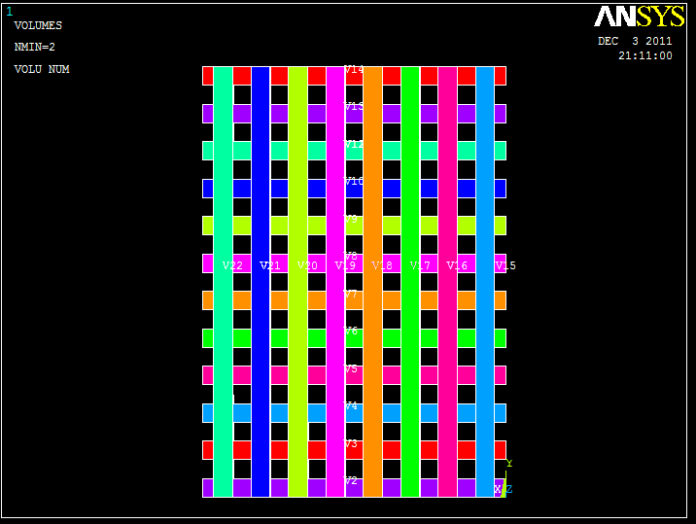

Figure (8) The Carbon Fiber Sheets arrangement

The static load was applied to an area of 25 X 50 cm at the deck center to simulate the tire contact area of an actual vehicle (Sim J. et al., 2006).
From the comparisons shown in Fig (9), it shows that the predictions are in close agreement with the experimental curves this indicates that the actual behavior of Deck Panel strengthened by Caron Fiber sheets can be accurately predicted by the ANSYS. Figure (10) shown at (a) the failure pattern of (Sim J. et al., 2006) while at (b) the deformed and un-deformed shape obtain by ANSYS.

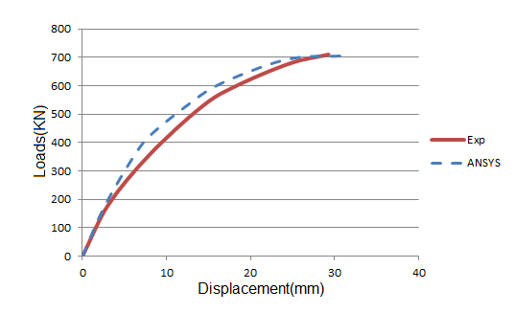
Loads (kN)
Displacement (mm)

Figure (9) Comparisons of experimental results of (Sim J. et al., 2006) with ANSYS

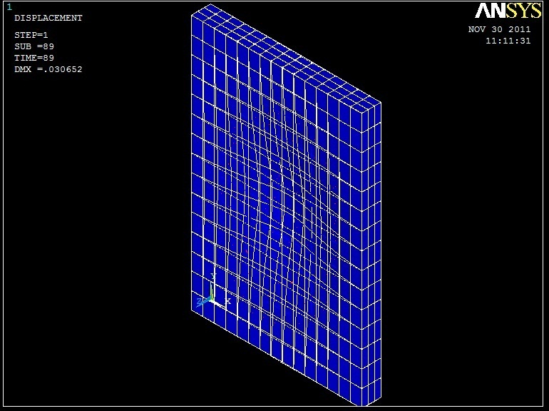
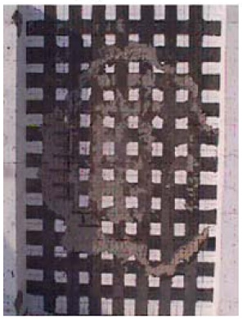

(a) (b)

Figure (10) a-the failure pattern of (Sim J., 2006), b-deformed and un-deformed shape obtain by ANSYS

- Parametric Studies:
In the present work, the effect of steel reinforcement ratio is investigated as well as the effect of carbon fiber sheets thickness on the Load-Displacement curve, there for a slab having dimensions of 240 cm length, 160cm width and 18cm thickness was taken as the reference for the parametric studies that the same one that used by Sim J. et al. (2006), with the same material properties.
First, the effect of steel reinforcement ratio “SRR” on the Loads–Displacement as shown in Figure (11), where the area steel in the transverse direction decreased. The letter H indicate the SRR at the original specimen while the letter M point to a SRR that decrease by 43%, then letter L are used to identify a SRR that decrease by 61%, It can be observed that loads at similar Displacements decrease when the SRR decrease.

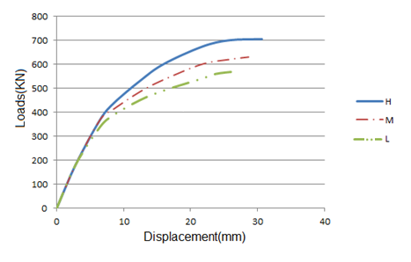
Loads (kN)
Displacement (mm)
Figure (11) Effect of steel reinforcement ratio

Second, the effect of carbon fiber sheets thickness on the Load-Displacement curve as shown in Figure (12), where three different thicknesses of carbon fiber sheets studied. The first carbon fiber sheet (CFS) with thickness 0.11 mm , the second CFS have thickness 0.8mm the last one have thickness 1.2mm. It can be observed that loads at similar Displacements increase when the CFS thicknesses increase.

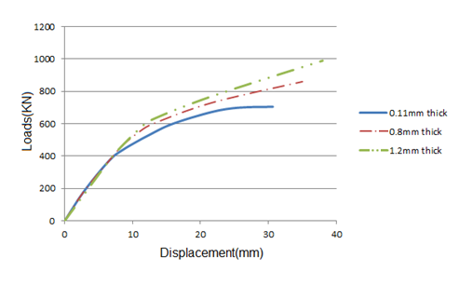
Displacement (mm)
Loads (kN)
Figure (12) Effect of carbon fiber sheets thickness

- Conclusions:
- The general behavior of the finite element models represented by the load-deflection plots show good agreement with the experimental results.
- Parametric studies showed that the steel reinforcement ratio is important factor affecting the descending region of the loads –Displacements curves for Bridge Deck Panels.
- Form Parametric studies showed that the loads at similar Displacements increase when the CFS thicknesses increase.
- The use of Carbon Fiber Sheet is effective for strengthening or repair the reinforcement concrete Bridge Deck Panels.

- References:
Sim J. and Oh H. (2004), “Structural behavior of strengthened bridge deck specimens under fatigue loading” Engineering Structures 26, Elsevier.
Sim J., Oh H., Yub J. and Shimc J. (2005), ” Theoretical assessment of the limit strengthening criterion of strengthened bridge decks based on failure characteristics” Cement and Concrete Research 35,ELSEVIER.
Far M. R., Jumaat M. Z., Razavi S.V. and Mohammadi P., Mohammadi H. (2011), ” Nonlinear analysis of load-deflection testing of reinforced one-way slab strengthened by carbon fiber reinforced polymer (CFRP) and using artificial neural network (ANN) for prediction” International Journal of the Physical Sciences Vol. 6(13).
Santhakumar R., Chandrasekaran E. and Dhanaraj R. (2004), “Analysis of Retrofitted Reinforced Concrete Shear Beams using Carbon Fiber Composites” Electronic Journal of Structural Engineering, 4.
ANSYS, ANSYS User’s Manual Revision 12.1, ANSYS, Inc.

Kachlakev D. and Miller T. (2001), ”Finite Element Modeling of Reinforced Concrete Structures Strengthened with FRP Laminates” California Polytechnic State University, San Luis Obispo, CA and Oregon State University, Corvallis, Oregon,USA.
Wolanski A. J. (2004), ”Flexural Behavior of Reinforced and Prestressed Concrete Beams Using Finite element Analysis” Marquette University, Milwaukee, Wisconsin.
ACI 318M (2008), “Building Code Requirements for Reinforced Concrete” American Concrete Institute, Farmington Hills, Michigan, U.S.A.
Belakhdar K. (2008), ”Nonlinear Finite Element Analysis of Reinforced Concrete Slab Strengthened with Shear Bolts” Jordan Journal of Civil Engineering, Volume 2, No. 1.
Büyükkaragöz A. (2010), “Finite element analysis of the beam strengthened with prefabricated reinforced concrete plate”, Scientific Research and Essays Vol. 5(6).
Sim J, Oh H. and Meyer C. (2006), ” Structural Assessment of Externally Strengthened Bridge Deck Panels”, Springer Science + Business Media, Inc.

