Controller Design for Active Suspension System for Car with Unknown Time-Delay and Road Disturbances

Ali I. Hassan
Mechanical Engineering Department, College of Engineering, University of Kerbala

Abstract
In this paper we consider the quarter car active suspension system suffering from unknown time-delay and external road disturbances . We derived a control law for achieving stability of the system and convergence that can considerably improved the ride comfort and road disturbance handling. This is accomplished by using Routh-Herwitz criterion and based on some assumptions. A mathematical proof is given to show the ability of the designed controller to ensure stability and convergence of the active suspension system and dispersion fast oscillation of system despite unknown time-delay and road disturbances . Simulations were also performed for controlling quarter car suspension, where the results obtained from these simulations verify the efficiency of the proposed design to faster suppression oscillation and obtain stability although present of unknown time-delay and road disturbance.

الخلاصة
في هذا البحث أخذنا بنظر الاعتبار نظام تعليق نشيط لربع سيارة يخضع لزمن تأخير مجهول مع وجود اضطرابات خارجية في الطريق.واشتققنا قانون سيطرة لتحقيق الاستقرارية للنظام والتقارب الذي يمكن إن يحسّنا راحة الجولة ومعالجة اضطرابات الطريق .لقد تم ذلك باستخدام تقنية راوث هيروتز و اعتماد بعض الفرضيات.استخدم برهان رياضي لبيان ملائمة تصميم المسيطر لتأكيد الاستقرارية والتقارب لنظام التعليق النشيط والاضمحلال السريع للتذبذب على الرغم من مجهولية زمن التأخير ووجود اضطرابات في الطريق . بالإضافة إلى ذلك تم تدعيم البرهان الرياضي من خلال تطبيق المسيطر المصمم للسيطرة على نظام تعليق لربع سيارة ، حيث أكدت النتائج المستحصلة كفاءة المسيطر المصمم لامتصاص التذبذب بسرعة والوصول إلى حالة الاستقرار بالرغم من وجود زمن تأخير مجهول واضطرابات في الطريق.

Nomenclature
$m_{b}$ Mass for the car body (kg) $m_{w}$ Mass for car wheel (kg)
$k_{b}$ Stiffness of the car body spring (N/m)
$k_{w}$ Stiffness of the car tire (N/m)
$c_{b}$ Damping of the damper (N/m)
$x_{b}$ Displacement of car body (m)
$x_{w}$ Displacement of wheel (m)
$w(t)$ Road disturbance (N)
$f_{a}(t)$ Control force (N)
$\text{e }(t)$ Steady-state errors
$r(t)$ Reference input
Keywords; ; Active suspension system, Time-delay ,Disturbance rejection.

1 Introduction
Suspension system is a system that consists of springs, shock absorbers and linkages that connect vehicle to its wheels. Vehicle suspension systems serve a dual purpose which are contributing to the road handling and braking devices for increase the safety and driving pleasure, and also keeping vehicle occupants comfortable and reasonably well isolated from road noise, bumps, and vibrations. The complexity of the system is due to the fact that it must accomplish a huge number of perquisite
Requirements parameters such as safety, noise, handling, comfort, etc ...
As it is mentioned, on the other word, the acceleration of the vehicle body can determine ride comfort and the task of the suspension system is to isolate disturbances from the vehicle body, which caused by the uneven road profile. The wheels ability to transfer the longitudinal and lateral forces onto the road can affect the safety of the vehicle while traveling. The necessity of the vehicle suspension system is to keep the wheels as close as possible the road surface. Wheel vibration must be dampened and any dangerous lifting of the wheels must be, as far as possible, avoided. The body of the vehicle is mostly isolated from high frequency disturbance of the road by the suspension system. The passengers in a car note these disturbances acoustically and thus the noise comfort is reduced. When there is a change in loading, the suspension system should be able to keep the vehicle level as stable as possible, so that the complete suspension travel is available for the wheel movements [Mohd Rizal Bin Ahmad and Manap, 2007]. In general, there are three types of the suspension system which are passive, semi-active and active suspension system.
The conventional suspension system is passive suspension system. Springs and dampers are two major elements of this type. The purpose of the damper is to dissipate the energy and the spring is to store the energy [Adizul Ahmad, 2005]. For this type of suspension system, damping coefficient and spring stiffness is fixed parameters. It could be a weakest point not only for ride comfort but also having a good handling which could be a function of road surface, vehicle speed and disturbances.
The components in the semi-active suspension system are similar to the passive suspension system [Crolla, 1988]. However, the difference between these systems is that the damping coefficient in semi-active suspension system can be controlled. High frequency hardness is a significant feature that has been observed during road tests. However, the literature confirmed that, the performance of semi-active suspension system is not very suitable to handle this feature [Mohd Satar Bin Ab Ghani, 2006].
The active suspension system is able to add energy into vehicle dynamic system by the use of actuators rather than dissipating energy by the use of spring in the passive suspension system. It can use further degrees of freedom in assigning transfer functions and therefore the performance is better than the conventional suspension system. Researchers have established various linear control strategies in designing the active suspension system such as fuzzy reasoning [Yoshimura, et al.,, 1999], robust linear control [Christophe Lauwerys, et al.,, 2005], $H∞$ [Ohsaku, et al., 1999], adaptive observer [Rajesh Rajamani and J. Karl Hedrick, 1995] and In [Hrovat, 1990] Hrovat studied the problem of optimal design of active suspensions by casting it into an equivalent linear-quadratic (LQG)-optimization problem.
The active suspension system also consists of an additional element, which is a sensor. In general, the function of a sensor in active suspension systems is to measure suspension variables such as body velocity, suspension displacement, wheel velocity, and wheel or body acceleration [Adizul Ahmad, 2005]. For any practical design of active suspension system, one of the main issues is its sensor necessity. Occasionally, it is impractical to use sensor due to its cost, accuracy or availability. A method that can replace the sensor is by using the state observer and it is used to calculate state variables which are not reachable and accessible from the plant. Estimated states, instead of actual states, can be fed to the controller. By introducing the appropriate controller into the active suspension system, the performance of the system can be improved further [Oliver. Et al., 2001].
Time-delay exists inevitably in most practical systems. Generally it is derived from on-line data acquisition, processing, control force calculation and transmission. Neglecting time-delay may cause degradation of control performance or even induce instability of the dynamic system. In recent years, the analysis and design of time-delay systems has received considerable attention from the research community, and some research results have been obtained in application as well as theory fields. For instance, a new successive approximation approach has been proposed by Tang et al. [Tang and Wang, 2003, Cai,et al., 2003] to solve the optimal control problem for discrete-time linear delay systems and linear large-scale systems with small time-delay, respectively. Cai et al. [Tang, 2001] provided an optimal control method for linear time-delay systems in vibration control. In the advanced engineering systems, such as vehicle systems, digital controllers, sensors, and actuators are connected over an electronic communication network [Simon, & Becker,1999], [Toy, et.al, 2002].Hence, time delays are unavoidable. In electronic controllers, transfer delays of sensor-controller and controller-actuator are encountered. Recently, issues on network-induced time-delay and sampled-data control problems have been attracted widely attention [Yue, et al., ,2003].
In this paper, Design of stable controllers that achieve stability with minimized overshoot has been implemented within the active suspension system that can considerably improved the ride comfort and road handling although present with unknown time-delay and the road disturbance by using Routh-Herwitz criterion.

2 Dynamic Model of Active Suspension System
"Fig. 1" demonstrates the quarter car active suspension system. The following are the equations of motion for the active suspension system of the quarter model for a car with time-delay:

$m_{b}{\overset{¨}{x}}_{b}+c_{b}({\overset{˙}{x}}_{b}−{\overset{˙}{x}}_{w})+k_{b}(x_{b}−x_{w})−u(t−T)f_{a}=0$ (1)

$m_{w}{\overset{¨}{x}}_{b}+c_{b}({\overset{˙}{x}}_{w}−{\overset{˙}{x}}_{b})+k_{b}(x_{w}−x_{b})+k_{w}(x_{w}−w)+u(t−T)f_{a}=0$ (2)

Where $m_{b}$ and $m_{w}$are the masses of the body and wheel. The displacements of wheel and car body are $x_{w}{\text{,x}}_{b}$ respectively. The spring coefficients are $k_{b}$and $k_{w}$.The damper coefficient is $c_{b}$and the road disturbance is$w(t)$. u is a unit-step function, T is unknown time-delay and $f_{a}(t)$, control force, is supposed to be the suspension system control input. The disturbance input is not in phase with the system input, which means, the system suffers from incompatible condition [Yaha et al., 2002]. Thus, The main objective of this paper is to propose controller, which is be robust enough to overcome the mismatched condition and, obviously, the disturbance would not have important effect on the system performance for different unknown time-delays using a bounded controller v(t).. and it has been implemented within the active suspension system that can considerably improved the ride comfort and road handling despite the presence of unknown time-delays and external road disturbances.

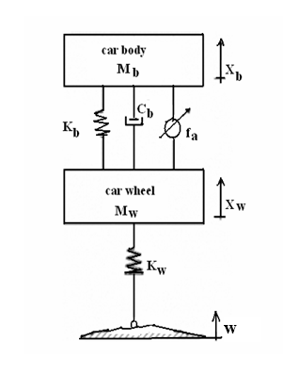
Figure 1.Active suspension system for a quarter-car

The following assumptions are used through this work:
Assumption 1: The parameters $m_{b}{\text{,m}}_{w}{\text{,k}}_{b}{\text{,k}}_{w}$ & $c_{b}$ are known constants.
Assumption 2: The time-delay T is unknown, but bounded by known constants
T${}_{1}$&T${}_{2}$ such that$0<T_{1}<T<T_{2}$.
Assumption 3: The road disturbance w(t) demonstrating a single bump as below[Elnaz Akbari1, Morteza Farsadi2, Intan Z.Mat Darus2 ,Ramin Ghelichi3,2010]:
$w(t)=\begin{aligned}\left\{\frac{a(1−\text{cos8}πt)}{2} τ_{1}≤t≤τ_{2} | \right\}\end{aligned}\left\{\right\}$ (3)
Where $a$ is the height of the bump, $τ_{1}$ and $τ_{2}$ are the lower
and the upper time limit of the bump.
Assumption 4: The term e${}^{−\text{Ts}}$can be represented by the following Tayler series [Norman S. Nise, 2008,2010]
$e^{−\text{Ts}}=1−\text{Ts}+\frac{T^{2}s^{2}}{\text{2!}}−\frac{T^{3}s^{3}}{\text{3!}}+−⋯$ (4.a)
The higher order terms can be neglected and Eq. (4) is reduced to:
$e^{−\text{Ts}}=1−\text{Ts}$ (4.b)

3 Main Theorem
The main theorem of this work will be presented in the following.
THEOREM: Under assumptions 1,2,3&4 system (1&2) is stable if we satisfy the control law:
$f_{\text{a1}}(t)=\frac{1}{k_{w}}\left\{A+\text{Bexp}({\text{-λ}}_{1}t) +\text{Cexp}({\text{-λ}}_{2}t) +\text{Dexp}({\text{-λ}}_{3}t)\right\}$ (5)
With,
$A=\frac{k_{b}k_{w}}{λ_{1} λ_{2} λ_{3}}$,$\text{ B}=\frac{\left\{−(c_{b}m_{b}+c_{b}m_{w})λ_{1^{3}}+(k_{b}m_{b}+k_{w}m_{b}+k_{b}m_{w})λ_{1^{2}}−c_{b}k_{w}λ_{1}+k_{b}k_{w}\right\}(1−{\text{Tλ}}_{1})}{−λ_{1}(−λ_{1}+λ_{2})(−λ_{1}+λ_{3})}$, $\text{ C}=\frac{\left\{−(c_{b}m_{b}+c_{b}m_{w})λ_{2^{3}}+(k_{b}m_{b}+k_{w}m_{b}+k_{b}m_{w})λ_{2^{2}}−c_{b}k_{w}λ_{2}+k_{b}k_{w}\right\}(1−{\text{Tλ}}_{2})}{−λ_{2}(−λ_{2}+λ_{1})(−λ_{2}+λ_{3})}$, and $D=\frac{\left\{−(c_{b}m_{b}+c_{b}m_{w})λ_{3^{3}}+(k_{b}m_{b}+k_{w}m_{b}+k_{b}m_{w})λ_{3^{2}}−c_{b}k_{w}λ_{3}+k_{b}k_{w}\right\}(1−{\text{Tλ}}_{3})}{−λ_{3}(−λ_{3}+λ_{1})(−λ_{3}+λ_{2})}$Remark 1:For more details about {A,B,C &D} see appendix A
Take the Laplace transformer (1)&(2) obtain:

$m_{b}s^{2}x_{b}+c_{b}{\text{sx}}_{b}−c_{b}x_{w}s+k_{b}x_{b}−k_{b}x_{w}−F_{a}e^{−\text{Ts}}=0$
$(m_{b}s^{2}+c_{b}s+k_{b})x_{b}−(c_{b}s+k_{b})x_{w}−F_{a}e^{−\text{Ts}}=0$ (6)
$m_{w}s^{2}x_{b}+c_{b}{\text{sx}}_{w}−c_{b}x_{b}s+k_{b}x_{w}−k_{b}x_{b}+k_{w}x_{w}−k_{w}W+F_{a}e^{−\text{Ts}}=0$ $(m_{w}s^{2}−c_{b}s−k_{b})x_{b}+(c_{b}s+k_{b}+k_{w})x_{w}−k_{w}W+F_{a}e^{−\text{Ts}}=0$
Then,
$x_{w}=\frac{(−m_{w}s^{2}+c_{b}s+k_{b})x_{b}+k_{w}W−F_{a}e^{−\text{Ts}}}{c_{b}s+k_{b}+k_{w}}$ (7)
Substitute (7) into (6) yields :-
$(m_{b}s^{2}+c_{b}s+k_{b})x_{b}−(c_{b}s+k_{b})[\frac{(−m_{w}s^{2}+c_{b}s+k_{b})x_{b}+k_{w}W−F_{a}e^{−\text{Ts}}}{c_{b}s+k_{b}+k_{w}}]−F_{a}e^{−\text{Ts}}=0$
$\begin{aligned}⇒ \\ \end{aligned}$
$\begin{aligned}⇒(c_{b}m_{b}s^{3}+c_{b^{2}}s^{2}+c_{b}k_{b}s+k_{b}m_{b}s^{2}+c_{b}k_{b}s+k_{b^{2}}+k_{w}m_{b}s^{2} \\ +k_{w}c_{b}s+k_{b}k_{w}+c_{b}m_{w}s^{3}−c_{b^{2}}s^{2}−c_{b}k_{b}s+k_{b}m_{w}s^{2}−c_{b}k_{b}s−k_{b^{2}})x_{b} \\ −(c_{b}k_{w}s+k_{b}k_{w})W+(c_{b}s+k_{b})F_{a}e^{−\text{Ts}}−(c_{b}s+k_{b}+k_{w})F_{a}e^{−\text{Ts}}=0\end{aligned}$
$\begin{aligned}⇒\left\{(c_{b}m_{b}+c_{b}m_{w})s^{3}+(k_{b}m_{b}+k_{w}m_{b}+k_{b}m_{w})s^{2}+(c_{b}k_{w})s+k_{b}k_{w}\right\}x_{b} \\ −k_{w}F_{a}e^{−\text{Ts}}−(c_{b}k_{w}s+k_{b}k_{w})W=0\end{aligned}$ (8)

Based on assumption 4, we can employ the approximation $e^{−\text{Ts}}≈1−\text{Ts}$ in (8) to obtain:

$\begin{aligned}\left\{(c_{b}m_{b}+c_{b}m_{w})s^{3}+(k_{b}m_{b}+k_{w}m_{b}+k_{b}m_{w})s^{2}+(c_{b}k_{w})s+k_{b}k_{w}\right\}x_{b} \\ −k_{w}F_{a}(1−\text{Ts})−(c_{b}k_{w}s+k_{b}k_{w})W=0\end{aligned}$ (9)
Then, (9) can be rewritten in the form :

$c_{1}x_{b}−c_{2}F_{a}−c_{3}W=0$ (10)
Where,
$c_{1}=(c_{b}m_{b}+c_{b}m_{w})s^{3}+(k_{b}m_{b}+k_{w}m_{b}+k_{b}m_{w})s^{2}+(c_{b}k_{w})s+k_{b}k_{w}$
,$c_{2}=k_{w}$ and $c_{3}=(c_{b}k_{w}s+k_{b}k_{w})$

$E(s)=X_{b}(s)\text{-R}(s)$ (11)

Let $F_{a}={\text{EF}}_{\text{a1}}$ and substitute in (10)
$c_{1}x_{b}−c_{2}{\text{EF}}_{\text{a1}}−c_{3}W=0$ (12)
From (12) we can found $x_{b}$

$x_{b}=\frac{c_{2}{\text{EF}}_{\text{a1}}+c_{3}W}{c_{1}}$ (13)

Take the Laplace transform of the controller (5), we find:
$c_{2}F_{\text{a1}}=\frac{c_{1}(1−\text{Ts})}{s^{4}+{\text{100s}}^{3}+{\text{100s}}^{2}+\text{100s}}$ (14)
Remark2:For more details about Eq.(14) see appendix B

From (11) system (13) can be represented by the block diagram shown in Fig.(2).

+
-
E(s)
X(s)
Controller
Plant
R(s)
Figure (2). Block Diagram of System (13)
(s)
+
+

This figure can be reduced to a simple block diagram shown in Fig.(3)

+
-
E(s)
X(s)
Controller
Plant
R(s)
Figure (3). Block Diagram of System (13)
D(s)
+
+

From Fig.(2), the corresponding characteristic equation is:
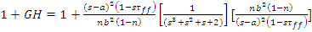
$G=G_{1}G_{2}$ where, $1+\text{GH}=1+\frac{c_{1}(1−\text{Ts})}{s^{4}+{\text{100s}}^{3}+{\text{100s}}^{2}+\text{100s}}[\frac{1}{c_{1}}]$
$\begin{aligned}1+\text{GH}=1+\left\{\frac{[(c_{b}m_{b}+c_{b}m_{w})s^{3}+(k_{b}m_{b}+k_{w}m_{b}+k_{b}m_{w})s^{2}+(c_{b}k_{w})s+k_{b}k_{w}](1−\text{Ts})}{s^{4}+{\text{100s}}^{3}+{\text{100s}}^{2}+\text{100s}}\right\}∗ [\frac{1}{(c_{b}m_{b}+c_{b}m_{w})s^{3}+(k_{b}m_{b}+k_{w}m_{b}+k_{b}m_{w})s^{2}+(c_{b}k_{w})s+k_{b}k_{w}}]\end{aligned}$
$1+\text{GH}=1+\frac{(\text{1-Ts})}{s^{4}+{\text{100s}}^{3}+{\text{100s}}^{2}+\text{100s}}$ (15)
Equating (15) to zero, we find
$s^{4}+{\text{100s}}^{3}+{\text{100s}}^{2}+\text{100s}+(\text{1-Ts})=0$
$s^{4}+{\text{100s}}^{3}+{\text{100s}}^{2}+(\text{100-T})s+1=0$ (16)
The corresponding Routh table (16) is constructed as follows:

Since, there is no change in the sign of the first column, hence all the poles of the closed-loop transfer function are at the left half of the s-plane, and the system is stable according to Routh-Hurwitz criterion.

4 Simulation
In this section, we demonstrate the validity of the proposed controller designed in Theorem throughout considering a case study of the active suspension system for the quarter of a car. Based on Theorem, the dynamics of this case study can be represented by the following equation:

$\begin{aligned}\left\{(c_{b}m_{b}+c_{b}m_{w})s^{3}+(k_{b}m_{b}+k_{w}m_{b}+k_{b}m_{w})s^{2}+(c_{b}k_{w})s+k_{b}k_{w}\right\}x_{b} \\ −k_{w}e^{\text{-Ts}}F_{a}−(c_{b}k_{w}s+k_{b}k_{w})W=0\end{aligned}$ (17)

where, $m_{b}$ and $m_{w}$are the masses of the body and wheel, $x_{b}$is the displacement of car body, . $k_{b}$and $k_{w}$ are the spring coefficients, $c_{b}$is the damper coefficient, $W(t)$is the road disturbance,$F_{a}(t)$, control force, is supposed to be the suspension system control input. For the purpose of simulation, we consider the numerical values of $a=\text{10cm}$,$τ_{1}=0$& $τ_{2}=\text{10}$and the dynamics parameters as shown in table 1 [Elnaz et al., 2010].

Table 1.Parameter value for the quarter car model
Mass for car body, | 300 kg
Mass for car body, | 500 kg
Mass for car wheel, | 50 kg
Stiffness of car body spring, | 16812 N/m
Stiffness of car wheel spring, | 190000 N/m
Damping of the damper, | 1000 Ns/m

The aim is to employ design the control law to make the implemented within the active car suspension system that can considerably improved the ride comfort and road handling. Figure (4) and (6) shows the time-response of system (9) by using control law (5).It is clear from this figure that the control law(5) achieves a good tracking performance and drives successfully the disturbances overshoot to the desired zero value with a fast rate of convergence using a bounded controller $f_{\text{a1}}$ applied between the wheel and car body. Also, Figure (5) shows that the passive suspension for quarter car travel produces an overshot about 30cm, while figure (6) shows the time-response of system (9) for three different time-delays of $T$(1s, 1.5s, 2s) by using the proposed controller design. As shown in this figure, the overshoot of the travel active suspension don't exceed (3cm) and then through few seconds faster suppression of the oscillation is achieved to the desired value (zero) with a good rate of convergence for the three values of T. Figure (7) shows the comparison between the displacement of body car for passive and active suspension using controller with three different values of time-delay. The difference between the body acceleration of passive and active suspension with three different values of time-delay clearly appear in figure (8). After that is necessary to show the behavior of the car wheel travel, where figure (9) shows the comparison between the deflection of wheel car for active with three different values of time-delay and passive suspension. Then, the wheel vibration be dampened and any dangerous lifting of the wheels is avoided despite the present of the present of time-delay and road disturbance.

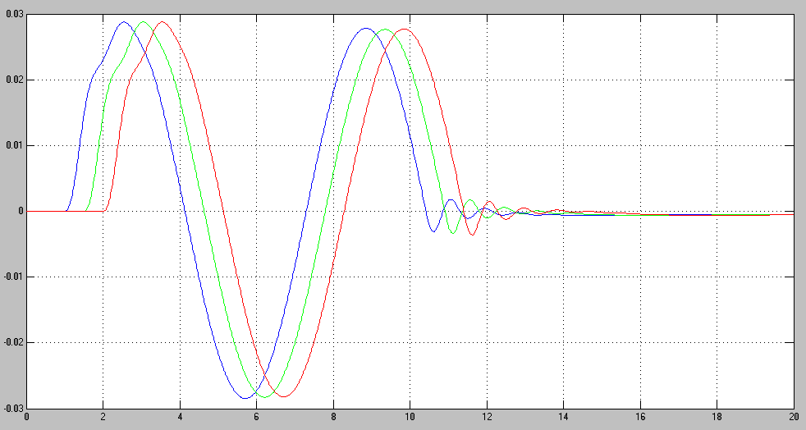
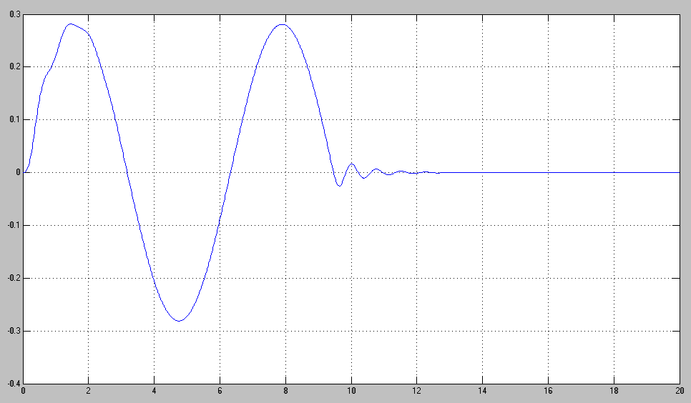
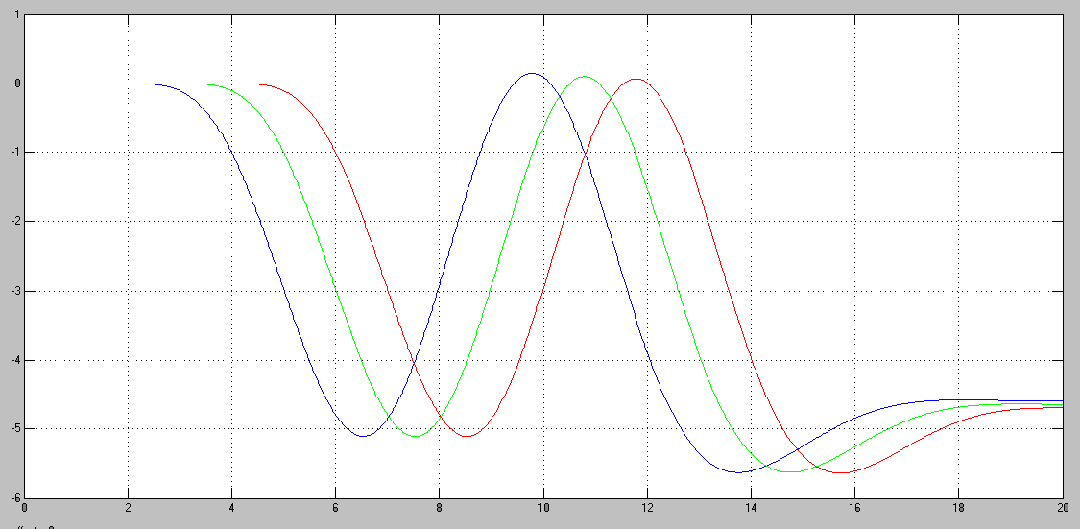
Figure (4). Control force supposed to be the system with three different values
for time-delay (1s,1.5s,2s)
Figure (6). Active suspension travel with three different values for time delay (1s,1.5s,2s)
using control law (5).
Figure (5). Passive suspension travel
Time (s)
Time (s)
Time (s)

$$x_{b}(m)$$

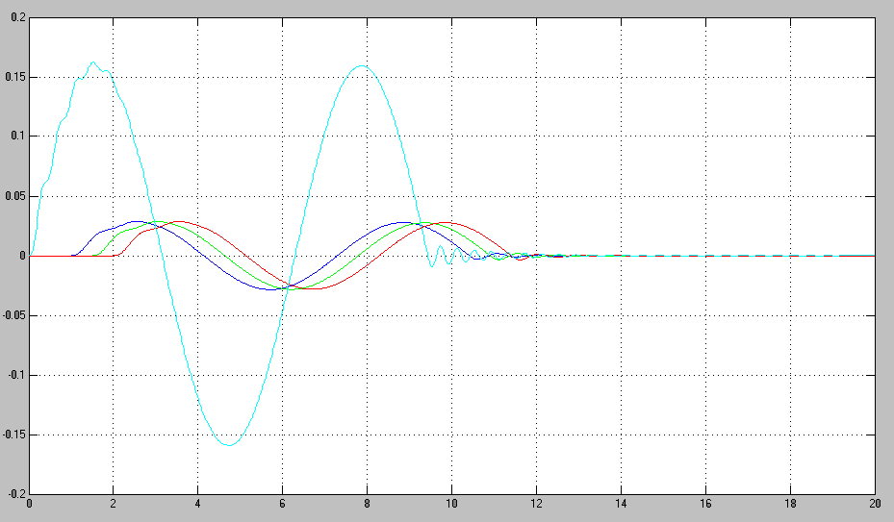
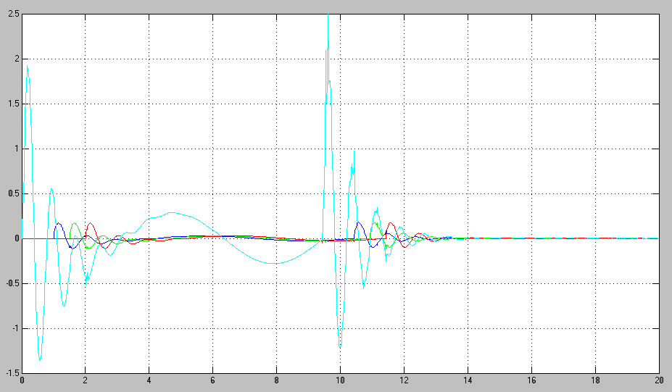
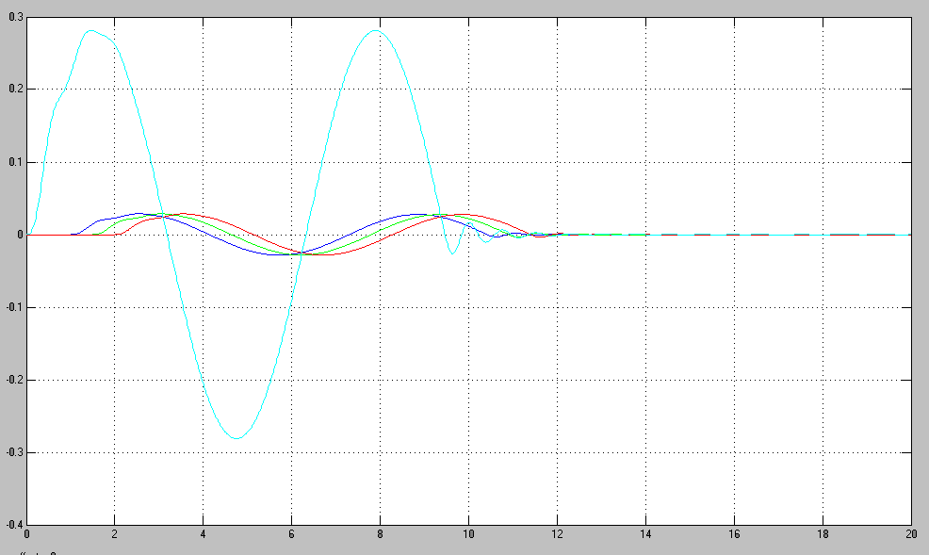
Figure( 8). Body acceleration between active with three different values for time-
delay (1s,1.5s,2s) and passive by using control law (5)

Figure (9). Wheel deflection between active with three different values for time-delay (1s,1.5s,2s) and passive by using control law (5)

Time (s)
Body acceleration
Time (s)
Figure (7). Suspension travel between active with three different values for time delay (1s,1.5s,2s)
and passive by using control law (5).
Time (s)

5 Conclusions
In this paper, controller is designed by using the Routh-Hurwitz stability criterion has been executed for the active car suspension system. i) The results of the presented mathematical model and simulation show a significant improvement in the performance and also disturbance absorption for system with unknown time-delay and road disturbance .ii) The control law (5) designed by using Routh-Hurwitz criterion has been implemented successfully to the active car suspension system ,and is robust in compensating the disturbance in the system and can improve the ride comfort and road handling. iii)For these reasons, the Routh-Hurwitz criterion control is recommended in solving time delay system with uncertainties. iv) For future work we can consider an active suspension control of a half car model using fuzzy reasoning, state observer, and disturbance rejection. The half car model can be treated and described as a nonlinear four degrees of freedom system subject to excitation from a road profile.

Acknowledgement
The author would like to express his acknowledgement to the reviewers for their constructive comments.

References
A. Simon, J. C. Becker, “Vehicle guidance for an autonomous vehicle,”Proc. IEEE Conf. Intell. Transp. Syst., pp. 429-434, 1999.
Adizul Ahmad, 2005, "An Observer Design for Active Suspension System," Master Thesis.University Teknologi Malaysia.
Christophe Lauwerys, Jan Swever and Paul Sas , 2005, "Robust Linear Control of an Active Suspension System on a Quarter Car Test-rig," Control Engineering Practice 13, Universities Leuven, pp. 577-586.
C. Toy, K. Leung, L. Alvarez, et. al, “Emergency vehicle maneuvers and control laws for automated highway systems,” IEEE Trans. Intell. Transp. Syst., vol. 3, pp. 109-119, 2002.
D. Nesic, A.R. Teel, “A framework for stabilization of nonlinear sampled-data systems based on their approximate discrete-time models,” IEEE Trans. Autom. Control, vol. 49, pp. 1103-1122, 2004.
D. Yue, Q. L. Han, J. Lam, “Network-based Robust H∞ Control of Systems with Uncertainty,” Automatica, vol. 41, pp. 999-1007, 2005.
Elnaz Akbari1, Morteza Farsadi2, Intan Z.Mat Darus2 ,Ramin Ghelichi3,2010,'' Observer Design for Active Suspension System U sing Sliding Mode Control"
G-P Cai, J-Z Huang, S. X. Yang, "An optimal control method for linear systems with time delay,"
Computers & Structures, vol. 81, pp. 1539-1546, July 2003.
G.-Y. Tang and F. Wang, "Suboptimal control for linear large-scale systems with small time-delay," Control Theory & Applications, vol. 20,pp. 121-124, February 2003 (in Chinese).
G.-Y. Tang, "Feed forward and feedback optimal control for linear system with sinusoidal disturbances," High Technology Letters, vol. 7,pp. 16-19, December 2001.
Hrovat D., 1990, “Optimal active suspension structures for quarter-car vehicle models,” Automatic, vol. 26,no. 5 pp. 845-860
L.-S. Hu, J. Lam, Y.-Y. Cao, H.-H. Shao, “LMI approach to robust 2 H sampled-data control for nonlinear uncertain systems,” IEEE Trans.Syst. Man Cyber, vol. 33, pp. 149-155, 2003 .an Active Vehicle Suspension System,"Master Thesis. University Teknologi Malaysia.
Mohd Satar Bin Ab Ghani, 2006, "Simulation and Experimental Analysis of a Suspension System,"Master Thesis. Faculty of Mechanical Engineering, University Teknologi Malaysia,.
Norman S. Nise, 2008,2010," Control Systems Engineering",pp35-36, pp.653-655,and pp291-294.
Oliver. Hanke, T. Bertram and Manfred Hiller, 200 1, "Analysis and Control of Vehicle Dynamics under Crosswind Conditions" IEEE/ASME International Conference on Advance Intelligent Mechatronics Proceeding, pp.331-336.
Rajesh Rajamani and J. Karl Hedrick, 1995, "Adaptive Observer for Active Automotive
Suspension: Theory and Experiment," IEEE Transactions on Control System Technology, Vol. 3,pp 86-93.
S. Ohsaku, T. Nakayama, I. Kamimura and Y. Motozono, 1999,"Nonlinear Hoo Control for Semi-active," JSAE Review 20, pp. 447-452.
T. Yoshimura, A. Nakminami, M. Kurimoto, and J. Hino, 1999, "Active Suspension of Passenger Cars Using Linear and Fuzzy logic Control" Control Engineering Practice, pp 41-47.
Yaha MD. Sam, Johari Halim Shah Osman,and Mohd Ruddin Abd.Ghani, 2002, " Sliding Mode Control of Active Suspension System," Jurnal Teknologi. Fakulti Kejuruteraan Elektrik, Universiti Teknologi Malaysia, pp. 92-93.

Appendix A
The constants (A,B,C &D) are obtained by taking the Laplace transform to the control law (5) and using partial-fraction expansion:
$F_{\text{a1}}=\frac{1}{c_{2}}[\frac{c_{1}(1−\text{Ts})}{s^{4}+{\text{100s}}^{3}+{\text{100s}}^{2}+\text{100s}}]$
Where
$c_{1}=(c_{b}m_{b}+c_{b}m_{w})s^{3}+(k_{b}m_{b}+k_{w}m_{b}+k_{b}m_{w})s^{2}+(c_{b}k_{w})s+k_{b}k_{w}$ (*)
$$c_{2}=k_{w}$$
$\frac{c_{1}(1−\text{Ts})}{s^{4}+{\text{100s}}^{3}+{\text{100s}}^{2}+\text{100s}}=\frac{c_{1}(1−\text{Ts})}{s(s+λ_{1})(s+λ_{2})(s+λ_{3})}=\frac{A}{s}+\frac{B}{(s+λ_{1})}+\frac{C}{(s+λ_{2})}+\frac{D}{(s+λ_{3})}$To obtain the value of A multiply $(\frac{c_{1}(1−\text{Ts})}{s(s+λ_{1})(s+λ_{2})(s+λ_{3})})$ by (s) and set $s→o$
$$A=\frac{c_{1}(1−\text{Ts})}{(s+λ_{1})(s+λ_{2})(s+λ_{3})}]_{s→0}$$
Substitute for c1 from (*) yields:
$A=\frac{[(c_{b}m_{b}+c_{b}m_{w})s^{3}+(k_{b}m_{b}+k_{w}m_{b}+k_{b}m_{w})s^{2}+(c_{b}k_{w})s+k_{b}k_{w}](1−\text{Ts})}{(s+λ_{1})(s+λ_{2})(s+λ_{3})}]_{s→0}$
$A=\frac{k_{b}k_{w}}{λ_{1}λ_{2}λ_{3}}$
To obtain the value of B multiply $(\frac{c_{1}(1−\text{Ts})}{s(s+λ_{1})(s+λ_{2})(s+λ_{3})})$ by$(s+λ_{1}$) and let $s→−λ_{1}$
$$B=\frac{c_{1}(1−\text{Ts})}{s(s+λ_{2})(s+λ_{3})}]_{s→−λ_{1}}$$
$$B=\frac{[(c_{b}m_{b}+c_{b}m_{w})s^{3}+(k_{b}m_{b}+k_{w}m_{b}+k_{b}m_{w})s^{2}+(c_{b}k_{w})s+k_{b}k_{w_{1}}](1−\text{Ts})}{s(s+λ_{2})(s+λ_{3})}]_{s→−λ_{1}}$$
$$B=\frac{[−(c_{b}m_{b}+c_{b}m_{w})λ_{1^{3}}+(k_{b}m_{b}+k_{w}m_{b}+k_{b}m_{w})λ_{1^{2}}+(c_{b}k_{w})λ_{1}+k_{b}k_{w_{1}}](1−{Tλ}_{1})}{−λ_{1}(−λ_{1}+λ_{2})(−λ_{1}+λ_{3})}$$
To obtain the value of C multiply $(\frac{c_{1}(1−\text{Ts})}{s(s+λ_{1})(s+λ_{2})(s+λ_{3})})$ by$(s+λ_{2})$ and set$s→−λ_{2}$

$$C=\frac{[(c_{b}m_{b}+c_{b}m_{w})s^{3}+(k_{b}m_{b}+k_{w}m_{b}+k_{b}m_{w})s^{2}+(c_{b}k_{w})s+k_{b}k_{w_{1}}](1−\text{Ts})}{s(s+λ_{1})(s+λ_{3})}]_{s→−λ_{2}}$$
$$C=\frac{[−(c_{b}m_{b}+c_{b}m_{w})λ_{2^{3}}+(k_{b}m_{b}+k_{w}m_{b}+k_{b}m_{w})λ_{2^{2}}+(c_{b}k_{w})λ_{2}+k_{b}k_{w_{1}}](1−{Tλ}_{2})}{−λ_{2}(−λ_{2}+λ_{1})(−λ_{2}+λ_{3})}$$
To obtain the value of D multiply $(\frac{c_{1}(1−\text{Ts})}{s(s+λ_{1})(s+λ_{2})(s+λ_{3})})$ by$(s+λ_{3}$) and let $s→−λ_{3}$

$$D=\frac{[(c_{b}m_{b}+c_{b}m_{w})s^{3}+(k_{b}m_{b}+k_{w}m_{b}+k_{b}m_{w})s^{2}+(c_{b}k_{w})s+k_{b}k_{w_{1}}](1−\text{Ts})}{s(s+λ_{1})(s+λ_{2})}]_{s→−λ_{3}}$$
$$D=\frac{[−(c_{b}m_{b}+c_{b}m_{w})λ_{3^{3}}+(k_{b}m_{b}+k_{w}m_{b}+k_{b}m_{w})λ_{3^{2}}+(c_{b}k_{w})λ_{3}+k_{b}k_{w_{1}}](1−{Tλ}_{3})}{−λ_{3}(−λ_{3}+λ_{1})(−λ_{3}+λ_{2})}$$

Appendix B

Explaining about the eq.(13)
The controller law (5)
$f_{\text{a1}}(t)=\frac{1}{k_{w}}\left\{A+\text{Bexp}(λ_{1}t) +\text{Cexp}(λ_{2}t) +\text{Dexp}(λ_{3}t)\right\}$ (5)

by taking the Laplace transform to eq. (5) $⇒$
$⇒\frac{1}{k_{w}}\left\{\frac{A}{s}+\frac{B}{s+λ_{1}}+\frac{C}{s+λ_{2}}+\frac{D}{s+λ_{3}}\right\}$ $\begin{aligned} \\ ⇒\frac{1}{k_{w}}\left\{\frac{A(s+λ_{1})(s+λ_{2})(s+λ_{3})+\text{Bs}(s+λ_{2})(s+λ_{3})+\text{Cs}(s+λ_{1})(s+λ_{3})+\text{Ds}(s+λ_{1})(s+λ_{2})}{s(s+λ_{1})(s+λ_{2})(s+λ_{3})}\right\}\end{aligned}$(**)
By substitute for A,B,C,D, c₁ &c₂ from appendix A in eq.(* *) and rearrangement we obtained that:
$$f_{\text{a1}}c_{2}=\frac{c_{1}(1−\text{Ts})}{s^{4}+{\text{100s}}^{3}+{\text{100s}}^{2}+\text{100s}}$$
Where,
$λ_{1}=−\text{99}$, $λ_{2}=−0\text{.}5+0\text{.}\text{87}i$& $λ3=−0\text{.}5−0\text{.}\text{87}i$

