Finding the Best Path Routing Using Multi-agent System
Abbas M. Al-Bakry
University of Babylon College of Science Technology
Ahmed S.Hatim
University of Babylon College of Information Dept. computer Science

Abstract
This work presents a new approach to accommodate routing demands in a highly dynamic network where segment status is rapidly changing to find the best path ,the router does not need to look at the network as a whole, as it is the case in routing algorithms designed so far . The proposed system consists of several agents (multi-agent) shared by some types of information for the purpose of clarifying the case of the network in general in the way to suggest the best path, which is used by the message from the source to the destination. Each agent activated at each router called Agent Sup-router to acquire local data of the current router ,this data gathered from the neighboring agents in order to direct path of moving packet from source to destination . In the proposed system , an intelligent notification message exchanged by Agents Sup-routers enable the system to evaluate the current status of the network instantly. This status has been acquired by the proposed distributed Intelligent Agents as an initiation for finding the best path. The proposed system has been implemented using java language and JADE platform .

الخلاصة
نقدم في هذا العمل اسلوباً جديداً لاحتواء طلبات التوجيه في شبكة دينامكية للغاية , حيث حالة المقطع (segment) سريعة التغيير لإيجاد المسار الأفضل , وإن الموجة (router ( لايحتاج إن يلقي نظرة إلى الشبكة ككل كما في خوارزميات التوجيه المصممة لهذا الغرض . يتكون النظام المقترح من مجموعة من الوكلاء (multi-agent) تشترك مع بعضها بأنواع المعلومات لغرض توضيح حالة الشبكة بصورة عامة في الطريق لاقتراح المسار الأفضل حيث يستخدم برسالة من المصدر إلى الهدف . كل وكيل يُفــَـــــــــعل في كل موجة يسمى بال (Agent Sup-router ) لاكتساب البيانات المحلية من الموجة الحالي وهذه البيانات يحصل عليها من الوكلاء المجاورين لغرض اختيار المسار الأفضل لانتقال الحزمة من المصدر الى الهدف. وفي النظام المقترح تُمكن رسالة الإعلام الذكية المتبادلة من قبل الوكلاء ( Agents Sup-routers ) النظام من تقييم الوضع الحالي للشبكة فورا .وقد اكتسبت هذه الصفة من توزيع الوكلاء الأذكياء كبداية لإيجاد المسار الأفضل . ونفذ النظام المقترح باستخدام لغة الجافا ومنصة إل JADE
Keywords
Routing , Multi-agent System , Best Path Routing , JADE
1 . Introduction
Computer networks have been growing at an enormous rate ever since the concept was first proposed . Networks such as the Internet have become an integral medium of information transfer, ranging from personal communication to electronic commerce. The basic function of a data network is very simple, delivering data from one network node to another. Data networks can be viewed as huge graph with routers as vertices and transmission lines as edges [Swap05] . Routing is simultaneously the most complicated function of a network and the most important [Cisc89]. Routing can be described as the process of creating a logical connection between nodes in a network so that packets sent by a node can reach their destination. The challenge in developing network routing algorithms is in dealing with the scale and distribution of the physical network. Also, routing algorithms need to cope with events such as node and link failures and recalculate paths whenever such events occur. Finally, routing algorithms need to calculate paths to allow nodes to achieve high network performance [Swap05] . Traditional routing methods do not have enough flexibility to satisfy the new routing demands, like new network services, and mainly the impressive increase in the amount of users that forces the network administrators to improve throughput. Nowadays, other very studied routing alternatives are based on agents [Benj00] . An agent is anything that can be viewed as perceiving its environment through sensors and acting upon that environment through effectors. A robotic agent substitutes cameras and infrared range finders for sensors and various motors for effectors. software agent has encoded bit strings as its percepts and actions [Stua95]. Multi-agent systems are a relatively new sub-field of computer science. Multi-agent systems are systems composed of multiple interacting computing elements, known as agents. Agents are computer systems with two important capabilities. First, they are at least to some extent capable of autonomous action of deciding for themselves what they need to do .Second, they are capable of interacting with other agents not simply by exchanging data, but the kind of social activity that we all engage in every day of our lives: cooperation, coordination and negotiation [Mich02]. Agents appear to be a promising approach to developing many complex applications,[Mich97]. The rest of the paper is organized as follows .Section 2 describes previous works related to our works. Our proposed system is given in section 3. Section 4 describes the results of the proposed system . Finally, section 5 is our conclusion.
2. Related works
J. Arokia Renjit , et. al : presented a network routing algorithm which has autonomous adaptability to network traffic conditions has been proposed when routing node has some different paths to a given destination they can evaluate these paths in terms of their latency(delay time),every node works as distributed autonomous agent for adaptive routing [J.aro08]. Fabio Bellifemine, A. Poggi and G. Rimassa : presented a software describing its intended uses ,The main architectural issues are discussed, and the major design decisions are outlined and brief discussion about the current implementation of JADE, its current use to develop applications and to test the interoperability with other agent platforms[Fabi99]. Fabio Bellifemine , et. al. : presented a technological components .The paper presented JADE – a software framework to facilitate the development of agent applications and described its software architecture and its provided functionalities as well as its integration with some technologies [Fabi07] .Fabio Bellifemine , et. al. : presented a software framework (JADE) to make easy the development of multi-agent applications in compliance with the FIPA specifications. JADE can then be considered a middle-ware that implements an efficient agent platform and supports the development of multi agent systems[Fabi01]. Nenad S. Kojić , et. al. : Designed an algorithm for packet routing with primary goal to find optimal path through dynamic network topology. This information is used for routing packets into the WMN. too. In this way updated messages are broadcasted all over the network via optimized flooding technique[Nena10]. J. Neto, and Helder Coelho : Described the approach to choose the best path all nodes will react when a network node/arc is inserted/deleted, and eventually producing other reactions on their immediate neighbors .This approach will see each node as an agent capable of dealing with several distinct problems, namely, how to send information to a certain destiny and how to solve all possible and unexpected changes of network topology[João01] .

3. The proposed system
The proposed system uses a multi-Agents for finding the best path routing from the source to the destination . Our proposed system can be presents in a conceptual view of each agent describes in figure (1) bellow.
Agent Behaviors’ pool
Agent Behavior
Activator Unit
Notifier
dispatch
Behavior queue
Execution Thread unit
User Interface Unit
Sequential
FiFo
ACL Message Queue
SQL
IP Settings

Communication scheme

Database Connection Unit

Figure (1) : Conceptual View of the proposed system
This proposed system is dedicated to build an intelligent routing techniques , The conceptual view in figure (1) above is presented as a units and the relations between them .The Execution Thread Unit is represented an autonomous agent that perceive the IP configuration setting from User Interface Unit in sequential ,the Communication part is responsible for exchange all messages between the agents waiting for processing by Agent behaviors , the Agent Behavior Activator Unit notify the Agent Behavior's Pool to dispatch the appropriate behavior . The Database Connection Unit is used to construct and update the routing table using SQL query .
3.1 Update Routing Table
The routing algorithm is an important part of the system which is used to build a routing table toward generating the best path, and further more the status of the link. figure (2 ) clarifies the structure routing table in proposal .
Network(Agent) | Interface(IP) | Status
AgentID | S0

Down
Busy

Active

Figure(2) : routing table
We use the MYSQL database management to manage routing tables ,we use the Wamp server program that it support the MySQL , each agent uses this table to save the neighbor routers. All operations dealing with the creation and updating of the database is in the Database Connection Unit (DCU) in figure (1) above. The proposed system relies upon Agent platform can make use of its unique features such as autonomous interaction to the environment and independent reactions through its effectors. The significant feature added by agent to routing protocol is the ability to do much over head processing due to its ability to perceive the environment (i.e., network status in this proposal) and upon conceptualizing the events that occurred within the environment (i.e., Adding router, deleting router , route status ,… etc) . Routing tables on neighbors routers Agents can be updated When Each router is added in the network , the agent can sends INFORM message to other routers that content the suitable address serial ports ,any agent in any router perceive this message , the agent can compare the message content with IP address ports in order to establish and maintain neighbor relationships .The agent can add the adjacent routers to the routing table when receive INFORM message . Figure(3) shows Adding adjacent router Algorithm.
Adding Adjacent router Algorithm
Input : the INFORM message received (labeled getcontentmsg)
Output : adding adjacent routers to routing table of agents.
Begin
- token1=cutter(getcontentmsg ," ; ") set Matchflag=false set WAN IP= all IP addresses of interfaces(ports) for i1=0 to countToken(token1) do begin for
if matchFlag=true then break set stra=nextToken of token1
token2= cutter (WAN IP," ; ")
for i2=0 to countToken(token2) do
begin for
if matchFlag=true then break
set strb=nextToken of token2
token4= cutter (strb ," .")
token3= cutter (stra ," .")
set str1= nextToken of token3
set parsestr1=converttoInteger(str1)
checking the parsestr1 if belong to Class1(1..126) or class2(128..191) or class3(191..223) to determine the iloop(1..3) set str2= nextToken of token4 for tt=0 to iloop do
set str2= nextToken of token4 if str1= str2 then
matchFlag = true
set str002 =strb
else
matchFlag=false
break;
endif
set str1= nextToken of token3
end for

end for
end for

if matchFlag=true then break
set stra=nextToken of token1
token2= cutter (WAN IP," ; ")
for i2=0 to countToken(token2) do
begin for
if matchFlag=true then break
set strb=nextToken of token2
token4= cutter (strb ," .")
token3= cutter (stra ," .")
set str1= nextToken of token3
set parsestr1=converttoInteger(str1)
checking the parsestr1 if belong to Class1(1..126) or class2(128..191) or class3(191..223) to determine the iloop(1..3) set str2= nextToken of token4
for tt=0 to iloop do
set str2= nextToken of token4 if str1= str2 then
matchFlag = true
set str002 =strb
else
matchFlag=false
break;
endif
set str1= nextToken of token3
end for
end for
end for
2-ifmatchFlag=truethen set SQLquery="INSERT INTO lan_table (Agent ,IP,status)VALUES
('"+ getsenderAgentNameID()
+'', "+" ' "+str002+" ',"+" '"+ getAgentState ()+" ')
call execute update function (SQLquery)
3- end algorithm

Figure(3):Adding Adjacent routers algorithm

Figure (3)adding adjacent routers algorithm

Communication scheme is the unit that responsible for sending and receiving messages from /to other agents .The received messages sent to the message queue waiting for further processes by Agent behaviors . The Agent behavior normally is a software part that can do some action based on the interpretation of the incoming messages .Each agent in our suggested system use different massage types to interact with the other agents at different routers in the environment after configure IP addressing for all interfaces of each router in the network ,each agent perceives this information from it environment , the agent broadcast INFORM message to other agents in other routers to determine neighbors and return also INFORM message from other agents at any shared router in same network in order to update the routing table at other agents . any router become out of the network , the related agent send CANCEL message to other agents .The REQUEST message is used to discover the paths to the destination and return an AGREE message that contains the paths to choose as the best paths if the destination is found based on the available bandwidth generated randomly as metrices , Figure(4) shows the message format or the content that dispatched in REQUEST message .

destination IP ; agentID1 , traffic1 , …, agentID n , traffic n ; totaltraffic ; hopcount

Figure(4) : Message Format
where
destination IP : the IP destination is requested .
agentID1 , traffic1 : the first agentID name and traffic on it in path .
agentID n , traffic n :the last agentID name and traffic on it in path.
totaltraffic : set of all traffic on path (traffic1+…. +traffic n).
hopcount : number of router in path .
we use the Maximum Hop Count and Split Horizon to prevent the routing loop when the agents interact REQUEST message between them to find the path in AGREE message that contain the path .The figure (5) shows below REQUEST Algorithm for each agent . The Route can be found based on the agent cooperation , where the message is sent and traveled over network hops (routers) in REQUEST message and return the best routing path. Each agent uses REQUEST message to recognize and find the best to destination and in AGREE message based on the highest Bandwidth and the Active status of the path if the destination is found .
REQUEST Algorithm
Input :The message contain the destination (msg) .
Output :AGREE message if destination is found ,or resend REQUEST message to neighbors .
Begin
- Tokenizer (cutter) the (msg) to return destIP , pathcost , totalcost ,hopcount, nexthopID and metric
Set pathcost1=pathcost Set agentAID=getAID() //return AID of this agent Set primemetric = totalcost
2-SQL Query to sure if it has the destination(destIP) Set resultset ="SELECT * FROM lan_table WHERE IP = destIP " // return records of table in resultset
3-If resultset = null then // Destination is not found, send to all other neighbor agents Set resultset1=" SELECT * FROM lan_table " // resultset1 contain all record
Set record=0
repeat
Set neighbor=getobject (2) of resultset1
set ss=convertAID(neighbor) // convert neighbor to AID
if ss<> agentAID then
if record=0 then // if first record
// setting massage to travel over other agents
set metric = Random () //generate randomly

pathcost = pathcost + "," + agentAID + "," + convert to string(metric)
set hopcount = hopcount +1
set totalcost = totalcost +metric
else // if record<>0 then
set metric1 = Random ()
set totalcost= primemetric
pathcost = pathcost 1+ "," + agentAID + "," + convert to string(metric1)
set totalcost = totalcost +metric1
endif
4- assemble message to travel again to other agent and send ACLMessage with performative (type of message) REQUEST to each neighbor to return paths
Set msg2=ACLMessage(); Set receivermsg2= ss // AID of next hop Set contentmsg2= ="destIP ; pathcost ; totaltcost ; hopcount "
// In order not to send to the same interface to prevent routing loop
If (ss<> getsenderAID of msg) and (hopcount<16) then
send(msg2)
set record=record +1
end if
until (resultset1.next()=null) else
// find the path to destination and send AGREE message ( type of message ) Set msg4=ACLMessage() Set receivermsg4 = nexthopID // AID of next hop pathcost = pathcost + "," + agentAID + "," + convert to string(generate random (metric4))
set hopcount = hopcount +1
set totalcost = totalcost +metric4
Set contentmsg4= "destIP ; pathcost ; totaltcost ; hopcount " send(msg4)
end if
End algorithm

Figure(5) : REQUEST algorithm

3.3 Agent behavior Activator
The Agent behavior activation is the unit responsible for activate agent behavior , from The agent behavior's pool based on the performative of message arrived to the agent . The proposed system uses different performatives or types of message as shown in section 3.2 (communication Scheme ) and it uses the format part from the contain as presented in figure (6) .

Router Agent Thread
Behaviors’ pool

B1

Dispatch

Current running

communication Thread

Message tokenizer (cutter)
Activator

Figure(6) : Agent behavior Activation part

4 .Results
The proposed system has been implemented using Java language (NetBeans IDE Version 6.9.1 ) with JADE agent platform which works as a distributed system implemented on a computer network . Our system are used the topology in the figure (7) below each node represent router (node1 represent source node and node6 represent destination node) , the agent is installed in each of router or node to configure the multi-agent environment to simulate this , we take a network consist of six laptop computer(each one the Processor: Intel® core ™ i5 2.30 GHz and 4GB main memory under the Microsoft Windows 7 Ultimate operating system) connected to (TP-LINK 150m wireless Lite N Router) each laptop computer represent node (router) .

Figure (7) : The chooses network structure
The Agents (Agent sup-router1, Agent sup-router2, Agent sup-router3, Agent sup-router4, Agent sup-router5 and Agent sup-router6 percept the IP addresses of interfaces configured to each router (serial and FastEthernet IP address interfaces) .After all agents percept IP addresses of interfaces , each Agent automatically broadcast INFORM message to other agents in each router that contain the IP addresses interfaces information to determine the neighbors that share in the same network .For example the Figure(8) shown add the neighbors to routing table of Agent Sup-router1 (Agent Sup-router2 and Agent Sup-router3).

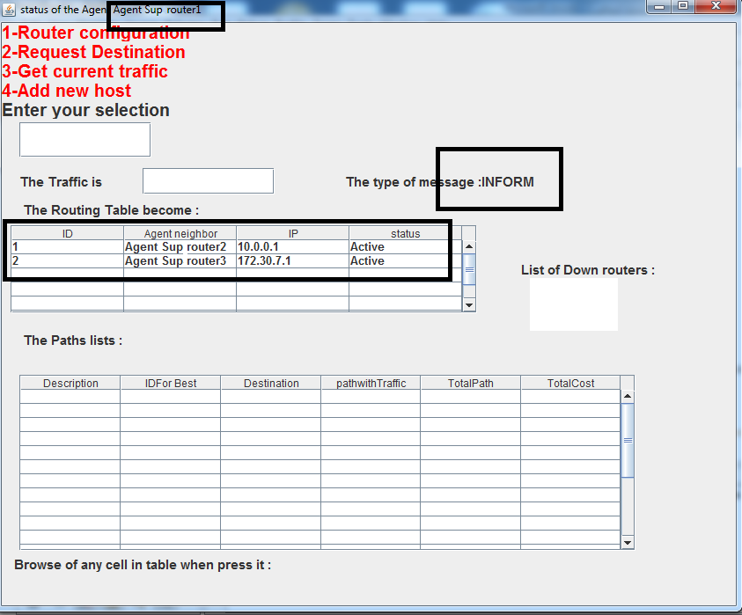
Figure(8) : The neighbors of Agent Sup-router1
For requesting and finding the best path from first router (source node 1) to the destination in six router (node 6) by exchange the REQUEST message to return the best path in AGREE message ,the result is shown in figure( 9) bellow .
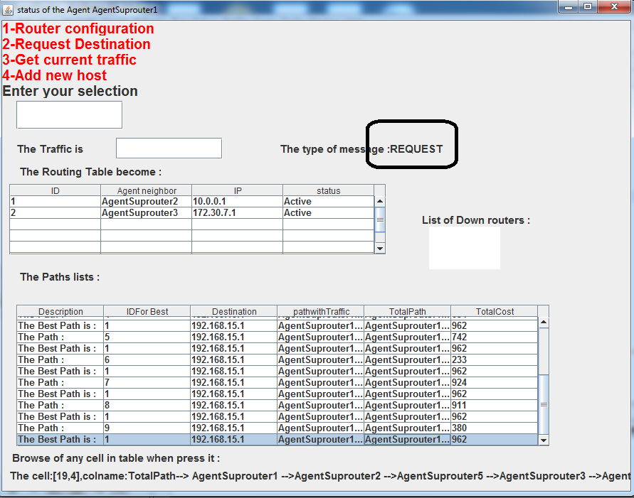 Figure(9) :The Results
To show the interactions by messages between the agents to find the best path from source to destination in The Figure(10 ) bellow. 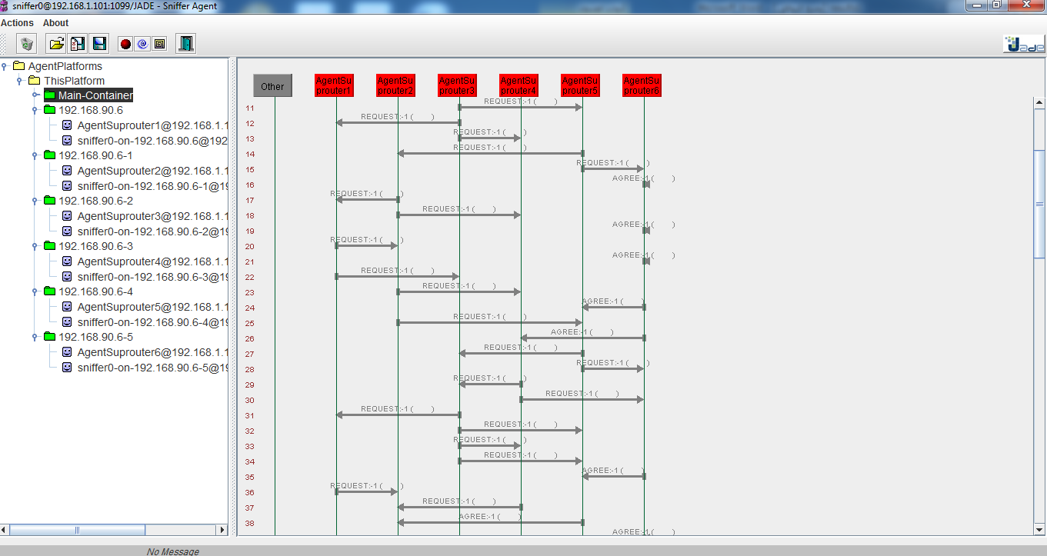 Figure(10) : An Interactions as viewed by the Sniffer agent from JADE
The Figure (11) bellow show the activated agent in the platform, as we can see there are six active agentSuprouter1, agentSup-router2, agentSup-router3,agentSup-router4,agentSup-router5 and agentSup-router6 and the agents running on each container .
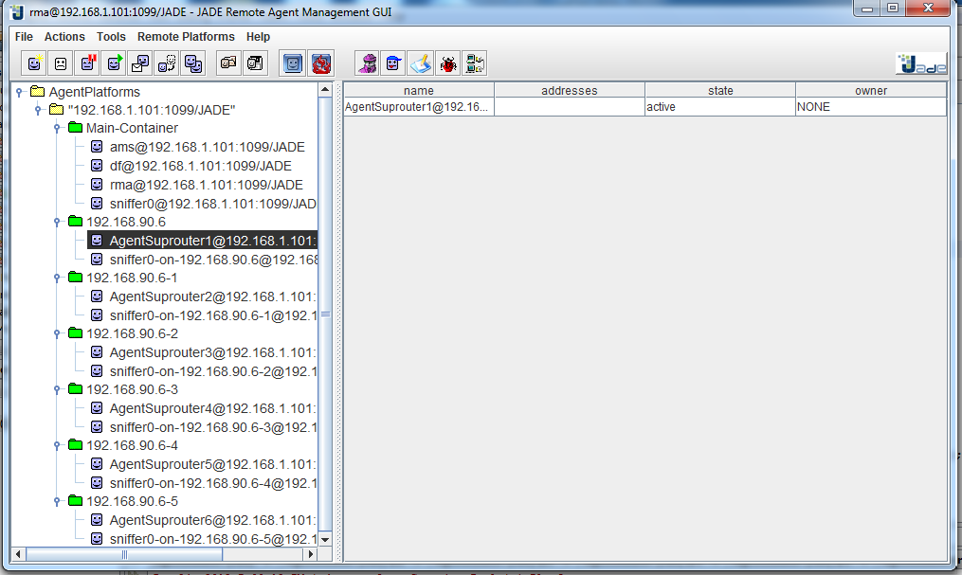 Figure(11) : view of agent platform

The paths list in figure(9) is shown in table (1)below ,the path 1 (in last record) is best path because it has available high bandwidth .

Table (1) The sample path results
Description |  | ID |  | Destination | Path with Traffic |  | Total Path |  |  | Total  Cost
 | 225 |  | AgentSuprouter1 ->AgentSuprouter2 ->AgentSuprouter4 ->AgentSuprouter6 --> |  |  | AgentSuprouter1@192.168.1.101:1099/JADE,154,AgentSuprouter2@192.168.1.101:1099/JADE,16,AgentSuprouter4@192.168.1.101:1099/JADE,12,AgentSuprouter6@192.168.1.101:1099/JADE,43 |  | 192.168.15.1 | 0 |  | The Path :
 | 962 |  | AgentSuprouter1 -->AgentSuprouter2 ->AgentSuprouter5 ->AgentSuprouter3 ->AgentSuprouter4 ->AgentSuprouter6 --> |  |  | AgentSuprouter1@192.168.1.101:1099/JADE,154,AgentSuprouter2@192.168.1.101:1099/JADE,101,AgentSuprouter5@192.168.1.101:1099/JADE,286,AgentSuprouter3@192.168.1.101:1099/JADE,5,AgentSuprouter4@192.168.1.101:1099/JADE,329,AgentSuprouter6@192.168.1.101:1099/JADE,87 |  | 192.168.15.1 | 1 |  | The Path :
 | 962 |  | AgentSuprouter1 -->AgentSuprouter2 ->AgentSuprouter5 ->AgentSuprouter3 ->AgentSuprouter4 ->AgentSuprouter6 --> |  |  | AgentSuprouter1@192.168.1.101:1099/JADE,154,AgentSuprouter2@192.168.1.101:1099/JADE,101,AgentSuprouter5@192.168.1.101:1099/JADE,286,AgentSuprouter3@192.168.1.101:1099/JADE,5,AgentSuprouter4@192.168.1.101:1099/JADE,329,AgentSuprouter6@192.168.1.101:1099/JADE,87 |  | 192.168.15.1 | 1 |  | The Best Path is :
 | 680 |  | AgentSuprouter1 -->AgentSuprouter3 ->AgentSuprouter5 ->AgentSuprouter2 ->AgentSuprouter4 ->AgentSuprouter6 --> |  |  | AgentSuprouter1@192.168.1.101:1099/JADE,154,AgentSuprouter3@192.168.1.101:1099/JADE,145,AgentSuprouter5@192.168.1.101:1099/JADE,66,AgentSuprouter2@192.168.1.101:1099/JADE,41,AgentSuprouter4@192.168.1.101:1099/JADE,253,AgentSuprouter6@192.168.1.101:1099/JADE,21 |  | 192.168.15.1 | 2 |  | The Path :
 | 962 |  | AgentSuprouter1 -->AgentSuprouter2 ->AgentSuprouter5 ->AgentSuprouter3 ->AgentSuprouter4 ->AgentSuprouter6 --> |  |  | AgentSuprouter1@192.168.1.101:1099/JADE,154,AgentSuprouter2@192.168.1.101:1099/JADE,101,AgentSuprouter5@192.168.1.101:1099/JADE,286,AgentSuprouter3@192.168.1.101:1099/JADE,5,AgentSuprouter1@192.168.1.101:1099/JADE,212,AgentSuprouter2@192.168.1.101:1099/JADE,49,AgentSuprouter5@192.168.1.101:1099/JADE,67,AgentSuprouter6@192.168.1.101:1099/JADE,37 |  | 192.168.15.1 | 1 |  | The Best Path is :
 | 256 |  | AgentSuprouter1 -->AgentSuprouter2 ->AgentSuprouter4 ->AgentSuprouter3 ->AgentSuprouter5 ->AgentSuprouter6 --> |  |  | AgentSuprouter1@192.168.1.101:1099/JADE,154,AgentSuprouter2@192.168.1.101:1099/JADE,16,AgentSuprouter4@192.168.1.101:1099/JADE,12,AgentSuprouter3@192.168.1.101:1099/JADE,9,AgentSuprouter5@192.168.1.101:1099/JADE,17,AgentSuprouter6@192.168.1.101:1099/JADE,48 |  | 192.168.15.1 | 3 |  | The Path :
 | 962 |  | AgentSuprouter1 -->AgentSuprouter2 ->AgentSuprouter5 ->AgentSuprouter3 ->AgentSuprouter4 ->AgentSuprouter6 --> |  |  | AgentSuprouter1@192.168.1.101:1099/JADE,154,AgentSuprouter2@192.168.1.101:1099/JADE,101,AgentSuprouter5@192.168.1.101:1099/JADE,286,AgentSuprouter3@192.168.1.101:1099/JADE,5,AgentSuprouter1@192.168.1.101:1099/JADE,212,AgentSuprouter2@192.168.1.101:1099/JADE,49,AgentSuprouter5@192.168.1.101:1099/JADE,67,AgentSuprouter6@192.168.1.101:1099/JADE,37 |  | 192.168.15.1 | 1 |  | The Best Path is :
 | 634 |  | AgentSuprouter1 -->AgentSuprouter3 ->AgentSuprouter5 ->AgentSuprouter2 ->AgentSuprouter1 ->AgentSuprouter3 ->AgentSuprouter5 ->AgentSuprouter6 --> |  |  | AgentSuprouter1@192.168.1.101:1099/JADE,154,AgentSuprouter3@192.168.1.101:1099/JADE,145,AgentSuprouter5@192.168.1.101:1099/JADE,66,AgentSuprouter2@192.168.1.101:1099/JADE,41,AgentSuprouter1@192.168.1.101:1099/JADE,19,AgentSuprouter3@192.168.1.101:1099/JADE,146,AgentSuprouter5@192.168.1.101:1099/JADE,15,AgentSuprouter6@192.168.1.101:1099/JADE,48 |  | 192.168.15.1 | 4 |  | The Path :
 | 962 |  | AgentSuprouter1 -->AgentSuprouter2 ->AgentSuprouter5 ->AgentSuprouter3 ->AgentSuprouter4 ->AgentSuprouter6 --> |  |  | AgentSuprouter1@192.168.1.101:1099/JADE,154,AgentSuprouter2@192.168.1.101:1099/JADE,101,AgentSuprouter5@192.168.1.101:1099/JADE,286,AgentSuprouter3@192.168.1.101:1099/JADE,5,AgentSuprouter1@192.168.1.101:1099/JADE,212,AgentSuprouter2@192.168.1.101:1099/JADE,49,AgentSuprouter5@192.168.1.101:1099/JADE,67,AgentSuprouter6@192.168.1.101:1099/JADE,37 |  | 192.168.15.1 | 1 |  | The Best Path is :
 | 742 |  | AgentSuprouter1 -->AgentSuprouter3 ->AgentSuprouter5 ->AgentSuprouter2 ->AgentSuprouter1 ->AgentSuprouter3 ->AgentSuprouter4 ->AgentSuprouter6 --> |  |  | AgentSuprouter1@192.168.1.101:1099/JADE,154,AgentSuprouter3@192.168.1.101:1099/JADE,145,AgentSuprouter5@192.168.1.101:1099/JADE,66,AgentSuprouter2@192.168.1.101:1099/JADE,41,AgentSuprouter1@192.168.1.101:1099/JADE,19,AgentSuprouter3@192.168.1.101:1099/JADE,146,AgentSuprouter4@192.168.1.101:1099/JADE,153,AgentSuprouter6@192.168.1.101:1099/JADE,18 |  | 192.168.15.1 | 5 |  | The Path :
 | 962 |  | AgentSuprouter1 -->AgentSuprouter2 ->AgentSuprouter5 ->AgentSuprouter3 ->AgentSuprouter4 ->AgentSuprouter6 --> |  |  | AgentSuprouter1@192.168.1.101:1099/JADE,154,AgentSuprouter2@192.168.1.101:1099/JADE,101,AgentSuprouter5@192.168.1.101:1099/JADE,286,AgentSuprouter3@192.168.1.101:1099/JADE,5,AgentSuprouter1@192.168.1.101:1099/JADE,212,AgentSuprouter2@192.168.1.101:1099/JADE,49,AgentSuprouter5@192.168.1.101:1099/JADE,67,AgentSuprouter6@192.168.1.101:1099/JADE,37 |  | 192.168.15.1 | 1 |  | The Best Path is :
 | 233 |  | AgentSuprouter1 -->AgentSuprouter3 ->AgentSuprouter5 ->AgentSuprouter6 --> |  |  | AgentSuprouter1@192.168.1.101:1099/JADE,23,AgentSuprouter3@192.168.1.101:1099/JADE,7,AgentSuprouter5@192.168.1.101:1099/JADE,50,AgentSuprouter6@192.168.1.101:1099/JADE,153 |  | 192.168.15.1 | 6 |  | The Path :
 | 924 |  | AgentSuprouter1 -->AgentSuprouter3 ->AgentSuprouter5 ->AgentSuprouter2 ->AgentSuprouter4 ->AgentSuprouter3 ->AgentSuprouter5 ->AgentSuprouter6 --> |  |  | AgentSuprouter1@192.168.1.101:1099/JADE,154,AgentSuprouter3@192.168.1.101:1099/JADE,145,AgentSuprouter5@192.168.1.101:1099/JADE,66,AgentSuprouter2@192.168.1.101:1099/JADE,41,AgentSuprouter4@192.168.1.101:1099/JADE,66,AgentSuprouter3@192.168.1.101:1099/JADE,5,AgentSuprouter5@192.168.1.101:1099/JADE,145,AgentSuprouter6@192.168.1.101:1099/JADE,302 |  | 192.168.15.1 | 7 |  | The Path :
 | 962 |  | AgentSuprouter1 -->AgentSuprouter2 ->AgentSuprouter5 ->AgentSuprouter3 ->AgentSuprouter4 ->AgentSuprouter6 --> |  |  | AgentSuprouter1@192.168.1.101:1099/JADE,154,AgentSuprouter2@192.168.1.101:1099/JADE,101,AgentSuprouter5@192.168.1.101:1099/JADE,286,AgentSuprouter3@192.168.1.101:1099/JADE,5,AgentSuprouter1@192.168.1.101:1099/JADE,212,AgentSuprouter2@192.168.1.101:1099/JADE,49,AgentSuprouter5@192.168.1.101:1099/JADE,67,AgentSuprouter6@192.168.1.101:1099/JADE,37 |  | 192.168.15.1 | 1 |  | The Best Path is :
 | 911 |  | AgentSuprouter1 -->AgentSuprouter2 ->AgentSuprouter5 ->AgentSuprouter3 ->AgentSuprouter1 ->AgentSuprouter2 ->AgentSuprouter5 ->AgentSuprouter6 --> |  |  | AgentSuprouter1@192.168.1.101:1099/JADE,154,AgentSuprouter2@192.168.1.101:1099/JADE,101,AgentSuprouter5@192.168.1.101:1099/JADE,286,AgentSuprouter3@192.168.1.101:1099/JADE,5,AgentSuprouter1@192.168.1.101:1099/JADE,212,AgentSuprouter2@192.168.1.101:1099/JADE,49,AgentSuprouter5@192.168.1.101:1099/JADE,67,AgentSuprouter6@192.168.1.101:1099/JADE,37 |  | 192.168.15.1 | 8 |  | The Path :
 | 380 |  | AgentSuprouter1 -->AgentSuprouter3 ->AgentSuprouter4 ->AgentSuprouter6 --> |  |  | AgentSuprouter1@192.168.1.101:1099/JADE,23,AgentSuprouter3@192.168.1.101:1099/JADE,7,AgentSuprouter4@192.168.1.101:1099/JADE,334,AgentSuprouter6@192.168.1.101:1099/JADE,16 |  | 192.168.15.1 | 9 |  | The Path :
 | 962 |  | AgentSuprouter1 >AgentSuprouter2 >AgentSuprouter5>AgentSuprouter3 >AgentSuprouter4 >AgentSuprouter6 --> |  |  | AgentSuprouter1@192.168.1.101:1099/JADE,154,AgentSuprouter2@192.168.1.101:1099/JADE,101,AgentSuprouter5@192.168.1.101:1099/JADE,286,AgentSuprouter3@192.168.1.101:1099/JADE,5,AgentSuprouter1@192.168.1.101:1099/JADE,212,AgentSuprouter2@192.168.1.101:1099/JADE,49,AgentSuprouter5@192.168.1.101:1099/JADE,67,AgentSuprouter6@192.168.1.101:1099/JADE,37 |  | 192.168.15.1 | 1 |  | The Best Path is:

V. Conclusions
- Due to the massive increase in network connection over the internet now days, the status of network segment is rapidly changed which presents a serious challenge for traditional routing protocols, which relies on the information gathered by querying the network devices before start delivering data. The information gathered will be used along delivering session especially in streaming data over the network where connection has to be valid over the entire session. This approach inhibits the performance of the network due to loss connections and compulsory demand on re-connect.
- Intelligent software Agent technology provides a cooperative environment to find best path in computer network, where network device can publish its segment capabilities to the neighbors. The capabilities can be used as metrics to determine best path .
- Agent-based provides an environment where the network can be self-organized and self-administering network due to social behaviors possessed by the Agent. The metrics used by agents to manage their behaviors include dynamic network topologies, bandwidth-constrains, variable capacity links.
- Deploying agent within routing domain needs efficient ontology designed for this task to accommodate emerged network terminologies and infrastructures. Network events, protocols, identification scheme should involved within the routing ontology.

References
[Cisc89] Cisco Systems Inc., "IP Routing Fundamentals" , Copyright 1989-1999.
[Swap05] Swapnil Shukla ," An Adaptive Probabilistic Routing Algorithm " , master thesis, Department of electrical engineering, Indian institute of the technology ,Kanpur,2005.
[Benj00] Benjamín Barán and Rubén Sosa," A new approach for AntNet Routing , IEEE,Ninth International Conference,2000
[Mich97] Michael Wooldridge ,"Agent-Based Software Engineering" ,Mitsubishi Electric Digital Library Group , London, September 19, 1997 .
[J.aro08] J. Arokia Renjit,L. Geoferla and Chandrasekhar Reddy , " Multi-agent Based Intelligent Routing System " ,Medwell Journals, India , 2008.
[Fabi99] Fabio Bellifemine , Agostino Poggi and Giovanni Rimassa , "JADE -A FIPA-compliant agent framework " ,1999.
[Fabi07] Fabio Bellifemine , Giovanni Caire , Agostino Poggi and Giovanni Rimassa ," JADE: A software framework for developing multi-agent applications . Lessons learned" , Italy,2007 .
[Fabi01] Fabio Bellifemine , Agostino Poggi , and Giovanni Rimassa , "Developing Multi-agent Systems with JADE" , © Springer-Verlag Berlin Heidelberg , 2001 .
[Nena10] Nenad S. Kojić , Marija B. Zajeganović Ivančić , Irini S. Reljin and Branimir D. Reljin ," New algorithm for packet routing in mobile ad-hoc networks" , journal of automatic control ,university of Belgrade , 2010 .
[João01] João Neto , and Helder Coelho," A Distributed Search (Best-Path) Algorithm based on Local Communication", Departamento de- Informática, Faculdade de Ciências da Universidade de Lisboa , PORTUGAL,2001.
[Stua95] Stuart J. Russell and Peter Norvig ," Artificial Intelligence A Modern Approach " , Second Edition, c Prentice-Hall ,Inc ,1995.
[Mich02] Michael Wooldridge, "An Introduction to Multi-agent Systems", John Wiley & Sons Ltd,2002 .

