Study the Diurnal Variation of the Thermospheric Parameters Due to the Effect of Solar Activity For Third Month of the Year

Hyder M. Abduljalil Rawaa M. obaid Abbas Ibrahem
Department of physics- College of Science – Babylon University

الخلاصة:ٍ
تم دراسة تغير معاملات الغلاف الجوي العلوي تحت تأثير النشاط الشمسي عند ارتفاع ألأقمار الصناعية الواطئة ذات المدار الواطئ 500 كم وذلك من خلال برنامج حاسوبي يعتمد على نموذج (DTM) Drag Temperature Model حيث تم حساب هذه المعامل لثلاثة أيام متفرقة ضمن الشهر الثالت من السنة من خلال تأثرها بمعامل الفيض الشمسي F_{10.7} والمعامل الجيومغناطيسي العالمي K_{p} والظروف شمسية مختلفة، وقد أظهرت النتائج بأن معاملات الغلاف الجوي العلوي المحسوبة تتغير تغيرا يوميا وتبعا لتغير معاملات النشاط الشمسي.
Abstract:
The upper atmospheric parameters variation have been studied under the effect of solar activity at altitude of low artificial satellites 500km. The atmospheric parameters have been determined for three days of the third month of the year from through their influence by the solar flux index F_{10.7} and geomagnetic activity index K_{p} for different solar conditions. This study base on Drag Temperature Model (DTM) model by computer program to study these variations. The results show that these parameters are changing due to the change in solar activity parameters.

Introduction
Much information about the upper atmosphere of the earth has been obtained in recent years from observation of earth satellites, a relatively high degree of uncertainty remains. It is known that the upper atmosphere is dynamic and is influenced primarily by radiation from the sun. the influence of this radiation increases with altitude, and is relatively small at altitudes below 100 km (Bowman et al., 2008 and Berger, et al.,1998).
The sun has principal effects on the upper atmosphere. Radiation from the sun heats the atmosphere and causes it to expand, in addition it injects particles into it. The expansion of the atmosphere produces variation in density and this expansion is proportional to the degree of heating, which in turn depends upon the activity of the sun(Benjamin,2006 ).
Solar electromagnetic radiation at ultraviolet (UV) and extreme ultraviolet (EUV) wavelengths changes substantially with the level of solar activity. Thus, thermospheric density is strongly dependent on the level of solar activity. An average 11-year solar cycle variation exists, similarly, a 27- day variation in density exists, which is related to the average 27-day solar rotation period; Variations, however, tend to be slightly longer than 27 days early in the solar cycle when active regions occur more frequently at higher solar latitudes and slightly shorter than 27 days later in the solar cycle when the active regions occur more frequently closer to the Sun's equator. Coronal holes (CHs), and active longitudes also affect this average 27-day variation. Change in the thermospheric density related to change in level of solar (and geomagnetic) activity; e.g., flares, eruptions, coronal
mass ejections (CMEs) and coronal holes can begin almost instantaneously (minutes to hours),although more often a lag of a day or occurs. Interaction of solar wind with the earth's magnetosphere referred to as geomagnetic activity leads to a high-latitude heat and momentum source for the thermospheric gases. Some of this heat and momentum is converted to low latitudes (Owens,2002, and Tobiska et al. 2008).
Various surrogate radices are used to quantify levels of solar activity; one is the 10.7-cm solar radio flux, designated 10.7. Although EUV radiation heats the atmosphere, this radiation cannot be measured from the ground. The F_{10.7} can be measured from the ground and correlates well with the EUV radiation. The second is the geomagnetic activity parameter K_{p} duo to interaction of solar wind with the Earth's magnetosphere its Value of K_{p} may range from zero to 9(Carbary,2005).

Atmospheric Models:
As early as 1959, scientists began noticing a link between heightened solar activity and the increment in drag on satellites. Several scientists attribute this to the increment in atmospheric density at high altitudes (Jacchia, 1959, Sehnal, 1990,Picone,et al., 2002 and Volkov,2004). Since that time, physicists, engineers, and other scientists have worked diligently in an attempt to understand and model these interactions and to obtain reliable atmospheric models. While scientists have been attempting to understand the theory behind solar-terrestrial interactions for over 40 years, the ability to computationally model the direct effects on atmospheric density at a given altitude have been limited by advances in technology coupled with the availability of data from satellites. One of the more popular models that attempts to calculate atmospheric density given a set of solar conditions is the Mass Spectrometer, Incoherent Scatter Drag Temperature Model (DTM) model. This model was first created in 1977 mainly by Barliar.
The DTM model is based on fitting spherical surface harmonic expansion to mach the angular independence exhibited by mass Spectrometer and Incoherent Scatter measurements
This model was combined with satellite drag data to constructed new three dimentional thermospheric models.(Barlier,et al.1978) which is represented by the acronym DTM. Since satellite drag data lead to total density in the vicinity of the perigee, some assumptions must be introduced to obtain concentrations for each atmospheric constituent. The construction of DTM is based on the fact that molecular nitrogen, atomic oxygen and helium are successively the major atmospheric constituent above 120 km as a consequence of diffusion separation in the earth's gravitational field. Barlier et al, 1978 used an iterative procedure to represents the three major constituents N₂, O₂ and He in terms of spherical harmonics at 120 km altitude. Using a thermopause temperature model and an analytical temperature profile possible to compute concentrations of the major atmospheric constituents at a given altitude as a function of local solar time, latitude, day number in the year, solar dicimetric flux F10.7 and geomagnetic index Kp.
Study the diurnal variation of atmospheric parameters is essential to understood our atmosphere (Meena, et al.,2007). Results of studies on the behavior of satellites in the upper atmosphere reveal that the diurnal fluctuations in atmospheric parameters such as constituents of _{N2}, O₂ and He, density and temperature are of substantial magnitude and increase with increasing altitude, becoming the dominant feature of the atmospheric model above 300 km (Rhoden, 2000) .To enable the computation the diurnal variation under the effect two solar conditions based on the fundamental parameters which influence on the thermospheric parameters (solar flux index and geomagnetic index), the programming of this model is made by numerical integration of equations of model (DTM) by using subroutine in (Barliar et al.,1978).
Results:
A computer program to DTM model lead to analyze the solar activity and the geomagnetic effect on atmospheric parameters, The computation are made at altitude 500 km for three days of the third month of the year, the change in thermospheric parameters are studied when the sun at low high solar activity.
Figures (1-3) show the constituents of , N₂, and He at the height of 500 Kms, for low solar activity, where the solar flux of value F_{10.7}= 80 and eomagnetic index of value K_{p}=1, these calculated for different days of the third month of the year are changing during the hours of day and become much more in value around 2 p.m local time, the values of these constituents increase with the increment the day of the year. Figures (4) and figure (5) show the diurnal change in thermospheric density and temperature calculated at same conditions of solar activity. It observed from these figure, these parameters are changing during the hours of day and become much more in value around 2 p.m local time and increase with the increment the day of the year.
Figures (6-8) show the constituents of , N₂,O₂ and He plotted against local time for three days of the third month of the year for high solar activity where the solar index of value F_{10.7}=150 and the geomagnetic index of value Kp= 9 at the height of 500 Kms, .It can be estimated from these figures, these concentration molecular calculated by such model are changing during the hours of day and become much more in value around 2 p.m local time and the values of these constituents increase with the increment the solar activity conditions ,the same behavior for density and temperature is noted in figure(9) and figure (10) at high solar activity.

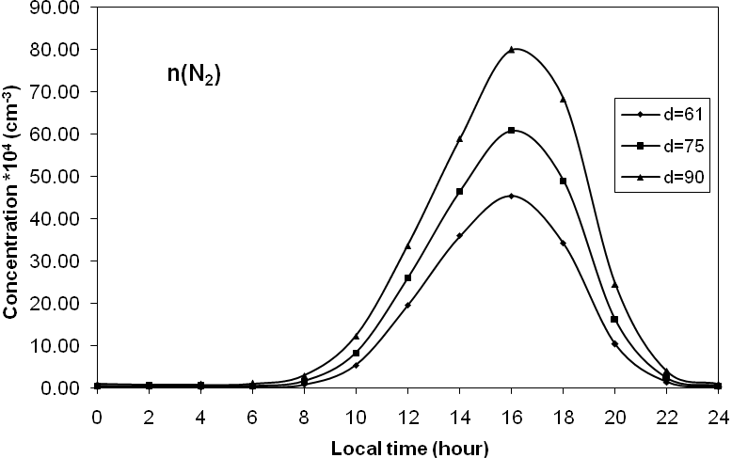

Fig (1): Diurnal variation of constituent of N₂ at 500 km at low solar activity

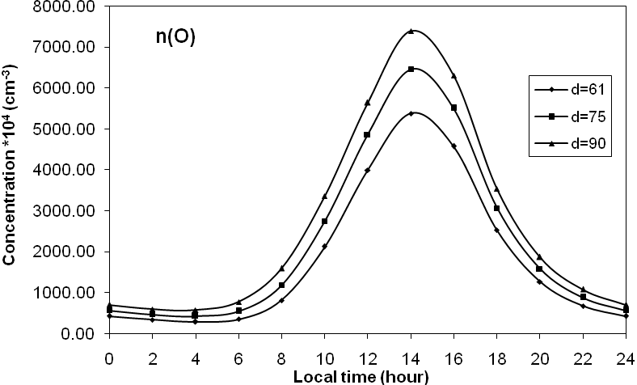
n(O₂)

Fig (2): Diurnal variation of constituent of O₂ at 500 km at low solar activity

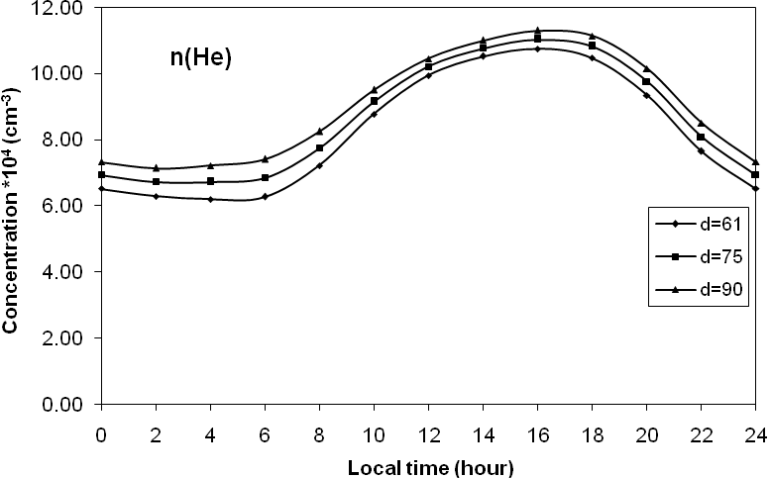

Fig (3): Diurnal variation constituent of He at 500 km at low solar activity

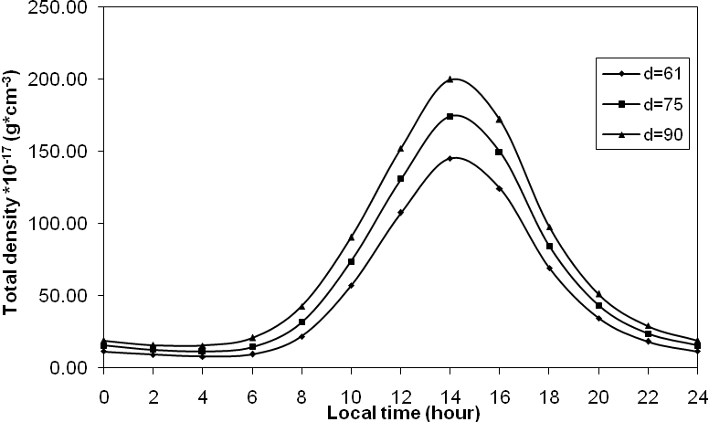

Fig (4): Diurnal variation of total density at 500 km at low solar activity

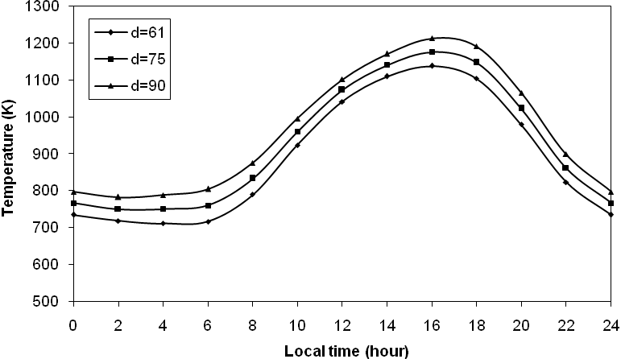

Fig (5): Diurnal variation of temperature at 500 km at low solar activity

Fig (6): Diurnal variation of constituent of N₂ at 500 km at high solar activity

n(O₂)

Fig (7): Diurnal variation of constituent of O₂ at 500 km at high solar activity

Fig (8): Diurnal variation of constituent of He at 500 km at high solar activity

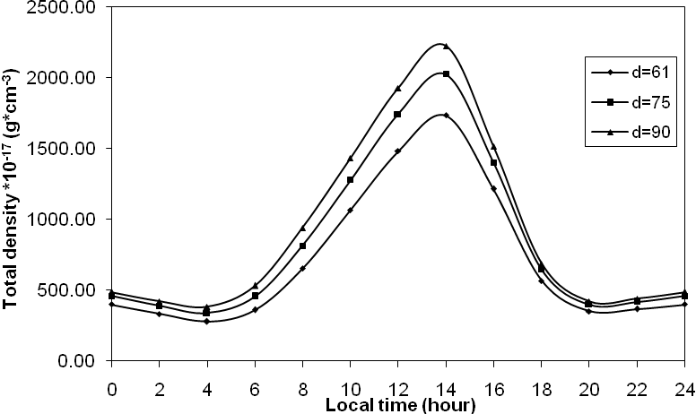

Fig (9): Diurnal variation of total density at 500 km at high solar activity

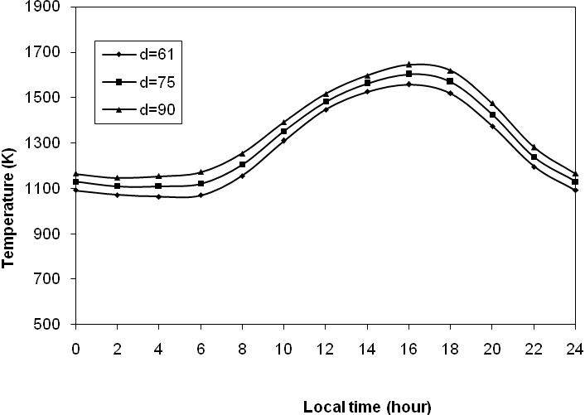

Fig (10): Diurnal variation of temperature at 500 km at high solar activity

Discussion and Conclusion

This section discus the results programming this model as follow:
1- the constituents of , N₂,O₂ and He at low and high solar activity maximize around 2 p.m.
local solar time for orbital altitudes because of the rotation of the Earth induces a diurnal
(24-hr period) variation in thermospheric temperature and density due to a lag in response
of the thermosphere to the EUV heat source
2- The minimum density and other parameters of an upper atmosphere occurs between 3 and
4 a.m local solar time .
3- The density of the atmosphere and other parameters at altitude 500 km is affected by three
basic variables: the molecular composition of the atmosphere, the incident solar flux and the geomagnetic interactions, when solar activity increases (the incident solar flux and geomagnetic interactions increase),the atmospheric parameters increase. The increment in these parameters cause the upper atmosphere to heat up and causes increasing in density and other parameters in the upper atmosphere.

Reference

Barlier, F., Berger, C., Falin, J.L., Kockarts, G., and Thuillier, G.(1978), A thermospheric model based on satellite drag data, Geophysics. 34, 9–24.
Benjamin Noll, B. A.,9(2006), Atmospheric Density Fluctuations Due to Solar Modulation & Orbital Debris Molding, M. SC. Thesis, taxes Teach University.
Berger, C., Biancale, R., Ill, M., and Barlier, F.,( 1998). Improvement of the empirical thermospheric model DTM: DTM94 – a comparative review of various temporal variations and prospects in space geodesy applications. J.Geodesy 72, 161–178.
Bowman B. R., Tobiski W. K., Marcos F. A. and Valladares C., (2008) The JB2006 Empirical Thermosphere Density Model, Journal Of Atmospheric And Solar Trrestrial Physics, Vol.70, 774-793.
Carbary, J, F, (2005), A Kp – based model of auroral boundaries, Space Weather, 3, 1-10.
Jacchia, L. G.,( 1959), Two Atmospheric Effects in the Orbital Acceleration of Artificial Satellites. Nature 183, 526–527.
Meena G. S., Jaadhav, D. B.,(2007). Study the Diurnal and seasonal Variation of nsity Model atmospheric No₂, O₂, H₂o and O₄ at PUne and India, Atmosphere, 20(3), 271-287.
Owens J. K.,(2002),NASA Marshall Engineering Model – Version 2.0 Thermospherie Marshall Space Flight Center, Alabame, NASA 2002 – 211786.
Picone, J. M., Hedin, A. E., Drob, D.P., Aikin, A.C., (2002). NRLMSISE-00 empirical model of the atmosphere: Statistical comparisons and scientific issues. J. Geophys. Res. 107(A12), 1468.
Rhoden, E.A., et al,( 2000). The influence of geomagnetic and solar variabilities on lower thermosphere density. Journal of Atmospheric and Solar-Terrestrial Physics 62, 999-1013.
Sehnal, L., (1990). Comparison of the thermosphere total density model TD88 with CIRA 86, Adv. Space Res. 10(6), 27–31.
Tobiski W. K., Bower S. D. and Bowman B. R.(2008), The Development Of New Solar Indices for Use In Themospheric Density Modeling, Journal Of Atmospheric And Solar Trrestrial Physics, Vol 70, 803-819.
Volkov I. I., (2004), Earth's Upper Atmosphre Density Model for Ballistic Support of the Flight of Artificial Earth satellites, GOST R25645, 166-2004, The Official Edition,National Standard of the Russian Federation, State Committee on Standardization and Metrology of Russian Federation Moscow, State , Russia ( in Russian).

