Prototype software Agent for solving a traffic light problem
Abbas M. Al-Bakry
College of information technology/ Babylon University
Zena Hassan Al – Hadad
Computer department / science college/ Babylon University

Abstract
The traffic in urban roads regularized by traffic lights, that distribute fixed time for intersection sides, which may be crossing time of vehicles for some sides and long waiting time for others in the intersection. In this work we proposed Agent subsystem which is local responsible for controlling the time periods to be distributed over time to each intersection according to the vehicles queue length and give the priority for the side that have the longer queue length of vehicles. The perception for this agent are sensors that evaluate the queue length at each intersection side of the traffic light location, and the effecter will be the distributed time for the intersection sides.
خلاصة :
السير في الشوارع المحلية ينظم باستخدام إشارات المرور و التي توزع أوقات ثابتة لشوارع التقاطع و التي ممكن أن تكون أوقات لعبور السيارات أو أوقات انتظار لسيارات أخرى في التقاطع . قدمنا في هذا العمل نظام وكيل ذكي الذي يكون مسؤول محليا عن السيطرة على فترات زمنية لتوزع لكل تقاطع اعتمادا على طول طابور المركبات و إعطاء الأولوية للشارع ذو طابور المركبات الأطول . المدخلان لهذا الوكيل الذكي هي متحسسات التي تقدر طول طابور في كل شارع ضمن منطقة التقاطع و المخرجات تكون الوقت الموزع على شوارع التقاطع.
Problem Statement
The current system of traffic light have been provides a fixed traffic control plan, which settings are based on prior traffic counts but may be manually changed. It is the most common form of signal control for nowadays and result in inappropriate behavior in traffic which differs from that which the plan was based, such as the use of unnecessary phases when the traffic is light.
Introduction
A traffic-light intersection is an intersection equipped with a traffic control system (TCS). The red, orange and green lights control access to the intersection for different movements in turn. This way, potential conflicts are separated in time rather than in space. Intersections are equipped with a traffic control system when they need to handle large flows of motorized traffic on the busiest urban roads, often with multiple lanes. The primary purpose of traffic signals is to separate conflicting traffic by the division of time, within the available road space, in a safe, efficient and equitable manner. Nowadays, with the growing number of vehicles, the congestion of the traffic and the delay of transportation in urban roads are increasingly worldwide. So, it is important to develop a system that help balancing the road traffic and make the motorists on highways and urban cities roads more comfort. The popular configuration is allocating right of way to the roads as distinct time intervals but this is not efficient way, so in our proposed agent we will describe the way that could solve this problem.

Basic concept
Signal sequences
Traffic signals alternately assign the right of way to different traffic movements at an intersection. Vehicular traffic is permitted to flow in a strictly controlled manner. The signal sequence at intersections is red, green, yellow, and red. The standard period during which a yellow signal is displayed is fixed at three seconds. Two basic kinds of controllers are used: Pre-timed and Traffic actuated

- Pre-timed Controllers : represent traffic control in its most basic form. They operate on a predetermined, regularly repeated sequence of signal indications. Pre-timed controllers are best suited for intersections where traffic volumes are predictable, stable, and fairly constant. They may also be preferable where pedestrian volumes are large and fairly constant. The timing of pre-timed signals is typically determined from visual observations and traffic counts. Once the timing programs are set, they remain fixed until they are changed manually. they are useful where progression is desired.( Progression refers to the nonstop movement of vehicles along a signalized street system.)

- Traffic-Actuated Controllers : their signal indications are not of fixed length, but rather change in response to variations in the level and speed of traffic. Traffic-actuated controllers are typically used where traffic volumes fluctuate irregularly or where it is desirable to minimize interruptions to traffic flow on the street carrying the greater volume of traffic. A simple traffic-actuated signal installation consists of four basic components: detectors, the controller unit, signal heads (the traffic lights), and connecting cables. The detectors are usually placed in the pavement, but they are sometimes positioned on signal poles. Commonly used types include the inductive loop detector, magnetic detector, magnetometer, and microwave detector. There are three basic types of traffic actuated controllers: Semi-actuated controllers, fully actuated controllers, and volume-density controllers. Another type of actuated control uses a computer to control, operate, and supervise a traffic control signal system. Computer-controlled systems basically consist of a central computer, communication media (cable, telephone, radio, etc.), and field equipment (local controllers, detectors, etc.)

Traffic signal control systems and structures
Concerning the level of aggregation, systems can be utilized to control: an individual intersection, an arterial, and a grid or network. According to the control strategy, two strategies can be distinguished: fixed time and traffic-responsive signal control. Thus, four variants can be described: fixed-time control, traffic-responsive signal plan selection, traffic-responsive signal plan modification, and traffic-responsive signal plan generation.
As for control structures, the principal ones are:
– First generation (non-computerized systems): the control functions are performed either by especially designed hard-wired logic in the form of an electromechanical device or by electronic logic;
– Second generation (centralized computer control): the individual control tasks can be carried out by a single computer if the number of intersections is relatively small. If several hundreds or thousands of intersections have to be coupled to the control center, then the installation of a computer hierarchy system may be necessary;
– Third generation (distributed computer control): microprocessors allows the individual intersections to be provided with their own processing unit. Measurements from detector can be locally evaluated and need no longer to be transmitted to the control center. Two versions of distributed traffic light control systems may be distinguished:

1. hierarchically structured distributed control systems: in large networks, it is necessary to have sub-control centers.
2. totally distributed traffic control systems: no control center exists; each local processor solves the control tasks occurring at its own intersection [ANA, 2005].

Traffic Control Methods
Influencing and steering a transportation network can be done through several technical means:
• Traffic signals and dynamic signposts: Adaptive control of the green- and red-phases of traffic lights may significantly reduce waiting times at intersections. This requires optimization of – sometimes high-dimensional and nonlinear – model-equations. The time for numerical solutions of such equations can be reduced using artificial intelligence techniques. Some cities (e.g. Dresden in Germany) route vehicle streams on some sections using dynamic signposts in order to achieve better load balancing. Like before, this also results in hard optimization problems, which can be alleviated by artificial intelligence techniques.
• Navigation recommendations: Some radio stations provide traffic information in their program to inform drivers of the current traffic situation, thus a driver can circumvent closed roads, delays by accidents or traffic jams thereby caused. The goal of these efforts is providing a decision support for a driver.
Broadly speaking, the most common artificial intelligence techniques are the following:
• Expert Systems: These can be classical rule-based systems, or employ more general forms of logic like fuzzy logic, resembling human reasoning more closely than crisp logic does.
• Self-Adapting algorithms: Neuronal Networks and Bayesian Networks have the capability of adapting themselves to a required behavior during a learning phase. This class of algorithms also includes Genetic Algorithms, resembling Darwin’s theory of improvement by selection of those individuals with best survival skills.
• Autonomously acting systems: Combining decision making techniques and self-adaptation principles gives powerful autonomously acting systems, known as agents. [Stefan Rass, 2006]

Related work

- [Cheonshik et. al ,2008],proposed an electro-sensitive traffic light using the smart agent algorithm to reduce traffic congestion and traffic accidents. They use the multi-agent system . The proposed method adaptively controls the cycle of traffic signals even though the traffic volume varies. And that reducing the car waiting time and start-up delay time using fuzzy control of feedback data[Cheonshik ,2008].

- [W . Wen , 2008], proposed a framework for a dynamic and automatic traffic light control expert system. The model adopts inter-arrival time and interdeparture time to simulate the arrival and leaving number of cars on roads. This model used a knowledge base system and rules. Depending on the traffic light data, which are collected by a radio frequency identification (RFID) reader, this model makes decisions that are needed to control the intersections[W . Wen , 2008].

- [Emad et. al. 2011], proposed monitoring system to be as an additional component to the intelligent traffic light system, this component able to determine three street cases (empty street case, normal street case and crowded street case) by using small associative memory. The work of the proposed monitoring system in two phases: training phase and recognition phase. The experiment was applied by using a program to monitor one intersection in Penang Island in Malaysia. The program can determine different weather conditions for all street cases depending on the stream of images, which are extracted from the streets video cameras. In addition, the observations show a high flexibility to learn all cases of the street using a few training images, thus the adaptation to any intersection can be done quickly[Emad. 2011]

- [Yujie et al.2011],In this paper, a neural network (NN) based signal controller is designed to control the traffic lights in an urban traffic road network. Scenarios of simulation are conducted under a microscopic traffic simulation software. Several criterions are collected. Results demonstrate that through online reinforcement training the controllers obtain better control effects than the widely used pre-time and actuated methods under various traffic conditions[Yujie, 2011].

- [Yanru, et al. 2011]. They present that based on analyzing the current situation of urban traffic signal control, Graph Theory and Fuzzy Control system for single intersection that consists of seven phase and three lanes are designed in this paper. This can be flexibly operation based on real-time traffic flow. First, they use Graph Theory to analyze the traffic flow of a variety of intersections, which is plain and simple. However, because of the lower availability for complex intersection, the other method Fuzzy Control is adopted in the paper. they can obtain the vehicle number of each lane through the sensor, and prescribe the maximum number of vehicles that phase traffic highest priority. It will turn to the highest priority phase when it transferred from the previous phase to the next. By fuzzy rules, namely fuzzy inference, which is adapted to the current queue length and traffic queue length, has the best green delay time. The simulation results show that the control of delay time in vehicles is improved by using fuzzy control method compared with the traditional control of time-fixed[Yanru, 2011]

Agent
An agent is anything that can be viewed as perceiving its environment through sensors, and acting upon that environment through actuators.
The term percept is refer to the agent's perceptual inputs at any given instant. An agent's percept sequence is the complete history of everything the agent has ever perceived. In general, an agent's choice of action at any given instant can depend on the entire percept sequence observed to date. If we can specify the agent's choice of action for every possible percept sequence, then we have said more or less everything there is to say about the agent. Mathematically speaking, we say that an agent's behavior is described by the agent function that maps any given percept sequence to an action. A software agent is a computational entity that is capable of autonomous behavior by virtue of a small number of simple rules that make each agent aware of the options available to it when faced with a decision-making task related to its domain of interest. Therefore, the two key features of agents are autonomy and communal interaction. Agent based system: system composed of simple locally interacting agents but which demonstrate complex group behavior offer several advantages over traditional multi agent systems. system composed of many interacting autonomous, artificial intelligent agents[Kristina Lerman,,2001].
In agent-based modeling (ABM), a system is modeled as a collection of autonomous decision-making entities called agents. Benefits of Agent-Based Modeling. The benefits of ABM over other modeling techniques can be captured in three statements: (i) ABM captures emergent phenomena; (ii) ABM provides a natural description of a system; and (iii) ABM is flexible. It is clear, however, that the ability of ABM to deal with emergent phenomena is what drives the other benefits [Eric Bonabeau, 2001].

The Proposed system

The structure of the proposed system with local Agent can consist of:

Agent perception: which are the length of queue in each road of the intersection and that can acquired from the environment by the signals which received from the sensors in the roads (one sensor at each 5 meters, along 50 meters).

Effectors: The traffic light signals which organize the crossing time for the vehicles in the intersection and the priority of distribution of the time.

Operation of the agent:
First the agent collect the data from its environment by the sensors, that data represent the lengths of four directions queues , and according to a specific cycle time (for example 2 minutes scaled to 1 minute in the program),then the agent according to that values could evaluate the appropriate time for each lane in the intersection.
And the priority of distributing the time for the lane that have the longer queue length.
In this system, the time distribution differ at each cycle according to the traffic flow at the snapshot before each cycle.
At first the system have no indication from the sensors, and this may be a case in some times, so the distribution of time will be equally and start sequentially. As shown in figure 1.
Another case where the flow have balanced load of vehicles flow and the case may be a heavy load in some times like the rush hours in morning or in 3 in evening, these cases presented in the figure 2 and 3.

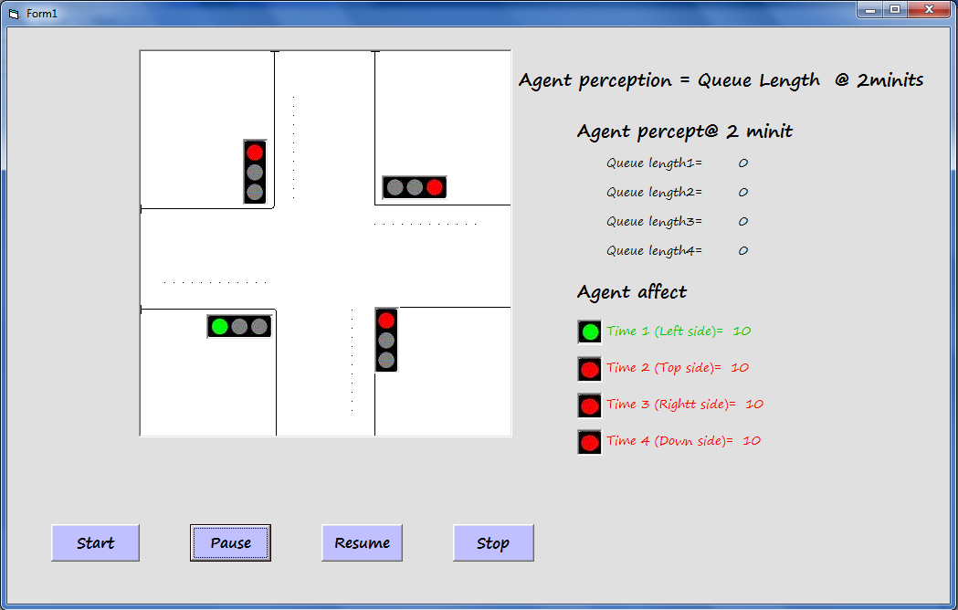

Figure 1(Snapshot of empty load intersection)

In this case the intersection have no vehicles, so the distribution of time equally and starting from left side, and switching until down side.

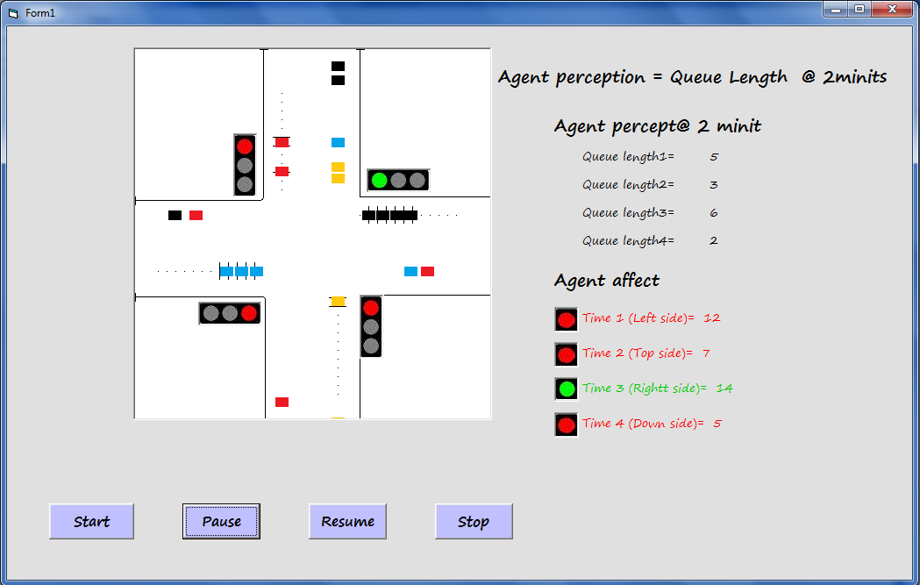

Figure 2(Snapshot of light load intersection)

In this case, the load of traffic is light but not equal, so the distributed time also not equal. At the that time the sensors have signaled the presented numbers, then our agent evaluate the time and distribute it as 12 second for left side , 7 second for top side , 14 second for right side , and 5 second for down side.
The priority of distribution as showed is for the right side which have the longer queue length, then after the interval elapsed the right of crossing is for the left side , then for top side and finally for down side.

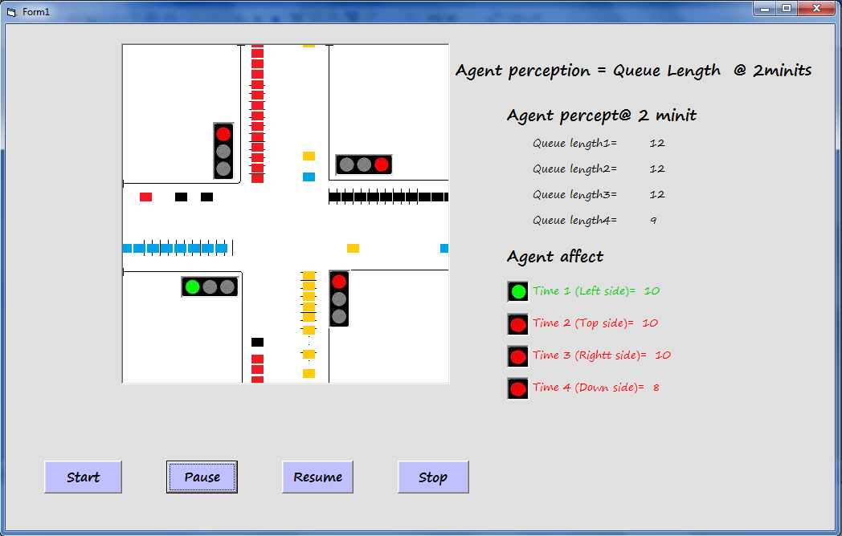

Figure 3(Snapshot of heavy load intersection)

This case has a heavy traffic load, where the first three sides have the same sensors indication and the last side (down side) has the lowest value. In this case the agent give equal time for the three sides that have equal queue length and the down side has the little value of seconds. The priority is first for the left, top, right, than for down side. The system can pause its work from the pause button and resume its work from the resume button.

Conclusion

We propose traffic light agent that receive signals from its sensors and depending on it, evaluate the fairly distribution of the time and give a sequence of distribution from the road that have the longer queue length to the road that have the shorter queue length.
We show in table 1 the results of executing the system with traditional traffic light configuration, when we assume the arrival rate 10 and we calculate the leaved vehicles rate and the average of waiting time for different number of cycles. And this result showed in figure 4.

Table 1: arrival rate= 10 and using traditional traffic light
No | No. of cycles | Leaved vehicles rate | Avg. W. T
1 | 10 | 75% | 42.69
2 | 30 | 86.36% | 46.5
3 | 40 | 88.7% | 54.16
4 | 100 | 96.7% | 53.6

In Table 2, we represent the leaved vehicles rate and average waiting time of the same cases used in the above table and with the same arrival rate, but using our local agent that show clear variation in the leaved vehicles rates in the system with local agent are much better than with traditional configuration of traffic light, and the average waiting time also. And this result showed in figure 5.

Table 2: arrival rate=10 and using local agent
No | No. of cycles | Leaved vehicles rate | Avg. W. T
1 | 10 | 78.12% | 37.36
2 | 30 | 91.47% | 45.56
3 | 40 | 92.44% | 41.47
4 | 100 | 99.30% | 38

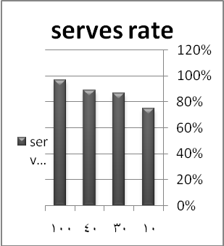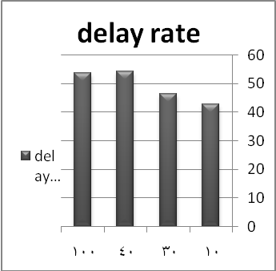
Figure 4: the results when the AR=10 in normal case

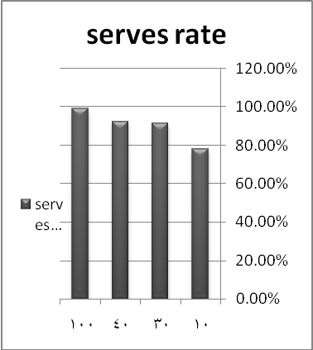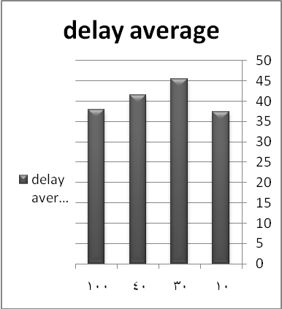

Figure 5: the results when the AR=10 using Agent Subsystem

References

[ANA, 2005]: ANA L. C. BAZZAN , "A Distributed Approach for Coordination of Traffic Signal Agents" , 2005
[Cheonshik, 2008] : Cheonshik Kim, You-Sik Hong , "Traffic Signal Using Smart Agent System", 2008
[Emad et. al. 2011]: Emad I Abdul Kareem, and Aman Jantan , "An Intelligent Traffic Light Monitor System using an Adaptive Associative memory", 2011
[Eric Bonabeau, 2001]: Eric Bonabeau , "Agent-based modeling: Methods and techniques for simulating human systems" , 2001
[Kristina Lerman,,2001]: Kristina Lerman, "design and Mathematical Analysis of Agent-based Systems" ,2001.
[Stefan Rass, 2006]: Stefan Rass, Kyandoghere Kyamakya ," Artificial Intelligence Techniques in Traffic Control" , 2006
[W . Wen , 2008]: W. Wen ,"A dynamic and automatic traffic light control expert system for solving the road congestion problem", 2008
[Yanru, et al. 2011]: Yanru Cai, Ziyang Lv, Jixin Chen, Lurong Wu , "An intelligent control for crossroads traffic light" , 2011
[Yujie, 2011]: Yujie Dai, Jinzong Hu, Dongbin Zhao , "Neural network based online traffic signal controller design with reinforcement training", 2011.

