Preparation of Schottky devices
(Al-GaAs &Ni-GaAs) and study of some photoelectronic properties

Burak Yahya Kadem

Babylon University/College of Science/Physics Dept

Abstract
Four samples of metal (n-type) semiconductor contact had been prepared as a form of Schottky contact, Aluminum and Nickel metals and semiconductor substrate GaAs (donor) where used. The Ohmic contact has been firstly made with thickness (500 nm) using Aluminum for two samples and Nickel for other two, four samples were collected. These samples were annealed under the temperature of (450 K) and pressure (10⁻⁴Torr) for (30 min.) to avoid the interfacial layers. Then Schottky contact where made using Aluminum twice and Nickel twice with (120 nm) thickness and then we annealed the samples under temperature (450 K) and pressure (10⁻⁴Torr) , the samples are as follows:(Al/GaAs/Al Ohmic, Al/GaAs/Ni Ohmic, Ni/GaAs/Al Ohmic , Ni/GaAs/Ni Ohmic). The photocurrent as a function of wavelength was calculated and it was found that the maximum value for the sample (Al/GaAs/Al Ohmic) in the wavelength (800 nm), the dark current is (1.9 x 10⁻⁹Ampere). The detector coefficients of the samples where calculated, the maximum Response at the wavelength (800 nm) was (0.157 Ampere/ Watt) and maximum Specific Directivity at the same wavelength is ( 63.7 x10¹¹ Hz ^{½} Watt⁻¹), the maximum Noise Equivalent Power is (0.157 Watt Hz ^{-½} ) and the maximum Efficiency is (24.4 %) at the same wavelength, the photocurrent and Response values depended on the absorption coefficients of metals and work functions the samples operated within the area under the near- infrared .

Keywords: Thin films; Schottky devices; GaAs; optoelectronics properties.
الخلاصة
تم تحضير اربع نماذج شوتكي باتصال معدن شبه موصل (مانح) على شكل تماس شوتكي حيث تم باستخدام معدني الالمنيوم والنيكل وارضيه شبه موصل ارسنيد الكاليوم (مانح), تم اولاً اجراء الاتصال الاومي بسمك (500 nm) باستخدام معدن الالمنيوم لنموذجين ومعدن النيكل لنموذجين فكانت المحصله اربع نماذج وتمت عمليه التلدين لهذه النماذج تحت درجه حرارة (450 كلفن) وضغط (10⁻⁴تور) لمدة نصف ساعه لتفادي حالات السطح البينيه ومن ثم اجراء اتصال شوتكي باستخدام معدن الالمنيوم مرتين والنيكل مرتين وبسمك (120 nm) ومن ثم اجراء عمليه التلدين الحراري تحت درجه (450 كلفن) وضغط (10⁻⁴تور) فكانت النماذج كالاتي: ( المنيوم- ارسنيد الكاليوم وبتماس اومي المنيوم, المنيوم- ارسنيد الكاليوم وبتماس اومي نيكل, نيكل - ارسنيد الكاليوم وبتماس اومي المنيوم , نيكل - ارسنيد الكاليوم وبتماس اومي نيكل) ومن ثم تم حساب قيم التيار الضوئي كداله للطول الموجي حيث كانت اعلى قيمه للتيار الضوئي عند الطول الموجي (800 nm) وكانت قيمه تيار الظلام ( 1.9 x 10⁻⁹امبير) ومن ثم حساب معاملات الكاشف للنماذج الاربعه, حيث تم حساب اعلى قيمه للاستجابه عند الطول الموجي (800 nm) وكانت (0.157 Amp./ Watt) واعلى قيمه للكشفيه النوعيه كانت عند نفس الطول الموجي (63.7 X10¹¹ Hz^{1/2} Watt ⁻¹) في حين كانت اقل قدرة مكافئة للضوضاء هي (0.157 Watt Hz^{-1/2}) واعلى كفاءه كميه مسجله هي ( 24.4%) وسجلت قيم التيار الضوئي والاستجابه اعتمادا على معامل امتصاص المعدن وداله شغله وكانت النماذج تعمل ضمن منطقه تحت الحمراء القريبه.

Introduction:

Infrared detectors entering their third generation of development with greater demand on their performance and capabilities, no longer is the goal of just achieving infrared images but now it is required to have greater performance with better uniformity over larger area, lower cost, and multispectral detection (Binh-Minh Nguyen, Darin Hoffman, Edward Kwei-wei Huang, Simeon Bogdanov, Pierre-Yves Delaunay, Manijeh Razeghi, and Meimei Z. Tidrow, 2009). Photodetectors based on different absorption materials were used for a corresponding spectral range, for instance, in the visible wavelength region Si-based photodetectors are preferred, while in the ultraviolet (UV) wavelengths the III–V nitrides are the promising materials. It is also well known that the GaAs has superior performance for detection in the 600–900-nm wavelength range. (Meng - Chyi Wu, Yun - Hsun Huang and Chong-Long Ho, 2007). It was reported that on the characterization of ZnSe-based Schottky barrier photodetectors grown on semi-insulating GaAs by molecular-beam epitaxy, the spectral response of the devices shows short wavelength responsivities of 0.10 A/W and detectivities as high as 1.4x10¹² cm Hz^{1/2}W⁻¹ ( Monroy E., Vigue F., Calle F., Izpura J. I. ,Mun˜oz E. and Faurie J.P., 2000). Schottky photodiodes with indium–tin–oxide (ITO) were fabricated and tested, it was utilized for detection in the ultraviolet spectra (λ< 400 nm), near-IR spectra (λ ~ 850 nm) and IR spectra (λ ~1550 nm). The material properties of thin ITO films were characterized using resonant-cavity-enhanced (RCE) detector structures, improved efficiency performance was achieved (Necmi Biyikli and Ibrahim Kimukin, 2004). It was reported that the growth and characterization of type-II InAs/GaSb super lattice photodiodes grown on a GaAs substrate, the detector exhibited a differential resistance at zero bias and a quantum efficiency of 36.4% at 77 K, providing a specific detectivity of 6 x10¹¹cm.Hz^{½}.W⁻¹ (Binh-Minh Nguyen, Darin Hoffman, Edward Kwei-wei Huang, Simeon Bogdanov, Pierre-Yves Delaunay, Manijeh Razeghi and Meimei Z. Tidrow, 2009). On the other hand, it was reported that the growth and characterization of long wavelength infrared type-II InAs/GaSb super lattice photodiodes , the quantum efficiency attains the expected value of 20% at zero bias, resulting in a Johnson limited detectivity of 1.1x 10¹¹ Jones (Abdollahi Pour S., Nguyen B-M., Bogdanov S. ,Huang E. K. and M. Razeghi, 2009). I. H. Campbell, 2010) demonstrated that the organic photodiodes with a transparency of ~ 80% throughout the visible spectrum and with up to ~ 80% external quantum efficiency (EQE) in the near infrared under reverse bias.

Theoretical part:

In Figure (1) n-type semiconductor brought into contact with a metal, Due to the positive work function difference between the metal and semiconductor, electrons are able to lower their energy by moving from the semiconductor into the metal forming a depletion region. Schottky barrier of a specific height will form and makes it difficult to inject electrons into the semiconductor. In opposite direction the semiconductor surface potential is Φ_{S} at zero bias and it changes with the applied bias. Thus, the resistance of the Schottky contact depends on the direction of the current flow. Schottky contacts are difficult to describe mathematically as they involve complicated transport mechanisms like thermionic emission and quantum tunneling. However, in case they are not essential for the device performance, Schottky contacts are often treated in a strongly simplified way, the carrier concentrations at the contact depend on the current densities. (Boer K.W.1990)

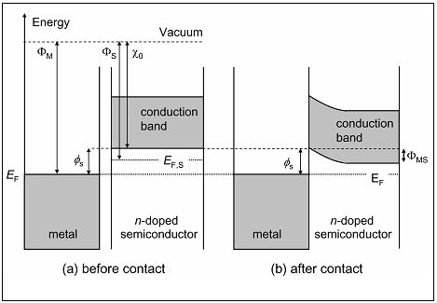

Figure (1) Metal-semiconductor (a) before contact (b) after contact

A photoconductor is a semiconductor device which exhibits a change in conductance (resistance) when photon energy is incident on it. Photon energy incident on the detector produces an electron-hole pair which lowers the detector resistance by producing more carriers; the change in the photoconductor resistance produces a change in the voltage. On the other hand, with photo emissive detectors, the photon energy must be greater than the band gap (E_{g}) at wavelengths less than (Ronald W. Waynant and Marwood N, 2000):

λ _{max} = hc / E_{g} …… (1)

λ _{max} is the critical wavelength, h is Plank constant (6.63 x 10⁻³⁴ J.s) , c is speed of light in vacuum (3 x 10¹⁰ cm/s). When the radiant energy is less than the band gap (E_{g}) (the band gap energy for the GaAs is 1.42)( Sze S.M. 1990), the thermionic emission is dominated because it is generated inside the metal only, this region is inside the (near infrared) wavelengths (Burak Y.K, 2001). The Spectral Response (R) is a function to the Photocurrent density and equal to: (Budde W, 1983)

R =J _{ph} / P_{N} …… (2)

J_{ph} is Photocurrent density (Ampere/cm²); P_{N} is power per unit area (Watt/cm²). The generation of electron–hole pairs requires the interaction with other particles that can be detected as electric signals ( Joachim piprek 2003) the signals is the photo current then we calculated the Noise Equivalent Power (NEP) as a function to the Spectral Response: (Jones R.C., 1954)

NEP = I_{n}/ R …… (3)

I_{n} is the noise current and{ I_{n}= (2q ID∆F) ½} I_{D} is Dark current (Burak Y.K, 2001). The Detectivity (D) is calculated by equation (4): (Budde W, 1983)

D = 1 / NEP …… (4)

The number of the electron-hole generated for each fallen photon is known as quantum efficiency (η) and given in the following equation: (Sze S.M., 1990, Budde W, 1983)

η = R h c / λ q …… (5)

(λ) is the wavelength in (nm), (q) is the Elementary charge (1.60218 x 10⁻¹⁹C) (Sze S.M., 1990). For charged particles, ionization may occur along the path of light by many low-recoil collisions with the electrons. Photons have first to undergo an interaction with a target electron or with the semiconductor nucleus. In any case part of the energy absorbed in the semiconductor will be converted into ionization (the creation of electron–hole pairs) the rest into phonons (lattice vibrations), which means finally into thermal energy. The part of energy converted into electron–hole pair creation is a property of the detector material. It is only weakly dependent on the type and energy of the radiation except at very low energies that are comparable with the band gap. (Gerhard Lutz 1999)

Experimental Result and discussion:
The samples have been prepared by using n-type GaAs as a semiconductor substrate with resistivity (2x10⁻⁶ Ohm.cm) and two types of metals Ni and Al as Schottky contact and Ohmic contact for different samples. Firstly, the GaAs substrates were cleaned by using NH₄OH:H₂O (1:2) for 2 min (Gerhard Lutz ,1999) and then by water for 5 min. Al were employed as Ohmic contact for two samples and Ni for other two with (500 nm) thickness. The samples were annealed under vacuum pressure (10⁻⁴ Torr) and (450 K) for 30 min to obtain a good Ohmic contact and small contact resistance (Chen C.P., 1994). After that the Schottky contact were fabricated with Ni for two samples and Al for other two with (120 nm) thickness then they were annealed under (450 K) temperature and (10⁻⁴ Torr) vacuum pressure for 30 min to avoid the interfacial layer effect on the Schottky barrier height (SBH) because it is presumed that oxygen play an important role in forming Schottky barrier and the Ohmic contacts (Otsubo M., 2004). The samples are: {Al/GaAs/Al Ohmic, Al/GaAs/Ni Ohmic), Ni/GaAs/Al Ohmic, Ni/GaAs/Ni Ohmic}. The Photocurrent was measured by using tungsten light with wavelengths range (400-1100 nm). Figure (2) shows the photocurrent as a function to the wavelength, it is noticeably that the sample (Al/GaAs/Al Ohmic) gives the best result of photocurrent while the other samples had less than this result especially the samples with (Ni) as Schottky contact, the absorption coefficient depends on the material and also on the wavelength of light which is being absorbed.

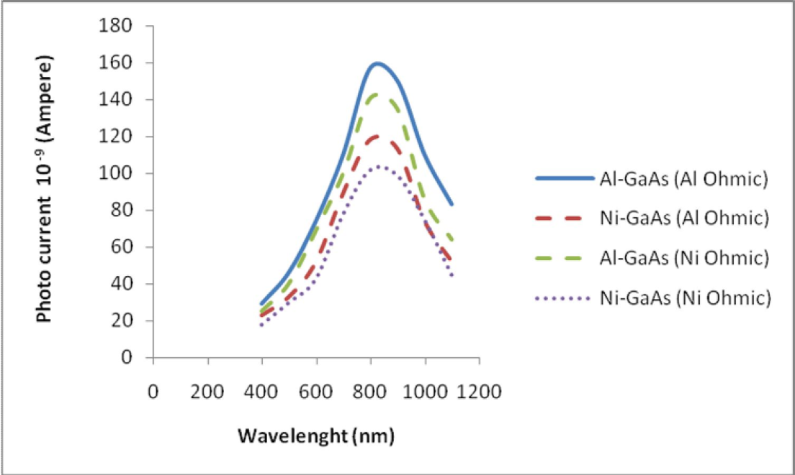
Figure (2) Photocurrent for the four samples as a function to the wavelength

Figure (2) could be divided into three regions as a function to the wavelength (Raheem G.K., 2007):

- Wavelengths less than (800 nm): The photocurrent increased with wavelength absorption of short wavelengths happened in the region near the surface due to possession of a large absorption coefficient, which means less depth absorption, this phenomenon is causes a gradual increase in the concentration of carriers generated by recombination at the surface area which makes the increase in the value of the response is a subject to the possibility of collected charge carriers
- Wavelengths between (800-900 nm): This region has the highest value of the photocurrent where it is assumed for the light absorption within the depletion region and this means high efficiency in the separation of electron–hole pairs generated by the electric field and the lack of recombination compare with 1st region.
- Wavelengths more than (900nm): Where there is a decrease in the value of the photo-current can be interpreted to the long wavelength which had less absorption because the photon energy does not have enough power to generate the electron –hole pairs then low ratio of generated carriers in the depletion region.

Figure (3) shows the photocurrent as a function of the photon energy, it could be divided into three regions: (Sze S.M., 1990):

- When Photon energy is less than the semiconductor band gap energy, it could be said that the absorption happened inside the semiconductor band gap because of the energy levels, this levels created from the semiconductor impurities, then the electron transition became extrinsic.

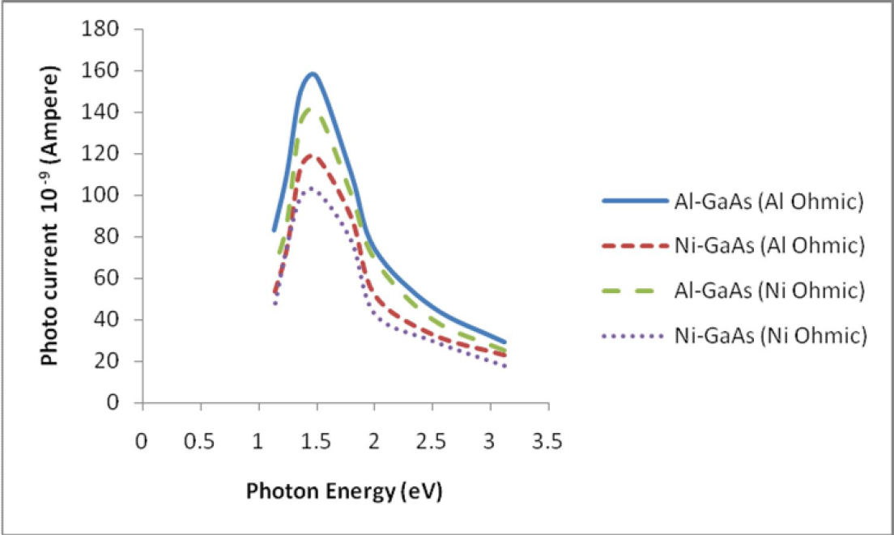
Figure (3) Photocurrent for the four samples as a function to the photon energy

- When the Photon energy is more than the semiconductor band gap energy, the different between the two energies and the transition became intrinsic. The absorption increases when the photon energy increases and then the absorption coefficients (α) increases as in equation (6) and the absorption happened at the surface of the semiconductor ( Martin A. green, 1989):

α = B*(hν –E_{g})…… (6) When B* is constant equal to (2 x 10⁴)
- When the Photon energy is equal to the semiconductor band gap energy then the absorption is the maximum in this energy (due to equation 1, the maximum wavelength we had is 875 nm) and this happened in wavelengths between (800-900 nm).

From figure (4) it could be said that the maximum response was (0.157 Ampere/Watt) for the sample (Al/GaAs/Al Ohmic) in the wavelength of (800 nm), the detectors were responded in the IR region. From figure (5), the specific detectivity versus the wavelength was depended on the wavelength and the samples preparation. The detectivity increased in the sample (Al/GaAs/Al Ohmic) to hit a peak with (63.7x10¹¹Hz ^{½} Watt⁻¹) at the wavelength (800 nm), this because it is a function of the response sensitivity as equations (3, 4) showed. The minimum NEP was (0.157x10⁻¹²(Watt Hz ^{-½}) for the same sample and wavelength. From figure(7) the quantum efficiency versus wavelength were showed the highest result (24.40 %) at (800 nm ) for the sample (Al/GaAs/Al Ohmic), this could be attributed to its relation with the response (the response is the number of the generated electron inside the detection for the incident light) thus it is a function to the response as equation (5).

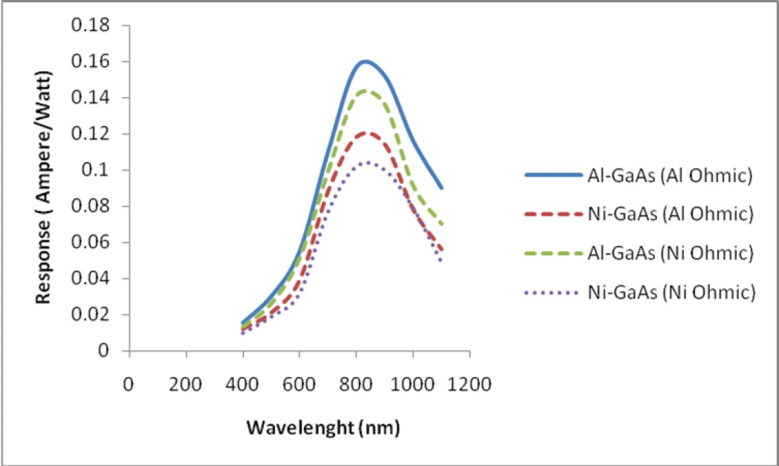
Figure (4) Response for the four samples as a function of the wavelength

The tables (1, 2) show the results we get for the four samples:

Table (1) shows the results of the currents per wavelengths (800 nm) for the four samples in this work

Samples | I_{ph} (Ampere) | I_{n}(Ampere) | I_{D} (Ampere)
Al-GaAs(Al Ohmic) | 157 x10⁻⁹ | 2.47 x10⁻¹⁴ | 1.9 x10⁻⁹
Ni-GaAs(Al Ohmic) | 118 x10⁻⁹ | 2.5 x10⁻¹⁴ | 2x10⁻⁹
Al-GaAs(Ni Ohmic) | 141 x10⁻⁹ | 2.5 x10⁻¹⁴ | 2x10⁻⁹
Ni-GaAs(Ni Ohmic) | 102 x10⁻⁹ | 2.5 x10⁻¹⁴ | 2x10⁻⁹

Table (2) shows the Detector Parameter per wavelengths (800 nm) for the four samples in this work

Samples | R (Ampere/watt) | D(Hz ^{½} Watt ⁻¹) | NEP(Watt Hz ^{-½}) | η %
Al-GaAs(Al Ohmic) | 0.157 | 63.7 x10¹¹ | 0.157 x10⁻¹² | 24.40
Ni-GaAs(Al Ohmic) | 0.118 | 47.2 x10¹¹ | 0.212 x10⁻¹² | 18.34
Al-GaAs(Ni Ohmic) | 0.141 | 56.5 x10¹¹ | 0.177 x10⁻¹² | 21.91
Ni-GaAs(Ni Ohmic) | 0.102 | 40.8 x10¹¹ | 0.245 x10⁻¹² | 15.90

Conclusions:

1- Photo current and response depended on the metal type as absorption coefficients and work function then the depletion region that the carrier generation happened inside it.
2- The result depended on the source type (photon energy)
3- An effect of Ohmic contact between the samples.
4- The maximum response and efficiency that we get was in wavelength of (800 nm) this means the detectors which we made works in the IR region

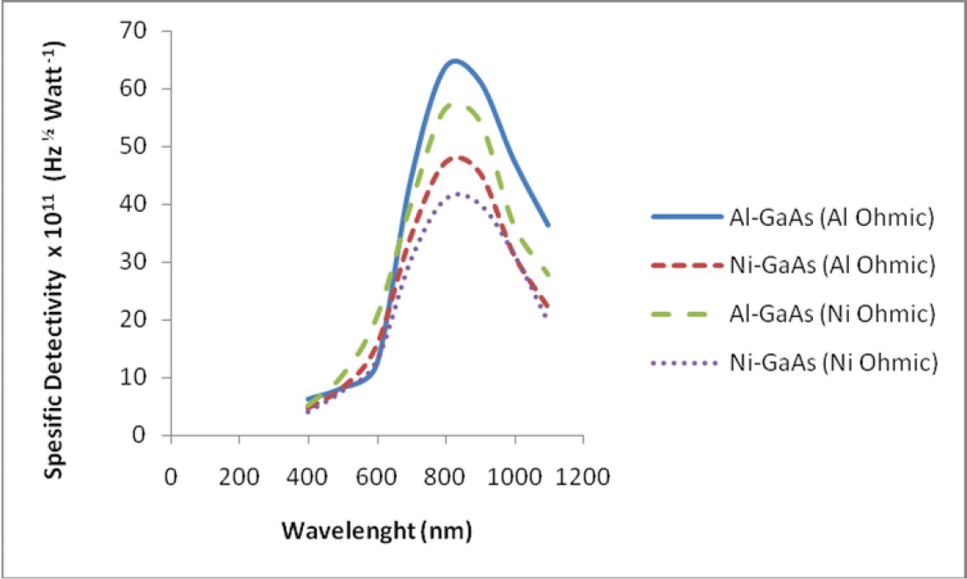
Figure (5) specific detectivity for the four samples as a function to the wavelength

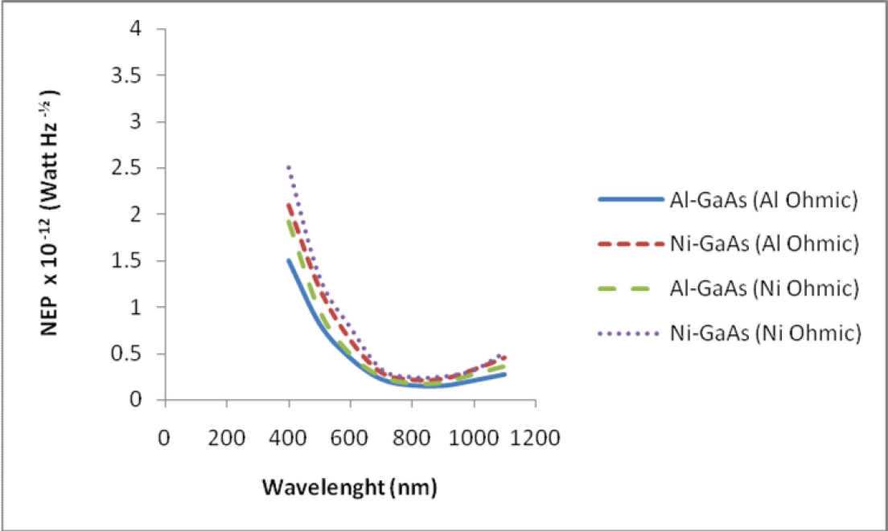
Figure (6) Noise equivalent power for the four samples as a function to the wavelength

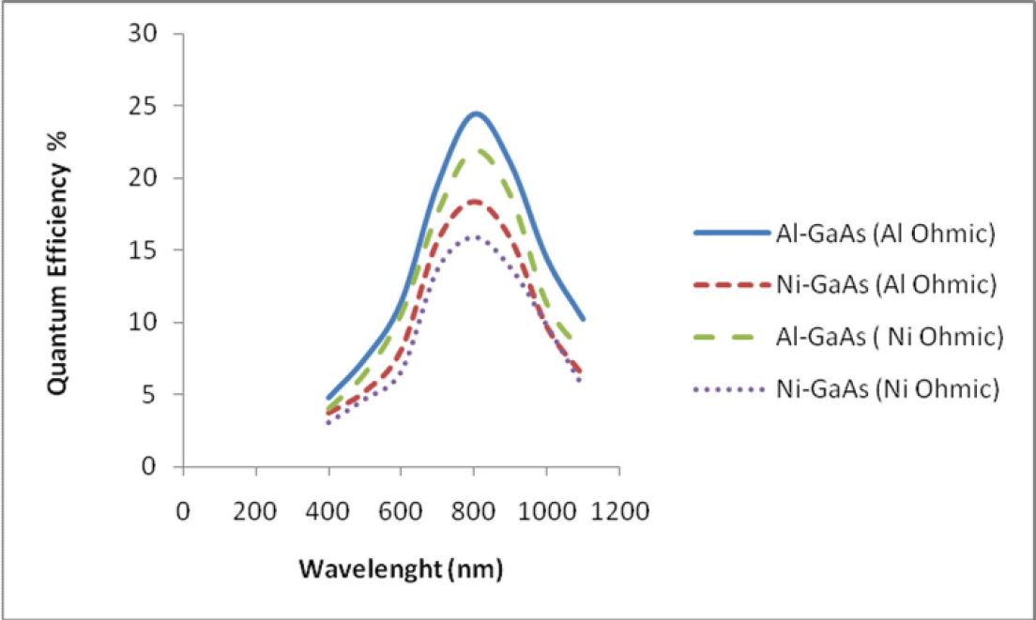
Figure (7) Quantum efficiency for the four samples as a function to the wavelength

References:

Binh-Minh Nguyen, Darin Hoffman, Edward Kwei-wei Huang, Simeon Bogdanov, Pierre-Yves Delaunay, Manijeh Razeghi, and Meimei Z. Tidrow , Demonstration of mid infrared type-II InAs/GaSb super lattice photodiodes grown on GaAs substrate , applied physics letters 94(2009)

Burak Y.K., Study the effect of the interfacial layer on the electrical and optical properties for Schottky devices GaAs at low temperature, p.74, (2001)

Chen C.P., Chang Y.A.and Kuech T. F., Schottky enhancement of reacted Ni Al /n-GaAs contacts, Appl. Phys. Lett. 64 (25), (1994)

Monroy E., Vigue F., Calle F., Izpura J. I., Mun˜oz E.and Faurie J.-P., Time response analysis of ZnSe-based Schottky barrier photodetectors, applied physics letters vol. 77, no. 17 (2000)

Gerhard Lutz, Semiconductor Radiation Detectors, Springer (1999)

Campbell I. H., Transparent organic photodiodes with high quantum efficiency in the near infrared, applied physics letters 97 (2010)

Joachim Piperk, Semiconductor Optoelectronic Devices, Academic Press, California (2003) Boer K.W., Survey of Semiconductor Physics, vol. I. New York: Van Nostrand Reinhold, (1990.)
Meng-Chyi Wu, Yun-Hsun Huang, and Chong-Long Ho, High-Speed InGaP/GaAs p-i-n Photodiodes With Wide Spectral
Range , ieee electron device letters vol. 28, no. 9, September (2007) Martin A. green, Solar Cells, Dar Al-Kutob ,Mousel ,Iraq , p.60 (1989)
Necmi Biyikli, Ibrahim Kimukin, ITO-Schottky Photodiodes for High-Performance Detection in the UV–IR Spectrum , IEEE journal of selected topics in quantum electronics , vol. 10, no. 4, (2004)

Otsubo M .,Semi K. ,Miyamoto T., Yamamoto K. , Ikeuchi H., Chiba h., Natural Science Chemical Etching Rate, Schottky Barrier Height, and Specific Contact Resistance Dependence on Crystal Face in n-Type 6H-SiC. Bulletin of the Faculty of Education, Wakayama University. Natural Science vol.no.54; p.33-41(2004)

Ronald W. Waynant ,Marwood N. ELECTRO-OPTICS HANDBOOK, Mc GRAW-HILL, Second Edition, p592,(2000) Jones R.C. (Noise in radiation detectors) proc.IRE. vol.45 (1954).
Raheem G.K./Study the structural, Electrical and Optical properties of hetrojunction CdTe 1-xSe x /Zn (S, Te) (2007) Sze S.M., semiconductor devices Physics and technology, Dar Al-Hekmea Mousel -Iraq (1990)
Abdollahi Pour S., Nguyen B-M., Bogdanov S., Huang E. K., and Razeghi M., Demonstration of high performance long wavelength infrared type II InAs/GaSb super lattice photodiode grown on GaAs substrate, applied physics letters 95, (2009)

Budde W.,(Physical detectors of optical radiation), Optical radiation measurement (vol.4) .Academic Press New York and London (1983)

