Finite Element model to Study the Deformation of Circular Cellular Cofferdams by Using Ansys Program

Majeed R. Saba’a. Basima Abbas Jabir AL-humairi.

Technical Institute of Musyab Technical Institute of Kut

Abstract
In the present work nonlinear finite element analysis has been used to predict the load displacement behavior of cellular retaining structure by using ANSYS (Analysis System) (version 9) computer program, eight-node brick element has been used to model cellular cofferdam and soil, non linear material behavior is adopted for the soil in which a Drucker - Prager (DP) model is used to represent that nonlinearity
The bond between cellular cofferdam and soil has been modeled by using surface to surface contact element , using of models in ansys program have been carried out on one (single) circular cell of width to height ratio equal to (1.00), with embedment depth ratios equal to (0.2H, 0.3H, 0.4H ) , and use three type of soils, these types subbase ,sand passing sieve No.4 and river sand . and their results are compared with experimental data[Al-Khyatt, (2009)] and found to give good agreement.
الخلاصة
في هذه الدراسة تم استخدام التحليل اللاخطي بطريقة العناصر المحددة للتنبؤ بعلاقة الحمل بالإزاحة بالنسبة لسدود الإنضاب وذلك باستخدام برنامج ANSYS V.9، وقد تم استخدام العناصر الطابوقية لتمثيل سدود الإنضاب و لتمثيل التربة, تم استخدام موديل (Drucker-Prager) لتمثيل السلوك اللاخطي للتربة, إضافة إلى ذلك تم تمثيل الروابط بين سدود الإنضاب الخلوية والتربة باستخدام العناصر البينية ذات السطح. حيث تم عمل موديلات في برنامج Ansys لخلية دائرية أحادية بنسب عرض/ ارتفاع(1.0) وذات نسب عمق الدفن تحت سطح الأرض مساوية إلى (0.2H , 0.3H, 0.4H) وتم استعمال ثلاث أنواع من الترب وهي السبيس و الرمل المار من غربال رقم 4 و الرمل النهري.وتم مقارنة نتائج التحليل مع النتائج العملية[Al-Khyatt, (2009)]. فوجد إن التحليل باستخدام طريقة العناصر المحددة تعطي نتائج متقاربة مع النتائج العملية.
Introduction
The ANSYS (Analysis System) computer program is a large-scale multipurpose finite element program which may be used for solving several classes of engineering problem. The analysis capabilities of ANSYS include the ability to solve static and dynamic structural problems, steady-state and transient heat transfer problems, mode-frequency and buckling Eigen value problems, static or time-varying magnetic analyses, and various types of field and coupled-field applications. The program contains many special features which allow nonlinearities or secondary effects to be included in the solution, such as plasticity large strains, hyper elasticity, creep, swelling, large deflections, contact, stress stiffening, temperature dependency, material anisotropy, and radiation. As ANSYS has been developed, with other special capabilities, such as sub structuring, sub modeling, random vibration, kinetostatics, kinetodynamics, free convection fluid analysis, acoustics, magnetics, piezoelectrics, coupled-field analysis and design optimization been added to the program. These capabilities contribute further to making ANSYS a multipurpose analysis tool for varied engineering disciplines. The ANSYS program has been in commercial use since 1970, and has been used extensively in aerospace, automotive, construction, electronic, energy services, manufacturing, nuclear, plastics, oil, and steel industries,(Ibrahim and Erdogan , (2006)) . AL - Kelabbee :studied nonlinear finite element analysis has been used to predict the load deflection behavior of circular cell cofferdam under lateral load by using ANSYS (Analysis System) (version 5.4) computer program. Three different sections of dam with ( diameter/depth (D/H) =1, 0.85, 0.75) have been analyzed in example one and their results are compared with experimental data and found to give good agreement. In addition to that, studied there are three case studies (cofferdam with arcs once and with arcs and backfilling another, cofferdam has filling material differ from the base of the dam, and cofferdam have filling soil layered) and there is isolated cell cofferdam in example two and last example was field study. Among the conclusions obtained, the stability of dam increases with diameter (base) to height ratio of dam decrease . In case studies (cofferdam supplied by arcs and backfilling , differ between filling soil inside and outside the dam and, dam with layered filling soil) there is reduction in displacement of cofferdam by about (82.58%, 89.24%, 5.1%, 40.91%) respectively. Al-Rmmahi (2009) studied the design and construction of cellular cofferdams through test models to observe their stability. Series of laboratory tests had been carried out on two diaphragm cells of different width to depth ratios (0.75, 0.85, and 1). The tests include the following factors. These factors are effect of width, height, properties of soil and embedment depth to height ratios (0.15, 0.3, and 0.45). Four type of soil are used. These types are subbase, sand passing sieve No.4, sand river and clay soil.Then analysis of cellular cofferdam by software which is known PLAXIS is used to compute deformations, stresses, and strain in the body of cofferdam and foundation. And comparison the results between laboratory tests and the software PLAXIS.
Reliability of results that obtained from experimental tests by statistical analysis to formulation these results by four functions are created to computes the deformations. The functions represent the relation between deformations and embedment depths that occurred after applied loads Many conclusions had been drawn from this study. Among these are the embedment depth is greatly affected the stability of cells. L. Kittisatra , (1976) developed a computer program state to analyze cellular cofferdam by finite element method. There were two :Basic types of element (1) Quadrilateral axisymmetric ring element to represent the soil and (2) Cylindrical shell element to represent steel sheet piles. No slippage between piers was assumed and it was assumed as one body. There was isolated circular cell with diameter (19.74m) and height (17.55) with the symmetric loading around the vertical axis case and other circular cell with diameter (19.74m) and height (17.66m) with lateral load due to back fill cell and tension force in the connecting zone between the arch and a cell. Stresses for soil and steel sheet piles were computed furthermore the deflection for soil and sheet pile and in the different level. More than one conclusions were found such as :-
A. Maximum elastic soil settlement was happened in the center of cell. and a few settlements in the edges.
B. Total elastic settlement in the back in fill more than front side.
C. The maximum hoop tension force and max radial displacement of the cell occur at the (1/6) from the net height of the cell above the natural level of the earth.
Duncan et al. (1980) presented computer program (EXCAV) for analysis cofferdam. A nonlinear hyperbolic stress-strain relationship (was used to describe the behavior of the soil.The short-term undrained conditions were simulated with a total stress analysis. The clay was assumed to be saturated and incompressible using a Poisson's ratio of 0.49. The elastic modulus was based on a E_{u}/c_{u} ratio of 200,. The total horizontal and vertical stresses are assumed to be equal prior to construction. The wall and the struts were modeled using linear elastic beam and elements, respectively.A 33-m-wide excavation were investigated under plane strain conditions.
The final depth of the excavation was 11 m with four levels of struts at depths of 1 m, 3.5 m, 6 m, and 4,5 .m. The length of the sheet piles (FSP-IIIA) below the bottom of the excavation was 6m, while the depth to the underlying hard stratum was 39m. A Constant undrained shear strength of the 35 KN /m ² was used in the analysis. In order carry out a finite element analysis using Ansys, needs to
1. model
2. and boundary conditions
3. specify the material properties
4- Creating Geometry Model
1. The Model
The geometry models created for the structure has driven into soil with height to embedment depth ratio (0.4H, 0.3H ,0.2H), for cell has width to height ratio(1.00).
2 .Loads and Boundary Condition
To set up the boundary condition, the standard fixities option is used. As a result a full fixity at the base and free condition at the horizontal side of geometry are generated. the point loads are take in state failure of cellular cofferdam in the laboratory tests,
3 .Specify the material properties
Material properties are required for most element types. Depending on the application, material properties may be linear or nonlinear, isotropic, orthotropic or anisotropic, constant temperature or temperature dependent. As with element types and real constants, each set of material properties has a material reference number. The table of material reference numbers versus material property sets is called the material table. In one analysis there may be multiple material property sets corresponding with multiple materials used in the model. Each set is identified with a unique reference number. Although material properties can be defined separately for each finite-element analysis, the ANSYS program enables storing a material property set in an archival material library file, then retrieving the set and reusing it in multiple analyses. Each material property set has its own library file. The material library files also make it possible for several users to share commonly used material property data( Nakasone et al., (2006)) the material properties for soil and cellular cofferdam for this research ,are shown in table(1) and table (2) .

Table ( 1) Material properties for soils
Unit | River Sand | Sand passing No.4 | Subbase | Name | Parameter
KN/m² | 7000 | 7000 | 10000 | E | Young s'  Modules
KN/ m² | 3 | 3 | 1 | C | Cohesion
KN/m³ | 14.5 | 16.5 | 17.5 | $$γ$$ | Soil unit weight
0  $$ο$$ | 32 | 34 | 38 | $$Φ$$ | Angle of  Friction
_ | 0.15 | 0.15 | 0.15 | $$ν$$ | Poisson 's ratio
Table ( 2) Material properties for cellular cofferdam

Steel) Cellular cofferdam(
Modulus of elasticity E
(kN/m²)=200E6
Poisson’s ratio ( ν)=0.3

4- Drawing the Model: -
In order to draw the model the following dimensions are defined:-
- Width of the soil box.
- Length of soil box
- Depth of soil box
- Dimensions of circular cellular cofferdam

Figure (1) shows the model dimensions and Figure(2) show the model in case embedment depth and table (3) shows the default values of model dimensions

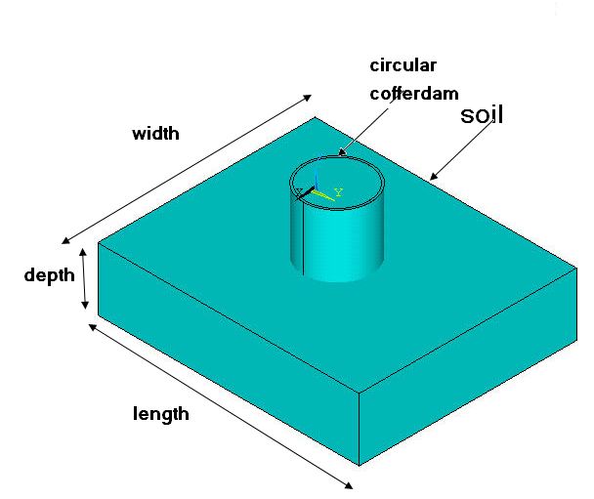
Fig. (1) Shows the model dimensions
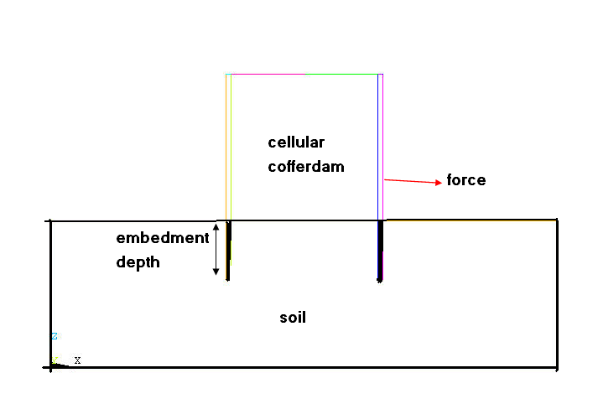
Fig.(2)Show the model in case embedment depth

Table (3) Model dimensions[Al-Khyatt, (2009)]
Dimensions | Default values (mm)
Width of soil box. | 1040
Length of soil box | 1250
Depth of soil box. | 300
Thickness of cellular cofferdam. | 100
( Inner Diameter) of cellular cofferdam | 300
Height of cellular cofferdam.(above ground surface) | 300
Embedment depth of cellular cofferdam. | 120,90,60

Selection of Element Type: -
One type of element are selected; Solid45 for soil and Circular cellular cofferdam These elements are brick elements with eight nodes one at each corner. The element is defined with eight nodes having three degrees of freedom at each node –translations in the nodal x, y, and z directions. The geometry and node locations for this element type are shown in Figure (3). The element has plasticity, creep, swelling, stress stiffening, large strain capabilities. A reduced integration option with hourglass control is available deflection.

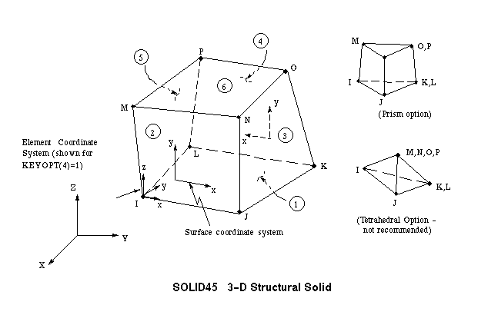

Fig. 3: Soild45 geometry(ANSYS Help, Release 9.0)

Definition of Real Constants:-
Element real constants are properties which depend on the element type, such as cross-sectional area of a beam element, moment of inertia, initial strain…etc. Not all element types require real constants, and different elements of the same type may have different real constant value( Nakasone et al., (2006) ) .

Effect of Contact Element
TARGE170 Element Description
In studying the contact between two bodies, the surface of one body is conventionally taken as a contact surface and the surface of the other body as a target surface. The “contact-target” pair concept has been widely used in finite element simulations. For rigid-flexible contact, the contact surface is associated with the deformable body; and the target surface must be the rigid surface. For flexible-flexible contact, both contact and target surfaces are associated with deformable bodies. The contact and target surfaces constitute a “Contact Pair”. TARGE170 is used to represent various 3-D target surfaces for the associated contact elements (CONTA173). The contact elements themselves overlay the solid elements describing the boundary of a deformable body that is potentially in contact with the rigid target surface, defined by TARGE170. Hence, a “target” is simply a geometric entity in space that senses and responds when one or more contact elements move into a target segment element "ANSYS Manual,2002" . The target surface is modeled through a set of target segments; typically several target segments comprise one target surface. Each target segment is a single element with a specific shape or segment type, as shown in Figure (4). and Figure (5) show the contact between cofferdam and soil in this study.

Fig. (4)Target 170 geometry(ANSYS Help, Release 9.0)

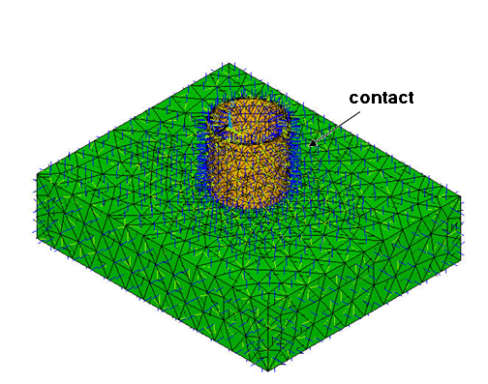
Fig. (5) The contact between cofferdam and soil .
Meshing the Model: -
In this stage, determine the number of elements for each material in the model. Figure (6) and Figure (7) shows the meshing of the model:-
- First volume represents soil.
- Second volume represents cellular cofferdam .
- Third volume represents the soil in cellular cofferdam.
The program asked for the number of elements for each volume in the X, Y, and Z directions.

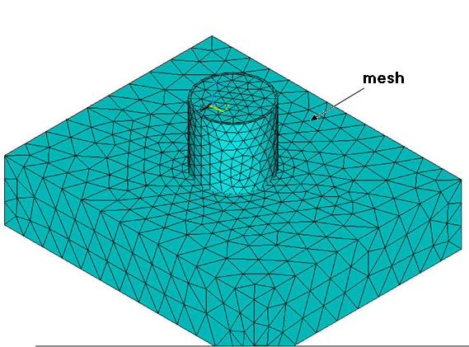

Fig. (6) Meshing of the model in case isometric view

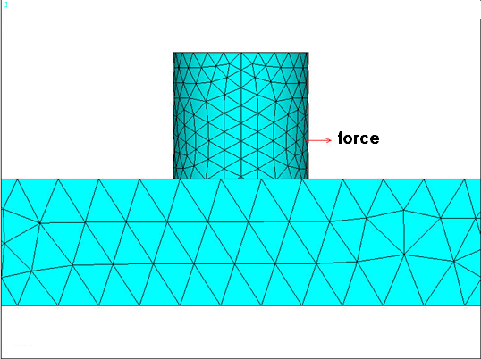
Fig. (7) Meshing of the model in case (front view)
Solution of the Problem: -
In the solution phase of the analysis, the computer takes over and solves the simultaneous equations that the finite element methods generate. Several methods of solving the simultaneous equations are available in the Ansys program which is: (ANSYS Solutions,www.ansysnonlinear.com)
- Frontal Solution.
- Sparse Direct Solution.
- Jacobi Conjugate Gradient (JCG) Solution.
- Incomplete Cholesky Conjugate Gradient (ICCG) Solution.
- Preconditioned Conjugate Gradient (PCG) Solution.
- Automatic Iterative Solver Option (ITER).
The following steps are carried out:-
1- In order to solve the simultaneous equations, sparse direction solution method is adopted, which is available for static and full transient, and can be used for linear and non-linear solutions.
2- Static analysis type is used as a structural analysis.
3- Because of non-linear soil behavior, the load must be broken into a series of load increments. To do this the load step file method is chosen
Results of Analysis
The calculations were based on values taken from laboratorial tests for each soil[Al-Khyatt, (2009)]. The differences range in displacement between ansys program and experimental tests from 7.36% to 37.07% are shown in table (4) to(6). Figure(8) and Figure (9) show the deformation of cell in case of overturning and sliding . The overturning case causes a compression on the back side and tension along the front side of the cell. Thus the sheet pile of the back side tends to sink down into the ground while that of front side tends to rise while the sliding case the cell slide to back side this depend on soil type and embedment depth ratio .
Table (4): Effect of Embedment Depth on Horizontal Displacement for Subbase Soil and Circular Cell with (b/H =1.00)
Differences% | Horizontal Displacement From ANSYS program (mm) | Horizontal Displacement From Test (mm) | Failure Load (kN) | Embedment Depth Ratios | NO
12.89% | 7.09 | 8.14 | 0.26 | 0.4H | 1
8.95% | 4.17 | 4.58 | 0.195 | 0.3H | 2
20.30% | 5.81 | 7.29 | 0.15 | 0.2H | 3
Table (5): Effect of Embedment Depth on Horizontal Displacement for Sand Soil and Circular Cell with (b/H =1.00)
Differences% | Horizontal Displacement From ANSYS program (mm) | Horizontal Displacement From Test (mm) | Failure Load (kN) | Embedment Depth Ratios | NO
20.80% | 5.33 | 6.73 | 0.24 | 0.4H | 1
-14.38% | 3.50 | 3.06 | 0.166 | 0.3H | 2
7.36% | 7.29 | 7.87 | 0.1435 | 0.2H | 3

Table (6): Effect of Embedment Depth on Horizontal Displacement for River Sand Soil and Circular Cell with (b/H =1.00)
Differences% | Horizontal Displacement From ANSYS program (mm) | Horizontal Displacement From Test (mm) | Failure Load (kN) | Embedment Depth Ratios | NO
% -37.07 | 10.76 | 7.85 | 0.2075 | 0.4H | 1
% 26.36 | 3.10 | 4.21 | 0.132 | 0.3H | 2
% -23.45 | 3.00 | 2.43 | 0.086 | 0.2H | 3

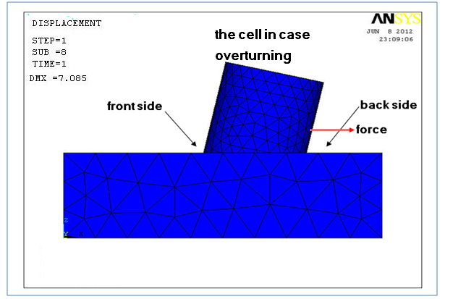
Fig(8) The deformation of cell in case overturning
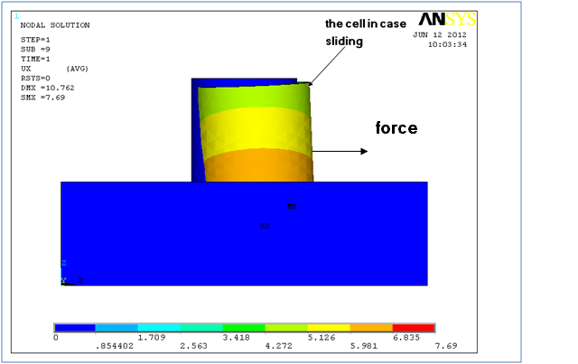
Fig.(9) The deformation of cell in case sliding
Conclusion
1- The differences range in displacement between ANSYS program and experimental data from 7.36% to 37.07%
2- The properties of soil are effecting on stability of cell, where increase the angle of internal friction of soil (Ø) lead to increase resistance of cell.
3- The displacement in case sliding greater than displacement in case overturning.
4- The embedment depth increases the resistance of cell

References:
“ANSYS Help” .ANSYS , Release 9.0, Copyright 2004.
"ANSYS Manual", Version 7.0, U.S.A., 2002.
"ANSYS Solutions", http // www.ansysnonlinear.com
Al –Kelabbee ,Z.D.(2010)" Finite element analysis of cellular circle bulkheads" M. Sc. thesis, College of Engineering, University of Babylon
Al-Khyatt, H.S. (2009): "Design sheet pile cellular structures cofferdams and retaining structures". M. Sc. thesis, College of Engineering, University of Babylon
Al-Rmmahi, S.H. (2009):"Effect of Width to Depth Ratio on Stability of Cellular Cofferdams". M. Sc. thesis, College of Engineering, University of Babylon
Duncan , J. M. ,et al.(1980)"Strength, stress-strain and bulk modulus parameters for finite element analysises of stresses and movements in soil masses". Geotech. Engrg. Res. Rept. No. VCB/GT/80-01, Univ. of California, Berkeley, calif.
Ibrahim, G. and Erdogan, M.,(2006)"The finite element method and applications in engineering using ansys", The University of Arizona,
L. Kittisatra , L., (1976) "Finite element analysis of circular cell bulkheads", Thesis presented to Oregon state University at carvallis, Oregon, in partial fulfillment of the requirement for the degree of doctor of philosophy
Nakasone, N., Stolarski , T. A. and Yoshimoto, S. (2006)" Engineering Analysis With ANSYS Software " Department of Mechanical Engineering.Tokyo University of Science, Tokyo, Japan.

