Experimental Study of Coupled Flow through Combined Weir-Gate Structure

Imad H. Obead | Riyadh Hamad
Dept. of Civil Eng., College of Eng.,  University of Babylon | Dept. of Civil Eng., College of Eng.,  University of Babylon
eng_imad2005@yahoo.com | Riyadh_hamad@yahoo.com

Abstract
This study presents a series of experimental investigations on combined flow over curved weirs and below rectangular gate to find the hydraulic characteristics of the flow. Six combined parabolic bottom triangular weirs were constructed and tested for two different triangular angles [θ_{w} = 45° and 60°] respectively. A generalized discharge model is proposed relating the discharge coefficient(C_{d}) , the weir head(h_{w}), gate opening ratio parameter in addition to weir geometry, the distance between the weir and the gate (Z), and weir opening ratio (b_{w}/h_{w}). Analysis of the results revealed that discharge equation is suitable for horizontal channel bed under submerged flow and for free flow. The predictions of equation shows fair agreement with experimental data.
الخلاصة
تهدف الدراسة الحالية إلى إجراء وتحليل سلسلة من التجارب المختبرية لكمية الجريان من خلال فتحات هدار مزدوج يتكون من بوابة سفلية مستطيلة الشكل وفتحة علوية مثلثة ذات قاعدة منحنية على شكل قطاع دائرة. يستخدم هذا النوع من الهدارات المزدوجة في قنوات الري لتحويل الجريان من القنوات الرئيسية إلى القنوات الفرعية بالإضافة إلى التحكم وقياس الجريان. استناداً إلى نتائج هذه التجارب تم التوصل إلى معادلة عامة للجريان تتضمن اغلب العوامل المؤثرة في التصريف في القنوات الأفقية، كمعامل التصريف(C_{d}) والشكل الهندسي للهدار المزدوج وارتفاع الماء فوق فتحة الجريان(h_{w}) والمسافة العمودية بين فتحتي الهدار العلوي والبوابة(Z) بالإضافة إلى أبعاد البوابة (H_{g} وB_{g})، وقد تم التوصل الى معادلات عامة تتضمن بعض المتغيرات الهيدروليكية والهندسية المؤثرة على الجريان وقد اظهرت دقة وتوافق جيد مقارنةً بالنتائج التجريبية.
1. Introduction
Gates and weirs have been used extensively for flow control and discharge measurement in open channel flow. Discharge-measuring structures have been studied by many researchers. Discharge equations derived from energy considerations are calibrated by experimental data for typical weir geometries. In all measuring structures definition of a discharge coefficient is necessary to represent influences of parameters that are not directly included in the derivation of the discharge equation. Limitations on the use of discharge equations are also reported in the literature. Discharge coefficient is usually dependent on dimensionless parameters such as Reynolds, Froud and Weber numbers associated with dynamic conditions of flow over the structure, and ratios of weir dimensions which reflect variations in the geometrical design of the measuring structures(Negm,2002), at high discharges the effect of surface tension and viscosity will be neglected so Weber number and Reynolds number had been neglected(Hayawi,2008).
2. Previous Researches
Previous studies indicates that Swamee (1988,1992) presents general equation separately for rectangular weirs and a sluice gate in term of coefficient of discharge (C_{d}) for both free and submerged flow. Negm (1995, 1997) analyzed the characteristics of the combined flow over contracted weirs and below contracted gates of rectangular shape with unequal contractions. Alhamid (1999) studied combined flow over V-notch weir and below contracted rectangular gate. This study covered both free and submerged gate flow conditions, under different weir-gate dimensions. Based on dimensional analysis and using non-linear regression analysis, discharge equation was developed for both free and submerged gate flows. Ferro (2000) reported the results of an investigation carried out to establish the stage-discharge relationship for a flow simultaneously discharging over and under a sluice or a broad crested gate. Negm et al. (2002) conducted some experiments to study the characteristics of the combined flow over the sharp-edged rectangular weir and below the sharp-edged rectangular gate with contractions. He introduced a general dimensionless relationship for predicting the discharge of the combined flow. Samani and Mazaheri (2007) presented a new physically based approach for estimating the stage discharge relationship of combined flow over the weir and under the gate for semi submerged and fully submerged conditions. Dehghani(2010) investigated experimentally the scour characteristics downstream of combined free over weir and below gate, the results shows that the main part of scour in combined flow is due to flow over weirs. Shahabi et al.(2011) presents the result of an experimental study on the characteristics of scour hole resulted by contracting the weir and gate cross section.
In this study a combination of rectangular gate and circular bottom- triangular weir were suggested and studied experimentally, this study is focused on determination of hydraulic characteristics of combined structure.
3. Theoretical Consideration
Figure(1) shows the definition outline for the discharge through combined weir system. The total discharge over weir and below gate is:
Q_{T} = Q_{g}+Q_{w} -----[1]
Where:
Q_{T} : total discharge through weir-gate structure.(L³T⁻¹)
Q_{g}: discharge below gate.( L³T⁻¹)
Q_{w}: discharge over weir.( L³T⁻¹)

Figure(1): Definition sketch for weir-gate structure

The conventional flow equation for rectangular gate is given by (Hayawi,2008).
Q_{g} = -----[2]
Where:
H_{t} :total head (H_{t} = h_{w}+Z+H_{g}). (L)
h_{w}: the measured head of water over weir. (L)
Z: the vertical distance between the lower edge of weir and upper edge of gate. (L)
H_{g}: the gate height. (L)
B_{g}: the gate width. (L)
g : gravitational acceleration. (LT⁻²)
to compute the discharge (Q_{w}) over the circular bottom-triangular weir the following equation may be derived.
Q_{w} = 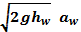 -----[3]
Where:
a_{w}: water way area of weir. (L²)
Consider the flow through combined structure as shown in figure(2) below. The area of flow rate bounded by the bottom edge of weir and water surface is.

Figure(2): Area of flow rate (a_{w}) through combined structure
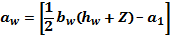 -----[4]
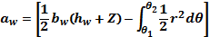 -----[5]
Where:
a₁:the area enclosed among the triangle legs and the circular bottom of upper weir. (L²)
θ₁, θ₂: angle of inclination for triangle legs.
The polar coordinates of the circle of radius (R) centered at point c((R+Z),π/2). Let point P(r,θ) be a point on the circle and apply The law of cosine to triangle (OCP) as shown in figure(3). This gives:

Figure(3):Geometric demonstration of weir(not to scale)

-----[6]
By rearranging, equation(6) can also be written:
-----[7]
The parameters related to the geometry and shape of weir such as (Z,R) and the head over weir (h_{w}) will be considered in derivation of the following equations:
1- For the case of (R=Z):
Referring to figure (3), y_{t}=rsinθ , equation (7) simplifies to:
-----[8]
Where:
y_{t}: the vertical distance of intersection between triangle legs and circle. (L)
Combining the two equations(5) and (8), the water way area of weir can written as:
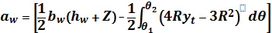 -----[9]
From figure (2) [ , substitution in equation(9) yields:
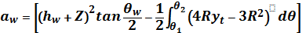 -----[10]
In the present research two angles(θ_{w}) were considered (45°,60°) respectively. By performing integration equation(10)can expressed as:
a- For the case of weir angle θ_{w} =45°
in this case θ₁=3π/8 and θ₂=3π/4, substitute in equation(9) to produce:
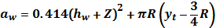 -----[11]
Combining equations(3) and (11) the discharge passes over weir for (θ_{w}=45°) can be represented as follows:
Q_{T} = ----[12]
---[13]
Where:
Q*_{T} : actual total discharge. (L³T⁻¹)
C_{d}: the discharge coefficient for the combined weir.
b- For the case of weir angle θ_{w} =60°
in this case θ₁=π/3 and θ₂=2π/3, substitute in equation(9) to produce:
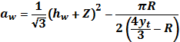 -----[14]
Combining equations(3) and (14) the discharge passes over weir for (θ_{w}=60°) can be represented as follows:
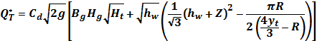 -----[15]
The discharge coefficient for combined structure flow identified by equations (13) and (15) is not easily to determined analytically. Thus, a series of experiments were performed to determine the equations of flow and the discharge coefficient.
In order to study the trend of variations due to change in geometric shape of weir, the effect of vertical distance between gate and weir, weir opening, and head over weir, the following cases were discussed:

2- For the case (R=):
equation (7) take the form:
-----[16]
Combining the two equations(5) ,(16) and performing integration yields:
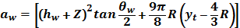 -----[17]
a- For the case of weir angle θ_{w} =45°
Q_{T} = -----[18]
b- For the case of weir angle θ_{w} =60°
Q_{T} = -----[19]
3- For the case (R= ):
equation (7) simplifies to:
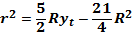 -----[20]
Combining the two equations(5) ,(20) and performing integration yields:
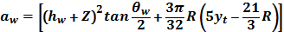 -----[21]
a- For the case of weir angle θ_{w} =45°
Q_{T} = -----[22]
b- For the case of weir angle θ_{w} =60°
Q_{T} = -----[23]

4. Experimental setup and procedure
To determine the equations of flow and the discharge coefficient for combined weir-gate system. The experiments were conducted in a straight rectangular channel at hydraulic laboratory of University of Babylon, College of engineering, Department of civil engineering of (10) m long (S6-Tilting flume of Slope equal zero) with cross section of (0.3) m width and (0.45) m height. The channel consisted of toughened glass walls and a stainless steel floor. Two movable carriages with point gauges were mounted on brass rails at the top of channel sides see figure(4).
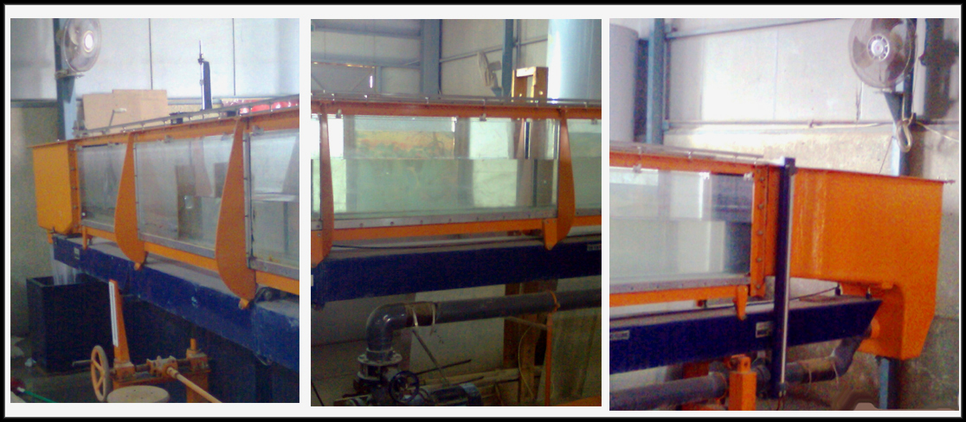

Figure(4): S6-Tilting flume front and side views

Six combined weir model were manufactured from a 10mm thick plywood sheets. In these models, a triangle notch of circular bottom with two different weir angles of (45°, 60°) above a rectangular gate notch at different distance (Z = 6,9 and 12 cm) between the gate and the weir.
The distance (Z) adopted in the present work depends on literature review, e.g. Hayawi (2008) considered three different values of distance between the gate and weir (5,10,15 cm)respectively. Shahabi et al.(2011) used a constant distance (h=3.5 cm) between weir and gate to investigate the effect of contraction on scouring in downstream of combined flow over weirs and below gates. Figure (5) and table (1) shows the tested models dimensions and details.
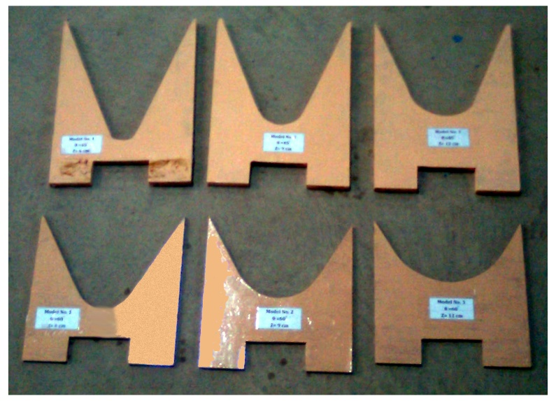

Figure(5):Combined weir models
For discharge measurements, a full width thin-plate sharp-crested rectangular weir fixed at the tail end of the channel section and the head upstream of the standard weir and the combined weir were measured with a precision point gauges.
Table (1): Details of combined weir models
Model No. | Run No. | Weir Angle(θ_{w}) | Z (cm) | R (cm)
1 | 1-3 | 45° | 6 | 6
2 | 4-7 | 45° | 9 | 9
3 | 8-11 | 45° | 12 | 12
4 | 12-15 | 60° | 6 | 6
5 | 16-19 | 60° | 9 | 9
6 | 20-23 | 60° | 12 | 12

5. Analysis of Results, Discussion and Conclusions
a- Prediction the coefficient of discharge (C_{d})
The coefficient of discharge (C_{d}) for combined flow condition are predicted and analyzed for a condition when the angle (θ_{w}) increase, the discharge coefficient(C_{d}) decrease which indicated that for (θ_{w} =45°,60°) the average values of (C_{d}) are(0.6649,0.6043)respectively.
b- Variation of combined total discharge (Q_{T})
Figures (6) and (7) presents the variations of (Q_{T}) versus weir opening ratio(b_{w}/h_{w}) for all tested models, comparison of both figures indicated that (Q_{T}) increases as (b_{w}/h_{w}) decreases and when the solid vertical distances between weir and gate (Z) increased, the trend of variation increased rapidly. It is clear that for a certain values of (h_{w}) the discharge increase linearly and there a significant effect of the angle (θ_{w}) on the discharge variation such that the bigger the angle the larger the flow rate obtained.
Similar variation between the combined total discharge(Q_{T}) and (R/h_{w}) for different geometric shape parameter of weir-gate structure (R/Z) has been showed in figures(8) and (9), The theoretical model for flow of combine flow over the weir and under the gate indicates that there are interactions between (Q_{T}) and the weir angle and the curvature of weir bottom alternatively. Also, It is obvious that by decreasing the(R/h_{w}) and (R/Z) the (Q_{T}) increases.

Figure(6): Variation of Q_{T} versus (b_{w}/h_{w}) for θ_{w}= 45°

Figure(7): Variation of Q_{T} versus (b_{w}/h_{w}) for θ_{w}= 60°

Figure(8): Variation of Q_{T} versus (R/h_{w}) for θ_{w}= 45°

Figure(9): Variation of Q_{T} versus (R/h_{w}) for θ_{w}= 60°

c- during the simulation of flow for combined structure, the discharge (Q) was found to be effected by a number of variables. A general non-dimensional equation for the discharge through a rectangular gate and over rounded bottom triangular weir can be written as:
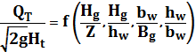 -----[16]
A multiple nonlinear regression analysis using Data-Fit Version9.0 Engineering Software to correlate the values of (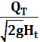 ) to both hydraulic and geometrical parameters.
The following equation fits the data with coefficient of multiple determination (R²=0.9998) and the value of standard error of estimate (SEE= 3.418E-05) for the case of weir angle (θ_{w}=45°).
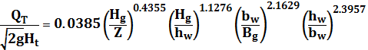 -----[17]
For the case of weir angle (θ_{w} =60°), the data maybe correlated by the following equation with coefficient of multiple determination (R²=0.9993) and the value of standard error of estimate (SEE= 8.841E-05).
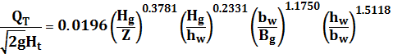 -----[18]

Figure (10) reveal the correlation between the predicated value of equations(17 and 18) and the measured value which indicates an noticeable agreement between the measured and predicated values of ( ).

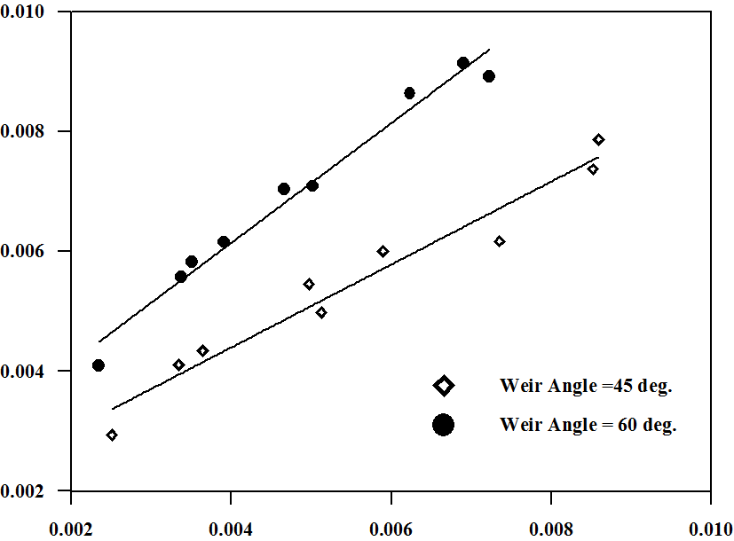

Figure(10): Verification of predicted vs. measured values of 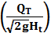

d- Conclusions
The results of this research show that:
1-The influence of weir angle has a significant effect on the combined discharge through the weir system.
2-The results of the coefficient of discharge (C_{d}) are calculated and discussed for a cases of weir angle (45°, 60°) respectively, and as the value of weir angle increase, the average value of (C_{d} = 0.6649,0.6043) decreased.
3- A multiple nonlinear regression model was predicted from the measured hydraulic and geometric parameter show in equations (17) and (18).
6. References
Negm,A.M. (2002).”Modeling of Submerged Simultaneous Flow through Combined Weirs and Gates Devices”. Proceedings of the 5th International Conference on Hydro Science and Engineering, ICHE2002,18–21 September, Warsaw, Poland.
Hana Abd Al-Majeed Hayawi, Amal Abd Al-Ghani Yahia, Ghania Abd Al-Majeed Hayawi.(2008). “ Free Combined Flow over Triangle Weir and under Rectangular Gate”. Damascus University Journal, Vol. 24, No.1, pp. 9-22.
Swamee, P.K. (1988). “Generalized Rectangular Weirs equations”, Proc. ASCE, Journal Hydraulic Engineering. Vol. 114, No. 8, August, pp. 945-949.
Swamee, P.K. (1992). “Sluice-gate Discharge Equations”. Journal of Irrigation and Drainage Engineering, Proc. ASCE, Vol. 118, No. 1, Jan./Feb., pp. 57-60.
Negm, A.M. (1995).” Characteristics of combined flow over weirs and under gates with unequal contractions”. Advances in Hydro-science and Engineering,Vol.2, Part A, (Edited by CHES and IRTCES, Proc.2nd ICHE-95, 22-26 March, Tsinghua University Press, Beijing, China, pp.285-292.
Negm, A.M. (1997).” Characteristics of combined flow over weirs and below gates” Sudan Engineering Society Journal, January,Vol.43, No.34.
Alhamid, A.A., Husain, D and Negm, A.M., (1996).” Discharge Equation for Combined Flow Over Rectangular Weirs and Below Inverted Triangular”. Arab Gulf Journal for Scientific Research, Riyadh, Saudi Arabia, Vol. 14, No.3, pp. 595-607.
Ferro, V. (2000). “Simultaneous flow over and under a gate”. Journal of Irrigation and Drainage Engineering, Vol.126, No.3, pp.190-193.
Negm, A. M., Al-Brahim, A. M., Al-Hamid A. A. (2002).”Combined-free flow over weirs and below gates”. Journal of Hydraulic Researches, Vol.40, No.3, pp.359-365.
Samani M.V. Jamal., Mazaheri, M. (2007).”Combined flow over weir and under gate”. 7th Iranian hydraulic conference, Power and Water University of Technology, Tehran, Iran, November, pp.81-86.
Dehghani, A. A., Bashiri, H., Dehghani, N.(2010).” Downstream scour of combined flow over weirs and below gates”, River Flow, Dittrich, Koll, Aberle & Geisenhainer, ISBN 978-3-939230-00-7.
Shahabi, M., Nasser, T., Ahmad, D.A., Abdoul-Rasoul,T., Reza, R.G.,(2011)” Experimental Investigation of the effect of Contraction on Scouring in Downstream of Combined flow over Weirs and below Gates”, 5th Symposium on Advances in Science and Technology, Mashhad, Iran, May 12-17.

