Experimental Study Effect of Using Glass Fiber on Cement Mortar
Rasha Salah Mahdi
Environmental engineering Dept.
rasha _ alkizwini 2015 @yahoo.com
Abstract:
Glass fiber reinforced mortar is considered as a new building material, which has different properties than those of ordinary mortar. Glass fiber reinforced concrete or mortar is usual for one or more of the following reasons. Structural such as (loading, fire, and earth quake), handling such as (to with stand stocking, transport and erection stress), and shrinkage (to with stand differential stresses). Glass fibers were found to improve significantly the tensile strength, flexural strength, and they were little affected on the compressive strength.
Three mixes of glass fiber reinforced mortar in addition to the reference were selected, using glass fiber content at (1, 1.5 and 2)% by weight of cement. The tests used to study the material characteristics were compressive strength, flexural strength and nondestructive test by Schmidt hammer.
These tests showed that the mortar mixed with 1% fiber content gave a higher compressive and flexural strength than the mortar mixed with 2% fiber content.
The nondestructive tests by Schmidt hammer which used to estimate the surface hardness of mortar . A high compressive strength and rebound number for (plain mortar) than the compressive strength and rebound number and of glass fiber reinforced mortar for all specimens.
Keywords: Glass Fiber, Cement
الخلاصة:
مونة الإسمنت او الخرسانة المسلحة بالألياف تعتبر كمادة جديدة للبناء والتي تمتلك خصائص مختلفة عن المونة الاعتيادية. مونة الإسمنت المسلحة بالألياف الزجاجية تستعمل لاحد او اكثر الأسباب التالية : انشائي (زيادة الحمل ، مقاومة النار ، مقاومة الهزات الأرضية )، المناولة (تحمل النقل والصدم)، والانكماش (تحمل الاختلاف في الإجهادات). ووجد ان الألياف الزجاجية تحسن بصورة كبيرة الخصائص الميكانيكية لمونة الإسمنت وهي مقاومة الانفلاق ومقاومة الانثناء ولكن هذه الالياف لها تأثير قليل على مقاومة الانضغاط. في هذا البحث تم اختيار ثلاث خلطات من مونة الإسمنت المسلحة بالالياف الزجاجية اضافة الى الخلطة المرجعية، تم إضافة نسبة (1.0،1.5 ،2.0) من الياف الزجاج من الوزن الكلي للاسمنت. الفحوصات التي أجريت لدراسة خصائص مونة الاسمنت المسلحة بالالياف الزجاجية هي مقاومة الانضغاط، مقاومة الانثناء والفحص اللااتلافي باستخدام مطرقة (Schmidt) وفحص الامواج فوق الصوتية باستخدام جهاز Pundit . هذه الفحوصات أظهرت بأن مونة الاسمنت الحاوية على (1%) الياف زجاجية من الوزن الكلي للاسمنت تعطي مقاومة انضغاط ومقاومة انثناء اعلى من مقاومة الانضغاط ومقاومة الانثناء التي تعطيها مونة الاسمنت الحاوية على (2%) الياف زجاجية من الوزن الكلي للاسمنت . أما بالنسبة للفحص اللااتلافي باستخدام مطرقة (Schmidt) المستعملة لتخمين صلادة سطح مونه الاسمنت والتي أعطت رقم ارتداد وسرعة انتقال ومقاومة انضغاط للخلطة المرجعية اكبر من الخلطة المسلحة بألياف الزجاج ولجميع النماذج.
مفتاح البحث:الياف الزجاج,السمنت
1- Introduction:
  - General:
The idea of incorporating fiber into organic cement. It ions material to improve its properties in not new. The use of straw in sunbaked clay bricks was widespread in early civilization. Asbestos was used to reinforce clay posts around 2500 B.C. . In more recent time's horse - hair has been added to plaster mixes.
Cement paste is not used as a material for construction as it cracks easily due to dimensional instability which may be caused by changes in environmental conditions. Aggregate was used to reduce that effect and the resulting product (concrete) possesses many advantage including low cost, general adaptability and utilization under different environmental condition. But in spite of all that concrete is fundamentally weak in tension and has comparatively low ductility and little resistance to impact loading.
Researchers have been conduction experiments to overcome these disadvantage by using various type of fiber which offer a convenient and practical means of achieving improvements in many of the engineering properties of the material such as fracture toughness. Fatigue resistance, impact resistance and flexural strength.
Various fibrous composite material. Both natural and nan-mode, have been used and are being used as building materials. Glass fibers are one example of materials of this type.
Utilization of glass fibers in concrete was first attempted in Russia in the late 1950s. Significant development work at the building research establishment in England led to production of alkali-resistance glass fibers containing zirconia in the late 1960s (Barzin,1989). Prestressed Concrete Institute (PCI,1985), reported that the potential for using glass fiber reinforced concrete system was recognized in 1940s, the result of work on plastics.

  - Advantages and disadvantage of glass fiber reinforced concrete:
1-2-1 Advantage:
- Glass fiber reinforced cement based composite has a high tensile strength and flexural strength than reference concrete.
- Improving the impact strength of concrete.
- The incorporation of the fibers is through to improve the mechanical properties by restraining the incipient cracks from propagation.
- Reinforcing concrete by mixing in fiber is one method for preventing cracks occurring due to drying shrinkage.
1-2-2 Disadvantage:
Glass fiber reinforced cement based composite lose a significant part of its tensile strength and does not present sufficient toughness after aging. This reduction in properties with age is the result of two main mechanics:-
- Chemical attack induced by the high alkalinity of Portland cement matrix.
- Microstructure changes around the fibers due to low nucleation and growth process with deposition of physically aggressive hydrates, mainly calcium hydroxide, nearby the filaments of glass fiber in cement based matrix, so even by using alkali- resistant glass fiber, the properties of these type of glass are effected by physical attack of the matrix. For that reason the most efficient way to improve the glass fiber reinforced concrete qualities is to solve the basic problem i.e. to use a matrix leading to less quantity of lime formed.
  - Glass Fibers (GF):
ASTM standard define glass, in general terms as :"An inorganic product of fusion which has cooled to a rigid condition without crystallizing. The last two words are particularly important in that they relate to the principle morphological of glass, i.e. (its amorphous nature).
Fig. (1) shows an idealized view of glass fiber strand containing 204 monofilaments each of diameter of 10 µm (Hannant,1980).
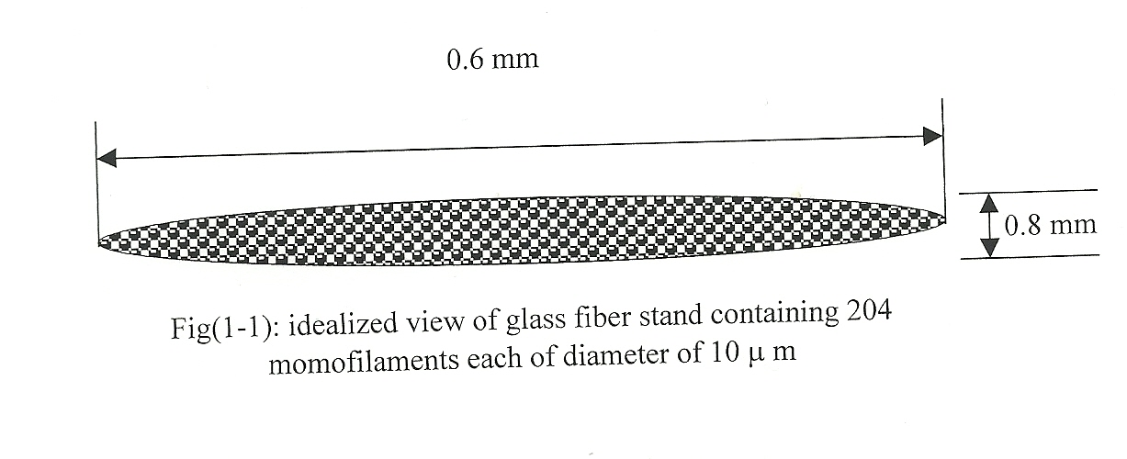
Fig.(1): Idealized view of glass fiber stand containing
204 momofilaments each diameter of 10 µm

2- Review of Literature:
2-1 Introduction:
Fiber reinforced concrete is a concrete made of hydraulic cements containing fine or fine and coarse aggregate and discontinuous discrete fiber. It may contain pozzolans and other admixture (ACI,1982). The main emphasis on research and practical application of glass fiber in cement paste has been concerned with the behavior of the fibers in ordinary Portland cement. The physical performance of the fibers in this matrix and as a result, the performance of composite is critically dependent on the microstructure of the matrix and of the fibers in the interfacial region where the fibers and matrix make contact. This region is important not only on the external surface of the fibers bundle but also within the bundle itself.

2-2 Mechanism of Fibers Reinforced Concrete:
Previous works on fiber reinforced concrete revealed that the properties of concrete such as strength and deformation are improved when fiber are added to the concrete. Such improvements are caused by transfer of load from concrete to the fibers, thus controls the crack growth. The load is transferred by interfacial shear stress and longitudinal tensile stress developed on the fibers as shown in fig. (2). The transfer of load from concrete to fibers depends on the following two considerations:-
- Critical fiber length or the fiber transfer length, it can be seen from fig.(2) that if the fiber length is greater than the critical length, fiber should yield at the failure of the composite. At equilibrium condition:-
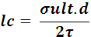 ……………….. (1)
Where ;
Lc: Critical length,
d: Fiber diameter ,
: Ultimate tensile strength of the fiber,
: Interfacial shear stress.

- The interfacial bonds between fibers and concrete in the vicinity of the crack increase to maximum and then decrease with increasing distance from crack edge as shown in fig.(3).
Fig.(3) shows that the failure of the fiber reinforced concrete occurs either by simultaneous yielding of the fiber and crashing of concrete or by bond failure at the concrete – fiber interface. The criterion that determines whether yielding or bond failure occurs is the fiber length and surface geometry (Ghazy,2000).
τ
τ
τ
τ
L
Lc/2
Lc/2
Lc/2
Lc=Critical fiber length
Lc=Transfer length
δfa
d
matrix
fiber

Fig.(2): Stress distribution for fiber in a discontinuous, aligned fiber composite(Ghazy,2000).

Lc/2
L
Lc/2
L>Lc
δ
δ
Bond stress distribution from matrix to fiber

Fig.(3): Bond stress distribution at fiber – matrix interface (Ghazy,2000)
2-3 Composite Materials Concept:
When a plain concrete beam is subject to increasing loads, cracking of the tensile zone immediately leads to failure of the beam. However, it should be noted that cracking in concrete is not a discrete phenomenon.
Careful measurements have revealed that a major crack which results in failure of a beam is preceded by slow micro crack growth (ACI,1982).
The two most important factors which influence the maximum load are the volume percentage of fibers and their aspect ratio (ACI,1982).
While the main factors controlling the theoretical performance of the composite material are the physical properties of the fibers and the matrix and the strength between two. It is apparent that the elongations at break of all the fibers are two or three order of magnitude than the strain at failure of the matrix and hence the matrix will crack long before strength is approached. This fact is the reason for the emphasis on post – cracking performance in theoretical treatment (Hannant,1980).

2-4 Mechanical Properties of Fiber Reinforced Concrete:
When fiber reinforced concrete specimens are loaded in flexural , four zones can be observed, as shown in fig.(3).
- Before cracking the curve is sensibly linear up to point "A" which called "first crack strength''; '' elastic limit" or " proportional limit". The area under this part of the curve is external work required to initiate cracking and it is equal to (1/2 PcVc), where (Pc) is the cracking load and (Vc) the corresponding deflection. The end of the zone is signaled by a drop in the load at constant deflection.
- After cracking the load again increase but the slope gradually decrease to zero at point "B" which is called "Ultimate Strength". At a typical crack the tensile force supplied by the glass many exceed that of the uncracked composite.
- A horizontal region in which the internal couple comprising the compressive force in the un cracked composite and the tensile force in the glass is relatively constant. This zone is characterized by fiberpull – out and load transfer between fibers.
- A progressive failure zone in which increase of deflection results in fall – off of load. This is region of stable crack growth the progressive failure of fibers (Ghazy,2000).
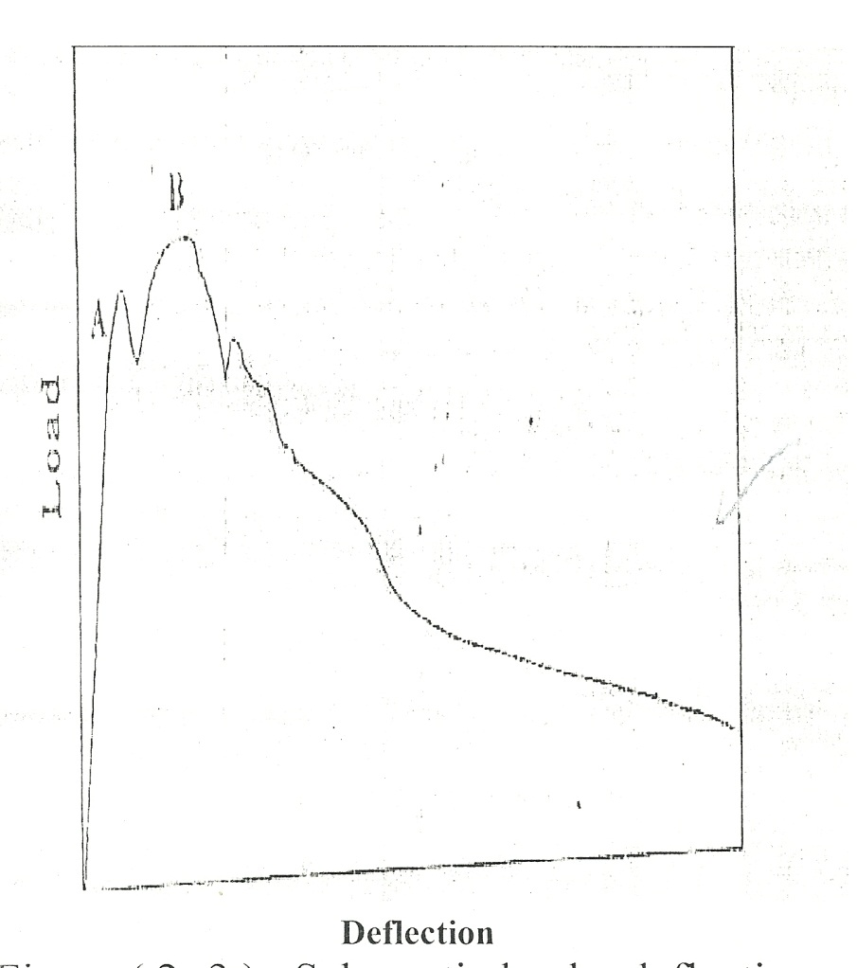

Fig.(4): Schematic load – deflection diagram for a concrete beam reinforced with fiber (ACI,1982)

2-4-1 Compressive strength of glass fiber reinforced concrete:
Different types of fibers (organic and inorganic) were used to improve the properties of concrete, but steel and glass fibers were found to be the most favorable types of fibers for structural concrete.
Takagi (Takagi,1974), in his investigation on the effect of length of randomly distributed glass fiber and their content on the performance of concrete, observed that the compressive strength of concrete increase as the glass fiber content increased to 0.75% by weight at length of 6, and 25mm fibers.
Hennery and Lawrence (Hennery,1979), reported that when the glass fiber content increases the compressive strength rise to a maximum occurs at fiber content of 0.5% by volume. The compressive strength at highest fiber volume percentage is equal to or slightly less than that of non. – Reinforced concrete. At 0.5% by volume of glass fiber, the composite strength measured were 20% to 25% greater than these of plain concrete.
The compressive strength of glass fiber reinforced concrete depends primarily on the properties of matrix. The orientation of the fiber also has some significance, since fibers aligned in the some direction as the force win weaken the compressive strength, while fibers at right angks to the applied load will help to keep the material together and so improve its fracture resistance.
2-4-2 Flexural Strength
2-4-2-1 Theoretical principles of fiber reinforced in flexural:
Many of major application of cement – bond fiber composite are likely to be subjected to flexural stress in addition to direct stress, and hence an understanding of the mechanism of strengthening in flexure may be more important than an analysis of the direct stress situation. The need for special theoretical treatment of flexure arises because of the large differences which are observed experimentally between the modules of rupture and the direct tensile - fiber concrete. In both of these materials the so called "Modulus of rupture" can be up to three times the direct tensile strength.
The main reason for the discrepancy in fiber – cement composites is that the post-cracking stress – strain curve, on the tensile side of a fiber cement or fiber concrete beam is very different from that in compression. The flexural strengthening mechanism in mainly due to this quasi – plastic behavior of fiber composite intention as a result of fiber pull – out or elastic extension of the fiber after matrix cracking, and the main principle are outlined in fig.(5).
Consider a fiber reinforced beam subjected to an increasing load(P) as shown in fig.(5).AS the tensile strain increase, cracks are formed but, un like plain cement or concrete, a proportion of the load is maintained across the crack by these fibers spanning the crack and hence equilibrium is maintained .Due to the formation of these cracks, themeasured tensile strains increase and the value of (dn),the distance of neutral axis from tensile surface ,increase. As further load is applied to the beam, the measured tensile strain increased at the greater rate than the compressive strain fig.(5,(b)) until there is no relationship measured strain and apparent stress sustained across the crack.
Fig.(5,(c and b))is more appropriate of glass reinforced cement where the fiber content is just below or will above Vf(cnr) respectively .As a first approximation it is assumed that the compressive stress block is triangular although this may not be entirely accurate at ultimate load for fibers volumes above Vf (crit.)(ASTM,1989).

P
Compression
da
Neutral axis
ε compression
ε tensile
(b)
(a)

(c)
Tension
(d)
da
da

Fig.(5): Strain and stress distribution in cracked fiber – cement or fiber – concrete section subjected to flexural (Annant,1980)
2-4-2-2 Flexural strength of glass Fiber Reinforced Concrete.
Flexural strength or modulus of rupture is the flexural stress computed at the ultimate load base on linear elastic assumption (Barzin,1989). The flexural strength was obtained from two-third point loading on(76*102)mm beam with 305mm span. Fig.(6) shows that the ultimate strength increases with increasing of fibers volume fraction up to 2%. The 12mm fiber length generally gave the lowest strength for a given fiber content but the effect of the fiber length was not very consistent, possibly because of the interaction effects of decreasing workability and increasing bond area. However, the 38mm fibers were probably most promising in terms of ultimate flexure strength (Annant,1980).
Henery and Lawerence (Henery,1995), showed that the first crack flexural strength is increased with the addition of glass fibers up to 3 times the strength of the non- reinforced concrete. In general the rate of strength increased then tends to decrease as volume percent of fibers is increased.

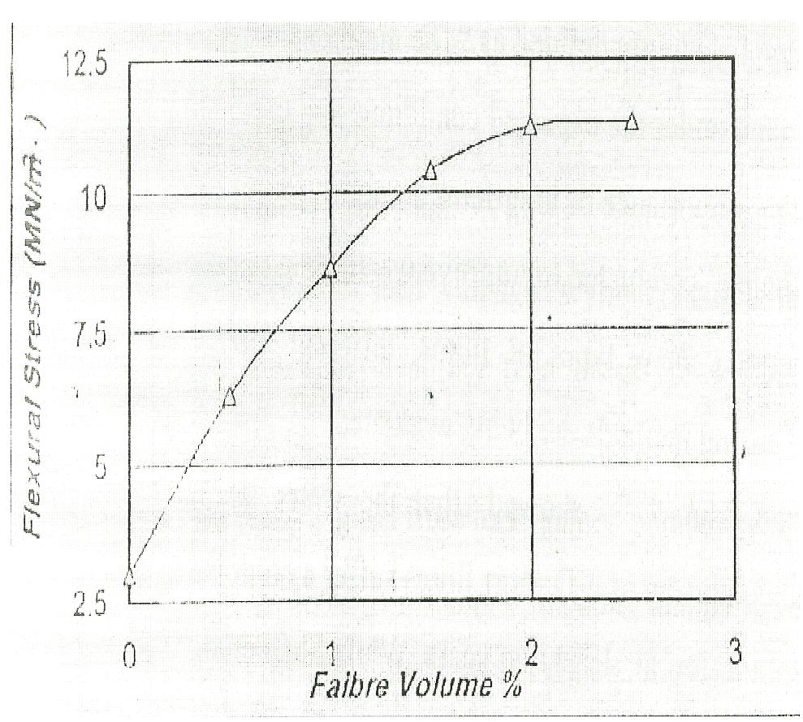

Fig.(6): Effect of fiber content on ultimate flexural strength (Hannant,1980)

2-4-3 Non-Destructive Test
The non-destructive tests are very important as a means of assessing existing structures before their failure. Also, its has been used in the laboratory for monitoring the changes in concrete properties due to various factors such as mix ingredients and their properties curing methods, deterioration due to aggressive environment, etc.
The use of non-destructive tests leads to increased safety and allows better scheduling of construction, thus making it possible to progress faster and more economically.
2-4-3-1 Rebound Method
This one of the oldest non-destructive tests and it is still widely used. The surface hardness of concrete members is tested by the “Schmidt Rebound hammer ". This testing hammer estimates the surface hardness by the rebound member which can be taken as a measure of concrete strength and percentage of voids(Nevill,1995).

3- Experimental Program
3-1 Introduction
In this part the materials used and the experimental details of this investigation are given and described. Mortar specimens were tested to find out the mechanical properties and the assess the durability of fiber reinforce mortar. Three mixes of glass fiber reinforce mortar in addition to the reference were selected, using glass fiber content at (1.0,1.5 and 2.0)%by weight of cement.
3-2 Materials
3-2-1 Cement
Ordinary Portland Cement (O.P.C) manufactured by the New Cement Plant of Kufa was used through this investigation which complied with Iraq specification No.5/1984 (1984,المواصفة القياسية العراقية). The cement was stored in a dry place to avoid the exposure of atmosphere. The physical and chemical composition properties of Portland cement are shown in Table(1).

Table (1): A) Physical Properties of Portland cement
Physical properties | Test results | Limits of Iraqi specification No.5/ 1984
Setting time, vicat's method Initial setting, hrs: min. Final setting, hrs: min. | 0:55 4:16 | ≥ 45 min ≤ 10 hrs.
Compressive strength  3 – day MPa  7 – day MPa | 19.70  26.45 | ≥ 15  ≥ 23

Table (1): B) Chemical composition of Portland cement

Oxide | Percentage (%) | IQS(No.5:1984) Limits
CaO | 60.49 | ----------
SiO₂ | 22.2 | ----------
Fe₂O₃ | 3.50 | ----------
Al₂O₃ | 5.2 | ----------
MgO | 3.25 | ≤ 5.0
SO₃ | 2.22 | ≤ 2.8
Free lime | 1.28
L.O.I. | 2.15 | ≤ 4.0
I.R. | 0.73 | ≤ 1.5
Compound composition | Percentage (%) | IQS(No.5:1984) Limits
C₃S | 40.50 | ----------
C₃S | 30.00 | ----------
C₃A | 7.25 | ----------
C₃AF | 10.50 | ----------
L.S.F. | 0.90 | 0.66 – 1.02

3-2-2 Fine aggregate:
Al-Akhaidur well-graded nature silica sand was used, and Passing through the sieve of No.1mm.

3-2-3 Glass fiber (GF)
Glass fiber, chopped strands with (5-25) mm length. The amounts used were (1.0,1.5,and2.0) percent by weight of cement.

3-2-4 Water
Ordinary tab water was used in this research for mixing and curing for all mortar specimens.

3-3 Mortar Mix Proportion
A total of (76), mortar specimens divided into cubes , prisms , and plates were cast ,and divided into (4) groups, as illustrated in Table (2)the difference between these groups in the amount of fiber percentage .
The ingredient were mixed by hand and the mixes were 1:3 (cement : sand) by weight with water/cement ratio equal to 0.45 for compressive and flexure strength test and 0.5 for non-destructive test.
Table (2): Details of Mortar Mixes (1:3) by weight

Specimen Designed | Glass fiber (% by weight of cement)
C0.0 | 0.0
C1.0 | 1.0
C1.5 | 1.5
C2.0 | 2.0

3-4 Casting and Curing
Before casting , the moulds were thoroughly oiled to facilitate demoulding and to obtain a fair face of casting. The mortar specimen were casting using (50mm) cubes, (25*25*250mm) prismatic steel moulds, and (25*300*300)mm plates of wood. After casting the specimens were stored in laboratory conditions and covered with Polyethylene these specimens sheets for 24 hours to prevent evaporation of water from mortar. The specimens were demoulding and submerged in tap water tanks having a relatively constant temperature of about (21± 2) ºC until time of testing.

3-5 Specimens and Tests:
3-5-1 Compressive Strength :
The compressive strength was determined according to ASTM, C109-88 (ASTM,1989), using (50mm) cubes. The mortar compressive strength was tested using compression machine of 200KN capacity, the specimens were tested at ages of 3,7 and 28-day. The average of three cubes was adopted for each age. plate(2) shows schematic diagram of the apparatus used in measuring compressive strength.

3-5-2 Flexural Strength (Modulus of Rupture)
The flexure strength was determined according to ASTM, C348-86(ASTM,1989). Flexural test was carried out on (25*25*250mm). Simply supported prisms with clear span of 100mm, under one point loading by using compression machine of 10KN capacity. The specimens were tested at ages of 3,7 and 28-day. The average of three specimens was adopted for each age.
The equation used was:-

$\text{fct}=\frac{2\text{PL}}{3{\text{bd}}^{2}}$……………………….(2)

Where:
fct:- Flexural strength, N/mm²,
P :- Failure load, N,
L:- Clear span length, mm
b:- Width of prism, mm
d:- Thickness of prism, mm
All the specimens were cast and curved under laboratory conditions shown in Plate (1)

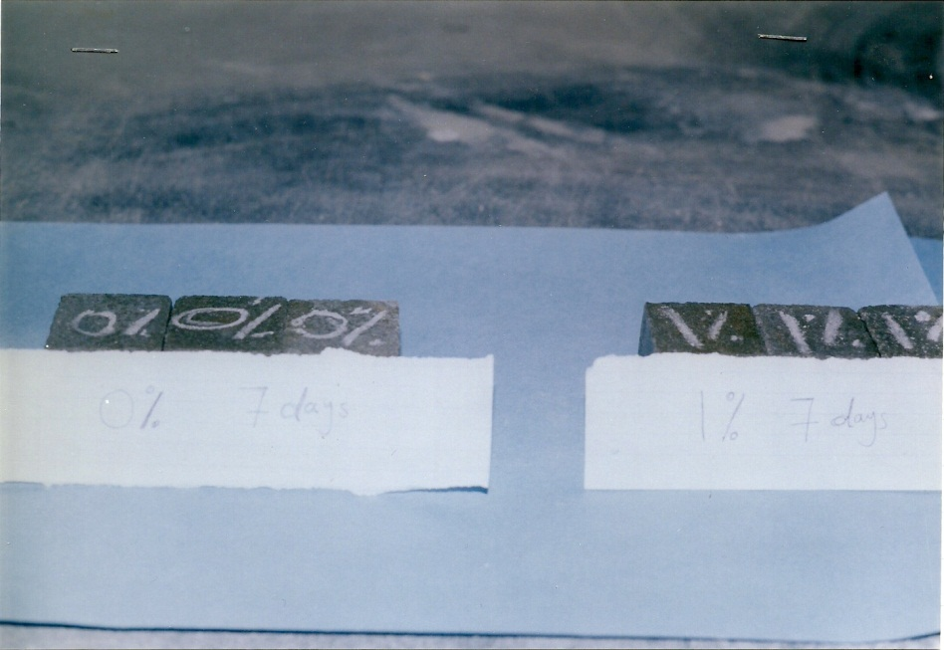

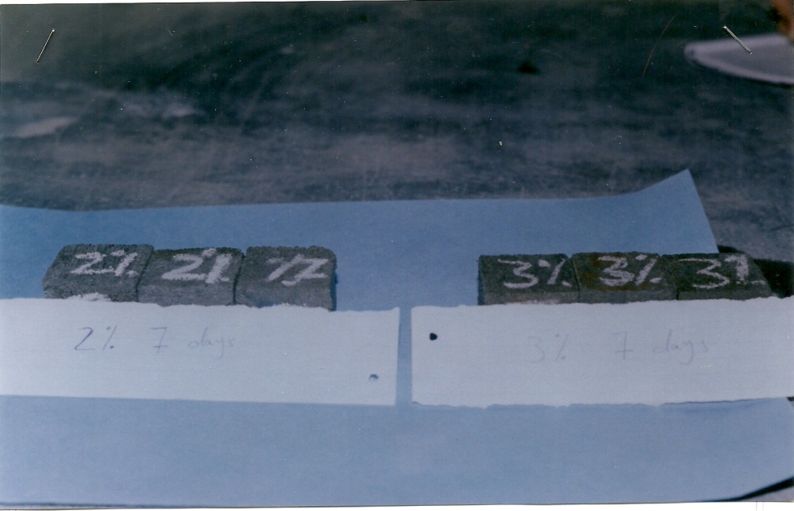

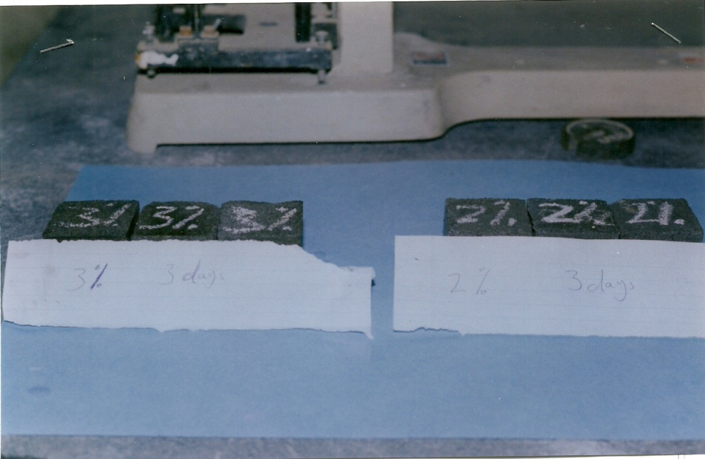

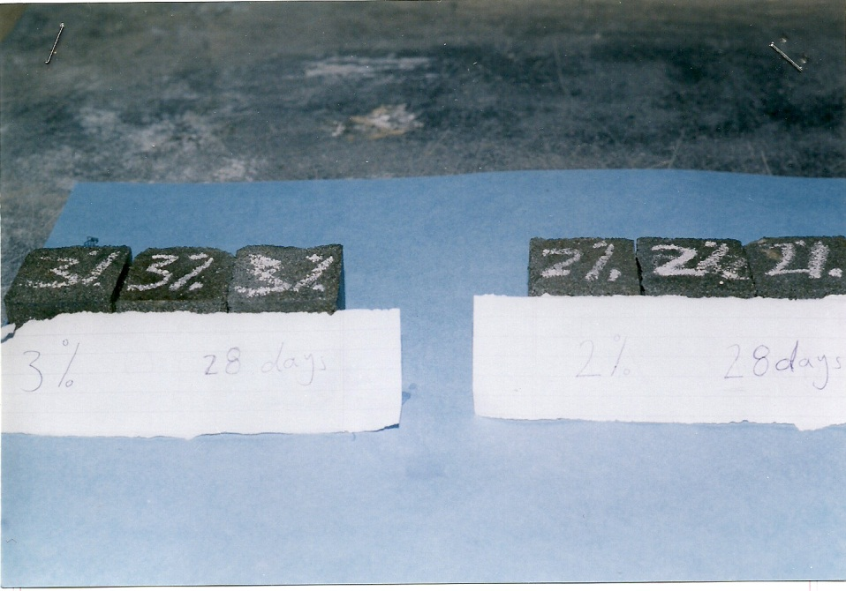

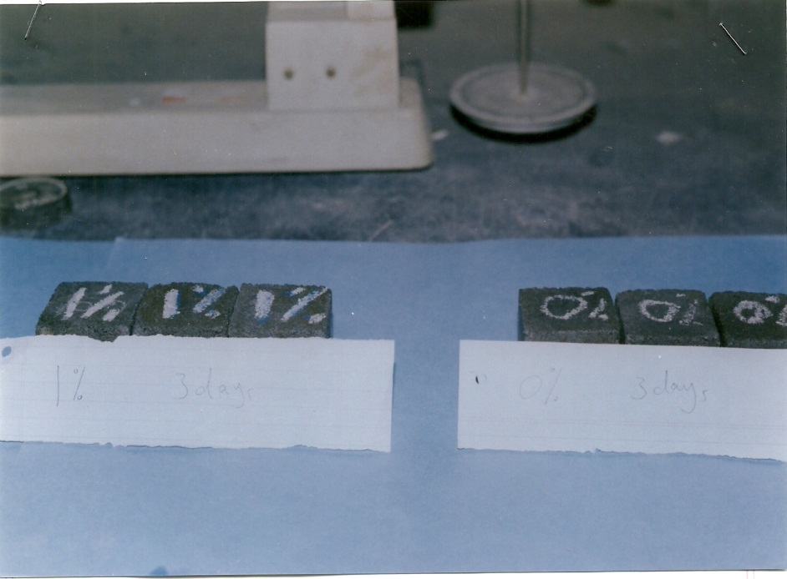

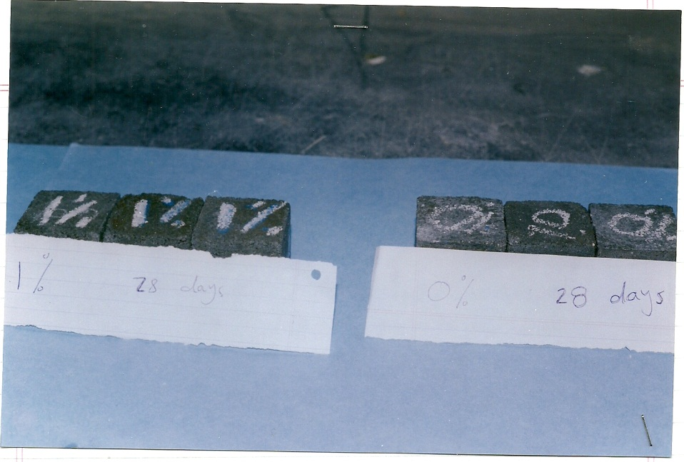

Plate (1): Models of cubes for the practical part of the research
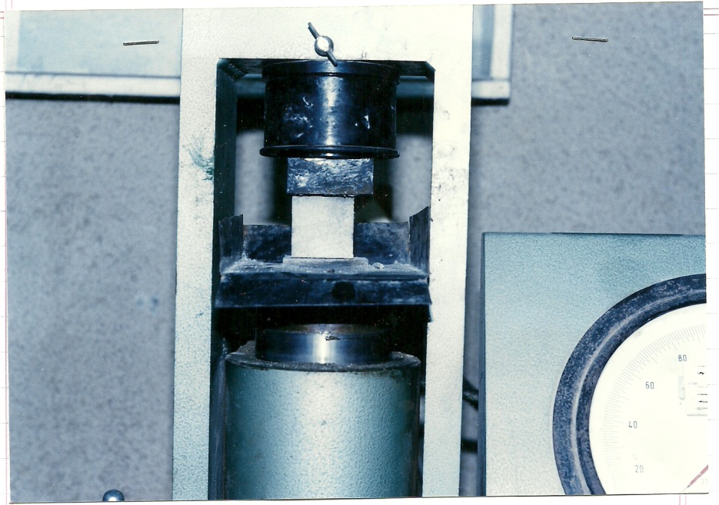

Plate (2): Schematic diagram of the apparatus used in measuring compressive strength

3-5-3 Non – destructive tests
3-5-3-1 Rebound Hammer Test
The test methods are prescribed by BS-4408; part 4:1971 (BSI,1986) specification. Schmidt hammer were used to estimate the surface hardness of mortar specimens by recording the rebound number, which could be as a measure of mortar strength and percentage of voids. Rebound hammer test by using plates (25*300*300mm). The specimens were tested at ages of 28 day. Plate(3) , shows a schematic diagram of the Schmidt hammer used in estimating the surface hardness of mortar.

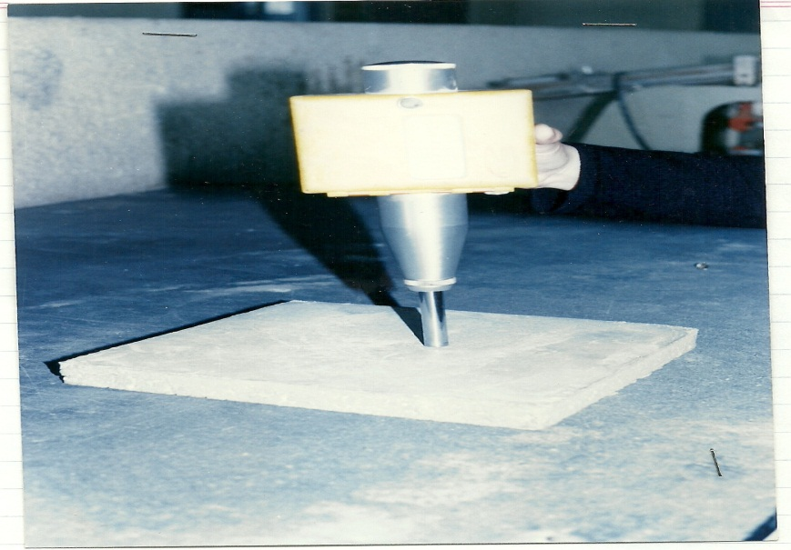

Plate(3): Schematic diagram of the Schmidt hammer used for estimating the surface hardness of mortar

4-Results and Discussion:
4-1 Introduction:
As it is common with many new materials, the use of glass fiber mortar has preceded full information on its engineering properties. The main objective of this part is to illustrate test results, representing the effect of inclusion of glass fiber on the properties of different mortar mixes. The glass fiber mortar used in this a investigation were (1, 1.5 and 2)% by weight of cement.

4-2 Compressive Strength
The compressive strength test results are presented in Table(3). The development of compressive strength with time is shown in figure (8).
Table (3) shows that the compressive strength of glass fiber reinforce mortar generally greater than plain mortar .But the maximum increase in compressive strength was in the mix with (1%) fiber content by weight cement. For example the 3-day compressive strength was increased for 18.21 MPa for reference mix to 19.12MPa and 15.80 MPa for C1andC2mortar mixes respectively.
The test results in fig.(8) show that compressive strength development with time ,it is clear that the strength of fiber reinforced mortar is greater than that of plain mortar. For example the 7 days compressive strength was 23.45, 25.21, 20.42 and19.11 MPa for C0.0 ,C1.0 ,C1.5 and C2.0 respectively .
From above results, we can notice that the use of glass fiber slightly improve the compressive strength .But the decrease in compressive strength with increasing fiber content, may be attributed to the disturbance in the homogeneity of the mix and also to the orientation of the fiber, because if the fiber orientation at right angle to the direction of applied load the resistance to fracture will increases. The compressive strength test results are a good agreement with Henry and Lawrence study.

Table (3) :Compressive strength results of the plain and fiber reinforced mortar

Specimen  Designed | Compressive strength (N/mm²)
Specimen  Designed | 3- days | 7 – days | 28 – days
C0.0 | 18.21 | 23.45 | 35.61
C1.0 | 19.12 | 25.21 | 37.32
C1.5 | 17.23 | 20.42 | 32.50
C2.0 | 15.80 | 19.11 | 29.53

Fig. (8) : Compressive strength results of the plain and fiber reinforced mortar

4-3 Flexural strength (Modulus of Rupture)
The test results of the flexural strength (modulus of rupture) are shown in Table (4) , and fig.(9) which are shown the effect of incorporation of glass fiber on flexural strength with time . Table (4) generally , indicated that the presence of glass fiber increase the flexural strength for all fiber content. Fig.(9) illustrate that the (1%) fiber content by weight of cement increase the flexural strength significantly although other fiber content also increase the flexural strength. For example at 3- days flexural strength for fiber reinforced mortar ranges between (3.10 – 2.62) MPa compared to 2.25 MPa for plain mortar.
Fig.(9) shows that the amount of improvement in the flexural strength was decreased with the increase of fiber content. The reasons for that are the difference of aggregate cement paste bonds , and orientation and distribution of fiber throughout the specimen, if the rupture occurs in zone containing fibers that fibers will resist the rupture, while if the failure occurs in zone without any fibers that lead to reduce the flexural strength. Henery and Lawerence, although they reached approximately to the same results, but they attributed this manner to the difficulties during mixing as the fiber content increase.

Table (4) : Flexural strength results of the plain and fiber reinforced mortar

Specimen design | Flexural strength (N /mm²)
Specimen design | 3 - days | 7 - days | 28 – days
C0.0 | 2.25 | 2.5 | 3.22
C1.0 | 3.10 | 3.64 | 4.45
C1.5 | 2.76 | 3.20 | 4.12
C2.0 | 2.62 | 2.98 | 3.78

MPa

Fig. (9):Flexural strength results of the plain and fiber reinforced mortar

4-4 Non-Destructive Test by Schmidt hammer
The test results of non-destructive test by Schmidt hammer which used to estimate the surface hardness of mortar are shown in Table (5) and (6) and fig. (10) and (11), which are show the effect of glass fiber content on rebound number and compressive strength. From Table (5) and (6) it can be noticed that the rebound number and compressive strength of plain mortar were greater than rebound number and compressive strength of glass fiber reinforced mortar for all specimens at age of 28-days. For example at 28-days the rebound number and compressive strength of reference mortar were 26.8 and 24.5 MPa respectively, while for glass fiber reinforced for C1.0, C1.5 and C2.0 the rebound number and compressive strength were (26.1, 23.6MPa), (25.3, 22.4 MPa), and (24.0, 21.0) respectively. This behavior due to the presence of glass fiber, which many increase the volume of voids and reduce the hardness of surface. From fig. (10) it can be noticed that the non-linear relationship between the rebound number and compressive strength for all specimens at age of 28days, as the rebound number increases the compressive strength increase.

MPa

Fig. (10): Rebound Number and Compressive Strength
Relationship at age 28- days

Table (5): Effect of glass fiber on rebound number and compressive strength

Specimen designed | Rebound number | Compressive strength (MPa) at age of 28-days
C0.0 | 26.8 | 24.5
C1.0 | 26.1 | 23.6
C1.5 | 25.3 | 22.4
C2.0 | 24.0 | 21.0

Fig. (11): Effect of Fiber Percentage on Rebound number

From Table (5) it can be noticed that the rebound number of plain mortar was greater than the rebound number of glass fiber reinforced mortar for all specimens at age of 28day. This behavior is due to presence of glass fiber, which may increase the volume of voids and reduce the surface hardness of mortar.
Fig.(11) shows the non-linear relationship between the fiber percentage and rebound number for all specimens, as the fiber percentage increase the rebound number decrease.

Table (6) : Compressive strength results of mortar specimen
Specimen designation | Compressive strength (MPa) at age of 28 days
C0.0 | 24.5
C1.0 | 23.6
C1.5 | 22.4
C2.0 | 21.0

MPa

Fig. (12): Compressive strength and fiber Percentage relationship

5- conclusions :
The following conclusions can be drawn from the experimental work of the present study.
- The workability of the glass reinforced mortar mixes decreases with increasing of glass fiber content.
- The glass fiber has not a significant effect on the compressive strength of mortar mixes compared with plain mortar. The (1%) glass fiber mortar mix produces higher compressive strength than other mixes.
- It was found that the presence of glass fiber enhance the flexural strength significantly, and particularly for C1 mortar mix, although other percentages of glass fiber increase the flexural strength compared with the reference specimens.
- The presence of glass fiber reduces the development rate for compressive, and flexural strength at early ages this manner is due to the addition of glass fiber which increases the voids at early ages which reduce the strength, but with time. This voids decreases as the hydration process which effect on strength.
- For non-destructive test by Schmidt hammer which used to estimate the surface hardness of mortar, the addition of glass fiber to mortar mixes reduce the rebound number and compressive strength, as the fiber content increase the rebound number and compressive strength increased. The C0.0% glass fiber mortar mix produces higher rebound number and compressive strength than other mixes.
- There is non – linear relationship between rebound number and , as the rebound number decreases the compressive strength decrease.
6- References:
Barzin, M; and Shah, S.P, "Test Parameters for Evaluating Toughness of Glass – Fiber Reinforced Concrete Panals". Technical Paper, ACI Material Journal, September - October 1989.PP448-458.
Prestressed Concrete Institute, " Glass Fiber Reinforced Concrete A Most Innovative Material", 3rd Publication, Concrete International Journal, vol.7, No.3, 1985.PP.69-70.
Shand, E.B., "Glass Engineering Hand Book''. McGrow Hill Book Company, 1958. PP. 73-82.
Hannant, D.J., ''Fiber Cement and Fiber Concrete"". John Wiley and Sons Co.,1980
ACI Committee 544, "State of the Art report on Fiber Reinforced Concrete". (ACI 544.IR-82), Concrete International Journal, May 1982. PP. 9-30.
Takagi, J., "Some Properties of Glass Fiber Reinforced Concrete" Fiber Reinforced Concrete, SP.44-5, 1974. PP.93-111.
Henery, N.M, and Lawrence, L., "Glass Fiber Reinforced Cement Base Materials". Fiber Reinforced Concrete, SP. 44-14, 1979. PP. 247-264.
Nevill, A.M., "Properties of Concrete ". 4th ed., Pitma, Publishing London, 1995, PP. 623-627.
المواصفة القياسية العراقية رقم 5 لسنة 1984 " السمنت البورتلاندي"
Ghazy, O.M., "Engineering Properties of Concrete Member Reinforced with Glass Fiber". M.Sc. thesis, University of Technology, 2000, PP. 10-16.
American Society for Testing and Material, C109-88, '' Standard Testing Method for Compressive Strength of Hydraulic Cement Mortar (Using 2in or 50mm Cube Specimen)", Annual Book of ASTM Standard, Vol.04.01,1989, PP. 57-61.
American Society for Testing and Material, C348-86, '' Standard Testing Method for Flexural Strength of Hydraulic Cement Mortar (Using Simple beam with Center– Point Loading)", Annual Book of ASTM Standard, Vol.04.01,1989, PP. 204-209.
British Standard Institution, "Recommendations for Measurement of Compressive Strength by Rebound Hammer", BS. 1881: Part 202: 1986.

